Supplementary File 1： ResLSTM Architecture
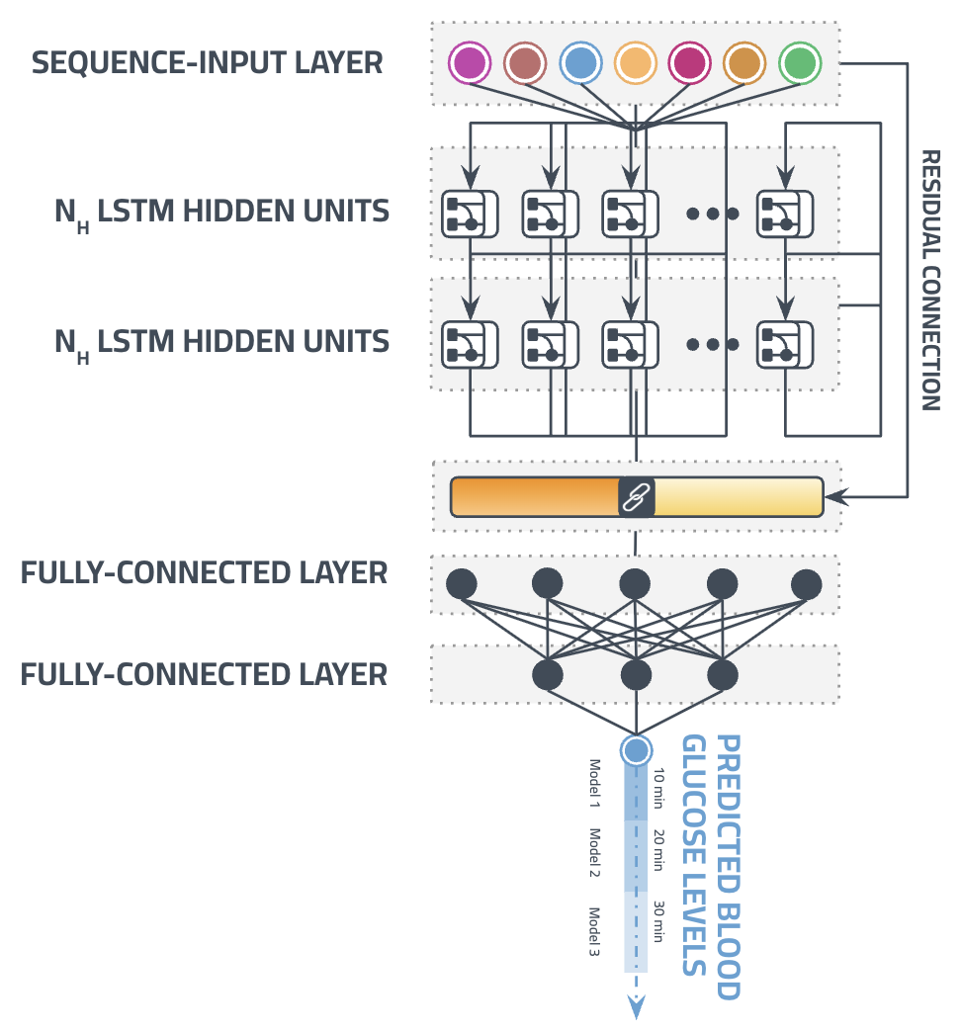
Figure S1: ResLSTM Architecture

