Self‑DNA as a chronic stress signal drives soil sickness in lisianthus by disrupting root integrity and facilitating pathogen invasion
Di HE¹, Han LI¹, Yiran YANG¹, Peihua ZHANG^{2*}
¹School of Agriculture, Yunnan University, Kunming 650200, China;
²Key Laboratory for Flower Breeding of Yunnan Province, Yunnan Academy of Agricultural Sciences, National Engineering Research Center for Ornamental Horticulture, Floriculture Research Institute, Kunming 650200, China;
* Corresponding author, E-mail: zhangpeihua@yaas.org.cn

Supplementary material
Supplementary Text 1: Material and method:
The detailed DNA extraction procedure:
Approximately 10 g of tissue was ground to a fine powder in liquid nitrogen and transferred to pre-warmed 2× CTAB lysis buffer (containing 1% β-mercaptoethanol), followed by incubation in a 65°C water bath for 45 min. The mixture was then extracted with an equal volume of chloroform-isoamyl alcohol (24:1). After centrifugation, the supernatant was collected, and DNA was precipitated by adding 0.6 volumes of isopropanol along with ammonium acetate to a final concentration of 0.3 M (pH 5.2), followed by incubation at -20°C overnight. The DNA pellet was collected by centrifugation, washed with 70% ethanol, air-dried, and dissolved in sterile ddH₂O.

DNA Fragmentation
To obtain DNA fragments in the target size range of 50–2000 bp, DNA samples were subjected to ultrasonication using an ultrasonic cell disruptor (JY92-IIDN, Scientz). A series of working conditions were tested to optimize the fragmentation efficiency and size distribution (Tab S1). The optimal condition (Condition 3: 8 min total duration with cycles of 30 s ON / 10 s OFF at 30% power, sample temperature maintained at 20°C) yielded fragments predominantly within the desired range. The fragmentation results under all tested conditions were analyzed by 1.5% agarose gel electrophoresis (Fig. S1).

Table S1 DNA ultrasonic fragmentation working conditions
 | Total time |  | ON | OFF | Power |  |  | Protection Temperature
1 |  | 12 min | 60 s | 30 s |  | 30% | 37 ℃
2 |  | 12 min | 60 s | 30 s |  | 30% | 20 ℃
3 |  | 8 min | 30 s | 10 s |  | 30% | 20 ℃
4 |  | 8 min | 3 s | 1 s |  | 30% | 20 ℃
5 |  | 12 min | 20 s | 80 s |  | 30% | 20 ℃
6 |  | 12 min | 12 s | 48 s |  | 30% | 20 ℃
7 |  | 12 min | 2 s | 8 s |  | 30% | 20 ℃
8 |  | 30 min | 1 s | 1 s |  | 30% | 20 ℃

Fig. S1 Electrophoresis results of DNA fragments generated under different ultrasonication conditions. DNA samples were ultrasonicated using the parameters listed in Supplementary Table 1 and separated on a 1.5% agarose gel. Lanes 1–8 correspond to the condition numbers in Table S1.

RNA extraction, library construction and sequencing
For each treatment, root tip tissues (approximately 0.1 g) were collected from three biological replicates, immediately frozen in liquid nitrogen, and stored at −80 °C until RNA extraction. Total RNA was isolated using the RNAprep Pure Plant Kit (Tiangen, China) according to the manufacturer’s instructions. RNA integrity and potential DNA contamination were assessed by agarose gel electrophoresis. RNA purity was measured using a NanoPhotometer spectrophotometer (Implen, Germany), and RNA concentration was accurately quantified with a Qubit 2.0 Fluorometer (Thermo Fisher Scientific, USA). The integrity of RNA was further examined with an Agilent 2100 bioanalyzer (Agilent Technologies, USA). For library preparation, mRNA was enriched using mRNA Capture Beads, followed by purification and fragmentation at high temperature. First-strand cDNA was synthesized from the fragmented mRNA using a reverse transcription system. Second-strand cDNA was then synthesized while performing end repair and A-tailing. Adapters were ligated to the resulting DNA fragments, and target fragments were selected and purified using Hieff NGS® DNA Selection Beads. Finally, PCR amplification was carried out to generate the sequencing library. The constructed cDNA libraries were sequenced on an Illumina NovaSeq X Plus platform by Guangzhou Gene Denovo Biotechnology Co., Ltd. (Guangzhou, China).
Supplementary Text 2: Results:
After quality control filtering, all samples yielded high-quality clean data, with the proportion of clean data exceeding 98.80% for each sample (Tab. S2). The percentages of bases with Q30 and Q20 quality scores were above 97.33% and 99.42%, respectively (Tab. S3), and the GC content remained stable between 43.25% and 44.07%, indicating reliable sequencing data suitable for subsequent analysis. Alignment results based on the reference genome showed a total alignment rate ranging from 90.63% to 91.95% (Tab. S4). A total of 55,972 genes were detected as expressed in this study (Tab. S5).
Table S2 Data filtering statistics table
Sample | RawDatas | CleanData(%)
CK-1 | 47471388 | 46900840 (98.80%)
CK-2 | 54250098 | 53876408 (99.31%)
CK-3 | 48077880 | 47715414 (99.25%)
T-200-1 | 46845126 | 46432636 (99.12%)
T-200-2 | 47776626 | 47400844 (99.21%)
T-200-3 | 54800268 | 54293254 (99.07%)

Table S3 Base information statistics table
Sample | BF_Q20(%) | BF_Q30(%) | BF_GC(%) | AF_Q20(%) | AF_Q30(%) | AF_GC(%)
CK-1 | 99.03% | 96.95% | 43.84% | 99.42% | 97.44% | 43.87%
CK-2 | 99.35% | 97.76% | 43.86% | 99.58% | 98.10% | 43.84%
CK-3 | 99.17% | 96.98% | 44.09% | 99.42% | 97.33% | 44.07%
T-200-1 | 99.20% | 97.45% | 43.42% | 99.48% | 97.82% | 43.43%
T-200-2 | 99.26% | 97.56% | 43.25% | 99.51% | 97.87% | 43.26%
T-200-3 | 99.22% | 97.45% | 43.38% | 99.51% | 97.81% | 43.41%

Table S4 Reference alignment statistics table
Sample | Unmapped(%) | Unique Mapped(%) | Multiple Mapped(%) | Total Mapped (%)
CK-1 | 8.55% | 81.75% | 9.69% | 91.45%
CK-2 | 8.73% | 81.38% | 9.89% | 91.27%
CK-3 | 8.05% | 81.93% | 10.02% | 91.95%
T-200-1 | 9.05% | 81.23% | 9.72% | 90.95%
T-200-2 | 9.37% | 81.17% | 9.45% | 90.63%
T-200-3 | 9.13% | 81.29% | 9.58% | 90.87%

Table S5 Genetic testing statistics table
Sample | Refer Genes | Sequenced Refer Genes (%) | Novel Genes | Sequenced Novel Genes(%) | Total Genes | Sequenced Total Genes (%)
all | 54305 | 72.66% | 1667 | 100.00% | 55972 | 73.47%
CK-1 | 54305 | 60.95% | 1667 | 82.72% | 55972 | 61.60%
CK-2 | 54305 | 62.12% | 1667 | 86.74% | 55972 | 62.85%
CK-3 | 54305 | 61.72% | 1667 | 82.30% | 55972 | 62.33%
T-200-1 | 54305 | 59.44% | 1667 | 85.36% | 55972 | 60.21%
T-200-2 | 54305 | 58.96% | 1667 | 84.28% | 55972 | 59.71%
T-200-3 | 54305 | 61.21% | 1667 | 84.76% | 55972 | 61.91%

To assess experimental reliability and the overall transcriptomic response, Principal Component Analysis (PCA) was performed. The PCA results clearly separated samples from the two distinct groups along the first principal component, which accounted for 72.2% of the total variance, while biological replicates within the same group clustered closely together (Fig. S2A). This demonstrates excellent intra-group reproducibility and indicates that the treatment-induced transcriptomic changes far exceeded the background biological variation. Differential expression analysis identified a total of 4,232 genes that were significantly altered in the T-200 treatment group compared to the CK group (FDR < 0.05). Among these differentially expressed genes (DEGs), 1,630 were upregulated and 2,602 were downregulated (Fig. S2B). The distribution of these DEGs is visualized in the volcano plot (Fig. S2C), which highlights the total transcriptomic changes and confirms a predominant trend of downregulation. The complete dataset of all expressed genes and the detailed list of significant DEGs, including gene identifiers, log₂ fold changes, and statistical values, are provided in Tab. S6 and Tab. S7, respectively.
Fig. S2 Transcriptomic analysis of the T-200 treatment group compared to the control (CK). (A) Principal Component Analysis (PCA) plot showing clear separation between the CK and T-200 groups along the first principal component (PC1, 72.2% of variance), with biological replicates clustering closely within each group. (B) Bar chart summarizing the number of differentially expressed genes (DEGs), with 1,630 upregulated and 2,602 downregulated genes (FDR < 0.05). (C) Volcano plot visualizing the distribution of all DEGs, highlighting the overall transcriptomic changes and the predominant trend of downregulation in the T-200 group.

The distribution of differentially expressed genes (DEGs) between the control (CK) and the 200 μg/mL sDNA treatment group (T-200) across the three main Gene Ontology (GO) categories was illustrated in Fig. S3A. Within Biological Processes, “Cellular process” and “Metabolic process” contained the highest number of DEGs, with downregulated genes substantially outnumbering upregulated ones. This pattern suggests that the T-200 treatment may significantly inhibit fundamental cellular metabolism and physiological activities. Similarly, processes such as “Response to stimulus” and “Biological regulation” also contained a considerable number of DEGs, indicating the induction of stress responses and dysregulation of biological controls. Regarding Molecular Function, the primary differences were concentrated in basic functions. “Binding” and “Catalytic activity” had the highest gene counts, with a clear predominance of downregulated genes. This indicates that the T-200 treatment likely impaired molecular binding capabilities and enzymatic activities, thereby interfering with cellular metabolism and signaling. “Transporter activity” and “ATP-dependent activity” also showed numerous downregulated genes, hinting at potential disruptions in substance transport and energy metabolism. The GO enrichment bubble chart (Fig. S3B) reveals that the impact of sDNA treatment on the lisianthus root transcriptome primarily manifests in two core aspects. Firstly, key terms related to photosynthesis pathways, including “Plastid organization”, “Thylakoid”, “Photosynthetic membrane”, “Plastid”, “Chloroplast”, and “Photosynthesis”, showed significant changes. This indicates that sDNA treatment significantly affected the expression of genes related to chloroplast/plastid structure and photosynthesis in the roots. Although roots typically do not perform photosynthesis, plastids may participate in other crucial metabolic pathways (e.g., hormone synthesis, signal transduction). It is hypothesized that sDNA might influence root physiology by regulating plastid function. Secondly, regarding activated defense responses, the treatment notably induced terms such as “Response to fungus”, “Defense response to fungus”, “Response to other organism”, “Response to external biotic stimulus”, and “Response to biotic stimulus”. This suggests that sDNA treatment activated root defensive responses against fungal and other biotic stimuli, potentially inducing an immune response analogous to that triggered by pathogen invasion, leading to the upregulation of related defense genes. Furthermore, changes were observed in some basic immunity and defense pathways, including “Immune response”, “Immune system process”, and “Lignin metabolic process”. These terms represent upstream or fundamental processes in defense pathways.Although the number of associated genes and the degree of enrichment were lower, they might represent secondary effects of the fungal response pathway or reflect a broad-spectrum regulation of basic immunity by sDNA. Regarding other pathways, “Oxidoreductase activity”, “acting on metal ions”, might be related to redox balance in defense responses (e.g., metal ion-mediated signaling), while “Photosynthesis, light reaction” is likely a sub-term of the photosynthesis pathway, regulated by the main pathway.
Fig. S3 Functional classification of differentially expressed genes (DEGs) based on Gene Ontology (GO) analysis (A). The histogram illustrates the distribution of DEGs between the control group (CK) and the 200 μg/mL self-DNA treatment group (T-200) across the three major GO categories: Biological Process, Molecular Function, and Cellular Component. The x-axis represents the number of genes, with blue and orange bars denoting up-regulated and down-regulated genes, respectively. Bubble chart of GO enrichment analysis for differentially expressed genes (DEGs). This chart displays significant functional terms identified through GO enrichment analysis (B). The x-axis (Gene Ratio) represents the enrichment ratio of DEGs within the corresponding GO term. The y-axis lists the statistically significant GO functional terms. Bubble size indicates the number of DEGs annotated to the respective GO term (legend range 200-600). Bubble color represents the level of enrichment significance, denoted by the -log₁₀(Q value) value, transitioning from blue to red indicating decreasing Q values (increasing significance). The Q value is the p-value adjusted using the False Discovery Rate (FDR) correction; the analysis screening threshold was set at Q value < 0.05.

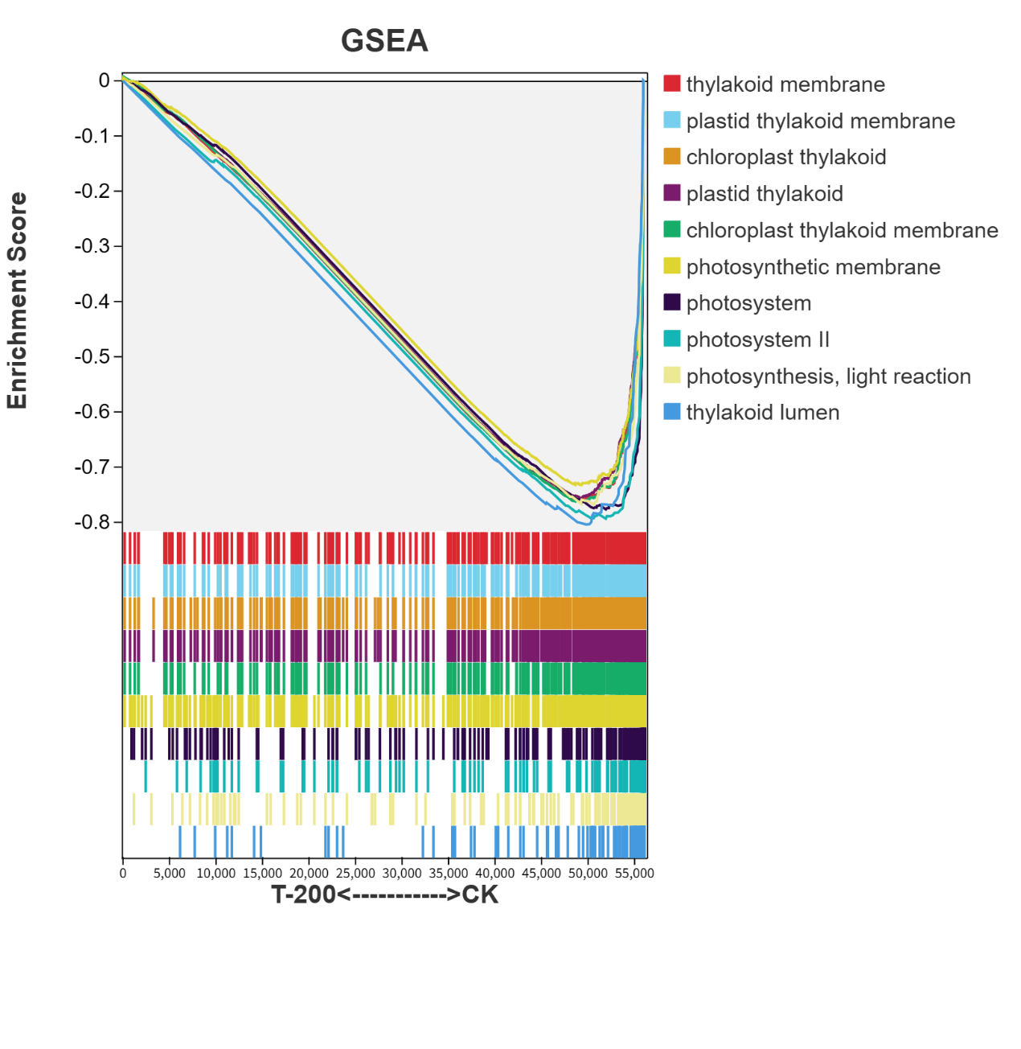
Fig. S4 GSEA plot of significantly enriched down-regulated gene sets in the T-200 treatment group compared to the control. Significantly enriched gene sets were identified under the following criteria: |Normalized Enrichment Score (NES)| > 1, gene set size > 50, nominal p-value < 0.05, and false discovery rate (FDR) < 0.25.The top ten significantly enriched gene sets are displayed. The profile (upper plot) shows the enrichment score (ES) across the ranked gene list (x-axis). The heatmap (lower part) indicates the positions of member genes (vertical black lines) in the ranked list.
Fig. S5. Content of Lisianthus sDNA in soil under different durations of continuous cropping. Y1: soil after 1 year of continuous cropping; Y3: soil after 3 years of continuous cropping; Y4: soil after 4 years of continuous cropping; Y4-1M: soil after 4 years of continuous cropping with one harvest.

