Electronic supplementary information
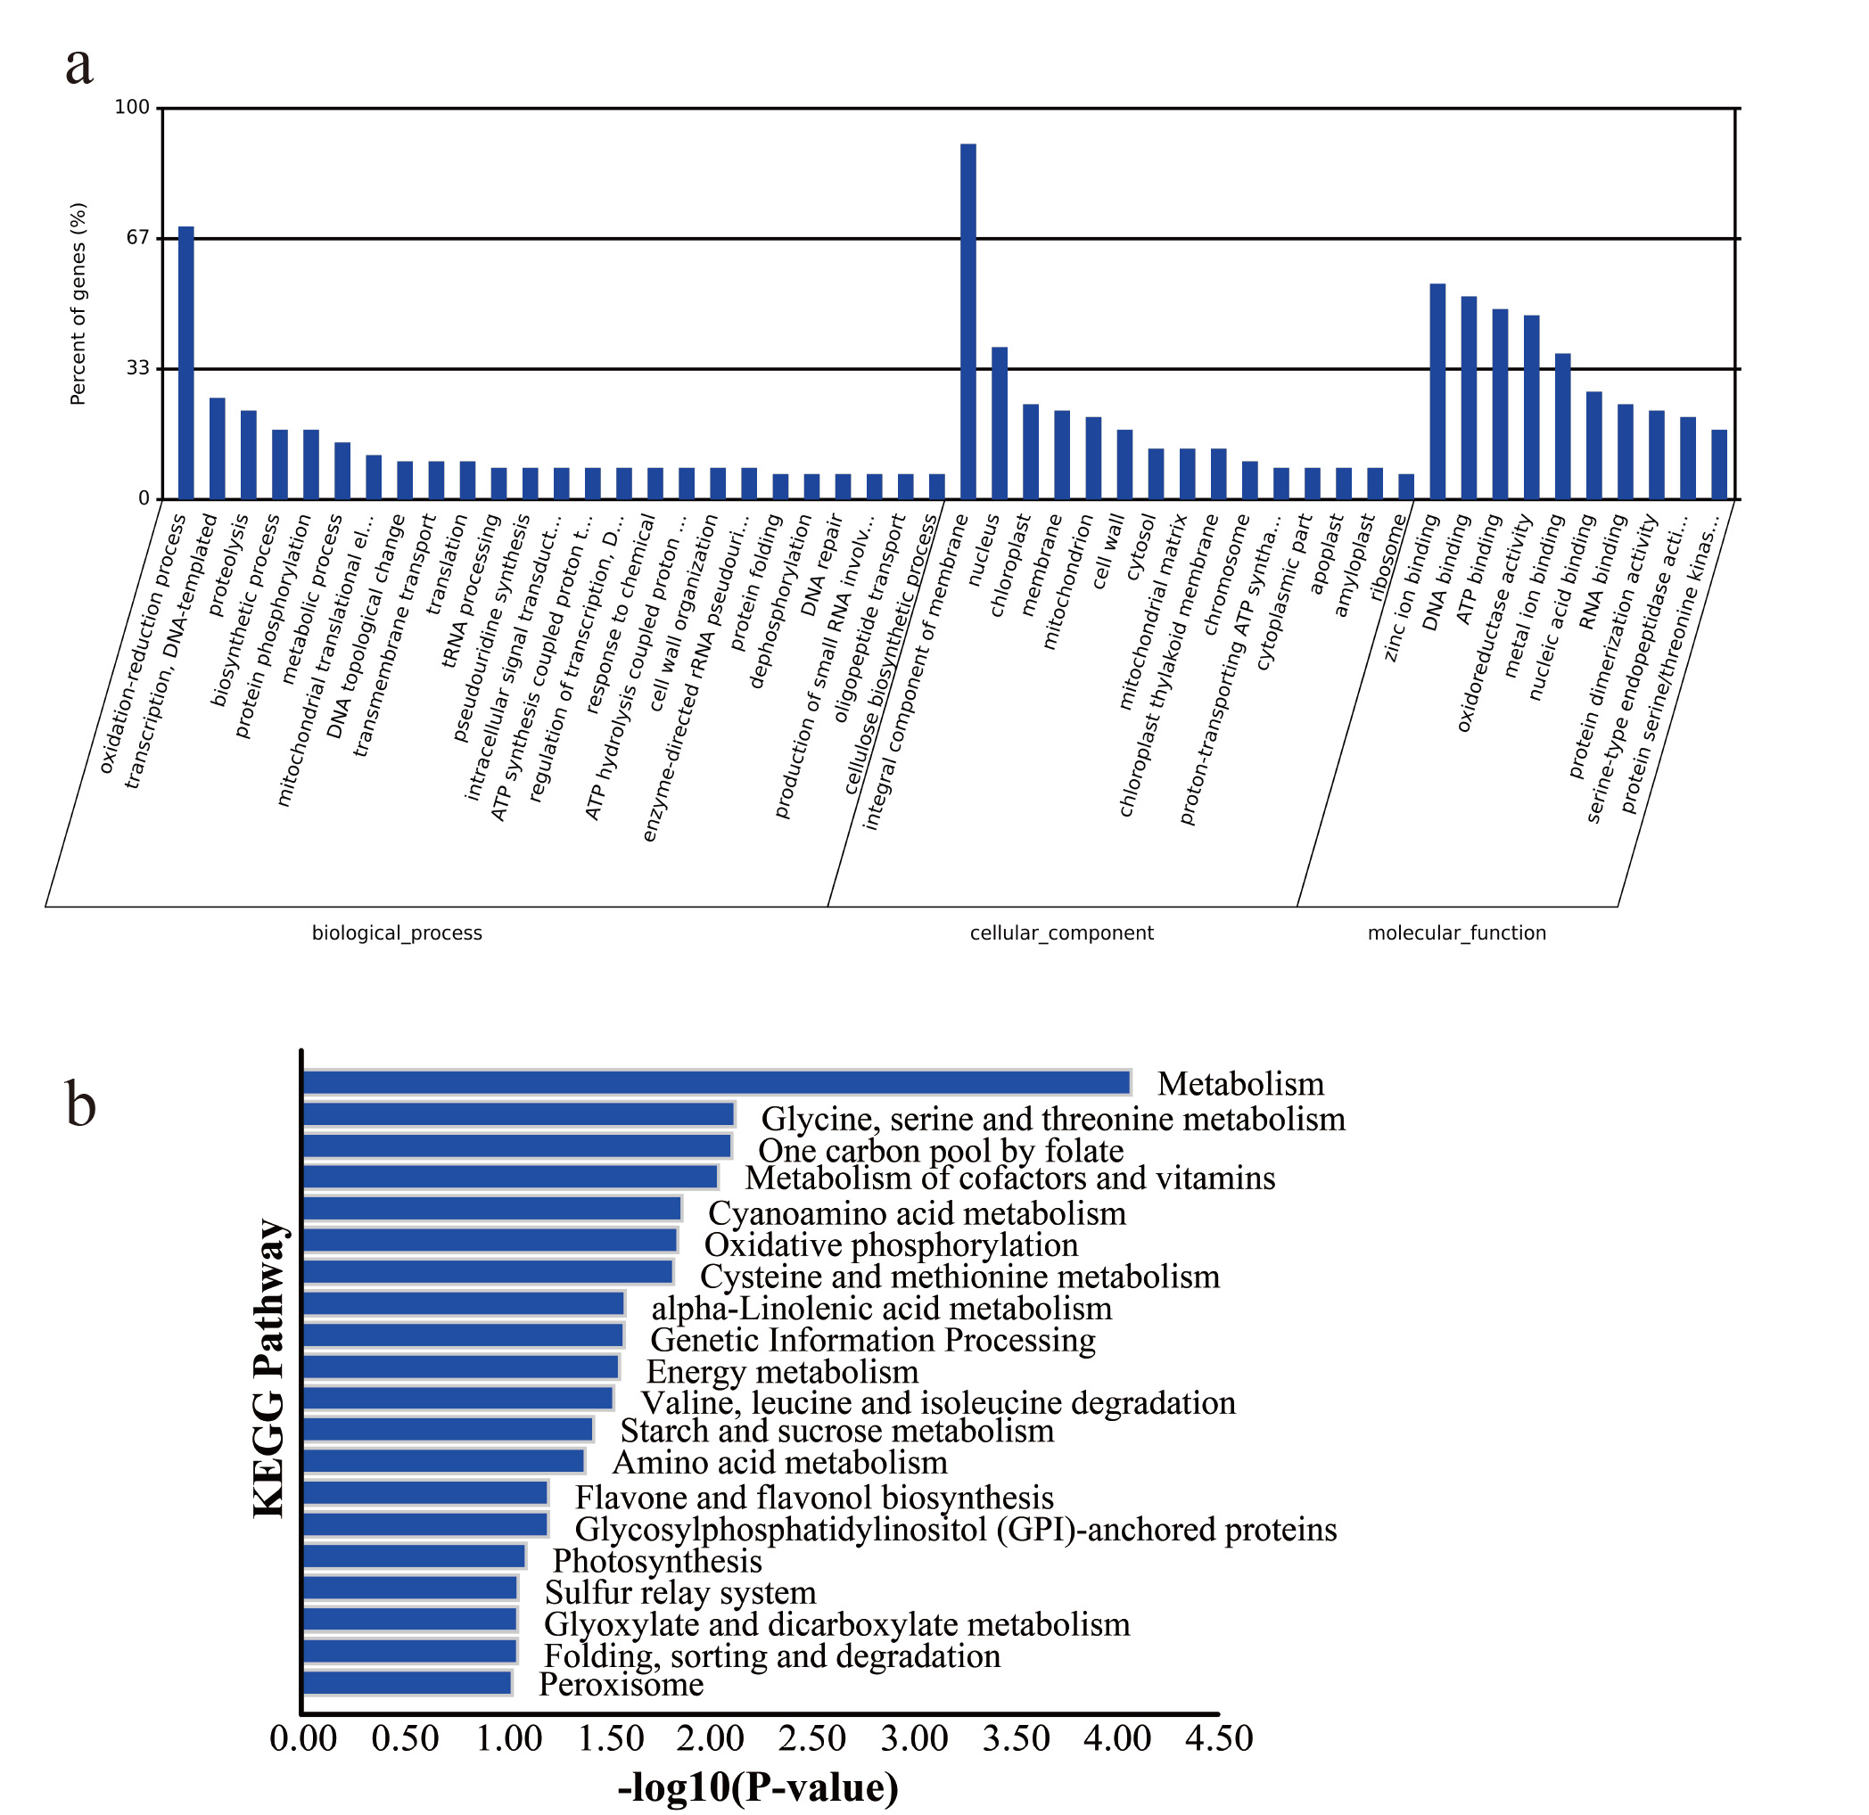
Figure S1. The enrichment analysis of the target genes A: The GO enrichment analysis of the target genes. B: KEGG Pathway Enrichment of the target genes.

