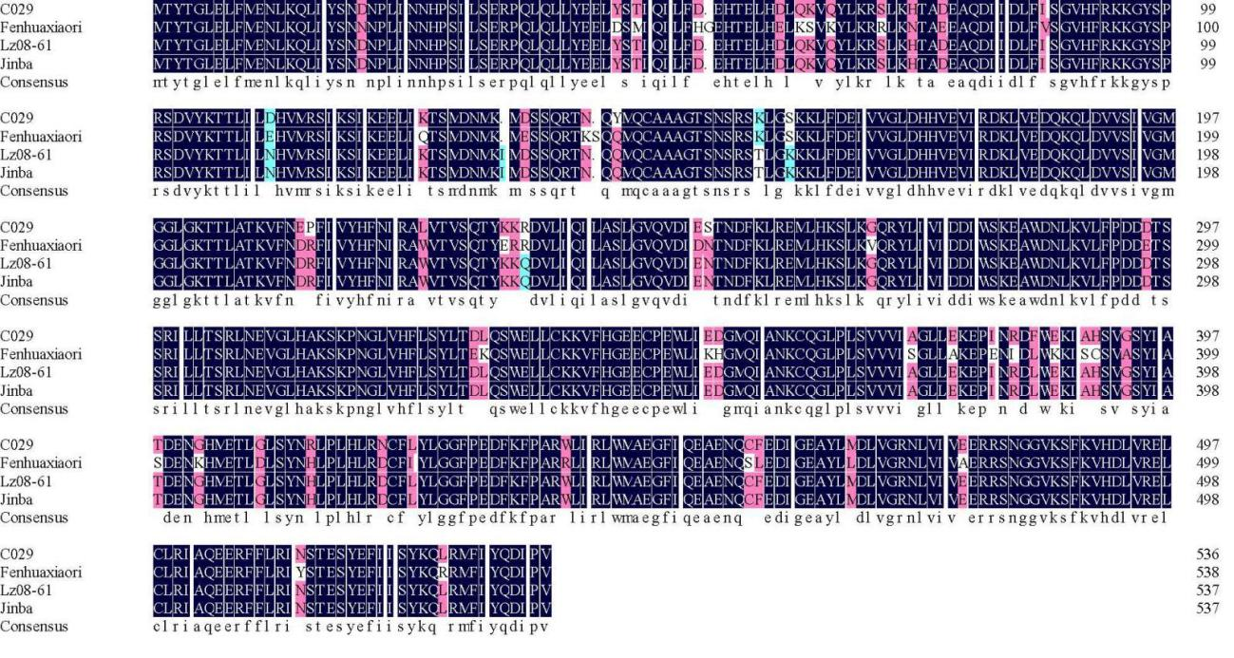
Fig. S2 The amino acid sequences of cultivars 'C029', 'Fenhuaxiaori', 'LZ08-61', and 'Jinba'
The red brackets represent the CC domain. The yellow brackets represent the NB-ARC domain.

