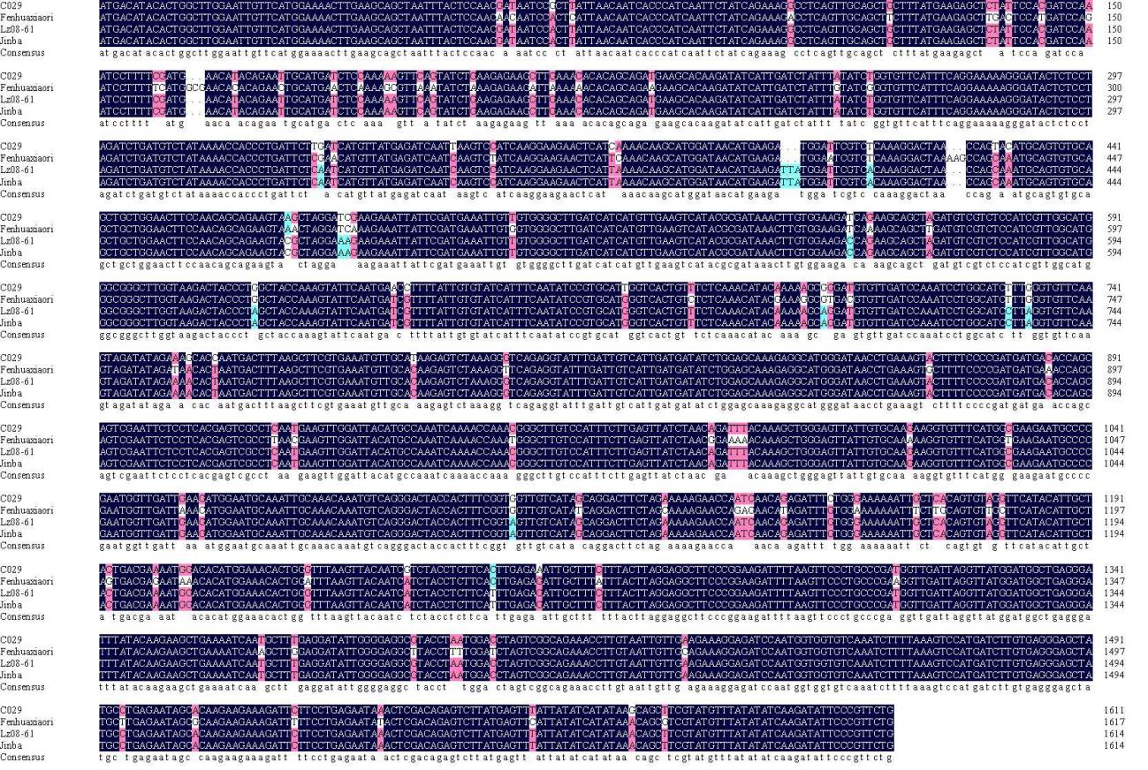
Fig. S1 The open reading frames of cultivars 'C029', 'Fenhuaxiaori', 'LZ08-61', and 'Jinba'

