Oxidant-dependent carbamazepine transformation: How aged microplastics modulate degradation pathways in UV-AOPs

Yuhui Wangª, Xiaochao Zhouª, Zhenyang Xuª, Hang Liuª, Xiaohui Wang^{a*}, Tingting Zhang^{a, *}

ª Department of Environmental Science and Engineering, College of Chemical Engineering, Beijing University of Chemical Technology, Beijing 100029, China

Text S1 Chemicals and reagents
Polyamide (PA) MPs powder was purchased from Shanghai Hui Plastic International Trade Co. Ltd. Carbamazepine (CBZ), potassium peroxymonosulfate (KHSO₅-0.5KHSO₄-0.5K₂SO₄) and sodium hypochlorite (NaClO) was obtained from Shanghai Maclean Biochemical Technology Co. Ltd. Sodium hydroxide (NaOH), hydrochloric acid (HCl), sulphuric acid (H₂SO₄), formic acid (HCOOH) and 30% hydrogen peroxide (30% H₂O₂) were bought from Beijing Tongguang Fine Chemical Company. Sodium nitrate (NaNO₃), sodium chloride (NaCl) and sodium bicarbonate (NaHCO₃) were obtained from Beijing Chemical Factory. Humic acid (HA) was analytically pure and purchased from Beijing Bailingway Technology Co. Ltd. This work obtained a high-performance liquid chromatography (HPLC) grade Acetonitrile from Thermo Fisher Scientific, USA. Tert-butanol (TBA), furfuryl alcohol (FFA), benzoic acid (BA) and p-benzoquinone (p-BQ) were bought from Shanghai Aladdin Biochemical Technology Co. Ltd.

Text S2 Experimental setup
The pristine PA MPs used in this work were >99% pure with an average particle size of 97.5 μm. All samples of pristine PA MPs were washed three times with ultrapure water to remove impurities from the surface of the MPs, dried at 40 °C, and stored away from light before the aging experiments [1]. Photoirradiation was the most commonly used technique to accelerate the aging of simulated MPs, followed by chemical oxidation [2]. UV irradiation was considered the main component of the photooxidation of plastic polymers in water [3]. Therefore, the MPs were prepared by exposure to UV+H₂O₂ in the photochemical reactor to simulate the long aging process in natural water. In each quartz tube, 10 g of the PA MPs and 30 mL of 10% H₂O₂ were added [4]. The quartz tubes were irradiated under UV light (500 W high-pressure mercury lamp), and the samples were continuously stirred in the reaction system with a magnetic stirrer (200 rpm) to simulate the mechanical wear of MPs in natural water [5]. The aging time was 12 h per day, and H₂O₂ was supplemented regularly during the aging period [6, 7]. The aged MPs were washed three times with deionized water to remove residual H₂O₂ from the surface. The samples were filtered with a 0.22 μm microporous filter membrane, collected, and dried at 40 °C. The accumulated irradiation times of the PA MPs was 96 h. It would correspond to 240 days of actual surface UV exposure [8]. Samples was obtained and named aged PA MPs. Finally, the prepared PA MPs were stored away from light for experimental and characterization purposes.

Text S3 Dark adsorption and environmental factor experiments
Dark adsorption experiments: It was to investigate the adsorption of contaminants by MPs apart from the photolysis of the contaminants. Each quartz tube contained 1 mg·L⁻¹ of CBZ. The control group did not add MPs, while the other tubes were filled with 2 g·L⁻¹ of MPs. Samples were taken at 0, 0.25, 0.5, 1, 1.5 and 2 hours, passed through a 0.22 μm filter membrane, and immediately analyzed by HPLC. The experiment was conducted thrice.
The effects of different environmental factors on degradation experiments were investigated. Among them, anion (NO₃⁻, Cl⁻ and HCO₃⁻) concentration gradients were chosen at 1, 5 and 10 mM, HA concentration gradients were set at 10 mg·L⁻¹, 20 mg·L⁻¹ and 50 mg·L⁻¹, and pH was selected at 3, 6 and 9. In addition, the river and lake waters in Beijing, China, were chosen to study the degradation of CBZ in natural water. The other parameters remained the same as the degradation experiments mentioned above.

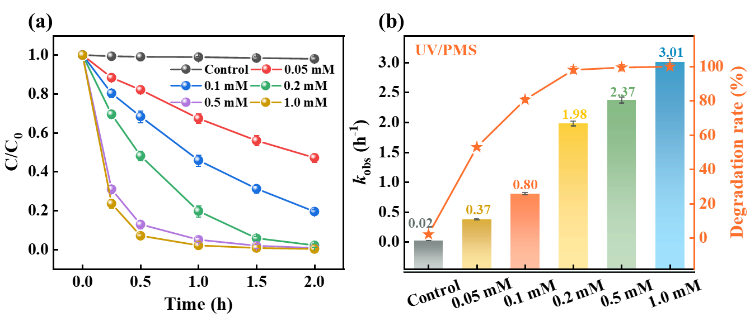
Figure S1. Effect of oxidant concentration on CBZ degradation in UV/PMS systems. Reaction conditions: [CBZ]₀ = 1 mg·L⁻¹, pH = 6.0 ± 0.5, T = 25 ℃.

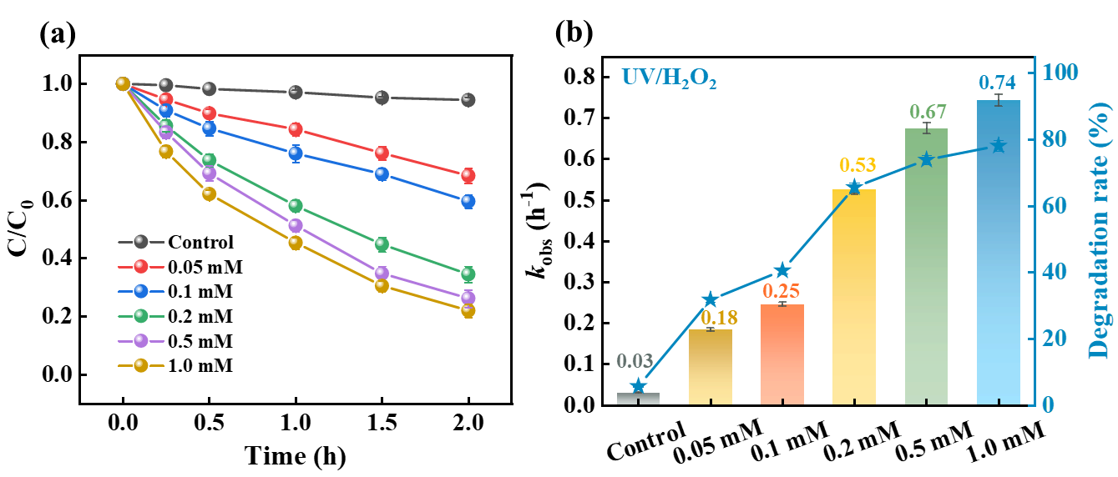
Figure S2. Effect of oxidant concentration on CBZ degradation in UV/H₂O₂ systems. Reaction conditions: [CBZ]₀ = 1 mg·L⁻¹, pH = 6.0 ± 0.5, T = 25 ℃.

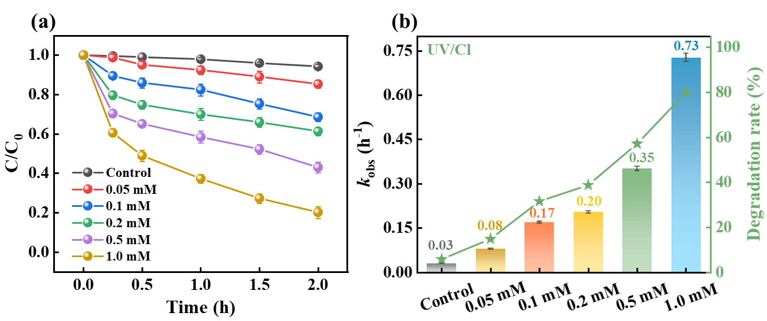
Figure S3. Effect of oxidant concentration on CBZ degradation in UV/Cl systems. Reaction conditions: [CBZ]₀ = 1 mg·L⁻¹, pH = 6.0 ± 0.5, T = 25 ℃.
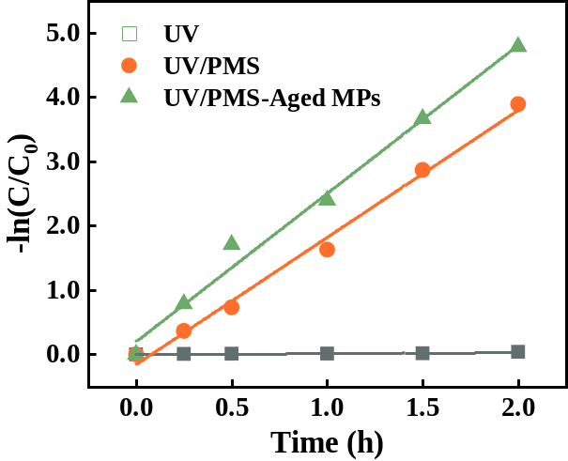
Figure S4. Effect of aging PA MPs on CBZ degradation in UV/PMS systems. Reaction conditions: [CBZ]₀ = 1 mg·L⁻¹, [PMS]₀ = [H₂O₂]₀ = [Cl]₀ = 0.2 mM, [PA MPs]₀ = 2 g·L⁻¹, pH = 6.0 ± 0.5, T = 25°C

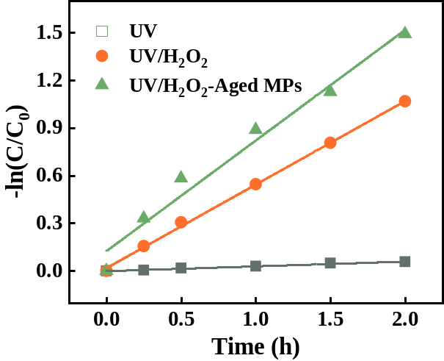
Figure S5. Effect of aging PA MPs on CBZ degradation in UV/H₂O₂ systems. Reaction conditions: [CBZ]₀ = 1 mg·L⁻¹, [PMS]₀ = [H₂O₂]₀ = [Cl]₀ = 0.2 mM, [PA MPs]₀ = 2 g·L⁻¹, pH = 6.0 ± 0.5, T = 25°C

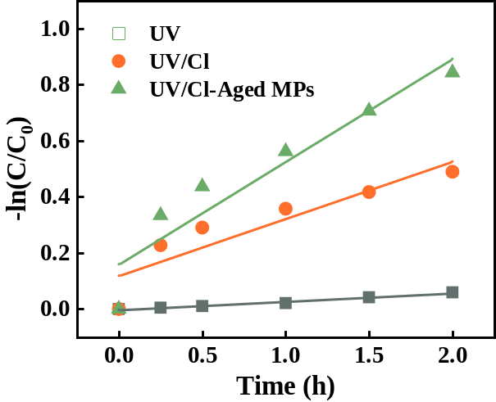
Figure S6. Effect of aging PA MPs on CBZ degradation in UV/Cl systems. Reaction conditions: [CBZ]₀ = 1 mg·L⁻¹, [PMS]₀ = [H₂O₂]₀ = [Cl]₀ = 0.2 mM, [PA MPs]₀ = 2 g·L⁻¹, pH = 6.0 ± 0.5, T = 25°C

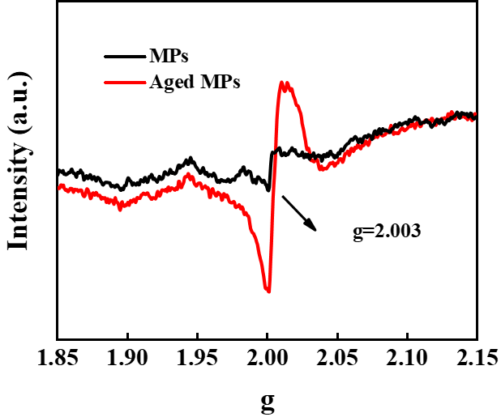
Figure S7. EPR spectra of EPFRs.

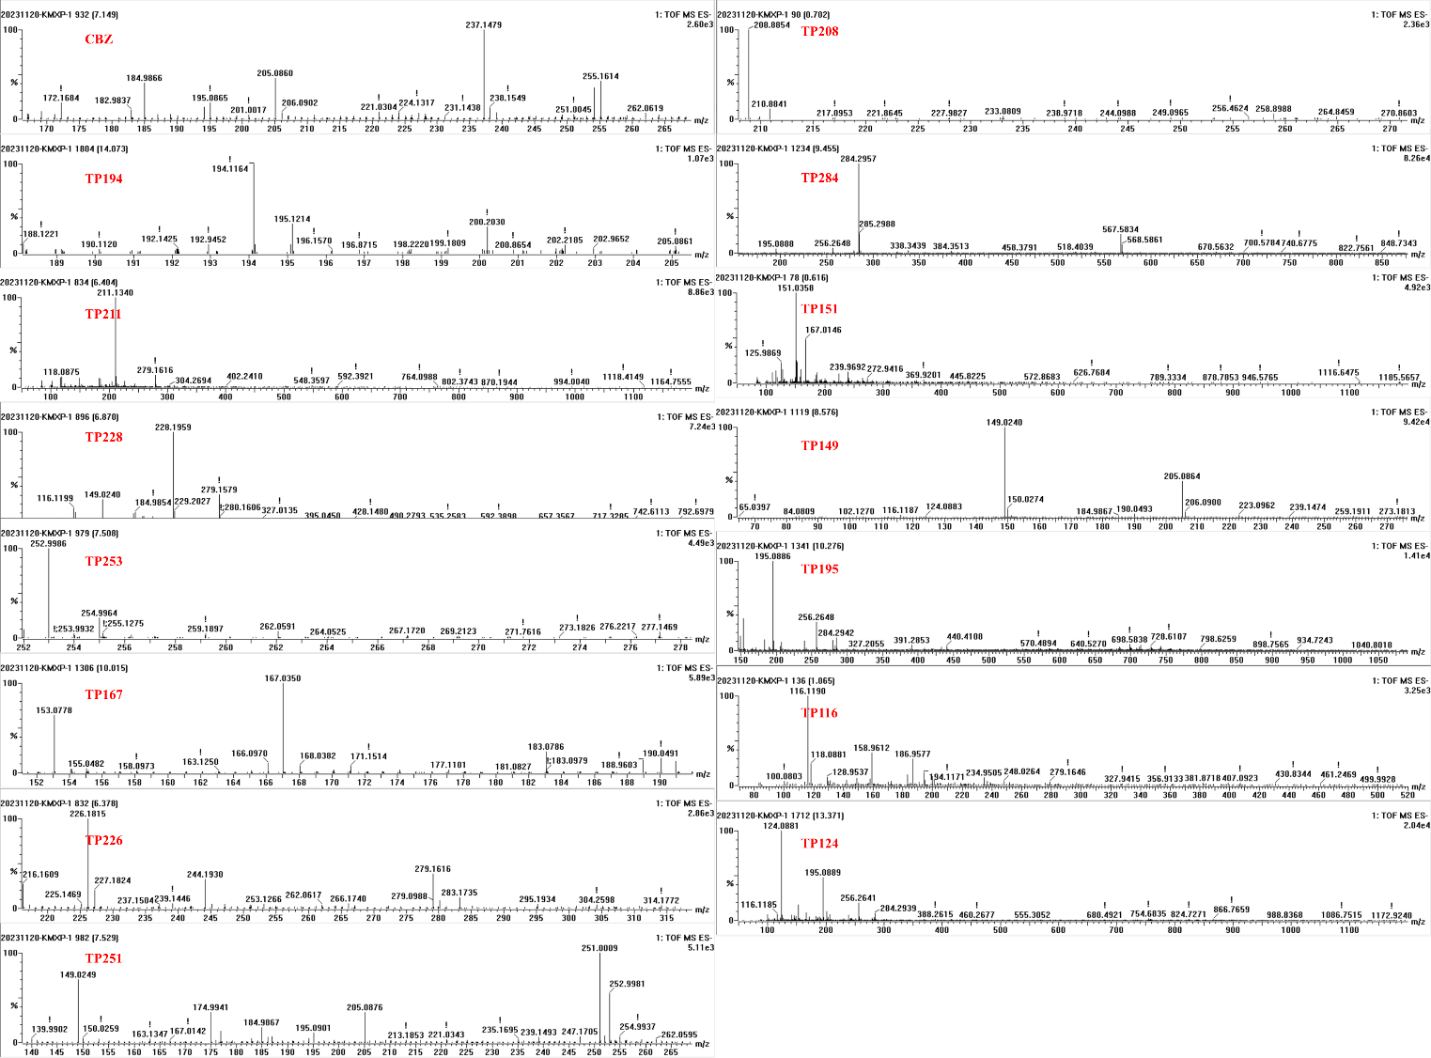
Figure S8. Mass spectra of different transformation products of CBZ in UV/PMS systems.
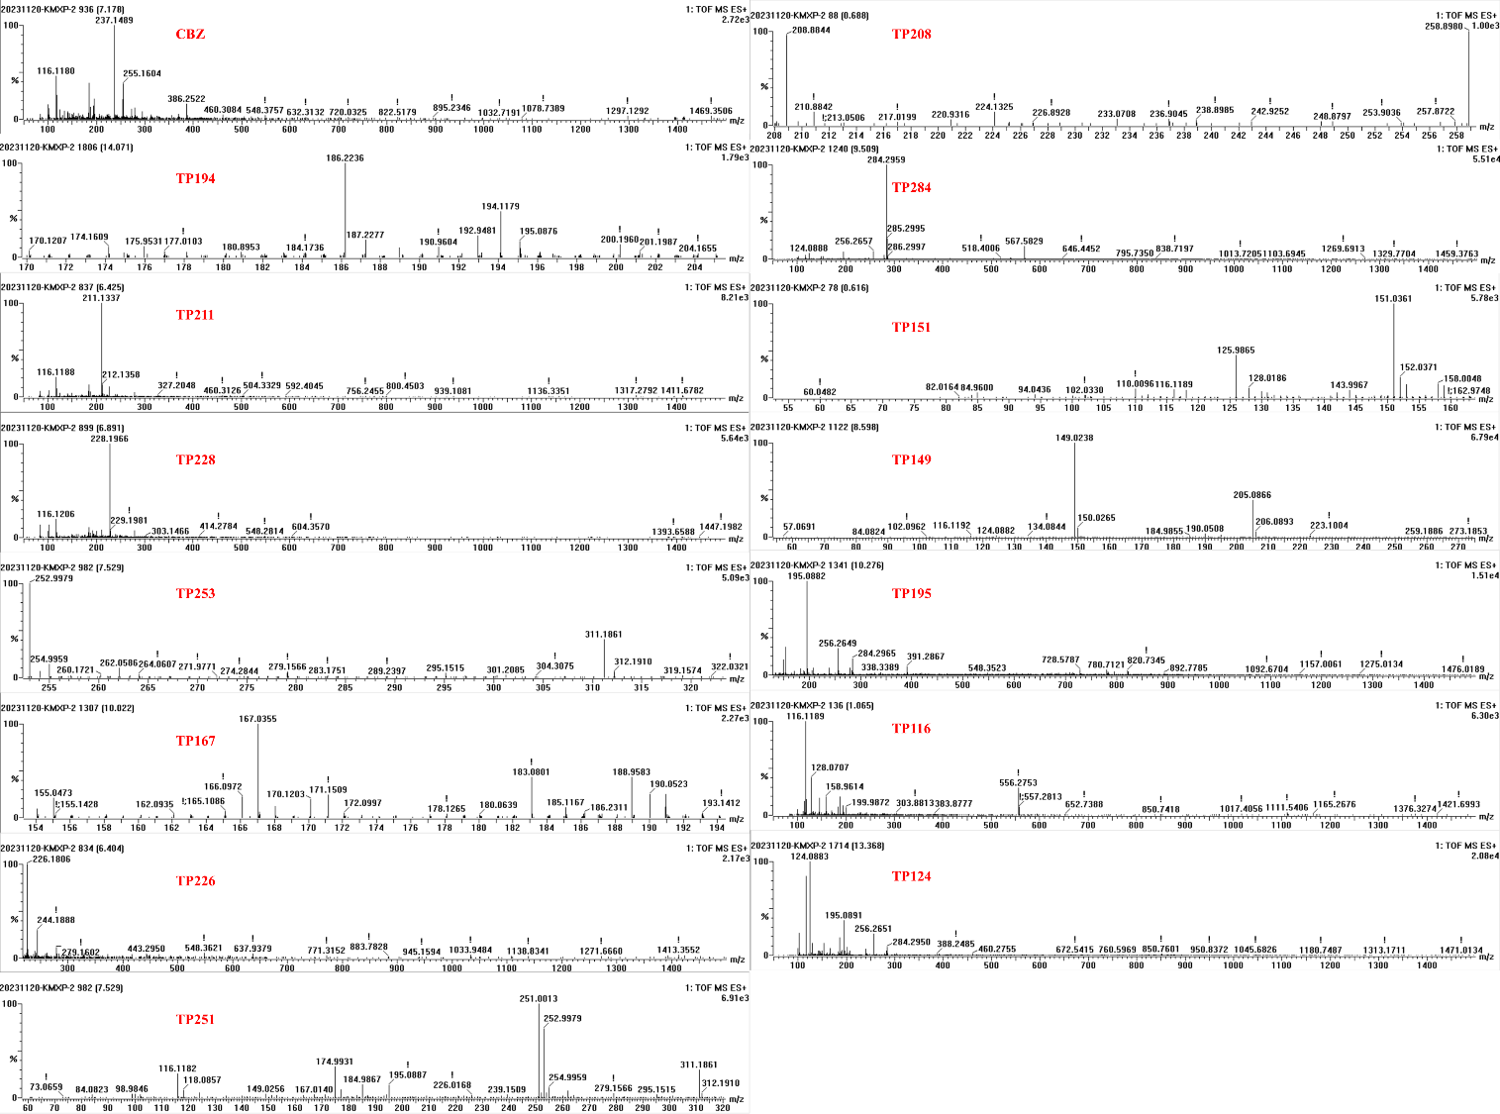
Figure S9. Mass spectra of different transformation products of CBZ in UV/PMS-aged MPs systems.
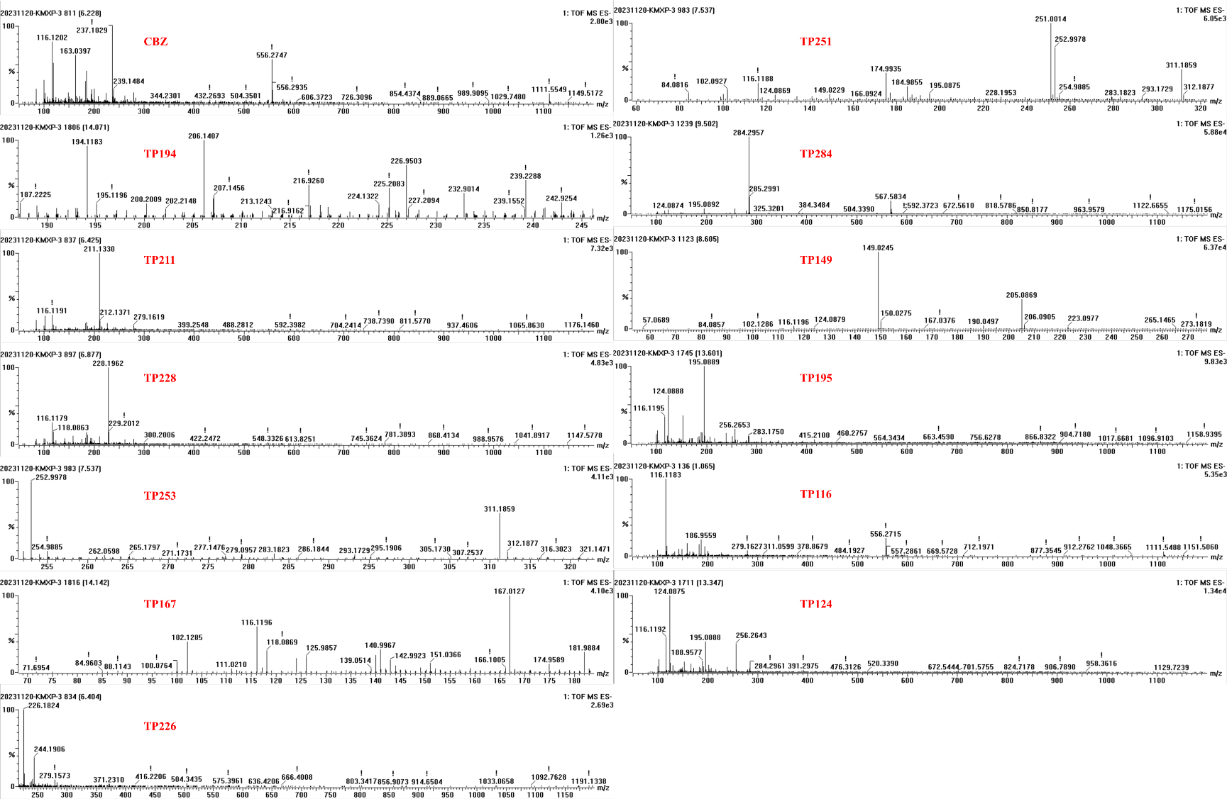
Figure S10. Mass spectra of different transformation products of CBZ in UV/H₂O₂ systems.
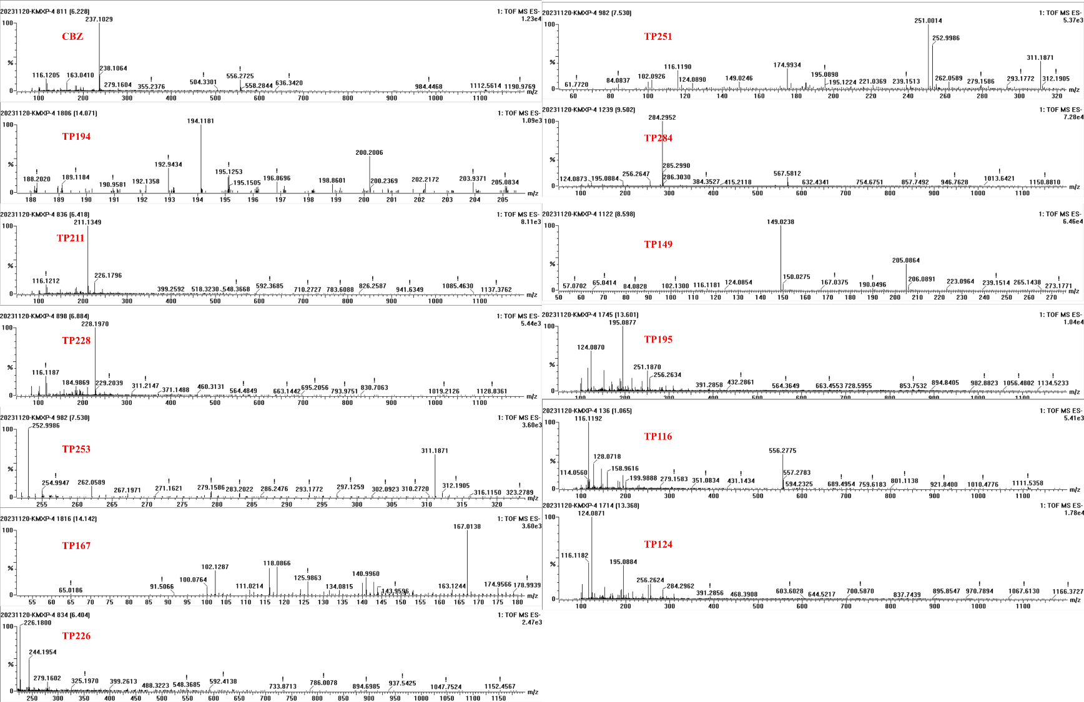
Figure S11. Mass spectra of different transformation products of CBZ in UV/H₂O₂-aged MPs systems.
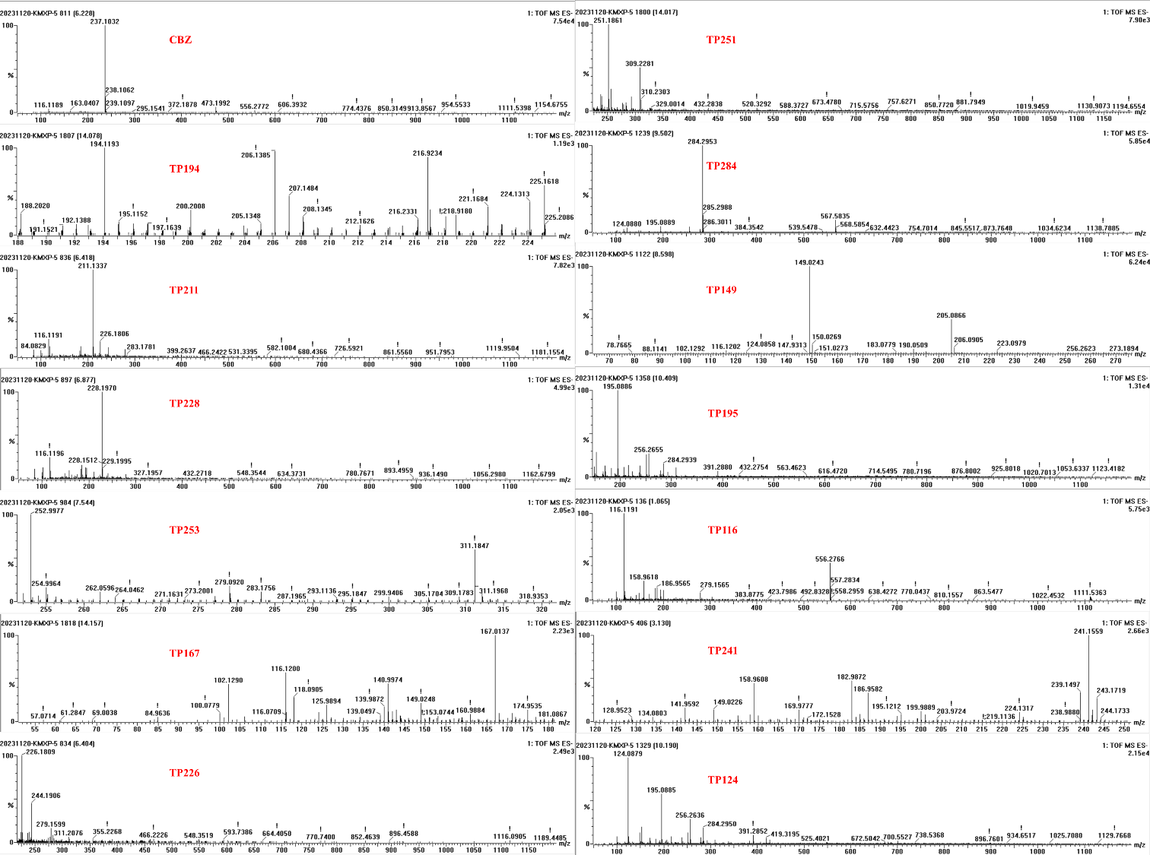
Figure S12. Mass spectra of different transformation products of CBZ in UV/Cl systems.
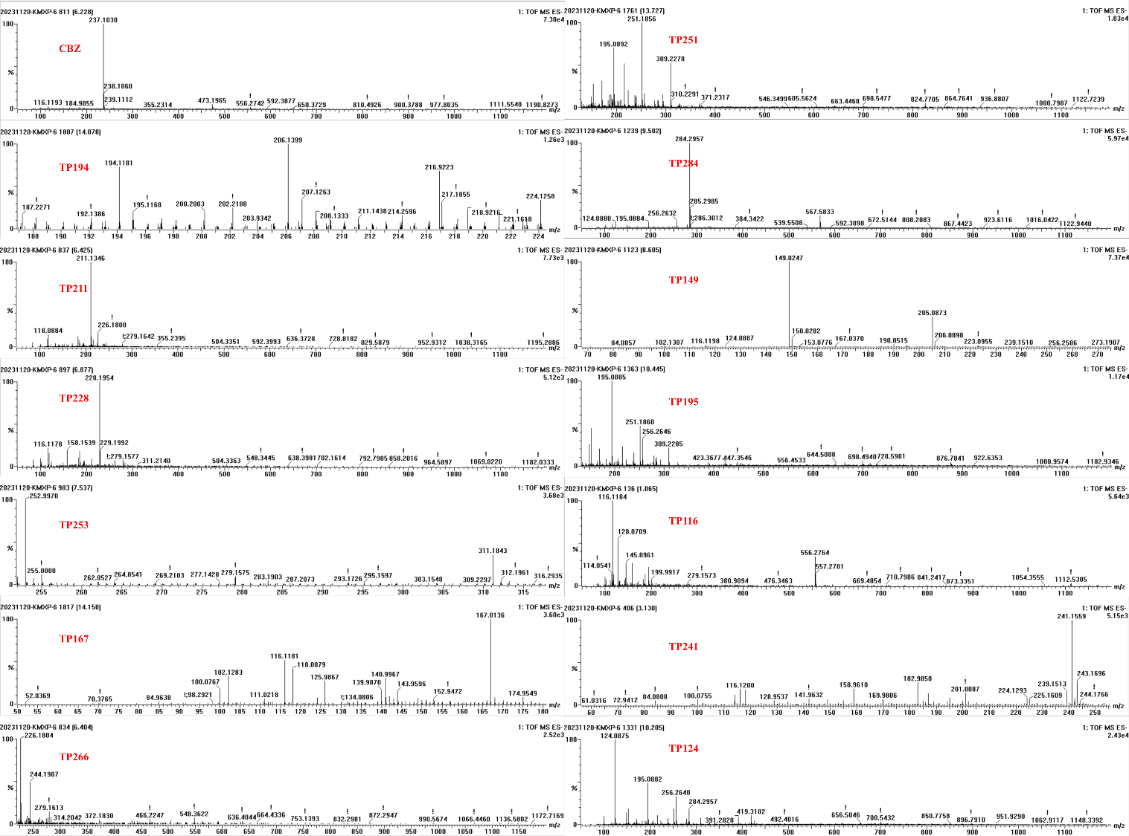
Figure S13. Mass spectra of different transformation products of CBZ in UV/Cl-aged MPs systems.
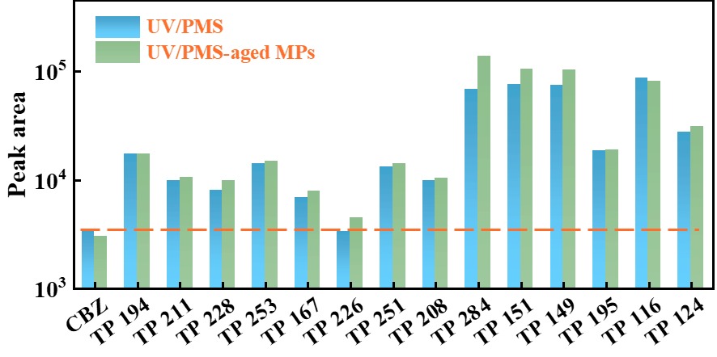
Figure S14. Relative contents of CBZ and its degradation intermediates in UV/PMS and UV/PMS-aged MPs systems (The data were quantified based on the peak areas of the extracted base peak ion chromatograms. Samples were collected and analyzed at the first hour of the reaction ).

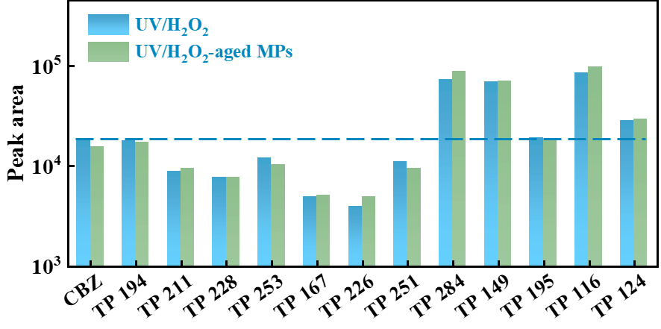
Figure S15. Relative contents of CBZ and its degradation intermediates in UV/H₂O₂ and UV/H₂O₂-aged MPs systems (The data were quantified based on the peak areas of the extracted base peak ion chromatograms. Samples were collected and analyzed at the first hour of the reaction ).

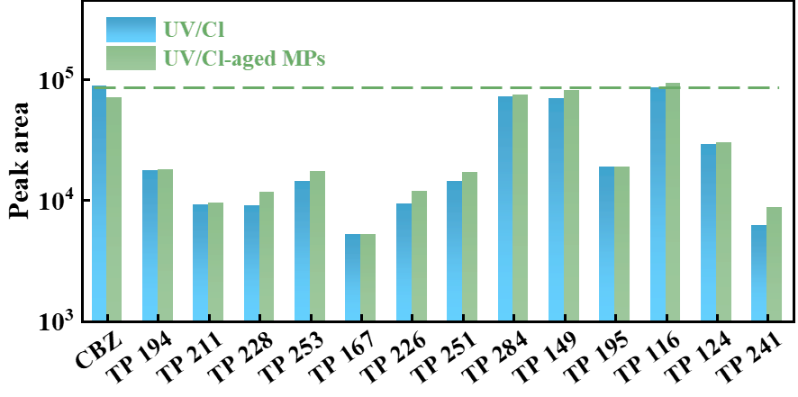
Figure S16. Relative contents of CBZ and its degradation intermediates in UV/Cl and UV/Cl-aged MPs systems (The data were quantified based on the peak areas of the extracted base peak ion chromatograms. Samples were collected and analyzed at the first hour of the reaction ).

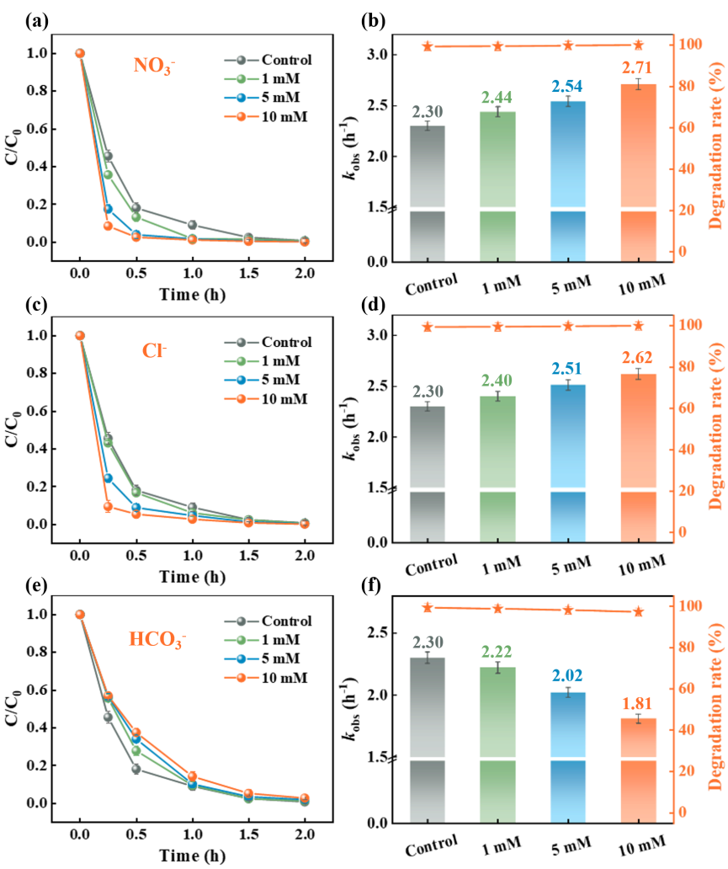
Figure S17. Effect of anions (NO₃⁻, Cl⁻ and HCO₃⁻) on the degradation of CBZ in UV/PMS-aged MPs system. Reaction conditions: [CBZ]₀ = 1 mg·L⁻¹, [PMS]₀ = 0.2 mM, [PA MPs]₀ = 2 g·L⁻¹, pH = 6.0 ± 0.5, T = 25°C

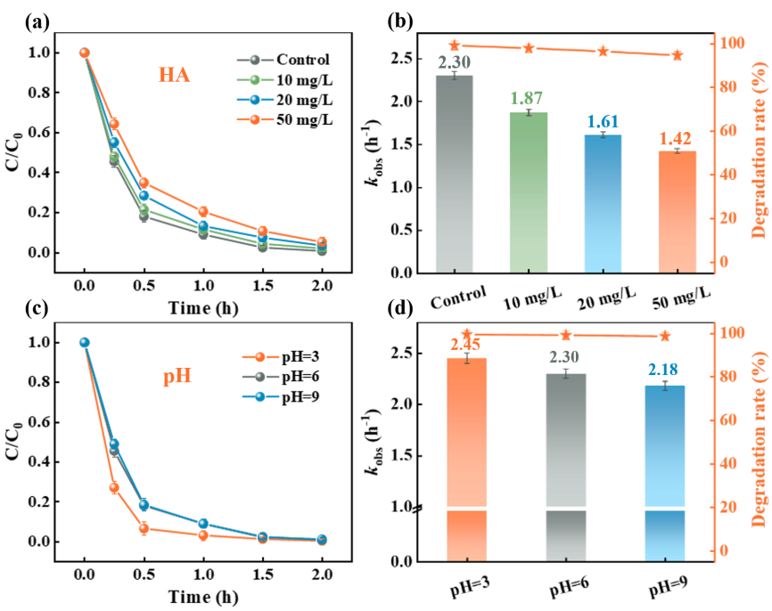
Figure S18. Effect of humic acid and pH on CBZ degradation in UV/PMS-aged MPs system. Reaction conditions: [CBZ]₀ = 1 mg·L⁻¹, [PMS]₀ = 0.2 mM, [PA MPs]₀ = 2 g·L⁻¹, pH = 6.0 ± 0.5, T = 25°C

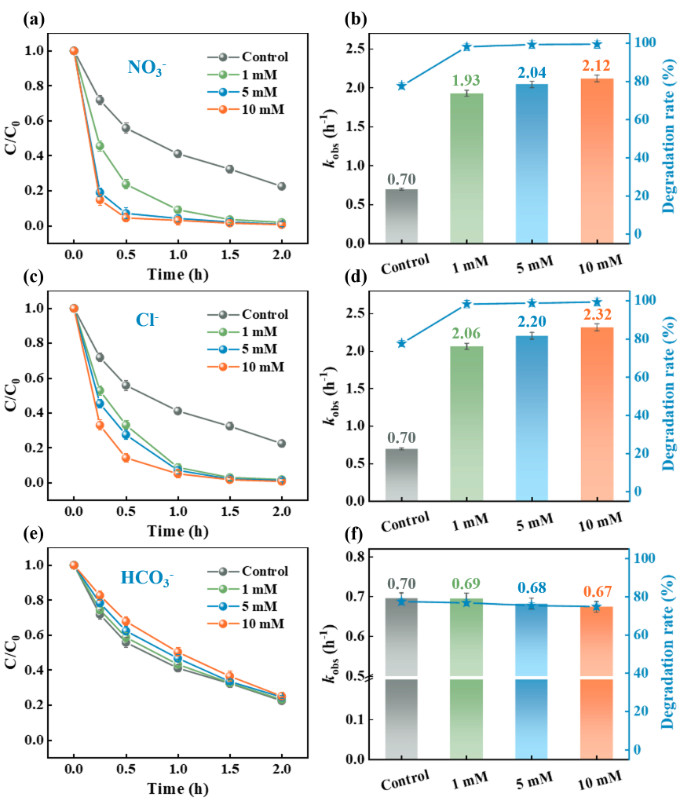
Figure S19. Effect of anions on CBZ degradation in UV/H₂O₂-aged MPs system. Reaction conditions: [CBZ]₀ = 1 mg·L⁻¹, [H₂O₂]₀ = 0.2 mM, [PA MPs]₀ = 2 g·L⁻¹, pH = 6.0 ± 0.5, T = 25°C

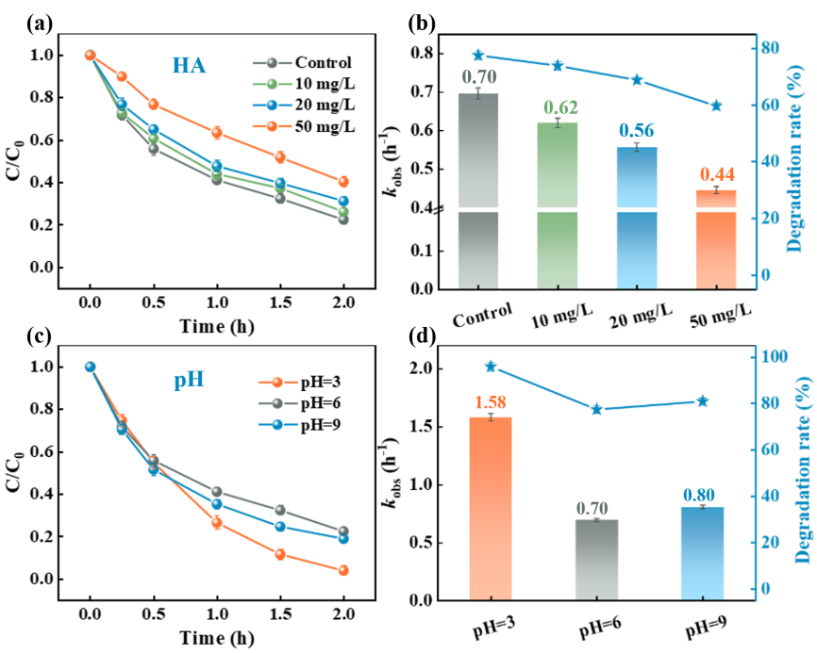
Figure S20. Effect of humic acid and pH on CBZ degradation in UV/H₂O₂-aged MPs system. Reaction conditions: [CBZ]₀ = 1 mg·L⁻¹, [H₂O₂]₀ = 0.2 mM, [PA MPs]₀ = 2 g·L⁻¹, pH = 6.0 ± 0.5, T = 25°C

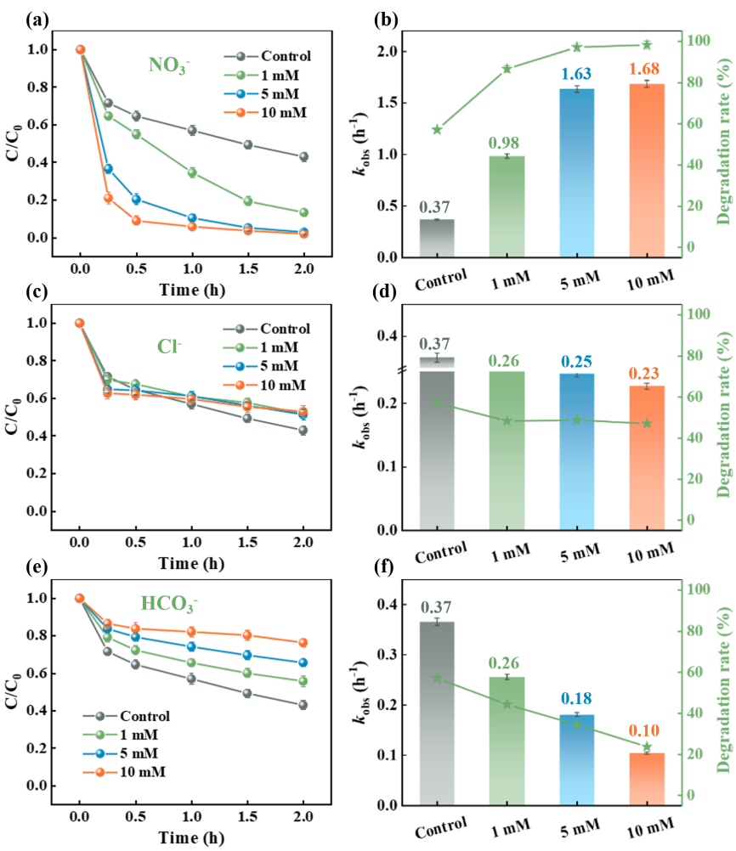
Figure S21. Effect of anions on CBZ degradation in UV/Cl-aged MPs system. Reaction conditions: [CBZ]₀ = 1 mg·L⁻¹, [NaClO]₀ = 0.2 mM, [PA MPs]₀ = 2 g·L⁻¹, pH = 6.0 ± 0.5, T = 25°C

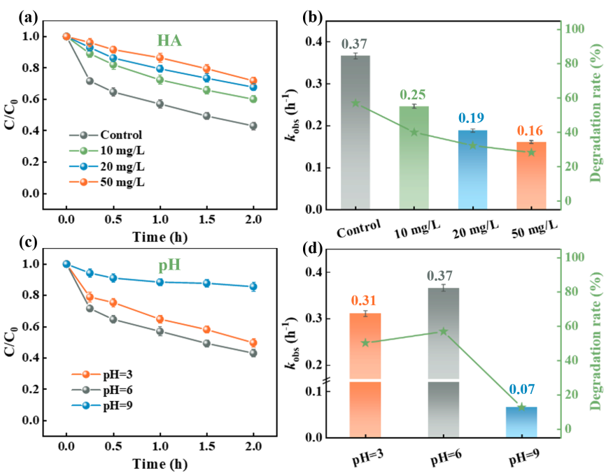
Figure S22. Effect of humic acid and pH on CBZ degradation in UV/Cl-aged MPs system. Reaction conditions: [CBZ]₀ = 1 mg·L⁻¹, [NaClO]₀ = 0.2 mM, [PA MPs]₀ = 2 g·L⁻¹, pH = 6.0 ± 0.5, T = 25°C

Table S1. Transformation products of CBZ in UV/PMS and UV/PMS-aged MPs systems.
TPs | Retention time (min) | m/z [M+H⁺] (UV/PMS) | m/z [M+H⁺] (UV/PMS-aged MPs) | Ball and stick structure
CBZ | 7.15 | 237.1479 | 237.1489 | 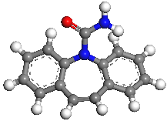
TP194 | 14.07 | 194.1164 | 194.1179 | 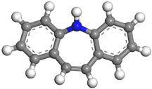
TP211 | 6.40 | 211.1340 | 211.1337 | 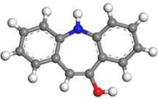
TP228 | 6.87 | 228.1959 | 228.1966 | 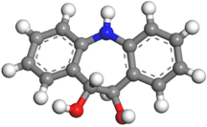
TP253a | 7.51 | 252.9986 | 252.9979 | 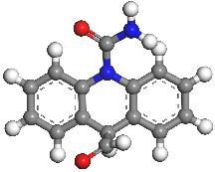
TP253b | 7.51 | 252.9986 | 252.9979 | 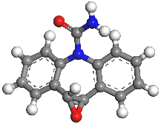
TP253c | 7.51 | 252.9986 | 252.9979 | 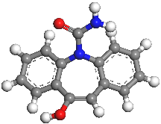
TP167 | 10.02 | 167.0350 | 167.0355 | 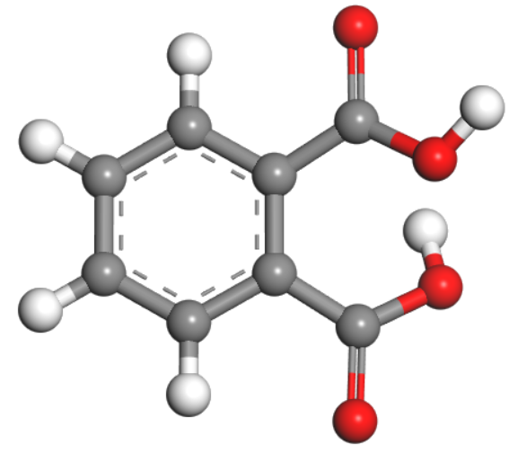

TPs | Retention time (min) | m/z [M+H⁺] (UV/PMS) | m/z [M+H⁺] (UV/PMS-aged MPs) | Ball and stick structure
TP226 | 6.38 | 226.1815 | 226.1806 | 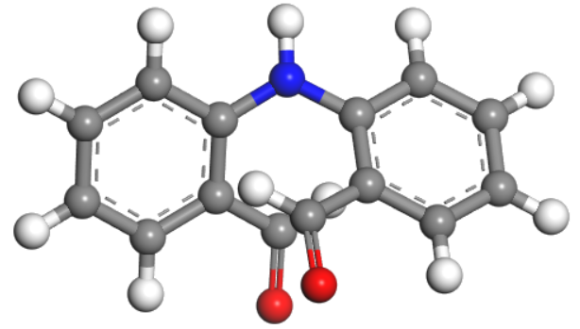
TP251 | 7.53 | 251.0009 | 251.0013 | 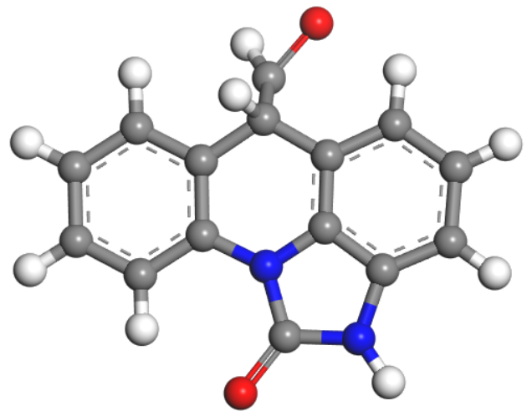
TP208 | 0.70 | 208.8854 | 208.8844 | 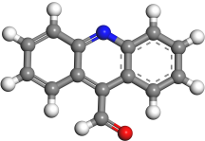
TP284 | 9.46 | 284.2957 | 284.2959 | 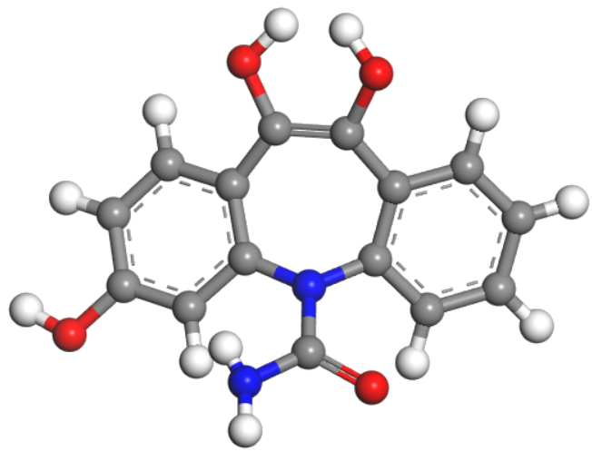
TP151 | 0.62 | 151.0358 | 151.0361 | 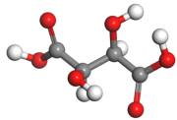
TP149 | 8.58 | 149.0240 | 149.0238 | 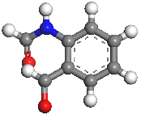
TP195 | 10.28 | 195.0886 | 195.0882 | 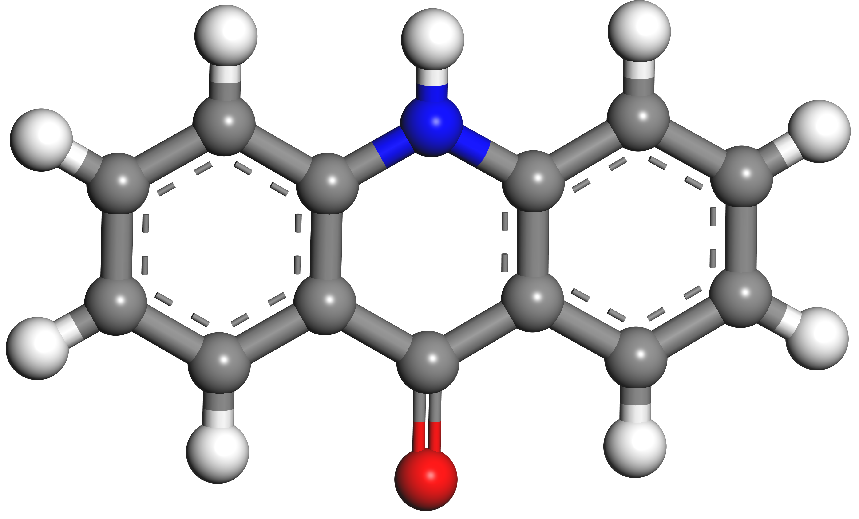
TP116 | 1.07 | 116.1190 | 116.1189 | 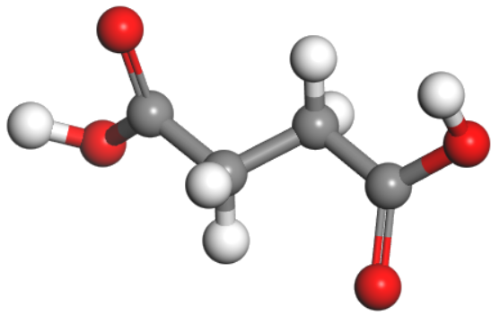
TP124 | 13.37 | 124.0881 | 124.0883 | 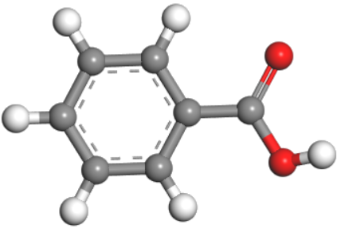

Table S2. Transformation products of CBZ in UV/H₂O₂ and UV/ H₂O₂-aged MPs systems.
TPs | Retention time (min) | m/z [M+H⁺] (UV/H₂O₂) | m/z [M+H⁺] (UV/H₂O₂-aged MPs) | Ball and stick structure
CBZ | 6.23 | 237.1029 | 237.1029
TP194 | 14.07 | 194.1183 | 194.1181
TP211 | 6.43 | 211.1130 | 211.1349
TP228 | 6.88 | 228.1962 | 228.1970
TP253a | 7.54 | 252.9978 | 252.9986
TP253b | 7.54 | 252.9978 | 252.9986
TP253c | 7.54 | 252.9978 | 252.9986
TP167 | 14.14 | 167.0127 | 167.0138

TPs | Retention time (min) | m/z [M+H⁺] (UV/H₂O₂) | m/z [M+H⁺] (UV/H₂O₂-aged MPs) | Ball and stick structure
TP226 | 6.40 | 226.1824 | 226.1800
TP251 | 7.54 | 251.0014 | 251.0014
TP284 | 9.50 | 284.2957 | 284.2952
TP149 | 8.61 | 149.0245 | 149.0238
TP195 | 13.6 | 195.0889 | 195.0877
TP116 | 1.07 | 116.1183 | 116.1192
TP124 | 13.35 | 124.0875 | 124.0871

Table S3. Transformation products of CBZ in UV/Cl and UV/Cl-aged MPs systems
TPs | Retention time | m/z [M+H⁺] (UV/Cl) | m/z [M+H⁺] (UV/Cl-aged MPs) | Ball and stick structure
CBZ | 6.23 | 237.1032 | 237.1030
TP194 | 14.08 | 194.1193 | 194.1181
TP211 | 6.42 | 211.1337 | 211.1346
TP228 | 6.88 | 228.1970 | 228.1954
TP253a | 7.54 | 252.9977 | 252.9970
TP253b | 7.54 | 252.9977 | 252.9970
TP253c | 7.54 | 252.9977 | 252.9970
TP167 | 14.16 | 167.0137 | 167.0136

TPs | Retention time | m/z [M+H⁺] (UV/Cl) | m/z [M+H⁺] (UV/Cl-aged MPs) | Ball and stick structure
TP226 | 6.40 | 226.1809 | 226.1804
TP251 | 14.02 | 251.1861 | 251.1856
TP284 | 9.50 | 284.2953 | 284.2957
TP149 | 8.60 | 149.0243 | 149.0247
TP195 | 10.41 | 195.0886 | 195.0885
TP116 | 1.07 | 116.1191 | 116.1184
TP241 | 3.13 | 241.1559 | 241.1559 | 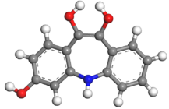
TP124 | 10.19 | 124.0879 | 124.0875

Table S4 Predicted toxicity of CBZ and its transformation products by ECOSAR program
Compounds | Acute toxicity (mg·L⁻¹) |  |  | Chronic toxicity (mg·L⁻¹)
Compounds | Fish  96h-LC₅₀ | Daphnid  48h-LC₅₀ | Green algae  96h-EC₅₀ | Fish  ChV | Daphnid  ChV | Green algae  ChV
CBZ | 1.16×10² | 6.75×10¹ | 5.53×10¹ | 1.17×10¹ | 7.01×10⁰ | 1.52×10¹
TP 194 | 2.25×10⁰ | 1.54×10⁰ | 2.52×10⁰ | 2.80×10⁻¹ | 2.60×10⁻¹ | 1.01×10⁰
TP 211 | 3.79×10¹ | 2.31×10¹ | 2.27×10¹ | 4.02×10⁰ | 2.72×10⁰ | 6.93×10⁰
TP 228 | 4.24×10² | 2.32×10² | 1.49×10² | 3.97×10¹ | 2.04×10¹ | 3.59×10¹
TP 253a | 2.01×10³ | 1.03×10³ | 5.06×10² | 1.75×10² | 7.60×10¹ | 1.06×10²
TP 253b | 1.83×10³ | 9.41×10² | 4.69×10² | 1.59×10² | 7.01×10¹ | 9.90×10¹
TP 253c | 7.74×10² | 4.14×10² | 2.42×10² | 7.06×10¹ | 3.43×10¹ | 5.56×10¹
TP 167 | 9.32×10³ | 4.86×10³ | 2.54×10³ | 8.24×10² | 3.73×10² | 5.49×10²
TP 226 | 4.13×10¹ | 2.51×10¹ | 2.46×10¹ | 4.37×10⁰ | 2.94×10⁰ | 7.48×10⁰
TP 251 | 7.14×10² | 3.83×10² | 2.27×10² | 6.53×10¹ | 3.20×10¹ | 5.25×10¹
TP 208 | 2.00×10¹ | 1.25×10¹ | 1.38×10¹ | 2.19×10⁰ | 1.59×10⁰ | 4.48×10⁰
TP 284 | 1.31×10⁴ | 6.21×10³ | 2.20×10³ | 1.04×10³ | 3.67×10² | 3.86×10²
TP 151 | 6.12×10⁵ | 2.63×10⁵ | 6.24×10⁴ | 4.31×10⁴ | 1.19×10⁴ | 8.81×10³
TP 149 | 1.32×10³ | 6.75×10² | 3.24×10² | 1.14×10² | 4.90×10¹ | 6.70×10¹
TP 195 | 3.08×10² | 1.70×10² | 1.12×10² | 2.91×10¹ | 1.53×10¹ | 2.75×10¹
TP 116 | 2.89×10⁵ | 1.27×10⁵ | 3.31×10⁴ | 2.09×10⁴ | 6.11×10³ | 4.92×10³
TP 124 | 1.30×10³ | 7.30×10² | 5.18×10² | 1.25×10² | 6.89×10¹ | 1.32×10²
TP 241 | 2.63×10² | 1.48×10² | 1.04×10² | 2.54×10¹ | 1.39×10¹ | 2.66×10¹

References
[1] X.W. Wu, P. Liu, H.Y. Wang, H.X.Y. Huang, Y.Q. Shi, C.F. Yang, S.X. Gao, Photo aging of polypropylene microplastics in estuary water and coastal seawater: Important role of chlorine ion, Water Res. 202 (2021) 117396-117405. https://doi.org/10.1016/j.watres.2021.117396.
[2] P. Liu, Y.Q. Shi, X.W. Wu, H.Y. Wang, H.X.Y. Huang, X.T. Guo, S.X. Gao, Review of the artificially-accelerated aging technology and ecological risk of microplastics, Sci. Total Environ. 768 (2021) 144969-144979. https://doi.org/10.1016/j.scitotenv.2021.144969.
[3] Y.Q. Shi, P. Liu, X.W. Wu, H.H. Shi, H.X.Y. Huang, H.Y. Wang, S.X. Gao, Insight into chain scission and release profiles from photodegradation of polycarbonate microplastics, Water Res. 195 (2021) 116980-116989. https://doi.org/10.1016/j.watres.2021.116980.
[4] Z.S. Jiang, L.L. Huang, Y.X. Fan, S.F. Zhou, X.M. Zou, Contrasting effects of microplastic aging upon the adsorption of sulfonamides and its mechanism, Chem. Eng. J. 430 (2022) 132939-132948. https://doi.org/10.1016/j.cej.2021.132939.
[5] X.W. Wu, P. Liu, H.H. Shi, H.Y. Wang, H.X.Y. Huang, Y.Q. Shi, S.X. Gao, Photo aging and fragmentation of polypropylene food packaging materials in artificial seawater, Water Res. 188 (2021) 116456-116465. https://doi.org/10.1016/j.watres.2020.116456.
[6] P. Zhang, P. Huang, H.W. Sun, J.L. Ma, B.X. Li, The structure of agricultural microplastics (PT, PU and UF) and their sorption capacities for PAHs and PHE derivates under various salinity and oxidation treatments, Environ. Pollut. 257 (2020) 113525-113532. https://doi.org/10.1016/j.envpol.2019.113525.
[7] H. Liu, Q.X. Jiao, T. Pan, W.Y. Liu, S.Y. Li, X.B. Zhu, T.T. Zhang, Aging behavior of biodegradable polylactic acid microplastics accelerated by UV/H₂O₂ processes, Chemosphere. 337 (2023) 139360-139370. https://doi.org/10.1016/j.chemosphere.2023.139360.
[8] C. Sorasan, C. Edo, M. Gonzalez-Pleiter, F. Fernandez-Pinas, F. Leganes, A. Rodriguez, R. Rosal, Ageing and fragmentation of marine microplastics, Sci Total Environ 827 (2022) 154438. https://doi.org/10.1016/j.scitotenv.2022.154438.

