Supporting Information
Microplastic as a vector for spread antibiotic resistance genes between aquatic ecosystems: microbial adaptation and temporal dynamics
Qiji Zhang^{1,2}, Xin Qian^{1,3}*
1 State Key Laboratory of Water Pollution Control and Green Resource Recycling, School of Environment, Nanjing University, Nanjing, Jiangsu, 210023, China
2 State Key Laboratory of Soil Pollution Control and Safety, School of Environmental Science and Engineering, Southern University of Science and Technology, Shenzhen 518055, China
3 Jiangsu Collaborative Innovation Center of Atmospheric Environment and Equipment Technology (CICAEET), Nanjing University of Information Science & Technology, Nanjing， Jiangsu, 210044, China
DNA Extraction and Metagenomic Sequencing
All samples were transferred to 50 mL centrifuge tubes, mixed with 20 mL of 1× PBS, vortexed for 30 seconds, and shaken on an orbital shaker for 2 hours. Subsequently, 2 mL of the shaken sample solution was transferred to 2 mL centrifuge tubes and centrifuged at 13,000 × g for 10 minutes, followed by supernatant removal. This process was repeated with additional shaken sample solution until complete processing. Beads and lysis buffer were then added for DNA extraction using the DNeasy PowerSoil Kit (Qiagen, Germany) according to the manufacturer's protocol.
Following genomic DNA extraction, DNA quality and concentration were assessed by 1% agarose gel electrophoresis. The DNA was fragmented to approximately 350 bp using Covaris M220 for library construction. Libraries were loaded onto an Illumina HiSeq platform for high-throughput sequencing. The TruSeq™ DNA Sample Prep Kit was employed for library preparation, the HiSeq 3000/4000 PE Cluster Kit for bridge PCR amplification, and the HiSeq 3000/4000 SBS Kits for sequencing. For metagenomic sequencing, the three replicate samples were pooled into a single composite sample for each treatment to obtain sufficient DNA yield and to represent the overall microbial community associated with the incubation condition.
Quality Control
Prior to in situ incubation, MPs were sterilized with 70% ethanol solution, rinsed with Milli-Q water, and stored in sterile glass bottles. All equipment—including incubation devices, forceps, water samplers, filter membranes, filtration assemblies, and conical flasks—underwent autoclave sterilization (121°C, 30 min) before use. Laboratory coats, gloves, and masks were worn throughout experimental procedures. Work surfaces were disinfected with 70% ethanol solution immediately before DNA extraction.

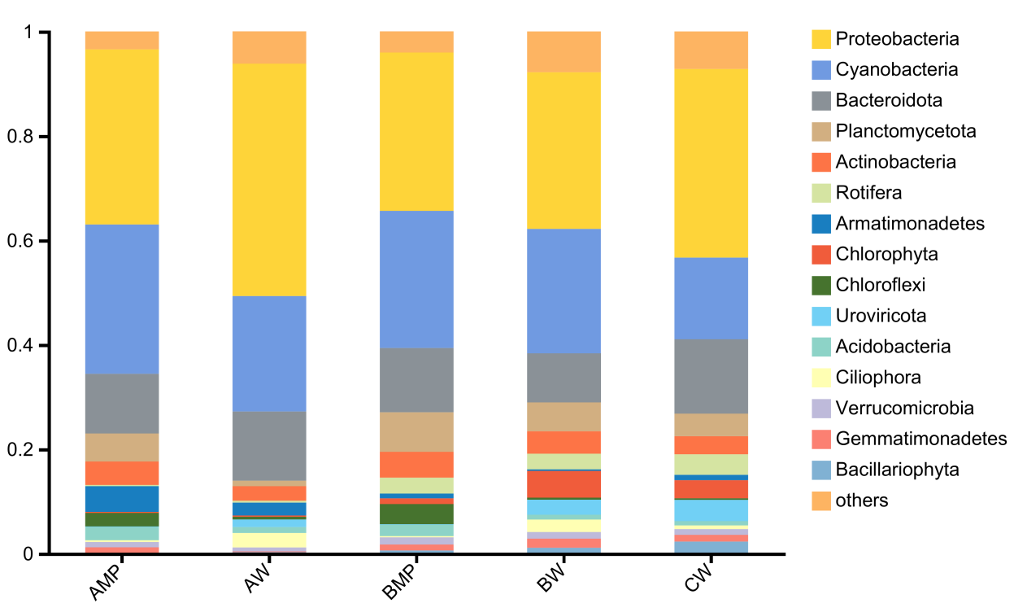
Figure S1. Microbial composition at the phylum level across different sample groups. AMP and BMP represent MP-associated biofilms from group A and group B, respectively; AW, BW, and CW correspond to water samples from groups A, B, and C, respectively.

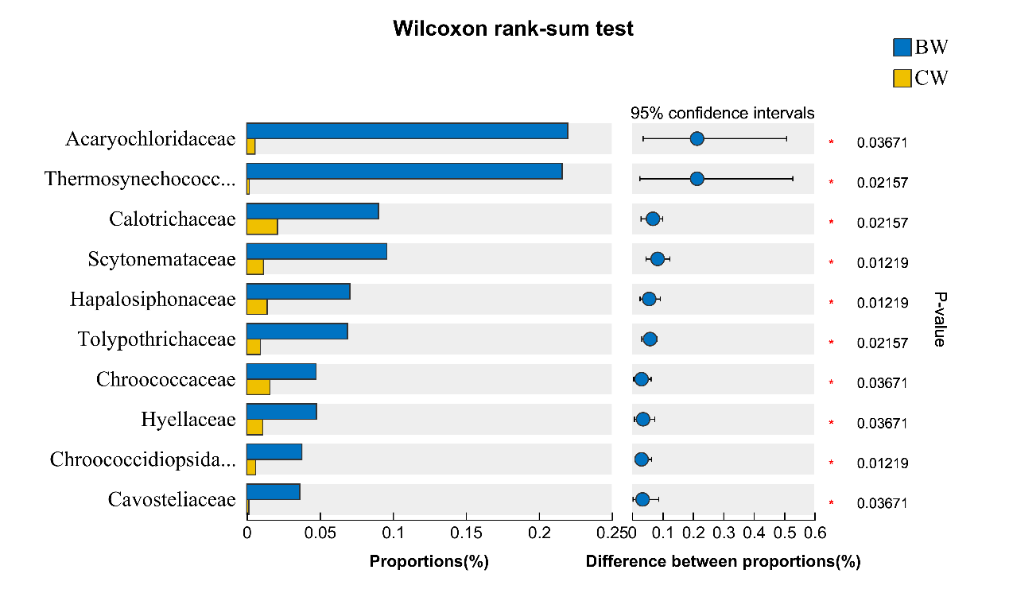
Figure S2. Microbial community comparison between BW and CW groups.

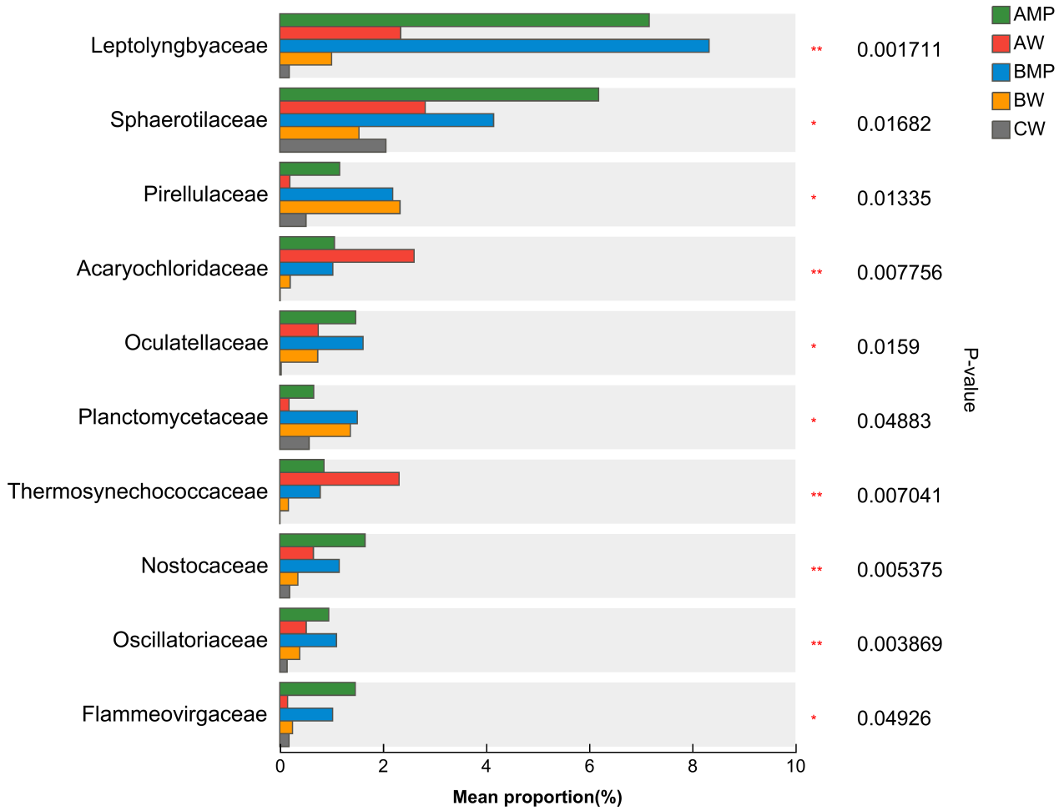
Figure S3. Comparison of microbial taxa at the family level across groups using the Kruskal-Wallis test.

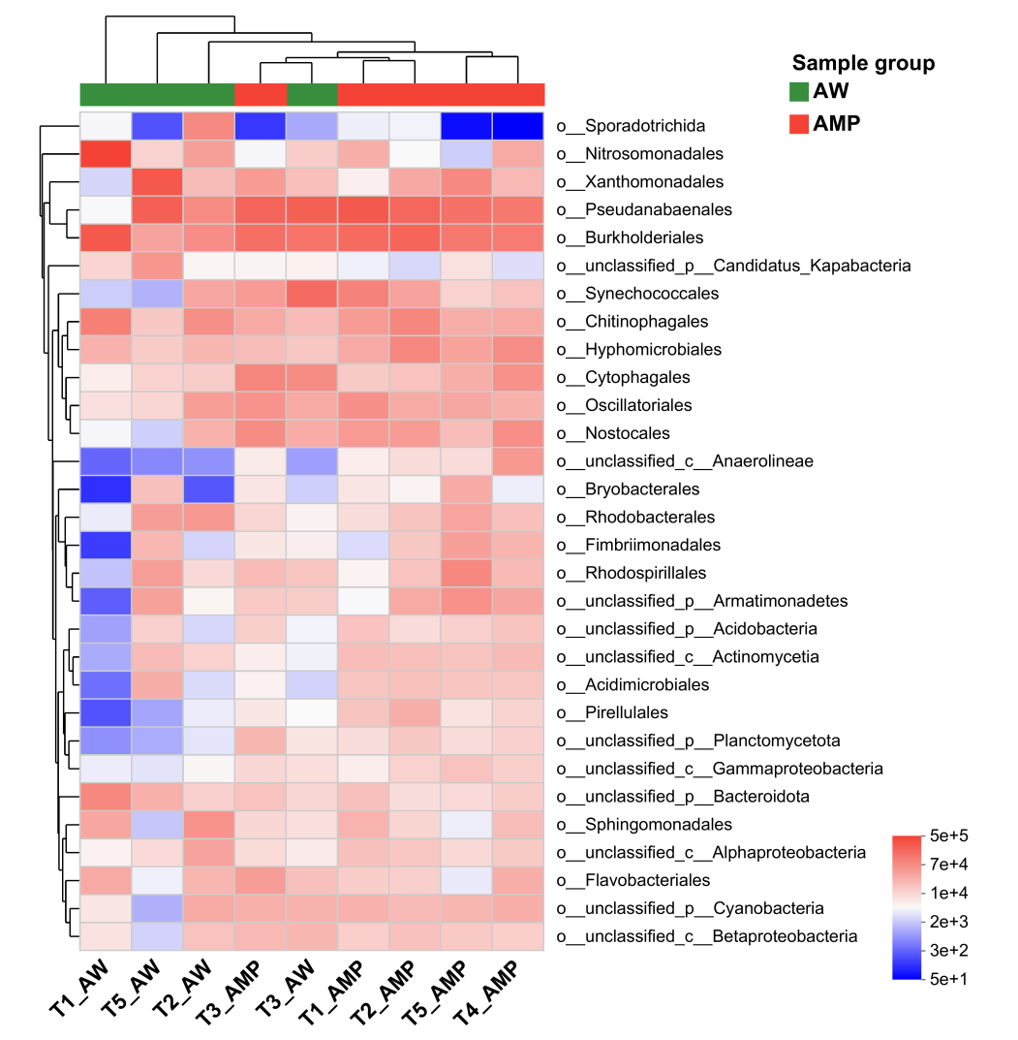
Figure S4. Differential microbial profiles between AMP and AW samples revealed by heatmap analysis.

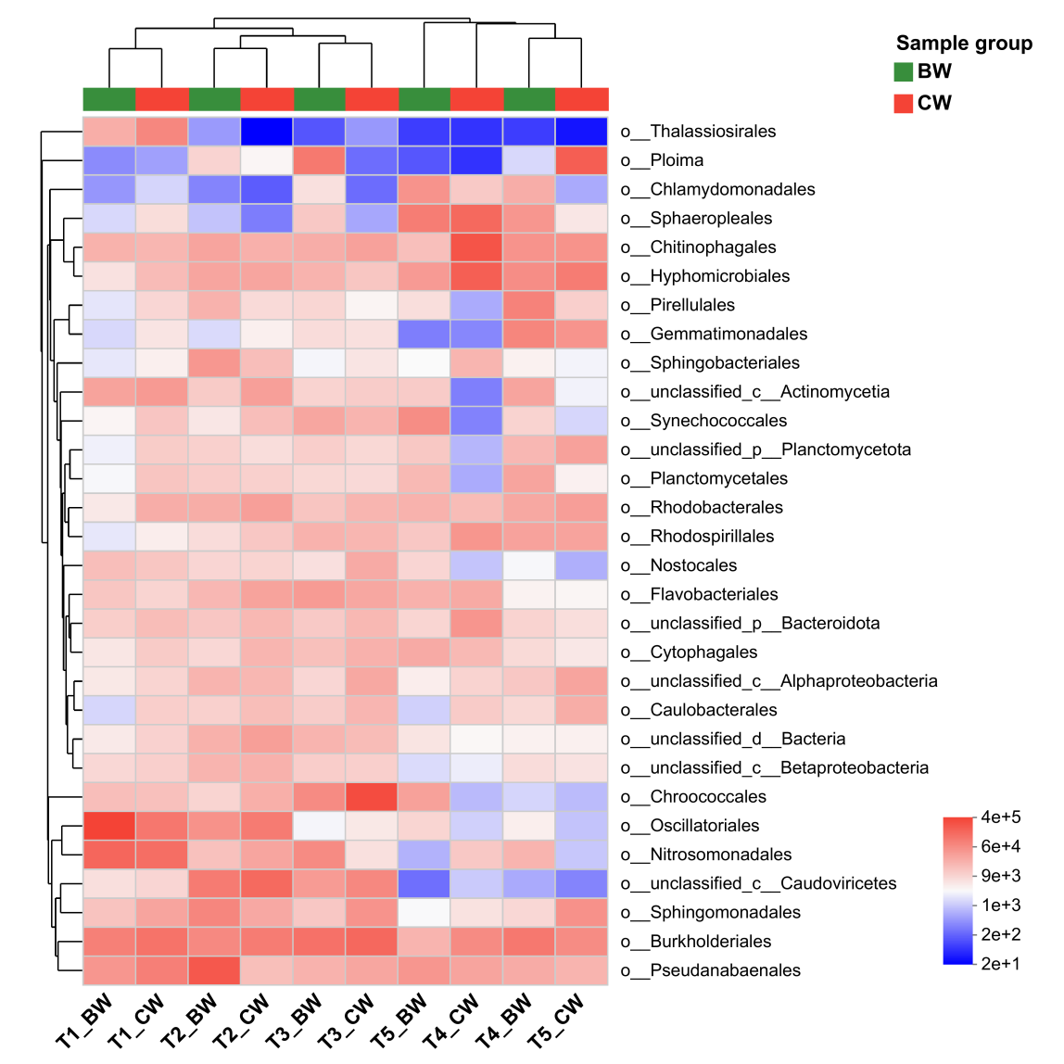
Figure S5. Differential microbial profiles between BW and CW samples revealed by heatmap analysis.

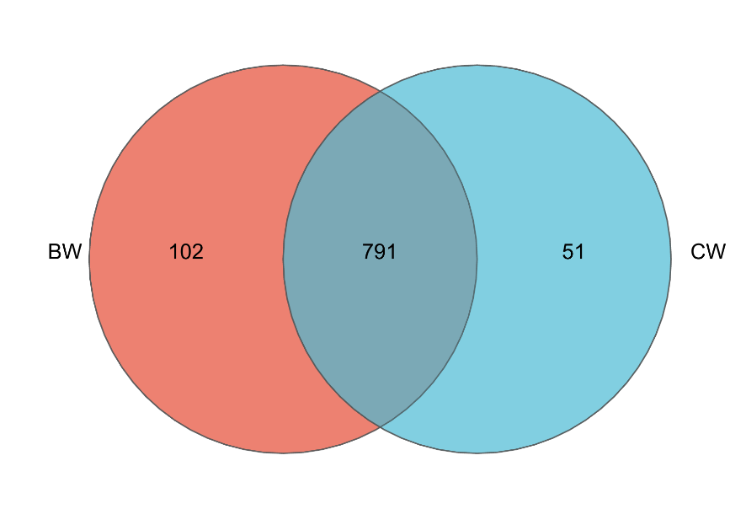
Figure S6. Venn diagram of ARG subtypes in BW and CW groups.

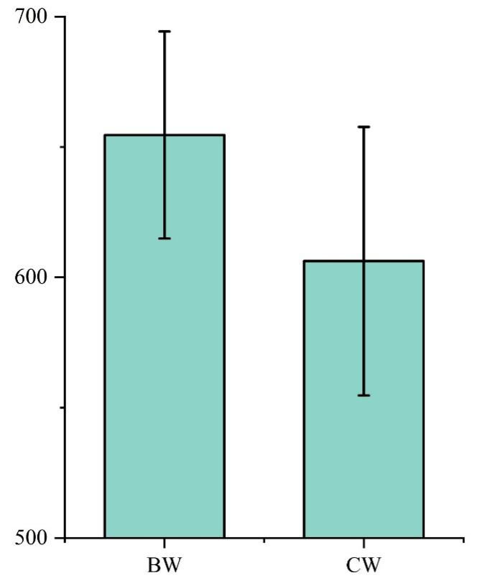
Figure S7. Comparison of ARG Chao1 richness between BW and CW groups.

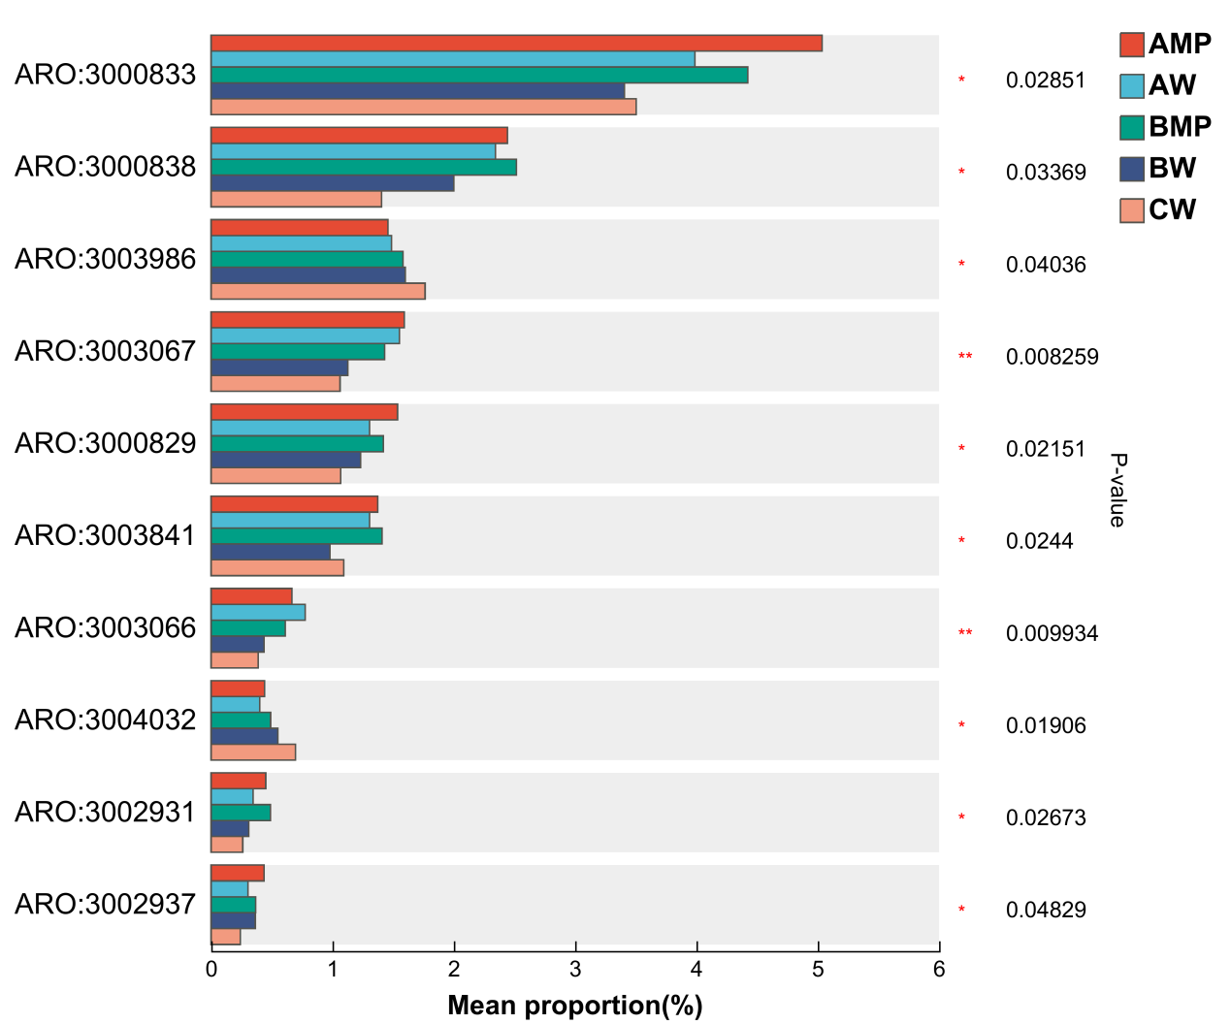
Figure S8 Comparison of ARG abundance across groups using the Kruskal-Wallis H test.

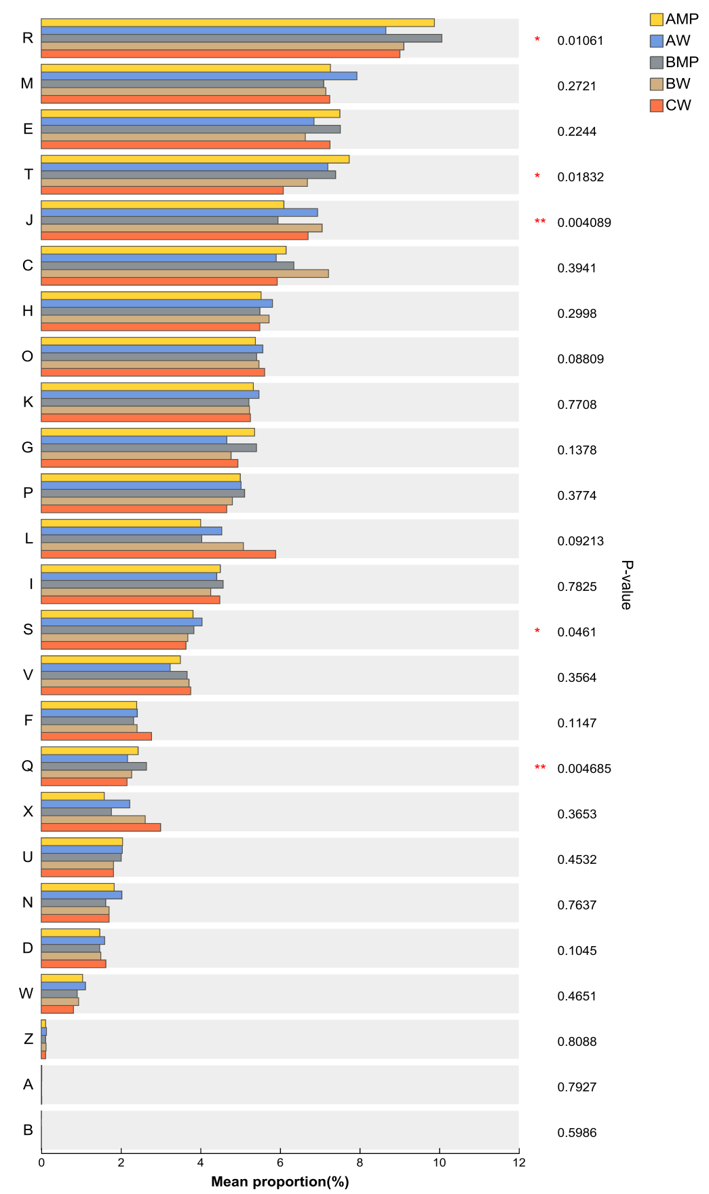
Figure S9 Comparison of COG functional abundance across groups by the Kruskal-Wallis test.

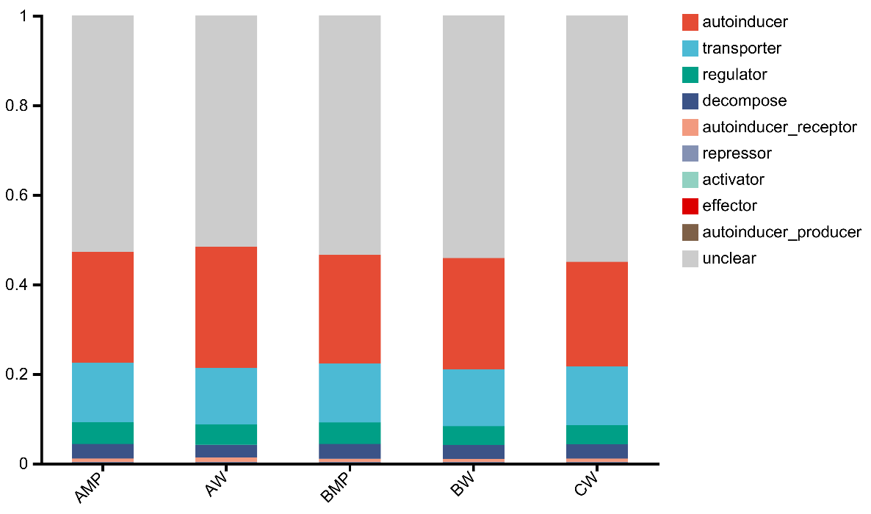

Figure S10 Profiles of quorum sensing (QS) genes in all sample groups.

