Supplementary Material
Enhanced degradation of biodegradable mulch films driven by interactions between clay mineral, UV light, soil burial depth
Cun Liang ¹, Cheng Ji ¹, Fang Feng ¹, Shutao Wang ², Guiming Liu ¹, Zhen Liang ¹, Yi Liang ¹, Shiming Su ³, Bing Han ⁴, Huan Wang ¹, Wei Liu ^{1,*}
¹ College of Chemistry and Materials Science, Key Laboratory of Analytical Science and Technology of Hebei Province, Key Laboratory of Medicinal Chemistry and Molecular Diagnosis, Ministry of Education, Field Scientific Observation and Research Station of Lake and Wetland Ecosystems in Baiyangdian Basin，Hebei University, Baoding 071002, China
² College of Land Resources, Key Laboratory for Farmland Eco-Environment of Hebei, Agricultural University of Hebei, Baoding 071002, China
³ Institute of Environment and Sustainable Development in Agriculture, Chinese Academy of Agricultural Sciences, Beijing 100081, China
⁴ School of Engineering, Deakin University, Geelong, Victoria 3216 Australia
* Corresponding author, E-mail: liuwei@hbu.edu.cn ( Wei Liu)

Text S1
In this study, white PBAT and PLA films (0.01 mm thick) were used. The mulch films were cut into square pieces of two sizes: 1 × 1 cm for photodegradation experiments and 5 × 5 cm for soil degradation experiments. All mulch films were thoroughly washed several times with anhydrous ethanol and ultrapure water, then dried at 30°C for 12 h prior to experimental use. At each sampling point, the mulch pieces were again washed with ethanol and ultrapure water and subjected to 30 min of ultrasonic cleaning to remove impurities and soil minerals from the surface. Before characterization, the cleaned samples were dried in a vacuum oven at 30°C for 12 h to eliminate moisture and ensure accurate measurements.
The photodegradation experiment mixture was placed in a 75-mm diameter glass Petri dish and reacted in an oscillator at a speed of 150 rpm. Samples were collected at set time points (0, 15, 30, 45, and 60 days). To control for light exposure, three dark control groups were established: Group A and Group B contained KL and MMT, respectively; Group C contained blank ultrapure water. Control samples were placed in 50-milliliter conical flasks, sealed with a sealing membrane, and wrapped in aluminum foil. They were processed under shaking conditions at 150 rpm. All recovered mulch films were sealed in bags under light-protected conditions for subsequent characterization and analysis.
Text S2
The surface morphology of the original BDM and the mulch film photodegradation under different treatments was observed using a multifunctional fast scanning electron microscope (SEM, PHENOM PROX, The Netherlands).SEM measurements were carried out at an accelerating voltage of 15 kV. The test surfaces of PLA and PBAT were treated with gold spraying and then placed on a conductive adhesive. The surface hydrophilicity and hydrophobicity of the mulch films were accurately measured by an optical contact angle meter (CA, OCA1 5EC, Germany) using the seated drop method and all samples were tested in triplicate. The thermal decomposition temperature of BDMs was characterized by the thermogravimetric analysis (TGA, NETZSCH STA, Germany) technique. The heating rate was 20 °C/min in a nitrogen atmosphere and the temperature range was set from 40 °C to 800 °C. The temperature of BDMs was determined by thermogravimetric analysis (TGA, NETZSCH STA, Germany). Fourier Transform Infrared Spectroscopy (FTIR, Nicolet iS10, USA) was used to evaluate the changes in functional groups of the microplastics.
Changes in chemical functional groups on the surface of virgin and aged plastics were determined using attenuated total reflection Fourier transform infrared spectroscopy (FTIR, Nicolet iS10, USA). After background data collection, each sample was scanned 32 times in the 4000-400 cm⁻¹ wavelength range. Each treatment group sample was measured three times. And baseline calibration and smoothing were performed using Omnic software. Two-dimensional correlation spectroscopy (Origin 2024) was used to reveal the sequential order of change of functional groups in the IR spectra of the plastics during the aging process. In addition, changes in the oxidative properties of plastics undergoing photoaging were quantitatively characterized by calculating the carbonyl index (CI), CI value was derived by determining the ratio of the peak area of the carbonyl peak (C=O) between 1850 cm⁻¹ and 1650 cm⁻¹ to that of the peak area of the methylene (-CH₂) on the spectra between 1500 cm⁻¹ and 1420 cm⁻¹.
X-ray photoelectron spectroscopy (XPS, ESCALAB 250Xi, UK) is used to analyze changes in the structure and chemistry of plastic surfaces. The full-spectrum scan of the analyser energy was 100 eV with an energy step of 1 eV. The narrow-spectrum scans of the analyser for oxygen and carbon had an energy of 50 eV with an energy step of 0.05 eV. Avantage software (version 5.948, Thermo Fisher Scientific, Waltham, MA, USA) was used to fit high-resolution XPS spectra and analyse chemical bonding in the region of C1 s and O 1 s. C1 s = 284 s and O 1 s were used for the analysis of chemical bonding. High-resolution XPS spectra and to analyse the chemical bonds.The binding energy of C1 s = 284.80 eV was used for the energy standard charge correction. In addition, O/C calculated from XPS was used to reflect the degree of photoaging of the plastics and was based on the peak area integral ratio of oxygen and carbon from the XPS data to.
Text S3
2D-COS: 2D-COS analysis was performed using Origin 2024 software. Aging time was used as an external interference for changes in functional groups in PBAT and PLA during aging. Based on the work of Noda and Ozaki^{[1-3]}, 2D correlation analyses were performed using a set of time-dependent ATR-FTIR spectra collected as described above. Briefly, the variation y(x, t) of the analyzed spectra as a function of the spectral variable (x, number of waves in the IR spectrum) and the perturbation variable (t, aging time) can be used to define the dynamic spectrum y(x, t) as follows:
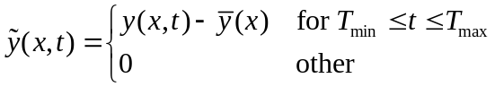 | (1)
In Eq. (1), the reference spectrum is set as time-averaged y(x, t), where Tmax and Tmin are the minimum and maximum values of the aging time, respectively.
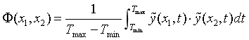 | (2)
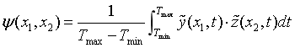 | (3)
In Eqs. (2) and (3), the values of Φ(x1, x2) indicate the same and different variations of the spectral intensities at x1, and x2 during the time interval between Tmax and Tmin; the intensities of ψ(x1, x2) indicate the asynchrony of the spectral intensity variations measured at x1, and x2. On the contrary, the intensity at ψ(x1, x2) indicates the asynchrony of the spectral intensity variations measured at x1 and x2, which can reveal the spectral intensity of the interference caused by external variations in the continuum.
Text S4
The three-dimensional excitation-emission matrix (3D-EEM) spectra of dissolved organic matter (DOM) in the reaction filtrate were determined by a fluorescence spectrophotometer (F-7000 Fluorescence Spectrophotometer, Japan) with a 0.01 m quartz cuvette for analysing the chemical composition of the DOM. The emission wavelengths of the EEM ranged from 200 to 600 nm and the excitation wavelengths ranged from 200 to 600 nm.The wavelength increments of both emission and excitation scans were 5 nm. The emission and excitation wavelengths were 200-600 nm and the excitation wavelengths were 200-600 nm. The wavelength increment was 5 nm for both emission and excitation scans, the slit width was set to 5 nm, and the scanning speed was 12000 nm min⁻¹.
The plastic degradation products were analysed by ultra performance liquid chromatography-tandem triple quadrupole mass spectrometry (UHPLC-MS/MS, Nexera X2-SCIEX TRIPLE QUAD 5500). The chromatographic separation was performed on a Kinetex C18 column (100 mm × 3.0 mm, 2.6 μm) with an injection volume of 20 μL, and the flow rate was set at 0.4 mL/min. The mobile phase A was 0.1% formic acid in water, and the mobile phase B was 0.1% formic acid in acetonitrile. Two gradient elution programs were set according to the analytical requirements: start at 90% A, hold for 1 min, linear gradient to 90% B within 20 min, hold for 5 min and return to 90% A within 3 min, and equilibrate for 2 min. The mass spectrometry analysis was performed using a heated electrospray ionisation source (HESI), with the temperature of the ionisation source set at 450 ℃ and operated in positive ionisation mode (ESI+), and the spray voltage was 5500 V. The ionisation source was operated in positive ionization mode (ESI+). The mass spectrometer was operated in positive ion mode (ESI+) with a spray voltage of 5500 V, a needle current of 3 mA, and spray and auxiliary heating gases of 50 and 55 psi, respectively. The mass spectrometer was used to perform a full scan at a scanning rate of 200 Da/s (m/z 100-1000), and the characteristic peaks detected in the full scan were subjected to the data-dependent Product Ion Scanning (MS₂) and Multi-Reaction Monitoring (MRM).
Text S5
Soil Properties Analysis
(1) Soil pH: Accurately weigh 2.5 g of soil sieved through a 20-mesh sieve and place it in a 50 mL polyethylene centrifuge tube. Add 6.3 mL of distilled water at a soil-to-water ratio of 1:2.5, stir for 1 minute, allow to stand for 30 minutes, then measure using a pH meter.
(2) Soil Electrical Conductivity (EC): Accurately weigh 2.5 g of soil passed through a 20-mesh sieve into a 50 mL polyethylene centrifuge tube. Add 6.3 mL of distilled water at a soil-to-water ratio of 1:2.5, mix thoroughly, and shake for 30 minutes before centrifuging. Measure using an electrical conductivity meter.
(3) Soil Organic Matter (SOM) was determined using the K₂Cr₄O₇ volumetric-spectrophotometric method: Weigh 0.10 g of soil passed through a 100-mesh sieve into a 10 mL colourimetric tube. Add sequentially 1 mL of K₂Cr₄O₇ solution and 1 mL of H₂SO₄. incubate at 90°C for 90 minutes, cool to room temperature, dilute to the mark with water, allow to stand overnight, then measure the absorbance at 590 nm using a UV spectrophotometer.
The samples were characterized with 5 mM K3[Fe(CN)6] solution in a standard three-electrode setup. The electrochemical impedance spectra were subjected to sinusoidal AC perturbation (5 mV) in the frequency range of 0.01-105 Hz, and Mott-Schottky (M-S) curves were obtained in the frequency range of 500-1000 Hz. Potentiometric scanning Mott-Schottky (M-S) curves were obtained in the range of -1.0-1.0 V (vs. Ag/AgCl) at a test frequency of 500 Hz.
Text S6
After the reaction, the plastic mulch was extracted, washed, and dried, and the mass loss (WL, %) of the plastic was calculated, and the weight loss of the plastic after the light reaction was calculated by the following formulae, which led to the evaluation of its photodegradation rate:
$WL(\%)=\frac{m_{i}-m_{f}}{m_{i}}×1$00 | (4)
In Eq. (4), WL is the weight loss (%) of the plastic, is the initial weight of mi (g), and mf is the weight of the plastic after the reaction (g).
To assess in depth the potential facilitating role of clay minerals in the photodegradation of plastics, a specific equation was used to calculate the photodegradation rate of plastics after light reaction, and thus to evaluate the effect of different soil types on the degradation efficiency:
$$R=\frac{{ML}_{Soil}-{ML}_{No Soil}}{{ML}_{Soil}}$$ | (5)
In Eq. (5), MLSoil is the mass loss (%) of plastics with soil-mediated exposure, and MLNo Soil is the mass loss (%) of plastics with light exposure only.
According to the definition of information entropy, the entropy value can be used to calculate the weight of each indicator, which facilitates a comprehensive and objective evaluation of multiple indicators.The methods described in (6)-(10). First, the original data matrix is constructed based on the various characterization indicators of MP:
All data are normalized by EQ. (6) and (7) to ensure consistency of all variables.
Positive indicators:
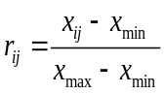 | (6)
Negative indicators:
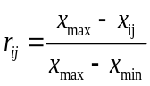 | (7)

Here, x_{ij} represents the i-th index of the j-th sample. r_{ij} represents the normalized data. Next, the proportion of the i-th index in the j-th sample is calculated to determine the variability of the index.
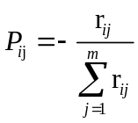 | (8)
pij is the proportion of index value of the i-th indicator in the j-th sample.
Finally, the information entropy and weight of each evaluation index can be calculated.
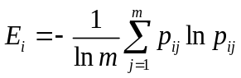 | (9)
E_{i}denotes the information entropy of the index. E_{i} lies in the domain [0, 1], and for the ith indicator, greater discriminability corresponds to higher E_{i} and importance.
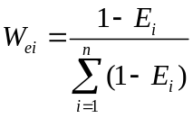 | (10)
W_{ei} is the weight of the indicator.

Table S1. Summary of Experimental Sample Groups and Their Abbreviations
Experimental sample set | Abbreviations
Pristine PBAT | Pristine PBAT
PBAT-Kaolinite-UV | PBAT-KL-UV
PBAT-Montmorillonite-UV | PBAT-MMT-UV
PBAT-Water-UV | PBAT-W-UV
PBAT-Kaolinite-Dark | PBAT-KL-Dark
PBAT-Montmorillonite-Dark | PBAT-MMT-Dark
PBAT-Water-Dark | PBAT-W-Dark
Pristine PLA | Pristine PLA
PLA-Kaolinite-UV | PLA-KL-UV
PLA-Montmorillonite-UV | PLA-MMT-UV
PLA-Water-UV | PLA-W-UV
PLA-Kaolinite-Dark | PLA-KL-Dark
PLA-Montmorillonite-Dark | PLA-MMT-Dark
PLA-Water-Dark | PLA-W-Dark
Note: Pristine PBAT and pristine PLA denote the untreated original BDMs used as reference samples.
Table S2. Soil component content in farmland
Soilcomposition | Content(%)
Na₂O | 1.61
MgO | 3.61
Al₂O₃ | 15.90
SiO₂ | 65.97
Fe₂O₃ | 5.38
CaO | 3.59
K₂O | 2.31
Na | 1.76
Mg | 3.36
Al | 13.82
Si | 57.39
Fe | 10.34
K | 4.56
Ca | 6.35

Table S3. Quality loss and photodegradation ratio of PBAT and PLA mulchs
Reactionconditions | Theweightloss(%) |  |  |  | R
 | 15d | 30d | 45d | 60d | R
PBAT-KL | 1.71±0.032 | 5.38±0.076 | 7.96±0.058 | 10.69±0.026 | 54.72%
PBAT-  MMT | 1.21±0.061 | 4.02±0.063 | 6.11±0.009 | 7.72±0.011 | 37.31%
PBAT-W | 0.76±0.012 | 2.29±0.060 | 3.77±0.007 | 4.84±0.055 | a.u.
PLA-KL | 1.49±0.065 | 3.55±0.05 | 5.93±0.046 | 8.26±0.051 | 48.18%
PLA-  MMT | 1.19±0.051 | 3.01±0.047 | 4.68±0.041 | 6.68±0.049 | 35.93%
PLA-W | 0.76±0.078 | 2.02±0.049 | 3.26±0.075 | 4.28±0.064 | a.u.

Table S4. Changes in total organic carbon (TOC) of PBAT and PLA in clay mineral leachate under continuous illumination for 60 days.
Condition | TOC(mg/l)
Pristine-PBAT | 2.05
PBAT-KL-UV | 14.71
PBAT-MMT-UV | 13.64
Pristine-PLA | 1.88
PLA-KL-UV | 10.10
PLA-MMT-UV | 8.16

Table S5. Changes in contact angle of PBAT and PLA mulch films during degradation on the soil surface and at a burial depth of 10 cm.
ContactAngle(°) | PBAT | PLA
Pristine | 93.82±0.07 | 100.9±0.15
Soil surface-60d | 45.40±0.33 | 50.20±0.32
Soildepthof10cm-60d | 49.15±0.49 | 59.45±0.27

Table S6. Thermal parameters were calculated from thermogravimetric analysis (TG) of PBAT and PLA mulch under the action of clay minerals.
Sample | T_{10%}  (℃) | T_{max1}  (℃) | WL₁  (%) | T_{max2}  (℃) | WL₂  (%) | T_{max3}  (℃) | T_{max4}  (℃) | Char₈₀₀  (%)
Pristine-PBAT | 338.2 | 288.9 | 5.3 | 413.5 | 52.9 | 599.1 | 705.9 | 13.0
PBAT-KL-UV | 339.3 | 290.5 | 5.0 | 405.3 | 47.9 | 593.0 | 700.8 | 14.6
PBAT-MMT-UV | 351.2 | 233.7 | 3.4 | 405.9 | 44.2 | 601.8 | 717.1 | 15.8
Pristine-PLA | 302.7 | 341.9 | 17.3 | 410.1 | 61.9 | 614.1 | - | 7.6
PLA-KL-UV | 324.3 | 332.4 | 14.0 | 403.1 | 55.8 | 593.3 | - | 9.7
PLA-MMT-UV | 328.2 | 322.9 | 7.4 | 404.2 | 57.9 | 606.7 | - | 9.3

Table S7. Atomic fraction changes of PBAT and PLA in the presence or absence of clay minerals and the elemental composition of soil surface and deep layers
ElementAssignments | TotalC(%) | TotalO(%) | O/Cratio
Pristine-PBAT | 82.71 | 17.29 | 0.21
PBAT-KL-UV | 72.32 | 27.68 | 0.38
PBAT-MMT-UV | 73.1 | 26.9 | 0.37
PBAT-W-UV | 73.8 | 26.2 | 0.36
PBAT 0 cm | 33.96 | 66.04 | 0.51
PBAT 10 cm | 58.91 | 41.09 | 1.43
Pristine-PLA | 84.01 | 15.99 | 0.19
PLA-KL-UV | 67.51 | 32.49 | 0.48
PLA-MMT-UV | 71.44 | 28.56 | 0.40
PLA-W-UV | 73.25 | 26.75 | 0.37
PLA 0 cm | 33.68 | 66.32 | 0.51
PLA 10cm | 44.61 | 55.39 | 0.81

Table S8. Crystallinity and Raman index of BDM.
Treatment | Crystallinity(%) | Raman Index
Pristine-PBAT | 5.52 | 1.10
PBAT-KL-UV | 7.41 | 1.45
PBAT-MMT-UV | 7.50 | 1.12
PBAT-W-UV | 7.76 | 1.58
PBAT 0 cm | 5.98 | 0.41
PBAT 10 cm | 6.31 | 0.51
Pristine-PLA | 4.64 | 1.06
PLA-KL-UV | 3.52 | 0.89
PLA-MMT-UV | 3.13 | 0.82
PLA-W-UV | 3.48 | 0.96
PLA 0 cm | 2.16 | 0.46
PLA 10cm | 4.13 | 0.90

Table S9. 2D-COS data on the attribution and sign of each cross peak in the synchronous (Φ) and asynchronous (PSI, in parentheses) graphs of PBAT under different conditions. (The symbol order inside and outside the parentheses respectively represent the photo-aging of kaolin and montmorillonite, as well as the soil surface and depth of 10cm).
Peak  (cm⁻¹) | Band  assignments | Sign
 |  | 727 | 1105 | 1265 | 1450 | 1710
727 | -CH | --- | +++(+++) | +++(+++) | +++(+++) | +++(+++)
1105 | C-O |  | --- | +(+-+) | +(+++) | +++(+++)
1265 | C-O |  |  | +++ | +++(++-) | ---(-++)
1450 | -CH₂ |  |  |  | --- | ---(---)
1710 | C=O |  |  |  |  | ---
Note: “+” means a positive sign; “−” means a negative sign.

Table S10. 2D-COS data on the attribution and sign of each cross peak in the synchronous (Φ) and asynchronous (PSI, in parentheses) graphs of PLA under different conditions. (The symbol order inside and outside the parentheses respectively represent the photo-aging of kaolin and montmorillonite, as well as the soil surface and depth of 10cm).
Peak  (cm⁻¹) | Band  assignments | Sign
 |  | 731 | 873 | 1265 | 1452 | 1710
731 | -CH₃ | +++ | ---(+-+) | +++(+-+) | +++(+-+) | +++(+--)
873 | O-CH-CH₃ |  | +++ | +++(+--) | +++(++-) | +++(+--)
1265 | C-O |  |  | --- | +++(+++) | ---(++-)
1452 | C-H |  |  |  | --- | ---(---)
1710 | C=O |  |  |  |  | +++
Note: “+” means a positive sign; “−” means a negative sign.

Table S11. The sequence of functional group changes on BDM based on 2D-COS.
TYPE | Functional group sequence
PBAT-KL-UV | 727cm⁻¹(-CH)＞1105cm⁻¹(C-O)＞1710cm⁻¹(C=O)＞1264cm⁻¹(C-O)＞1450cm⁻¹(-CH₂)
PBAT-MMT-UV | 727cm⁻¹(-CH)＞1105cm⁻¹(C-O)＞1710cm⁻¹(C=O)＞1264cm⁻¹(C-O)＞1450cm⁻¹(-CH₂)
PBAT0cm | 1710cm⁻¹(C=O)＞727cm⁻¹(-CH)＞1105cm⁻¹(C-O)＞1264cm⁻¹(C-O)＞1450cm⁻¹(-CH₂)
PBAT10cm | 1710cm⁻¹(C=O)＞727cm⁻¹(C-H)＞1105cm⁻¹(C-O)＞1264cm⁻¹(C-O)＞1450cm⁻¹(-CH₂)
PLA-KL-UV | 873cm⁻¹(O-CH-CH₃)＞731cm⁻¹(-CH₃)＞1710cm⁻¹(C=O)＞1265cm⁻¹(C-O)＞1452cm⁻¹(C-H)
PLA-MMT-UV | 731cm⁻¹(-CH₃)＞873cm⁻¹(O-CH-CH₃)＞1265cm⁻¹(C-O)＞1710cm⁻¹(C=O)＞1452cm⁻¹(C-H)
PLA0cm | 1710cm⁻¹(C=O)＞731cm⁻¹(-CH₃)＞1265cm⁻¹(C-O)＞873cm⁻¹(O-CH-CH₃)＞1452cm⁻¹(C-H)
PLA 10cm | 1710cm⁻¹(C=O)＞731cm⁻¹(-CH₃)＞1265cm⁻¹(C-O)＞873cm⁻¹(O-CH-CH₃)＞1452cm⁻¹(C-H)

Table S12. Entropy weight method(EWM) calculation results of BDMs
Agingindicator | Weights (%) | Measuredvalue
Agingindicator | Weights (%) | CK-PBAT | PBAT-KL | PBAT-MMT | PBAT-W | PBAT 0cm | PBAT 10cm | CK-PLA | PLA-KL | PLA-MMT | PLA-W | PLA 0cm | PLA 10cm
O/C | 0.65 | 20.9 | 38.27 | 36.8 | 35.50 | 51.420 | 143.37 | 19.03 | 48.10 | 40.00 | 36.52 | 50.78 | 80.54
CI | 9.01 | 2.23 | 1.58 | 1.82 | 2.13 | 1.55 | 1.78 | 10.14 | 8.03 | 8.71 | 9.67 | 8.22 | 8.55
WL | 7.75 | 0.00 | 10.69 | 7.72 | 4.84 | 0.78 | 3.78 | 0.00 | 8.26 | 6.68 | 4.28 | 0.1 | 0.41
CA | 3.56 | 93.82 | 74.27 | 78.87 | 83.8 | 45.4 | 59.45 | 100.92 | 80.00 | 82.5 | 88.2 | 45.4 | 49.15
C-C/H(C1s) | 1.46 | 76.8 | 61.27 | 64.43 | 69.4 | 74.4 | 70.72 | 79.46 | 59.80 | 58.20 | 70.89 | 72.24 | 9.28
C-O(C1s) | 10.68 | 14.71 | 24.69 | 20.44 | 27.56 | 17.85 | 19.73 | 14.94 | 20.80 | 25.50 | 18.44 | 23.55 | 25.090
C=O(C1s) | 1.65 | 8.49 | 14.04 | 10.16 | 8.01 | 7.75 | 9.56 | 5.59 | 19.4 | 16.4 | 10.67 | 4.21 | 65.63
O-C=O/C-OOH(O1s) | 35.66 | 63.83 | 88.35 | 84.34 | 74.61 | 83.89 | 85.42 | 34.61 | 86.00 | 86.20 | 89.18 | 82.62 | 81.59
O=C-O/O-H (O1s) | 5.28 | 36.17 | 11.65 | 15.66 | 25.39 | 16.11 | 14.58 | 35.39 | 14.00 | 13.80 | 10.82 | 17.38 | 18.41
Cry | 10.85 | 5.52 | 7.41 | 7.5 | 7.76 | 5.9 | 6.31 | 4.64 | 3.52 | 3.13 | 3.48 | 2.16 | 4.13
RI | 13.45 | 1.60 | 1.45 | 1.12 | 1.58 | 0.41 | 0.51 | 1.06 | 0.89 | 0.82 | 0.96 | 0.46 | 0.90
Composite aging index |  | 2.49 | 7.25 | 5.85 | 5.24 | 7.86 | 24.02 | 2.16 | 5.55 | 5.29 | 5.06 | 7.74 | 12.98
Table S13.Quantitative analysis of hydroxyl radicals (•OH) and superoxide radicals (O₂•⁻) generated by clay minerals under light irradiation determined by EPR
Clay mineral | Irradiation time (min) | ROS | Spin density (spins mm⁻³) | Total spins
Kaolinite | 10 | •OH | 1.02 × 10¹¹ | 3.21 × 10¹²
Kaolinite | 20 | •OH | 1.57 × 10¹¹ | 4.92 × 10¹²
Kaolinite | 10 | O₂•⁻ | 3.79 × 10¹¹ | 1.19 × 10¹³
Kaolinite | 20 | O₂•⁻ | 4.37 × 10¹¹ | 1.37 × 10¹³
Kaolinite | 10 | ¹O₂ | - | -
Kaolinite | 20 | ¹O₂ | - | -
Montmorillonite | 10 | •OH | 5.03 × 10¹⁰ | 1.58 × 10¹²
Montmorillonite | 20 | •OH | 8.21× 10¹⁰ | 2.58× 10¹²
Montmorillonite | 10 | O₂•⁻ | 2.37× 10¹⁰ | 7.45× 10¹²
Montmorillonite | 20 | O₂•⁻ | 3.09× 10¹⁰ | 9.69× 10¹²
Montmorillonite | 10 | ¹O₂ | 5.68× 10¹⁰ | 1.78× 10¹²
Montmorillonite | 20 | ¹O₂ | 1.04× 10¹¹ | 3.25× 10¹²
Note:-represents not producing its free radicals
Table S14. Additive substances were identified in PBAT and PLA eluents.
Compound type | Formula | Observed  m/z |  | Function | PBAT | PLA
Group1：Antioxidants |  |  |  | Prevent oxidative degradation
Stearyldiethanolamine | C₂₂H₄₇NO₂ | 358.36796 |  |  | Y | NA
Didecylamine | C₂₀H₄₃NO₂ | 330.33666 |  |  | Y | NA
2,6-Di-tert-butyl-4-methylphenol | C₁₅H₂₄O | 221.18999 |  |  | Y | Y
1-Stearoylglycerol | C₂₁H₄₂O₄ | 359.31559 |  |  | Y | NA
2,5-Di-tert-butyl hydroquinone | C₁₄H₂₂O₂ | 223.16926 |  |  | Y | NA
Irgafos® 168 ox | C₄₂H₆₃O₄P | 663.45368 |  |  | Y | Y
2,2,4-trimethyl-1,2-dihydroquinoline | C₁₄H₁₇NO₂ | 232.13321 |  |  | Y | Y
Group2：Stabilizers |  |  |  | Improve light stability
Bis(2,2,6,6-tetramethyl-4-piperidyl)sebacate | C₂₈H₅₂N₂O₄ | 481.39999 |  |  | Y | Y
Resorcinol diglycidyl ether | C₁₂H₁₄O₄ | 205.0862 |  |  | Y | Y
Pentaerythritol | C₅H₁₂O₄ | 137.08084 |  |  | NA | Y
Dimethyl succinate | C₆H₁₀O₄ | 147.06519 |  |  | NA | Y
2,2,6,6-Tetramethyl-4-piperidinyl | C₉H₁₉NO | 158.15394 |  |  | Y | Y
2,6-diisopropyl aniline | C₁₂H₁₉N | 178.15903 |  |  | NA | Y
Group3：Plastieizers |  |  |  | Increase plasticity and fluidity.
Diethyl phthalate | C₁₂H₁₄O₄ | 223.09649 |  |  | Y | Y
Diethyl Sebacate | C₁₄H₂₆O₄ | 259.19039 |  |  | Y | NA
Dimethyl terephthalate | C₁₀H₁₀O₄ | 195.06519 |  |  | Y | Y
Lactic acid dimer | C₆H₁₀O₅ | 163.0601 |  |  | NA | Y
Group4：Lubricants |  |  |  | Preventstatic charge on the surface.
Ethyl hydrogen sebacate | C₁₂H₂₂O₄ | 231.15909 |  |  | Y | NA
Adogen® 73 (Adogen 73) | C₁₈H₃₇NO | 284.29479 |  |  | Y | Y
11-hydroxy-dodecanoic acid | C₁₂H₂₄O₃ | 217.17982 |  |  | Y | Y
Glycerol polymers | C₆H₁₆O₆ | 185.10196 |  |  | Y | NA
7-hydroxyoctanoic acid | C₈H₁₆O₃ | 161.11722 |  |  | Y | NA
(Z)-11-Eicosenamide | C₂₀H₃₉ NO | 310.31044 |  |  | NA | Y
C16:0 fatty acid methyl ester | C₁₇H₃₄O₂ | 271.26316 |  |  | NA | Y
1,2-benzenedicarboxylic acid, dioctyl ester | C₂₄H₃₈O₄ | 391.28429 |  |  | NA | Y
Oleonitrile | C₁₈H₃₃N | 264.26858 |  |  | NA | Y
Icosenamide | C₂₀H₃₉NO | 310.31044 |  |  | NA | Y
Group5: Antibacterial agents |  |  |  | Inhibit microbial proliferation
NEO2734 | C₂₂H₂₄F₃N₃O₃ |  | 436.18425 |  | Y | Y
Group6:Chainextenders |  |  |  | Increasingthe length of polymermolecular chains
2,6-diisopropyl phenyl isocyanate | C₁₃H₁₇NO | 204.13829 |  |  | Y | Y
Note: NAmeans not available.

Table S15.Toxicity analysis results of PBAT and PLA intermediate degradation toxicity assessment.
Compound | Daphnid magna (48 h) LC50 (mg·L⁻¹) | Bioconcentration factor | Compound | Daphnid magna (48 h) LC50 (mg·L⁻¹) | Bioconcentration factor
PBAT | 41.23 | 0.99 | PLA | 884.88 | 0.68
P1 | 96.56 | 0.78 | P1 | 142.77 | 0.82
P2 | 1703.67 | 0.40 | P2 | N.A. | 0.76
P3 | 3312.70 | 0.34 | P3 | N.A. | 0.75
P4 | 264.47 | 0.51 | P4 | 1006.83 | 0.69
P5 | 108.41 | 0.47 | P5 | 307.00 | 0.69
P6 | 422.06 | 0.64 | P6 | 219.39 | 0.68
P7 | 167.60 | 0.62 | P7 | 884.88 | 0.67
P8 | 437.58 | 0.47 | P8 | 51.30 | 0.64
P9 | 106.23 | 0.66 | P9 | 1643.72 | 0.64
P10 | 296.56 | 0.66 | P10 | N.A. | 0.61
P11 | 11.26 | 0.58
N.A.: not available, indicating that the predicted value was outside the applicability domain of the T.E.S.T. model and was therefore not considered a reliable toxicity estimate.

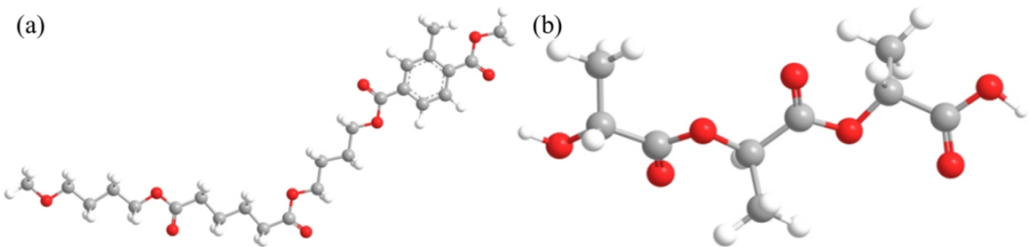
Fig. S1. Chemical structure of PBAT (a) and PLA (b).

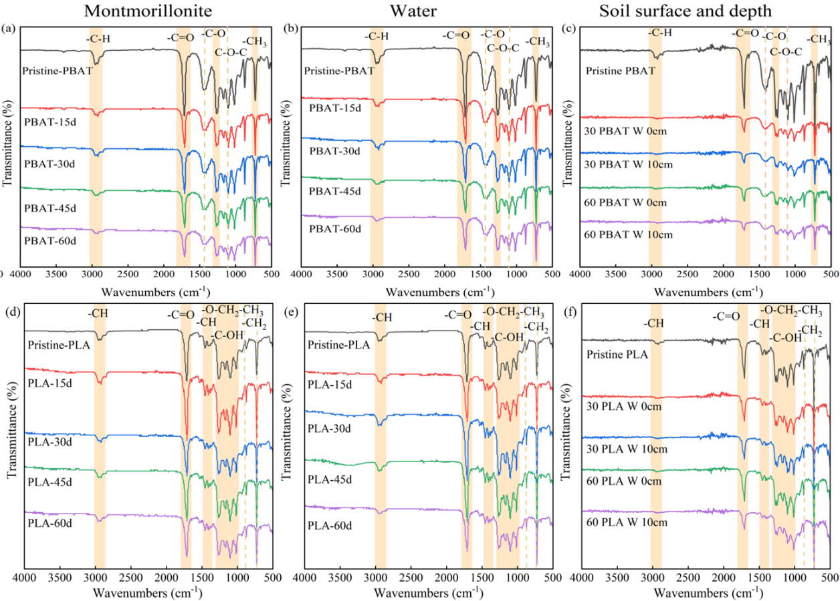
Fig. S2. ATR-FTIR spectra of PBAT and PLA under different degradation treatments. (a) PBAT in MMT; (b) PBAT in water; (c) PBAT at soil surface and 10 cm soil depth; (d) PLA in MMT; (e) PLA in water; (f) PLA at soil surface and 10 cm soil depth.

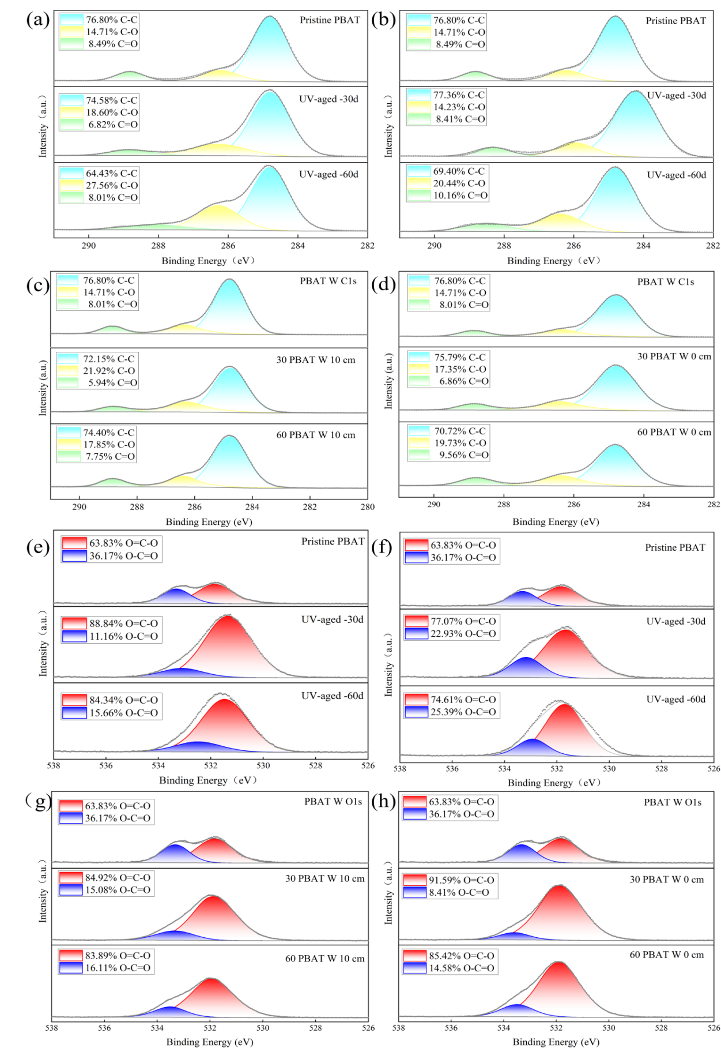
Fig.S3.High-resolution XPS spectra of C 1s and O 1s of PBAT under different conditions (a, e: montmorillonite; b、f: Water; c、g： Soil surface; d、h: Deep in the soil).
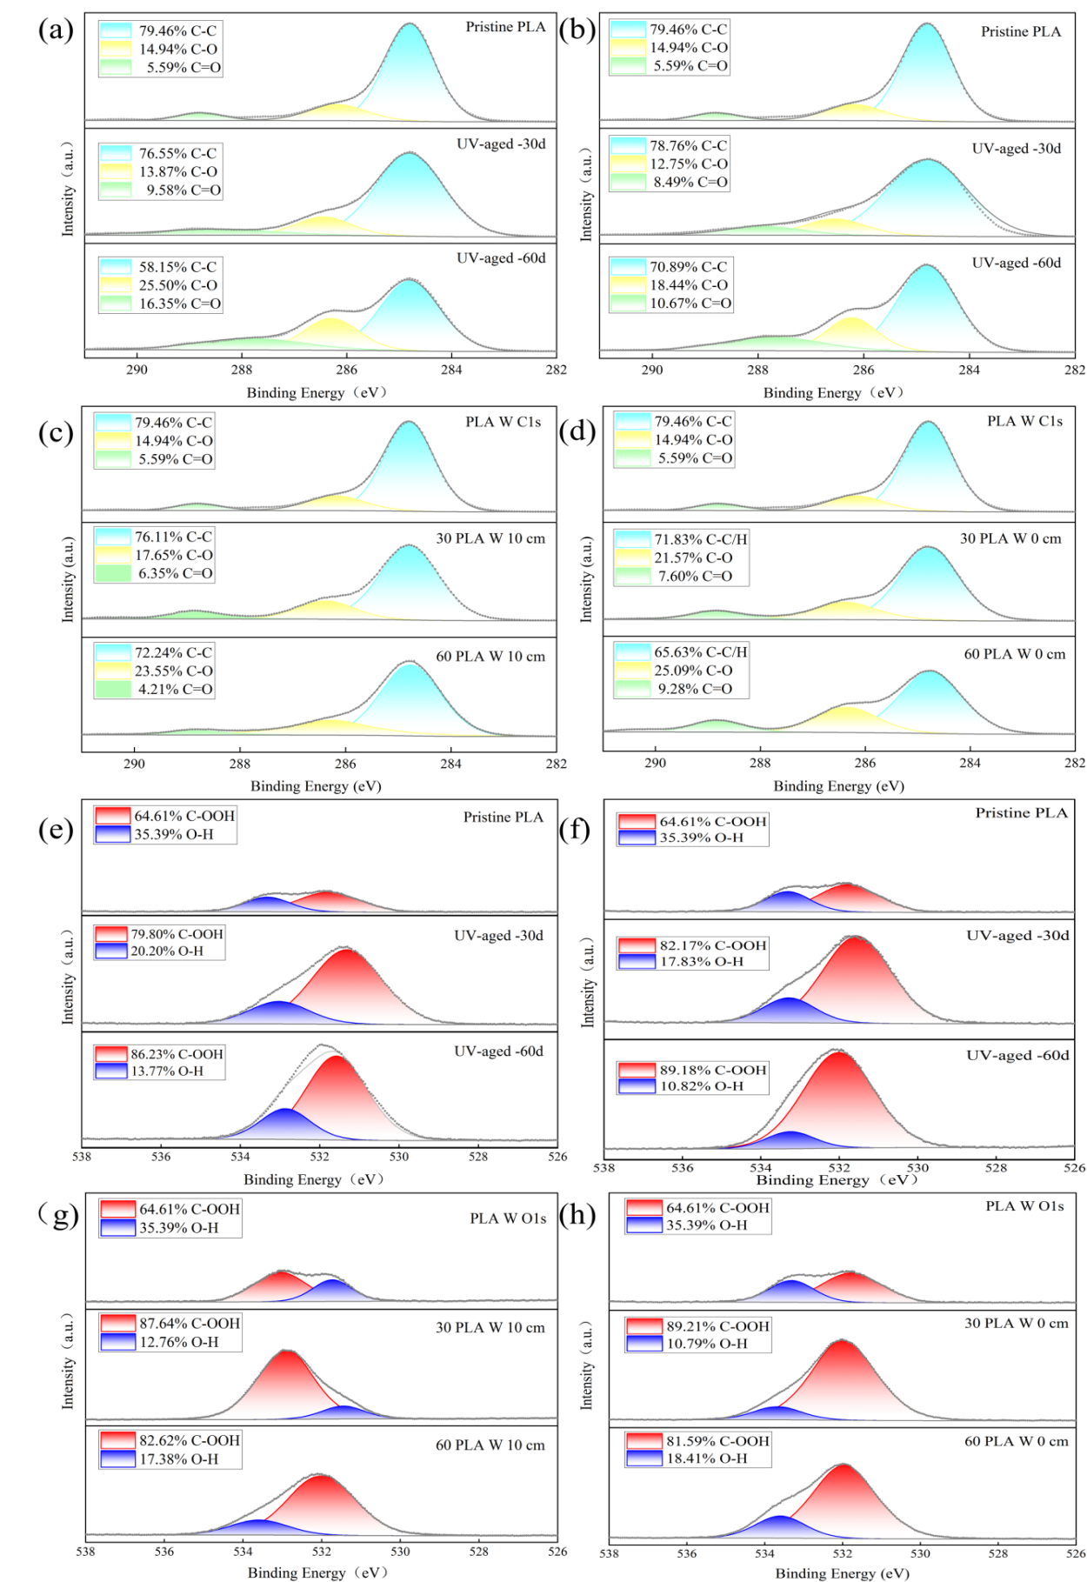
Fig.S4.High-resolution XPS spectra of C 1s and O 1s of PLA under different conditions (a, e: montmorillonite; b、f: Water; c、g： Soil surface; d、h: Deep in the soil).

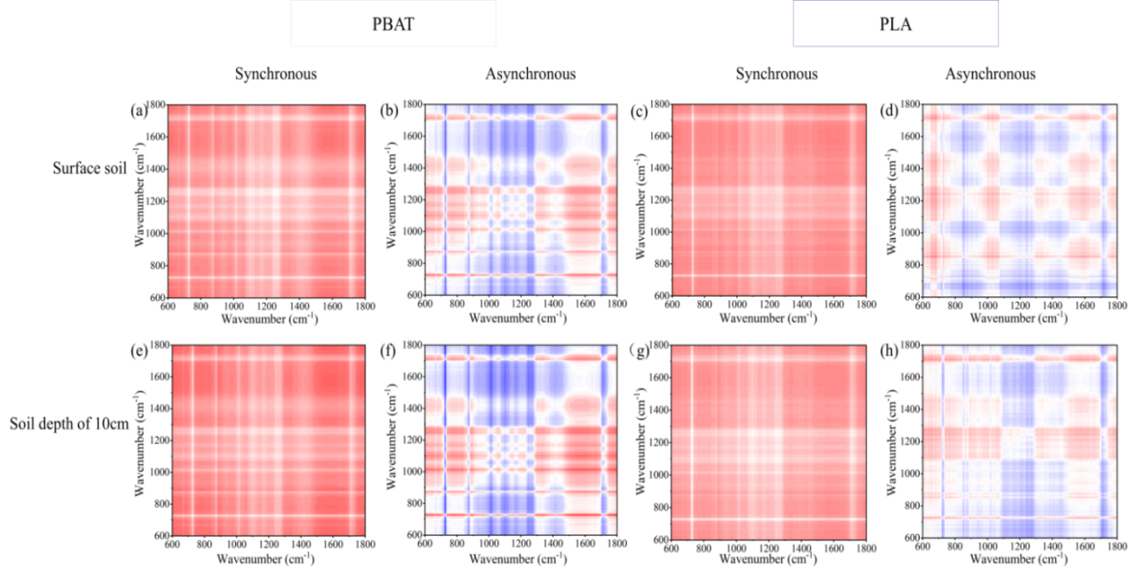

Fig. S5. Synchronous and asynchronous correlation maps of PBAT and PLA constructed based on ATR-FTIR spectra at different time intervals. (a), (c), (e), (g): synchronous maps; (b), (d), (f), (h): asynchronous maps under surface soil and 10 cm soil depth conditions.

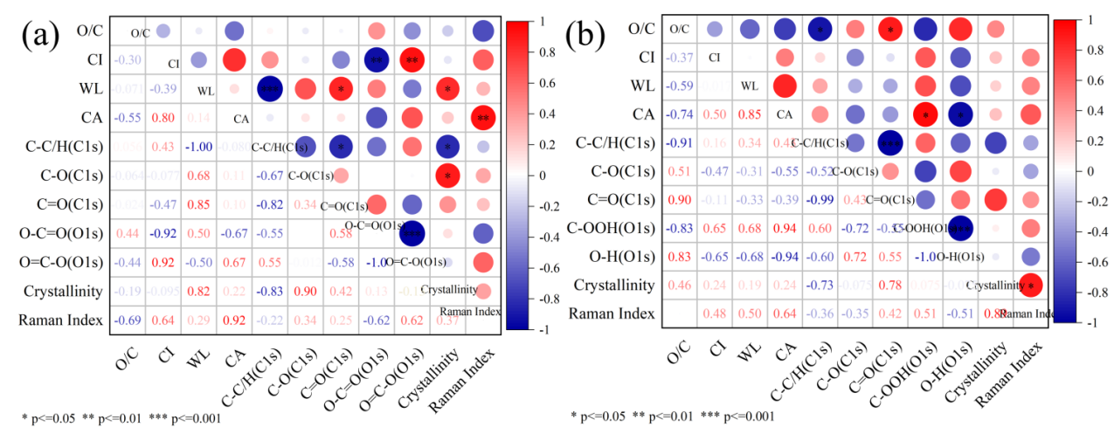
Fig. S6. Pearson’s correlations between aging characteristics of PBAT and PLA (a,b).

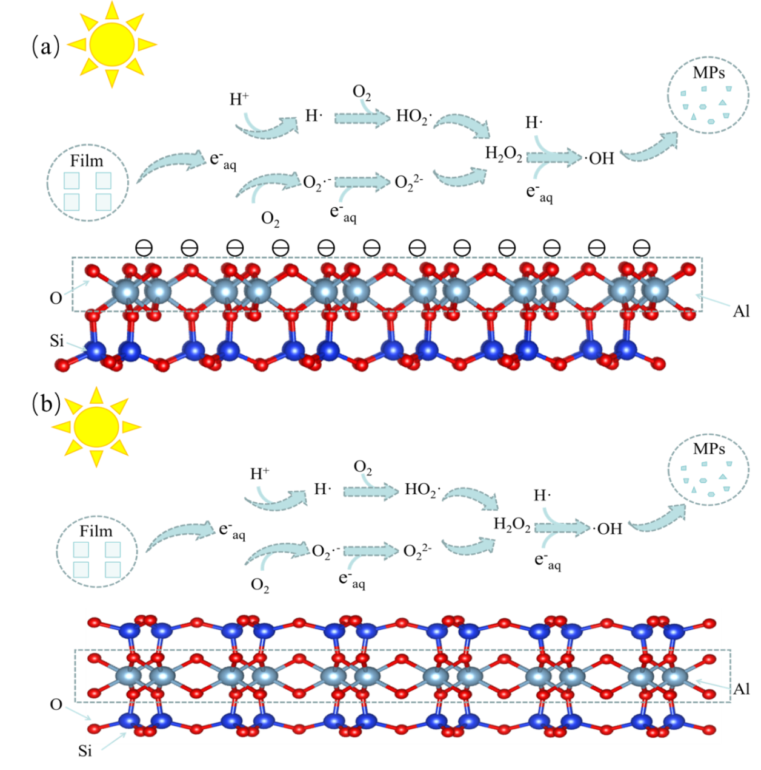
Fig. S7. Proposed mediating mechanism of kaolinite (a) and montmorillonite (b) in the reaction system.

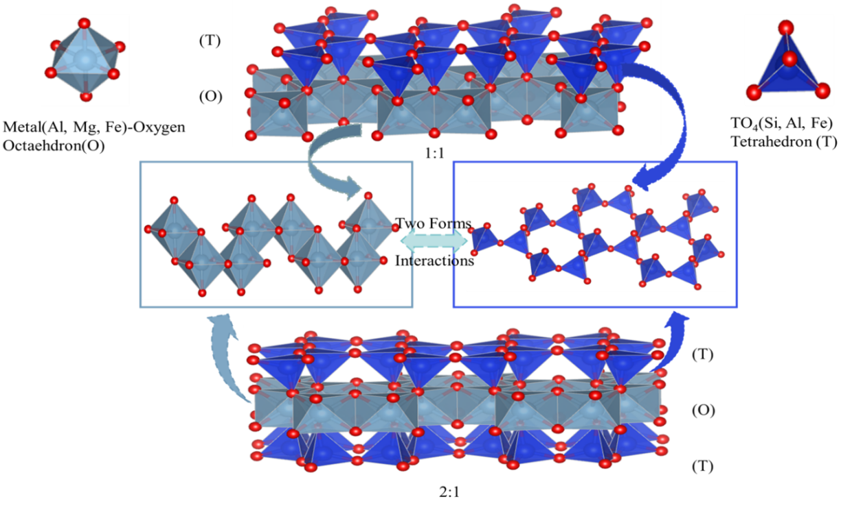
Fig. S8. Representative models of tetrahedral and octahedral thin mulchs, forming 1:1 (TO) and 2:1 (TOT) layers.

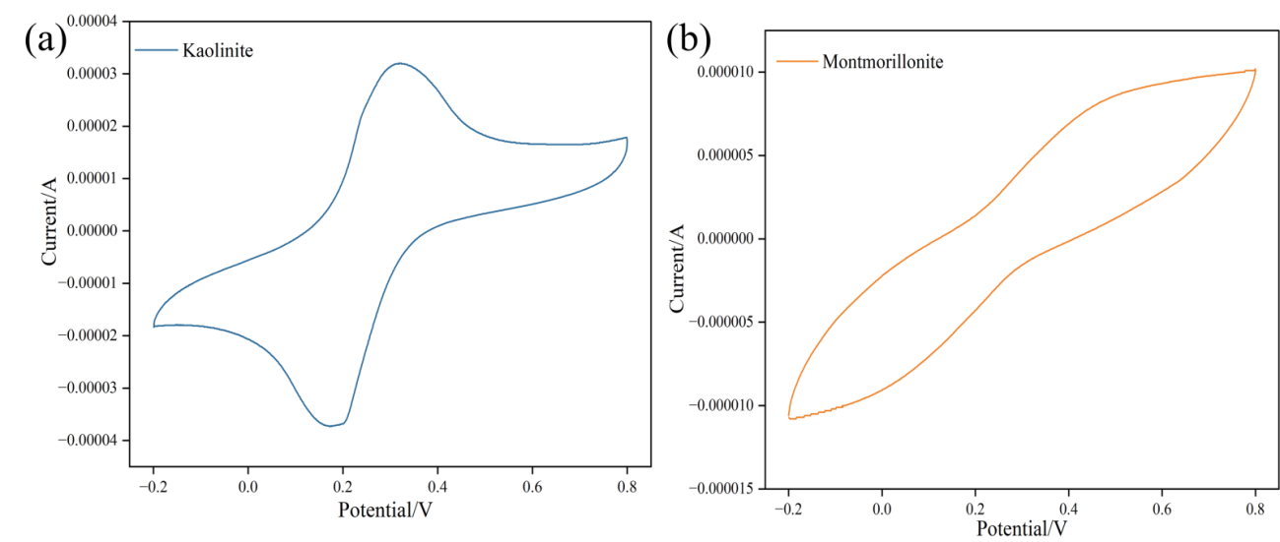
Fig. S9. CV of kaolinite (a) and montmorillonite (b).

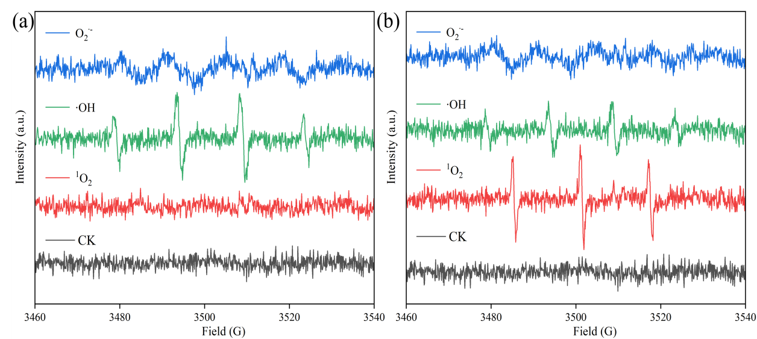
Fig. S10.EPR spectra of ROS generated by clay minerals in photocatalytic reactions (a) kaolin;(b) montmorillonite.

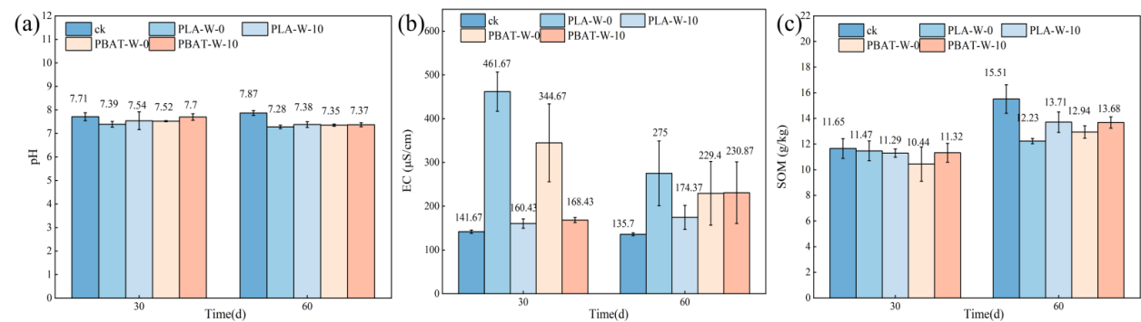
Fig. S11. Changes in soil pH (a), EC (b), and SOM (c) during the degradation process of PLA and PBAT in the soil surface and at a depth of 10 cm.

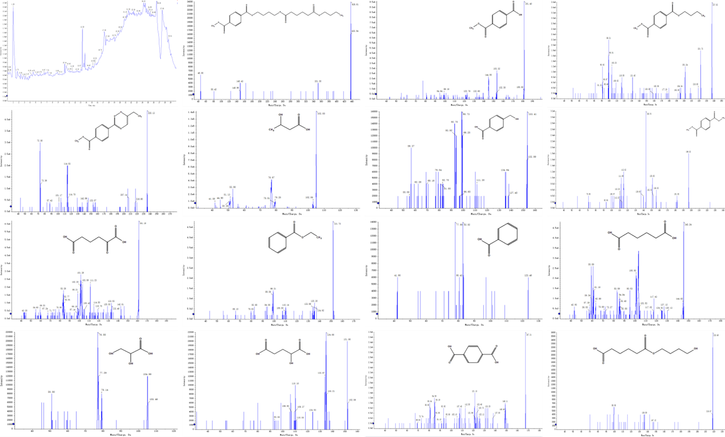
Fig. S12. Total ion chromatogram (TIC) and tandem mass spectrometry (MS/MS) fragmentation mode of photoaged PBAT mulch leachate in soil minerals.

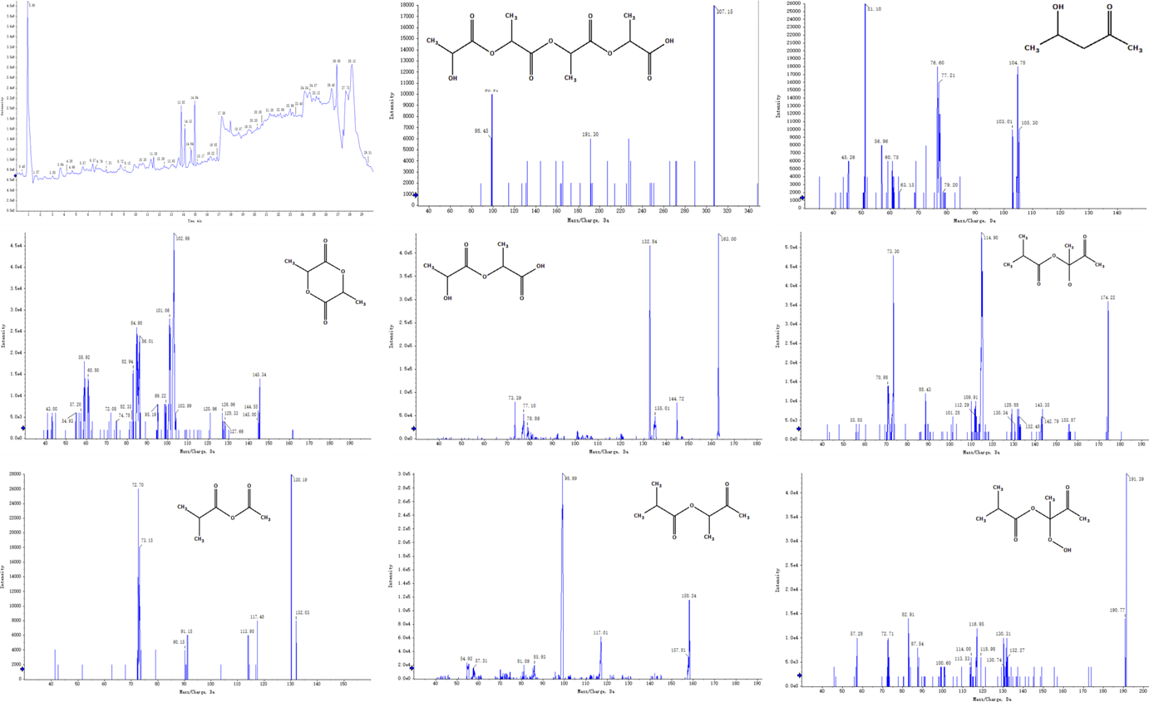
Fig. S13. Total ion chromatogram (TIC) and tandem mass spectrometry (MS/MS) fragmentation mode of photoaged PLA mulch leachate in soil minerals.

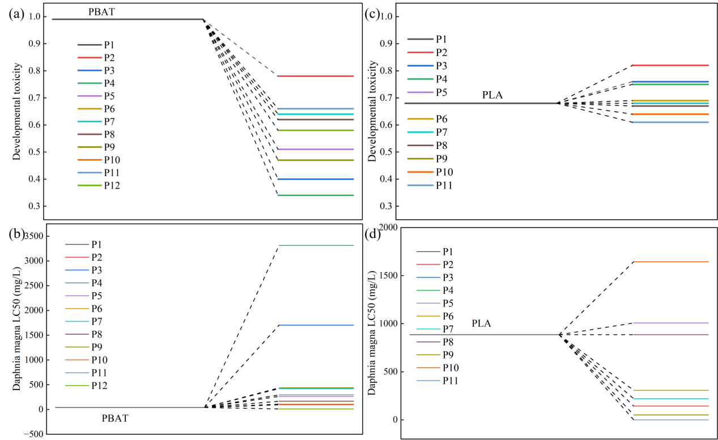
Fig. S14. Toxicity evaluation of intermediate species formed during the degradation of PBAT and PLA. (a) Developmental toxicity of PBAT degradation intermediates; (b) Daphnia magna LC50 of PBAT degradation intermediates; (c) Developmental toxicity of PLA degradation intermediates; (d) Daphnia magna LC50 of PLA degradation intermediates.

References
[1] Jung Y.M., Shin H.S., Kim S.B., Noda I. 2002. New approach to generalized two-dimensional correlation spectroscopy. 1: Combination of principal component analysis and two-dimensional correlation spectroscopy. Applied Spectroscopy. 56 (12), 1562–1567. doi: 10.1366/000370202321116020.
[2] Šašić S., Ozaki Y. 2001. Comparison of principal component analysis and generalized two-dimensional correlation spectroscopy: Spectral analysis of synthetic model system and near-infrared spectra of milk. Applied Spectroscopy. 55 (1), 29–38. doi: 10.1366/0003702011951399.
[3] Lasch P., Noda I. 2019. Two-dimensional correlation spectroscopy (2D-COS) for analysis of spatially resolved vibrational spectra. Applied Spectroscopy. 73 (4), 359–379. doi: 10.1177/0003702818819880.

