Straw return methods differentially mitigate N₂O emissions with reduced AOB amoA abundance and shifted community composition in N fertilized saline‑alkali soils
Zhen Li^{1,a}, Huimin Dong^{1,a}, Wenshuo Liu¹, Yaqi Yu¹, Marcela Hernández², Yanhong Lou¹, Haojie Feng¹, Hui Wang¹, Quangang Yang¹, Hongjie Di¹, Hong Pan^{1*}, Yuping Zhuge^{1*}
Authors affiliations:
¹National Engineering Research Center for Efficient Utilization of Soil and Fertilizer Resources, College of Resources and Environment, Shandong Agricultural University, Daizong Road, Tai’an City 271018, Shandong, China
²School of Biological Sciences, University of East Anglia, Norwich NR4 7TJ, UK
ª These authors contributed equally to this work.
* Corresponding authors: Hong Pan, Yuping Zhuge
Tel: +86 538 8243918
FAX: +86-538- 8242250
E-mail addresses: panhong6239@163.com; zhugeyp@sdau.edu.cn
Add: College of Resources and Environment, Shandong Agricultural University, Tai’an City, Shandong, China

Table S1. The basic properties of different straw materials
Treatment | C/N | pH | EC (ms cm⁻¹) | DOC (g kg⁻¹) | Reference
CS | 48 | 6.5 | 2.1 | 10.2 | [1]
PS | 50 | 6.8 | 1.5 | 5.3 | [2]
MS | 20 | 8.0 | 5.2 | 18.2 | [3]
CBS | 100 | 9.0 | 1.4 | 1.8 | [4]

Table S2. PCR primers and thermal cycling conditions used for gene quantification
Gene | Primer | Sequence | Amplicon  size (bp) | Thermal conditions | Reference
nirS | nirSCd3aF | GTSAACGTSAAGGARACSGG | 425 | 95 °C, 3 min; 35 × (95 °C for 10 s, 56 °C for 30 s, 72 °C for 20 s+ plate read); Melt curve: 65.0 °C to 95.0 °C, increment 0.5 °C, 0:05+ plate read | [5]
nirS | nirSR3cd | GASTTCGGRTGSGTCTTGA | 425 |  | [5]
nirK | nirKF1aCu | ATCATGGTSCTGCCGCG | 473 | 95 °C, 3 min; 35 × (95 °C for 10 s, 56 °C for 30 s, 72 °C for 20 s+ plate read); Melt curve: 65.0 °C to 95.0 °C, increment 0.5 °C, 0:05+ plate read | [5]
nirK | nirKR3Cu | GCCTCGATCAGRTTGTGGTT | 473 |  | [5]
nosZ | nosLb | CCCGCTGCACACCRCCTTCGA | 300 | 95 °C, 3 min; 35 × (95 °C for 10 s, 56.8 °C for 30 s, 72 °C for 20 s+ plate read); Melt curve: 65.0 °C to 95.0 °C, increment 0.5 °C, 0:05+ plate read | [6]
nosZ | nosRb | CGTCGCCSGAGATGTCGATCA | 300 |  | [6]
Archaeal amoA | Arch-amoAF | STAATGGTCTGGCTTAGACG | 635 | 95 °C, 3min；35 × (95 °C for 30 s, 55 °C for 30 s, 72 °C for 45 s+ plate read); Melt curve: 65.0 °C to 95.0 °C, increment 0.5 °C, 0:05+ plate read | [7]
Archaeal amoA | Arch-amoAR | GCGGCCATCCATCTGTATGT | 635 |  | [7]
Bacterial amoA | amoA-1F | GGGGTTTCTACTGGTGGT | 491 | 95 °C, 3min; 35 × (95 °C for 30 s, 55 °C for 30 s, 72 °C for 45 s+ plate read); Melt curve: 65.0 °C to 95.0 °C, increment 0.5 °C, 0:05+ plate read | [8]
Bacterial amoA | amoA-2R | CCC CTC KGS AAA GCCTTCTTC | 491 |  | [8]

Table S3. Analysis of variance of accumulated N₂O emissions from straw, N fertilizer and their interactions in saline-alkali soil
 | Factors and their interaction
 |  | Straw | Nitrogen | Straw × Nitrogen
N₂O emission | Df | 2 | 1 | 2
N₂O emission | F | 83.6 | 200 | 6.05
N₂O emission | P | < 0.001 | < 0.001 | 0.002

Table S4. Results of regression analysis to assess the significance of associations between N₂O flux (y) and soil characteristics or abundance of functional genes of N₂O-forming and reducing microorganisms (x) on day 90
Soil characteristics | Regression equation | R² value | F value | p value
SOC | --- | 0.136 | 2.08 | 0.145
MBC | y = 0.016x² − 6.119x + 698.84 | 0.482 | 13.05 | < 0.001
SOC/MBC | y = 274e − 28.8x | 0.715 | 70.11 | < 0.001
NH₄⁺-N | --- | 0.012 | 0.34 | 0.564
NO₃⁻-N | y = 1.298x + 49.11 | 0.284 | 11.13 | 0.002
MNN | y = 274e − 0.265x | 0.618 | 45.7 | < 0.001
AOA amoA gene (×10⁸) | --- | 0.108 | 3.38 | 0.076
AOB amoA gene (×10⁸) | y = 15.63x + 68.60 | 0.328 | 13.64 | 0.001
nirK gene (×10⁸) | --- | 0.087 | 2.51 | 0.201
nirS gene (×10⁸) | --- | 0.008 | 0.220 | 0.640
nosZ gene (×10⁸) | --- | 0.089 | 2.74 | 0.104
nosZ/(nirS+nirK) | --- | 0.019 | 0.54 | 0.468

Table S5. Spearman correlations between abundance of functional genes of N₂O-forming and reducing microorganisms and soil biochemical properties on day 90
 | NH₄⁺-N | NO₃⁻-N | SOC | MBC | MBC/SOC | MNN
AOA amoA gene | −0.290 | 0.120 | −0.140 | −0.280* | −0.200 | −0.270*
AOB amoA gene | −0.053 | 0.730*** | 0.460* | −0.420* | −0.520** | −0.510***
nirS | −0.300 | −0.320 | 0.067 | 0.260 | 0.360* | 0.260
nirK | 0.000 | 0.180 | −0.270 | 0.110 | 0.100 | 0.170
nosZ | 0.000 | 0.460 | 0.380 | −0.170 | −0.190 | −0.330
nosZ/(nirS+nirK) | 0.072 | 0.210 | 0.200 | −0.270 | −0.100 | −0.170

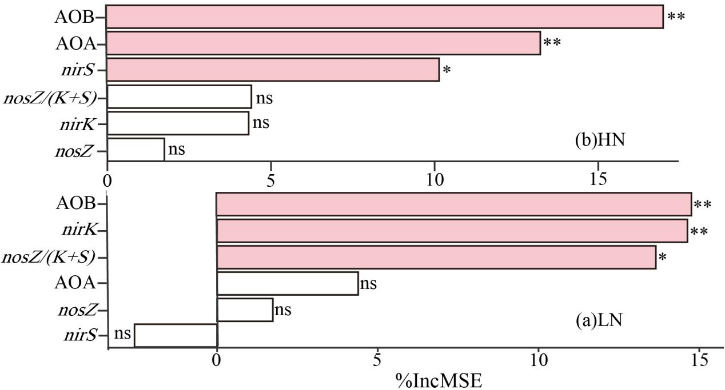
Fig. S1 Random forest variable importance models were used to predict the effects of denitrification gene abundance and nitrification gene abundance on cumulative N₂O emissions under low-N fertilizer (a) and high-N fertilizer (b) conditions (* p < 0.05, ** p < 0.01, ns indicates no significant difference).

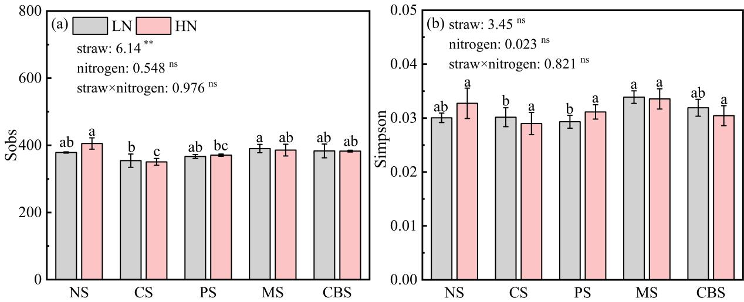
Fig. S2 After the cultivation process was completed, the diversity index was calculated by pyrosequencing the bacterial AOB sequences in the soil under different straw application methods under low- or high-N conditions. Different letters indicated significant differences between treatments (p < 0.05). The vertical lines represent the standard error of the mean (n = 3).

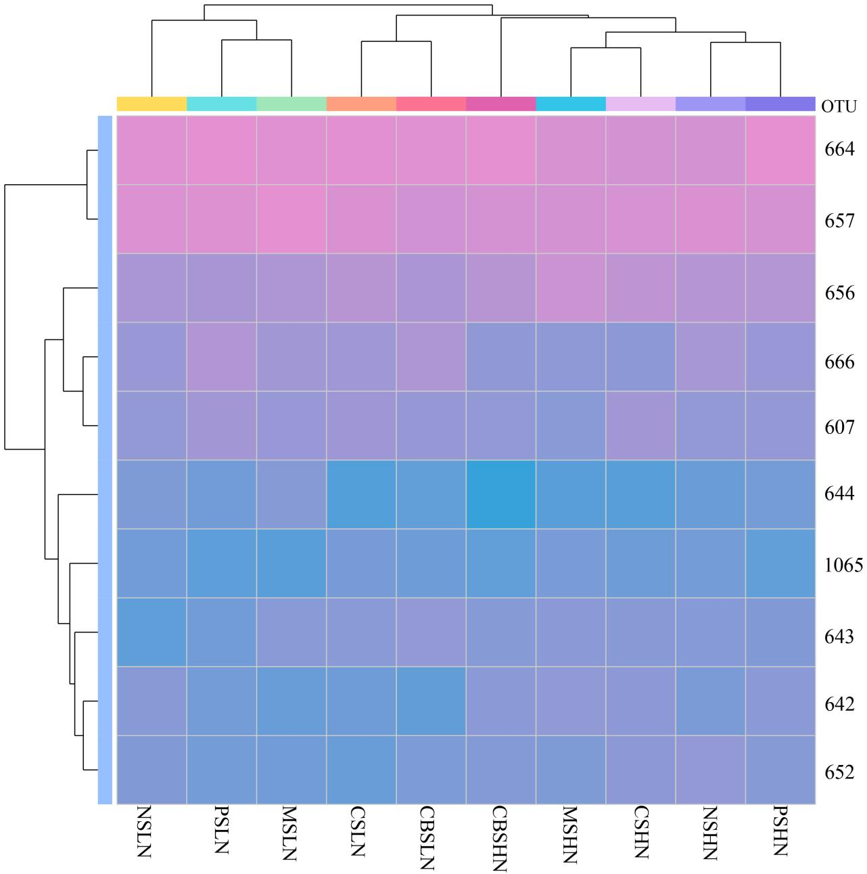
Fig. S3 Heatmap of AOB OTU sequences retrieved from soil under different straw application methods on day 90 under low- or high-N conditions. The heatmap shows the 10 most abundant OTUs; the greater the relative abundance of the OTU, the darker the color.

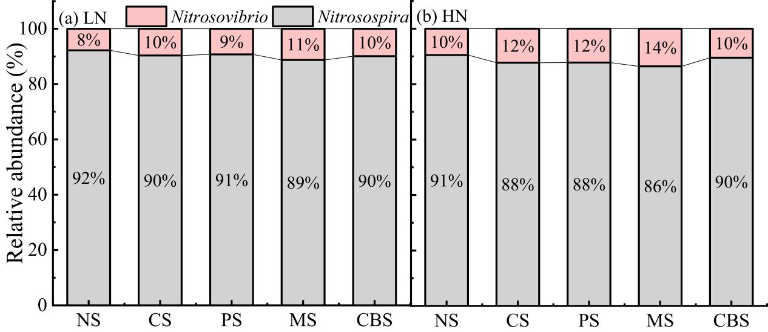
Fig. S4 Relative abundance of bacterial communities as defined by AOB in the soil under five different straw application methods under low- or high-N conditions.

References
- Cong P, Wang J, Li YY, Liu, N, Dong JX, et al. 2020. Changes in soil organic carbon and microbial community under varying straw incorporation strategies. Soil and Tillage Research 204:104735 doi:10.1016/j.still.2020.104735
- Ai P, Zhang XZ, Ran Y, Meng L, Elsayed M, et al. 2019. Biomass briquetting reduces the energy loss during long-term ensiling and enhances anaerobic digestion: A case study on rice straw. Bioresource Technology 292:121912 doi:110.1016/j.biortech.2019.121912
- Liang YC, Si J, Nikolic M, Peng Y, Chen W, et al. 2005. Organic manure stimulates biological activity and barley growth in soil subject to secondary salinization. Soil Biology and Biochemistry 37 (6):1185-1195 doi:10.1016/j.soilbio.2004.11.017
- Chandra S, Bhattacharya J. 2019. Influence of temperature and duration of pyrolysis on the property heterogeneity of rice straw biochar and optimization of pyrolysis conditions for its application in soils. Journal of Cleaner Production 215:1123-1139 doi:110.1016/j.biortech.2019.121912
- Throbäck IN. Enwall-K, Jarvia Å, Hallin S. 2004 Reassessing PCR primers targeting ninS, nirK and nosZ genes for community surveys of denitrifying bacteria with DGGE. Fems Microbiology Ecology 49(3):40-417
- Chèneby D. Hartmann A, Hénault C. Topp E. et al. 1998. Diversity of denitrifying microflora and ability to reduce N₂O in twosoils. Biology and Fertilit of Soils 28:19-26
- Ward BB. 2005. Molecular approaches to maring microbial ecology and the maring nitrogen cycle. Anmual Review of Earth and Planetary Sciences 33:30-33
- Wattenburger CJ, Gutknecht J, Zhang Q, Brutnell T, et al. 2020. The rhizosphere and cropping system, but not arbuscular mycorrhizae, affect ammonia oxidizing archaea and bacteria abundances in two agricultural soils. Applied Soil Ecology 151:103540

