Warming reshapes nitrogen partitioning and stabilization pathways in flooded rice soils
Hyeon Ji Song^{1,2}, Young Ho Seo¹, Ho Jun Shin¹, Jae Jin Lee³, Snowie Jane G. Ampode^{1,4}, Pil Joo Kim^{1,5}

¹Division of Applied Life Science (BK 21), Gyeongsang National University, Jinju 52828, South Korea.
²Department of Agronomy, Iowa State University, Ames, Iowa 50010, USA
³Department of Agricultural and Biosystems Engineering, Iowa State University, Ames, Iowa 50010, USA
⁴Philippines College of Agriculture, Forestry, and Environmental Sciences, Western Philippines University, Palawan 5302, Philippines
⁵Institute of Agriculture & Life Sciences, Gyeongsang National University, Jinju 52828, South Korea.

* Corresponding author: Pil Joo Kim (Email: pjkim@gnu.ac.kr)

Supplementary Figure 1. Rice grain yield, N content in grain and straw, and N uptake by grain and straw under different atmospheric conditions for 2 years. Error bars indicate standard deviation (n = 3 within-plot subsamples). Different letters represent statistical difference at 0.05.
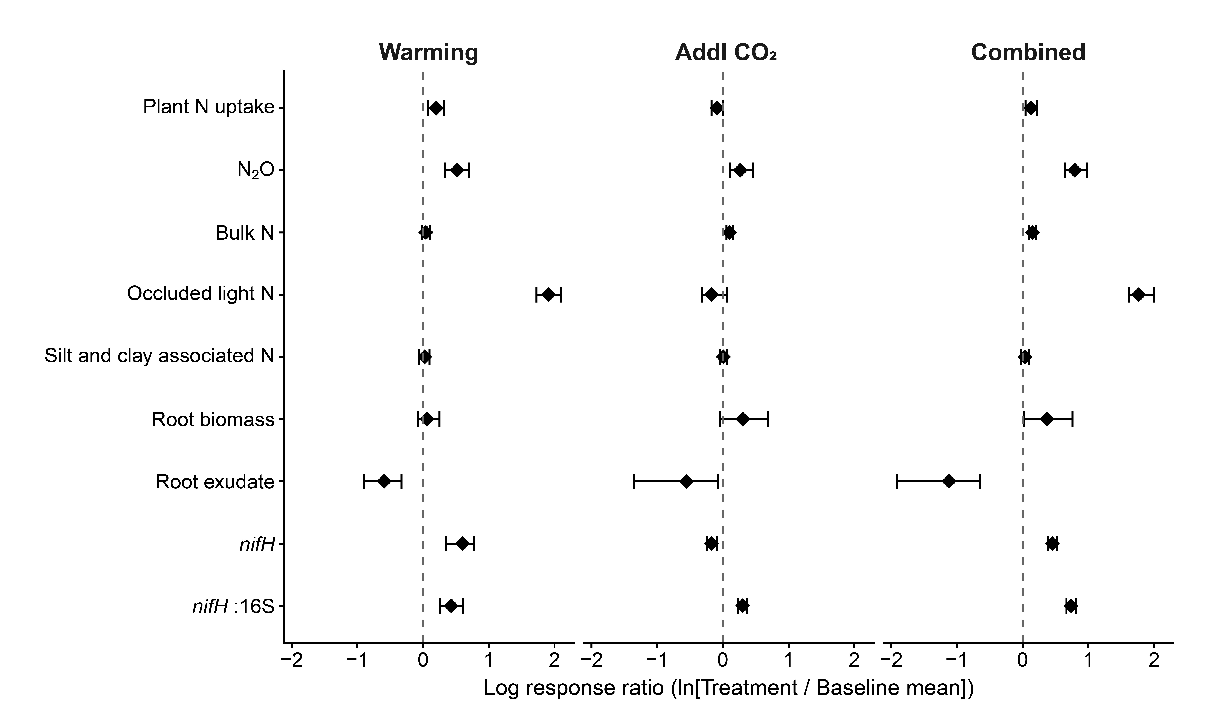
Supplementary Figure 2. Responses are shown as log response ratios (ln[Treatment/Baseline mean]). Baseline is Amb for the warming and combined effects, and ET for the additional CO₂ effect under warming. Points represent mean responses (n = 3 within-plot subsamples). Error bars denote bootstrap 95% confidence intervals of the mean lnRR (5,000 iterations), used for visualization only and not as a test of statistical significance.

Supplementary Figure 2. Monthly changes in available N (NH₄⁺-N and NO₃⁻-N) and water extractable N under different atmospheric conditions in the 3rd year. Error bars indicate standard deviation (n = 3 within-plot subsamples). Asterisks represent statistical difference among atmospheric conditions at 0.05.

