Supplementary information for
Geographical and Micro-environmental Factors Regulate Nitrogen Removal in a Forest-dominated River
Wenshi Zhang^{1,2}, Xiaodong Li^{1,3}, Hao Jiang^{2,4*}, Quanfa Zhang^{2,4}
¹ Institute of Surface-Earth System Science, School of Earth System Science, Tianjin University, Tianjin 300072, China
² Wuhan Botanical Garden, Chinese Academy of Sciences, Wuhan 430074, China
³Tianjin Key Laboratory of Earth’s Critical Zone Science and Sustainable Development in Bohai Rim, Tianjin University, Tianjin 300072, China
⁴ Danjiangkou Wetland Ecosystem Field Scientific Observation and Research Station, Chinese Academy of Sciences & Hubei Province, Wuhan 430074, China
*Corresponding author
Hao Jiang (jianghao@wbgcas.cn)

Contents of this file
Text S1 to S2
Figs. S1 to S2
Table S1

Text S1: Methods for determining N transformation rates of sediment
The net nitrification rate was assessed using an aerobic incubation approach ^{[1,2]}. In this procedure, 20 g of field-moist sediment was incubated under aerobic conditions in the dark at the in situ temperature for a duration of 14 days. To quantify the net nitrification rate, nitrate (NO₃⁻) concentrations were measured at the beginning and end of the incubation period.
Denitrification and anammox rates were quantified using the ¹⁵N isotope pairing technique ^{[3,4]}. Seven homogenized sediment subsamples (2 g of fresh sediment each) were mixed with helium-purged water at a 1:5 ratio and transferred into 12 mL gas-tight vials (Exetainer, Labco, U.K.). After a 72-hour pre-incubation period to eliminate residual NO₂⁻, NO₃⁻, and O₂, potassium K¹⁵NO₃ (99.2% ¹⁵N) was added to six of the vials. Immediately after tracer addition, 200 μL of ZnCl₂ solution was injected into three of the vials to halt microbial activity. The remaining three were incubated for an additional 8 hours prior to ZnCl₂ injection. One additional vial received ZnCl₂ immediately after the pre-incubation phase to serve as a time-zero control. The incubation duration was based on preliminary tests, which confirmed a linear increase in ²⁹N₂ and ³⁰N₂ production over the 8-hour period. A membrane inlet mass spectrometer (MIMS; HPR-40, Hiden Analytical, U.K.) was used to quantify ²⁹N₂ and ³⁰N₂ concentrations in the samples. Subsequently, denitrification and anammox rates were computed following the methods described by Deng et al. and Ma et al. ^{[4, 5]} In brief, both denitrification and anammox can produce ²⁹N₂:
P₂₉ = D₂₉ + A₂₉
where P₂₉ represents the ²⁹N₂ production rate after 8 h of samples incubation; D₂₉ and A₂₉ are the ²⁹N₂ production rates from denitrification and anammox, respectively. Given the ²⁸N₂, ²⁹N₂, and ³⁰N₂ produced from denitrification follow random isotope pairing, D₂₉ can be estimated by the following equation:
D₂₉ = P₃₀ × 2 × (1 – F_{N}) × F_{N}^{–1}
where P₃₀ represents the ³⁰N₂ production rate after 8 h of samples incubation, and F_{N} is the fraction of ¹⁵N in the total NO₃– pool, which is calculated from the NO₃– concentration before and after the spiking of ¹⁵NO₃–. At last, the rates of denitrification (DR) and anammox (AR) can be quantified by the following equations:
DR = D₂₉ + 2 × P₃₀
AR = A₂₉ = P₂₉ – D₂₉
The DNRA rates were also measured using an ¹⁵N pairing technique ^{[6]}. For each sediment sample, ten vials were prepared. The pre-purged slurry was first transferred into glass vials and pre-incubated for 72 hours under conditions identical to those used for denitrification and anammox experiments. Following this pre-incubation, the slurries were returned to conical flasks, subjected to an additional purging step, and then redistributed into glass vials for an 8-hour incubation. The oxidation of dissolved ¹⁵NH₄⁺ resulted in the production of nitrogen gas ²⁹N₂ and/or ³⁰N₂), which was subsequently analyzed using a MIMS. The DNRA rate was determined by calculating the difference in ¹⁵NH₄⁺ concentrations between the initial and final samples ^{[7]}.
DNRAR = (¹⁵NH₄⁺_{final} – ¹⁵NH₄⁺_{initial}) × V × W^{–1} × T^{–1}
where DNRAR is the rate of DNRA, ¹⁵NH₄⁺_{final} and ¹⁵NH₄⁺_{initial} are the concentrations of ¹⁵NH₄⁺ in the final and initial samples, respectively, V is the volume of the vial, W is the dry weight of the sample, and T is the incubation time.
Text S2: Methods for determining Functional gene abundances
Quantitative PCR (qPCR) was employed to quantify key functional genes involved in nitrogen cycling, including amoA-AOA and amoA-AOB (nitrification), nirK, nirS, and nosZ (denitrification), hzsA (anammox), and nrfA (DNRA). Genomic DNA was extracted from 0.5 g of sediment using the HiPure Soil DNA Kit (Magen, Guangzhou, China), following the manufacturer’s protocol. DNA concentration and purity were assessed based on absorbance ratios at 260/280 nm and 260/230 nm, measured using a NanoDrop 2000 spectrophotometer (Thermo Fisher Scientific, Waltham, USA). High-quality DNA samples were subsequently fragmented via sonication to approximately 350 bp in length. The resulting fragments underwent end-repair, A-tailing, and ligation with full-length adapters, followed by purification. Purified libraries were amplified by PCR and sequenced using the Illumina platform. Standard curves were generated using a series of plasmid DNA dilutions with known concentrations, ensuring a correlation coefficient (R²) exceeding 0.99.
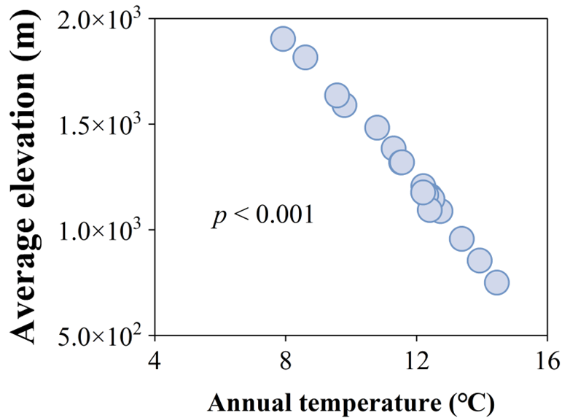

Fig. S1 Linear regression illustrating the relationship between mean elevation and mean annual temperature (MAT) across sampling sites.
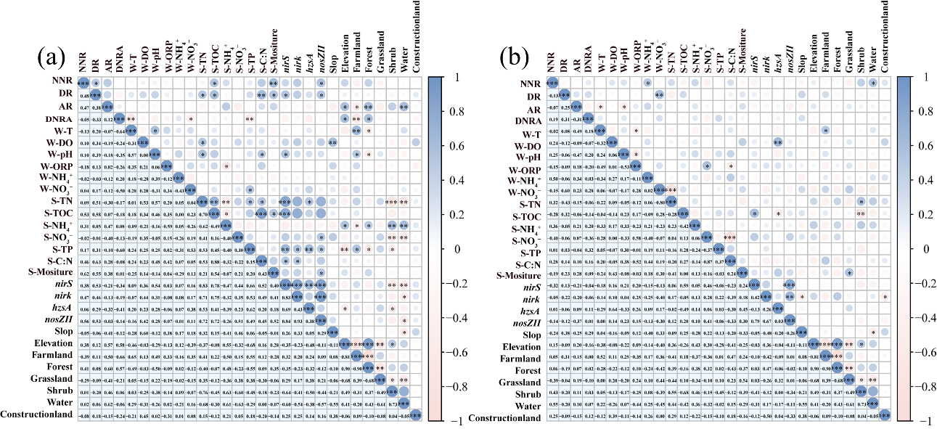
Fig. S2 Spearman correlation plots showing the relationships between biotic and abiotic factors and the rates of nitrification, denitrification, anammox, and DNRA in sediments during (a) summer and (b) winter. W- and S- represent water and sediment, respectively. Abbreviations: NNR – net nitrification rate; DR – denitrification rate; AR – anammox rate; DNRAR – DNRA rate. *, p < 0.05; **, p < 0.01; ***, p < 0.00.
Table S1 The altitude, slope gradient, annual mean temperature, and land use types of sampling points.
Sample | Altitude | Slop | T | Average T· | Construction land | Farm  land | Forest | Grassland |  | Shrubland | Water
No. | m |  | ℃ |  | %
Summer
JS-1 | 1903.60 | 21.95 | 16.78 | 7.92 | 0.00 | 0.03 | 97.53 | 2.36 |  | 0.05 | 0.04
JS-2 | 1482.77 | 27.83 | 17.30 | 10.80 | 0.00 | 0.00 | 95.73 | 2.48 |  | 1.79 | 0.00
JS-3 | 1590.08 | 23.60 | 18.79 | 9.80 | 0.00 | 2.26 | 97.01 | 0.25 |  | 0.29 | 0.19
JS-4 | 1384.59 | 24.11 | 20.45 | 11.30 | 0.43 | 6.40 | 91.75 | 0.30 |  | 0.78 | 0.34
JS-5 | 1206.36 | 19.61 | 22.73 | 12.21 | 0.00 | 4.82 | 91.35 | 2.55 |  | 1.00 | 0.28
JS-6 | 1159.30 | 22.30 | 20.61 | 12.41 | 0.00 | 2.90 | 95.63 | 0.89 |  | 0.13 | 0.45
JS-7 | 1318.61 | 23.58 | 21.55 | 11.53 | 0.00 | 2.61 | 96.29 | 0.30 |  | 0.39 | 0.41
JS-8 | 1815.82 | 23.76 | 17.89 | 8.60 | 0.00 | 0.53 | 98.44 | 0.69 |  | 0.06 | 0.27
JS-9 | 1635.85 | 25.77 | 18.30 | 9.58 | 0.00 | 2.12 | 97.34 | 0.53 |  | 0.00 | 0.00
JS-10 | 1319.26 | 22.00 | 19.01 | 11.56 | 0.00 | 2.30 | 94.92 | 2.78 |  | 0.00 | 0.00
JS-11 | 1088.38 | 19.81 | 19.88 | 12.74 | 0.00 | 4.34 | 89.64 | 6.02 |  | 0.00 | 0.00
JS-12 | 1145.41 | 25.11 | 17.87 | 12.49 | 0.85 | 2.49 | 93.07 | 3.58 |  | 0.00 | 0.00
JS-13 | 1164.43 | 26.50 | 18.51 | 12.30 | 1.91 | 4.71 | 91.50 | 1.86 |  | 0.01 | 0.00
JS-14 | 1093.11 | 24.79 | 18.90 | 12.41 | 0.00 | 9.82 | 88.13 | 2.05 |  | 0.00 | 0.00
JS-15 | 956.65 | 23.94 | 19.58 | 13.39 | 0.00 | 19.96 | 75.11 | 4.92 |  | 0.01 | 0.00
JS-16 | 853.57 | 24.93 | 20.15 | 13.93 | 0.00 | 15.71 | 78.81 | 5.48 |  | 0.00 | 0.00
JS-17 | 749.29 | 24.11 | 20.88 | 14.46 | 0.00 | 15.39 | 71.48 | 13.13 |  | 0.00 | 0.00
JS-18 | 1176.29 | 26.36 | 21.89 | 12.20 | 0.00 | 5.77 | 92.61 | 1.62 |  | 0.00 | 0.00
Winter
JS-1 | 1903.60 | 21.95 | 3.41 | 7.92 | 0.00 | 0.03 | 97.53 | 2.36 |  | 0.05 | 0.04
JS-2 | 1482.77 | 27.83 | 2.83 | 10.80 | 0.00 | 0.00 | 95.73 | 2.48 |  | 1.79 | 0.00
JS-3 | 1590.08 | 23.60 | 4.24 | 9.80 | 0.00 | 2.26 | 97.01 | 0.25 |  | 0.29 | 0.19
JS-4 | 1384.59 | 24.11 | 3.73 | 11.30 | 0.43 | 6.40 | 91.75 | 0.30 |  | 0.78 | 0.34
JS-5 | 1206.36 | 19.61 | 4.81 | 12.21 | 0.00 | 4.82 | 91.35 | 2.55 |  | 1.00 | 0.28
JS-6 | 1159.30 | 22.30 | 4.38 | 12.41 | 0.00 | 2.90 | 95.63 | 0.89 |  | 0.13 | 0.45
JS-7 | 1318.61 | 23.58 | 5.13 | 11.53 | 0.00 | 2.61 | 96.29 | 0.30 |  | 0.39 | 0.41
JS-8 | 1815.82 | 23.76 | 4.70 | 8.60 | 0.00 | 0.53 | 98.44 | 0.69 |  | 0.06 | 0.27
JS-9 | 1635.85 | 25.77 | 2.99 | 9.58 | 0.00 | 2.12 | 97.34 | 0.53 |  | 0.00 | 0.00
JS-10 | 1319.26 | 22.00 | 2.39 | 11.56 | 0.00 | 2.30 | 94.92 | 2.78 |  | 0.00 | 0.00
JS-11 | 1088.38 | 19.81 | 2.65 | 12.74 | 0.00 | 4.34 | 89.64 | 6.02 |  | 0.00 | 0.00
JS-12 | 1145.41 | 25.11 | 4.40 | 12.49 | 0.85 | 2.49 | 93.07 | 3.58 |  | 0.00 | 0.00
JS-13 | 1164.43 | 26.50 | 3.85 | 12.30 | 1.91 | 4.71 | 91.50 | 1.86 |  | 0.01 | 0.00
JS-14 | 1093.11 | 24.79 | 4.27 | 12.41 | 0.00 | 9.82 | 88.13 | 2.05 |  | 0.00 | 0.00
JS-15 | 956.65 | 23.94 | 4.93 | 13.39 | 0.00 | 19.96 | 75.11 | 4.92 |  | 0.01 | 0.00
JS-16 | 853.57 | 24.93 | 4.90 | 13.93 | 0.00 | 15.71 | 78.81 | 5.48 |  | 0.00 | 0.00
JS-17 | 749.29 | 24.11 | 4.54 | 14.46 | 0.00 | 15.39 | 71.48 | 13.13 |  | 0.00 | 0.00
JS-18 | 1176.29 | 26.36 | 4.81 | 12.20 | 0.00 | 5.77 | 92.61 | 1.62 |  | 0.00 | 0.00
DO, dissolved oxygen; T, water temperature.

References
[1] Hart SC, Stark JM, Davidson EA, Firestone MK. 2018. Nitrogen Mineralization, Immobilization, and Nitrification. In: Weaver RW, Angle S, Bottomley P, Bezdicek D, Smith S, Tabatabai A, Wollum A (eds) SSSA Book Series. Soil Science Society of America, Madison, WI, USA, pp 985–1018
[2] Neill C, Piccolo MC, Cerri CC, Steudler PA, Melillo JM, et al. 1997. Net nitrogen mineralization and net nitrification rates in soils following deforestation for pasture across the southwestern Brazilian Amazon Basin landscape. Oecologia 110： 243–252. https://doi.org/10.1007/s004420050157
[3] Risgaard-Petersen N, Meyer R, Schmid M, Jetten M, Enrich-Prast A, et al. 2004. Anaerobic ammonium oxidation in an estuarine sediment. Aquatic Microbial Ecology 36：293–304. https://doi.org/10.3354/ame036293
[4] Deng F, Hou L, Liu M, Zheng Y, Yin G, et al. 2015. Dissimilatory nitrate reduction processes and associated contribution to nitrogen removal in sediments of the Yangtze Estuary. Journal Of Geophysical Research-biogeosciences 120： 1521–1531. https://doi.org/10.1002/2015JG003007
[5] Ma L, Jiang X, Liu G, Yao L, Liu W, et al. 2020. Environmental Factors and Microbial Diversity and Abundance Jointly Regulate Soil Nitrogen and Carbon Biogeochemical Processes in Tibetan Wetlands. Environmental Science & Technology 54：3267–3277. https://doi.org/10.1021/acs.est.9b06716
[6] Yin G, Hou L, Liu M, Liu Z, Gardner WS. 2014. A Novel Membrane Inlet Mass Spectrometer Method to Measure ¹⁵NH₄⁺ for Isotope-Enrichment Experiments in Aquatic Ecosystems. Environmental Science & Technology 48：9555–9562. https://doi.org/10.1021/es501261s
[7] Shan J, Zhao X, Sheng R, Xia Y, ti C, et al. 2016. Dissimilatory Nitrate Reduction Processes in Typical Chinese Paddy Soils: Rates, Relative Contributions, and Influencing Factors. Environmental Science & Technology 50： 9972–9980. https://doi.org/10.1021/acs.est.6b01765

