Comparative study of microbial communities and denitrification gas emissions in typical Chinese farmland soils under varying C/N conditions
Qiaoyu Wu, Siyu Yu, Zhen Xie, Xianchao Qin, Ji Li, Xiaojun Zhang*
State Key Laboratory of Microbial Metabolism, and Joint International Research Laboratory of Metabolic & Developmental Sciences, and School of Life Sciences & Biotechnology, Shanghai Jiao Tong University, Shanghai, 200240, China

*Corresponding author: Dr. Xiaojun Zhang
State Key Laboratory of Microbial Metabolism, School of Life Sciences & Biotechnology, Shanghai Jiao Tong University, Shanghai 20040, PR China.
Tel: +86 21-34204878; Fax: +86 21-34204878;
- mail: xjzhang68@sjtu.edu.cn

Supplementary Information
Table S1 Physicochemical properties of five in situ farmland soils with low- and high- fertilization histories.
 | BFL | BFH | LFL | LFH | YFL | YFH | RFL | RFH | FFL | FFH
pH | 7.69±0.15 | 7.67±0.01 | 8.34±0.07 | 8.11±0.01 | 7.80±0.18 | 7.08±0.03 | 6.52±0.22 | 5.42±0.03 | 8.02±0.10 | 7.93±0.08
NO₃⁻-N（mg/kg) | 14.48±2.97 | 13.67±0.12 | 12.17±0.72 | 107.29±1.02 | 2.51±0.3 | 240.27±3.6 | 2.01±0.13 | 11.81±0.11 | 5.96±0.14 | 26.11±0.47
NO₂⁻-N（mg/kg) | ND | ND | ND | ND | ND | ND | ND | ND | ND | ND
NH₄⁺-N（mg/kg) | 7.57±4.16 | 4.94±5.73 | 4.53±4.06 | 1.76±0.72 | 2.91±1.65 | 5.57±3.13 | 0.94±0.82 | 0.04±0.02 | 0.47±0.77 | 0.26±0.29
DOC（mg/kg） | 24.16±1.86 | 26.95±1.11 | 31.06±0.39 | 25.67±3.28 | 16.78±0.04 | 26.39±1.59 | 1.65±0.62 | 4.01±0.21 | 14.06±0.89 | 18.08±0.96
Water content（%） | 17.74±0.15 | 18.90±0.04 | 15.87±0.13 | 16.91±0.03 | 17.73±0.10 | 17.05±0.08 | 15.85±0.05 | 19.86±0.34 | 9.47±0.09 | 10.17±0.06
WHC（%） | 41.21±0.87 | 45.26±1.50 | 42.01±2.77 | 41.90±1.67 | 43.22±2.37 | 39.96±2.64 | 48.32±1.35 | 52.13±0.32 | 40.24±0.25 | 41.34±0.08
PDR（nmol/g/h） | 21.71±1.27 | 26.07±0.46 | 54.50±1.83 | 51.71±0.65 | 35.59±1.79 | 28.28±1.88 | 3.50±1.10 | 4.46±0.28 | 31.30±0.79 | 38.69±1.62
Note: Values represent mean ± standard deviation (n=3); ND: not detected. PDR: represents potential denitrification rate.
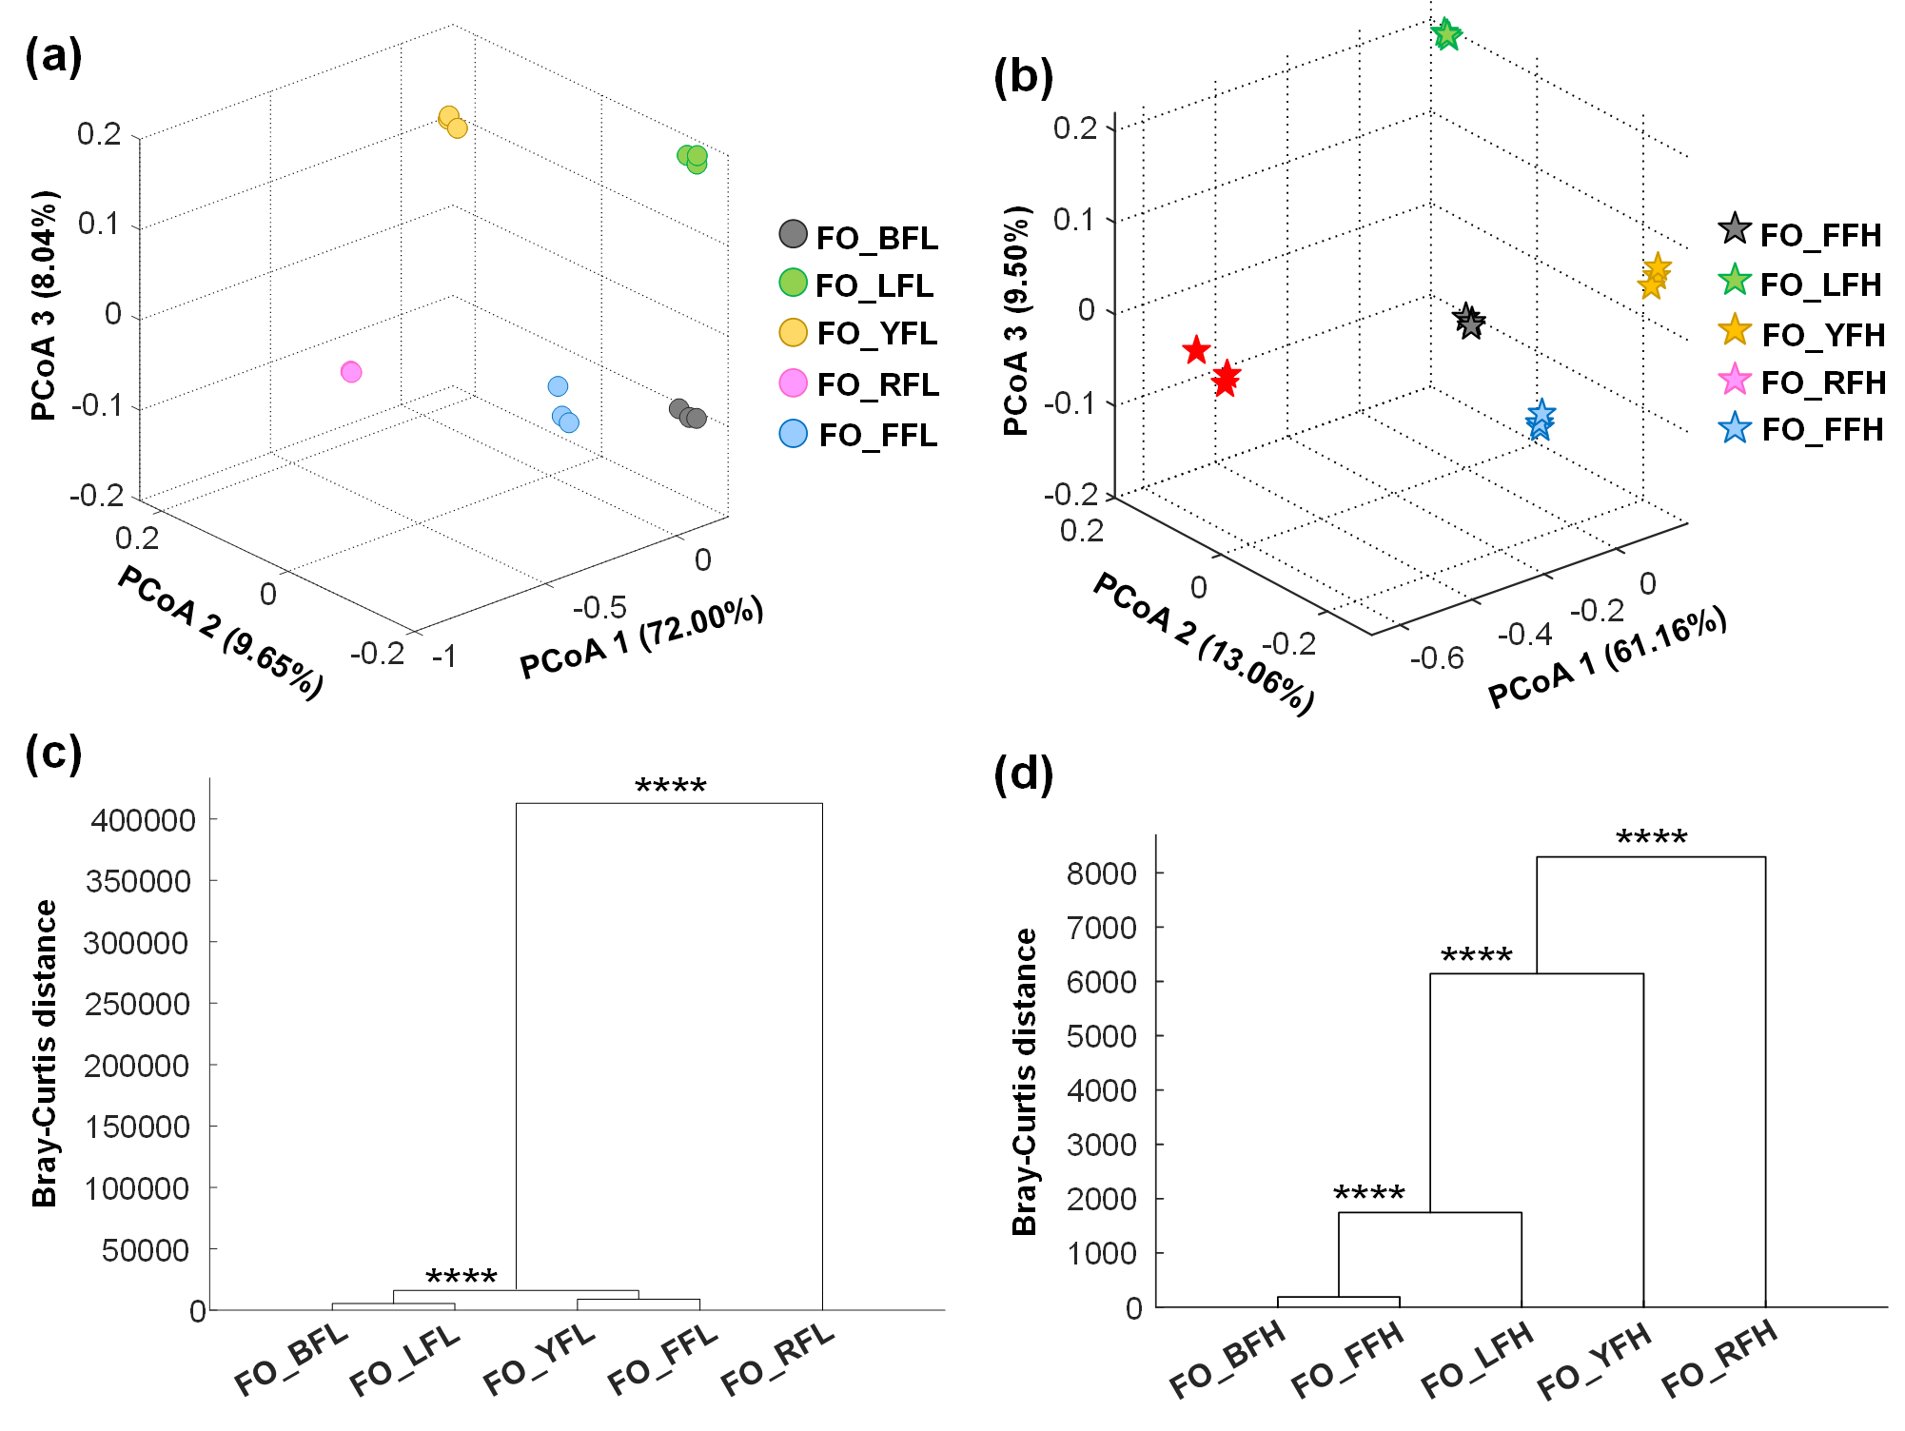
Fig. S1 Microbial community structure in in situ farmland soils. PCoA plots for the FO group under low (a) and high (b) fertilization histories. (c, d) Corresponding statistical significance (MANOVA test, ****p < 0.0001).

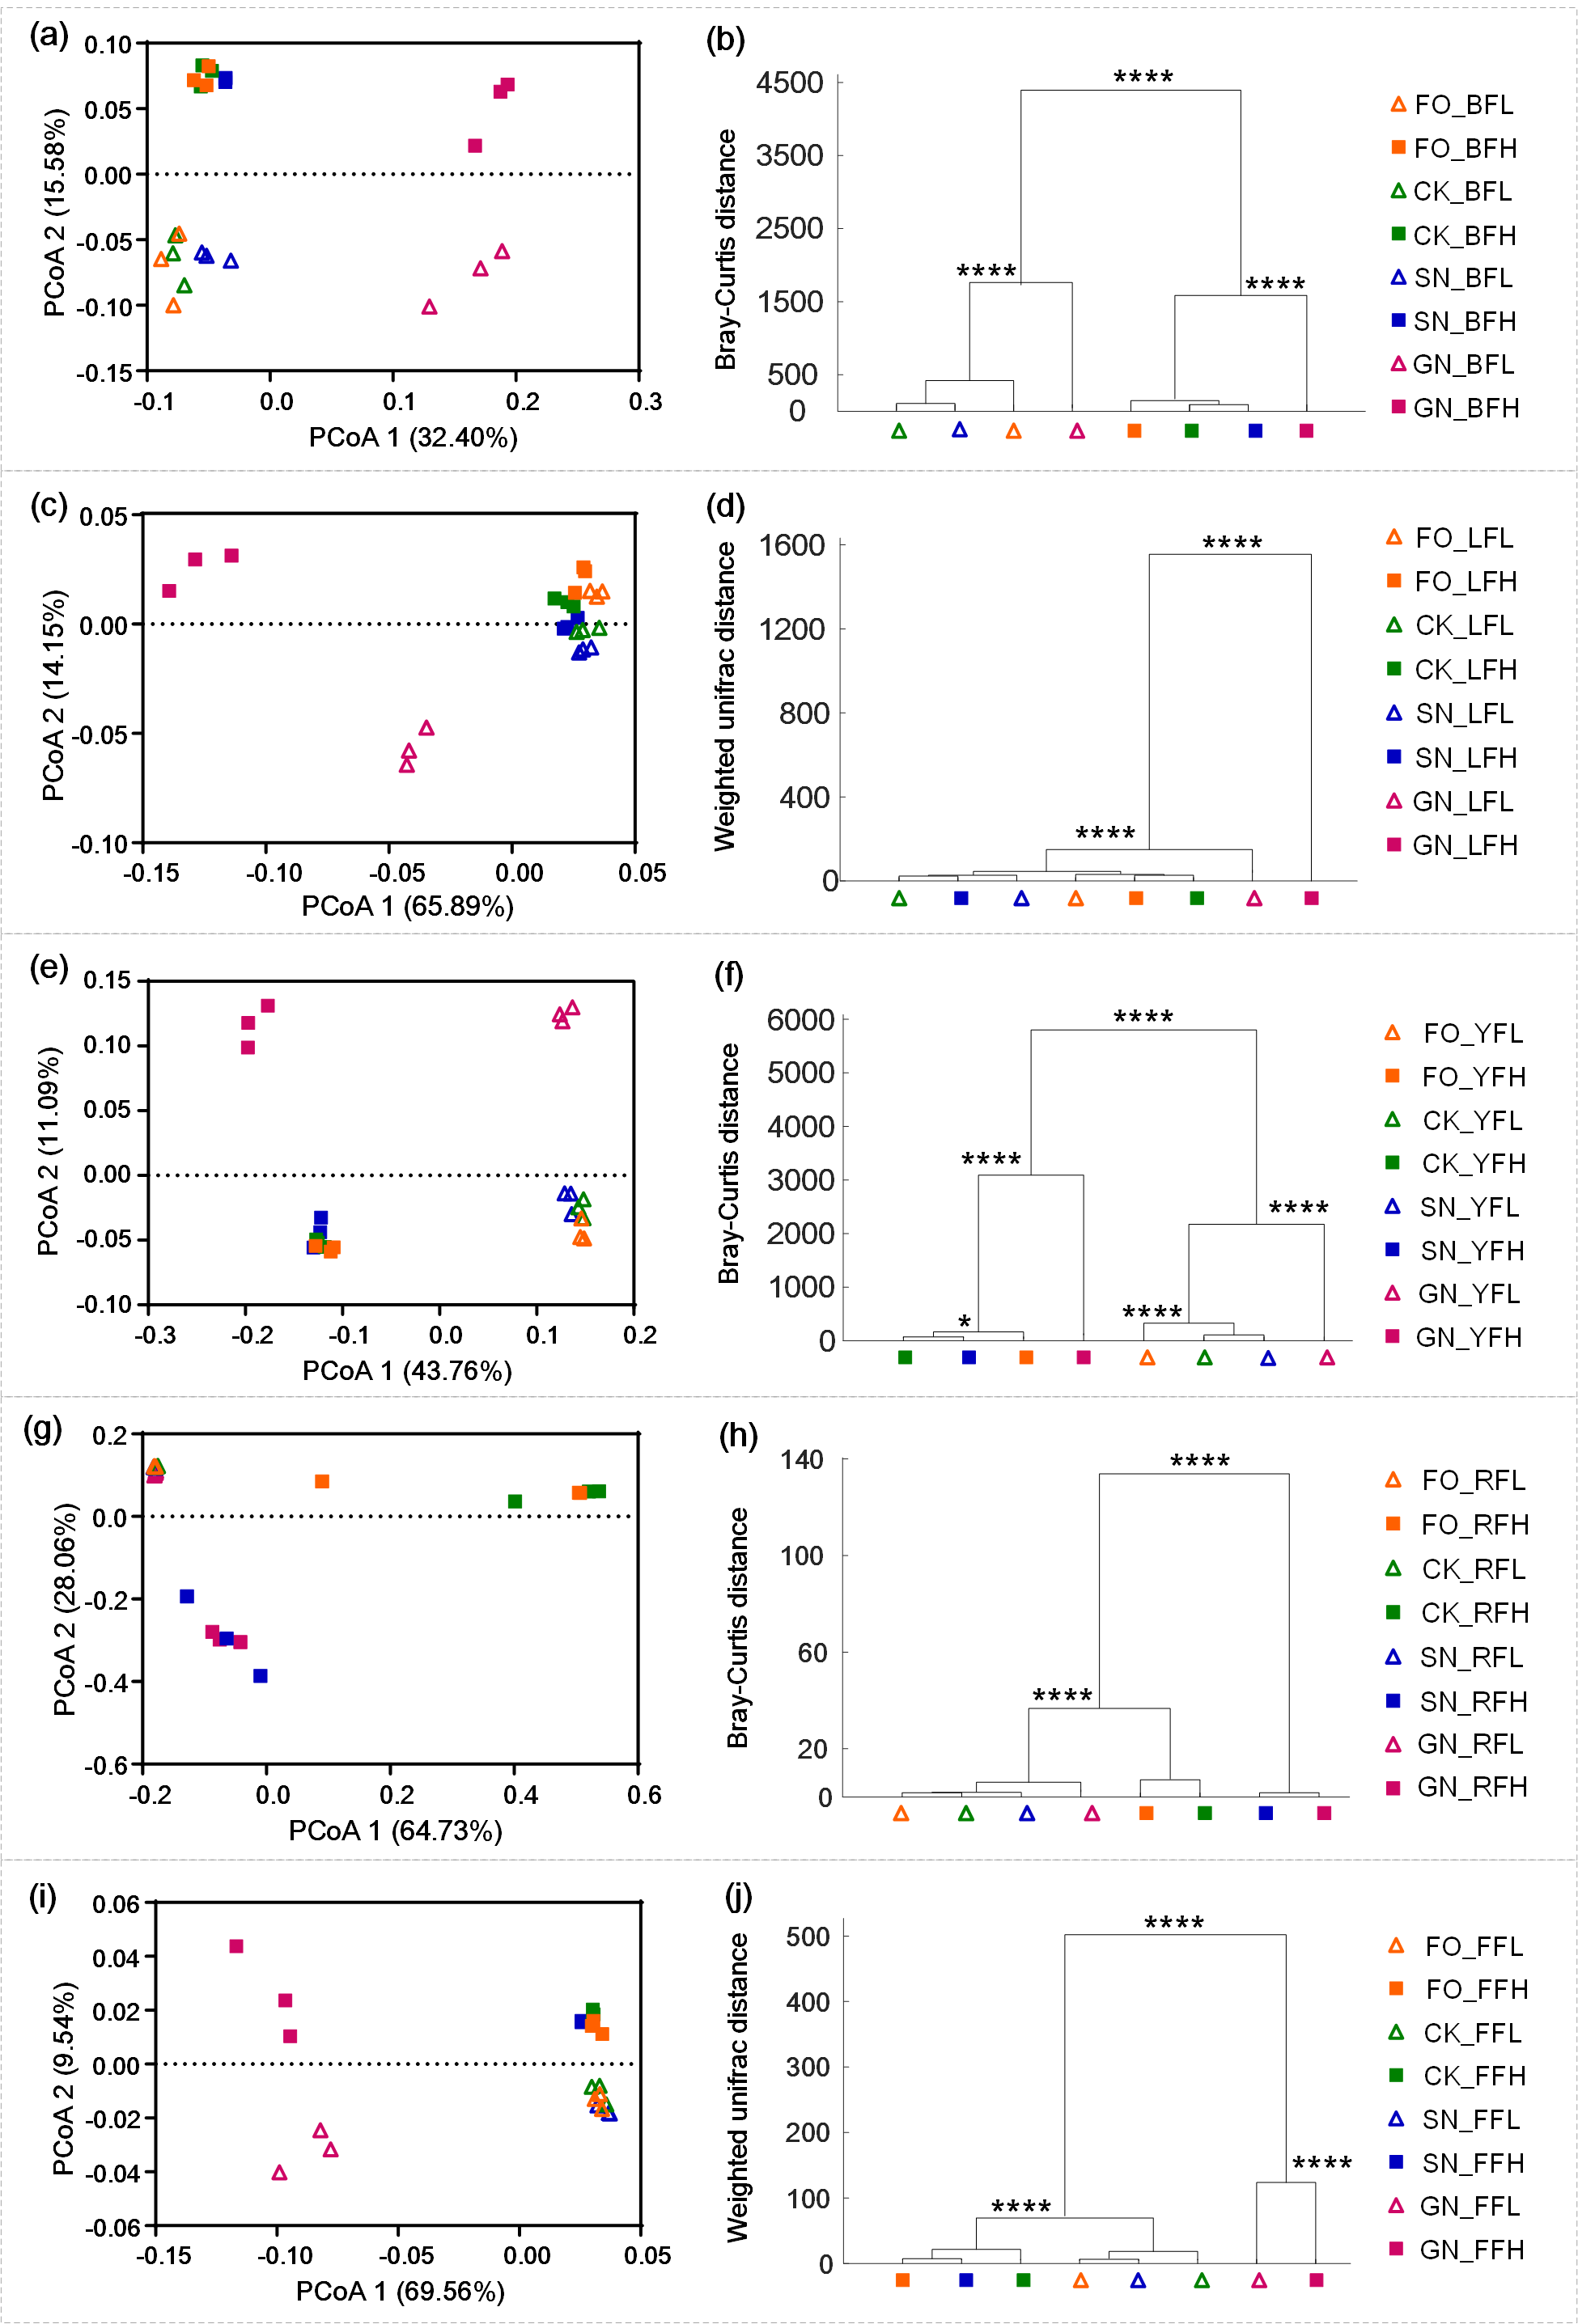
Fig. S2 Comparison of microbial community structure in soils with different treatments. PCoA analysis and statistical significance of microbial community clustering (MANOVA test, ****p < 0.0001) across five soils: black soil (a, b; Bray-Curtis distance), lime concretion black soil (c, d; Weighted unifrac distance), yellow-cinnamon soil (e, f; Bray-Curtis distance), red soil (g, h; Bray-Curtis distance), and fluvo-aquic soil (i, j; Weighted unifrac distance).
Table S2 Community composition of dominant bacterial taxa at the phylum and genus levels in five farmland soils.
 | Dominant species of the bacterial community at the phylum level | Dominant species of the bacterial community at the genus level
Black soil | Acidobacteria, Actinobacteria, Bacteroidetes, Chloroflexi, Firmicutes, Gemmatimonadetes, Nitrospirae, Planctomycetes, Proteobacteria | Ammoniphilus, Arthrobacter, Bacillus, Blastococcus, Ensifer, Gaiella, Geminicoccus, Gemmatimonas, Gp16, Gp6, Ilumatobacter, Nitrospira, Nocardioides, Rubrobacter, Solirubrobacter
Lime concretion black soil | Acidobacteria, Actinobacteria, Bacteroidetes, Chloroflexi, Firmicutes, Gemmatimonadetes, Planctomycetes, Proteobacteria, Candidate division WPS-1 | Ammoniphilus, Arthrobacter, Bacillus, Blastococcus, Ensifer, Gaiella, Geminicoccus, Gemmatimonas, Gp16, Gp6, Ilumatobacter, Lysobacter, WPS-1_genera_incertae_sedis, Nocardioides, Pseudomonas, Rubrobacter, Solirubrobacter, Streptomyces
Yellow-cinnamon soil | Acidobacteria, Actinobacteria, Chloroflexi, Firmicutes, Gemmatimonadetes, Planctomycetes, Proteobacteria | Ammoniphilus, Arthrobacter, Blastococcus, Gemmatimonas, Gaiella, Gp16, Gp6, Ilumatobacter, Nocardioides, Rhodanobacter, Solirubrobacter, Streptomyces
Red soil | Acidobacteria, Actinobacteria, Bacteroidetes, Candidatus Saccharibacteria, Cyanobacteria/Chloroplast, Firmicutes, Gemmatimonadetes, Proteobacteria, Candidate division WPS-1 | Alicyclobacillus, Ammoniphilus, Arthrobacter, Bradyrhizobium, Brevundimonas, Burkholderia, Candidatus Koribacter, Gaiella, Gemmatimonas, Gp1, Gp3, Gp7, Granulicella, Massilia, Pseudomonas, Rhizobium, Shinella, Sphingomonas, Saccharibacteria_genera_incertae_sedis, WPS-1_genera_incertae_sedis
Fluvo-aquic soil | Acidobacteria, Actinobacteria, Bacteroidetes, Chloroflexi, Firmicutes, Gemmatimonadetes, Nitrospirae, Planctomycetes, Proteobacteria | Ammoniphilus, Arthrobacter, Bacillus, Blastococcus, Castellaniella, Ensifer, Gaiella, Geminicoccus, Gemmatimonas, Gp16, Gp6, Ilumatobacter, Nitrospira, Nocardioides, Streptomyces

Taxonomic composition of the shared microbiome across five farmland soils
At the phylum level, Proteobacteria and Actinobacteria dominated the shared microbial communities across the five soils under both low and high fertilization levels in all four treatments (Fig. 4a-h). In the SN and GN treatments, some shared OTUs under high fertilization were affiliated with Acidobacteria. Additionally, in the GN treatment, Firmicutes were consistently present among the shared OTUs under both fertilization levels.

At the genus level, a large proportion of the shared OTUs remained unclassified. Nevertheless, Pseudomonas and Arthrobacter were consistently detected across all four treatments and both fertilization levels (Fig. 4a-h). Under high fertilization, shared OTUs affiliated with Gaiella, Blastococcus, and GP16 were identified across all treatments. In the GN treatment, Ammoniphilus was detected among shared OTUs under both low and high fertilization, whereas Bacillus was detected only under high fertilization (Fig. 4g, h).

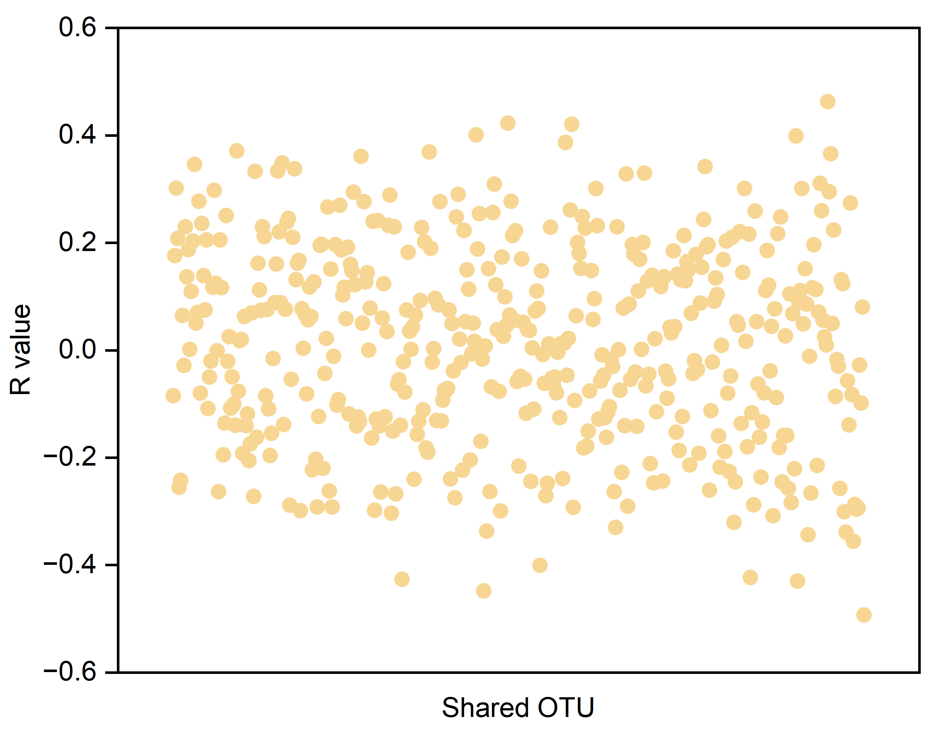
Fig. S3 Distribution of Spearman correlation coefficients between the relative abundance of each of the 457 shared OTUs across the five soils and the N₂O/(N₂O+N₂) ratio. Each point represents the Spearman correlation coefficient (R) for a single shared OTU. P values were corrected for multiple comparisons using the false discovery rate (FDR) method. No shared OTUs showed significant correlations with N₂O/(N₂O+N₂) after FDR correction (adjusted p > 0.89 for all OTUs). Due to the large number of taxa, individual OTU names are not displayed on the x-axis and are collectively denoted as “Shared OTUs”. The 457 shared OTUs were defined as the union of OTUs detected in any of the five soils under either low- or high-fertilization histories, across all incubation treatments (FO, CK, SN, and GN).

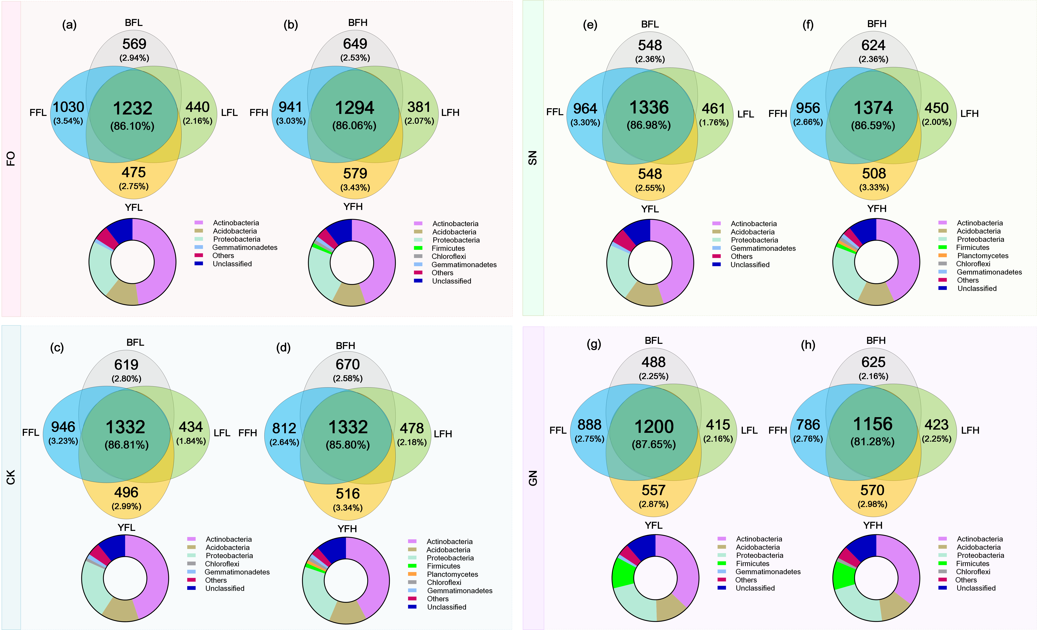

Fig. S4 Shared and unique OTUs in four farmland soils under different fertilization histories and treatments.

Venn diagrams illustrating the counts and relative abundances of shared OTUs (common to all four soils) and unique OTUs (specific to each soil), along with the taxonomic classification of dominant taxa among the shared OTUs. (a, b) FO treatment; (c, d) CK treatment; (e, f) SN treatment; (g, h) GN treatment. Within each pair of panels, the left panel (a, c, e, g) represents soils with low fertilization history, and the right panel (b, d, f, h) represents soils with high fertilization history.

Venn diagram analysis of shared and unique OTUs in four farmland soils
Venn diagrams were constructed to evaluate the distribution of shared and unique operational taxonomic units (OTUs) among four farmland soil types (black soil, lime concretion black soil, yellow-cinnamon soil, and fluvo-aquic soil) under four treatments (FO, CK, SN, GN) with low- and high-fertilization histories (Fig. S4). Under low fertilization history, the number and average relative abundance of shared OTUs across the four soils was 1232 (86.10%), 1332 (86.81%), 1336 (86.98%), and 1200 (87.65%) for the FO, CK, SN, and GN treatments, respectively. Under high fertilization history, the corresponding values were 1294 (86.06%), 1332 (85.80%), 1374 (86.59%), and 1156 (81.28%), respectively. Unique OTUs accounted for only 1.76–3.54% of the total relative abundance across all soils and treatments. The shared OTUs, which constituted the core microbiome, were dominated by Actinobacteria, Acidobacteria, Proteobacteria, and Gemmatimonadetes under low fertilization. In contrast, under high fertilization, the dominant phyla of shared OTUs were Actinobacteria, Acidobacteria, Proteobacteria, Chloroflexi, and Firmicutes. Notably, the GN treatment consistently showed a higher proportion of Firmicutes among the shared OTUs than the other three treatments, and this difference was observed under both low- and high-fertilization histories (Fig. S4).
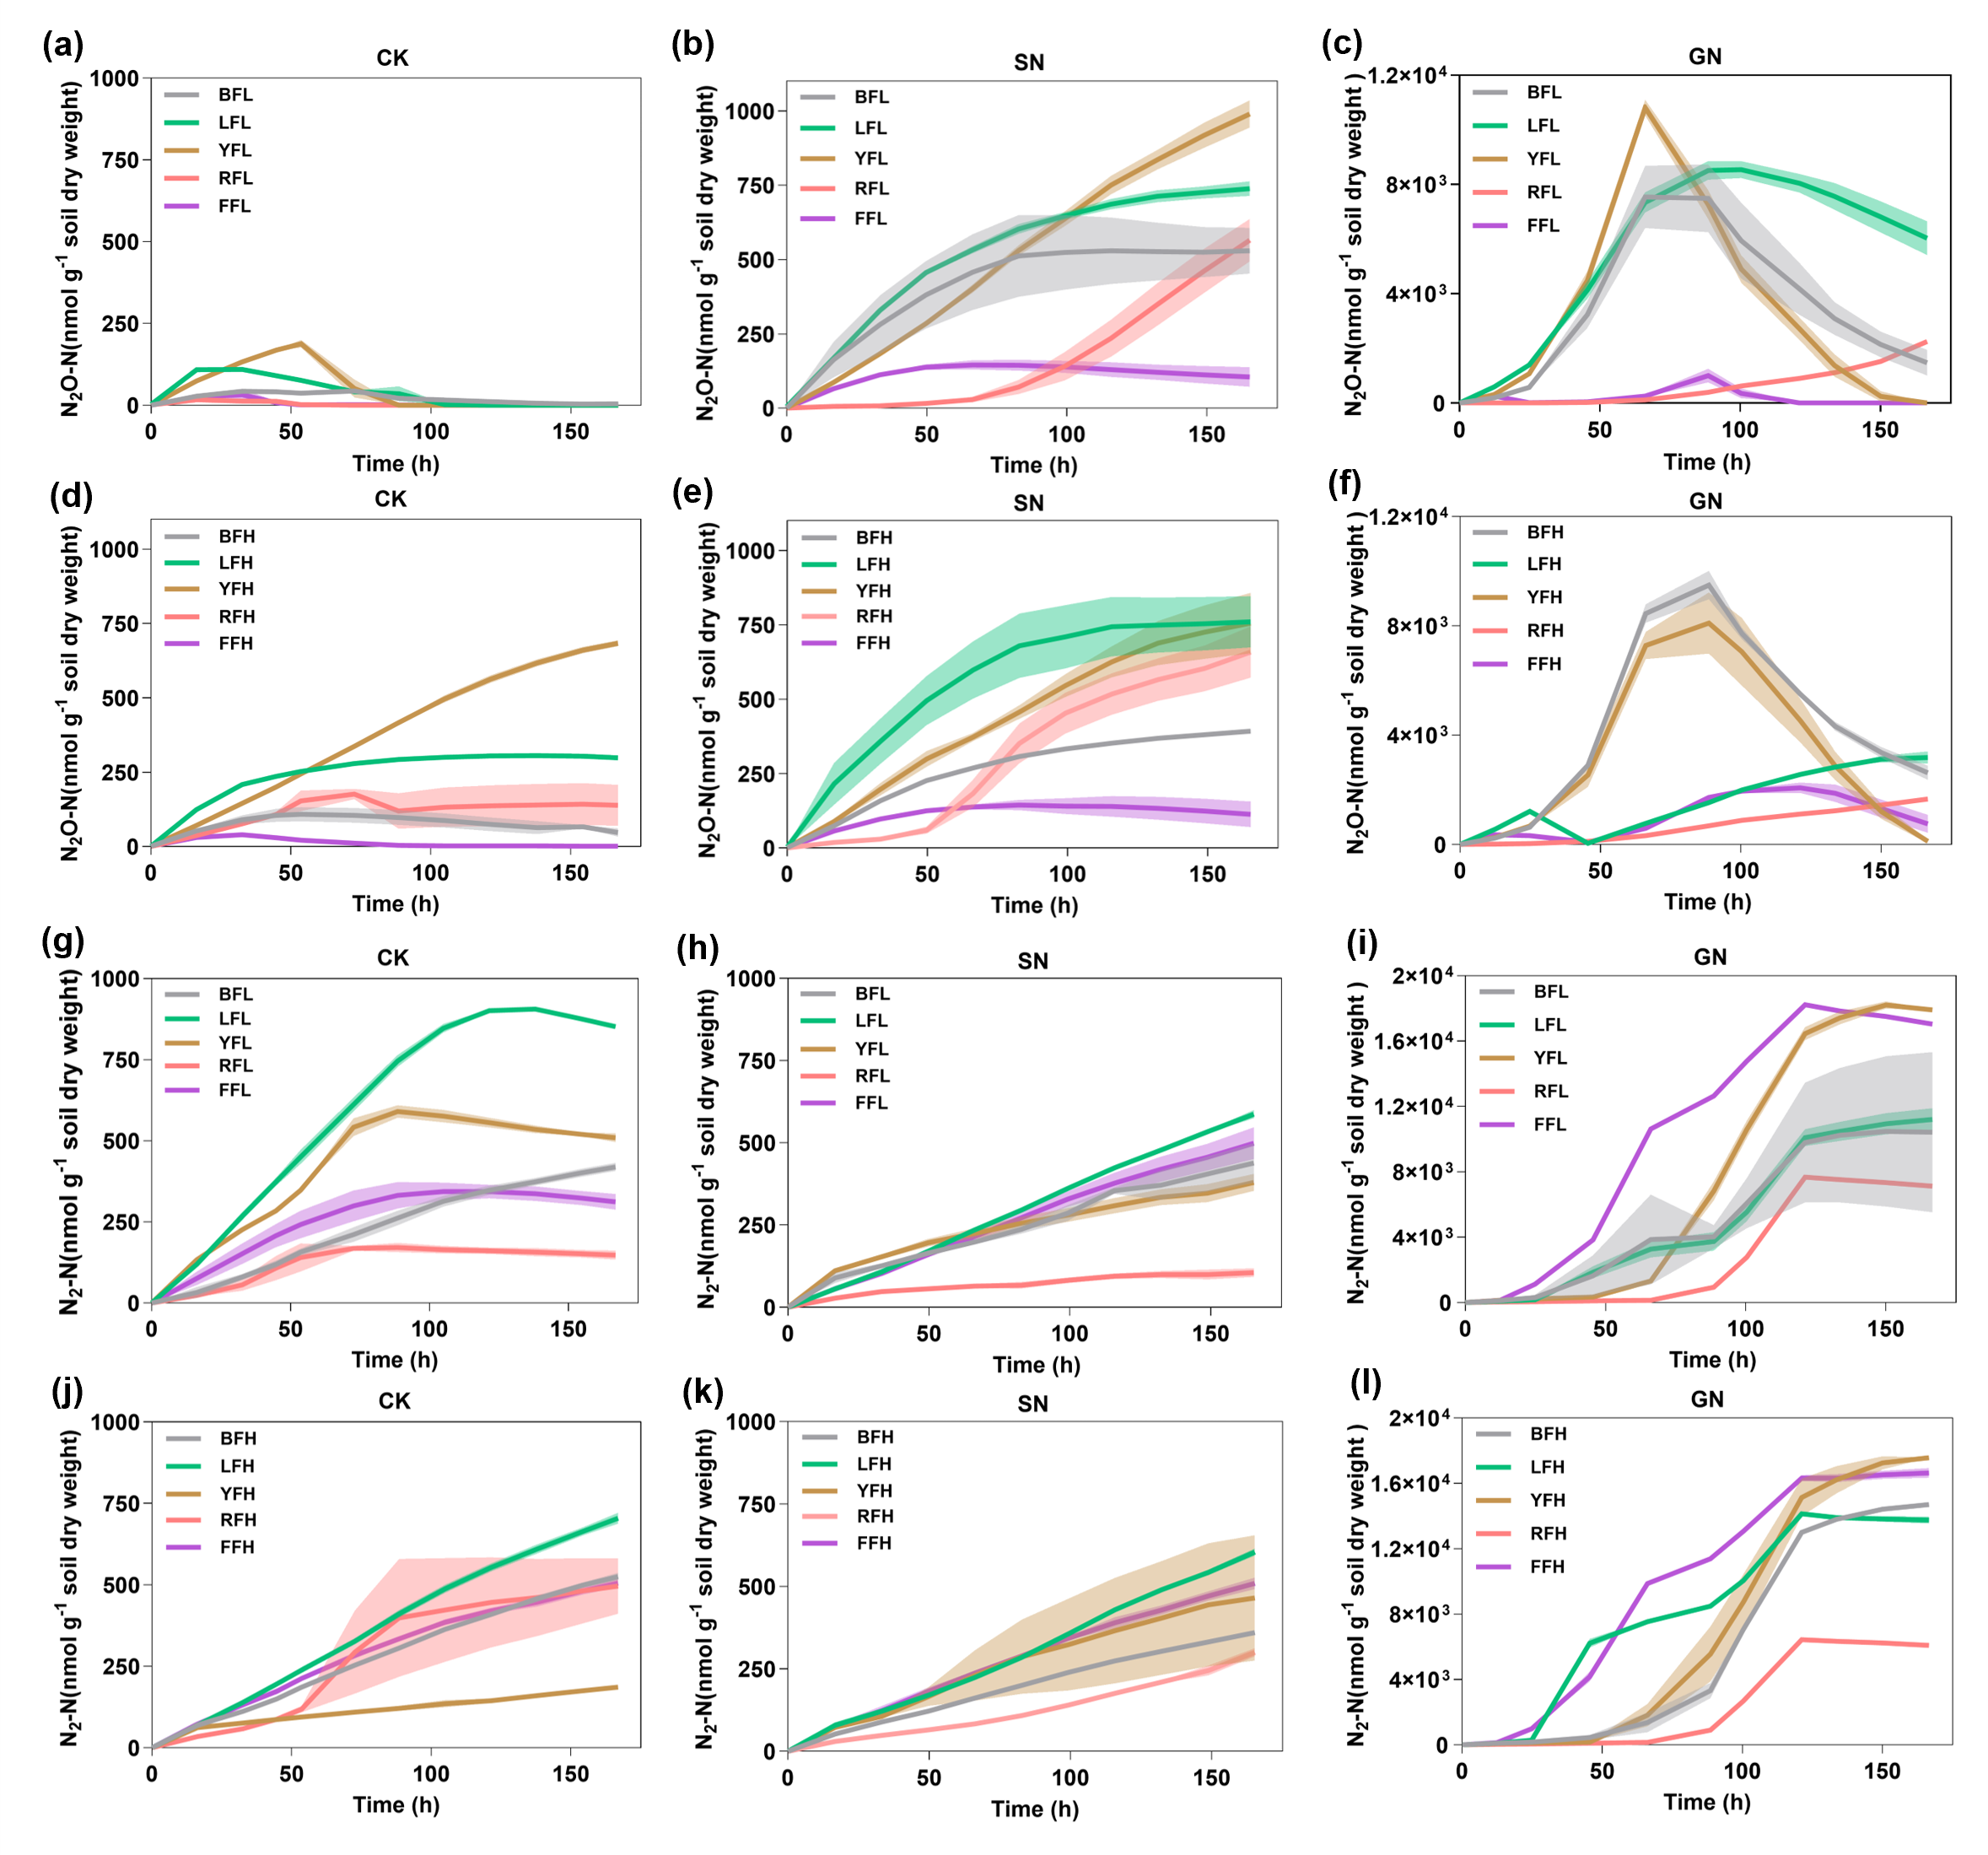
Fig. S5 Effects of different carbon and nitrogen additions on N₂O and N₂ fluxes in five farmland soils. (a-c) N₂O fluxes and (g-i) N₂ fluxes in five soils with low fertilization history under different treatments; (d-f) N₂O fluxes and (j-l) N₂ fluxes in five soils with high fertilization history under different treatments. Shading indicates standard deviation from the mean.

