Supplementary Materials:
Table S1 Correlation between soil nitrous oxide (N₂O) emission rate from different yak excreta treatments (UA, urine application; DE, dung application; UDE, combined urine and dung application) and nitrifying and denitrifying enzyme activities (NEA and DEA).
Enzyme activities | UA |  | DA |  | UDA
Enzyme activities | r | P | r | P | r | P
NEA | 0.81 | 0.001 | -0.32 | 0.16 | 0.93 | < 0.001
DEA | -0.03 | 0.91 | 0.79 | 0.002 | 0.78 | 0.002

Table S2 Effects of yak excreta application on the soil N-cycling functional gene (AOA amoA, AOB amoA, nirS, nirK, nir, nosZ and nir/nos), NEA and DEA across the experimental period.
Soil parameters | Different periods | Treatments
Soil parameters | Different periods | CK | UA | DA | UDA
AOA amoA  (×10⁶ copies g⁻¹) | Early | 2.42±0.28a | 2.09±0.15a | 1.79±0.42a | 1.94±0.45a
AOA amoA  (×10⁶ copies g⁻¹) | Late | 4.49±1.25a | 1.73±0.13b | 1.35±0.30b | 1.92±0.35b
AOA amoA  (×10⁶ copies g⁻¹) | Whole | 3.66±0.78a | 1.88±0.11b | 1.53±0.24b | 1.93±0.27b
AOB amoA | Early | 0.95±0.07b | 9.89±2.10a | 2.36±0.45b | 11.27±3.40a
(×10⁵ copies g⁻¹) | Late | 1.94±0.36b | 29.32±3.60a | 4.05±0.77b | 23.31±2.96a
 | Whole | 1.55±0.24b | 21.55±3.15a | 3.38±0.52b | 18.49±2.56a
nirS | Early | 3.69±0.16a | 3.05±0.24a | 2.91±0.30b | 3.90±0.18a
(×10⁶ copies g⁻¹) | Late | 3.73±0.22b | 3.93±0.19b | 5.56±0.31ab | 7.31±1.27a
 | Whole | 3.72±0.15b | 3.58±0.17b | 4.50±0.37b | 5.95±0.84a
nirK | Early | 3.75±1.05a | 4.52±1.31a | 4.13±1.11a | 5.19±1.47a
(×10⁶ copies g⁻¹) | Late | 12.15±0.79b | 22.73±4.06ab | 23.04±3.26a | 32.05±5.44a
 | Whole | 8.79±1.13b | 15.45±3.19a | 15.48±2.90a | 21.30±4.44a
nir | Early | 7.44±1.02a | 7.57±1.52a | 7.05±1.34a | 9.09±1.37a
(×10⁶ copies g⁻¹) | Late | 15.88±0.63c | 26.66±4.19bc | 28.60±3.29ab | 39.36±6.22a
 | Whole | 12.50±1.09b | 19.03±3.32a | 19.98±3.15a | 27.25±5.03a
nosZ | Early | 4.45±0.23a | 4.85±0.48a | 2.83±0.14b | 5.55±0.62a
(×10⁶ copies g⁻¹) | Late | 5.00±0.37b | 7.42±0.32a | 4.52±0.25b | 8.60±1.59a
 | Whole | 4.78±0.25b | 6.39±0.39a | 3.84±0.25b | 7.38±1.02a
nir/nos | Early | 1.68±0.23a | 1.64±0.39a | 2.49±0.45a | 1.90±0.41a
(×10⁶ copies g⁻¹) | Late | 3.48±0.41b | 3.57±0.49b | 6.51±0.86a | 5.24±1.02ab
 | Whole | 2.76±0.33b | 2.80±0.39b | 4.90±0.70a | 3.90±0.73ab
NEA | Early | 5.55±1.19b | 12.18±2.83a | 5.24±0.35b | 11.75±0.57a
(mg kg⁻¹ h⁻¹) | Late | 4.45±0.22b | 5.68±0.47a | 4.78±0.30b | 5.47±0.36a
 | Whole | 4.81±0.42b | 7.85±1.29a | 4.93±0.23b | 7.56±0.94a
DEA | Early | 0.81±0.05b | 0.88±0.01a | 0.84±0.05b | 0.86±0.02b
(mg kg⁻¹ h⁻¹) | Late | 0.82±0.01b | 0.84±0.07b | 1.71±0.07a | 1.80±0.07a
 | Whole | 0.82±0.02b | 0.85±0.04b | 1.43±0.13a | 1.49±0.14a
Cumulative | Early | 86.82±9.36b | 100.21±11.70a | 101.56±6.79a | 114.55±4.75a
CO₂ emissions | Late | 33.61±3.93ab | 29.60±3.69b | 27.69±3.25b | 45.50±4.72a
(kg C ha⁻¹) | Whole | 120.43±9.55b | 129.81±9.29b | 129.25±6.31b | 160.05±4.37a

Table S3 Effects of yak excreta application on soil pH, DOC, NH₄⁺-N and NO₃⁻-N concentrations across the experimental period.
Soil parameters | Different periods | Treatments
Soil parameters | Different periods | CK | UA | DA | UDA
pH | Early | 5.68±0.02b | 6.09±0.12a | 5.76±0.03b | 6.20±0.08a
pH | Late | 5.65±0.05a | 5.35±0.08b | 5.54±0.06ab | 5.42±0.08b
pH | Whole | 5.66±0.03a | 5.65±0.11a | 5.63±0.05a | 5.73±0.10a
DOC | Early | 57.36±5.62c | 107.14±12.10a | 88.81±4.85b | 100.19±9.20a
(mg kg⁻¹) | Late | 60.36±4.35b | 70.56±6.67b | 179.68±49.61ab | 138.84±25.86a
 | Whole | 59.16±3.37c | 85.19±7.34bc | 143.33±31.03a | 123.38±16.23ab
NH₄⁺-N | Early | 33.74±1.94b | 344.21±39.88a | 82.12±3.41b | 365.11±19.29a
(mg kg⁻¹) | Late | 22.48±5.02b | 44.84±10.26ab | 34.87±3.37b | 68.87±13.30a
 | Whole | 26.98±3.30b | 164.59±37.46a | 53.77±5.82b | 187.37±35.00a
NO₃⁻-N | Early | 11.50±0.72b | 21.93±2.92a | 11.13±1.62b | 27.56±4.05a
(mg kg⁻¹) | Late | 16.77±2.11b | 91.66±8.67a | 16.64±1.82b | 103.87±13.02a
 | Whole | 14.66±1.40b | 63.77±9.42a | 14.44±1.39b | 73.34±11.61a

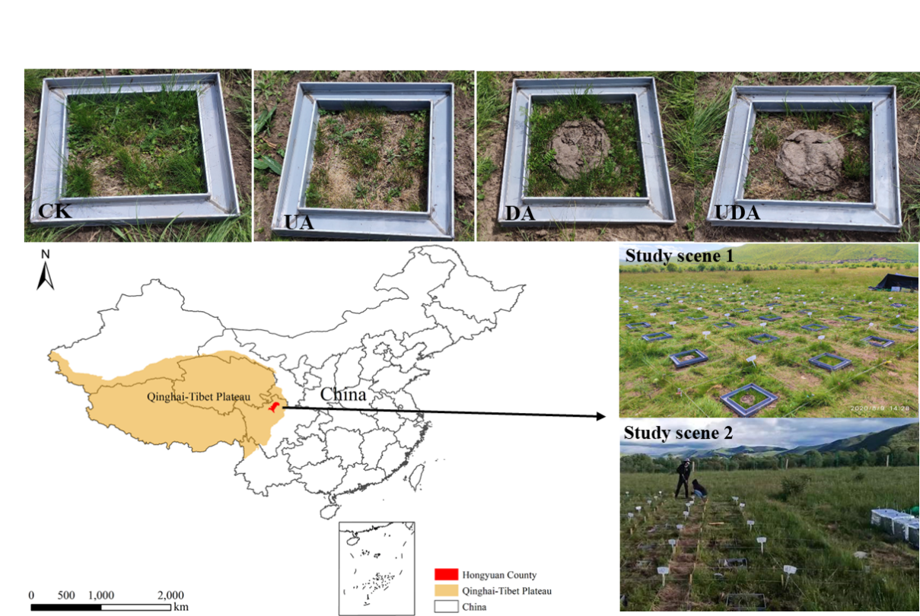
Fig. S1 Schematic of the study area and distribution of the sampling plots. Abbreviations: CK, without excretion application; UA, urine application; DA, dung application; UDA, combined urine and dung application.

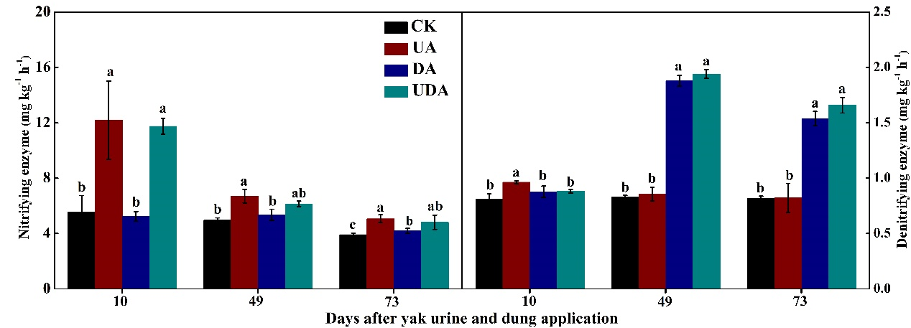
Fig. S2 The activities of nitrifying and denitrifying enzymes under different urine and dung excreta application treatments. CK, without excretion application; UA, urine application; DA, dung application; UDA, combined urine and dung application. The error bars represent the standard errors of the mean ( n = 4 ). The lowercase letters indicate significant differences among treatments at the same sampling time.

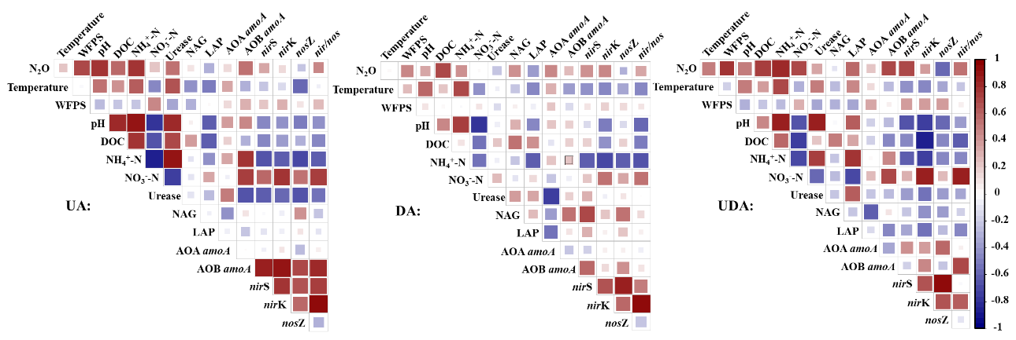
Fig. S3 Pearson correlation analysis between soil physicochemical properties, functional gene abundances, and soil N₂O emissions under different yak excreta application treatments. The red boxes represent positive correlations and blue boxes represent negative correlations. The extent of colors indicates the strength of the correlation. UA, urine application; DA, dung application; UDA, combined urine and dung application. Abbreviations: N₂O, soil N₂O emissions; WFPS, water-filled pore space; DOC, dissolved organic carbon; NH₄⁺-N, ammonium nitrogen; NO₃⁻-N, nitrate nitrogen; NAG, β-N-acetylglucosaminidase activities; LAP, leucine aminopeptidase activities; nosZ, nosZ gene abundance; nir/nos, the ratio of nirS and nosZ gene abundance.

