Supporting Information for

Bacterial rather than fungal denitrification as a key driver for increased denitrification rate under warming in paddy soil

Lixin Jia^{1,2}, Yong Li^{3*}, Roland Bol^{4,5}, Di Wu^{2*}

¹ College of Resources and Environmental Sciences, China Agricultural University, Beijing 100193, China
² CAS Key Laboratory of Forest Ecology and Silviculture, Key Laboratory of Stable Isotope Techniques and Applications, Institute of Applied Ecology, Chinese Academy of Sciences, Shenyang 110016, China.
³ Zhejiang Provincial Key Laboratory of Agricultural Resources and Environment, State Key Laboratory of Soil Pollution Control and Safety, College of Environmental and Resource Sciences, Zhejiang University, Hangzhou 310058, China
⁴ Institute of Bio- and Geosciences, Agrosphere (IBG-3), Forschungszentrum Jülich GmbH, 52425 Jülich, Germany
⁵ Environment Centre Wales, Bangor University, Gwynedd, LL57 2UW, UK

*Corresponding authors:
Di Wu, professor
E-mail: wudi@iae.ac.cn
Yong Li, Professor
E-mail: liyongcn@zju.edu.cn

Supplementary Figures and Tables
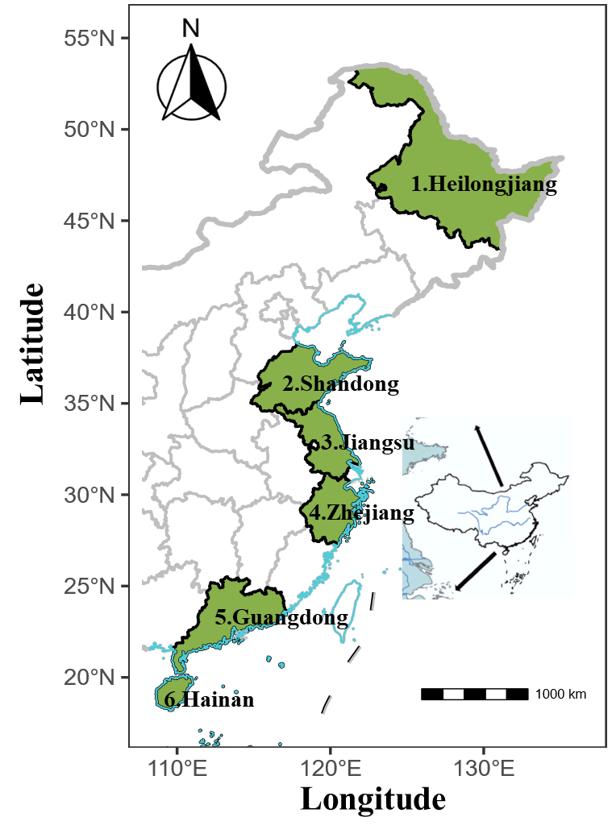
Fig. S1. Study site map
Fig. S2. Effects of warming on soil properties at different sampling sites. Three replicates of one soil sample were used for warming incubations. (aT) represents the local average annual temperature, and (eT) represents the elevated temperature (4 ℃ above the average annual temperature). Sample locations: Heilongjiang (Hj), Shandong (Sd), Jiangsu (Js), Zhejiang (Zj), Guangdong (Gd), and Hainan (Hn). The level of significance is determined by a two-sided t-test; *p < 0.05, **p < 0.01 and ***p < 0.001.

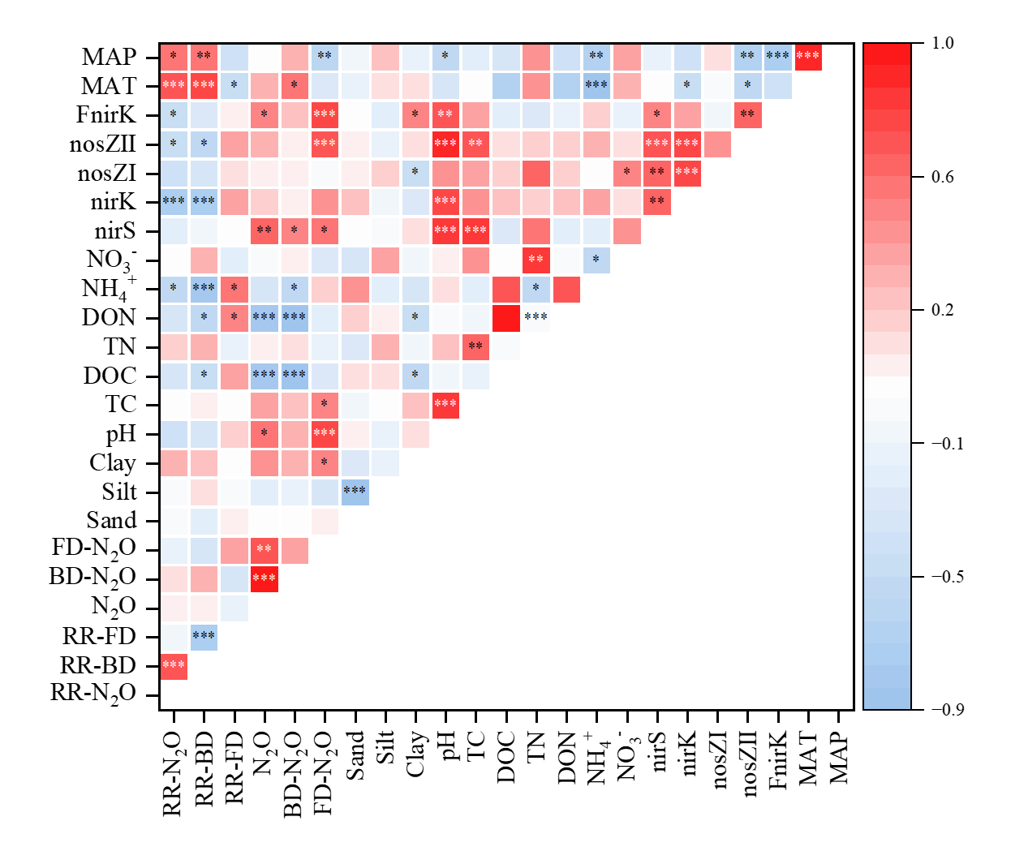Fig. S3. Heatmap showing Pearson correlation coefficients between warming response ratios of denitrification-derived N₂O production, bacterial/fungal denitrification rates, and key soil abiotic and biotic factors across 18 paddy soils. Color intensity and circle size are proportional to the correlation coefficients (red = positive, blue = negative). Significance levels are indicated as *p < 0.05, **p < 0.01 and ***p < 0.001.

Table S1. Detailed information on soil sampling sites and soil texture

Sampling  Site | Site abbreviations | Mean-  annual precipitation (mm) | Mean-annual temperature  (℃) | Coordinates | Sand | Silt | Clay
Heilongjiang | HJ | 554 | 5 | 45°31′N,126°51′E | 89 | 11 | 0
Shandong | SD | 667 | 14 | 35°54′N,116°18′E | 84 | 12 | 4
Jiangsu | JS | 1200 | 16 | 32°48′N,118°37′E | 83 | 13 | 4
Zhejiang | ZJ | 1763 | 18 | 29°2′N,119°1′E | 82 | 17 | 1
Guangdong | GD | 2029 | 22 | 22°24′N,112°25′E | 86 | 14 | 0
Hainan | HN | 1913 | 25 | 19°53′N,110°37′E | 86 | 11 | 3

Table S2 Soil properties before incubation

Sampling site | Water content | pH | SOC | Field moisture capacity | NO₃⁻ | NH₄⁺ | TN | TC | AP
HJ | 0.33 | 5.33 | 0.012 | 0.65 | 24.17 | 3.28 | 0.12 | 1.62 | 34.75
SD | 0.34 | 7.28 | 0.010 | 0.76 | 38.24 | 12.48 | 0.16 | 3.68 | 32.97
JS | 0.36 | 5.18 | 0.012 | 0.65 | 15.20 | 2.95 | 0.09 | 1.15 | 32.29
ZJ | 0.34 | 4.39 | 0.014 | 0.66 | 71.80 | 10.29 | 0.16 | 1.84 | 37.74
GD | 0.32 | 5.50 | 0.014 | 0.64 | 75.17 | 7.94 | 0.16 | 1.66 | 35.24
HN | 0.23 | 4.25 | 0.011 | 0.60 | 31.86 | 4.56 | 0.14 | 1.60 | 31.72

Table S3. Incubation temperatures applied to each paddy soil during the 28-day pre-incubation
Province | Ambient temperature (AT, °C) | Elevated temperature (ET, °C)
Heilongjiang | 5 | 9
Shandong | 14 | 18
Jiangsu | 16 | 20
Zhejiang | 18 | 22
Guangdong | 22 | 26
Hainan | 25 | 29

Table S4. Primer sets and thermal profile for qPCR analysis
Gene | Primer | Sequence 5’-3’ | Thermal cycling conditions | Reference
nirS | nirS-cd3aF | GTSAACGTSAAGGARACSGG | 94 °C for 2 min - × 1 cycle; 94 °C for 30 s, 51 °C for 1 min, 72 °C for 1 min - × 35 cycles; 72 °C for 10min | [1]
nirS | nirS-R3cd | GASTTCGGRTGSGTCTTGA |  | [1]
nirK | nirK-FlaCu | ATCATGGTSCTGCCGCG | 94 °C for 3 min - × 1 cycle; 94 °C for 30 s, 57 °C for 1 min, 73 °C for 1 min - × 35 cycles; 75 °C for 10min | [2]
nirK | nirK-R3Cu-GCb | GCCTCGATCAGRTTGTGGTT |  | [2]
Fungal nirK | nirKfF | TACGGGCTCATGtaygtnsarcc | 95°C, 5 min- × 1 cycle; 95°C for 30 s, 61.5°C for 30 s, 72°C for 15 s- × 35 cycle; 72°C for 10 min- × 1 cycle; | [3]
Fungal nirK | nirKfR | AGGAATCCCACAscnccyttntc |  | [3]
nosZ Ⅰ | nosZⅠF | GGCAARCTVTCDCCVAC | 95 °C for 2 min - × 1 cycle; 95 °C for 45 s, 53 °C for 45 s, 72 °C for 1min - × 35 cycles; 72 °C for 7min | [4]
nosZ Ⅰ | nosZⅠR | AVCGGTCYTTVGAGAAYTT |  | [4]
nosZ Ⅱ | nosZ-Ⅱ-F | CTIGGICCIYTKCAYAC | 95 °C for 5 min - × 1 cycle; 95 °C for 30 s, 54 °C for 60 s, 72 °C for 1min - × 35 cycles；72 °C for 10min | [5]
nosZ Ⅱ | nosZ-Ⅱ-R | GCIGARCARAAITCBGTRC |  | [5]

Reference
[1] Throbäck IN, Enwall K, Jarvis Å, Hallin S. 2004. Reassessing PCR primers targeting nirS, nirK and nosZ genes for community surveys of denitrifying bacteria with DGGE. FEMS Microbiology Ecology 49:401–417. https://doi.org/10.1016/j.femsec.2004.04.011
[2] Hallin S, Lindgren P-E. 1999. PCR detection of genes encoding nitrite reductase in denitrifying bacteria. Applied and Environmental Microbiology 65:1652–1657.
[3] Wei W, Isobe K, Shiratori Y, Nishizawa T, Ohte N, et al. 2015. Development of PCR primers targeting fungal nirK to study fungal denitrification in the environment. Soil Biology and Biochemistry 81:282–286. https://doi.org/10.1016/j.soilbio.2014.11.026
[4] Zhang B, Penton CR, Yu Z, Xue C, Chen Q, et al. 2021. A new primer set for Clade I nosZ that recovers genes from a broader range of taxa. Biology and Fertility of Soils 57:523–531. https://doi.org/10.1007/s00374-021-01544-6
[5] Jones CM, Graf DR, Bru D, Philippot L, Hallin S. 2013. The unaccounted yet abundant nitrous oxide-reducing microbial community: a potential nitrous oxide sink. The ISME Journal 7:417–426. https://doi.org/10.1038/ismej.2012.125

