Supplementary Information

Evolving Global Oceanic Nitrogen Deposition under Future Emission Pathways and Responses to Nitrogen Emission Reductions

Jialin Deng¹, Yixin Guo², Ni Lu¹, Xingpei Ye¹, Yuanhong Zhao³, Jiayu Xu⁴, Lei Liu⁵, Lin Zhang^{1,*}
¹ Laboratory for Climate and Ocean-Atmosphere Studies, Department of Atmospheric and Oceanic Sciences, School of Physics, Peking University, Beijing 100871, People’s Republic of China
² Earth, Ocean and Atmospheric Sciences Thrust, Hong Kong University of Science and Technology, Guangzhou 511453, China
³ College of Oceanic and Atmospheric Sciences, Ocean University of China, Qingdao 266100, China
⁴ Laboratoire des Sciences du Climat et de l’Environnement (LSCE), CEA-CNRS-UVSQ, Université Paris-Saclay, Gif-sur-Yvette 91191, France
⁵ State Key Laboratory of Lake and Watershed Science for Water Security, Nanjing Institute of Geography and Limnology, Chinese Academy of Sciences, Nanjing 211135, China
Correspondence to: Lin Zhang (zhanglg@pku.edu.cn)

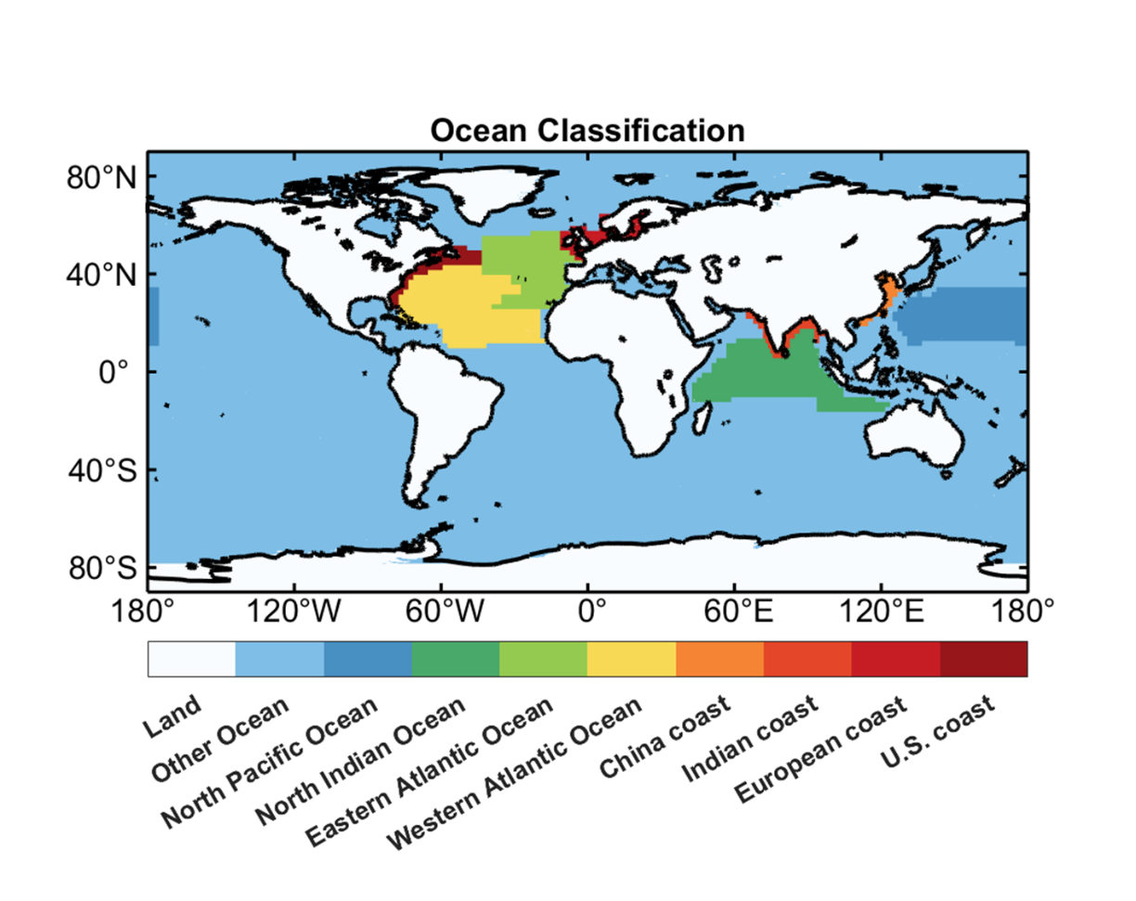
Fig. S1. The selected ocean regions in this study.

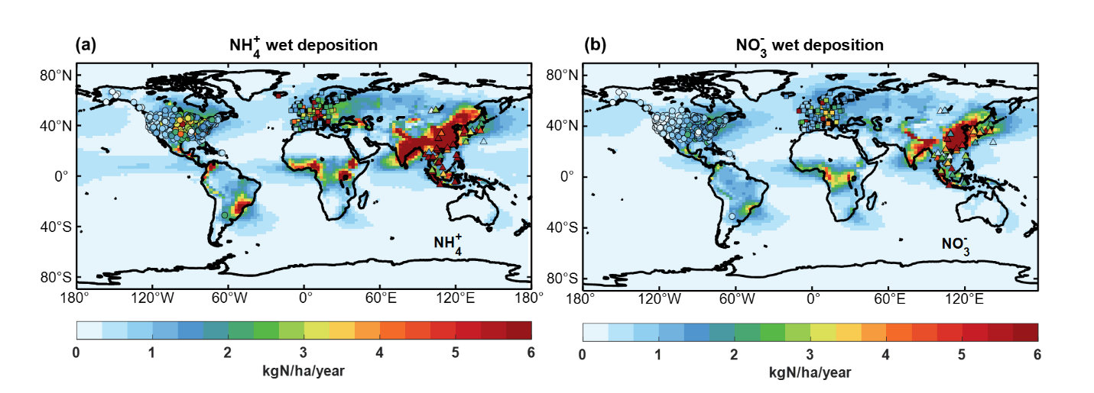
Fig. S2. Distribution of observation sites and spatial comparison. Circles represent US monitoring sites from NADP, squares represent European sites from EMEP, and triangles represent Asian sites from EANET. (a) Comparison of modeled and observed NH₄⁺ wet deposition. (b) Comparison of modeled and observed NO₃⁻ wet deposition.
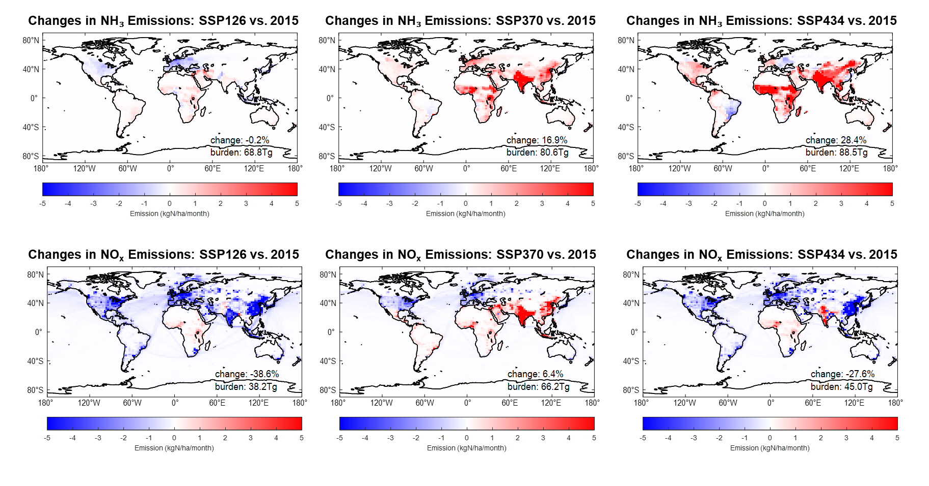
Fig. S3. Changes in global reactive nitrogen emissions under different future scenarios. The first row shows changes in NH₃ emissions, and the second row shows changes in NO_{x} emissions. From left to right, the results correspond to the three future scenarios SSP126, SSP370, and SSP434.

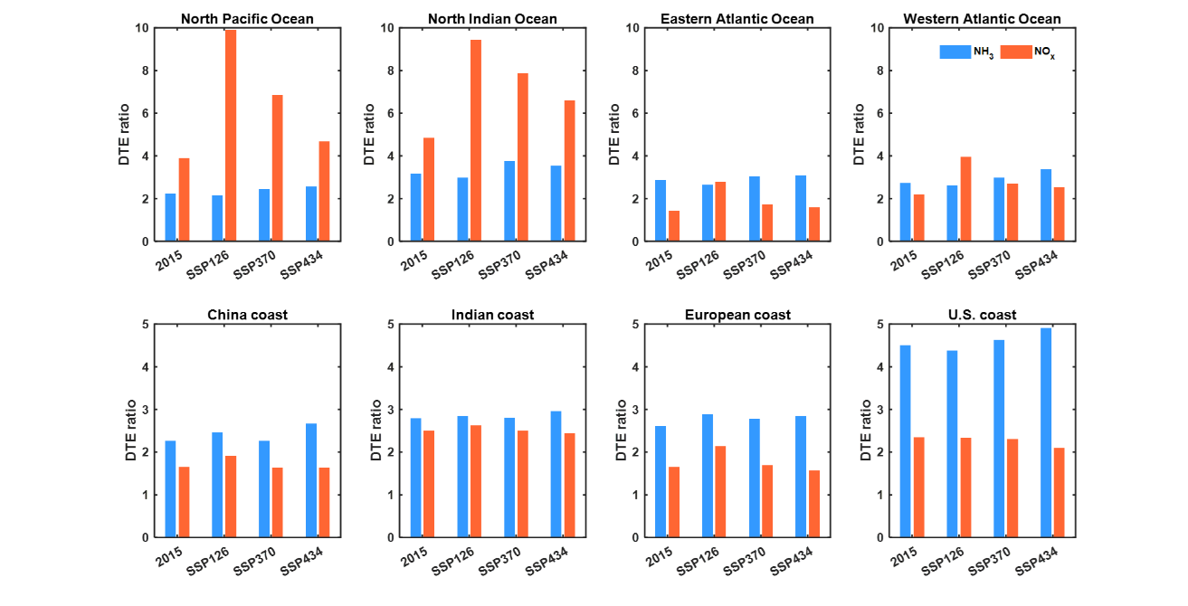
Fig. S4. The DTE (Deposition To Emission) ratios for NH₃ and NO_{x} in different ocean regions in 2015 and in 2050 under various future scenarios.

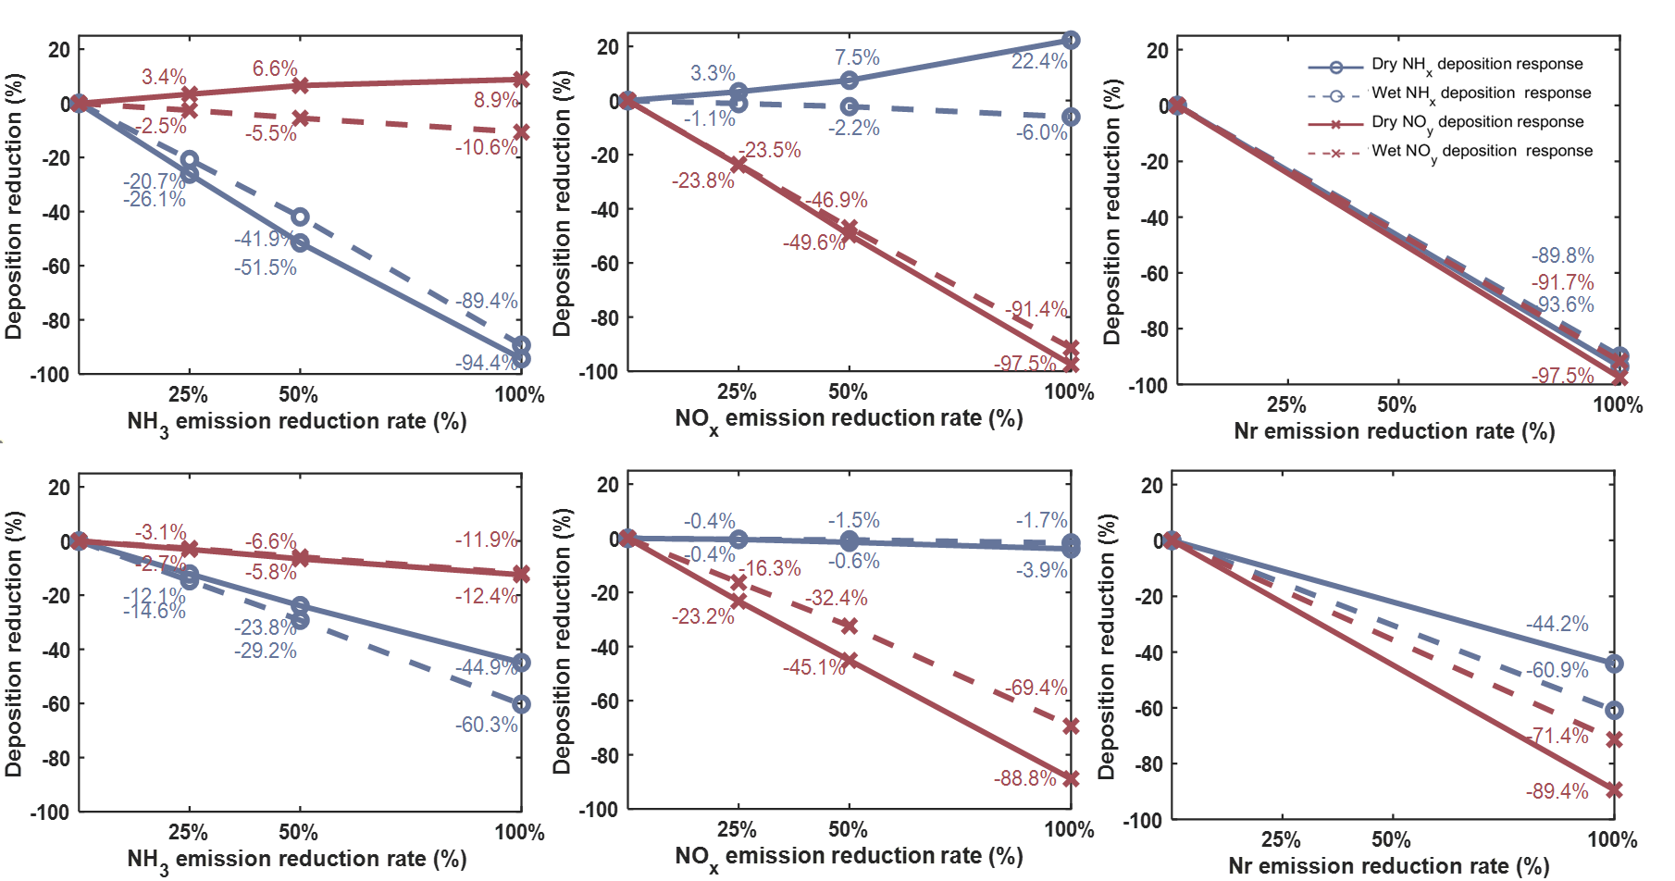
Fig. S5. Same as Figure 5, but for the China coast and the North Pacific Ocean.

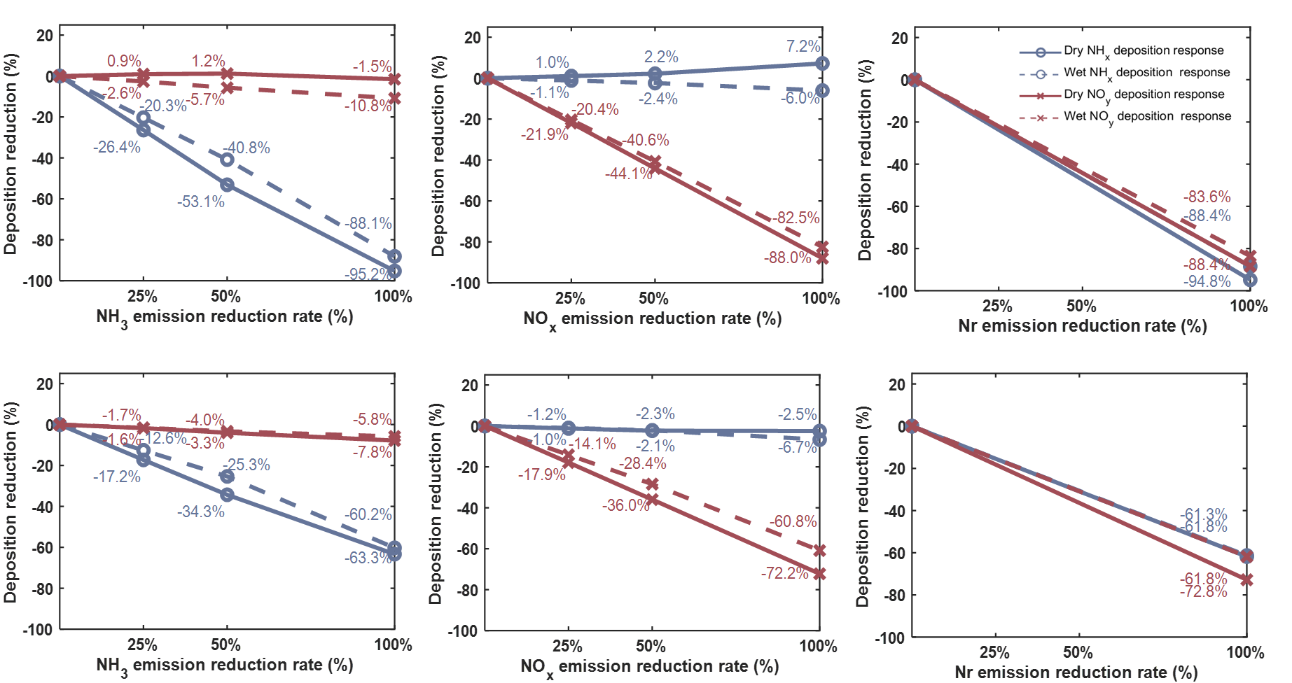
Fig. S6. Same as Figure 5, but for the Indian coast and the North Indian Ocean.

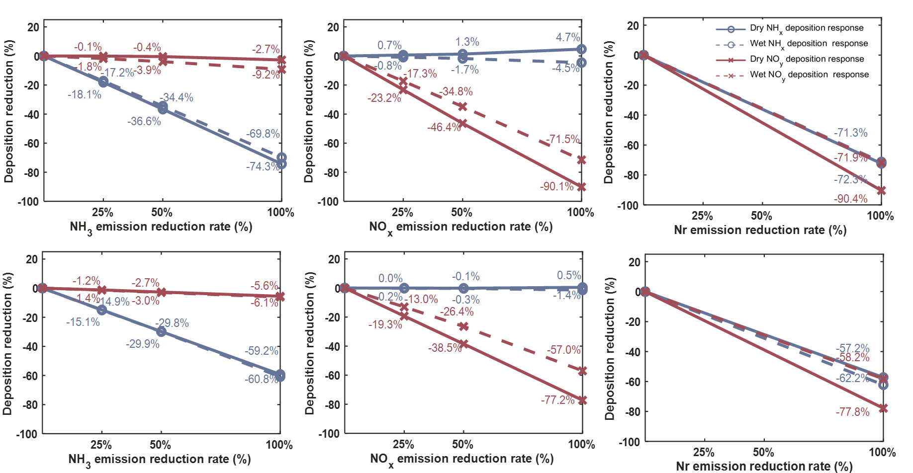
Fig. S7. Same as Figure 5, but for the US coast and Western Atlantic Ocean.

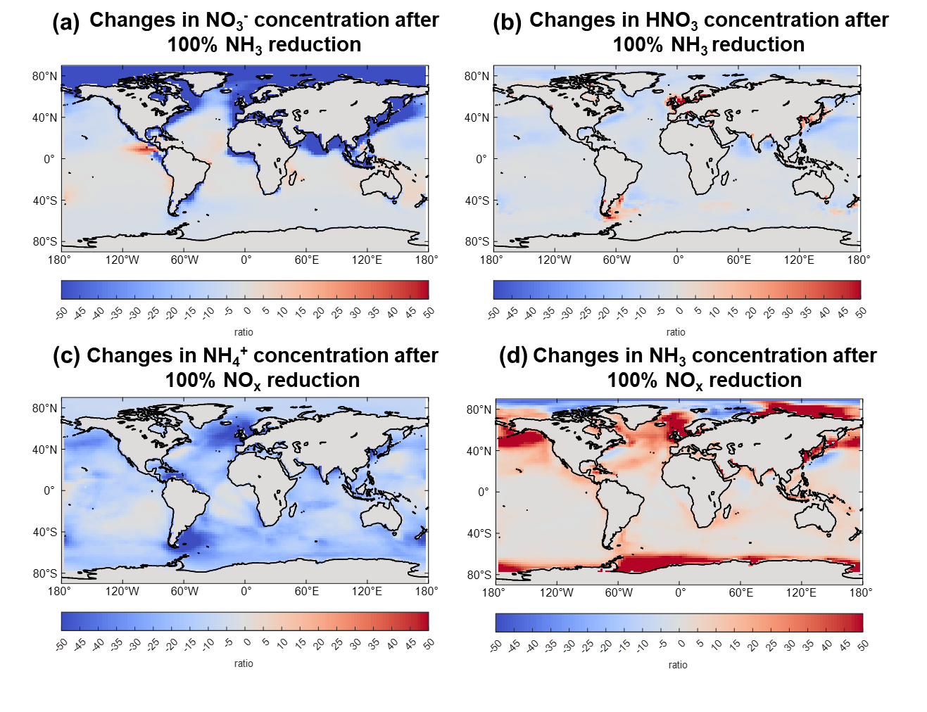
Fig. S8. Impact of a 100% reduction in NH₃ emissions (a, b) and NO_{x} emissions (c, d) under the SSP126 scenario in 2050 on the concentrations of NO₃⁻ (a), HNO₃ (b), NH₄⁺ (c), and NH₃ (d).

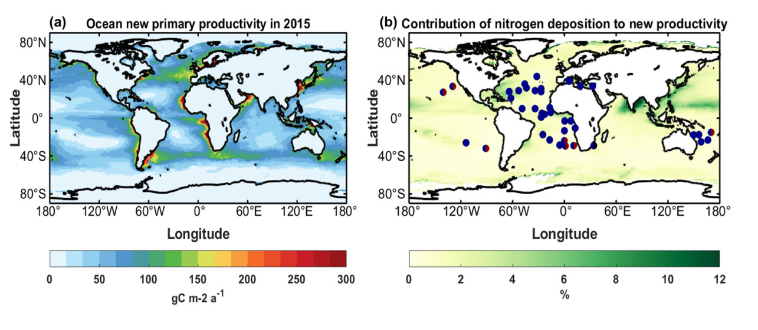
Fig. S9. Spatial distribution of marine new production (a) and the contribution of global oceanic nitrogen deposition to new productivity (b). The blue circles indicate nitrogen-limited oceanic regions, while the blue-red divided circles represent areas co-limited by nitrogen and iron, and the blue-black divided circles indicate regions co-limited by nitrogen and phosphorus (from Bindoff et al.^{[1]}).

References
[1] Bindoff NL, Cheung WWL, Kairo JG, Arístegui J, Guinder VA, et al. Changing OceChanging Ocean, Marine Ecosystems, and Dependent Communities. In IPCC Special Report on the Ocean and Cryosphere in a Changing Climate, eds. Pörtner HO, Roberts DC, Masson-Delmotte V, Zhai P, Tignor M, et al. Cambridge, United Kingdom: Cambridge University Press. pp. 447–587 https://doi.org/10.1017/9781009157964

