Increased soil N₂O emissions under natural gradient of atmospheric NH₃ deposition

Wuying Yi ^{a, b}, Guoping Liu ^{c}, Man Kang ª, Juan Wang ª, Hongzhao Yuan ª, Deli Chen ^{d}, Jinshui Wu ª, Jianlin Shen ^{a, *}
ª Changsha Research Station for Agricultural and Environmental Monitoring, Institute of Subtropical Agriculture, Chinese Academy of Sciences, Changsha 410125, China
^{b} Institute of Mountain Resources, Guizhou Academy of Sciences, Guiyang 550025, China
^{c} College of Animal Science, Yangtze University, Jingzhou 434025, China
^{d} School of Agriculture and Food, Faculty of Veterinary & Agricultural Sciences, The University of Melbourne, Melbourne, Victoria 3010, Australia

*Corresponding authors: Jianlin Shen
Telephone: +86-731-84619722; Fax: +86-731-84612685; E-mail: jlshen@isa.ac.cn;
Postal address: Institute of Subtropical Agriculture, Chinese Academy of Sciences, Yuanda Erlu Road No.644, Furong District, Changsha, 410125, China

Figure
Fig. S1 Soil temperature in N and NE transects of the pig farm.
Fig. S2 Soil moisture in N and NE transects of the pig farm.
Fig. S3 Relationship between soil N₂O flux and soil NH₄⁺-N from August 2018 to July 2019.
Fig. S4 Relationship between soil N₂O flux and soil NO₃⁻-N from August 2018 to July 2019.
Fig. S5 Relationship between soil N₂O flux and soil moisture from August 2018 to July 2019.
Fig. S6 Relationship between soil N₂O flux and soil temperature from August 2018 to July 2019.
Fig. S7 Relationship between N₂O flux and AOA amoA gene abundance.
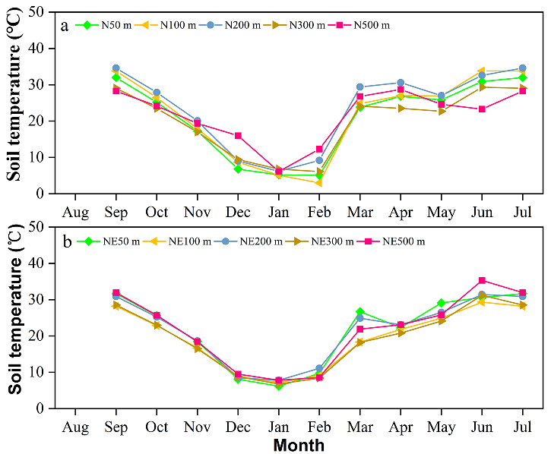
Fig. S1
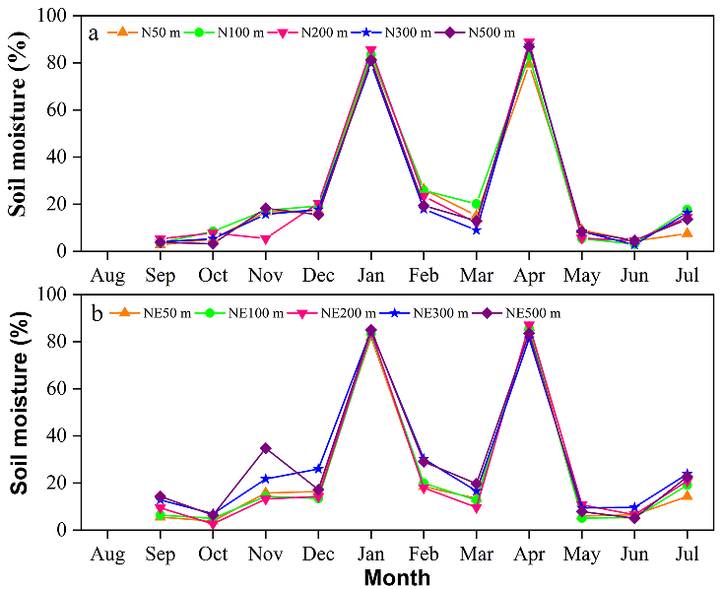
Fig. S2

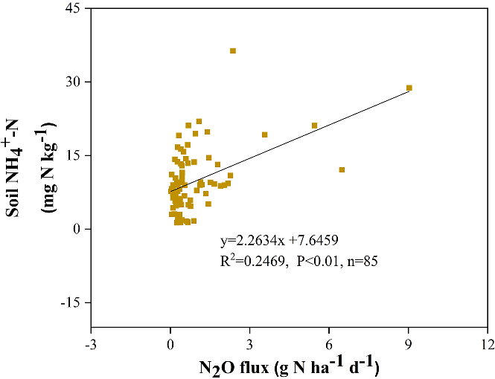
Fig. S3
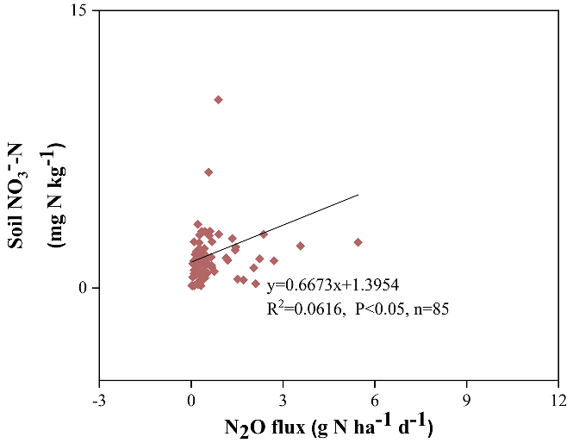
Fig. S4
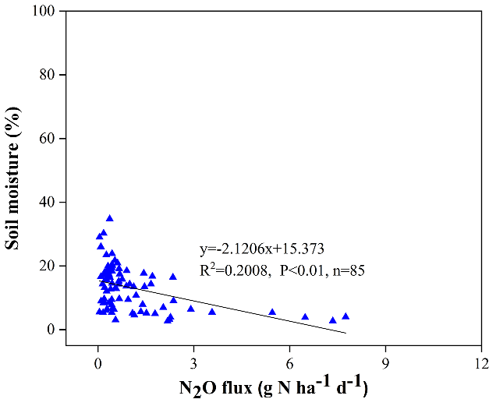
Fig. S5
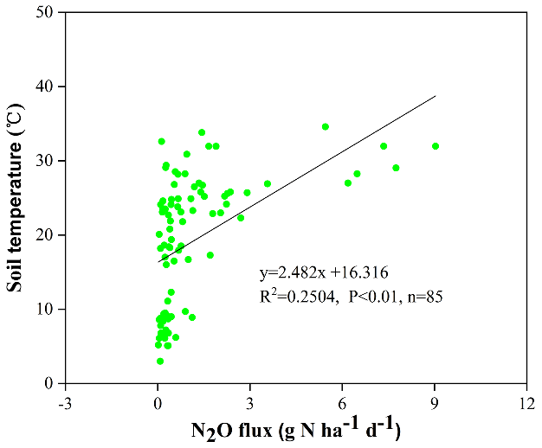
Fig. S6
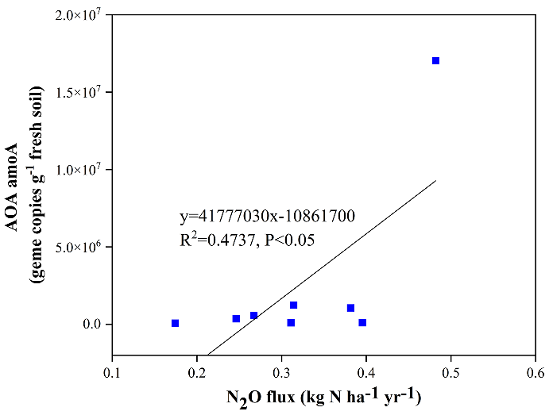
Fig. S7

Table S1 Physicochemical properties of soil samples used for DNA extraction.
Site | NO₃⁻-N | NH₄⁺-N | SOC | TN | TP | pH
Site | mg kg⁻¹ | mg kg⁻¹ | g kg⁻¹ | g kg⁻¹ | g kg⁻¹
N50 | 6.3 | 10.5 | 15.6 | 1.3 | 0.8 | 4.9
N100 | 16.2 | 8.3 | 15.0 | 1.3 | 0.2 | 5.3
N300 | 5.3 | 5.9 | 10.8 | 0.8 | 0.4 | 5.5
N500 | 4.4 | 5.1 | 11.9 | 0.9 | 0.5 | 5.5
NE50 | 13.1 | 16.4 | 10.4 | 1.0 | 1.2 | 5.2
NE100 | 8.2 | 12.9 | 8.0 | 0.7 | 0.6 | 5.5
NE200 | 4.2 | 6.3 | 10.7 | 0.9 | 0.5 | 5.6
NE300 | 1.3 | 6.5 | 14.2 | 1.3 | 0.4 | 5.7
NE500 | 1.4 | 5.4 | 17.9 | 1.5 | 1.0 | 5.3

Table S2 The primers of five genes
Gene name | Primer name | Primer sequence 5’ to 3’ | Product Length
AOA | CHEND-arch-amoA-23F | ATGGTCTGGCTWAGACG | 629
AOA | CHEND-arch-amoA-616R | GCCATCCATCTGTATGTCCA | 629
AOB | AmoA-1F | GGGGTTTCTACTGGTGGT | 491
AOB | AmoA-2R | CCCCTCKGSAAAGCCTTCTTC | 491
nirK | nirK876 | ATYGGCGGVCAYGGCGA | 165
nirK | nirK1040 | GCCTCGATCAGRTTRTGGTT | 165
nirS | cd3AF | GTSAACGTSAAGGARACSGG | 425
nirS | R3cd | GASTTCGGRTGSGTCTTGA | 425
nosZ | CHEND-nosZ-1126F | GGGCTBGGGCCRTTGCA | 255
nosZ | CHEND-nosZ-1381R | GAAGCGRTCCTTSGARAACTTG | 255

Table S3 The estimated N₂O emissions in eight major wind directions within 500 meters from the pig farm.
Distance  (m) | Soil N₂O emission fluxes (kg N ha⁻¹ yr⁻¹)
Distance  (m) | North | Northeast | East | Southeast | South | Southwest | West | Northwest
50 | 0.75 | 0.45 | 0.50 | 0.77 | 0.72 | 0.44 | 0.34 | 0.55
100 | 0.57 | 0.36 | 0.41 | 0.62 | 0.57 | 0.36 | 0.28 | 0.43
200 | 0.41 | 0.29 | 0.33 | 0.48 | 0.43 | 0.29 | 0.24 | 0.32
300 | 0.35 | 0.25 | 0.26 | 0.35 | 0.33 | 0.25 | 0.22 | 0.28
500 | 0.27 | 0.21 | 0.19 | 0.22 | 0.22 | 0.20 | 0.19 | 0.24

