Supplementary Materials
A large net source revealed by the atmospheric reactive nitrogen budget in a subtropical plateau lake basin, southwest China
Qikun Shen^{1#}, Bowen Tang^{1#}, Xinyu Wu^{1#}, Jiahui Kang¹, Jiawei Li², Yuepeng Pan³, Xuejun Liu¹, Wen Xu^{1*}
¹College of Resources and Environmental Sciences, National Academy of Agriculture Green Development, Key Laboratory of Plant–Soil Interactions, Ministry of Education, National Observation and Research Station of Agriculture Green Development (Quzhou, Hebei), China Agricultural University, Beijing 100193, China
²Key Laboratory of Regional Climate-Environment for Temperate East Asia (RCE-TEA), Institute of Atmospheric Physics (IAP), Chinese Academy of Sciences (CAS), Beijing, 100029, China
³State Key Laboratory of Atmospheric Boundary Layer Physics and Atmospheric Chemistry, Institute of Atmospheric Physics, Chinese Academy of Sciences, Beijing 100029, China

*Correspondence to: W. Xu (wenxu@cau.edu.cn)
#Equal contribution

Text S1. The calculation of total NH₃ emissions (TAN) from different manure management stages
The total ammonia nitrogen (TAN) produced from livestock excrement was used as a basis for estimating NH₃ emissions. The TAN production from indoor and outdoor sources was calculated using Eq. (S1):
${TAN}_{j}=\sum_{k}{\sum_{q}{N_{k}×E_{k,l}×{NC}_{k,l}×{TANC}_{k}×P_{k,q}}}$ (S1)
where TANⱼ represents the TAN production from rearing system j (indoor or outdoor); Nₖ is the annual population of livestock category k (using year-end stock numbers for animals with a rearing cycle >1 year and slaughter numbers for those with a cycle <1 year); Eₖ,ₗ is the daily excretion of waste type l (urine or feces) from livestock k; NCₖ,ₗ is the nitrogen content in waste type l from livestock k; TANCₖ is the ratio of TAN to total N in the excrement of livestock k; and Pₖ,ᵩ is the proportion of livestock k reared under system ᵩ (indoors or outdoors). In free-range systems, excrement was assumed to be evenly split (50%) between indoor and outdoor areas, whereas in intensive systems, 100% was assigned to indoors and 0% to outdoors. The values for daily excretion, nitrogen content, and the TAN ratio are provided in Table S3.
Subsequently, the amount of TAN available for NH₃ volatilization at each management stage was calculated. The TAN from outdoor areas was considered entirely available for volatilization. For indoor systems, the TAN flow was tracked through housing, storage, and field application stages using the following equations:
$A_{outdoors}={TAN}_{outdoors}$ .(S2)
$A_{housing}={TAN}_{indoors}×X$ .(S3)
$A_{storage}=A_{housing}-A_{housing}×{EF}_{housing}$ (S4)
$A_{spread}=\left(A_{storage}-A_{storage}×{EF}_{storage}-EN\right)×\left(1-R_{feed}\right)$ (S5)
$EN=A_{storage}×f×\left({EF}_{storage-N2O}+{EF}_{storage-NO}+{EF}_{storage-N2}\right)$ (S6)
Here, A_{outdoor}, A_{housing}, A_{storage}, and A_{spread} denote the TAN amount available for NH₃ volatilization in the outdoor, housing, manure storage, and manure spreading stages, respectively. EF_{housing}, NH_{3,} and EF_{storage}, NH₃ are the NH₃ emission factors for the housing and storage stages at 10–20 ºC (Table S3). X is the proportion of urine (or feces, for poultry) to total excrement mass (11% for free-range systems, 50% for intensive systems for livestock, and 0 for poultry). EN represents the nitrogen loss via denitrification and other non-NH₃ gaseous emissions (N₂O, NO, N₂) during storage. The parameter f is the conversion factor from TAN to organic nitrogen during storage (10% for solid manure, 100% for liquid manure), and EF_{storage}-N₂O, EF_{storage}-NO, and EF_{storage}-N₂ are the respective emission factors for these gases. R_{feed} is the proportion of manure used as ecological feed in intensive systems (Table S3).
Text S2. Description of atmospheric deposition monitoring sites
A network of nine monitoring sites was established across the Erhai Lake Basin (ELB) to capture the spatial variability in atmospheric nitrogen deposition over diverse underlying surfaces. The site selection strategy aimed to represent major land-use types, including agricultural areas, rural villages, urban peripheries, lake islands, and a background site. The sites are GS (Gusheng Village) in a typical agricultural area with intensive vegetable and crop cultivation; TY (Taoyuan Village) in a mixed area with cropland and residential dwellings; NZ (Nanzhao Island), an island site within Erhai Lake representing deposition influenced by both regional transport and local lake-surface emissions; JS (Jinsuo Island), another lake island site selected for its minimal direct agricultural influence to characterize background deposition levels; XG (Xiaguan Town), an urban site influenced by traffic and commercial activities in the southern part of the basin; EY (Eryuan County), a site in the northern urban center also affected by surrounding agricultural activities; NJ (Niujie Town), located in an intensive agricultural and livestock production zone in Eryuan County representing a potential emission hotspot; GSNT (Gusheng Cropland), an additional cropland site adjacent to GS providing replication for agricultural deposition; and DZ (Dazhuang Village), a rural village site with moderate agricultural influence. The precise geographical coordinates, elevation, and primary land-use classification for each site are provided in Table S10. This stratified design ensures that our deposition measurements are robust and representative of the basin’s heterogeneity.
Text S3. Modeling dry deposition velocity using WRF-Chem.
The dry deposition velocity ($V_{d}$) for each nitrogen species is a critical, spatially and temporally variable parameter. We employed the Weather Research and Forecasting model coupled with Chemistry (WRF-Chem), version 4.5.1, to simulate monthly $V_{d}$ values for each monitoring site and species (NH₃, NO₂, HNO₃, pNH₄⁺, pNO₃⁻). The model configuration included the MOSAIC aerosol module and the GOCART gas-phase chemistry mechanism, both of which can simulate the relevant Nᵣ species. The core of the $V_{d}$ calculation is a big-leaf resistance-in-series model^{[1]}, which parameterizes the deposition process as a function of atmospheric turbulence (aerodynamic resistance, $R_{a}$), the molecular or Brownian diffusion through the quasi-laminar sub-layer (quasi-laminar resistance, $R_{b}$), and the uptake by the surface itself (canopy or surface resistance, $R_{c}$), expressed as $V_{d}=(R_{a}+R_{b}+R_{c})^{-1}$. The model dynamically calculates $R_{a}$ and $R_{b}$ based on meteorological conditions (e.g., wind speed, temperature, atmospheric stability). The $R_{c}$, which is highly species- and surface-dependent, was parameterized based on the land-use category of each site (e.g., cropland, forest, water, urban). Land-use data were derived from high-resolution remote sensing products. The simulation was driven by reanalysis data from the National Centers for Environmental Prediction (NCEP) Final Analysis (FNL), with the model domain centered over the ELB and a high-resolution grid to resolve the complex plateau topography. The application and performance of this WRF-Chem setup for simulating atmospheric processes in the ELB have been previously documented and evaluated^{[2]}. The resulting monthly mean $V_{d}$ values for each species and site are presented in Fig. S2. This approach provides a more physically based and site-specific estimation of $V_{d}$ compared to using constant, literature-based values.
Text S4. Protocols for DELTA and Gradko sampler operation and analysis
The Denuder for Long-Term Atmospheric (DELTA) system was used for measuring monthly mean concentrations of NH₃, HNO₃, pNH₄⁺, and pNO₃⁻. The DELTA system uses coated tubes and filters to separate and collect gaseous and particulate species based on their diffusion rates and chemical properties. Sampling was conducted on a monthly basis. Air was drawn through an inlet, which removed large particles, and then passed through a series of components: a citric acid-coated denuder to selectively capture basic gases, primarily NH₃; a nylon filter to capture acidic gases, particularly HNO₃, which reacts to form particulate nitrate on the filter; an acid-coated filter (e.g., citric acid) to collect pNH₄⁺; and a backup nylon filter to capture any nitrate volatilized from the first nylon filter. After exposure, each component was extracted separately with ultrapure water in a defined protocol. The denuder was rinsed, and filters were sonicated to ensure complete extraction of the collected nitrogen species. The extracts were analyzed using a continuous-flow analyzer (SKALAR San++, the Netherlands) for NH₄⁺-N and NO₃⁻-N concentrations. The concentrations were then converted to atmospheric mixing ratios (μg N m⁻³) using the sampled air volume.
For NO₂, Gradko passive diffusion tubes were employed. These tubes operate on the principle of molecular diffusion: NO₂ in the air diffuses into the tube and is absorbed onto a triethanolamine (TEA) coating, where it is stabilized. Tubes were deployed in triplicate at each site for one month, mounted on a stand with a weather shield to protect them from rain and direct sunlight, ensuring open-air diffusion. After retrieval, the exposed TEA absorbent was extracted with ultrapure water. The concentration of nitrite (NO₂⁻) in the extract, which is stoichiometrically related to the absorbed NO₂, was determined by ion chromatography (Dionex ICS-90, USA). The atmospheric NO₂ concentration (μg N m⁻³) was calculated based on the mass of NO₂-N absorbed, the diffusion coefficient of NO₂, and the exposure duration. Strict quality assurance/quality control (QA/QC) procedures, including field blanks, laboratory blanks, and duplicate samples, were implemented for all sampling methods.

Text S5. Analytical methods for wet deposition samples
Wet deposition samples were collected on a rainfall-event basis and analyzed for a comprehensive suite of nitrogen species to fully quantify the nitrogen input via precipitation. APS-3B automatic rainfall collectors were used, which open at the onset of precipitation and close after the event, preventing contamination from dry deposition. Immediately after collection, the volume of each sample was recorded. Samples were then filtered through pre-combusted (450 ºC for 4 hours) Whatman GF/F filters (0.7 μm pore size) to separate the dissolved and particulate fractions. The filtered water was analyzed directly for ammonium (NH₄⁺) and nitrate (NO₃⁻) concentrations using a continuous flow analyzer (SKALAR San++). The concentration of Total Dissolved Nitrogen (TDN) was determined on the filtered sample using the persulfate oxidation method, which converts all dissolved nitrogen compounds to nitrate. The Dissolved Organic Nitrogen (DON) concentration was then calculated by difference: $DON=TDN-(NH_{4}^{+}\text{-}N+NO_{3}^{-}\text{-}N)$. The filter containing the particulate matter was dried and then analyzed for its total nitrogen content using an elemental analyzer (Vario EL III, Elementar, Germany) to determine the Particulate Nitrogen (PN) fraction. This fraction, while potentially containing some crustal nitrogen, primarily consists of nitrogen derived from atmospheric Nᵣ species incorporated into particles. The volume-weighted mean (VWM) concentration for the entire monitoring period was calculated for each species using Equation (9) in the main text, and the fluxes were derived using Equation (10).

Text S6. Uncertainty analysis for emission inventories
The uncertainties in the NH₃ and NO_{x} emission inventories were quantitatively assessed using the error-propagation method recommended by the IPCC^{[3]}. This approach combines the uncertainties of activity data (AD) and emission factors (EF) for each source category.
The overall uncertainty for the total emission inventory was estimated as:
$U_{total}=\sqrt{\sum_{i}{U_{E,i}^{2}}}$ (S7)
where $U_{total}$ is the percentage uncertainty of the total emissions, and $U_{E,i}$ is the percentage uncertainty of the emissions from source category $i$.
The uncertainty for emissions from a specific source category $i$ was calculated as:
$U_{E,i}=\sqrt{U_{AD,i}^{2}+U_{EF,i}^{2}}$ (S8)
where $U_{AD,i}$ and $U_{EF,i}$ are the percentage uncertainties associated with the activity data and emission factor for that source, respectively.
The uncertainties for activity data ($U_{AD}$) and emission factors ($U_{EF}$) were assigned based on data quality and literature review (e.g., Zhu et al.^{[16]}; MEE guidelines). Activity data uncertainties ranged from ±5% for well-documented statistics (e.g., livestock populations from yearbooks, vehicle numbers) to ±15% for survey-derived data (e.g., fertilizer application rates). Emission factor uncertainties ranged from ±30% for sources with localized measurements (e.g., some livestock categories) to ±60% for sources where default EFs from national guidelines were applied without local validation (e.g., specific vehicle types, waste treatment).
The detailed uncertainty values assigned to each source category’s AD and EF, along with the resulting uncertainty for each category's emissions ($U_{E,i}$) and the final overall inventory uncertainty ($U_{total}$), are provided in Tables S13-S19. The NH₃ inventory had an overall uncertainty of ±10.6%, while the NOₓ inventory uncertainty was ±11.4%, dominated by the vehicle sector.

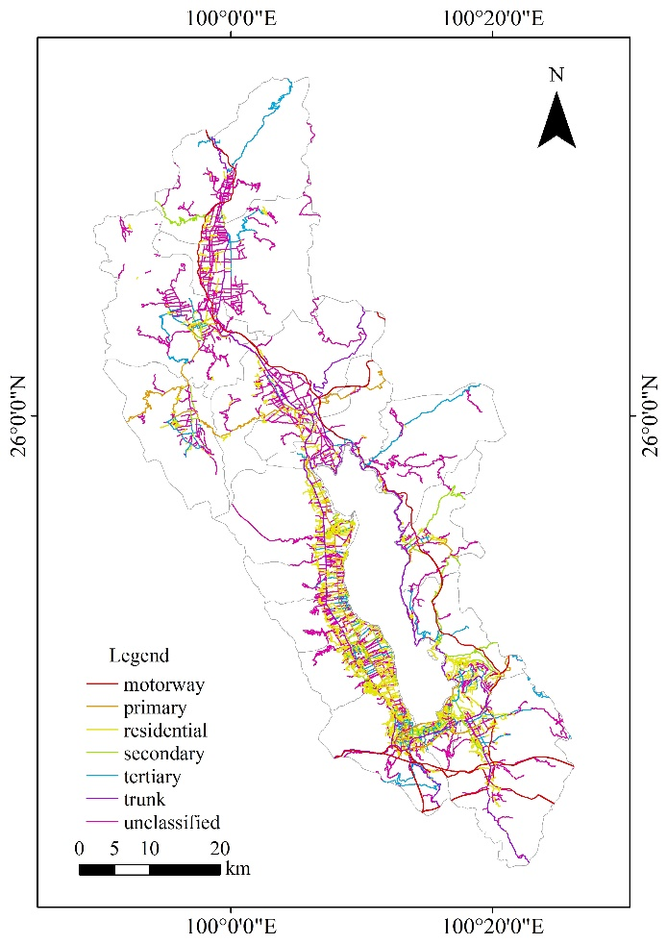
Fig. S1. Spatial distribution of the road network used for allocating vehicular emissions in the Erhai Lake Basin. Road types (e.g., motorways, primary, residential) were sourced from OpenStreetMap.

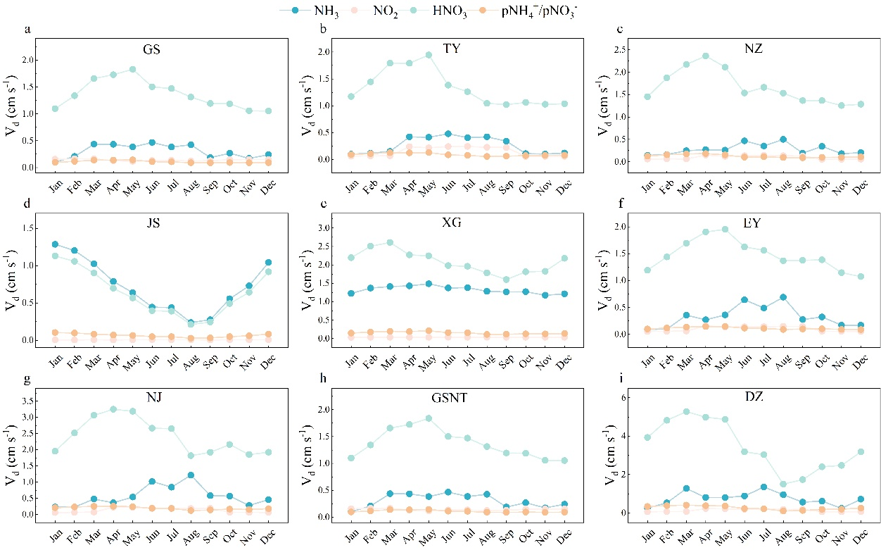
Fig. S2. Monthly dry deposition velocities (V_{d}) for N_{r} species (NH₃, NO₂, HNO₃, pNH₄⁺, pNO₃⁻) at the nine monitoring sites, simulated by the WRF-Chem model.

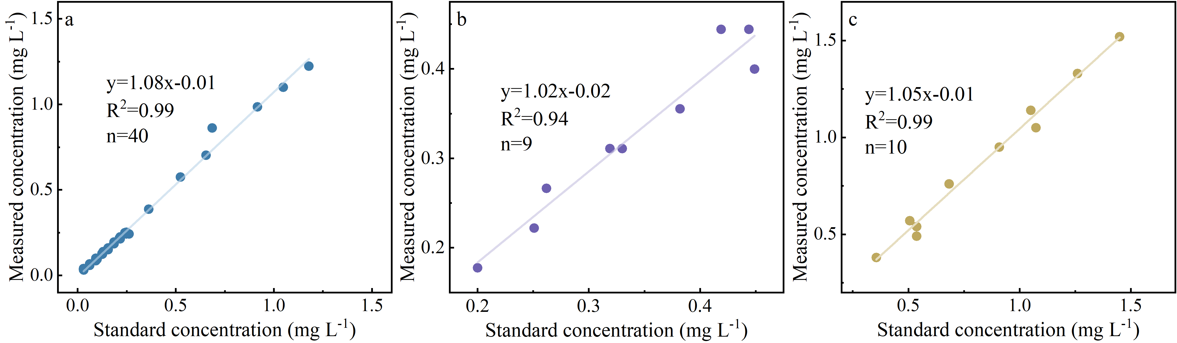
Fig. S3. Recovery rates of standard reference materials for total nitrogen (TN), NH₄⁺-N, and NO₃⁻-N analysis, demonstrating the accuracy of the analytical methods.

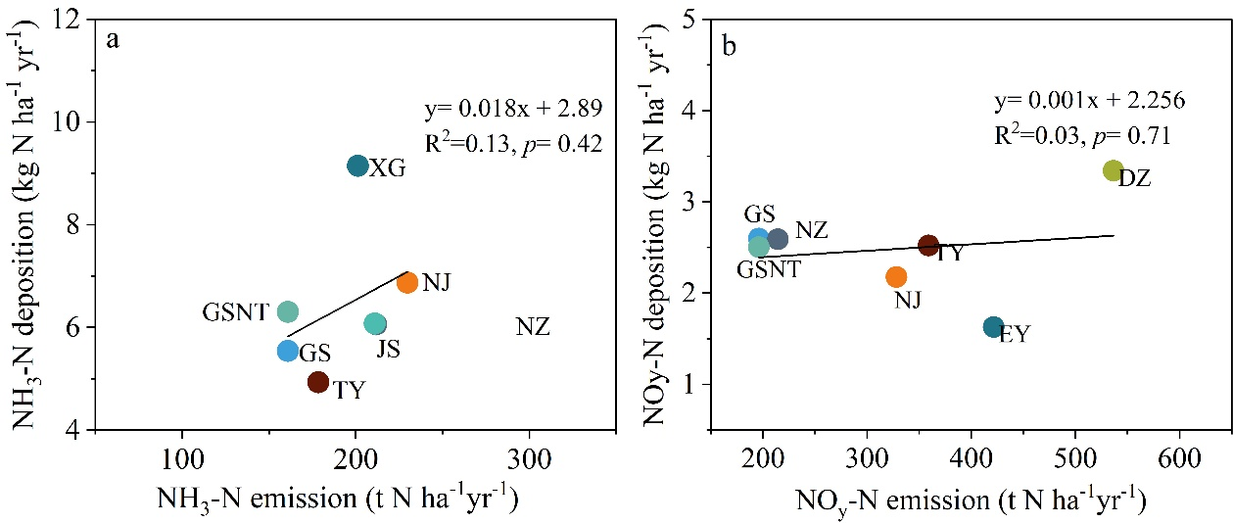
Fig. S4. Relationship of NH_{x} deposition vs. NH₃ emission (a) and NO_{y} deposition vs. NO_{x} emission(b).

Table S1. Categories and sub-categories of atmospheric reactive nitrogen (N_{r}) emission sources estimated in this study.
Category | NH₃ Sub-category | NO_{x} Sub-category
Livestock | Domestic animal (hog, sow, dairy cattle, beef cow, goat, sheep, horse, donkey, mule)  Poultry (broiler, laying hen, meat duck, meat geese) | Domestic animal (hog, sow, dairy cow, beef cow, goat, sheep, horse, donkey, mule)  Poultry (broiler, laying hen, meat duck, meat geese)
Farmland ecosystem | Crop fertilization (wheat, soybean, potato, barley, rice, corn, rapeseed, tobacco, vegetable, fruit tree); Compost of crop residues; Cropland soil; N-fixing plant (bean) | Crop fertilization (wheat, soybean, potato, barely, rice, corn, rapeseed, tobacco, vegetable, fruit tree)
Vehicles | Large passenger car (LPC), Middle passenger car (MPC), Small passenger car (SPC), Mini passenger car (MPC), Heavy-duty trucks (HDT), Middle-duty trucks (MDT), Light-duty trucks (LDT), Ordinary motorcycle (OM), Light motorcycle (LM) | Large passenger car (LPC), Middle passenger car (MPC), Small passenger car (SPC), Mini passenger car (MPC), Heavy-duty trucks (HDT), Middle-duty trucks (MDT), Light-duty trucks (LDT), Ordinary motorcycle (OM), Light motorcycle (LM)
Humans | Excretion | -
Biomass burning | Straw burning (wheat, soybeans, potato, barely, rice, corn, rapeseed, tobacco)  Forest fires | Straw burning (wheat, soybeans, potato, barely, rice, corn, rapeseed, tobacco)  Forest fires
Waste treatment | Sewage treatment, Solid waste landfill,  Solid waste incineration | -
Fuel combustion | Domestic combustion (fuel coal, fuel oil, fuel gas) | Domestic combustion (fuel coal, fuel oil, fuel gas)

Table S2. Emission factors (EFs) for NH₃ and NO_{x} from sources other than livestock, farmland ecosystem, and vehicles.
Sources |  | NH₃ |  | NO_{x} | Unit
Biomass burning | Corn |  | 0.68^{[4]} | 4.3 ^{[4]} | g kg⁻¹
Biomass burning | Soybeans |  | 0.53 ^{[4]} | 2.92 ^{[4]} | g kg⁻¹
Biomass burning | Rice |  | 0.53 ^{[4]} | 1.42 ^{[4]} | g kg⁻¹
Biomass burning | Potato |  | 0.53 ^{[4]} | 2.92 ^{[4]} | g kg⁻¹
Biomass burning | Barely |  | 0.37 ^{[4]} | 3.31 ^{[4]} | g kg⁻¹
Biomass burning | Tobacco |  | 0.53 ^{[4]} | 2.92 ^{[4]} | g kg⁻¹
Biomass burning | Rapeseed |  | 0.53 ^{[4]} | 2.92 ^{[4]} | g kg⁻¹
Biomass burning | Wheat |  | 0.37 ^{[4]} | 3.31 ^{[4]} | g kg⁻¹
Biomass burning | Forest fire |  | 2.9 ^{[4]} | 1.6 ^{[4]} | g kg⁻¹
Human excrement |  |  | 0.787 ^{[4]} | - | kg yr⁻¹
Waste tenement | Solid waste landfill |  | 0.56 ^{[4]} | - | kg t⁻¹
Waste tenement | Solid waste incineration |  | 0.21 ^{[4]} | - | kg t⁻¹
Waste tenement | Sewage treatment |  | 0.003 ^{[4]} | - | g m³
Fuel burning | Fuel coal |  | 0.82 ^{[5]} | 0.86 ^{[6]} | kg N t⁻¹
Fuel burning | Fuel oil |  | 0.15 ^{[5]} | 0.83 ^{[6]} | kg N t⁻¹
Fuel burning | Fuel gas |  | 320.5^{[5]} | 440 ^{[6]} | Mg N m⁻³

Table S3. Parameters for estimating NH₃ emissions from different manure management stages for various livestock categories.
Livestock | Excreta  (kg day⁻¹cap⁻¹) |  | N content  (%) |  | TAN  (%) | EF outside  (% of TAN) | EF_{house}  (% of TAN, 10-20 ℃) |  | EF_{storage} Slurry  (% of TAN) |  |  |  | EF_{storage} solid  (% of TAN) |  |  |  | R_{feed}  (%) | EF_{spread}  (% of TAN)
 | Urine | Faeces | Urine | Faeces |  |  | Slurry | Solid | NH₃ | N₂O | NO | N₂ | NH₃ | N₂O | NO | N₂ |  | Slurry | Solid
Free-range system
Beef cattle | 10 | 20 | 0.9 | 0.38 | 60 | 53 | 14 | 14 | 20 | 1 | 0.01 | 0.3 | 27 | 8 | 1 | 30 | 0 | 55 | 79
Daily cattle | 19 | 40 | 0.9 | 0.38 | 60 | 53 | 14 | 14 | 20 | 1 | 0.01 | 0.3 | 27 | 8 | 1 | 30 | 0 | 55 | 79
Goat | 0.75 | 2.6 | 1.35 | 0.75 | 50 | 75 | 14 | 14 | 28 | 7 | 0.01 | 0.3 | 28 | 7 | 1 | 30 | 0 | 90 | 81
Sheep | 0.75 | 2.6 | 1.35 | 0.75 | 50 | 75 | 14 | 14 | 28 | 7 | 0.01 | 0.3 | 28 | 7 | 1 | 30 | 0 | 90 | 81
Sow | 5.7 | 2.1 | 0.4 | 0.34 | 70 | 0 | 14.7 | 14.7 | 14 | 0 | 0.01 | 0.3 | 45 | 5 | 1 | 30 | 0 | 40 | 81
Hog | 3.2 | 1.5 | 0.4 | 0.34 | 70 | 0 | 10.2 | 10.2 | 14 | 0 | 0.01 | 0.3 | 45 | 5 | 1 | 30 | 0 | 40 | 81
Horse, donkey and mule | 6.5 | 15 | 1.4 | 0.2 | 60 | 0 | 14 | 14 | 35 | 0 | 0.01 | 0.3 | 45 | 8 | 1 | 30 | 0 | 90 | 81
Laying hen | 0 | 0.12 | 0 | 1.63 | 70 | 69 | 45.2 | 45.2 | 0 | 0 | 0 | 0 | 14 | 4 | 1 | 30 | 0 | 0 | 63
Broiler | 0 | 0.09 | 0 | 1.63 | 70 | 66 | 40.3 | 40.3 | 0 | 0 | 0 | 0 | 17 | 3 | 1 | 30 | 0 | 0 | 63
Meat duck | 0 | 0.1 | 0 | 1.1 | 70 | 54 | 40.3 | 40.3 | 0 | 0 | 0 | 0 | 24 | 3 | 1 | 30 | 0 | 0 | 63
Meat geese | 0 | 0.1 | 0 | 0.55 | 70 | 54 | 40.3 | 40.3 | 0 | 0 | 0 | 0 | 24 | 3 | 1 | 30 | 0 | 0 | 63
Intensive system
Beef cattle | 10 | 20 | 0.9 | 0.38 | 60 | 53 | 14 | 14 | 15.8 | 1 | 0.01 | 0.3 | 4.2 | 8 | 1 | 30 | 20 | 55 | 79
Daily cattle | 19 | 40 | 0.9 | 0.38 | 60 | 30 | 14 | 14 | 15.8 | 1 | 0.01 | 0.3 | 4.2 | 8 | 1 | 30 | 20 | 55 | 79
Goat | 0.75 | 2.6 | 1.35 | 0.75 | 50 | 75 | 14 | 14 | 15.8 | 7 | 0.01 | 0.3 | 4.2 | 7 | 1 | 30 | 20 | 90 | 81
Sheep | 0.75 | 2.6 | 1.35 | 0.75 | 50 | 75 | 14 | 14 | 15.8 | 7 | 0.01 | 0.3 | 4.2 | 7 | 1 | 30 | 20 | 90 | 81
Sow | 5.7 | 2.1 | 0.4 | 0.34 | 70 | 0 | 14.3 | 14.3 | 3.8 | 0 | 0.01 | 0.3 | 4.6 | 5 | 1 | 30 | 30 | 40 | 81
Hog | 3.2 | 1.5 | 0.4 | 0.34 | 70 | 0 | 18.5 | 18.5 | 3.8 | 0 | 0.01 | 0.3 | 4.6 | 5 | 1 | 30 | 30 | 40 | 81
Horse, donkey and mule | 6.5 | 15 | 1.4 | 0.2 | 60 | 0 | 14 | 14 | 15.8 | 0 | 0.01 | 0.3 | 4.2 | 8 | 1 | 30 | 0 | 90 | 81
Laying hen | 0 | 0.12 | 0 | 1.63 | 70 | 69 | 0 | 35.9 | 0 | 0 | 0 | 0 | 3.7 | 4 | 1 | 30 | 50 | 0 | 63
Broiler | 0 | 0.09 | 0 | 1.63 | 70 | 66 | 0 | 40.3 | 0 | 0 | 0 | 0 | 0.8 | 3 | 1 | 30 | 50 | 0 | 63
Meat duck | 0 | 0.1 | 0 | 1.1 | 70 | 54 | 0 | 40.3 | 0 | 0 | 0 | 0 | 0.8 | 3 | 1 | 30 | 0 | 0 | 63
Meat geese | 0 | 0.1 | 0 | 0.55 | 70 | 54 | 0 | 40.3 | 0 | 0 | 0 | 0 | 0.8 | 3 | 1 | 30 | 0 | 0 | 63
Values are derived from MEE ^{[4]}.
Table S4. Fertilizer application rates for different crops in the Erhai Lake Basin, as reported by farmer surveys.
Crop type | Planting area  (ha) | Nitrogen application  (kg N ha⁻¹) | The ratio of crop residues to compost  (%)
Rice | 383.7 | 264 | 64
Wheat | 3770.1 | 191 | 41
Corn | 11191.8 | 272 | 42
Soybeans | 9952.5 | 195 | 46
Barely | 3386.5 | 264 | 64
Potato | 2480.8 | 390 | 40
Rapeseed | 1558.8 | 320 | 32
Tobacco | 4228.0 | 141 | 5
Vegetable | 9991.6 | 263 | 0
Fruit tree | 6634.2 | 359 | 0
Values are derived from the farmer surveys in the Erhai Lake basin.
Table S5. Manure nitrogen allocation per unit area for different crops.
Crop type | Nutrient allocation  (kg N ha⁻¹)
Rice | 59.3
Wheat | 48.4
Corn | 63.6
Soybeans | 46.9
Potato | 81.0
Barely | 55.8
Rapeseed | 72.2
Tobacco | 35.7
Vegetable | 66.6
Fruit tree | 90.9

Table S6. Parameters and data sources for estimating NH₃ emissions from biomass burning and straw composting.
Crop residue | Yield (kg) | Residue to crop yields ratio (%) | Ratio of open burning of straw | Combustion efficiency
Rice | 61182 | 1.323 | 20% | 0.9
Wheat | 1907 | 1.718 | 20% | 0.9
Corn | 92384 | 1.269 | 20% | 0.9
Soybeans | 43697 | 1.5 | 20% | 0.9
Potato | 11575 | 1.5 | 20% | 0.9
Barely | 14167 | 1.718 | 20% | 0.9
Rapeseed | 4231 | 1.5 | 20% | 0.9
Tobacco | 8612 | 1.5 | 20% | 0.9
Values are sourced from MEE ^{[7]}.

Table S7. Emission factors for NH₃ and NO_{x} from the farmland ecosystem.
Source | Sub-category | NH₃ | NO_{x} | Unit
Crop  fertilization | Rice | 7.3^{[8]} | 0.06^{[12]} | %
Crop  fertilization | Wheat | 4.9^{[9]} | 0.06^{[12]} | %
Crop  fertilization | Corn | 4.9^{[9]} | 0.26^{[12]} | %
Crop  fertilization | Soybeans | 5^{[10]} | 0.26^{[12]} | %
Crop  fertilization | Potato | 4.9^{[10]} | 0.06^{[12]} | %
Crop  fertilization | Barely | 4.9^{[9]} | 0.06^{[12]} | %
Crop  fertilization | Rapeseed | 4.9^{[10]} | 0.06^{[12]} | %
Crop  fertilization | Tobacco | 4.9^{[10]} | 0.26^{[12]} | %
Crop  fertilization | Vegetable | 5^{[11]} | 0.24^{[13]} | %
Crop  fertilization | Fruit tree | 4.9^{[10]} | 0.03^{[14]} | %
Crop soil |  | 0.008^{[4]} |  | kg ha⁻¹ yr⁻¹
Compost |  | 0.32^{[4]} |  | kg t⁻¹
Nix-fixing plant | Soybeans | 0.07^{[4]} |  | kg ha⁻¹

Table S8. Activity data, related parameters, and emission factors (EFs) for motor vehicles.
Sources | Amount of motor vehicle | Annual average mileage (km) | NH₃ EFs  (mg km⁻¹) | NO_{x} EFs  (mg N km⁻¹)
Large passenger vehicle | 0.17 | 58000^{[15]} | 28^{[4]} | 1.5×10^{3[16]}
Middle passenger vehicle | 0.21 | 31300^{[15]} | 28^{[4]} | 1.5×10^{3[16]}
Small passenger vehicle | 49.18 | 18000^{[15]} | 26^{[4]} | 0.76×10^{3[16]}
Mini passenger vehicles | 0.19 | 18000^{[15]} | 17^{[4]} | 0.76×10^{3[16]}
Heavy-duty trucks | 1.64 | 75000^{[15]} | 17^{[4]} | 6.4×10^{3[16]}
Middle-duty trucks | 0.25 | 35000^{[15]} | 4^{[4]} | 6.4×10^{3[16]}
Light-duty trucks | 8.24 | 30000^{[15]} | 4^{[4]} | 1.2×10^{3[16]}
Motorcycles | 59.55 | 6000^{[15]} | 7^{[4]} | 60^{[16]}
Light-motorcycles | 4.64 | 6000^{[15]} | 7^{[4]} | 60^{[16]}

Table S9. Activity data for atmospheric Nᵣ emission sources in the Erhai Lake Basin.
Sources | Sub-categories | Amount | unit
Livestock | Meat pig | 251.1 | head× 10³
Livestock | Sow | 12.6 | head× 10³
Livestock | Meat cow | 16.2 | head× 10³
Livestock | Milk cow | 37.5 | head× 10³
Livestock | Goat | 43.4 | head× 10³
Livestock | Sheep | 13.8 | head× 10³
Livestock | Meat chicken | 2869.3 | head× 10³
Livestock | Egg chicken | 1857.9 | head× 10³
Livestock | Meat duck | 62.9 | head× 10³
Livestock | Meat geese | 6.0 | head× 10³
Livestock | Horse, mule and donkey | 4.8 | head× 10³
Fuel burning | Fuel coal | 5482.7 | t
Fuel burning | Fuel oil | 8260.2 | t
Fuel burning | Fuel gas | 4787.2 | m³× 10⁴
Biomass burning | Straw (dry) | 59034.3 | t
Biomass burning | Fuel wood | 4481.5 | t
human |  | 426378 | person
Waste treatment | landfill treatment | 84.4 | t× 10³
Waste treatment | Waste incineration | 358.9 | t× 10³
Waste treatment | Wastewater treatment | 8244.5 | m³× 10⁴
Fixing-nitrogen plant |  | 9952.5 | ha× 10³
Soil |  | 50656.8 | ha× 10³

Table S10. Geographical coordinates and description of the atmospheric nitrogen deposition monitoring sites.
Sites | Longitude (°) | Latitude (°) | Sample period | Rainfall (mm) | Sample numbers
 |  |  |  |  | Dry | Wet
GS | 100.148 | 25.821 | 23.01-23.12 | 1025.1 | 48 | 64
TY | 100.117 | 25.909 | 23.01-23.12 | 796.2 | 48 | 50
NZ | 100.190 | 25.905 | 23.01-23.12 | 874.2 | 48 | 54
JS | 100.255 | 25.697 | 23.01-23.12 | 696.4 | 48 | 40
XG | 100.223 | 25.613 | 23.01-23.12 | 796.2 | 48 | 68
EY | 99.961 | 26.119 | 23.01-23.12 | 677.7 | 48 | 53
NJ | 99.968 | 26.238 | 23.01-23.12 | 440.6 | 48 | 36
DZ | 100.204 | 25.663 | 23.01-23.12 |  | 48 | -
GSNT | 100.138 | 25.818 | 23.01-23.12 |  | 48 | -
Notes: GS, TY, NZ, JS, XG, EY, NJ, GSNT, and DZ correspond to Gusheng Village, Taoyuan Village, Nanzhao Island, Jinsuo Island, Xiaguan Town, Eryuan County, Niujie Town, Gusheng Cropland, and Dazhuang Village, respectively.
Table S11. Detailed annual NH₃ and NO_{x} emission inventory for the Erhai Lake Basin (2022).
Sources | Sub-category | Sub-category | NH₃-N (t) | NO_{x}-N (t)
Livestock | Hog |  | 447.9 | 2.9
Livestock | Sow |  | 22.5 | 0.2
Livestock | Dairy cattle |  | 843.1 | 3.8
Livestock | Beef cattle |  | 243.7 | 0.9
Livestock | Goat |  | 109.3 | 0.3
Livestock | Sheep |  | 34.7 | 0.1
Livestock | Broiler |  | 84.1 | 0.2
Livestock | Laying hen |  | 513.3 | 1.3
Livestock | Meat duck |  | 1.42 | 0
Livestock | Meat geese |  | 0.08 | 0
Livestock | Horse, mule and donkey |  | 28.4 | 0.2
Farmland ecosystem | Crop fertilization | Wheat | 10.7 | 0
Farmland ecosystem | Crop fertilization | Soybean | 269.8 | 1.1
Farmland ecosystem | Crop fertilization | Potato | 116.4 | 0.1
Farmland ecosystem | Crop fertilization | Barely | 109.4 | 0.1
Farmland ecosystem | Crop fertilization | Rice | 231.3 | 0.2
Farmland ecosystem | Crop fertilization | Corn | 411.6 | 1.7
Farmland ecosystem | Crop fertilization | Rapeseed | 65.1 | 0.1
Farmland ecosystem | Crop fertilization | Tobacco | 87.4 | 0.4
Farmland ecosystem | Crop fertilization | Vegetable | 385.1 | 1.4
Farmland ecosystem | Crop fertilization | Fruit tree | 349.0 | 0.2
Farmland ecosystem | Soil emission |  | 75.1 | -
Farmland ecosystem | Straw compost |  | 40.1 | -
Farmland ecosystem | Nitrogen-fixing plants |  | 8.6 | -
Vehicle | LPC |  | 0.7 | 46.5
Vehicle | MPC |  | 0.5 | 31
Vehicle | SPC |  | 59.6 | 2115.3
Vehicle | MIPC |  | 0.2 | 8.2
Vehicle | HTD |  | 5.4 | 2475
Vehicle | MTD |  | 0.4 | 176.1
Vehicle | LTD |  | 2.6 | 932.7
Vehicle | OM |  | 6.5 | 67.4
Vehicle | LM |  | 0.5 | 5.25
Human | Excretion |  | 33.2 | -
Biomass burning | Straw burning |  | 28.3 | 54.7
Biomass burning | Forest fires |  | 10.7 | 2.2
Waste treatment | Sewage treatment |  | 0.2 | -
Waste treatment | Solid waste landfill |  | 39.0 | -
Waste treatment | Solid waste incineration |  | 62.1 | -
Fuel burning | Coal |  | 4.5 | 4.7
Fuel burning | Oil |  | 1.2 | 6.9
Fuel burning | Gas |  | 15.3 | 21

Table S12. Annual mean deposition fluxes of Nᵣ species at each monitoring site (2023).
Sites | Dry deposition  kg N ha⁻¹ yr⁻¹ | Wet deposition  Kg N ha⁻¹ yr⁻¹ | Total deposition  kg N ha⁻¹ yr⁻¹
GS | 4.1 | 4.8 | 8.9
TY | 3.8 | 4.8 | 8.6
NZ | 2.4 | 9.4 | 11.8
JS | 4.7 | 2.8 | 7.5
XG | 7.9 | 3.6 | 11.5
EY | 4.8 | 4.8 | 9.6
NJ | 12.9 | 4.8 | 17.7
DZ | 5.7 | 2.4 | 8.1
GSNT | 7.7 | 1.7 | 9.4
Notes: GS, TY, NZ, JS, XG, EY, NJ, GSNT, and DZ correspond to Gusheng Village, Taoyuan Village, Nanzhao Island, Jinsuo Island, Xiaguan Town, Eryuan County, Niujie Town, Gusheng Cropland, and Dazhuang Village, respectively.

Table S13. Comparison of livestock NH₃ emission factors from different literature sources (kg NH₃-N animal⁻¹ yr⁻¹).
Category | This study |  | Wu et al., 2024^{[11]} | Zheng et al., 2012^{[17]} | Zhou et al., 2015^{[18]} | Battye et al., 1994^{[19]} | Zhu et al., 2021^{[16]} |  | Zhou et al., 202^{[20]}
Meat pig | 4.18 | 4.8 |  | 2.82 | 11.55 | 6.98 | 2.82 | 4.8
Sow | 4.15 | 4.8 |  | 11.55 | 11.55 | 5.22 | 11.55 | 4.8
Meat cow | 29.59 | 16.39 |  | 22.58 | 22.58 | 27.91 | 25.52 | 11.7
Milk cow | 49.12 | 26.67 |  | 37.61 | 37.61 | 39.72 | 25.52 | 26.1
Goat | 5.36 | 0.09 |  | 4.93 | 5.96 | 6.4 | 4.1 | 1.2
Sheep | 5.36 | 0.09 |  | 4.93 | 5.96 | 6.4 | 4.1 | 1.2
Meat chicken | 0.05 | 0.03 |  | 0.18 | 0.18 | 0.167 | 0.24 | 0.22
Egg chicken | 0.43 | 0.03 |  | 0.49 | 0.61 | 0.305 | 0.24 | 0.22
Meat duck | 0.04 | 0.02 |  | 0.03 | 0.03 | 0.117 | 0.24 | 0.22
Meat geese | 0.02 | - |  | 0.24 | 0.24 | - | 0.24 | 0.22
Horse, mule and donkey | 22.01 | - |  | - | 18.6 | 12.2 | - | -

Table S14. Comparison of NH₃ emission factors for nitrogen fertilizer application from different literature sources (% of applied N).
Wheat | Beans | Potato | Barely | Rice | Corn | Rape seed | Tobacco | Vegetable | Fruit tree
4.9 | 5 | 4.9 | 4.9 | 7.3 | 4.9 | 4.9 | 4.9 | 5 | 4.9
4^{[21]} | 4^{[21]} | 4^{[21]} | 4^{[21]} | 4^{[21]} | 4^{[21]} | 4^{[21]} | 4^{[21]} | 4^{[21]} | 4^{[21]}
3.6^{[17]} | 3.6^{[17]} | 3.6^{[17]} | 3.6^{[17]} | 7.51^{[8]} | 3.6^{[17]} | 3.6^{[17]} | 3.6^{[17]} | 3.6^{[17]} | 3.6^{[17]}
6.19^{[22]} | 0.7^{[23]} | 0.7^{[23]} | 6.19^{[22]} | 6. 7^{[23]} | 4.56^{[24]} | 7.6^{[25]} | 3.84^{[26]} | 1.12^{[27]} | 4.29^{[28]}
5.9^{[29]} | 6.54^{[13]} | 6.54^{[13]} | 5.9^{[29]} | 6.54^{[13]} | 6.54^{[13]} | 6.54^{[13]} | 6.54^{[13]} | 6.54^{[13]} | 2.79^{[30]}

Table S15. Comparison of NH₃ emission factors for human excrement from different literature sources (kg NH₃-N person⁻¹ yr⁻¹).
Category | This study | Yu et al., 2020^{[31]} | Zhu et al., 2024^{[21]} | Zheng et al., 2012^{[17]} | Zhu et al., 2021^{[16]}
Human excrement | 0.787 | 0.5 | 0.83 | 0.76 | 0.648

Table S16. Comparison of NH₃ emission factors for biomass burning from different literature sources (g N kg⁻¹).
Category | This study | Yu et al.,  2020^{[31]} | Zhu et al.,  2024^{[21]} | Zheng et al.,  2012^{[17]} | Zhou et al., 2015^{[18]} | Kang et al., 2016^{[32]} | Zhou et al., 2021^{[20]} | Gao et al., 2003^{[33]}
Maize | 0.37 | 1.3 | 0.37 | 0.53 | 0.53 | 0.37 | 0.37 | 0.41
Beans | 0.53 | 1.3 | 0.52 | 0.53 | 0.53 | 0.52 | 0.53 | 0.53
Potato | 0.53 | 1.3 | 0.52 | 0.53 | 0.53 | 0.52 | - | 0.53
Barely | 0.37 | 1.3 | 0.37 | 0.53 | 0.53 | 0.37 | 0.37 | 0.41
Rice | 0.53 | 1.3 | 0.52 | 0.53 | 4.1 | 0.52 | 0.53 | 0.53
Tobacco | 0.68 | 1.3 | 0.68 | 0.53 | 0.68 | 0.68 | 0.68 | 0.72
Rape seed | 0.53 | 1.3 | 0.52 | 0.53 | 0.53 | 0.52 | - | -
Wheat | 0.53 | 1.3 | 0.52 | 0.53 | - | 0.52 | - | -
Forest fire | 2.9 | 1.21 | 1.55 | 1.02 | 1.02 | 1.1 | - | 2.9

Table S17. Comparison of NH₃ and NO_{x} emission factors for vehicles from different literature sources (mg N km⁻¹).
Category (NH₃) | This study | Zheng et al.,  2012^{[17]} | Zhou et al.,  2015^{[18]} | Shen et al., 2014^{[34]}
Large-duty passenger vehicle | 28 | 28 | 36.4 | 23.1
Middle-duty passenger vehicle | 28 | 28 | 36.4 | 23.1
Small-duty passenger vehicle | 26 | 63.2 | 36.4 | 57.9
Miniature-duty passenger vehicles | 26 | 63.2 | 36.4 | 57.9
Heavy-duty trucks | 17 | 16.8 | 3 | 14
Middle-duty trucks | 17 | 16.8 | 3 | 14
Light-duty trucks | 4 | 4.2 | 1 | 3.5
Ordinary motorcycle | 7 | 7 | 2 | 5.8
Light-duty motorcycle | 28 | 28 | 36.4 | 23.1
Category (NO_{x}) | This study | Zhou et al., 2022^{[24]} | Wang et al., 2019^{[35]}
Large-duty passenger vehicle | 1.5 | 1.7 | 3
Middle-duty passenger vehicle | 1.5 | 1.7 | 1.5
Small-duty passenger vehicle | 0.76 | 0.902 | 1.3
Miniature-duty passenger vehicles | 0.76 | 0.902 | 0.5
Heavy-duty trucks | 6.4 | 7 | 4.8
Middle-duty trucks | 6.4 | 7 | 1.8
Light-duty trucks | 1.2 | 1.7 | 1.3
Ordinary motorcycle | 0.06 | 0.1616 | 2.2
Light-duty motorcycle | 0.06 | 0.1616 | 1.5

Table S18. Comparison of NH₃ emission factors for fuel combustion from different literature sources.
Category
Fuel coal (kg N t⁻¹) |  | Fuel oil (kg N t⁻¹) |  | Fuel gas (mg N m⁻³)
0.82 | This study | 0.15 | This study | 320.5 | This study
0.9 | Zhu et al., 2024^{[21]} | 0.096 | Battye et al., 1994^{[19]} | 320.3 | Wang et al., 2024^{[27]}
0.908 | Zhou et al., 2015^{[18]} | 0.11 | Zhou et al., 2021^{[20]} | 320.38 | Zhu et al., 2024 ^{[21]}
1 | Battye et al., 1994^{[19]} | 0.13 | Gao et al., 2003^{[33]} | 288 | Battye et al., 1994^{[19]}

Table S19. Estimated uncertainties in NH₃ and NO_{x} emissions for different source categories.
Sources | NH₃ | NOx
Livestock | ±17.9%
Crop Fertilization | ±11.6%
Human excrement | ±17.6%
Biomass burning | ±20.9%
Fuel burning | ±5.5%
Vehicle | ±26.7% | ±11.4%
Soil
Fixing-nitrogen plant
Waste treatment
Total | ±10.6% | ±11.4%

References:
[1] Zhang L, Jacob DJ, Knipping EM, Kumar N, Munger JW, et al. 2012. Nitrogen deposition to the United States: distribution, sources, and processes. Atmospheric Chemistry and Physics 12(1):4539-4554 https://doi.org/10.5194/acp-12-4539-2012
[2] Kang JH, Du XY, Tang BW, Shen QK, Li JW, et al. 2025. Wet and dry deposition of atmospheric nitrogen to Lake Erhai basin: Composition, spatiotemporal patterns and implications for nitrogen inputs into the lake. Atmospheric Environment 345:120995 https://doi.org/10.1016/j.atmosenv.2024.120995
[3] IPCC. 1997. Quantifying uncertainties in practice. Chapter 6 In: Good practice guidance and uncertainty management in national greenhouse gas inventories. IES, IPCC, OECD, Bracknell
[4] Ministry of Ecology and Environment of the People's Republic of China (MEE). 2014a. Technical guidelines for the compilation of atmospheric ammonia source emission inventories (for trial implementation)
[5] Sutton MA, Dragosits U, Tang YS, Fowler D. 2000. Ammonia emissions from non-agricultural sources in the UK. Atmospheric Environment 34(6):855-869 https://doi.org/10.1016/S1352-2310(99)00362-3
[6] Tian HZ, Hao JM, Lu YQ. 2001. Nitrogen oxides emissions arising from commercial energy consumption in China. Environmental Science (06) :24-28 (in Chinese) https://doi.org/10.13227/j.hjkx.2001.06.005
[7] Ministry of Ecology and Environment of the People's Republic of China (MEE). 2014b. Technical guideline for the compilation of air pollutant emission inventory from biomass combustion sources (for trial implementation)
[8] Wu F, Zhang KQ, Xie K, Wang F, Wang RQ, et al. 2019. Characteristics of ammonia volatilization from rice paddy fields under different fertilization treatments in typical agricultural areas of Erhai basin. Journal of Agro-Environment Science 38(08):1735-1742 (in Chinese) https://doi.org/10.11654/jaes.2018-1621
[9] Zou TT, Meng FL, Zhou JC, Ying H, Liu XJ, et al. 2023. Quantifying nitrogen and phosphorus losses from crop and livestock production and mitigation potentials in Erhai Lake Basin, China. Agricultural Systems 211:103745 https://doi.org/10.1016/j.agsy.2023.103745
[10] Yang QL, Liu P, Dong ST, Zhang JW, Zhao, B. 2020. Combined application of organic and inorganic fertilizers mitigates ammonia and nitrous oxide emissions in a maize field. Nutrient Cycling in Agroecosystems 117(1):13-27 https://doi.org/10.1007/s10705-020-10060-2
[11] Wu XK, Jiang ZC, Lu ZX, Lu G, Xu YH, et al. 2020. Effects of the partial replacement of chemical fertilizer with manure on the yield and nitrogen emissions in leafy vegetable production. Chinese Journal of Eco-Agriculture 28(3):349-356 (in Chinese) https://doi.org/10.13930/j.cnki.cjea.190761
[12] Xiao QY, Huang YS, Hu YX, Zhu B. 2018. Effects of fertilization regimes on N2O and NO emissions from agro-ecosystem of purplish soil. Chinese Journal of Eco-Agriculture 26(02):203-213 (in Chinese) https://doi.org/10.13930/j.cnki.cjea.171158
[13] Ren TJ. 2022. Effect of nutrient management on nitrogen-containing gas emission and yield and quality of greenhouse vegetable. Chinese Academy of Agricultural Sciences (in Chinese) https://doi.org/10.27630/d.cnki.gznky.2022.000078
[14] Cheng Y, Xie W, Huang R, Yan XY, Wang SQ. 2017. Extremely high N2O but unexpectedly low NO emissions from a highly organic and chemical fertilized peach orchard system in China. Agriculture, Ecosystems & Environment 246:202-209 https://doi.org/10.1016/j.agee.2017.06.015
[15] Ministry of Ecology and Environment of the People's Republic of China (MEE). 2014c. Technical guideline for compiling the air pollutant emission inventory of road motor vehicles (for trial implementation)
[16] Zhu X, Shen JL, Li Y, Liu XJ, Xu W, et al. 2021. Nitrogen emission and deposition budget in an agricultural catchment in subtropical central China. Environmental Pollution 289:117870 https://doi.org/10.1016/j.envpol.2021.117870
[17] Zheng JY, Yin SS, Kang DW, Che WW, Zhong LJ. 2012. Development and uncertainty analysis of a high-resolution NH3 emissions inventory and its implications with precipitation over the Pearl River Delta region, China. Atmospheric Chemistry and Physics 12(15):7041-7058 https://doi.org/10.5194/acp-12-7041-2012
[18] Zhou Y, Cheng SY, Lang JL, Chen DS, Zhao BB, et al. 2015. A comprehensive ammonia emission inventory with high-resolution and its evaluation in the Beijing–Tianjin–Hebei (BTH) region, China. Atmospheric Environment 106:305-317 https://doi.org/10.1016/j.atmosenv.2015.01.069
[19] Battye R, Battye W, Overcash C, Fudge S. 1994. Development and selection of ammonia emission factors. Final report prepared for U.S. Environmental Protection Agency, Office of Research and Development, Research Triangle Park, NC, EPA Contract No.68-D3-0034.
[20] Zhou MM, Jiang W, Gao WD, Gao XM, Ma MC, et al. 2021. Anthropogenic emission inventory of multiple air pollutants and their spatiotemporal variations in 2017 for the Shandong Province, China. Environmental Pollution 288:117666 https://doi.org/10.1016/j.envpol.2021.117666
[21] Zhu CY, Li RQ, Qiu MY, Zhu CT, Gai YC, et al. 2024. High spatiotemporal resolution ammonia emission inventory from typical industrial and agricultural province of China from 2000 to 2020. Science of The Total Environment 918:170732 https://doi.org/10.1016/j.scitotenv.2024.170732
[22] Yin YJ, Han K, Zhao B, Liu GL, Lin DX, et al. 2022. The comparison of ammonia volatilization loss in winter wheat- summer maize rotation system with long-term different fertilization measures. Scientia Agricultura Sinica 55(23):4600-4613 (in Chinese) https://doi.org/10.3864/j.issn.0578-1752.2022.23.003
[23] Xie ZH, Fan PG, Wu H, Cheng K, Pan GX. 2020. Deriving volatile factors and estimating direct ammonia emissions for crop cultivation in China. Acta Scientiae Circumstantiae 40(11) (in Chinese) https://doi.org/10.13671/j.hjkxxb.2020.0183
[24] Zhou, H. 2022. Research of combined application organic and inorganic nitrogen on the nitrogen transformation and yield regulation mechanism. Inner Mongolia Agricultural University (in Chinese) https://doi.org/10.27229/d.cnki.gnmnu.2022.000025
[25] Räbiger T, Andres M, Hegewald H, Kesenheimer K, Köbke S, et al. 2020. Indirect nitrous oxide emissions from oilseed rape cropping systems by NH₃ volatilization and nitrate leaching as affected by nitrogen source, N rate and site conditions. European Journal of Agronomy 116:126039 https://doi.org/10.1016/j.eja.2020.126039
[26] Ma XG. 2022. Effects of biochar loaded nitrogen on the variation characteristics of gaseous nitrogen flux in tobacco growing soil. Tobacco Research Institute of CAAS Graduate School (in Chinese) https://doi.org/10.27630/d.cnki.gznky.2022.000667
[27] Wang X, Zhou QW, Wu LY, Hu RN, Gong LX, et al. 2024. Reducing organic fertilizer with exogenous carbon-based fertilizers on impacts on ammonia volatilization and cucumber yield in greenhouse cropping. Journal of Agro⁃Environment Science 43(7):1677-1686 (in Chinese) https://doi.org/10.11654/jaes.2023-1109
[28] Ge, S. F. 2011. Study on gross nitrification-denitrification and ammonia volatilization losses in apple orchard. Shandong Agricultural University (in Chinese)
[29] Zhang SQ, Zhang B, Yue K, Lin S, Guo DD, et al. 2022. Effects of long-term fertilization on the nitrogen absorption and ammonia volatilization of wheat in the Huang Huai-Hai plain of China. Soil and Fertilizer Sciences in China 11:40-47 (in Chinese) https://doi.org/10.11838/sfsc.1673-6257.21560
[30] Ge SF, Jiang YM, Peng FT, Fang XJ, Wang HN, et al. 2010. Effect of Chemical Fertilizers Application Combined with Organic Manure on Ammonia Volatilization in Spring in Apple Orchard. Journal of Soil and Water Conservation 24(05) (in Chinese) https://doi.org/10.13870/j.cnki.stbcxb.2010.05.044
[31] Yu XN, Shen L, Hou XH, Yuan L, Pan YP, et al. 2020. High-resolution anthropogenic ammonia emission inventory for the Yangtze River Delta, China. Chemosphere 251:126342 https://doi.org/10.1016/j.chemosphere.2020.126342
[32] Kang YN, Liu MX, Song Y, Huang X, Yao H, et al. 2016. High-resolution ammonia emissions inventories in China from 1980 to 2012. Atmospheric Chemistry and Physics 16(4):2043-2058 https://doi.org/10.5194/acp-16-2043-2016
[33] Gao, XH, Wang L, Cao YZ, Li LH. 2006. Preliminary study on nitrogen oxides emission inventory of Liaoning Province from 1980 to 2003. Research of Environmental Sciences 19(06) (in Chinese) https://doi.org/10.13198/j.res.2006.06.37.gaoxh.007
[34] Shen XL, Yin SS, Zheng JY, Lu Q, Zhong LJ. 2014. Anthropogenic ammonia emission inventory and its mitigation potential in Guangdong Province. Acta Scientiae Circumstantiae 34(01) (in Chinese) https://doi.org/10.13671/j.hjkxxb.2014.01.024
[35] Wang JN. 2019. The research on prediction and control countermeasures of motor vehicle nitrogen oxide emission in Hunan Province. Hunan University (in Chinese) https://doi.org/10.27135/d.cnki.ghudu.2019.004676

