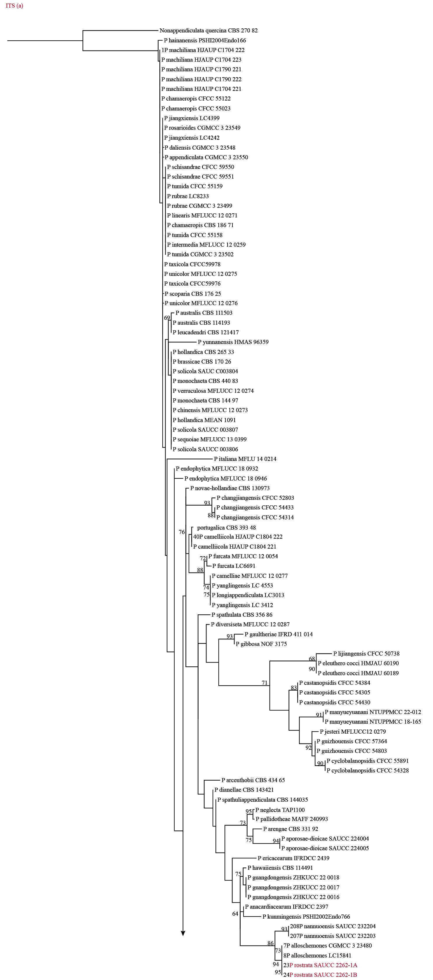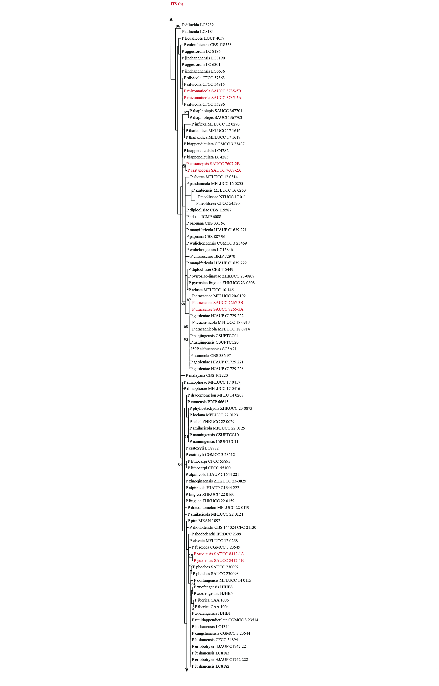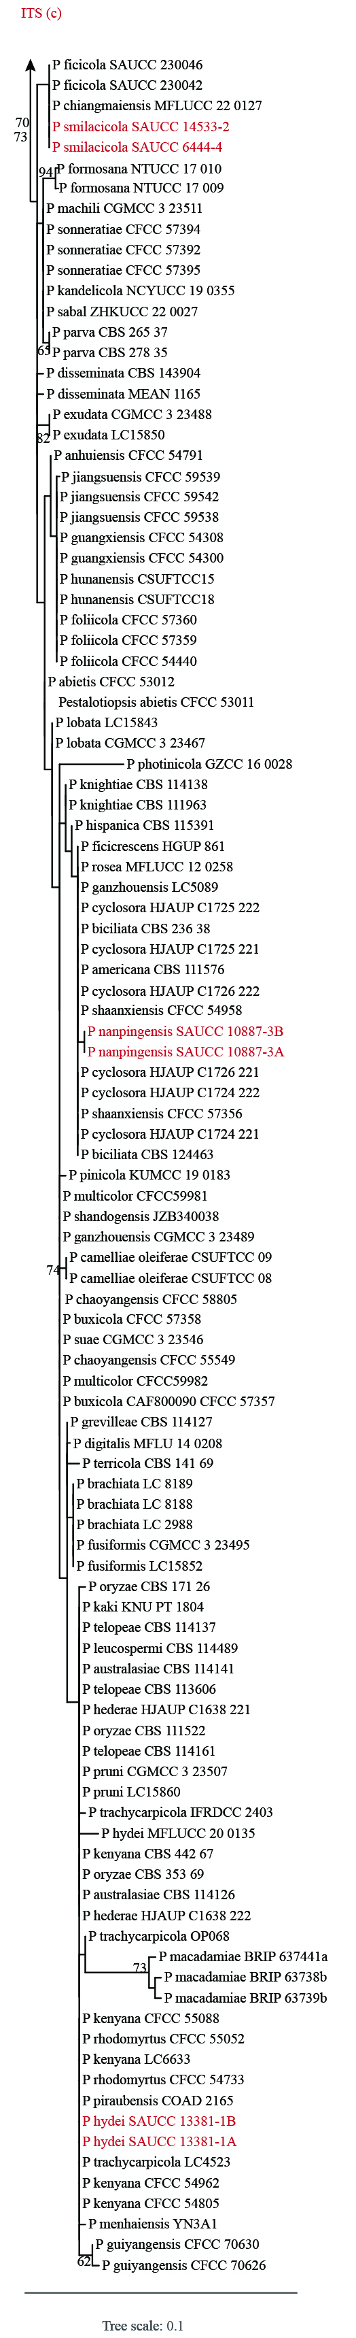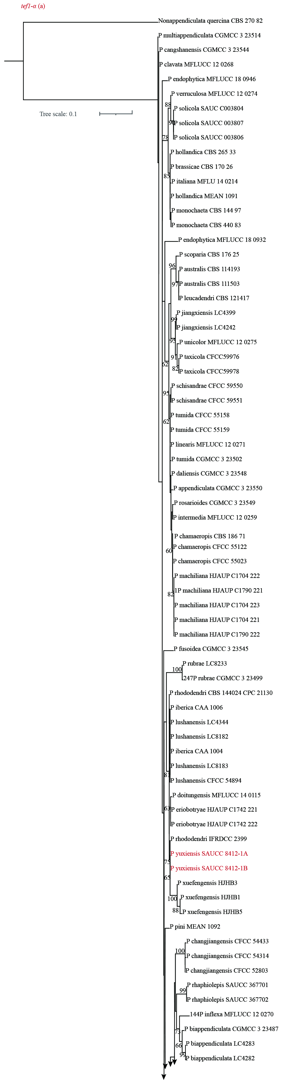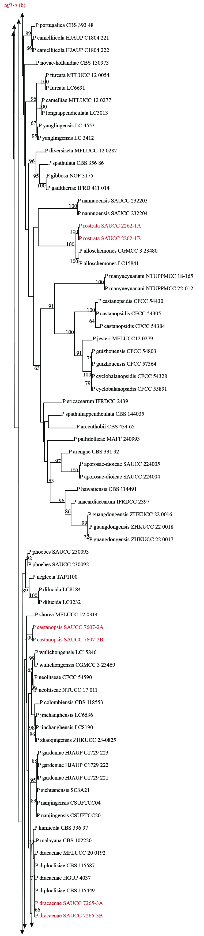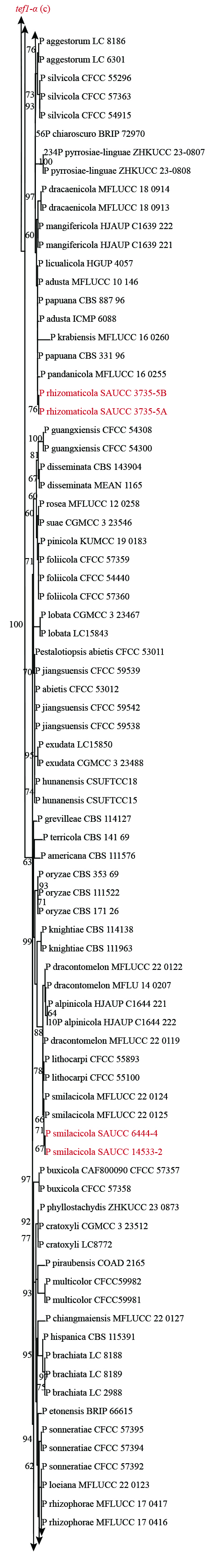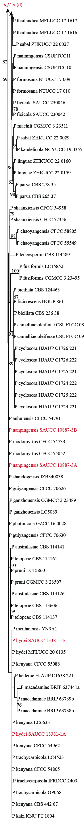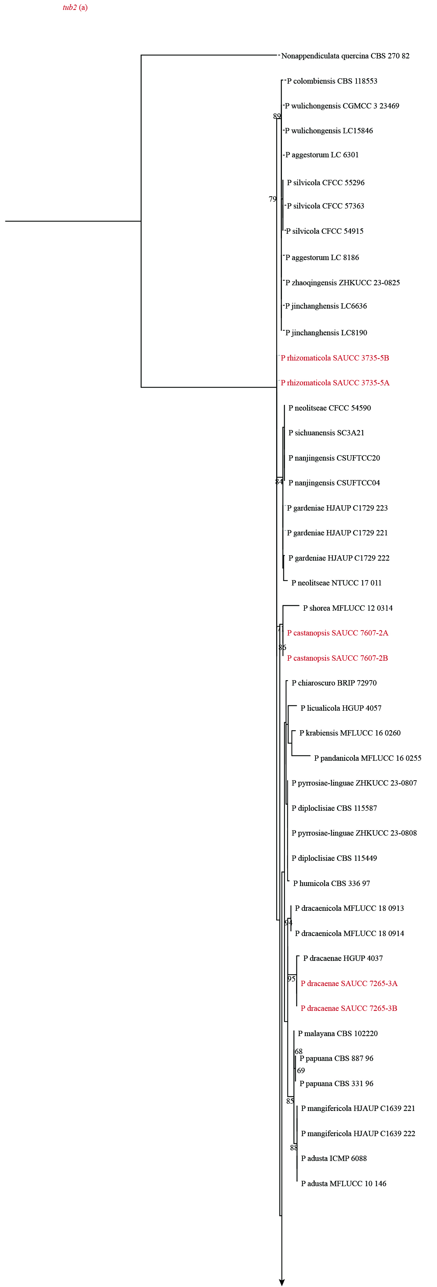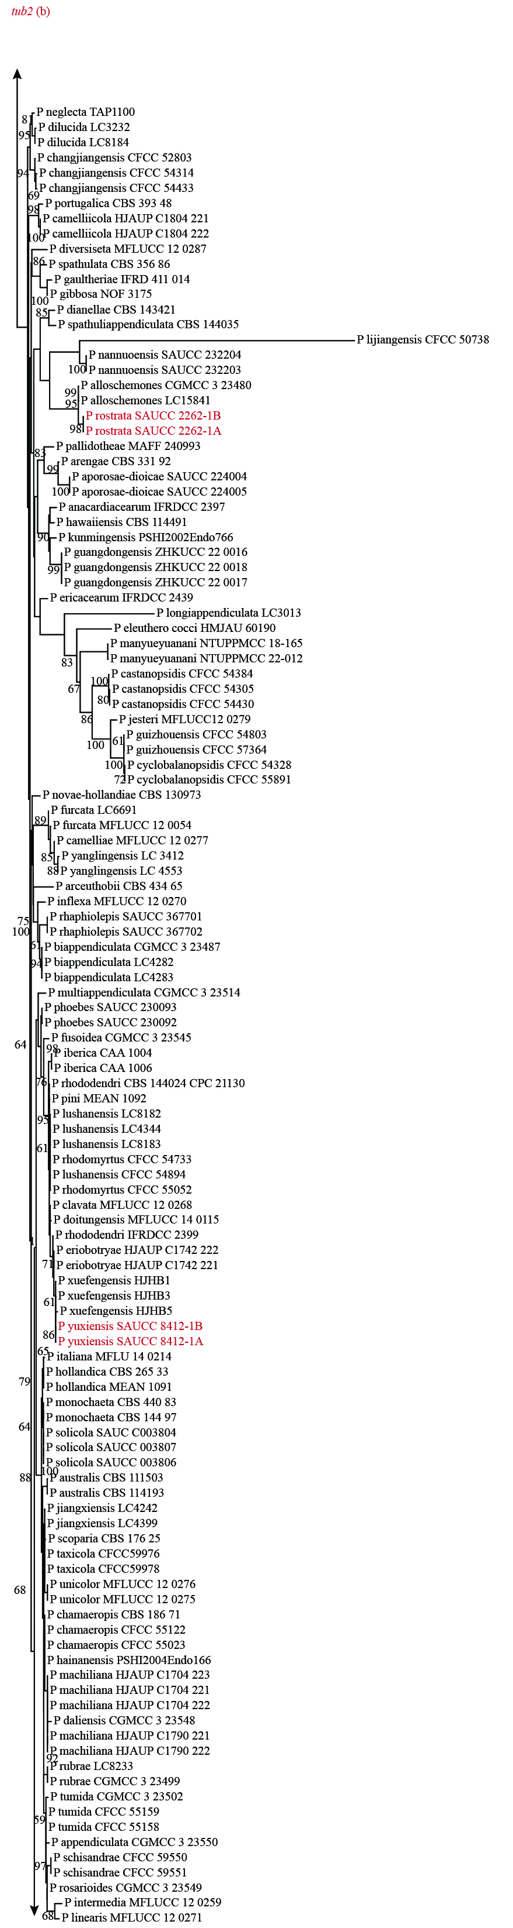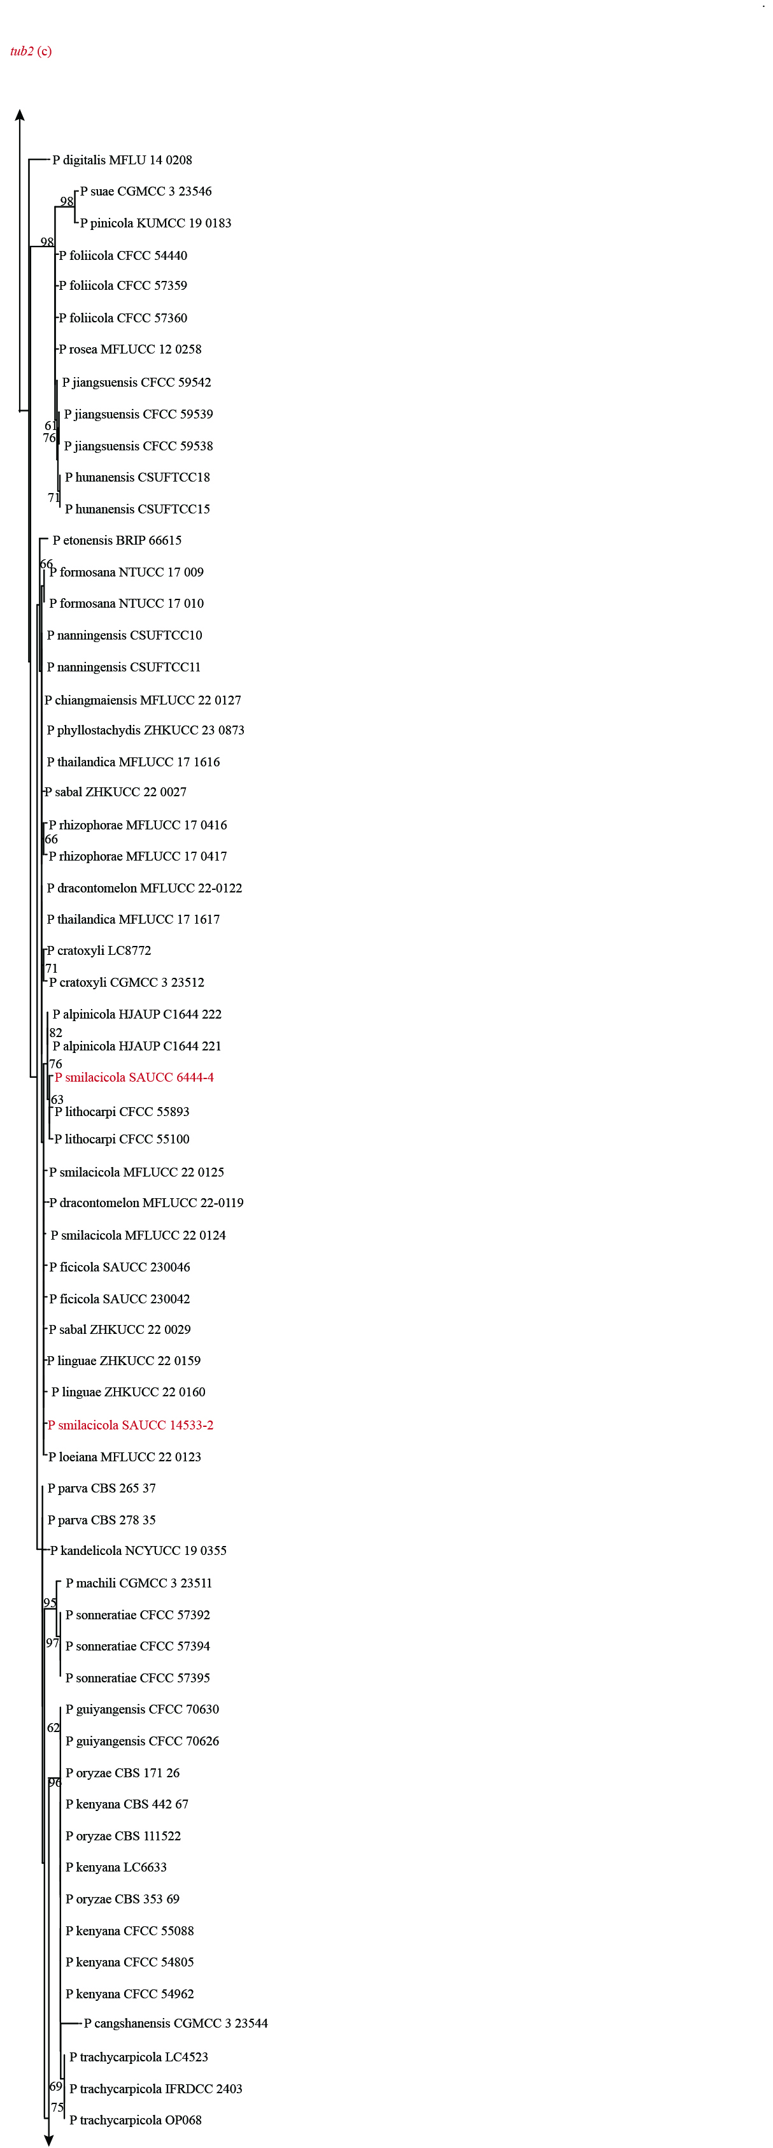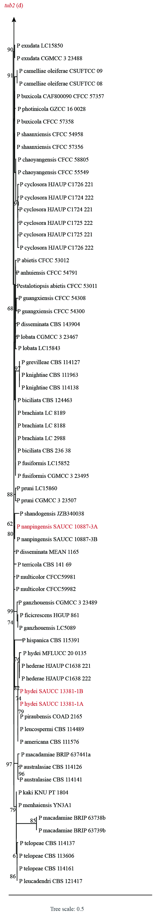
Supplementary Information 13: Single-locus phylograms of the genus Pestalotiopsis based on alignments of the ITS, tef1-α, and tub2 regions, respectively. Each tree is rooted with Nonappendiculata quercina as the outgroup. The Maximum Likelihood Bootstrap Value (MLBV ≥ 60%) are shown above the nodes. Strains isolated in this study were indicated in red.

