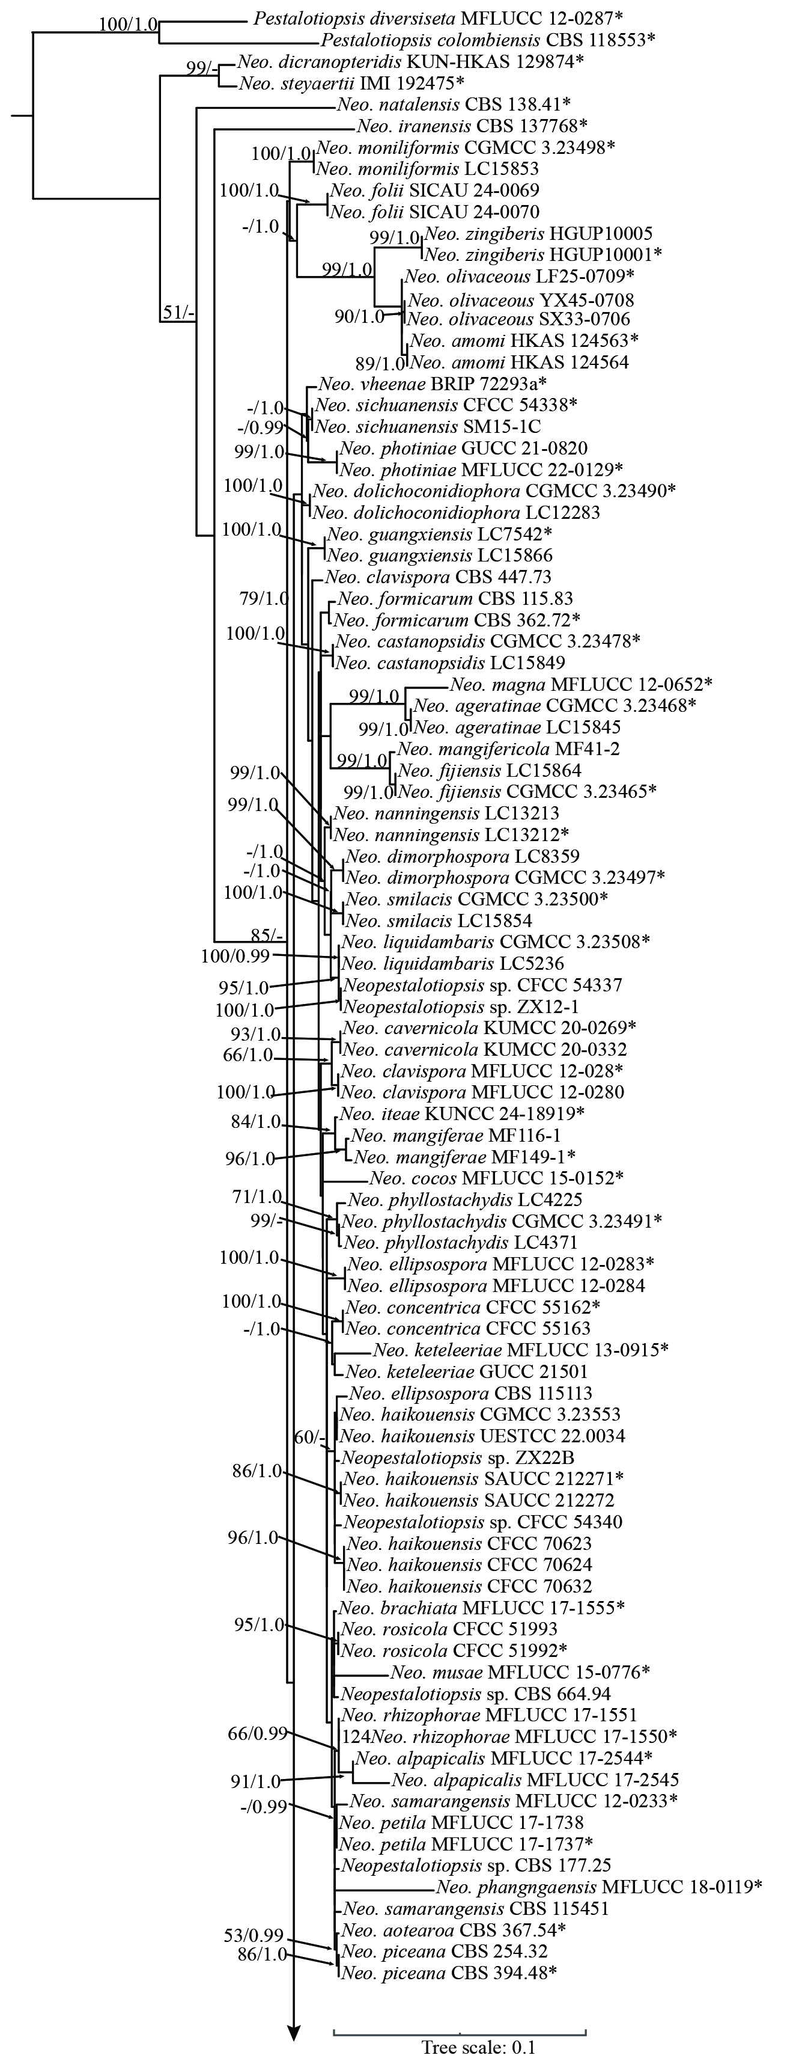
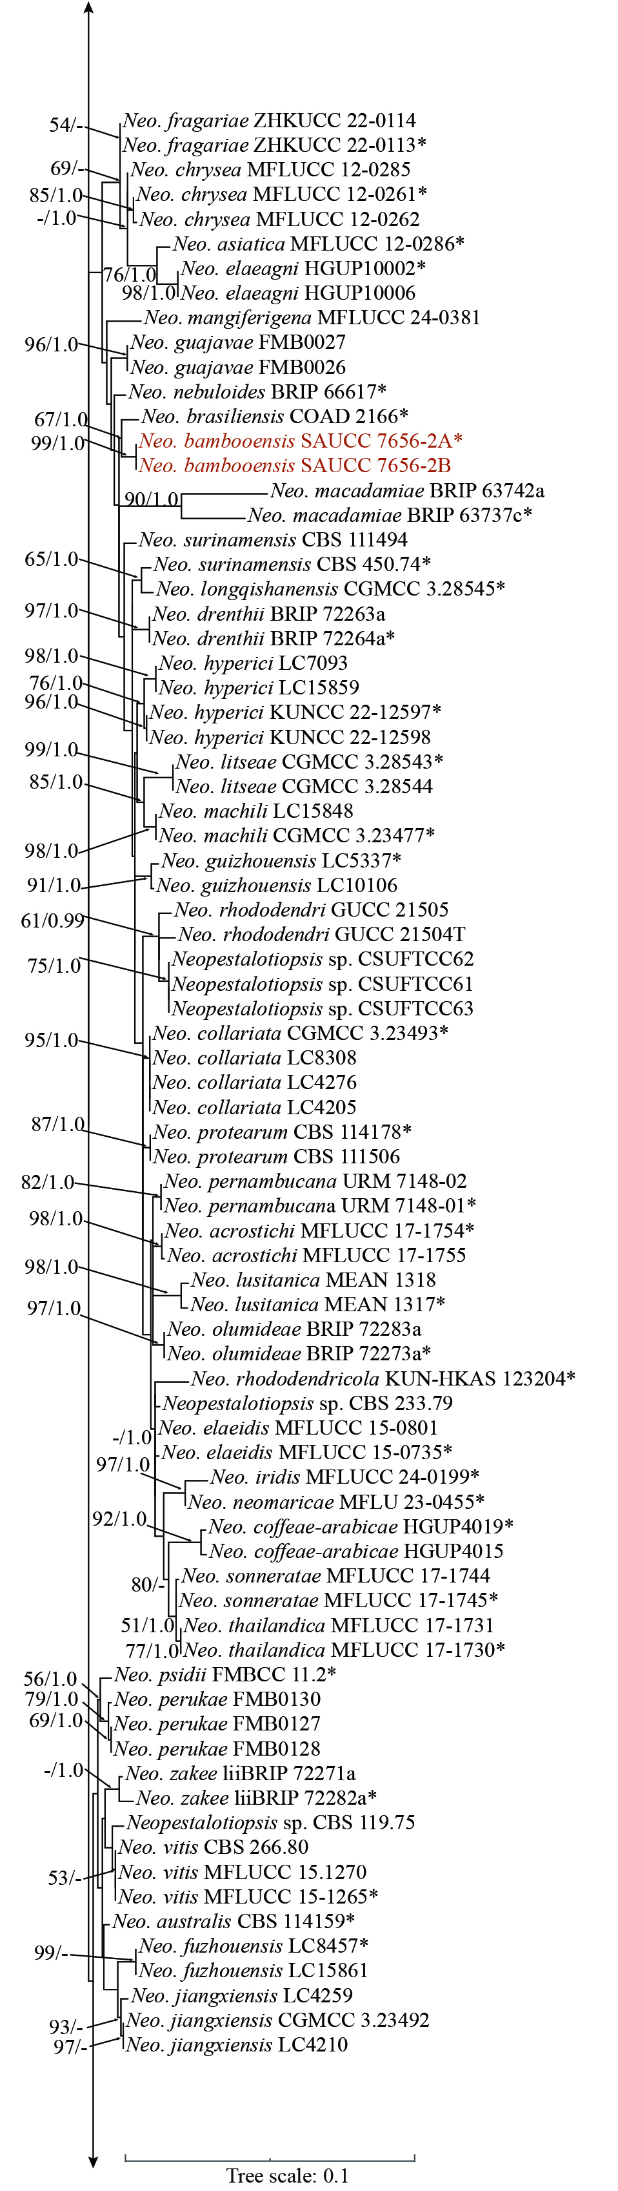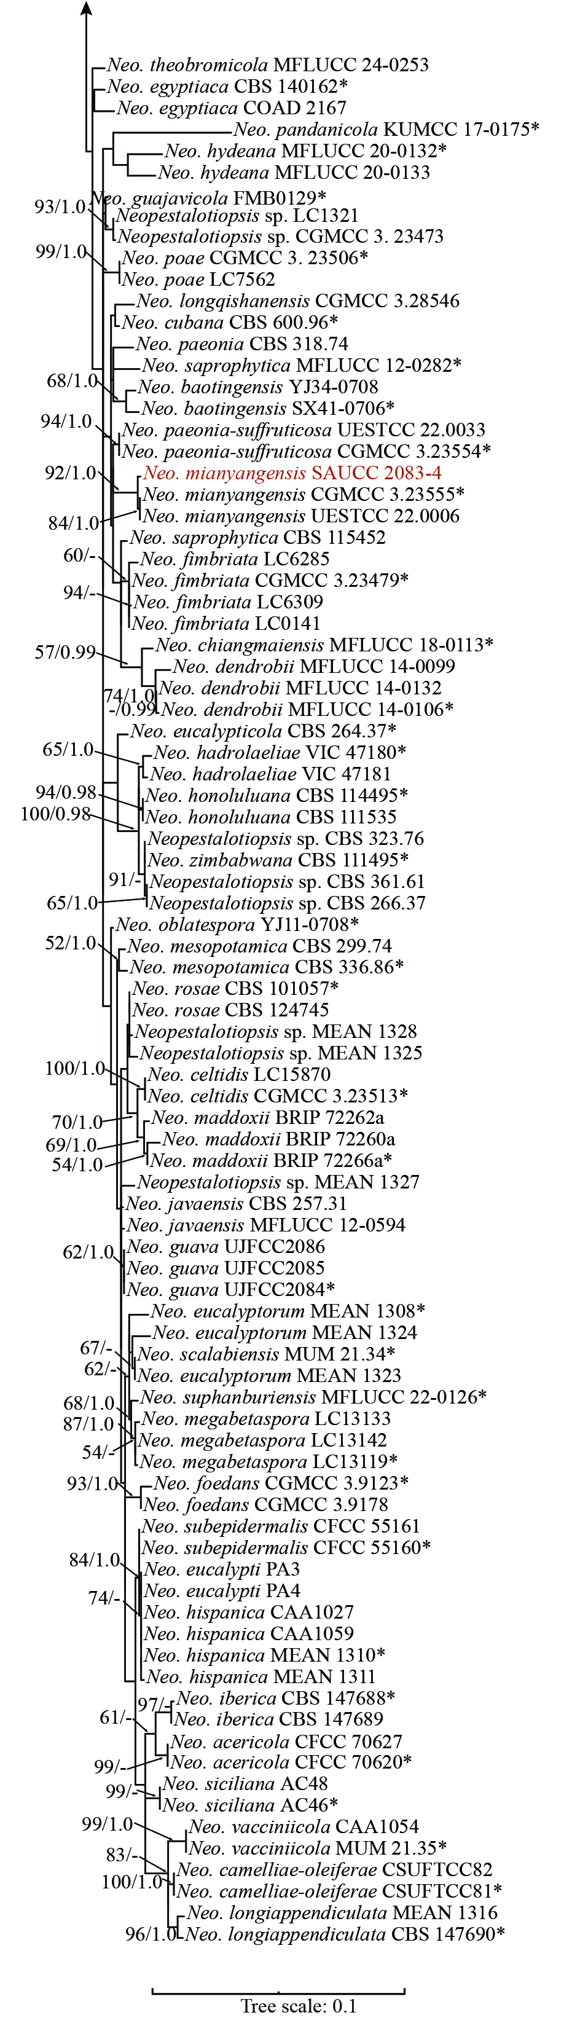
Supplementary Information 12. Phylogram of the genus Neopestalotiopsis based on a concatenated ITS, tef1-α, and tub2 sequence alignment, with Pestalotiopsis colombiensis and P. diversiseta serving as outgroups. The Bayesian Inference Posterior Probability (right, BIPP ≥ 0.90) and the Maximum Likelihood Bootstrap Value (left, MLBV ≥ 50%) are shown as MLBV/BIPP above the nodes. Those marked “*” in the tree are represented as ex-type or ex-epitype strains. Strains isolated in this study were indicated in red. The scale bar at the bottom indicates 0.1 substitutions per site.

