Supplementary Information 1. Details of known species.
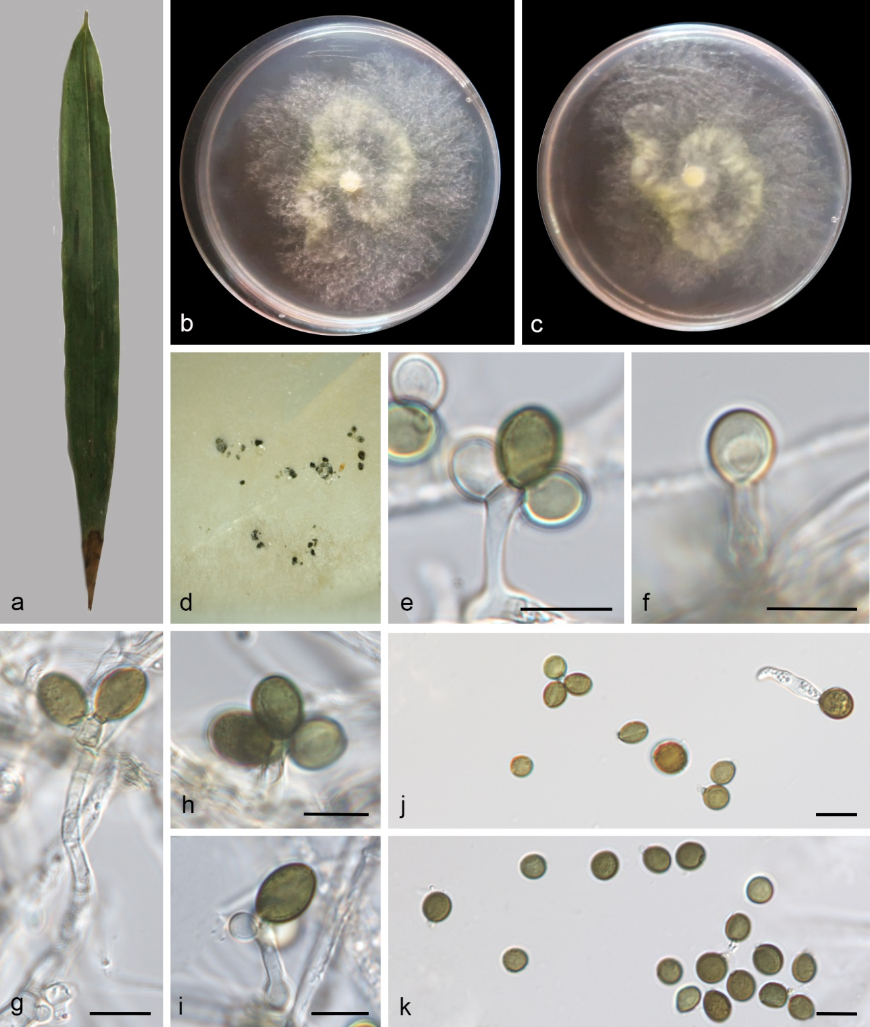
Figure S1. Apiospora adinandrae (SAUCC 11044-2, new host record). a Leaf of host plant. b–c Colonies on PDA after incubation for 7 days from above (b) and below (c). d Conidiomata formed in culture. e–f, h–i Conidiogenous cells giving rise to conidia. g Conidiophores with conidiogenous cells and conidia. j–k Conidia. Scale bars: 10 μm (e–k).

Apiospora adinandrae X.Y. Liu, Z.X. Zhang and X.G. Zhang, Journal of Fungi 10 (1, no. 74): 6 (2024) Figs. 1, S1
Asexual morph: hyphae 1.5–4.2 μm diameter, micronematous, hyaline, branched, thick-walled, guttulate, septate. Conidiophores 97.83–101.85 × 2.68–3.33 µm (av. = 99.8 × 3.00 µm), erect, solitary, subcylindrical, branched, straight or slightly flexuous, hyaline, verrucose, sometimes reduced to conidiogenous cells. Conidiogenous cells 4.91–15.93 × 2.09–3.87 μm (av. = 10.66 ± 3.68 × 3.02 ± 0.66 μm), arising from hyphae, holoblastic and polyblastic, hyaline, cylindrical, straight or flexuous, aseptate, smooth-walled. Conidia 5.83–9.31 × 4.28–7.32 µm (av. = 7.61 ± 0.81 × 5.74 ± 0.92 μm, n = 24), globose, subglobose to ovoid, aseptate, hyaline to dark brown when mature, with an equatorial germ-slit.
Culture characteristics – On the PDA, the colony surfaces pale yellow in the centre, white at the margin, colony margin undulate, aerial mycelia scant and reverse pale yellow in the centre, white at the margin. Colonies on PDA grown in the dark reaching 69.80–75.11 mm diam after 7 d at 25 °C.
Material examined – CHINA, Fujian Province, Wuyishan City, Da'anyuan Eco-Tourism Area (27.873682 N, 117.856120 E, 496 m), on diseased bamboo leaves (Poaceae sp.), 20 October 2024, M.Y. Zhang (HSAUP 11044-2), living cultures SAUCC 11044-2; ibid., on diseased leaves of Ficus heteromorpha, 20 October 2024, Q.Y. Liu (HSAUP 11949-1), living cultures SAUCC 11949-1.
Distribution – China, Fujian and Hainan Provinces.
Ecology – Associated with diseased leaves of Adinandra glischroloma, bamboo (Poaceae sp.), and Ficus heteromorpha.
Notes – Existing strains of Apiospora adinandrae and our isolates clustered in the phylogenetic tree. Our strains and A. adinandrae (SAUCC 1282B-1, ex-type) have few nucleotide differences. Morphologically, our isolates are similar to A. adinandrae by its conidia shape and hyphae diameter (1.5–4.2 μm vs. 2.5–4.0 µm). However, the conidial size of SAUCC 11044-2 is smaller than that of the SAUCC 1282B-1 (5.83–9.31 × 4.28–7.32 µm vs. 7.5–12.4 × 6.3–10.5 µm). These morphological variations may be attributable to varying environmental conditions ^{[59]}. SAUCC 1282B-1 and SAUCC 1282B-2 were isolated from Adinandra glischroloma in Fujian Province; SAUCC 11044-2 and SAUCC 11949-1 were collected from bamboo (Poaceae sp.) and Ficus heteromorpha, respectively, Fujian Province, China, serving as new host records ^{[60]}.
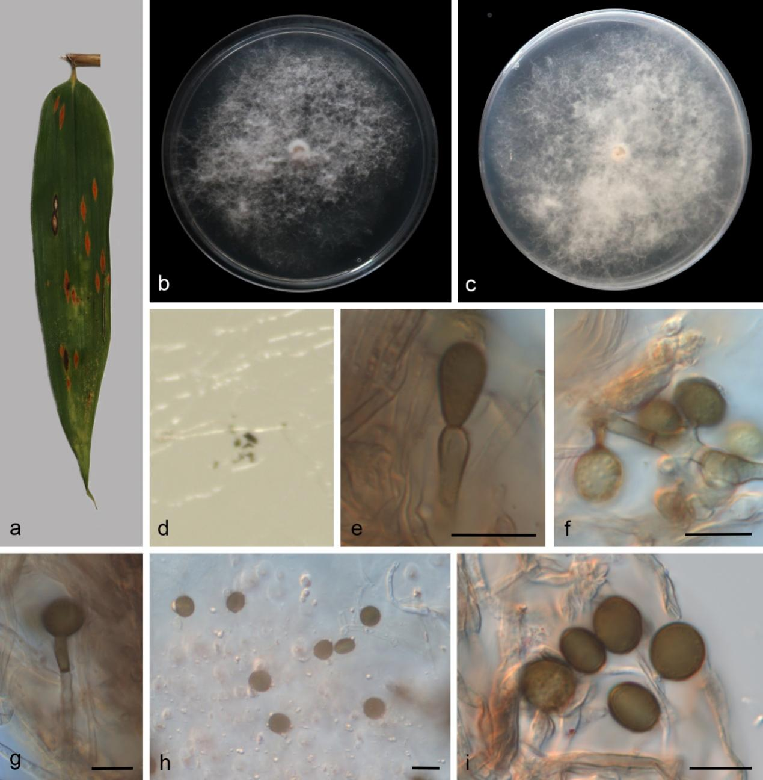
Figure S2. Apiospora arecacearum (SAUCC 8215-2, new host and geographical records). a Leaf of host plant. b–c Colonies on PDA after incubation for 7 days from above (b) and below (c). d Conidiomata formed in culture. e–f Conidiogenous cells giving rise to conidia. g Conidiophores with conidiogenous cells and conidia. h–i Conidia. Scale bars: 10 μm (e–i).

Apiospora arecacearum L.S. Dissan., K.D. Hyde & J.C. Kang, Mycosphere 15 (1): 1675–1793 (2024) Figs. 1, S2
On PDA. Asexual morph: hyphae 2.2–4.2 μm diameter, hyaline to pale brown, sometimes branched, thick-walled, septate. Conidiophores 36.59–45.59 × 2.71–3.56 µm (av. = 41.41 ± 4.19 × 3.05 ± 0.37 μm), erect, solitary, cylindrical, unbranched, straight or flexuous, hyaline to pale brown. Conidiogenous cells 2.43–17.63 × 2.31–3.40 µm (av. = 8.89 ± 4.81 × 2.87 ± 0.32 μm) arising from hyphae or conidiophores, holoblastic, hyaline to brown, cylindrical, straight or flexuous, aseptate, smooth-walled. Conidia 7.14–9.33 × 4.62–8.59 µm (av. = 8.04 ± 0.59 × 6.95 ± 0.93 μm, n = 19), globose to subglobose, aseptate, pale brown to dark brown, guttulate, with an equatorial germ-slit.
Culture characteristics – On the PDA, the colony surfaces are white, flat, floccose, aerial mycelia scant and reverse white. PDA attaining 90 mm in diameter after 7 days at 25 °C.
Material examined – CHINA, Yunnan Province, Yuxi City, Hongta District, Bailongtan Park (24.401241 N, 102.591765 E, 1707 m), on diseased leaves of Pseudosasa japonica, 12 May 2024, Q.Y. Liu (HSAUP 8215-2), living cultures SAUCC 8215-2.
Distribution – China, Sichuan and Yunnan Provinces.
Ecology – Associated with leaves of Pseudosasa japonica and Trachycarpus fortune.
Notes – Existing strains of Apiospora arecacearum and our isolate (SAUCC 8215-2) clustered with good support in the phylogenetic tree. Our strain (SAUCC 8215-2) and A. arecacearum (KUNCC 23-15554, ex-type) showed nucleotide differences in the ITS (2/500 bp), LSU (2/785 bp), tef1-α (0/389 bp), and tub2 (3/380 bp) gene regions. Morphologically, our isolate is similar to A. arecacearum by its conidia (7.14–9.33 × 4.62–8.59 µm, globose to subglobose, with an equatorial germ-slit vs. 8–11 μm diameter, globose to subglobose, with an equatorial germ-slit). Thus, we consider the isolated strain as A. arecacearum. Apiospora arecacearum was isolated from Trachycarpus fortune (Arecaceae), in Sichuan Province, China ^{[61]}. Our isolate was isolated from Pseudosasa japonica in Yunnan Province, China. Therefore, our strain represents a new host and geographical records.
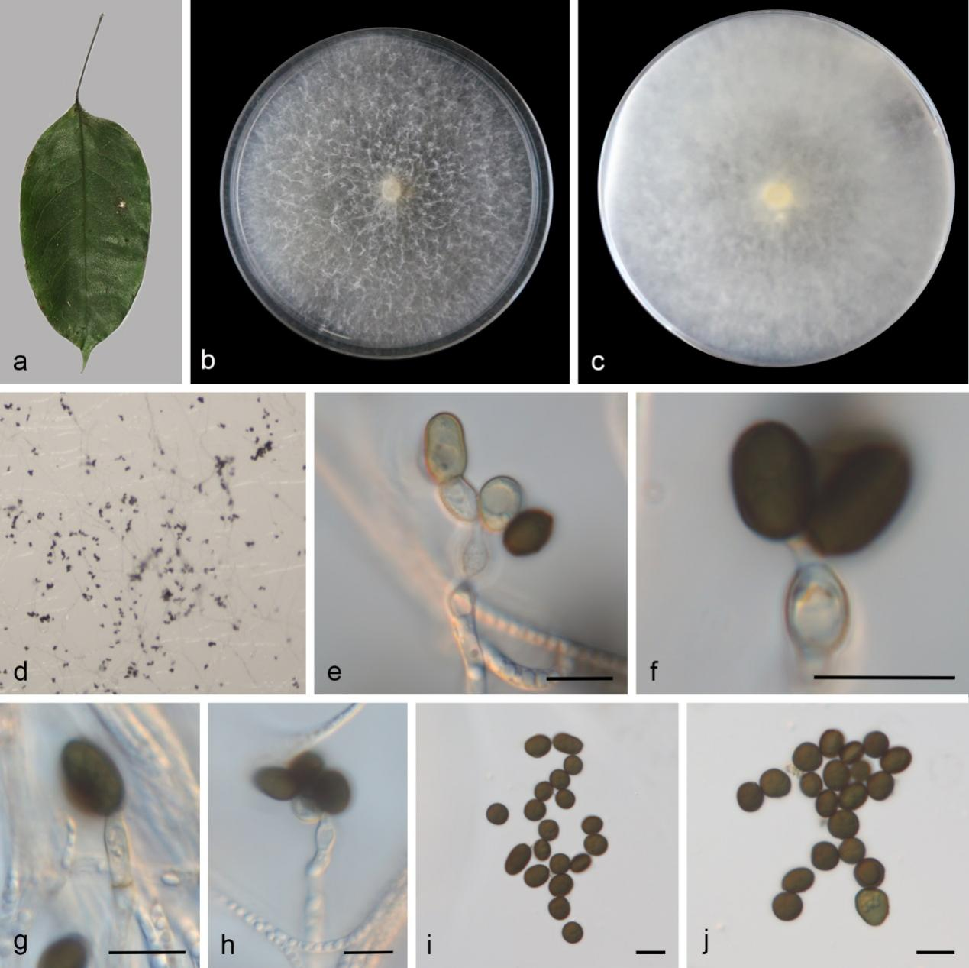
Figure S3. Apiospora babylonica (SAUCC 6480-1B, new host and geographical records). a Leaf of host plant. b–c Colonies on PDA after incubation for 7 days from above (b) and below (c). d Conidiomata formed in culture. f–g Conidiogenous cells giving rise to conidia. e, h Conidiophores with conidiogenous cells and conidia. i–j Conidia. Scale bars: 10 μm (e–j).

Apiospora babylonica H. Sheng, Z.X. Zhang & X.G. Zhang, Microorganisms 12: 1372 (2024)
Figs. 1, S3
Asexual morph: On WA, hyphae 1.46–3.24 μm diameter, micronematous, hyaline, sometimes branched, thick-walled, septate, guttulate. Conidiophores 67.68–119.49 × 2.84–3.88 µm (av. = 94.4 × 3.22 µm, n = 15), erect, solitary, subcylindrical, unbranched, straight or flexuous, hyaline, verrucose, sometimes reduced to conidiogenous cells. Conidiogenous cells 4.91–13.42 × 3.47–4.89 µm (av. = 9.63 ± 2.80 × 4.09 ± 0.55 μm, n = 17), holoblastic or polyblastic, hyaline, cylindrical or ampulliform, straight or flexuous, aseptate, smooth-walled. Conidia 6.66–12.60 × 4.94–8.10 µm (av. = 8.36 ± 1.38 × 6.83 ± 0.82 μm, n = 20), globose to cylindrical, aseptate, dark brown, guttulate, with an equatorial germ-slit.
Culture characteristics – On the PDA, the colony surfaces and reverse white, colony margin entire, filiform and reverse white. On PDA incubated at 25°C, colonies grew rapidly, reaching a diameter of 90 mm within 7 days (average growth rate: 12.9 mm per day).
Material examined – CHINA, Hainan Province, Changjiang Li Autonomous County, Bawangling National Forest Park (19.0859333 N, 109.122752 E, 462 m), on leaves of Argyreia acuta, 14 October 2023, W.W. Liu (HSAUP 6480-1B), living cultures SAUCC 6480-1B; CHINA, Hainan Province, Diaoluo Mountain National Forest Park (18.660546 N, 109.936445 E, 94 m), on diseased bamboo leaves (Poaceae sp.), 27 March 2024, M.Y. Zhang (HSAUP 7580-6), living cultures SAUCC 7580-6; CHINA, Hainan Province, Diaoluo Mountain National Forest Park (18.660546 N, 109.936445 E, 94 m), on diseased bamboo leaves (Poaceae sp.), 27 March 2024, Q.Y. Liu (HSAUP 7634-3), living cultures SAUCC 7634-3; CHINA, Hainan Province, Diaoluo Mountain National Forest Park (18.660546 N, 109.936445 E, 94 m), on diseased bamboo leaves (Poaceae sp.), 27 March 2024, Q.Y. Liu (HSAUP 7641-2), living cultures SAUCC 7641-2; CHINA, Hainan Province, Diaoluo Mountain National Forest Park (18.660546 N, 109.936445 E, 94 m), on diseased bamboo leaves (Poaceae sp.), 27 March 2024, Q.Y. Liu (HSAUP 7634-2), living cultures SAUCC 7634-2; CHINA, Hainan Province, Diaoluo Mountain National Forest Park (18.660546 N, 109.936445 E, 94 m), on diseased bamboo leaves (Poaceae sp.), 27 March 2024, Q.Y. Liu (HSAUP 7436-3), living cultures SAUCC 7436-3.
Distribution – China, Hainan and Shandong Provinces.
Ecology – Associated with leaves of Argyreia acuta, bamboo, and Salix babylonica.
Notes – Existing strains of Apiospora piptatheri and our isolates clustered in the phylogenetic tree. Our strains and A. piptatheri (MFLUCC 11-0481, ex-type) have few nucleotide differences. Morphologically, our isolates are similar to A. piptatheri by its conidia and conidiogenous cells. SAUCC DL1841 was isolated from Salix babylonica in Shandong Province ^{[62]}. Our strains were isolated from Argyreia acuta and bamboo in Hainan Province, China. Serving as new host and geographical records.
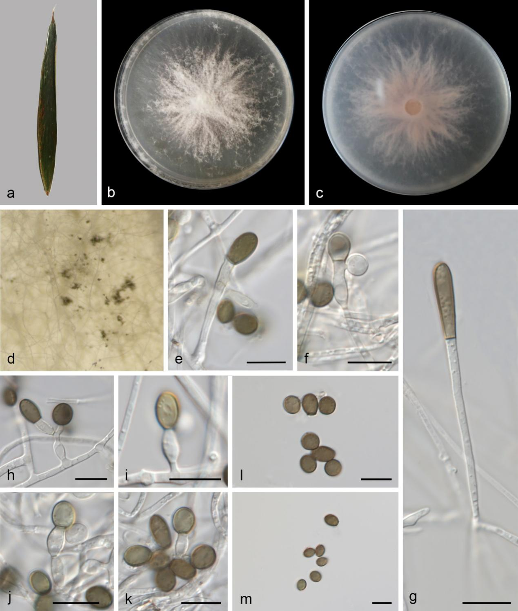
Figure S4. Apiospora bambusicaulis (SAUCC 7555-1, new geographical record). a Leaf of host plant. b–c Colonies on PDA after incubation for 7 days from above (b) and below (c). d Conidiomata formed in culture. e, g Conidiophore giving rise to conidia. f, h, j Conidiophores with conidiogenous cells and conidia. i, k Conidiogenous cells giving rise to conidia. l–m Conidia. Scale bars: 10 μm (e–m).

Apiospora bambusicaulis K.M. Yu & Y.L. Jiang, MycoKeys 112: 233–252 (2025) Figs. 1, S4
On diseased bamboos leaves. Asexual morph: hyphae 1.1–2.8 μm diameter, micronematous, hyaline, branched, thick-walled, septate. Conidiophores 13.67–55.38 × 1.93–3.06 µm (av. = 32 × 2.4 µm, n = 16), micronematous, erect, solitary, subcylindrical, branched, straight or flexuous, hyaline, smooth-walled, sometimes reduced to conidiogenous cells. Conidiogenous cells 2.96–13.68 × 1.74–4.11 µm (av. = 8.41 ± 2.54 × 3.22 ± 0.57 μm, n = 22), holoblastic or polyblastic, hyaline, cylindrical, straight, aseptate, smooth-walled. Conidia 5.47–15.53 × 3.42–6.64 µm (av. = 8.22 ± 2.79 × 5.17 ± 0.85 μm, n = 28), globose, ellipsoidal or cylindric-clavate, aseptate, hyaline to dark brown when mature, smooth.
Culture characteristics – On the PDA, the colony surfaces are white, flat, radiating outwards, irregular edge, the mycelia white, reverse pink. PDA attaining 61 mm in diameter after 7 days at 25 °C, growth rate 8.7 mm/day.
Material examined – CHINA, Hainan Province, Diaoluoshan National Forest Park (18.660546 N, 109.936445 E, 94 m), on diseased leaves of Arundinaria gigantean, 27 March 2024, Q.Y. Liu (HSAUP 7555-1), living cultures SAUCC 7555-1; ibid., Qiongzhong Li and Miao Autonomous County, Baihualing Tropical Rainforest Tourist and Cultural Area (19.005802 N, 109.825167 E, 392 m), on diseased leaves of Bambusa ventricosa, 03 December 2024, Q.Y. Liu (HSAUP 14311-1), living cultures SAUCC 14311-1; ibid., Lingshui Li Autonomous County, Diaoluo Mountain (18.725571 N, 109.868524 E, 923 m), on diseased leaves of Sasaella masamuneana, 06 March 2025, Q.Y. Liu (HSAUP 16722-1), living cultures SAUCC 16722-1.
Distribution – CHINA, Hainan and Guizhou Provinces.
Ecology – Associated with diseased bamboo branch, diseased leaves of Arundinaria gigantean, Bambusa ventricosa, and Sasaella masamuneana.
Notes – Apiospora bambusicaulis (strains GUCC17.41 and GUCC17.42) was reported from diseased bamboo branch in Guizhou Province, China ^{[63]}. In the present study, three strains (SAUCC 7555-1, SAUCC 14311-1, and SAUCC 16722-1) are clustered with A. bambusicaulis clade in the combined phylogenetic tree (Fig. 1). SAUCC 7555-1, SAUCC 14311-1, and SAUCC 16722-1 were similar to the A. bambusicaulis (GUCC17.41, ex-type) in LSU (100%, 100%, and 100%, respectively), tub2 (99.16%, 99.49%, and 99.49%, respectively), tef1-α (99.76%, 99.28%, and 100%, respectively) sequences. Morphologically, our strains closely resembled A. bambusicaulis (GUCC17.41, ex-type) in conidiogenous cells (2.96–13.68 × 1.74–4.11 µm vs. 1.5–3.5 × 2–13.5 µm). However, the conidial size of SAUCC 7555-1 is loner than that of the GUCC17.41 (5.47–15.53 µm vs. 4.5–6) ^{[63]}. These morphological variations may be attributable to varying environmental conditions ^{[59]}. Thus, this study is the first report of Apiospora bambusicaulis in Hainan.
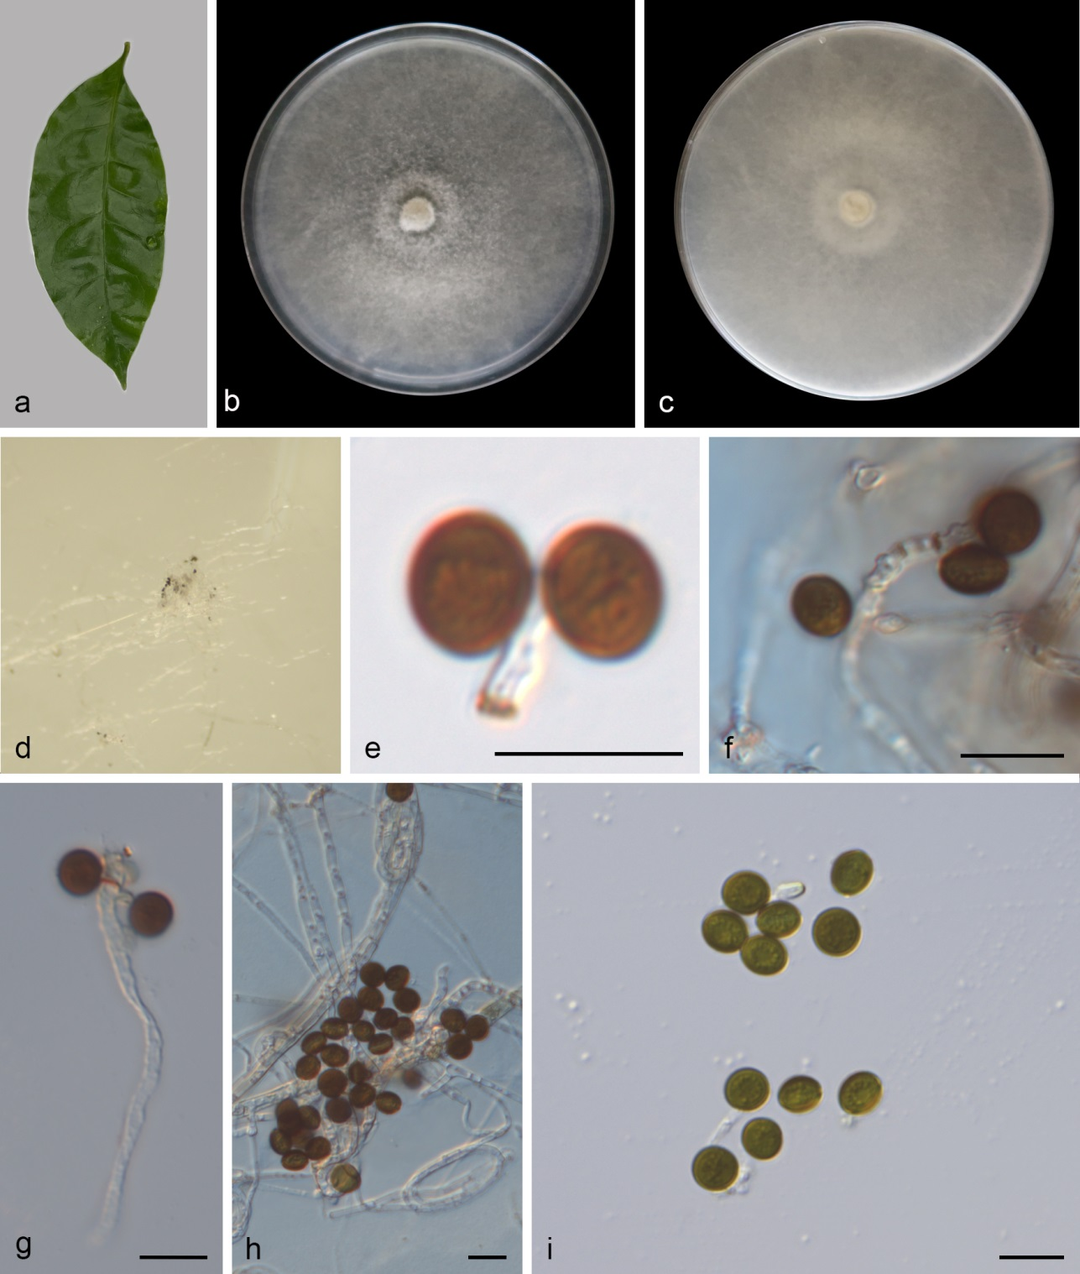
Figure S5. Apiospora chiangraiense (SAUCC 2372-1, new host and geographical records). a Leaf of host plant. b–c Colonies on PDA after incubation for 7 days from above (b) and below (c). d Conidiomata formed in culture. e Conidiogenous cells bearing conidia. f–g Conidia with conidiophores. h–i Conidia. Scale bars: 10 μm (e–i).

Apiospora chiangraiense X.G. Tian & Tibpromma S, Life 11: 1071 (2021) Figs. 1, S5
On leaves of Evodia lepta. Asexual morph: hyphae 1.4–7.2 μm diameter, micronematous, hyaline, branched, thick-walled, septate. Conidiophores 23.89–57.36 × 2.51–3.32 µm (av. = 33.99 ± 13.47 × 2.72 ± 0.35 µm, n = 12), micronematous, mononematous, erect, solitary, subcylindrical, unbranched, straight or flexuous, hyaline, smooth-walled, sometimes reduced to conidiogenous cells. Conidiogenous cells 3.69–7.93 × 2.11–4.73 µm (av. = 5.60 ± 1.65 × 2.87 ± 0.93 μm, n = 18) arising from hyphae, polyblastic, hyaline to light brown, cylindrical, straight, aseptate, smooth-walled. Conidia 6.40–8.80 × 4.70–7.72 µm (av. = 7.45 ± 0.67 × 6.19 ± 0.84 μm, n = 27), globose to subglobose, aseptate, dark brown, with an equatorial germ-slit.
Culture characteristics – On the PDA, the colony surfaces are yellowish-gray, flat, with abundant aerial mycelia and reverse yellowish-gray. After 7 days at 25 °C, the colony on PDA attained 90 mm in diameter.
Material examined – CHINA, Yunnan Province, Menghai County, Nannuo Mountain (21.923863 N, 100.594751 E, 1876 m), on leaves of Evodia lepta, 18 March 2023, D.H. Li (HSAUP 2372-1), living cultures SAUCC 2372-1.
Distribution – CHINA (Yunnan Province) and Thailand.
Ecology – Associated with diseased diseased leaves of bamboo (Poaceae sp.) and leaves of Evodia lepta.
Notes – In this paper, our new isolate (SAUCC 2372-1) clustered with the ex-type strain of A. chiangraiense. Morphologically, new isolate (SAUCC 2372-1) is similar to A. chiangraiense (MFLU 21-0046, ex-type) in having similar size of conidiogenous cells (3.69–7.93 × 2.11–4.73 µm vs. 4–7.5 × 3–4 µm) that are arising from hyphae, polyblastic, hyaline to light brown, cylindrical, straight, smooth-walled. Based on nucleotide comparisons, A. chiangraiense (SAUCC 2372-1) is slightly different from A. chiangraiense (MFLU 21-0046, ex-type) in 1/479 bp (0.21%) of the ITS, 1/802 bp (0.12%) of the LSU, and 2/383 bp (0.52%) of tub2. Thus, the new isolate (SAUCC 2372-1) is identified as A. chiangraiense ^{[64]}.This is the first report of A. chiangraiense (SAUCC 2372-1) isolated from leaves of Evodia lepta in China, which was originally isolated from bamboo in Thailand.
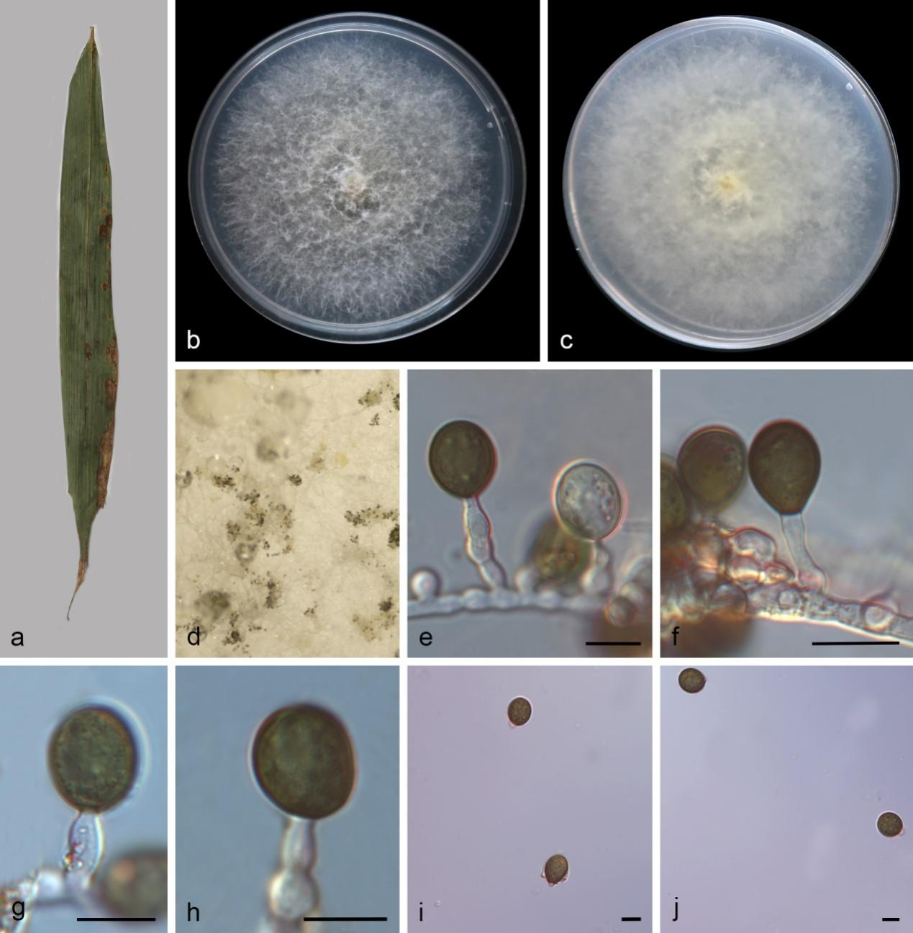
Figure S6. Apiospora dematiacea (SAUCC 17334-2, new host and geographical records). a Leaf of host plant. b–c Colonies on PDA after incubation for 7 days from above (b) and below (c). d Conidiomata formed in culture. e–h Conidiogenous cells giving rise to conidia. i–j Conidia. Scale bars: 10 μm (e–j).

Apiospora dematiacea C.F. Liao & Doilom, Journal of Fungi 9 (no. 1087): 10 (2023) Figs. 1, S6
On diseased bamboos leaves. Asexual morph: hyphae 1.8–4.9 μm diameter, hyaline, sometimes branched, thick-walled, septate. Conidiophores reduced to conidiogenous cells. Conidiogenous cells 9.77–28.39 × 3.05–4.39 µm (av. = 15.59 ± 6.31 × 3.91 ± 0.47 μm, n = 17) arising from hyphae, holoblastic, hyaline, cylindrical, straight or flexuous, aseptate, smooth-walled. Conidia 11.31–15.66 × 10.38–13.16 µm (av. = 14.04 ± 1.31 × 11.77 ± 0.81 μm, n = 25), globose to ellipsoidal, aseptate, hyaline to dark brown when mature, smooth.
Culture characteristics – On the PDA, the colony surfaces are white, flat, filiform, with abundant aerial mycelia and reverse white to pale yellow. On PDA incubated at 25°C, colonies grew rapidly, reaching a diameter of 82 mm within 7 days (average growth rate: 11.7 mm per day).
Material examined – CHINA, Guangdong Province, Shaoguan City, Renhua County, Xiafu Nuan Keng Village (25.004042 N, 113.676879 E, 90.6 m), on diseased bamboo leaves (Poaceae sp.), 3 May 2025, Q.Y. Liu (HSAUP 17334-2), living cultures SAUCC 17334-2.
Distribution – CHINA, Guangdong and Guizhou Provinces.
Ecology – Associated with Dicranopteris ampla and diseased bamboo leaves (Poaceae sp.).
Notes – Existing strains of A. dematiacea and our isolate (SAUCC 17334-2) clustered in the phylogenetic tree. The nucleotide differences in the ITS, LSU, tef1-α, and tub2 gene regions between our strain and A. dematiacea (HKAS 129910, ex-type) are 0/514 bp, 0/751 bp, 4/374 bp, and 2/379 bp, respectively. Morphologically, our isolate is similar to A. dematiacea by its conidiogenous cells and conidia. Apiospora dematiacea was isolated from Dicranopteris ampla in Guizhou Province ^{[65]}. In this study, we report the first record of A. dematiacea collected from diseased bamboo leaves in Guangdong Province, China.

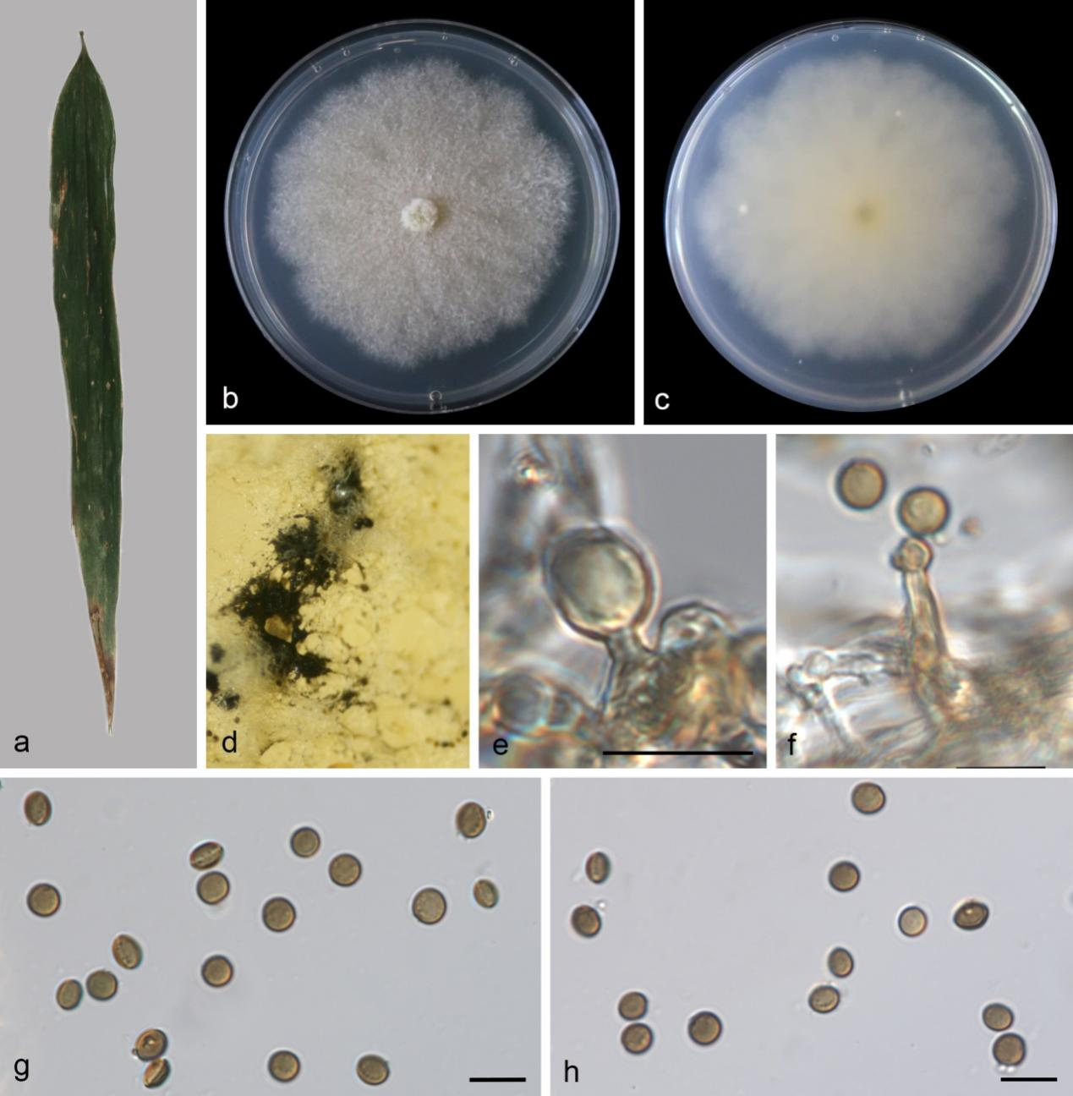
Figure S7. Apiospora guangdongensis (SAUCC 13426-2, new geographical record). a Leaf of host plant. b–c Colonies on PDA after incubation for 7 days from above (b) and below (c). d Conidiomata formed in culture. e Conidiogenous cells giving rise to conidia. f Conidiophores with conidiogenous cells and conidia. g–h Conidia. Scale bars: 10 μm (e–h).

Apiospora guangdongensis J.Y. Zhang & Y.Z. Lu, Journal of Fungi 9 (no. 1096): 12 (2023)
Figs. 1, S7
On diseased leaves of bamboos. Asexual morph: hyphae 2.0–4.3 μm diameter, micronematous, hyaline to pale brown, branched, thick-walled, septate. Conidiophores 11–20 × 1.38–3.26 µm (av. = 49 × 2.5 µm, n = 12), erect, solitary, subcylindrical, unbranched, straight or flexuous, hyaline, smooth-walled, sometimes reduced to conidiogenous cells. Conidiogenous cells 2.69–10.54 × 1.80–3.31 µm (av. = 6.01 ± 3.45 × 2.36 ± 0.67 μm, n = 16) arising from hyphae, holoblastic and monoblastic, hyaline to pale brown, cylindrical, straight, aseptate, smooth-walled. Conidia 5.57–7.19 × 3.60–7.04 µm (av. = 6.37 ± 0.47 × 5.02 ± 0.88 μm, n = 18), globose to ellipsoidal, aseptate, medium brown, smooth with a broad equatorial germ-slit.
Culture characteristics – On the PDA, the colony surfaces are grayish, flat, floccose, with abundant aerial mycelia and reverse pale yellow. After 7 days, colonies on PDA attained a diameter of 75.9 mm at 25 °C.
Material examined – CHINA, Guangxi Zhuang Autonomous Region, Fangchenggang City, Shiwandashan National Forest Park (21.905823 N, 107.903671 E, 277 m), on diseased bamboo leaves (Poaceae sp.), 02 December 2024, Q.Y. Liu (HSAUP 13426-2), living cultures SAUCC 13426-2; CHINA, Guangdong Province, Shaoguan City, Lechang City (25.098040 N, 113.023250 E, 252 m), on dead leaves of bamboo (Poaceae sp.) leaves, 05 March 2025, Q.Y. Liu (HSAUP 17368-4), living cultures SAUCC 17368-4.
Distribution – CHINA, Guangdong Province and Guangxi Zhuang Autonomous Region.
Ecology – Associated with leaves of Wurfbainia villosa and bamboo (Poaceae sp.).
Notes – Apiospora guangdongensis (strains ZHKUCC 23-0004 and ZHKUCC 23-0005) as an endophyte isolated from asymptomatic leaves of Wurfbainia villosa in Guangdong Province, China ^{[66]}. Subsequently, A. guangdongensis (strains KUNCC 24-17544 and KUNCC 24-17545) from dead culms of Poaceae sp. in Yunnan Province, China ^{[61]}. In the present study, two strains (SAUCC 13426-2 and SAUCC 17368-4) are clustered with A. guangdongensis clade in the combined phylogenetic tree (Fig. 1). SAUCC 13426-2 and SAUCC 17368-4 were similar to the A. guangdongensis (ZHKUCC 23-0004, ex-type) in LSU (100% and 100%, respectively), tub2 (99.48% and 99.74%, respectively), tef1-α (98.83% and 100%, respectively) sequences. Morphologically, our strains closely resembled A. guangdongensis (ZHKUCC 23-0004 ex-type) in conidial characteristics, displaying globose to ellipsoidal (5.57–7.19 × 3.60–7.04 µm vs. 6–9 × 5–9 µm in face view and 5–8 × 4–6 µm in side view), aseptate, smooth-walled conidia, all featuring a distinct broad equatorial germ-slit. Apiospora guangdongensis (SAUCC 13426-2) was first recorded in Guangxi Province.
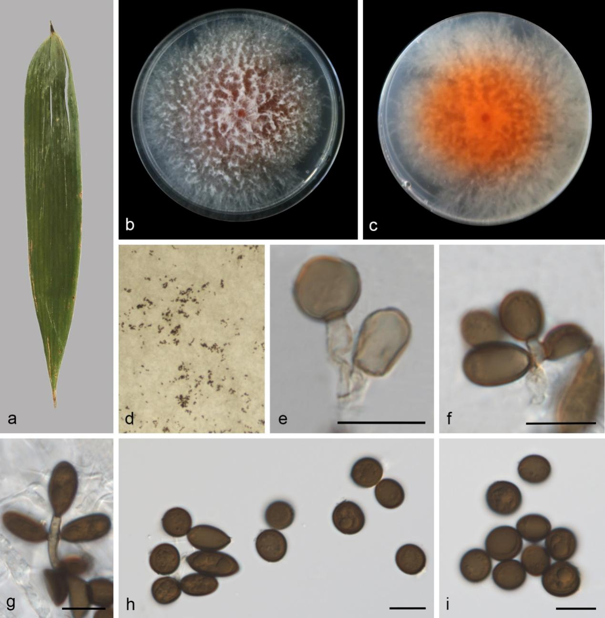
Figure S8. Apiospora hainanensis (SAUCC 14251-2). a Leaf of host plant. b–c Colonies on PDA after incubation for 7 days from above (b) and below (c). d Conidiomata formed in culture. e Conidiogenous cells giving rise to sterile cells. f–g Conidiogenous cells giving rise to conidia. h–i Conidia. Scale bars: 10 μm (e–i).
Apiospora hainanensis R.Y. Liu, J.W. Xia & X.G. Zhang, MycoKeys 95: 37 (2023) Figs. 1, S8
Asexual morph: On PDA, hyphae 1.1–3.6 μm diameter, micronematous, hyaline, branched, thick-walled. Conidiophores reduced to conidiogenous cells. Conidiogenous cells 4.12–17.73 × 1.79–4.24 μm (av. = 9.75 ± 4.38 × 2.90 ± 0.66 μm), arising from hyphae, holoblastic and polyblastic, hyaline or brown, cylindrical, straight or flexuous, aseptate, verrucose. Sterile cells terminal on hyphae, pale brown, subglobose to cylindrical, 8.09–8.38 × 5.00–7.40 μm. Conidia 7.81–11.48 × 6.39–10.28 µm (av. = 9.50 ± 0.84 × 8.23 ± 1.00 μm, n = 27), subglobose, lenticular to fusoid, occasionally elongated to ellipsoidal, aseptate, dark brown, guttulate, smooth to finely roughened, without an equatorial germ-slit.
Culture characteristics – On the PDA, the colony surfaces red in the centre, white at the margin, colony margin undulate, floccose, and reverse red in the centre, white at the margin. Colonies on PDA attaining 70.92–89.16 mm in diameter after 7 days at 25 °C, growth rate 11.8 mm/day.
Material examined – CHINA, Hainan Province, Wuzhishan City, Wuzhishan National Nature Reserve (18.907212 N, 109.679171 E, 379 m), on diseased bamboo leaves (Poaceae sp.), 12 December 2024, Y.L. Wang (HSAUP 14251-2), living cultures SAUCC 14251-2; ibid., on diseased Indocalamus latifolius leaves, 12 December 2024, Q.Y. Liu (HSAUP 14256-1A), living cultures CGMCC 3.29233 = SAUCC 14256-1A; ibid., HSAUP 14256-1B, living culture SAUCC 14256-1B; on diseased leaves of Nothofagus moorei, 28 March 2024, Q.Y. Liu (HSAUP 8020-1A), living cultures CGMCC 3.29206 = SAUCC 8020-1A; ibid., HSAUP 8020-1B, living culture SAUCC 8020-1B; on decaying leaves, 02 December 2024, Q.Y. Liu (HSAUP 14213-2), living cultures CGMCC 3.29229 = SAUCC 14213-2; ibid., Hongxia Gu Tourism Area (18.905649 N, 109.683331 E, 392 m), on diseased leaves of bamboo (Poaceae sp.), 28 March 2024, Q.Y. Liu (HSAUP 7993-2), living cultures SAUCC 7993-2; ibid., on diseased leaves of Trachelospermum jasminoides, 14 October 2023, Q.Y. Liu (HSAUP 6569-6), living cultures SAUCC 6569-6; ibid., Qiongzhong Li and Miao Autonomous County, Baihualing Tropical Rainforest Tourism and Cultural Zone (19.005802 N, 109.825167 E, 392 m), on diseased leaves of Bambusa ventricosa, 03 December 2024, Q.Y. Liu (HSAUP 14311-3), living cultures SAUCC 14311-3.
Distribution – CHINA, Hainan Province.
Ecology – Associated with diseased leaves of bamboo (Poaceae sp.), Indocalamus latifolius, Nothofagus moorei, Trachelospermum jasminoides, and decaying leaves.
Notes – Existing strains of A. hainanensis and our isolate clustered in the phylogenetic tree. The nucleotide differences in the ITS, LSU, tef1-α, and tub2 gene regions between our strain and A. hainanensis (SAUCC 1681, ex-type) are 6/519 bp, 0/787 bp, 2/418 bp, and 2/368 bp, respectively. Morphologically, SAUCC 14251-2 and SAUCC 1681 were cultured under different culture medium conditions (PDA vs. WA). Our isolate is similar to A. hainanensis by its conidia shape and hyphae diameter (subglobose, lenticular to fusoid; 1.1–3.6 μm vs. globose, subglobose to lenticular; 1.2–3.4 μm). However, the conidiogenous cells and conidial size of SAUCC 14251-2 are bigger than that of the SAUCC 1681 (4.12–17.73 × 1.79–4.24 μm, 7.81–11.48 × 6.39–10.28 µm vs. 6.4–8.8 × 5.2–7.1 μm, 5.5–8.5 × 5.0–7.5 μm). These morphological variations may be attributable to varying environmental conditions ^{[59]}. SAUCC 1681 and SAUCC 1682 were isolated from bamboo in Hainan Province ^{[29]}. Therefore, SAUCC 8020-1A, SAUCC 8020-1B, SAUCC 14213-2, and SAUCC 6569-6 as new host records.
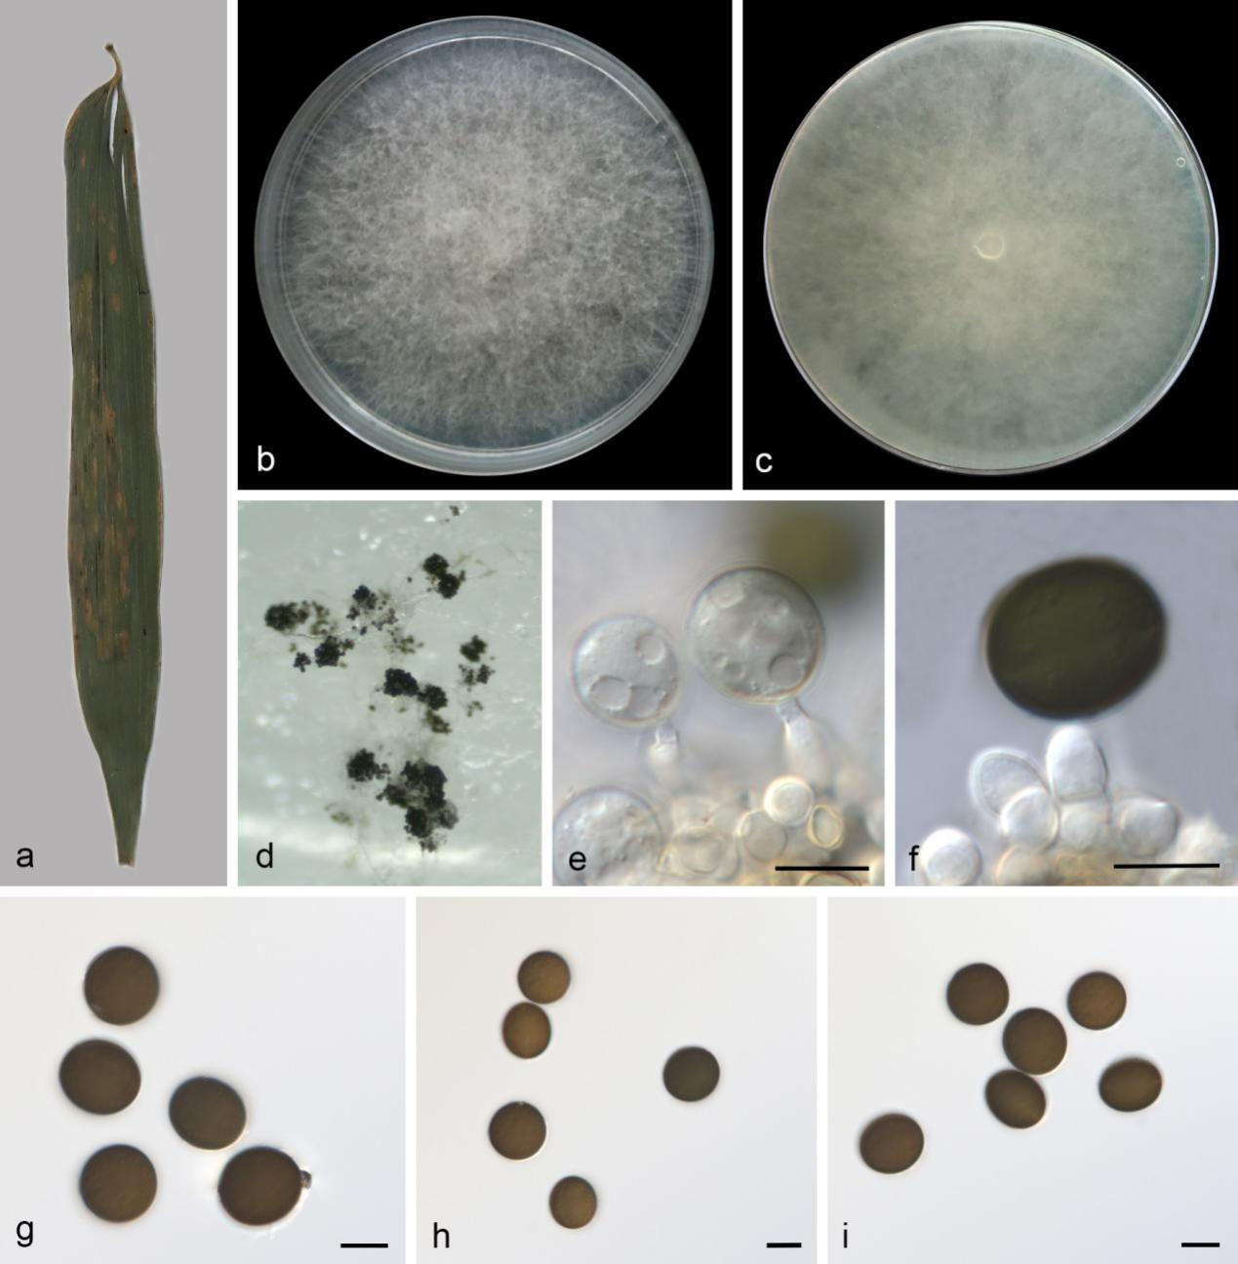
Figure S9. Apiospora hydei (SAUCC 14491-1). a Leaf of host plant. b–c Colonies on PDA after incubation for 7 days from above (b) and below (c). d Conidiomata formed in culture. e–f Conidiogenous cells giving rise to conidia. g–i Conidia. Scale bars: 10 μm (e–i).

Apiospora hydei (Crous) Pintos & P. Alvarado, Fungal Systematics and Evolution 7: 207 (2021) Figs. 1, S9
On diseased bamboos leaves. Asexual morph: hyphae 1.2–3.9 μm diameter, micronematous, hyaline, sometimes branched, thick-walled, septate. Conidiophores reduced to conidiogenous cells. Conidiogenous cells 4.01–13.79 × 2.07–5.93 µm (av. = 8.86 ± 2.77 × 3.37 ± 1.33 μm, n = 18) arising from hyphae, holoblastic, hyaline, cylindrical, straight or flexuous, aseptate, smooth-walled. Conidia 15.22–20.22 × 14.28–15.42 µm (av. = 17.38 ± 1.27 × 14.52 ± 0.35 μm, n = 32), globose to ellipsoidal, aseptate, hyaline to dark brown when mature, smooth, with an equatorial germ-slit.
Culture characteristics – On the PDA, the colony surfaces are white, flat, filiform, with abundant aerial mycelia and reverse white to pale yellow. PDA attaining 90 mm in diameter after 7 days at 25 °C.
Material examined – CHINA, Hainan Province, Ledong Li Autonomous County, Jianfengling National Forest Park (18.700142 N, 108.812270 E, 126 m), on diseased bamboo leaves (Poaceae sp.), 4 December 2024, Q.Y. Liu (HSAUP 14491-1), living cultures SAUCC 14491-1; ibid., Danzhou City, Hainan Tropical Botanical Garden (19.5119332 N, 109.5008408 E, 108 m), on diseased bamboo leaves (Poaceae sp.), 15 October 2024, Q.Y. Liu (HSAUP 6688-1), living cultures SAUCC 6688-1; ibid., HSAUP 6688-5, living cultures SAUCC 6688-5; ibid., Changjiang Li Autonomous County, Bawangling National Forest Park (19.0859333 N, 109.122752 E, 462 m), on diseased leaves of Phragmites australis, 14 October 2023, Q.Y. Liu (HSAUP 6526-1), living cultures SAUCC 6526-1; ibid., Wuzhishan City, Wuzhishan National Nature Reserve (18.907212 N, 109.679171 E, 379 m), on diseased bamboo leaves (Poaceae sp.), 2 December 2024, Y.L. Wang (HSAUP 14251-1), living cultures SAUCC 14251-1; ibid., Qiongzhong Li and Miao Autonomous County, Qiongzhong Li and Miao Autonomous County (19.005802 N, 109.825167 E, 392 m), on diseased bamboo leaves (Poaceae sp.), 3 December 2024, Y.L. Wang (HSAUP 14296-3), living cultures SAUCC 14296-3; CHINA, Sichuan Province, Chengdu, Dujiangyan City (30.964723 N, 103.5871281 E, 708 m), on diseased leaves of Breynia fruticosa, 24 June 2023, Y. Jiang (HSAUP 4279-1), living cultures SAUCC 4279-1; CHINA, Yunnan Province, Nannuo Mountain (21.923863 N, 100.594751 E, 1876 m), on decaying leaves, 18 March 2023, D.H. Li (HSAUP 2374B-1), living cultures SAUCC 2374B-1; ibid., Yuxi City, Xinping Yi and Dai Autonomous County (24.040269 N, 101.526037 E, 1462 m), on decaying leaves, 14 May 2024, Q.Y. Liu (HSAUP 8572-2), living cultures SAUCC 8572-2.
Distribution – CHINA: Hainan, Guizhou, Sichuan, Yunnan Provinces, Hong Kong, and Taiwan.
Ecology – Associated with Bambusa tuldoides, bamboo, Celtis formosana, Phragmites australis, Phyllostachys nigra, and decaying leaves.
Notes – Existing strains of Apiospora hydei and our isolates clustered in the phylogenetic tree. Our strains and A. hydei (CBS 114990, ex-type) have few nucleotide differences. Morphologically, our isolates are similar to A. hydei by its conidia (15.22–20.22 × 14.28–15.42 µm vs. (15–)17–19(–22) μm diam in surface view, (10–)11–12(–14) μm diam in side view). Arthrinium hydei was originally identified by Crous & Groenewald ^{[22]} from Bambusa tuldoides in Hong Kong, China. It was subsequently synonymized under A. hydei by Pintos & Alvarado ^{[25]}, based on phylogenetic evidence. CBS 114990 was isolated from Bambusa tuldoides in Hong Kong ^{[22]}; KUMCC 16-0204 was isolated from dead culms of bamboo in Yunnan Province ^{[67]}; LC7103 and LC7105 were isolated from bamboo in China ^{[68]}; GZCC 20-0113 was isolated from bamboo in Guizhou Province ^{[69]}; MFLUCC 19-0070 was isolated from Celtis formosana (Cannabaceae) in Taiwan ^{[70]}; SICAUCC 22-0032 was isolated from Phyllostachys nigra in Sichuan Province ^{[71]}. SAUCC 6526-1 was isolated from Phragmites australis in Hainan Province; SAUCC 4279-1 was isolated from Breynia fruticosa in Sichuan Province. SAUCC 2374B-1 and SAUCC 8572-2 were discovered on decaying leaves. SAUCC 2374B-1, SAUCC 8572-2, SAUCC 6526-1, and SAUCC 4279-1 as new host records.
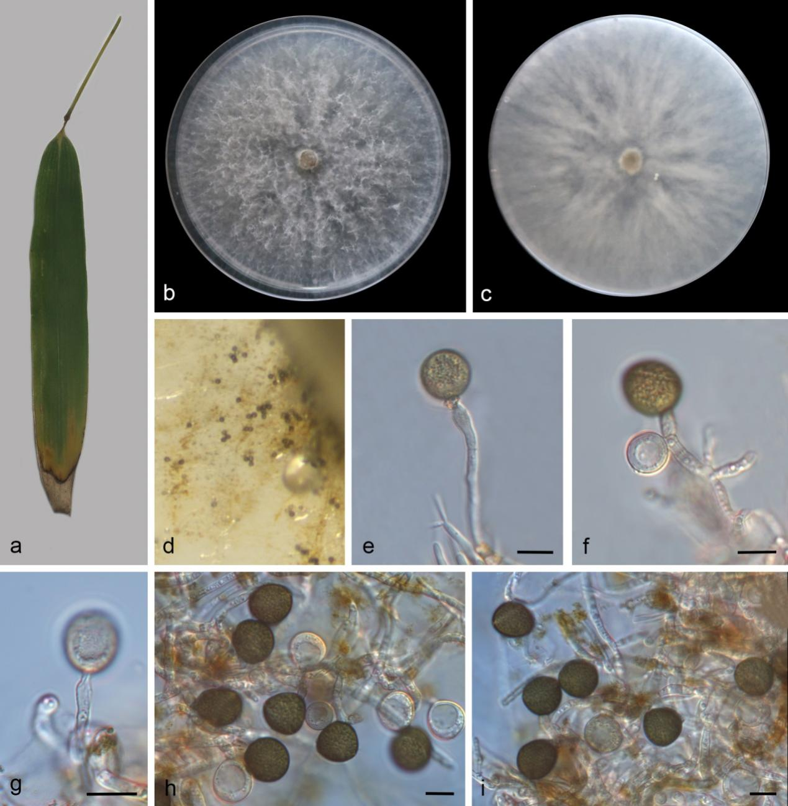
Figure S10. Apiospora hysterina (SAUCC 10675-2). a Leaf of host plant. b–c Colonies on PDA after incubation for 7 days from above (b) and below (c). d Conidiomata formed in culture. e–i Conidiogenous cells giving rise to conidia. Scale bars: 10 μm (e–i).

Apiospora hysterina (Sacc.) Pintos & Alvarado, Fungal Systematics and Evolution 7:206P. (2021)
Figs. 1, S10
On diseased bamboo leaves. Asexual morph: hyphae 1.8–5.1 μm diameter, micronematous, hyaline, branched, thick-walled, septate. Conidiophores reduced to conidiogenous cells. Conidiogenous cells 28.15-44.5 × 2.3–4.8 μm (av. = 32.87 ± 6.89 × 3.48 ± 0.91 μm), arising from hyphae, holoblastic, polyblastic and monoblastic, hyaline, cylindrical, straight or flexuous, septate or not, smooth-walled. Conidia 14.91–16.97 μm diameter (av. = 15.91 ± 1.27 μm, n = 21), subglobose to obovoid, aseptate, hyaline to dark brown when mature, with an equatorial germ-slit.
Culture characteristics – On the PDA, the colony surfaces are white, flat, spreading, filiform, with sparse aerial mycelium and reverse white, pigment absent. PDA attaining 90 mm in diameter after 7 days at 25 °C.
Material examined – CHINA, Shandong Province, Taian City, Longtan Park (36.196715 N, 117.115043 E, 159.6 m), on diseased bamboo leaves (Poaceae sp.), 8 October 2024, Q.Y. Liu (HSAUP 10675-2), living cultures SAUCC 10675-2.
Distribution – CHINA (Shandong Province), Korea, New Zealand, and Spain.
Ecology – Associated with Bambusa sp., Phyllostachys aurea, and Phyllostachys bambusoides.
Notes – Existing strains of Apiospora hysterina and our isolate (SAUCC 10675-2) clustered with good support in the phylogenetic tree. Our strain and A. hysterina (ICPM 6889, ex-type) have few nucleotide differences. Morphologically, our isolate is similar to A. hysterina by its conidia shape and size. However, the pigment of A. hysterina (ICPM 6889, ex-type) was observed on the MEA medium, but our strain (SAUCC 10675-2) was observed on the PDA medium ^{[72]}. Our strain exhibits both polyblastic and holoblastic conidiogenesis. It was subsequently synonymized under A. hysterina based on phylogenetic evidence by Pintos & Alvarado ^{[25]}. The strain ICMP 6889 was isolated from Bambusa sp. in New Zealand. The fungal strains AP12118, AP29717, AP2410173, and AP15318 were isolated from Phyllostachys aurea in Spain ^{[72]}. Strains KUC21437 and KUC21438 were isolated from Phyllostachys bambusoides in Korea ^{[73]}. GUCC-19-5271 was isolated from Faba Bean in China ^{[63]}.
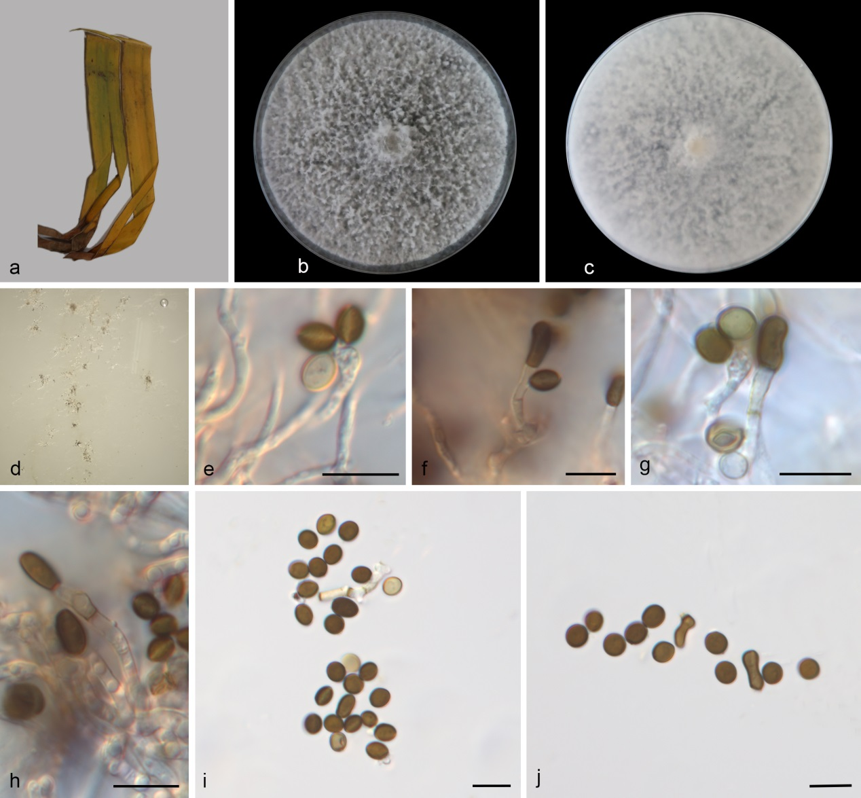
Figure S11. Apiospora intestini (SAUCC 9350-2, new host and geographical records). a leaf of host plant. b–c Colonies on PDA after incubation for 7 days from above (b) and below (c). d conidiomata formed in culture. e Conidiogenous cells giving rise to conidia. f–h Conidiophores with conidiogenous cells and conidia. i Conidia. j Conidia and elongated conidia. Scale bars: 10 μm (e–j).

Apiospora intestini (Kajale, Sonawane & Rohit Sharma) Pintos & P. Alvarado, Fungal Systematics and Evolution 7: 206 (2021) Figs. 1, S11
On diseased leaves of Musa basjoo. Asexual morph: hyphae 1.6–3.54 μm diameter, micronematous, hyaline to pale brown, branched, thick-walled, septate. Conidiophores 22–49 × 1.67–3.51 µm (av. = 32 × 9.8 µm, n = 12), erect, solitary, subcylindrical, unbranched, straight or flexuous, hyaline, smooth-walled, transversely septate, sometimes reduced to conidiogenous cells. Conidiogenous cells 3.81–11.68 × 2.24–3.94 µm (av. = 9.08 ± 2.48 × 2.95 ± 0.48 μm, n = 14) arising from hyphae, holoblastic or polyblastic, hyaline, cylindrical, straight or flexuous, aseptate, smooth-walled. Conidia 4.82–7.11 × 4.13–5.92 µm (av. = 6.00 ± 0.36 × 4.72 ± 0.53 μm, n = 27), globose to ellipsoidal, aseptate, hyaline to dark brown when mature, brown, elongated cells at times intermingled among conidia.
Culture characteristics – On the PDA, the colony surfaces are white, floccose, sparse, filiform, reverse white. PDA attaining 90 mm in diameter after 7 days at 25 °C.
Material examined – CHINA, Yunnan Province, Kunming City, Laoyuhe Wetland Park (24.820652 N, 102.76962 E, 1863 m), on diseased Musa basjoo leaves, 17 May 2024, Q.Y. Liu (HSAUP 9350-2), living cultures SAUCC 9350-2.
Distribution – CHINA (Yunnan Province), India, and Thailand.
Ecology – Associated with gut of a grasshopper, bamboo, and Musa basjoo.
Notes – Apiospora intestini (CBS 135835, ex-type) was introduced based on the morphology of asexual morph and the phylogenetic analysis, and it was isolated from the gut of a grasshopper in India ^{[32]}. Subsequently, the strain A. intestini (MFLUCC 21-0052) on bamboo in Thailand ^{[64]}. In this paper, our new isolate (SAUCC 9350-2) clustered with A. intestine. Morphologically, the conidia of the new isolate (SAUCC 9350-2) is similar to A. intestini (CBS 135835, ex-type) in having similar size of conidiophores (22–49 × 1.67–3.51 µm vs. 21.5–50 × 2–2.5 μm). Based on nucleotide comparisons, A. intestini (SAUCC 9350-2) is slightly different from A. intestini (CBS 135835, ex-type) in 3/768 bp (0.39%) of the LSU, 1/325 bp (0.31%) of the tef1-α, 2/367 bp (0.55%) of the tub2. It was subsequently synonymized under A. intestini by Pintos & Alvarado ^{[25]}, based on phylogenetic evidence. SAUCC 9350-2 represents new host and geographical records in China.
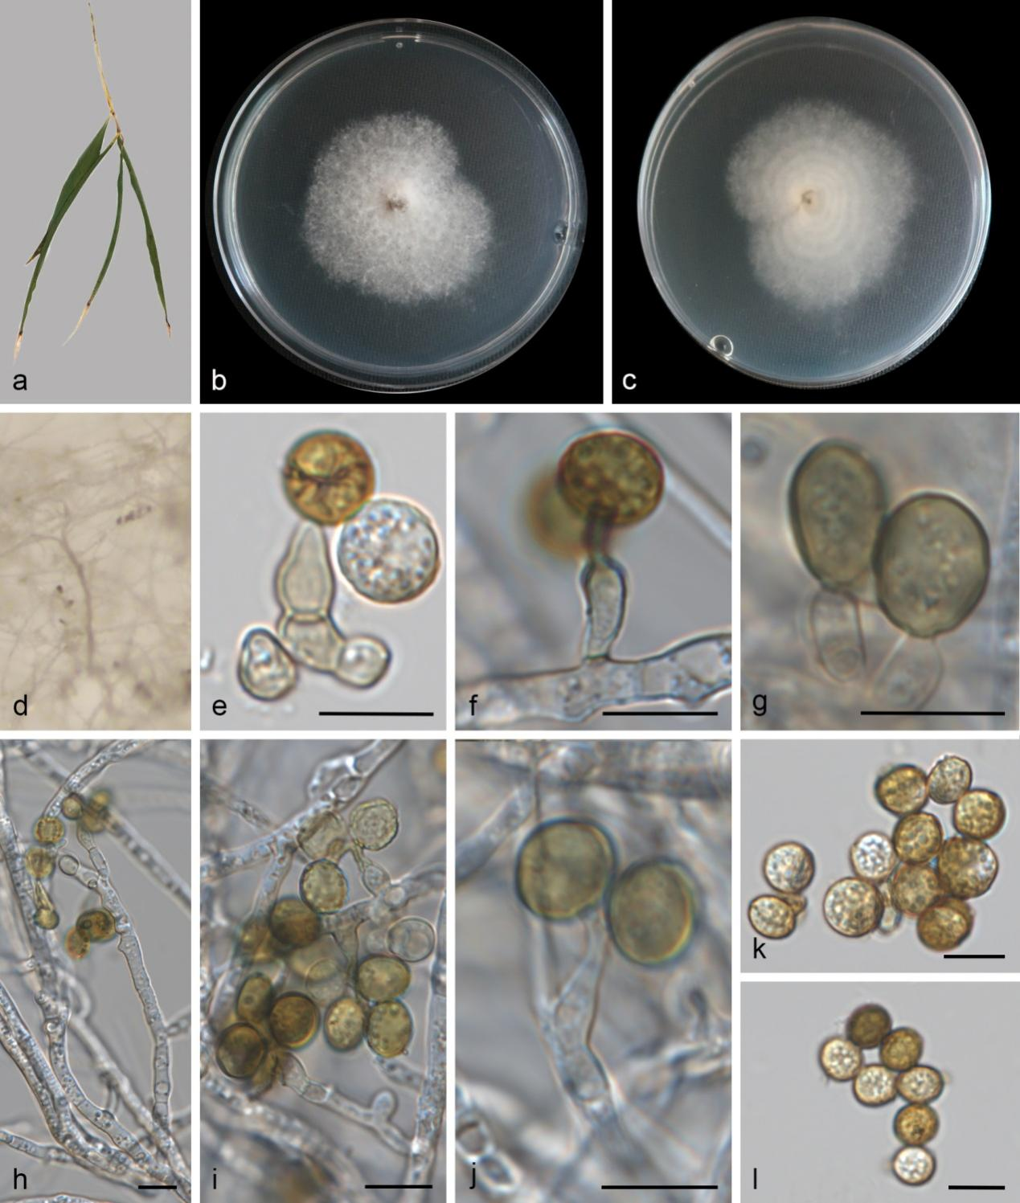
Figure S12. Apiospora jiangxiensis (SAUCC 11156-2, new geographical record). a Leaf of host plant. b–c Colonies on PDA after incubation for 7 days from above (b) and below (c). d Conidiomata formed in culture. e–g, i Conidiogenous cells giving rise to conidia. h, j Conidiophores with conidiogenous cell and conidia. k–l Conidia. Scale bars: 10 μm (e–l).

Apiospora jiangxiensis (Mei Wang & L. Cai) Pintos & P. Alvarado, Fungal Systematics and Evolution 7: 206 (2021) Figs. 1, S12
On PDA. Asexual morph: hyphae 3.2–4.6 μm diameter, hyaline, branched, thick-walled, septate, guttulate. Conidiophores 21.93–138.19 × 3.39–5.66µm (av. = 78.62 ± 43.49 × 4.43 ± 0.98 μm, n = 6), solitary, subcylindrical, branched, flexuous, hyaline, smooth-walled, sometimes reduced to conidiogenous cells. Conidiogenous cells 4.64–19.12 × 2.43–5.25 µm (av. = 10.65 ± 3.25 × 3.74 ± 0.84 μm, n = 19) arising from hyphae or conidiophores, holoblastic or polyblastic, hyaline, cylindrical or ampulliform, straight or flexuous, aseptate, smooth-walled. Conidia 7.25–10.18 × 5.94–9.31 µm (av. = 8.32 ± 0.70 × 7.65 ± 0.85 μm, n = 26), globose to ellipsoidal, aseptate, hyaline to pale brown when mature, smooth to finely roughened, without a broad equatorial germ-slit.
Culture characteristics – On the PDA, the colony surfaces are white, flat, floccose, with moderate aerial mycelia and reverse white with concentric ring patterns. PDA attaining 44 mm in diameter after 7 days at 25 °C, growth rate 6.73 mm/day.
Material examined – CHINA, Fujian Province, Wuyishan City, West side of Longguiyuan Ticket Office (27.853637 N, 117.880774 E, 590 m), on diseased bamboo leaves (Poaceae sp.), 20 October 2024, Q.Y. Liu (HSAUP 11156-2), living cultures SAUCC 11156-2; ibid., on diseased leaves of Kalimeris indica, 20 October 2024, Q.Y. Liu (HSAUP 11956-1), living cultures SAUCC 11956-1.
Distribution – CHINA, Fujian, Hunan, and Jiangxi Provinces.
Ecology – Associated with bamboo (Poaceae sp.), Camellia sinensis, Imperata cylindrical, Kadsura coccinea, Kalimeris indica, Maesa sp., Machilus sp., and Phyllostachys sp..
Notes – In the present study, our new isolates (SAUCC 11156-2 and SAUCC 11956-1) clustered together with A. jiangxiensis in the multi-locus phylogenetic tree (Fig. 1). SAUCC 11156-2 and SAUCC 11956-1 were similar to the CGMCC 3.18381 in ITS (99.8%, 100%), LSU (100%, 100%), tef1-α (100%, 99.76%), tub2 (100%, 99.98%) sequences. Morphologically, this study shows the similar conidiogenous cells (4.64–19.12 × 2.43–5.25 µm vs. 6.0–15.0 × 2.5–5.0 µm) and conidia (7.25–10.18 × 5.94–9.31 µm vs. surface view:7.5–10.0 µm diam; side view: 4.5–7.0 µm diam) ^{[68]}. Arthrinium jiangxiense was originally identified from Maesa sp. in Jiangxi Province, CHINA ^{[68]}. It was subsequently synonymized under A. jiangxiensis by Pintos & Alvarado ^{[25]}, based on phylogenetic evidence. Apiospora jiangxiensis isolates from bamboo (Poaceae sp.), Phyllostachys sp., Maesa sp., Machilus sp., Camellia sinensis, Imperata cylindrical, and Kadsura coccinea in Jiangxi and Hunan Provinces ^{[68,74]}. SAUCC 11956-1 was isolates from Kalimeris indica. Thus, these strains were identified as A. jiangxiensis, and SAUCC 11956-1 serving as new host and geographical records, SAUCC 11156-2 serving as a new geographical record.
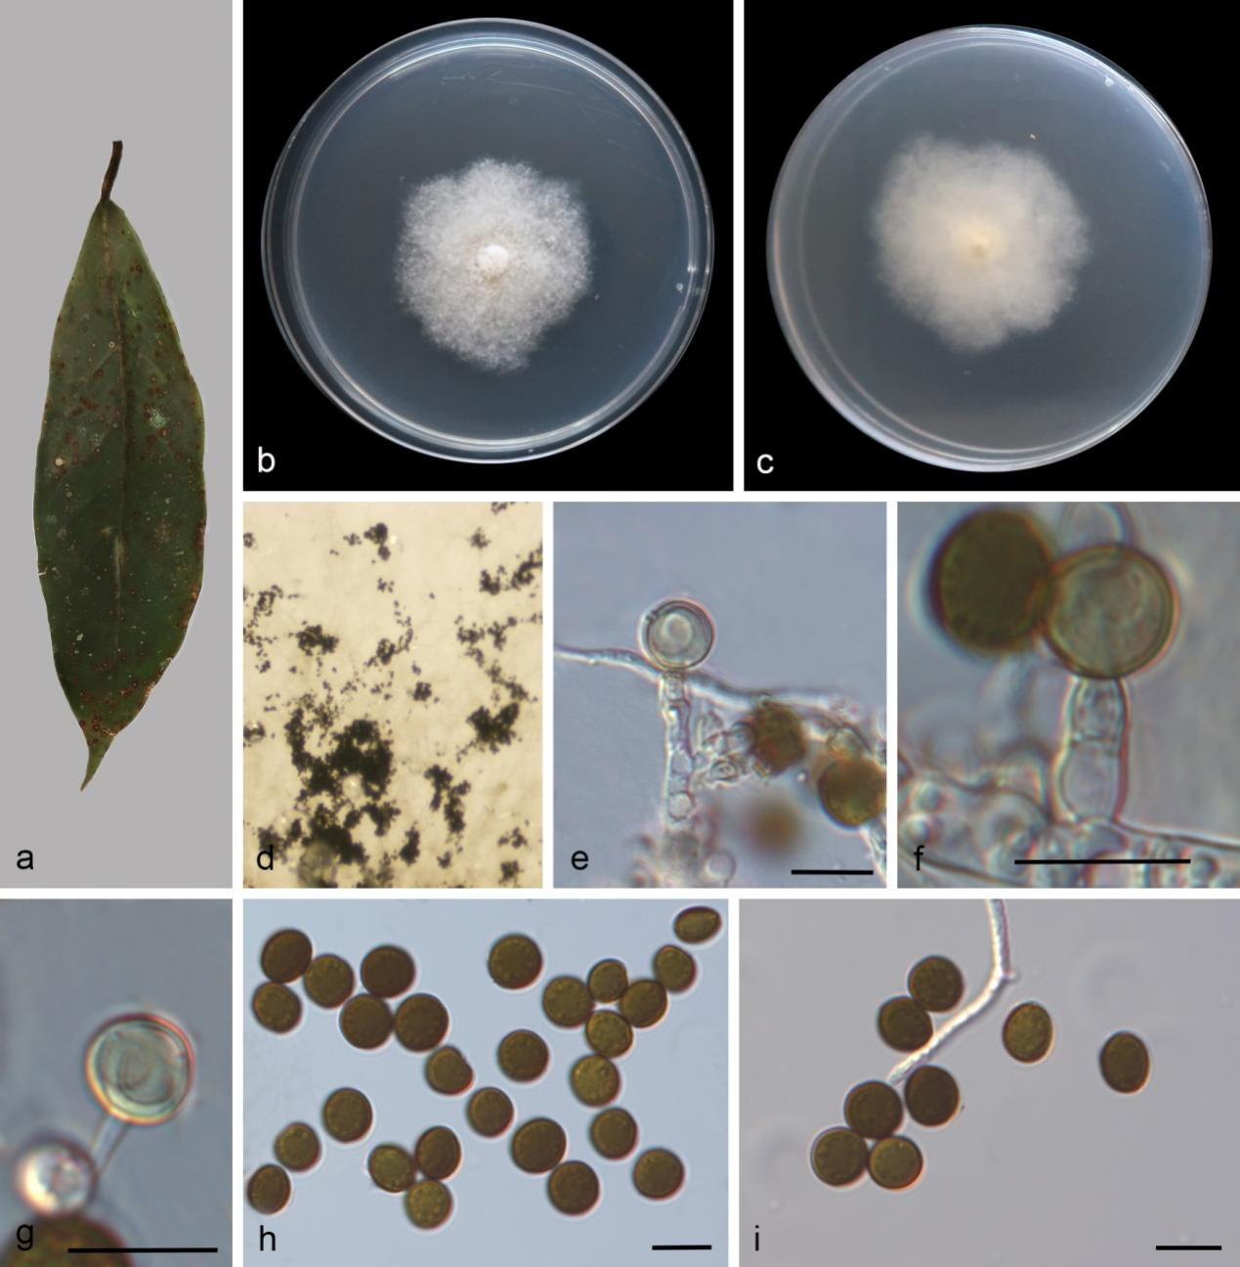
Figure S13. Apiospora lageniformis (SAUCC 11956-2, new host and geographical records). a Leaf of host plant. b–c Colonies on PDA after incubation for 7 days from above (b) and below (c). d Conidiomata formed in culture. e–g Conidiogenous cells giving rise to conidia. h–i Conidia. Scale bars: 10 μm (e–i).

Apiospora lageniformis S.L. Kwon & J.J. Kim, Mycobiology 50 (5): 302–316 (2022) Figs. 1, S13
On PDA. Asexual morph: hyphae 2.9–4.6 μm diameter, hyaline to pale brown, sometimes branched, thick-walled, septate. Conidiophores reduced to conidiogenous cells. Conidiogenous cells 3.47–19.72 × 1.61–3.86 µm (av. = 11.66 ± 6.52 × 3.06 ± 0.83 μm) arising from hyphae, holoblastic, hyaline, cylindrical to doliiform, straight or flexuous. Conidia 6.81–9.49 × 4.79–8.77 µm (av. = 8.59 ± 0.55 × 7.92 ± 0.83 μm, n = 20), globose to subglobose, aseptate, pale brown to dark brown, with an equatorial germ-slit.
Culture characteristics – On the PDA, the colony surfaces are white, floccose, with moderate aerial mycelia, colony margin undulate and reverse white. PDA attaining 43 mm in diameter after 7 days at 25 °C.
Material examined – CHINA, Fujian Province, Wuyishan City, Xingcun Town (27.730683 N, 117.661531 E, 843 m), on decaying leaves, 14 October 2022, Y.X. Liu (HSAUP 1588-4), living cultures SAUCC 1588-4; ibid., on diseased leaves of bamboo (Poaceae sp.), 20 October 2024, Q.Y. Liu (HSAUP 11156-1), living cultures SAUCC 11156-1; ibid., Nanping City, Wuyishan City, Da'anyuan Ecological Tourism Area (27.873682 N, 117.856120 E, 496 m), on diseased leaves of Kalimeris indica, 20 October 2024, Q.Y. Liu (HSAUP 11956-2), living cultures SAUCC 11956-2; CHINA, Guangdong Province, Shaoguan City, Renhua County (25.006676 N, 113.667021 E, 266 m), on diseased bamboo leaves of Sasa fortunei (Poaceae sp.), 03 March 2025, Y.L. Wang (HSAUP 17357-1), living cultures SAUCC 17357-1.
Distribution – CHINA (Fujian and Guangdong Provinces), Korea.
Ecology – Associated with bamboo, Kalimeris indica, Phyllostachys nigra var. henonis, and Sasa fortunei (Poaceae sp.).
Notes – Existing strains of Apiospora lageniformis and our isolates clustered in the phylogenetic tree. Our strains and A. lageniformis (KUC21686, ex-type) have few nucleotide differences. Morphologically, our isolates are similar to A. lageniformis by its conidia (6.81–9.49 × 4.79–8.77 µm vs. surface view: (7.8–)8.1–9.0(–9.5) × (6.8–)7.5–8.5(–9.0) µm; side view: (7.0–)8.0–9.5(–9.5) × (5.3–)6.0–7.0(–7.5) µm). Thus, we consider the isolated strains as A. lageniformis. Apiospora lageniformis was isolated from Phyllostachys nigra var. henonis in Korea ^{[73]}. Our isolates were isolated from Kalimeris indica in Fujian Province, China. Therefore, we consider our strains to represent a new host and geographical records.
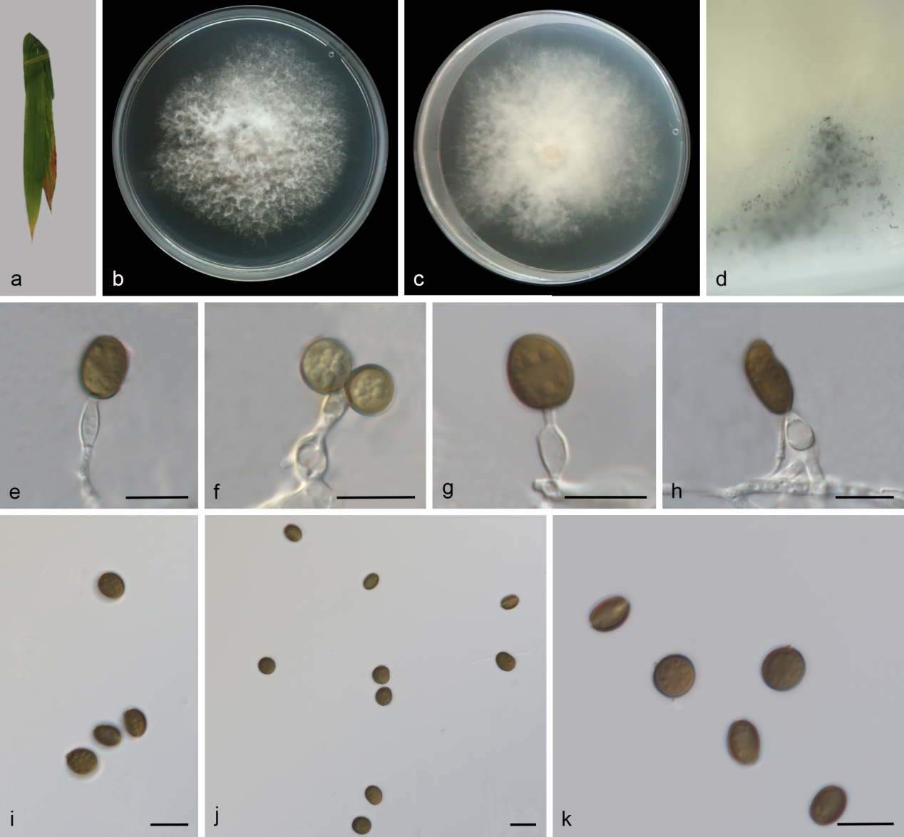
Figure S14. Apiospora armeniaca (SAUCC 14451-2A, new host and geographical records). a Leaf of host plant. b–c Colonies on PDA after incubation for 7 days from above (b) and below (c). d Conidiomata formed in culture. e–h Conidiogenous cells giving rise to conidia. i–k Conidia. Scale bars: 10 μm (e–k).

Apiospora armeniaca H. Sheng, Z.X. Zhang & X.G. Zhang, Microorganisms 2024, 12, 1372
Figs. 1, S14
Asexual morph: On PDA, hyphae 1.6–4.2 μm diameter, hyaline, branched, thick-walled. Conidiophores reduced to conidiogenous cells. Conidiogenous cells 10.03–13.04 × 3.09–4.49 μm (av. = 12.46 ± 1.57 × 3.73 ± 0.54 μm), arising from hyphae, holoblastic and polyblastic, hyaline, ampulliform, straight or flexuous, aseptate. Conidia 6.14–12.98 × 4.83–7.81 µm (av. = 8.06 ± 1.65 × 6.14 ± 1.06 μm, n = 24), globose, subglobose to cylindric-clavate, aseptate, pale brown to dark brown when mature, guttulate, smooth to finely roughened, with an equatorial germ-slit.
Culture characteristics – On the PDA, the colony surfaces are white, flat, with abundant aerial mycelia and reverse yellow. Colonies on PDA grown in the dark reaching 67.51–70.56 mm diam after 7 d at 25 °C.
Material examined – CHINA, Hainan Province, Ledong Li Autonomous County, Jianfengling National Forest Park (18.700142 N, 108.812270 E, 126 m), on diseased leaves of Bambusa multiplex, 04 December 2024, Q.Y. Liu (HSAUP 14451-2A), living culture CGMCC 3.29209 = SAUCC 14451-2A; ibid., HSAUP 14451-2B, living culture SAUCC 14451-2B.
Distribution – CHINA, Hainan and Shandong Provinces.
Ecology – Associated with Bambusa multiplex and Prunus armeniaca.
Notes – Existing strains of A. armeniaca and our isolates clustered in the phylogenetic tree. Our strains and A. armeniaca (SAUCC DL1831, ex-type) have few nucleotide differences. Morphologically, our isolates are similar to A. lageniformis by its conidia (6.14–12.98 × 4.83–7.81 µm vs. 6.2–7.3 × 4.8–6.1 μm). Thus, we consider the isolated strains as A. armeniaca. Apiospora armeniaca was isolated from Prunus armeniaca in Shandong Province, China ^{[62]}. Our isolates were isolated from Bambusa multiplex in Hainan Province, China. Therefore, we consider our strains to represent a new host and geographical records.

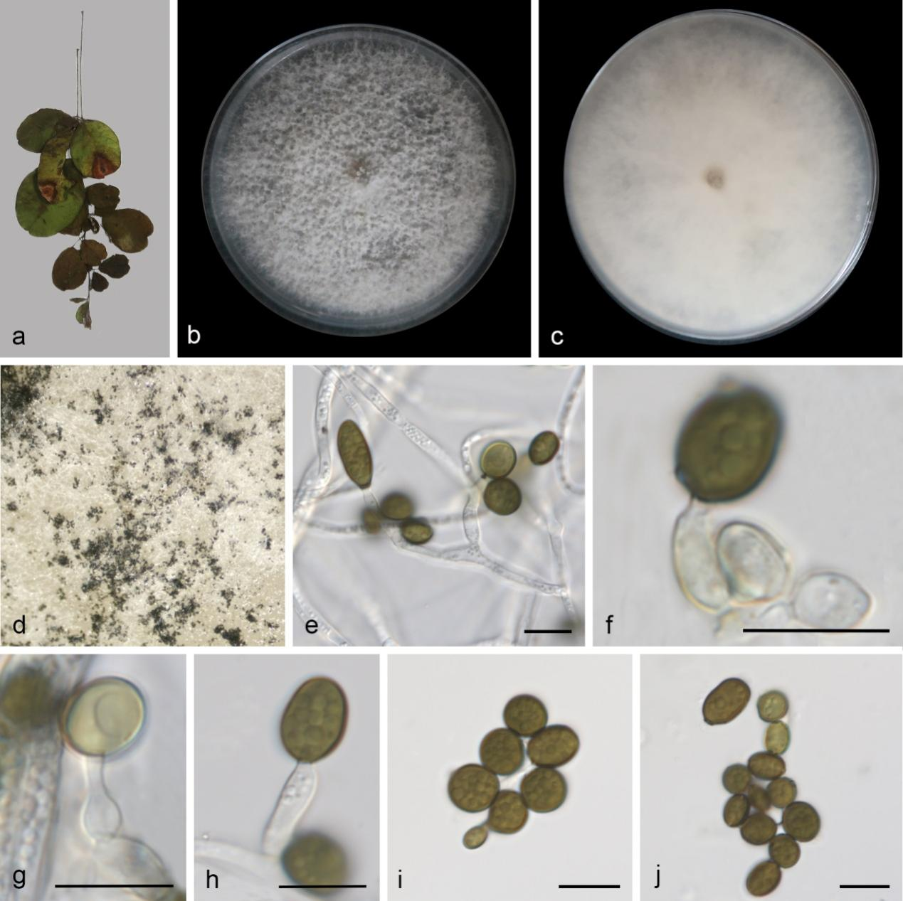
Figure S15. Apiospora locuta-pollinis (SAUCC 9588-1, new host record). a Leaf of host plant. b–c Colonies on PDA after incubation for 7 days from above (b) and below (c). d Conidiomata formed in culture. e Conidiophores with conidiogenous cells and conidia. f–h Conidiogenous cells giving rise to conidia. i–j Conidia. Scale bars: 10 μm (e–j).
Apiospora locuta-pollinis (F. Liu & L. Cai) Pintos & P. Alvarado, Fungal Systematics and Evolution 7: 207 (2021) Figs. 1, S15
On diseased leaves of Campylotropis macrocarpa. Asexual morph: On PDA, hyphae 2.0–3.6 μm diameter, hyaline, sometimes branched, thick-walled, septate, guttulate. Conidiophores 37.52–51.41 × 2.27–3.46 µm (av. = 44.5± 9.82 × 2.87 ± 0.83 μm), erect, solitary, subcylindrical or ampulliform, branched, straight or flexuous, hyaline, verrucose, guttulate, sometimes reduced to conidiogenous cells. Conidiogenous cells 4.40–26.81 × 1.72–4.14 µm (av. = 12.36 ± 5.98 × 3.22 ± 0.63 μm, n = 23) arising from hyphae, holoblastic, hyaline, cylindrical or ampulliform, straight or flexuous, aseptate, smooth-walled. Conidia 5.72–12.17 × 3.83–7.65 µm (av. = 7.84 ± 1.47 × 6.10 ± 1.05 μm, n = 23), globose to ellipsoidal, aseptate, pale brown to dark brown when mature, guttulate, with an equatorial germ-slit.
Culture characteristics – On the PDA, the colony surfaces are white, flat, floccose, with abundant aerial mycelia and reverse white. PDA attaining 90 mm in diameter after 7 days at 25 °C.
Material examined – CHINA, Yunnan Province, Chenggong District, Kunming City, Laoyuhe Wetland Park (24.820652 N, 102.76962 E, 1863 m), on diseased leaves of Campylotropis macrocarpa, 17 May 2024, Q.Y. Liu (HSAUP 9588-1), living cultures SAUCC 9588-1.
Distribution – CHINA (Sichuan and Yunnan Provinces), Italian, and Thailand.
Ecology – Associated with leaves of Aristolochia debilis, Brassica campestris, Phyllostachys aureosulcata, ecaying stem of bamboo, and in decaying wood.
Notes – Existing strains of Apiospora locuta-pollinis and our isolate clustered in the phylogenetic tree. Our strains and A. locuta-pollinis (LC11683, ex-type) have few nucleotide differences. Morphologically, LC11683 and SAUCC 9588-1 were cultured under different culture medium conditions (PDA vs. MEA). Our isolate is similar to A. locuta-pollinis by its conidia shape (globose to ellipsoidal vs. globose to subglobose or ellipsoidal). However, the conidiogenous cells and conidia of SAUCC 9588-1 (4.40–26.81 × 1.72–4.14 µm and 5.72–12.17 × 3.83–7.65 µm, respectively) are bigger than those of the ex-type strain LC11683 (3–7.5 × 3–6 μm and 5.5–9 × 4.5–8 μm (or 8–15 × 5–9.5 μm), respectively. These morphological variations may be attributable to varying environmental conditions ^{[59]}. Arthrinium locuta-pollinis (LC11683, LC11688, and LC11689) were isolated from the flowering season of Brassica campestris in Italian ^{[75]}. Arthrinium pseudomarii was isolated from Aristolochia debilis in Yunnan Province, China ^{[76]}. Arthrinium pseudomarii was synonymed under Arthrinium locuta-pollinis, and basionymed Arthrinium locutum-pollinis under Apiospora locuta-pollinis following a phylogenetic analysis ^{[64]}. Apiospora locuta-pollinis was reported from a dead leaf of Musa sp. and in Thailand ^{[77]}. Apiospora locuta-pollinis was reported from culm blight on Phyllostachys aureosulcata in Chengdu City, China ^{[78]}. Apiospora locuta-pollinis was reported from bamboo and in Yunnan Province, China ^{[79]}. Apiospora fuxianhuensis was obtained from submerged decaying wood in Yunnan, China; and synonymed under A. locuta-pollinis ^{[80]}. In this study, we report this strain of Apiospora locuta-pollinis as a new host record.

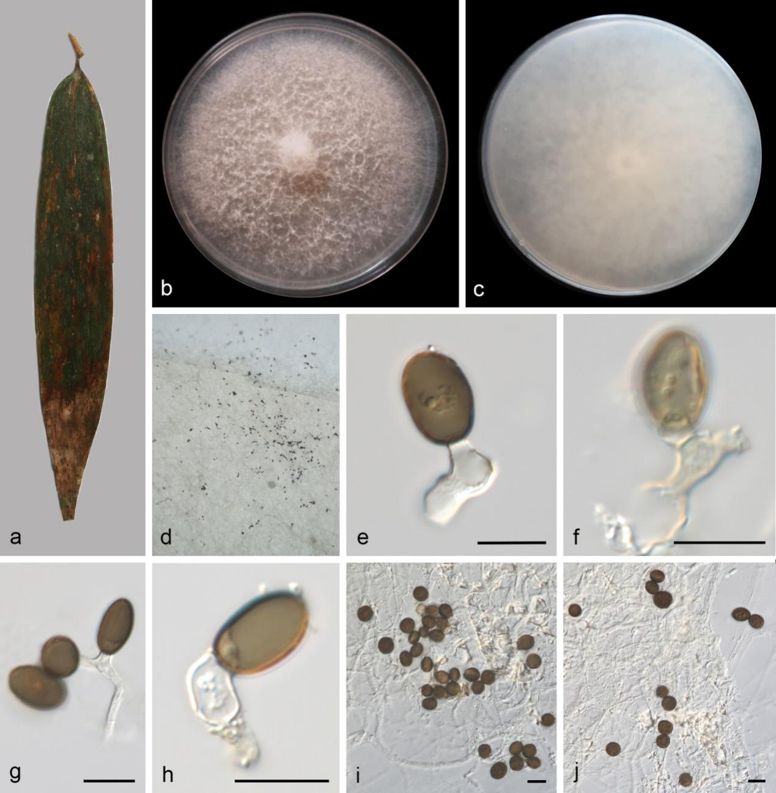
Figure S16. Apiospora longistroma (SAUCC 7605-3, new geographical record). a Leaf of host plant. b–c Colonies on PDA after incubation for 7 days from above (b) and below (c). e, g–h Conidiogenous cells giving rise to conidia. f Conidiogenous cells giving rise to sterile cells. i–j Hyphae and conidia. Scale bars: 10 μm (e–j).
Apiospora longistroma (D.Q. Dai & K.D. Hyde) Pintos & P. Alvarado, Fungal Systematics and Evolution 7: 207 (2021) Figs. 1, S16
On diseased leaves of bamboo. Asexual morph: On PDA, hyphae 1.5–3.4 μm diameter, micronematous, hyaline, sometimes branched, thick-walled, septate, guttulate. Conidiophores reduced to conidiogenous cells. Conidiogenous cells 4.24–17.40 × 2.37–4.99 µm (av. = 11.74 ± 3.42 × 3.71 ± 0.97 μm, n = 11) arising from hyphae, holoblastic or polyblastic, hyaline, cylindrical, straight or flexuous, aseptate, smooth-walled. Sterile cells terminal on conidiogenous cells or hyphae, pale brown, subglobose to elliptical, 8.42–10.93 × 6.07–7.98 μm. Conidia 9.26–12.70 × 4.80–9.35 µm (av. = 10.54 ± 1.11 × 7.06 ± 1.09 μm, n = 24), globose to cylindrical, aseptate, dark brown, guttulate, without an equatorial germ-slit.
Culture characteristics – On the PDA, the colony surfaces pink, colony margin entire, floccose and reverse white. Colonies on PDA attaining 90 mm in diameter after 7 days at 25 °C.
Material examined – CHINA, Hainan Province, Diaoluo Mountain National Forest Park (18.660546 N, 109.936445 E, 94 m), on diseased bamboo leaves (Poaceae sp.), 15 March 2024, Q.Y. Liu (HSAUP 7605-3), living cultures SAUCC 7605-3.
Distribution – CHINA (Hainan Province); Thailand.
Ecology – Associated with bamboo.
Notes – Existing strains of Apiospora longistroma and our isolate (SAUCC 7605-3) clustered in the phylogenetic tree. Our strain and A. longistroma (MFLUCC 11-0481, ex-type) showed identical nucleotide sequences in both the ITS (520 bp) and LSU (804 bp) gene regions, with no base differences detected. No asexual morph description is available for MFLUCC 11-0479 and MFLUCC 11-0481. Arthrinium longistromum was originally identified from dead bamboo culms in Thailand ^{[81]}. It was subsequently synonymized under A. longistroma by Pintos & Alvarado ^{[25]}, based on phylogenetic evidence. Thus, this study is the first report of Apiospora longistroma in Hainan.
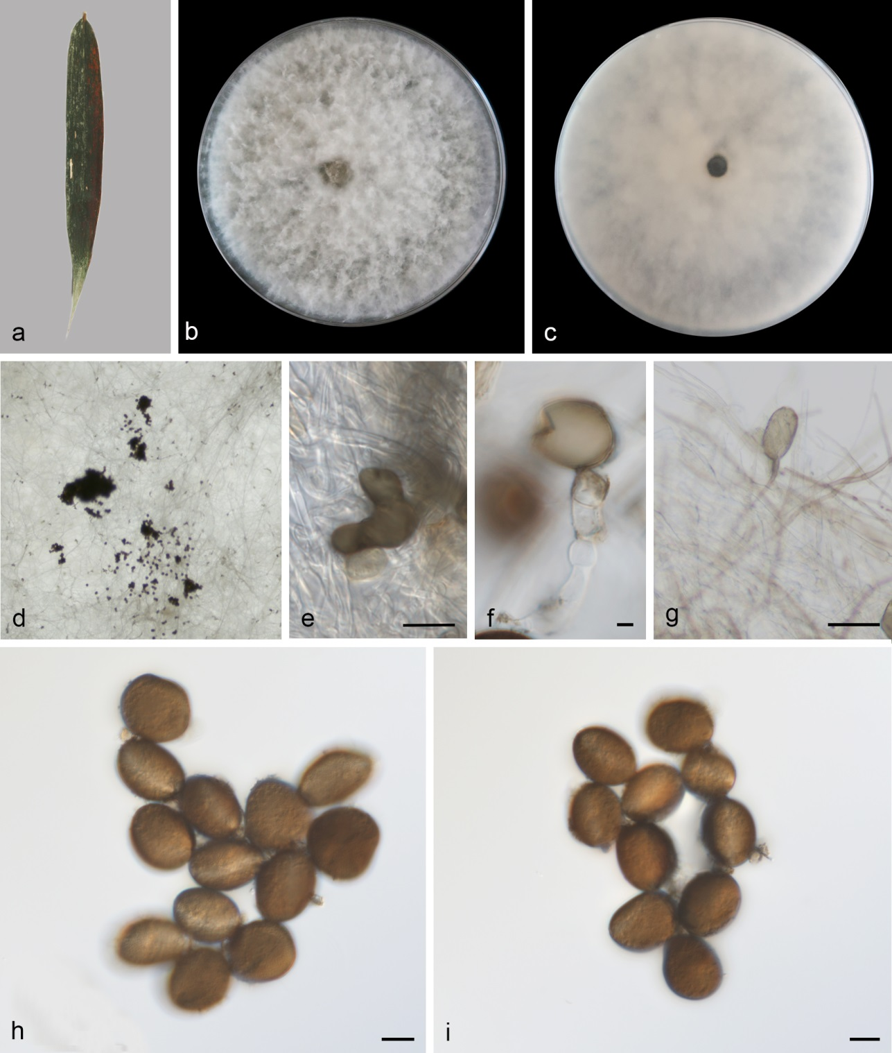
Figure S17. Apiospora pseudoparenchymatica (SAUCC 6761-4, new geographical record). a Leaf of host plant. b–c Colonies on PDA after incubation for 7 days from above (b) and below (c). d Conidiomata formed in culture. e Dentate conidia. f Conidiogenous cells giving rise to conidia. g Sterile cells and hyphae. h–i Conidia. Scale bars: 10 μm (e–i).

Apiospora pseudoparenchymatica (M. Wang & L. Cai) Pintos & P. Alvarado, Fungal Systematics and Evolution 7: 207 (2021) Figs. 1, S17
On diseased bamboo leaves. Asexual morph: hyphae 1.8–4.4 μm diameter, micronematous, hyaline to pale brown, branched, thick-walled, septate. Conidiophores reduced to conidiogenous cells. Conidiogenous cells arising from hyphae, hyaline to pale brown, cylindrical, straight, aseptate, smooth-walled. Sterile cells terminal on conidiogenous cells, pale brown, subglobose to cylindrical, 20.76–23.84 × 15.09–21.59 μm. Conidia 20.28–25.90 × 15.20–21.21 μm (av. = 22.74 ± 1.39 × 17.85 ± 2.09 μm, n = 23), globose to subglobose, aseptate, dark brown, with an equatorial germ-slit.
Culture characteristics – On the PDA, the colony surfaces are white, flat, spreading, filiform, with abundant aerial mycelia and reverse pale yellow. PDA attaining 90 mm in diameter after 7 days at 25 °C.
Material examined – CHINA, Yunnan Province, Mengla, Xishuangbanna (19.511933 N, 109.500840 E, 108 m), on diseased bamboo leaves (Poaceae sp.), 15 October 2023, Q.Y. Liu (HSAUP 6761-4), living cultures SAUCC 6761-4.
Distribution – CHINA, Guangdong and Yunnan Provinces.
Ecology – Associated with diseased leaves of bamboo (Poaceae sp.) and dead stalks of grass (Poaceae).
Notes – Existing strains of Apiospora pseudoparenchymatica and our isolate (SAUCC 6761-4) clustered in the phylogenetic tree. The nucleotide differences in the LSU and tef1-α gene regions between our strain and A. pseudoparenchymatica are 1/786 bp and 2/385 bp, respectively. Morphologically, our isolate is similar to A. pseudoparenchymatica by its conidia (20.28–25.90 × 15.20–21.21 μm vs. 13.5–27.0 × 12.0–23.5 µm) ^{[68]}. Thus, this study is the first report of Apiospora pseudoparenchymatica in Hainan.
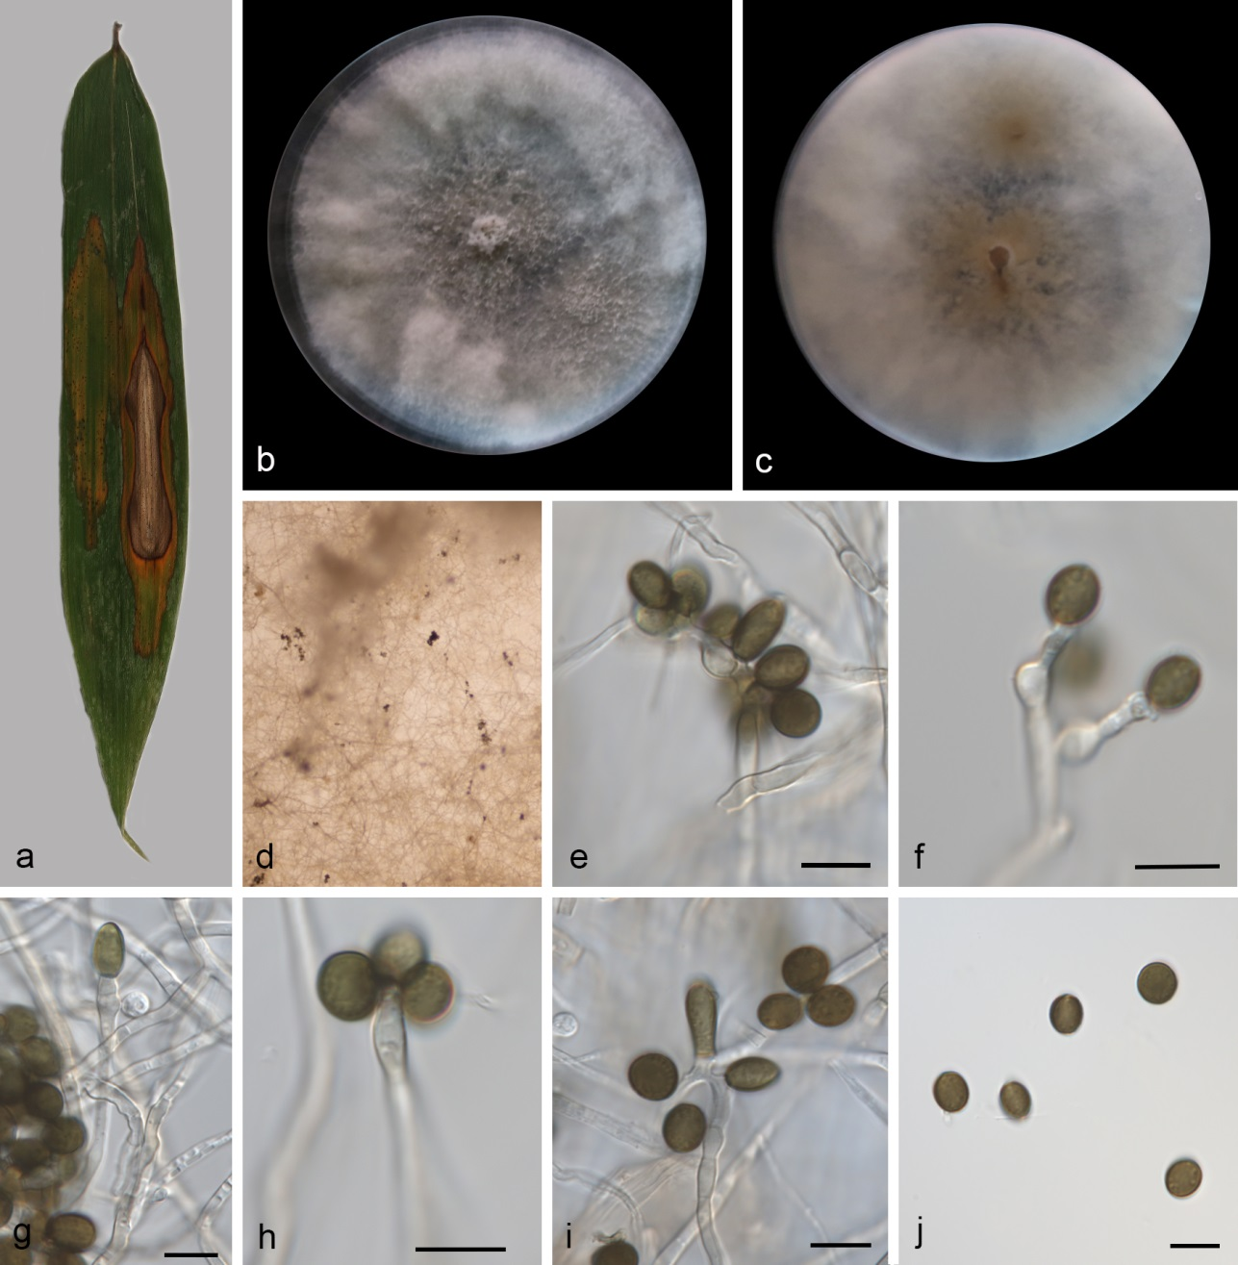
Figure S18. Apiospora cyclobalanopsidis (CGMCC 3.29218, new host and geographical records). a Leaf of host plant. b–c Colonies on PDA after incubation for 7 days from above (b) and below (c). d Conidiomata formed in culture. e–i Conidiophores, conidiogenous cells giving rise to conidia. j Conidia. Scale bars: 10 μm (e–j).

Apiospora cyclobalanopsidis (Yao Feng & Jian K. Liu) X.G. Tian & Tibpromma, in Tian, Karunarathna, Mapook, Promputtha, Xu, Bao & Tibpromma, Life 11 (no. 1071): 17 (2021)
Figs. 1, S18
On PDA. Asexual morph: hyphae 2.34–4.02 μm diameter, hyaline, branched, thick-walled, septate. Conidiophores 31.43–79.69 × 1.87–4.21 µm (av. = 47.25 ± 15.59 × 3.15 ± 0.66 μm, n = 13), hyaline, branched or unbranched, straight or flexuous, smooth, septate or aseptate. Conidiogenous cells 1.89–19.26 × 1.70–5.35 µm (av. = 8.45 ± 4.34 × 3.50 ± 1.09 μm, n = 15), aggregated in clusters on hyphae or from conidiophores, holoblastic or polyblastic, hyaline, cylindrical or ampulliform, straight, aseptate, smooth-walled. Conidia 6.76–13.42 × 4.79–8.31 μm (av. = 8.16 ± 0.93 × 6.39 ± 1.09 μm, n = 20), globose, subglobose, lenticular to cylindric-clavate, aseptate, hyaline to brown when mature, smooth to finely roughened, with pale equatorial slit.
Culture characteristics – Colonies on PDA mycelium abundant, filiform, margin entire, surface and reverse pale orange. PDA attaining 90 mm in diameter after 7 days at 25 °C.
Material examined – CHINA, Hainan Province, Diaoluoshan National Forest Park (18.6786181 N, 109.9481903 E, 94 m), on diseased leaves of bamboo (Poaceae sp.), 27 March 2024, Q.Y. Liu (HSAUP 7429-1), living cultures culture CGMCC 3.29218 = SAUCC 7429-1; ibid., HSAUP 7429-3B, living culture SAUCC 7429-3B.
Distribution – CHINA, Hainan and Guizhou Provinces.
Ecology – Associated with diseased leaves of bamboo (Poaceae sp.) and Cyclobalanopsidis glauca.
Notes – SAUCC 7429-1 and SAUCC 7429-3B were found to be phylogenetically related to A. cyclobalanopsidis (CGMCC 3.20136, ex-type) (Fig. 1). Two species showed nucleotide differences in the ITS (1/498 bp), tef1-α (3/406 bp), and tub2 (8/392 bp) gene regions. Morphologically, our isolates are similar to A. cyclobalanopsidis (CGMCC 3.20136, ex-type) by its conidiogenous cells (1.89–19.26 × 1.70–5.35 µm vs. 6.0–19.0 µm × 2.5–7.0 µm) and conidia (6.76–13.42 × 4.79–8.31 μm vs. surface view: 8–12 µm long; side view: 10–14 µm long). Arthrinium cyclobalanopsidis was originally identified from Cyclobalanopsidis glauca in Guizhou Province, China ^{[69]}. Subsequently, it was synonymized under A. cyclobalanopsidis following a phylogenetic analysis ^{[64]}. Thus, this study is the first report of Apiospora cyclobalanopsidis from diseased leaves of bamboo (Poaceae sp.) in Hainan, Province.

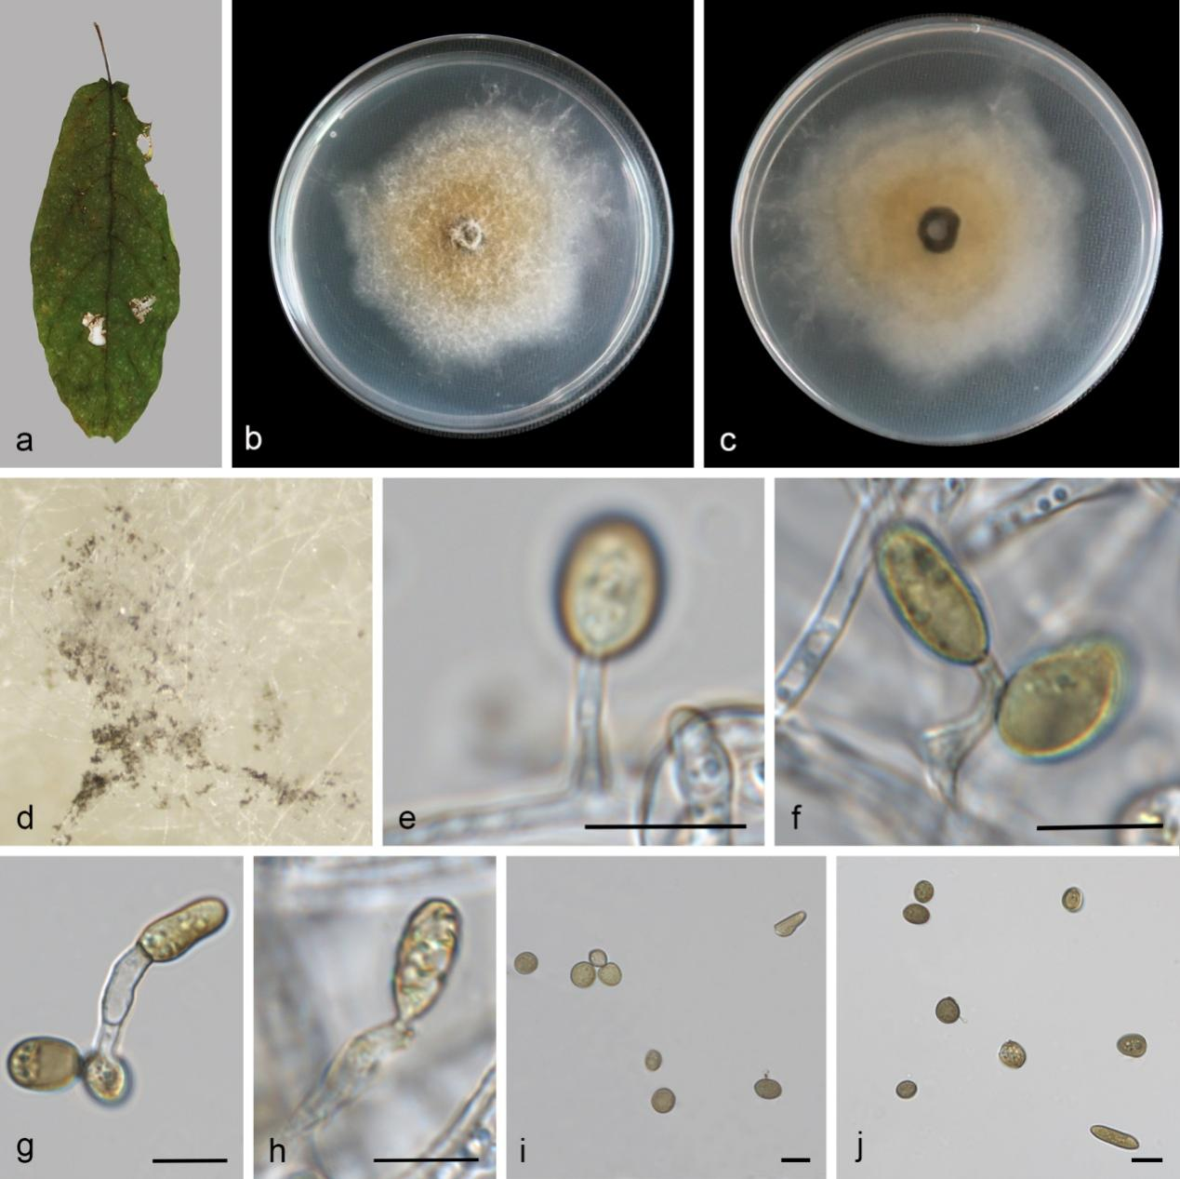
Figure S19. Apiospora xiangxiensis (CGMCC 3.29225, new host and geographical records). a Leaf of host plant. b–c Colonies on PDA after incubation for 7 days from above (b) and below (c). d Conidiomata formed in culture. e–h Conidiogenous cells giving rise to conidia. i–j Conidia. Scale bars: 10 μm (e–j).

Apiospora xiangxiensis X.Y. Chang & M.J. Chen, MycoKeys 116: 214 (2025) Figs. 1, S19
On diseased leaves of Ficus heteromorpha. Asexual morph: hyphae 2.1–6.8 μm diameter, hyaline, branched, thick-walled, septate. Conidiophores reduced to conidiogenous cells. Conidiogenous cells 5.97–13.18 × 1.71–5.73 µm (av. = 10.30 ± 2.59 × 3.39 ± 1.46 μm, n = 17), holoblastic, hyaline, cylindrical, straight or flexuous, aseptate, smooth-walled. Conidia 5.84–16.54 × 4.39–8.49 μm (av. = 10.31 ± 2.75 × 6.68 ± 1.16 μm, n = 22), obglobose to cylindric-clavate, aseptate, pale brown, guttulate, without a centra scar.
Culture characteristics – On the PDA, the colony surfaces yellow flat, floccose, with moderate aerial mycelia, colony margin undulate and reverse yellow. PDA attaining 63 mm in diameter after 7 days at 25 °C, growth rate 9.0 mm/day.
Material examined – CHINA, Fujian Province, Wuyishan City, Da'anyuan Eco-Tourism Area (27.873682 N, 117.856120 E, 496 m), on diseased leaves of Ficus heteromorpha, 12 May 2024, Q.Y. Liu (HSAUP 11949-2A, holotype), living culture CGMCC 3.29225 = SAUCC 11949-2A; ibid., HSAUP 11949-2B, living culture SAUCC 11949-2B.
Distribution – CHINA, Hunan and Fujian Provinces.
Ecology – Associated with diseased leaves of Ficus heteromorpha and dead culms of Poaceae sp..
Notes – Apiospora xiangxiensis (strains RCEF20001 and RCEF20002) was reported from dead culms of Poaceae sp. in Hunan Province, China ^{[28]}. In the present study, two strains (SAUCC 11949-2A and SAUCC 11949-2B) are clustered with A. xiangxiense clade in the combined phylogenetic tree (Fig. 1). Our strains were similar to the A. xiangxiensis (RCEF20001, ex-type) in ITS (2/498 bp, 99.6%), LSU (0/766 bp, 100%), tub2 (1/390, 99.7%), and tef1-α (0/413, 100%) sequences. Morphologically, our strains closely resembled A. xiangxiensis (RCEF20001, ex-type) in conidial size (5.84–16.54 × 4.39–8.49 μm vs. 8.6–15.4 × 6.7–10.2 µm) and conidiogenous cells length (5.97–13.18 × 1.71–5.73 µm vs. 2.0–15.5 × 1.4–3.9 µm). Apiospora xiangxiensis was first recorded from diseased leaves of Ficus heteromorpha in Fujian Province.
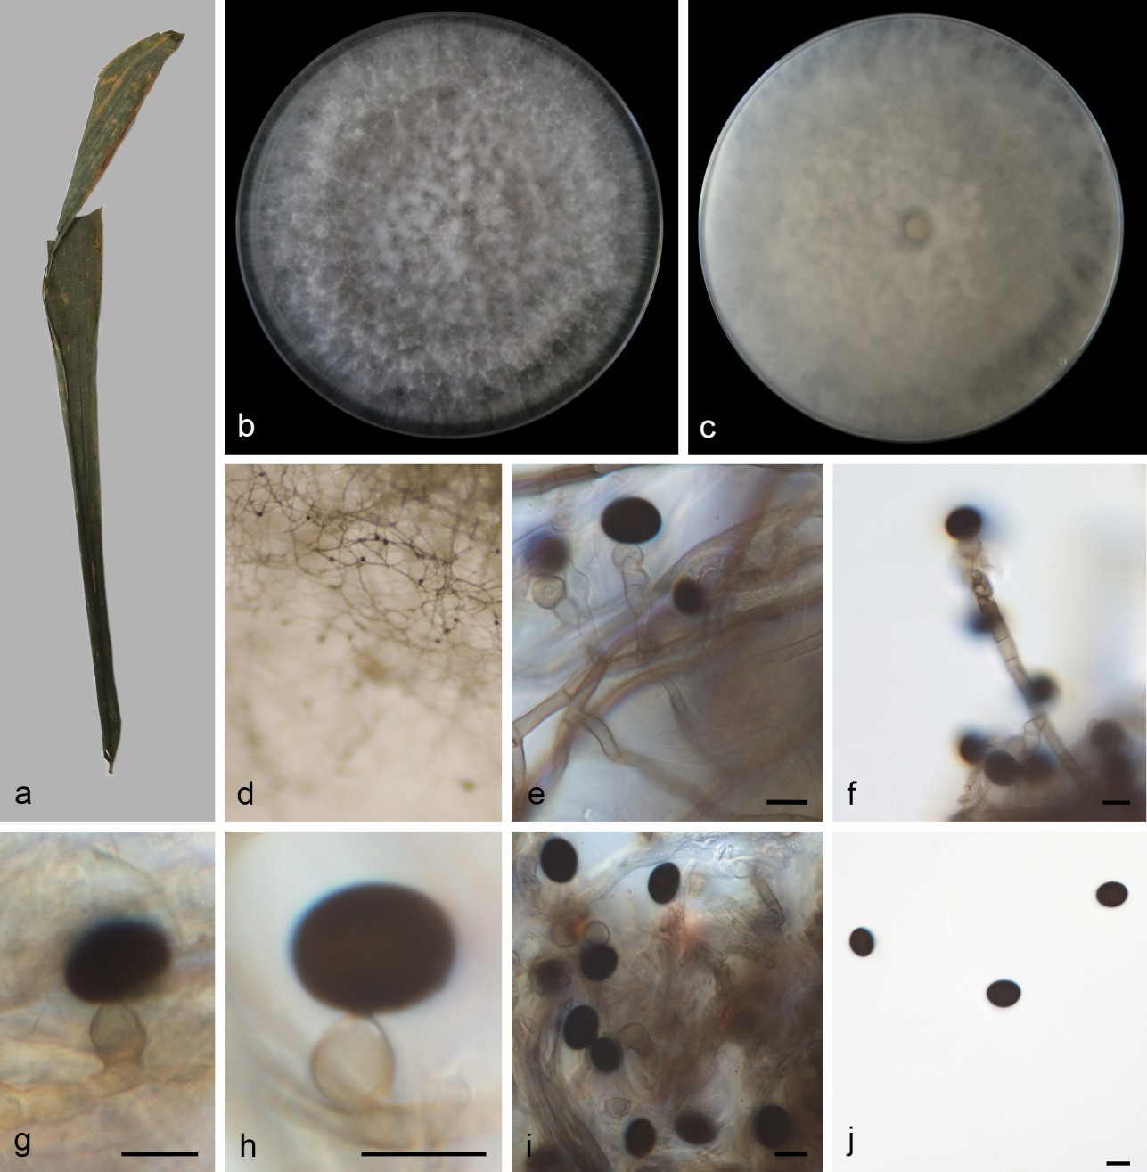
Figure S20. Nigrospora bambusae (SAUCC 14170-1, new geographical record). a Leaf of host plant. b–c Colonies on PDA after incubation for 7 days from above (b) and below (c). d Conidiomata formed in culture. e–f Conidiophores and conidiogenous cells giving rise to conidia. g–i Conidiogenous cells giving rise to conidia. j Conidia. Scale bars: 10 μm (e–j).

Nigrospora bambusae Mei Wang & L. Cai, Persoonia 39: 127 (2017) Figs. 27, S20
Asexual morph: hyphae smooth, pale brown, branched, septate, 3.2–5.7 μm diam. Conidiophores 24.33–100.67 × 3.51–7.91 µm (av. = 62.15 ± 27.01 × 5.42 ± 1.78 μm) straight, pale brown, aseptate or septate, unbranched, sometimes reduced to conidiogenous cells. Conidiogenous cells aggregated in clusters on hyphae, pale brown, globose, subglobose to ampulliform, 5.54–14.40 × 4.77–8.50 μm (av. = 8.67 ± 2.21 × 6.74 ± 1.11, n = 13). Conidia solitary, globose or subglobose, black, shiny, smooth, aseptate, 10.45–16.35 × 8.89–13.67 μm (av. = 12.53 ± 1.62 × 10.69 ± 1.44, n = 17).
Culture characteristics – On the PDA, the colony surfaces are white, prominent, floccose, with abundant aerial mycelia and reverse fawn. PDA attaining 90 mm in diameter after 7 days at 25 °C.
Material examined – CHINA, Hainan Province, Wuzhishan City, Wuzhishan National Nature Reserve (18.907212 N, 109.679171 E, 379 m), on diseased leaves of bamboo (Poaceae sp.), 02 December 2024, Y.L. Wang (HSAUP 14170-1), living cultures SAUCC 14170-1.
Distribution – CHINA (Hainan, Guangdong, and Jiangxi Provinces), Thailand.
Ecology – Associated with bamboo.
Notes – Phylogenetic analysis showed that the newly obtained strain (SAUCC 14170-1) clustered with Nig. bambusae (CGMCC 3.18327 and LC7244) (Fig. 27). Our new isolate is morphologically indistinguishable from Nig. bambusae (CGMCC 3.18327, ex-type) ^{[82]}. The phylogeny and morphology of our new isolate is not significantly different from Nig. bambusae. Thus, we identified our new isolates as Nig. bambusae. CGMCC 3.18327 was isolated from bamboo in Guangdong Province, China; LC7244 was isolated from bamboo in Jiangxi Province, China ^{[82]}. ZHKUCC 22-0126 and ZHKUCC 22-0144 were isolated from bamboo leaves, Thailand ^{[83]}. Since the new isolate was first found on bamboo, in Hainan Province, China. We identified it as a new geographical record.
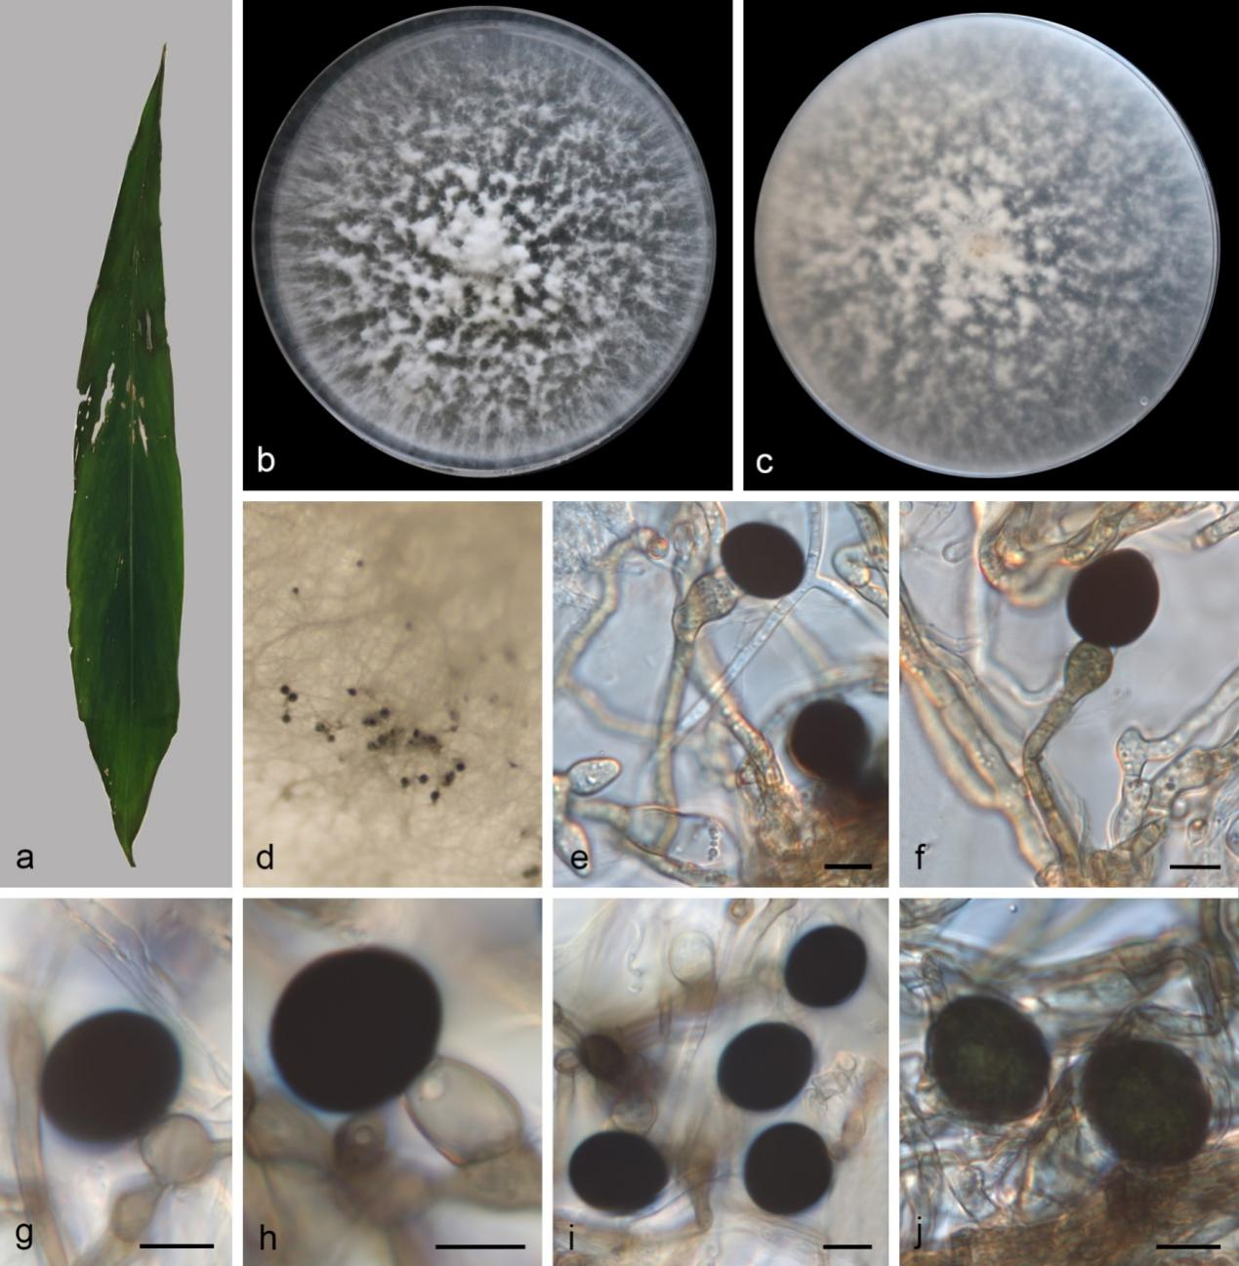
Figure S21. Nigrospora brasiliensis (SAUCC 2361-1, new host and geographical records). a Leaf of host plant. b–c Colonies on PDA after incubation for 7 days from above (b) and below (c). d Conidiomata formed in culture. e–f Conidiophores and conidiogenous cells giving rise to conidia. g–h Conidiogenous cells giving rise to conidia. i–j Conidia. Scale bars: 10 μm (e–j).

Nigrospora brasiliensis A.C.Q. Brito, C. Conforto, A.R. Machado, Persoonia 42: 439 (2019)
Figs. 27, S21
On PDA. Asexual morph: hyphae guttulate, verrucose, hyaline to pale brown, branched, septate, 2.3–5.1 μm diam. Conidiophores rare, 55.79–71.83 × 3.9–4.9 µm (av. = 63.81 × 4.4), flexuous, pale brown, aseptate, unbranched, sometimes reduced to conidiogenous cells. Conidiogenous cells aggregated in clusters on hyphae, hyaline to pale brown, doliiform, subglobose to ampulliform, 8.15–14.70 × 7.09–12.55 μm (av. = 12.44 ± 2.23 × 9.33 ± 1.59, n = 12). Conidia solitary, globose or subglobose, black, shiny, smooth, aseptate, acrogenous, 16.37–22.45 × 13.75–19.10 μm (av. = 19.49 ± 1.61 × 16.86 ± 1.47, n = 25).
Culture characteristics – On the PDA, the colony surfaces are white, prominent, floccose, with abundant aerial mycelia and reverse white. PDA attaining 90 mm in diameter after 7 days at 25 °C.
Material examined – CHINA, Yunnan Province, Menghai County, Nannuo Mountain (21.9238632 N, 100.5947519 E, 1876 m), on diseased leaves of Trachycarpus fortunei, 18 March 2023, D.H. Li (HSAUP 2361-1), living cultures SAUCC 2361-1.
Distribution – CHINA (Yunnan Province), Brazil.
Ecology – Associated with Nopalea cochenillifera and Trachycarpus fortune.
Notes – Phylogenetic analysis showed that the newly obtained strains (SAUCC 2361-1) clustered with Nig. brasiliensis (CMM 1214, ex-type) (Fig. 27). Our new isolate exhibit minor morphological and phylogenetic variations ^{[84]}. Thus, we identified our new isolates as Nig. brasiliensis. Nigrospora brasiliensis was isolated from Nopalea cochenillifera in Brazil ^{[84]}. Since the new isolate was first found on Trachycarpus fortunei in China. We identified it as a new host and geographical records.
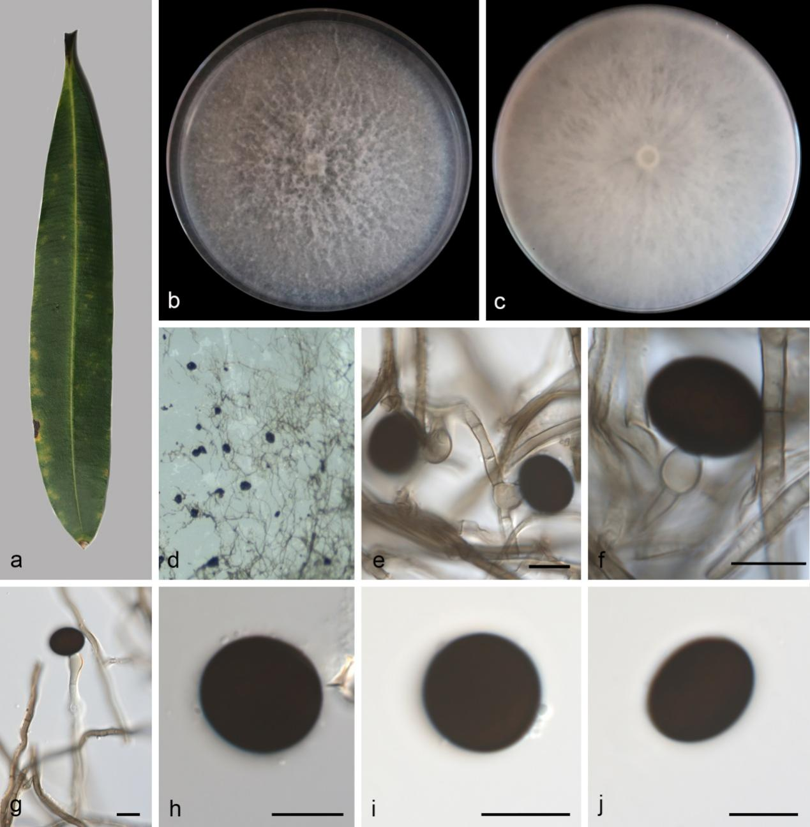
Figure S22. Nigrospora camelliae-sinensis (SAUCC 8826-3, new host record). a Leaf of host plant. b–c Colonies on PDA after incubation for 7 days from above (b) and below (c). d Conidiomata formed in culture. e–f Conidiogenous cells giving rise to conidia. g Conidiophores and conidiogenous cells giving rise to conidia. h–j Conidia. Scale bars: 10 μm (e–j).

Nigrospora camelliae-sinensis Mei Wang & L. Cai, Persoonia 39: 127 (2017) Figs. 27, S22
On PDA. Asexual morph: hyphae smooth, pale brown, branched, septate, 2.4–3.6 μm diam. Conidiophores rare, 66.55 × 3.17 µm, straight, hyaline to pale brown, aseptate, unbranched, sometimes reduced to conidiogenous cells. Conidiogenous cells monoblastic, hyaline to pale brown, subglobose to ampulliform, sometimes appearing as the bulge directly from the mycelia without septa, 5.49–13.18 × 3.54–5.22 μm (av. = 9.99 ± 3.35 × 4.63 ± 0.70, n = 15). Conidia solitary, globose or subglobose, black, shiny, smooth, aseptate, 13.70–17.56 × 10.77–14.45 μm (av. = 15.43 ± 1.19 × 12.81 ± 1.15, n = 21).
Culture characteristics – On the PDA, the colony surfaces are white, floccose, with abundant aerial mycelia and reverse white. PDA attaining 90 mm in diameter after 7 days at 25 °C.
Material examined – CHINA, Yunnan Province, Pu'er City, Simao District, Yixiang Town (22.593953 N, 101.086217 E, 1596 m), on diseased leaves of Nerium indicum, 15 May 2024, Q.Y. Liu (HSAUP 8826-3), living cultures SAUCC 8826-3; ibid., Jinghong City, Xishuangbanna Primitive Forest Park (22.0312884 N, 100.8769031 E, 678 m), on diseased leaves of Tectaria subtriphylla, 17 March 2023, D.H. Li (HSAUP 2075-2), living cultures SAUCC 2075-2.
Distribution – CHINA.
Ecology – Associated with Aquilaria sinensis, Camellia sinensis, Castanopsis sp., Lumnitzera littorea Musa paradisiaca, and Tectaria subtriphylla.
Notes – Phylogenetic analysis showed that the newly obtained strains (SAUCC 8826-3 and SAUCC 2075-2) clustered with Nig. camelliae-sinensis (Fig. 27). Our new isolates exhibit minor morphological variations, it shows no phylogenetic differences from Nig. camelliae-sinensis ^{[82]}. Thus, we identified our new isolates as Nig. camelliae-sinensis. Nigrospora camelliae-sinensis was isolated from Aquilaria sinensis, Camellia sinensis, Castanopsis sp., Lumnitzera littorea, and Musa paradisiaca in China ^{[82,85,86]}. Since the new isolates were first found on Nerium indicum and Tectaria subtriphylla in China. We identified as new host records.
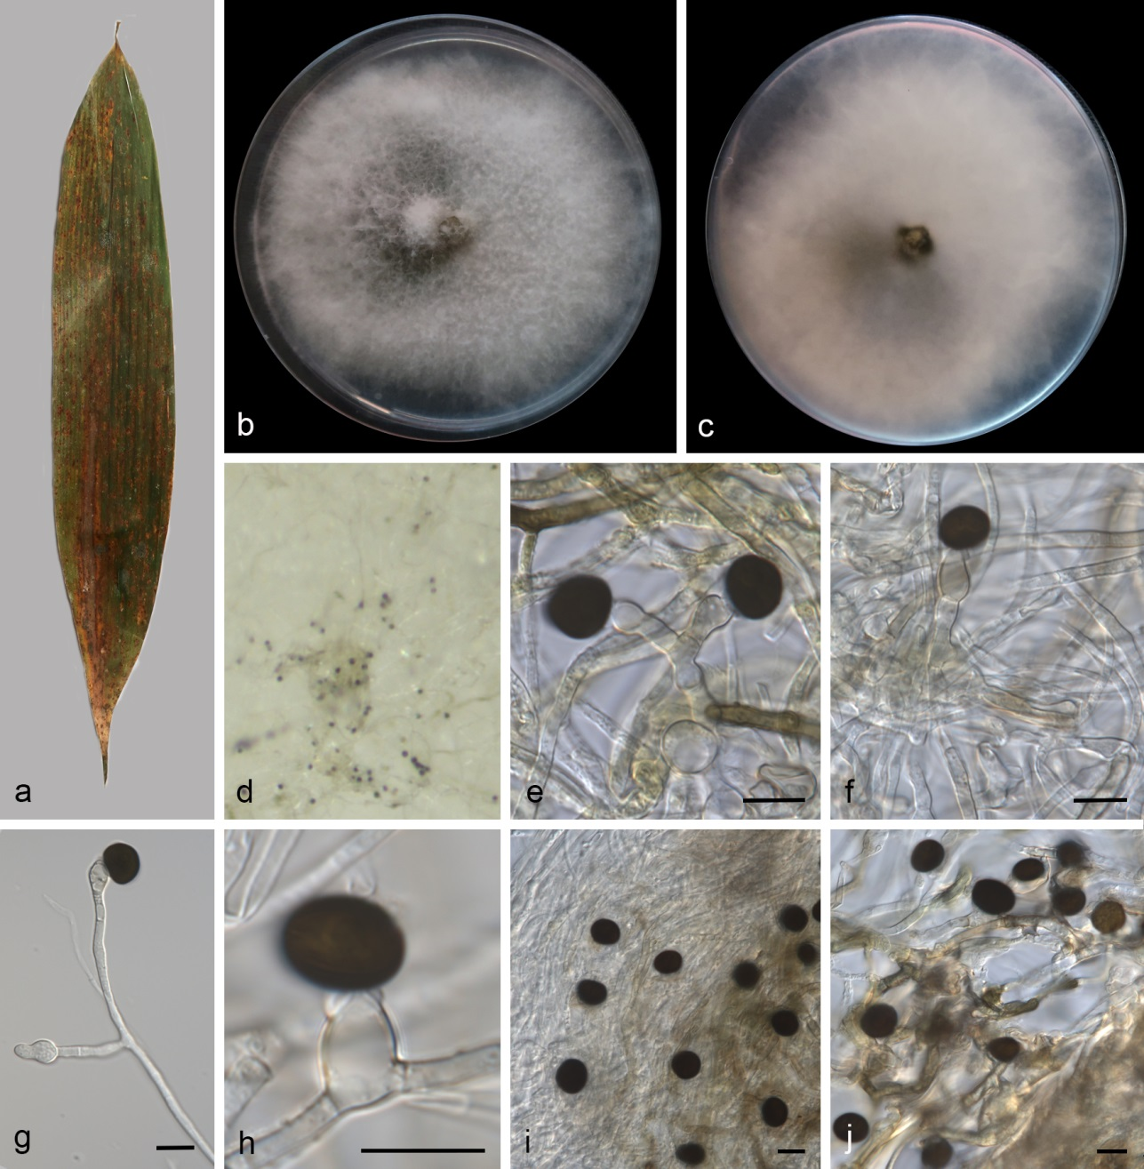
Figure S23. Nigrospora chinensis (SAUCC 7515-4, new host record). a Leaf of host plant. b–c Colonies on PDA after incubation for 7 days from above (b) and below (c). d Conidiomata formed in culture. e, h Conidiogenous cells giving rise to conidia. f–g Conidiophores and conidiogenous cells giving rise to conidia. i–j Conidia. Scale bars: 10 μm (e–j).

Nigrospora chinensis Mei Wang & L. Cai, Persoonia 39: 129 (2017) Figs. 27, S23
Asexual morph: hyphae smooth, hyaline to pale brown, branched, septate, 1.6–4.0 μm diam. Conidiophores rare, 37.14–87.40 × 2.89–3.98 μm (av. = 53.45 ± 18.96 × 3.36 ± 0.40, n = 6), straight or slightly flexuous, hyaline, aseptate, unbranched or branched, sometimes reduced to conidiogenous cells. Conidiogenous cells monoblastic, solitary, hyaline, ovoid or ampulliform, 5.30–16.28 × 3.35–5.84 μm (av. = 9.62 ± 2.69 × 4.81 ± 0.77, n = 18). Conidia solitary, globose or subglobose, black, shiny, smooth, aseptate, 8.19–12.94 × 6.76–10.78 μm (av. = 9.88 ± 1.278 × 8.09 ± 1.01, n = 23).
Culture characteristics – On the PDA, the colony surfaces are grey, prominent, floccose, with abundant aerial mycelia and reverse grey. PDA attaining 90 mm in diameter after 7 days at 25 °C.
Material examined – CHINA, Hainan Province, Diaoluoshan National Forest Park (18.660546 N, 109.936445 E, 94 m), on diseased leaves of bamboo (Poaceae sp.), 27 March 2024, M.Y. Zhang (HSAUP 7515-4), living cultures SAUCC 7515-4; ibid., Ledong Li Autonomous County (18.688815 N, 108.858742 E, 697 m), on diseased leaves of Schima superba, 12 April 2023, Y. Jiang (HSAUP 3751-1), living cultures SAUCC 3751-1; CHINA, Yunnan Province, Jinghong City, Xishuangbanna Primitive Forest Park (22.0312884 N, 100.8769031 E, 678 m), on diseased leaves of Rhaphidophora hongkongensis, 17 March 2023, D.H. Li (HSAUP 2062-1), living cultures SAUCC 2062-1.
Distribution – China, Republic of Korea, and Thailand.
Ecology – Associated with Aucuba japonica, bamboo, Camellia oleifera, Camellia sinensis, Castanopsis sp., Eleiodoxa conferta, Ginkgo biloba, Ilex cornuta, Itea sp., Lindera aggregate, Machilus breviflora, Magnolia candolli, Machilus duthiei, Musa paradisiaca, Nicotiana tabacum, Osmanthus sp., Quercus sp., Rhaphidophora hongkongensis, Selenicereus monacanthus, Schima superba, Smilax ocreata, tobacco, and orange.
Notes – Phylogenetic analysis showed that the newly obtained strains (SAUCC 7515-4, SAUCC 3751-1, and SAUCC 2062-1) clustered with Nig. chinensis (Fig. 27). Our new isolates exhibit minor morphological and phylogenetic differences from Nig. chinensis ^{[82]}. Thus, we identified our new isolates as Nig. chinensis. Nigrospora chinensis was isolated from Aucuba japonica, Camellia oleifera, Camellia sinensis, Castanopsis sp., Eleiodoxa conferta, Ginkgo biloba, Ilex cornuta, Itea sp., Lindera aggregate, Machilus breviflora, Magnolia candolli, Machilus duthiei, Musa paradisiaca, Nicotiana tabacum, Osmanthus sp., Quercus sp., Selenicereus monacanthus, Smilax ocreata, tobacco, and orange in China, Republic of Korea, and Thailand ^{[82,87-93]}. Since the new isolates were first found on bamboo, Schima superba, and Rhaphidophora hongkongensis in China. We identified as new host records.
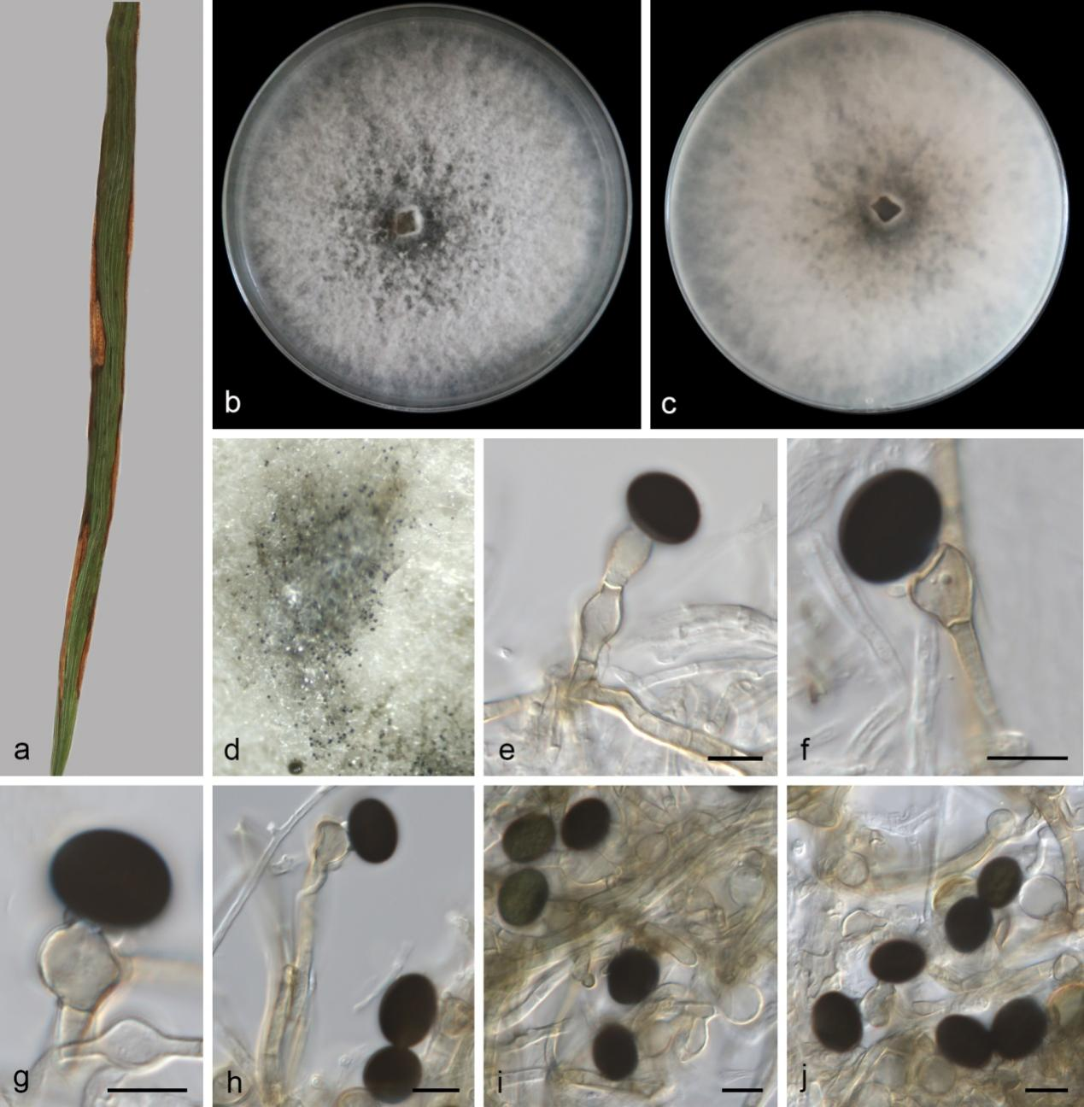
Figure S24. Nigrospora lacticolonia (SAUCC 13990-1, new host record). a Leaf of host plant. b–c Colonies on PDA after incubation for 7 days from above (b) and below (c). d Conidiomata formed in culture. e–f, h Conidiophores and conidiogenous cells giving rise to conidia. g Conidiogenous cells giving rise to conidia. i–j Conidia. Scale bars: 10 μm (e–j).

Nigrospora lacticolonia Mei Wang & L. Cai, Persoonia 39: 06 (2017) Figs. 27, S24
Asexual morph: hyphae smooth, hyaline to pale brown, branched, septate, 1.5–4.8 μm diam. Conidiophores rare, 39.27–55.03 × 3.61–7.81 μm (av. = 47.20 ± 6.94 × 4.82 ± 1.61, n = 6) straight, pale brown, aseptate, unbranched, sometimes reduced to conidiogenous cells. Conidiogenous cells monoblastic, solitary, hyaline to pale brown, doliiform or ampulliform, 8.20–14.07 × 6.71–10.53 μm (av. = 10.03 ± 1.63 × 8.07 ± 1.22, n = 24). Conidia solitary, globose or subglobose, black, shiny, smooth, aseptate, 12.17–16.58 × 9.38–13.75 μm (av. = 14.73 ± 1.02 × 12.23 ± 1.06, n = 33).
Culture characteristics – On the PDA, the colony surfaces and reverse are black in the center and white at the edges, floccose, with abundant aerial mycelia. PDA attaining 90 mm in diameter after 7 days at 25 °C.
Material examined – CHINA, Hainan Province, Lingshui Li Autonomous County (18.699416 N, 109.878394 E, 98 m), on diseased leaves of Allium sativum, 30 November 2024, Y.L. Wang (HSAUP 13990-1), living cultures SAUCC 13990-1; ibid., Haikou City, Meilan District, Baishamen Park (20.068965 N, 110.332418 E, 5 m), on decaying leaves, 28 March 2024, Q.Y. Liu (HSAUP 8123-5), living cultures SAUCC 8123-5; ibid., Ledong Li Autonomous County, Jiandao Town (18.688815 N, 108.858742 E, 697 m), on diseased leaves of Magnolia liliiflora, 12 April 2023, Y. Jiang (HSAUP 3745-1), living cultures SAUCC 3745-1.
Distribution – Brazil, China, Iran, Korea, Malaysia, Oman, and Thailand.
Ecology – Associated with Allium sativum, Bougainvillea spectabilis, Camellia sinensis, Cucurbita pepo, Helianthus tuberosus, Hylocereus polyrhizus, Magnolia liliiflora, Manihot esculenta, Musa paradisiaca, Phoenix dactylifera, Sargassum sp., and Tamarix passerinoides.
Notes – Phylogenetic analysis showed that the newly obtained strains (SAUCC 13990-1 SAUCC 8123-5, and SAUCC 3745-1) clustered with three strains of Nig. lacticolonia (CGMCC 3.18123, LC7009, and LC12060) (Fig. 27). Our new isolates show only minor differences from Nig. lacticolonia, both morphologically and phylogenetically ^{[82]}. Thus, we identified our new isolates as Nig. lacticolonia. Nigrospora lacticolonia was isolated from Bougainvillea spectabilis, Camellia sinensis, Cucurbita pepo, Helianthus tuberosus, Hylocereus polyrhizus, Manihot esculenta, Musa paradisiaca, Phoenix dactylifera, Sargassum sp., Tamarix passerinoides in Brazil, China, Iran, Korea, Malaysia, Oman, Thailand ^{[82,94-101]}. Since the new isolates were first found on Allium sativum, Magnolia liliiflora, and decaying leaves in China. We identified as new host records.
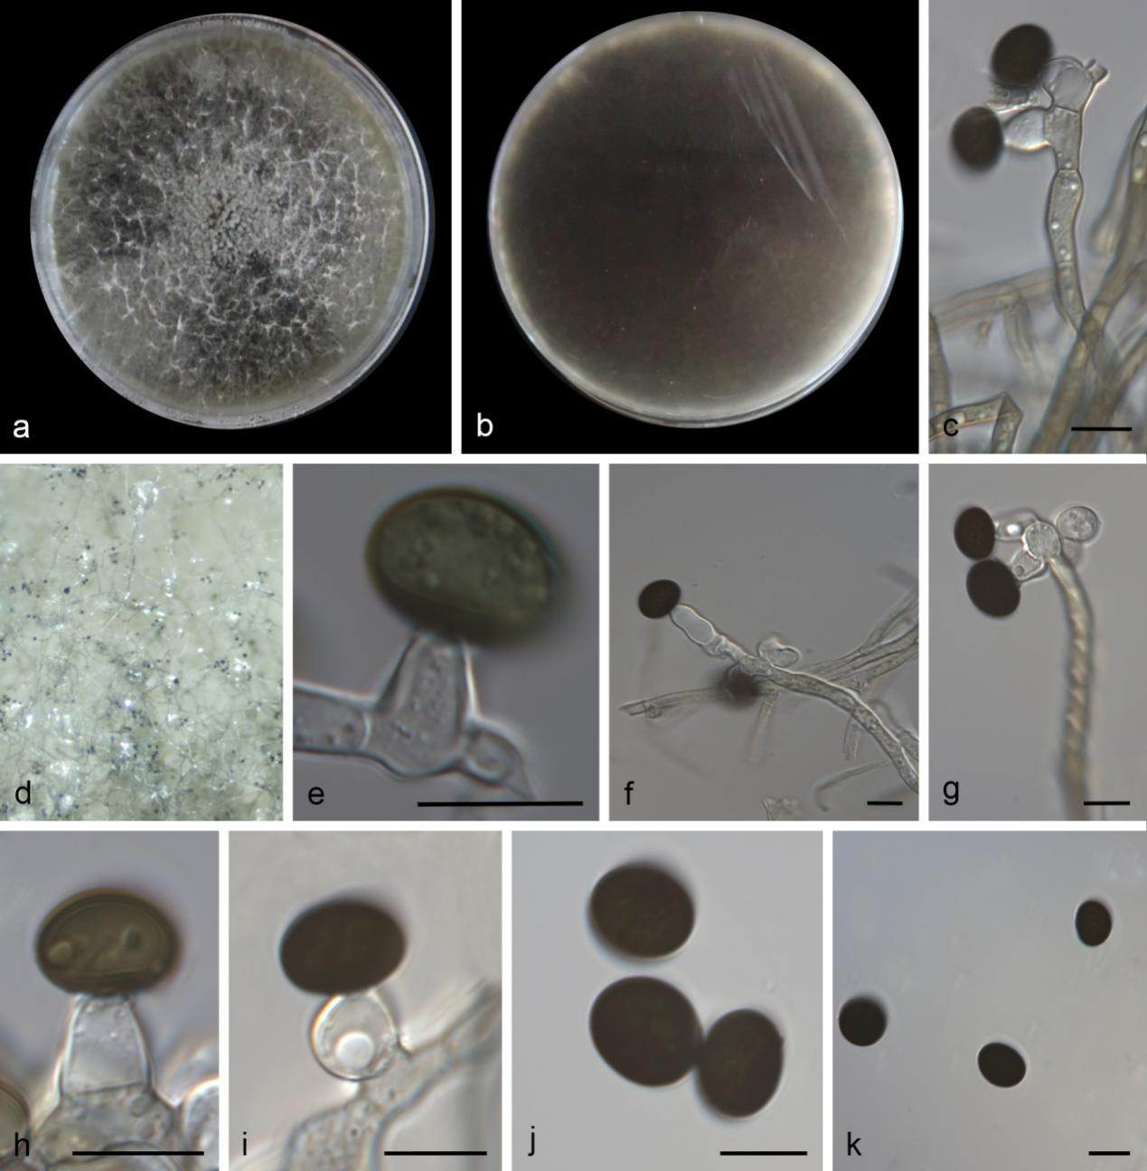
Figure S25. Nigrospora oryzae (SAUCC 2083-1, new host record). a–b Colonies on PDA after incubation for 7 days from above (a) and below (b). d Conidiomata formed in culture. c, f–g Conidiophores and conidiogenous cells giving rise to conidia. e, h–i Conidiogenous cells giving rise to conidia. j–k Conidia. Scale bars: 10 μm (e–k).

Nigrospora oryzae (Berk. & Broome) Petch (1924) Figs. 27, S25
On PDA. Asexual morph: hyphae smooth, hyaline, branched, septate, 2.3–4.7 μm diam. Conidiophores rare, flexuous, hyaline, aseptate, sometimes reduced to conidiogenous cells. Conidiogenous cells aggregated in clusters on hyphae, hyaline to pale brown, subglobose to ampulliform, 7.38–14.65 × 4.11–9.05 μm (av. = 10.01 ± 1.92 × 6.33 ± 1.18, n = 19). Conidia solitary, globose or subglobose, black, shiny, smooth, aseptate, acrogenous, 10.84–23.11 × 8.28–12.28 μm (av. = 11.93 ± 0.68 × 9.70 ± 1.19, n = 27).
Culture characteristics – On the PDA, the colony surfaces are black, floccose, with abundant aerial mycelia and reverse black. PDA attaining 90 mm in diameter after 7 days at 25 °C.
Material examined – CHINA, Yunnan Province, Jinghong City, Xishuangbanna Primitive Forest Park (22.0312884 N, 100.8769031 E, 678 m), on diseased leaves of Pometia tomentosa, 17 March 2023, D.H. Li (HSAUP 2083-1), living cultures SAUCC 2083-1; ibid., Menghai County, Nannuo Mountain (21.9238632 N, 100.5947519 E, 1876 m), on diseased leaves of Calophanoides alba, 18 March 2023, D.H. Li (HSAUP 2392-2), living cultures SAUCC 2392-2; CHINA, Fujian Province, Wuyishan City (27.81545 N, 117.710744 E, 1145 m), on diseased leaves of Prunus avium, 17 March 2023, X.Y. Liu (HSAUP 1470-1), living cultures SAUCC 1470-1; CHINA, Hainan Province, Ledong Li Autonomous County (18.688815 N, 108.858742 E, 697 m), on diseased leaves of Photinia serratifolia, 12 April 2023, Y. Jiang (HSAUP 3758-4), living cultures SAUCC 3758-4; CHINA, Guangxi Zhuang Autonomous Region, Nanning City (22.575828 N, 108.141214 E, 120 m), on diseased leaves of Saccharum officinarum, 02 December 2024, Y. Jiang (HSAUP 13359-3), living cultures SAUCC 13359-3; ibid., on diseased leaves of Bothriochloa ischaemum, 02 December 2024, Y. Jiang (HSAUP 13360-6), living cultures SAUCC 13360-6.
Notes – Phylogenetic analysis showed that the newly obtained strains clustered with strains of Nig. oryzae (Fig. 27). Our new isolates exhibit minor morphological and phylogenetic variations. Thus, we identified our new isolates as Nig. oryzae. Nigrospora oryzae has been found on a wide range of hosts with a worldwide distribution ^{[86,102,103]}. Since the new isolates were first found on Bothriochloa ischaemum, Calophanoides alba, Photinia serratifolia, Pometia tomentosa, Prunus avium, and Saccharum officinarum in China. We identified as new host records.
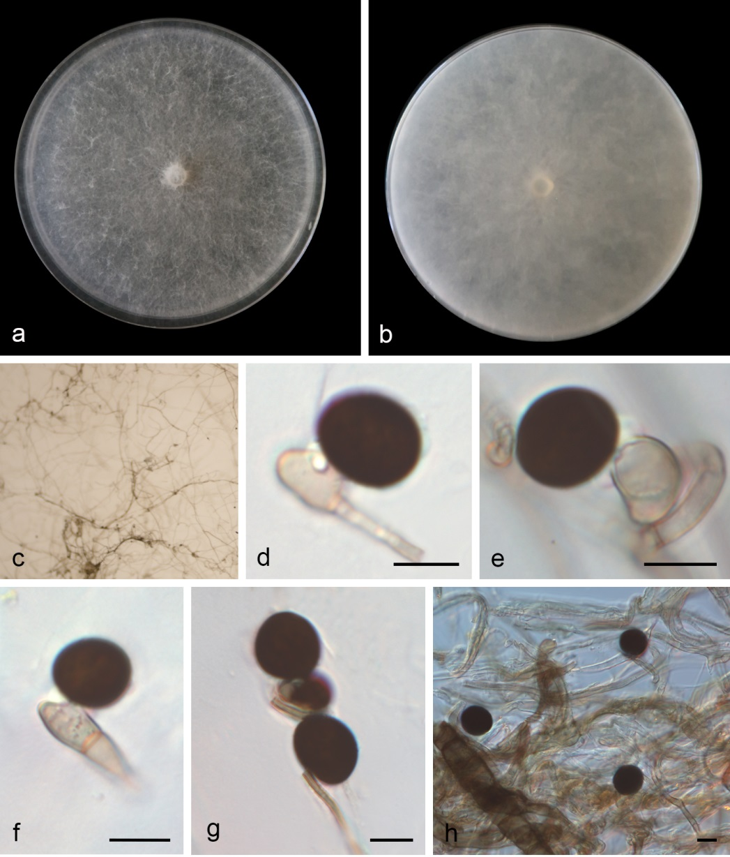
Figure S26. Nigrospora pyriformis (SAUCC 2049-2, new host record). a–b Colonies on PDA after incubation for 7 days from above (a) and below (b). c Conidiomata formed in culture. d–f Conidiogenous cells giving rise to conidia. g Conidia. h Conidia and hyphae. Scale bars: 10 μm (e–h).

Nigrospora pyriformis Mei Wang & L. Cai, Persoonia 39: 126 (2017) Figs. 27, S26
On PDA. Asexual morph: hyphae smooth, hyaline to pale brown, branched, septate, 2.7–5.2 μm diam. Conidiophores reduced to conidiogenous cells. Conidiogenous cells aggregated in clusters on hyphae, hyaline to pale brown, subglobose to ampulliform, 7.34–26.35 × 5.26–9.37 μm (av. = 16.31 ± 8.56 × 6.49 ± 1.93, n = 14). Conidia solitary, globose or subglobose, black, shiny, smooth, aseptate, 14.96–19.51 × 13.18–19.06 μm (av. = 16.44 ± 1.35 × 15.14 ± 1.70, n = 20).
Culture characteristics – On the PDA, the colony surfaces are white, flat, floccose, with moderate aerial mycelia and reverse fawn. PDA attaining 90 mm in diameter after 7 days at 25 °C.
Material examined – CHINA, Yunnan Province, Jinghong City, Xishuangbanna Primitive Forest Park (22.0312884 N, 100.8769031 E, 678 m), on leaves of Artocarpus heterophyllus. 17 March 2023, D.H. Li (HSAUP 2049-2), living cultures SAUCC 2049-2.
Distribution – China, Brazil, and South Korea.
Ecology – Associated with Artocarpus heterophyllus, Camellia sinensis, Castanopsis sp. Chenopodium album, Citrus reticulate, Citrus sp., Clematis chinensis, Laurencia sp., Lindera aggregate, Manihot esculenta, Musa paradisiaca, Nelumbo nucifera, Polyopes sp., Rosa sp., Rubus reflexus, and Sargassum sp..
Notes – Phylogenetic analysis showed that the newly obtained strain (SAUCC 2049-2) clustered with Nig. pyriformis (CGMCC 3.18122, ex-type) (Fig. 27). Our new isolate is morphologically similar to the type specimen of Nig. pyriformis (CGMCC 3.18122, ex-type), but exhibits minor differences in conidial morphology ^{[82]}. This slight difference may be attributed to the different culture media. The phylogeny and morphology of our new isolate is not significantly different from Nig. pyriformis. Thus, we identified our new isolate as Nig. pyriformis. Nigrospora pyriformis was isolated from Camellia sinensis, Castanopsis sp. Chenopodium album, Citrus reticulate, Citrus sp., Clematis chinensis, Laurencia sp., Lindera aggregate, Manihot esculenta, Musa paradisiaca, Nelumbo nucifera, Polyopes sp., Rosa sp., Rubus reflexus, Sargassum sp. in China, Brazil, and South Korea ^{[82,83,98,99,104,105]}. Since the new isolate was first found on Artocarpus heterophyllus, in Yunnan Province, China. We identified it as new host record.
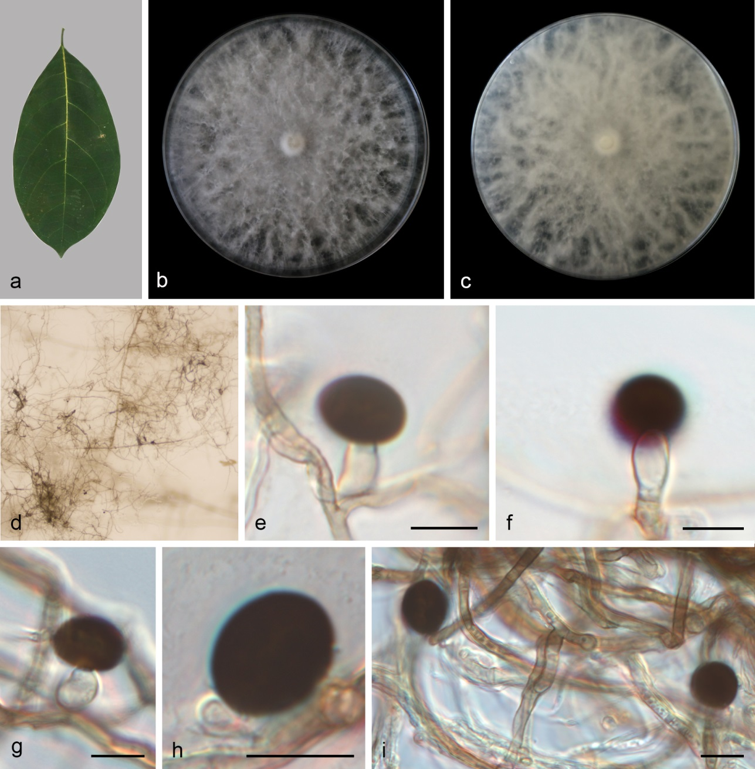
Figure S27. Nigrospora rubi (SAUCC 2049-3, new host and geographical records). a Leaf of host plant. b–c Colonies on PDA after incubation for 7 days from above (b) and below (c). d Conidiomata formed in culture. e–g Conidiogenous cells giving rise to conidia. h Conidia. i Conidia and hyphae. Scale bars: 10 μm (e–i).

Nigrospora rubi Mei Wang & L. Cai, Persoonia 39: 127 (2017) Figs. 27, S27
On PDA. Asexual morph: hyphae smooth, hyaline to pale brown, branched, septate, 2.2–5.0 μm diam. Conidiophores reduced to conidiogenous cells. Conidiogenous cells aggregated in clusters on hyphae, hyaline to pale brown, subglobose to ampulliform, 8.02–14.73 × 3.29–6.95 μm (av. = 11.37 ± 3.18 × 5.00 ± 1.41, n = 15). Conidia solitary, globose or subglobose, black, shiny, smooth, aseptate, 9.67–13.79 × 8.42–10.84 μm (av. = 11.83 ± 1.33 × 9.53 ± 0.79, n = 17).
Culture characteristics – On the PDA, the colony surfaces are white, flat, floccose, with moderate aerial mycelia and reverse fawn. PDA attaining 90 mm in diameter after 7 days at 25 °C.
Material examined – CHINA, Yunnan Province, Jinghong City, Xishuangbanna Primitive Forest Park (22.0312884 N, 100.8769031 E, 678 m), on leaves of Artocarpus heterophyllus. 17 March 2023, D.H. Li (HSAUP 2049-3), living cultures SAUCC 2049-3.
Distribution – China (Jiangxi, Shandong, and Yunnan Provinces), Korea.
Ecology – Associated with Artocarpus heterophyllus, Fraxinus sp. Rubus sp., and Sargassum sp..
Notes – Phylogenetic analysis showed that the newly obtained strain (SAUCC 2049-3) clustered with Nig. rubi (CGMCC 3.18326, ex-type) (Fig. 27). Our new isolate is morphologically indistinguishable from the type specimen of Nig. rubi (CGMCC 3.18326, ex-type) ^{[82]}. This slight difference may be attributed to the different culture media. The phylogeny and morphology of our new isolate is not significantly different from Nig. rubi; thus, we identified our new isolate as Nig. rubi. CGMCC 3.18326 was isolated from Rubus sp. in Jiangxi Province, China ^{[82]}. SFC20230324-M17 was isolated from Sargassum sp. in South Korea ^{[99]}. JZB 3230012 was isolated from Fraxinus sp. in Shandong Province, China ^{[106]}. Since the new isolate was first found on Artocarpus heterophyllus, in Yunnan Province, China. We identified it as new host and geographical records.
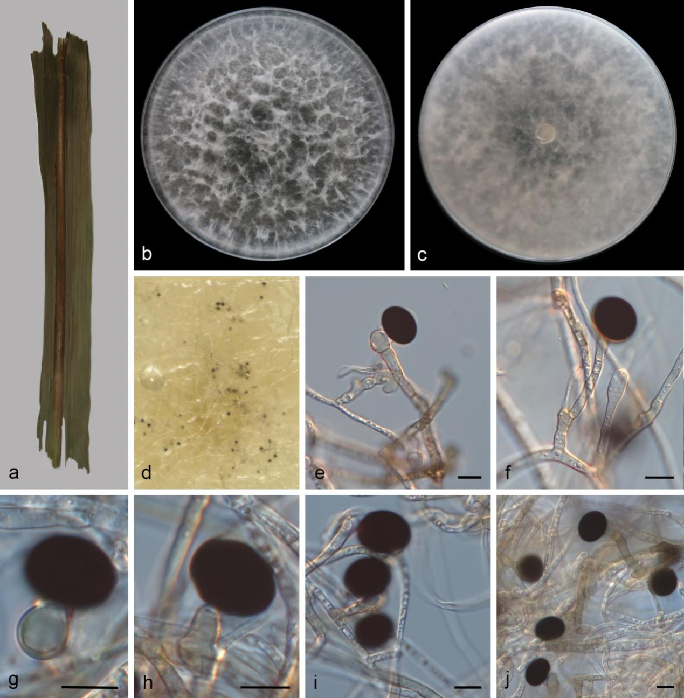
Figure S28. Nigrospora sacchari-officinarum (SAUCC 13359-2, new host record). a Leaf of host plant. b–c Colonies on PDA after incubation for 7 days from above (b) and below (c). d Conidiomata formed in culture. e–h Conidiogenous cells giving rise to conidia. i–j Conidia. Scale bars: 10 μm (e–j).

Nigrospora sacchari-officinarum M. Raza & L. Cai, Fungal Diversity 99: 95 (2019) Figs. 27, S28
Asexual morph: hyphae smooth, hyaline to pale brown, branched, septate, 3.1–3.9 μm diam. Conidiophores reduced to conidiogenous cells. Conidiogenous cells monoblastic, solitary, hyaline, ovoid or ampulliform, 7.61–40.64 × 2.31–8.81 μm (av. = 13.58 ± 8.53 × 6.26 ± 1.74, n = 15). Conidia solitary, globose or subglobose, black, shiny, smooth, aseptate, 16.18–19.88 × 12.99–18.38 μm (av. = 17.66 ± 0.95 × 15.80 ± 1.47, n = 19).
Culture characteristics – On the PDA, the colony surfaces are white, filiform, with abundant aerial mycelia and reverse white. PDA attaining 90 mm in diameter after 7 days at 25 °C.
Material examined – CHINA, Guangxi Zhuang Autonomous Region, Nanning City, Jiangnan District (22.575828 N, 108.141214 E, 120 m), on diseased leaves of Saccharum officinarum, 02 December 2024, Q.Y. Liu (HSAUP 13359-2), living cultures SAUCC 13359-2; CHINA, Yunnan Province, Xishuangbanna Primitive Forest Park (22.0312884 N, 100.8769031 E, 678 m), on diseased leaves of Cocculus laurifolius, 17 March 2023, D.H. Li (HSAUP 2048-2), living cultures SAUCC 2048-2.
Distribution – Brazil and China.
Ecology – Associated with Calea pinnatifida, Cocculus laurifolius, and Saccharum officinarum.
Notes – Phylogenetic analysis showed that the newly obtained strains (SAUCC 13359-2 and SAUCC 2048-2) clustered with Nig. sacchari-officinarum (Fig. 27). Our new isolates exhibit minor morphological and phylogenetic differences from Nig. sacchari-officinarum ^{[107]}. Thus, we identified our new isolates as Nig. sacchari-officinarum. Nigrospora chinensis was isolated from Calea pinnatifida and Saccharum officinarum in Brazil and China ^{[107,108]}. Since the new isolates were first found on Saccharum officinarum and Cocculus laurifolius in China. We identified as new host records.
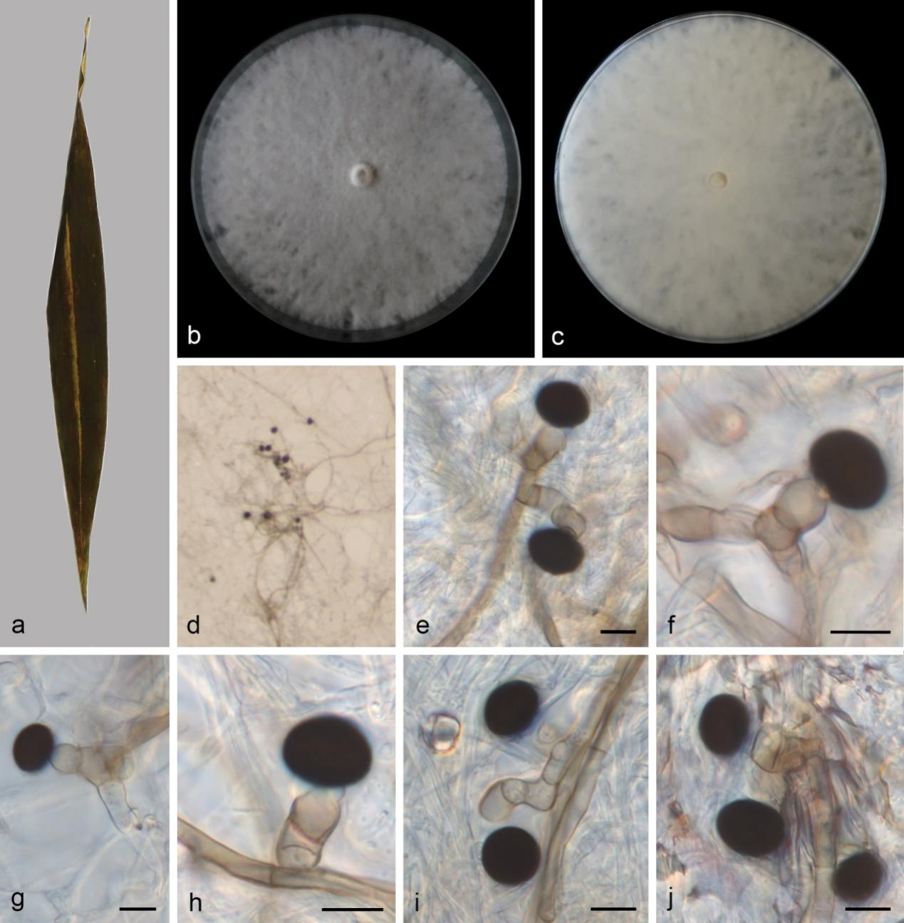
Figure S29. Nigrospora vesicularifera (SAUCC 14319-1, new host record). a Leaf of host plant. b–c Colonies on PDA after incubation for 7 days from above (b) and below (c). d Sporulation on PDA medium. e Conidiophores and conidiogenous cells giving rise to conidia. f–h Conidiogenous cells giving rise to conidia. i–j Conidia. Scale bars: 10 μm (e–j).

Nigrospora vesicularifera M. Raza & L. Cai, Fungal Diversity 99: 96 (2019) Figs. 27, S29
On WA. Asexual morph: hyphae smooth, hyaline to pale brown, branched, septate, 1.8–4.2 μm diam. Conidiophores rare, 85.83 × 4.34 µm, slightly flexuous, pale brown, aseptate, unbranched, sometimes reduced to conidiogenous cells. Conidiogenous cells arising from hyphae, pale brown, globose to ampulliform, 7.46–19.32 × 6.06–9.02 μm (av. = 14.94 ± 3.37 × 7.64 ± 0.72, n = 15). Conidia solitary, globose or subglobose, black, shiny, smooth, aseptate, 10.49–15.68 × 8.57–13.18 μm (av. = 13.59 ± 1.62 × 10.81 ± 1.49, n = 23).
Culture characteristics – On the PDA, the colony surfaces are white, floccose, with abundant aerial mycelia and reverse white. PDA attaining 90 mm in diameter after 7 days at 25 °C.
Material examined – CHINA, Hainan Province, Qiongzhong Li and Miao Autonomous County, Baihualing Tropical Rainforest Tourism and Culture Area (19.005802 N, 109.825167 E, 392 m), on diseased leaves of Apluda mutica, 03 December 2024, Y.L. Wang (HSAUP 14319-1), living cultures SAUCC 14319-1.
Distribution – Brazil and China.
Ecology – Associated with Apluda mutica, Saccharum officinarum, Manihot esculenta, and potato.
Notes – Phylogenetic analysis showed that the newly obtained strain (SAUCC 14319-1) clustered with two strains of Nig. vesicularifera (CGMCC 3.19333 and URM8718) (Fig. 27). Our new isolate is morphologically distinguishable from the type specimen of Nig. vesicularifera (CGMCC 3.19333, ex-type) in conidiogenous cells (7.46–19.32 × 6.06–9.02 μm vs. 7.5–10 × 12.5–15.5 μm), which may be attributed to different in culture medium conditions. The phylogeny of our new isolate is not significantly different from Nig. vesicularifera (CGMCC 3.19333, ex-type); thus, we identified our new isolates as Nig. vesicularifera. Nigrospora vesicularifera was isolated from Saccharum officinarum, Manihot esculenta, and potato in China and Brazil ^{[98,107,109]}. Since the new isolate was first found on Apluda mutica in Hainan Province, China. We identified it as a new host record.

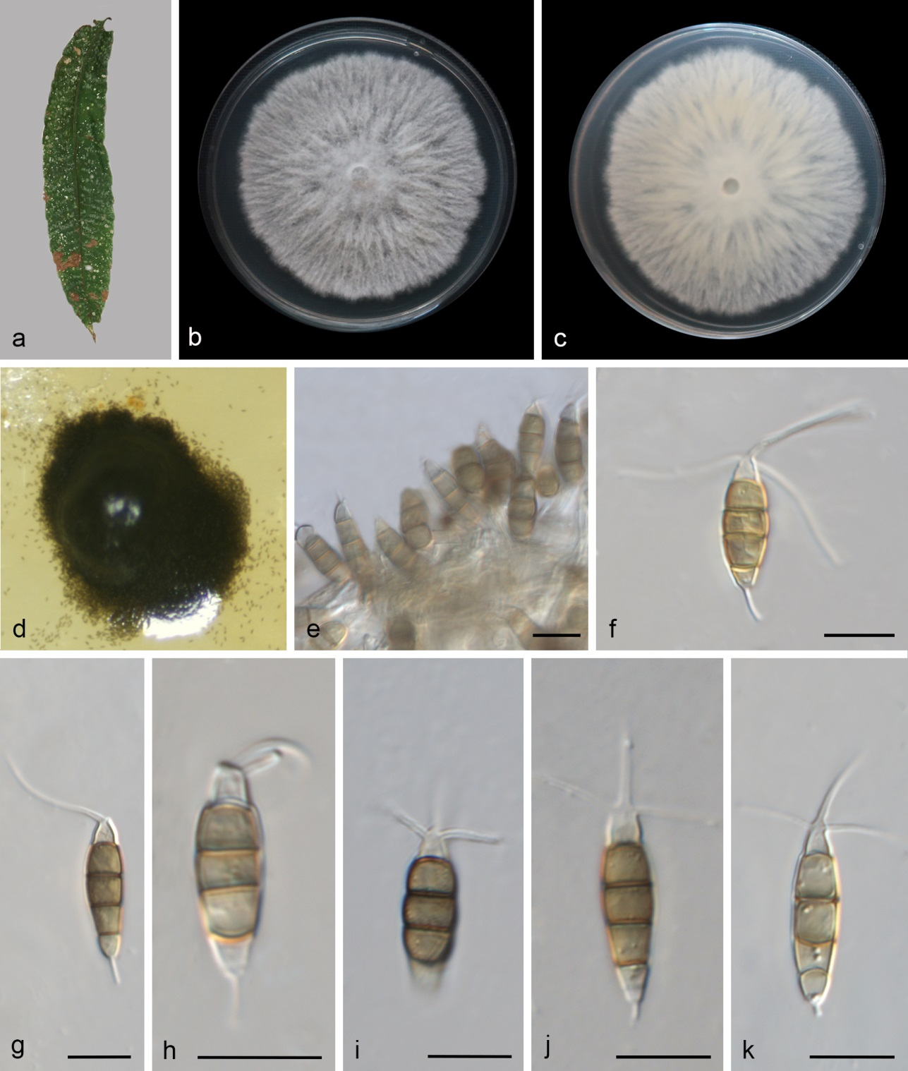
Figure S30. Neopestalotiopsis mianyangensis (SAUCC 2083-4, new host record). a Leaf of host plant. b–c Colonies on PDA after incubation for 7 days from above (b) and below (c). d Conidiomata formed in culture. e Conidiogenous cells giving rise to conidia. f–k Conidia. Scale bars: 10 μm (e–k).

Neopestalotiopsis mianyangensis W.L. Li & Jian K. Liu, Journal of Fungi 8: 10 (2022)
Figs. 35, S30
Asexual morph on PDA: conidiomata acervular, globose, black, solitary, releasing conidia in a black, slimy, globose mass. Conidiophores indistinct and reduced to conidiogenous cells. Conidiogenous cells discrete, smooth-walled, pale yellow, cylindrical or ampulliform. Conidia fusiform, straight or slightly curved, 16.62–20.66 × 5.13–7.00 μm (av. = 18.59 ± 1.35 × 6.04 ± 0.52 μm, n = 21); mostly 4-septate, slightly constricted at the septa; basal cells obconic with a truncate base, 2.63–4.61 μm (av. = 3.51 μm) long, hyaline to pale yellow, smooth, thin-walled; the three intermediate cells columnar or cylindrical, homochromatic, pale brown, 9.36–14.23 μm (av. = 12.21 ± 1.24 μm) long, septa and periclinal walls darker than rest of the cell; second cell from the base pale brown, 3.71–5.25 μm (av. = 4.62 ± 0.47 μm) long; third cell pale brown, 3.07–5.15 μm (av. = 4.07 ± 0.54 μm) long; fourth cell pale brown, 3.10–5.44 μm (av. = 4.68 ± 0.58 μm) long; apical cell hyaline, subcylindrical, 2.13–4.49 μm (av. = 2.97 ± 0.60 μm) long; with 1–3 tubular apical appendages (mostly 2), unbranched, 14.97–23.15 μm (av. = 18.88 ± 2.42 μm) long; basal appendage 0–1, tubular, unbranched, 2.67–6.66 μm (av. = 4.34 ± 0.98 μm) long. Sexual morph not observed.
Culture characteristics – On the PDA, the colony surfaces white, flat, filiform, radial and reverse yellowish white. PDA attaining 78 mm in diameter after 7 days at 25 °C, growth rate 11.1 mm/day.
Material examined – CHINA, Yunnan Province, Xishuangbanna Primeval Forest Park (22.0312884 N, 100.8769031 E, 678 m), on diseased leaves of Pometia pinnata, 17 March 2023, D.H. Li (HSAUP 2083-4), living cultures SAUCC 2083-4.
Distribution – CHINA, Sichuan and Yunnan Provinces.
Ecology – Associated with diseased leaves of Paeonia suffruticosa and Pometia pinnata.
Notes – SAUCC 2083-4 obtained in this study clustered with Neopestalotiopsis mianyangensis (CGMCC 3.23555 and UESTCC 22.0006) (Fig 35). The comparison of ITS, tef1-α, and tub2 genes showed only a few base pair differences. Furthermore, SAUCC 2083-4 showes similar characteristics of asexual morph with Neo. mianyangensis (CGMCC 3.23554, ex-type) in conidial size and shape ^{[110]}. Thus, we identified these newly obtained isolates as Neo. mianyangensis. This species has been discovered on diseased leaves of Paeonia suffruticosa in Sichuan, China. Strain SAUCC 2083-4 was first discovered on diseased leaves of Pometia pinnata in Yunnan, China.
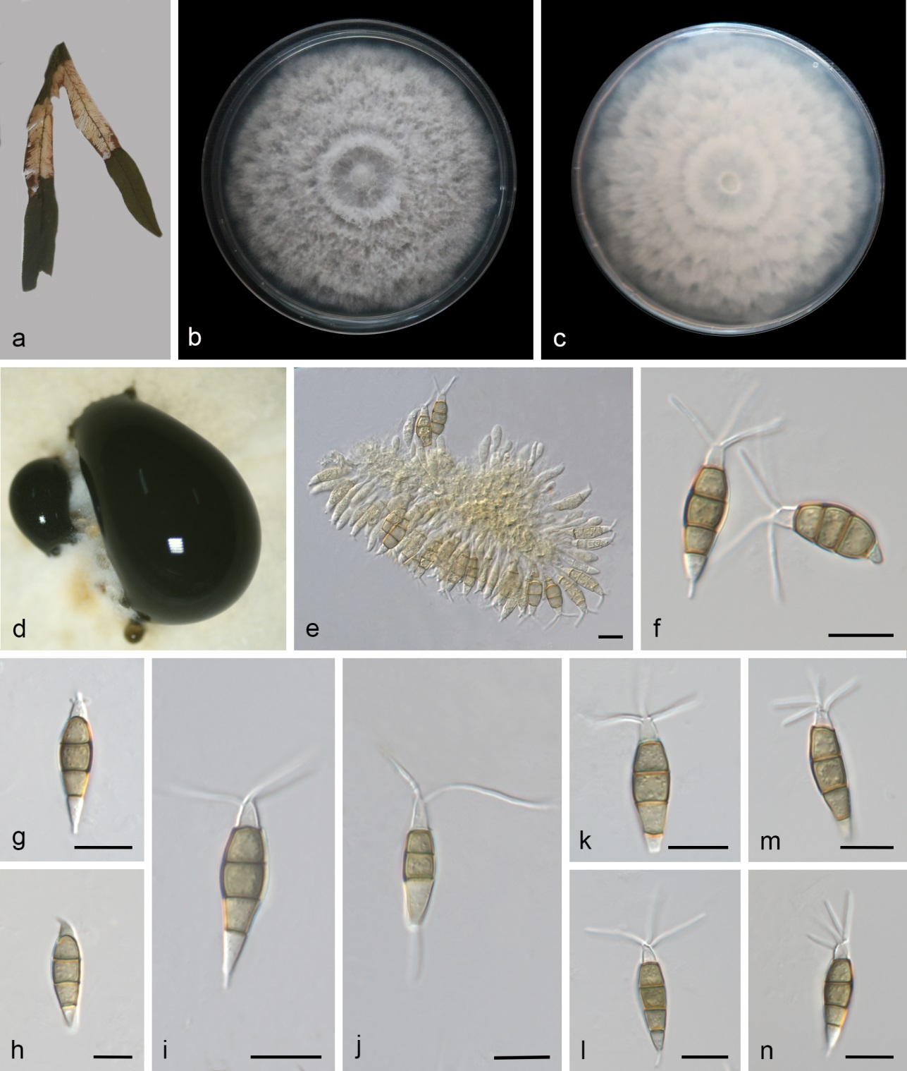
Figure S31. Pestalotiopsis dracaenae (CGMCC 3.29377, new host record). a Leaf of host plant. b–c Colonies on PDA after incubation for 7 days from above (b) and below (c). d Conidiomata formed in culture. e Conidiogenous cells giving rise to conidia. f–n Conidia. Scale bars: 10 μm (e–n).

Pestalotiopsis dracaenae Yong Wang bis, Y. Song, K. Geng & K.D. Hyde, Fungal Diversity 75: 164 (2015) Figs. 37, S31
Asexual morph on PDA: conidiomata acervular, globose, black, solitary, releasing conidia in a black, slimy, globose mass. Conidiophores indistinct and reduced to conidiogenous cells. Conidiogenous cells discrete, smooth-walled, hyaline, cylindrical, 3.34–6.67 × 1.90–3.28 μm (av. = 4.63 ± 1.06 × 2.56 ± 0.49 μm). Conidia fusiform, straight or slightly curved, 19.43–25.77 × 5.08–8.00 μm (av. = 22.83 ± 1.61 × 6.34 ± 0.58 μm, n = 30); 3-septate and 4-septate, slightly constricted at the septa; basal cells obconic with a truncate base, 2.70–6.14 μm (av. = 4.68 μm) long, hyaline, smooth, thin-walled; the intermediate cells columnar or cylindrical, concolourous, pale brown, 13.11–17.13 μm (av. = 15.00 ± 0.97 μm) long, septa and periclinal walls darker than rest of the cell; second cell from the base pale brown, 4.30–6.70 μm (av. = 5.28 ± 0.65 μm) long; third cell brown or light brown, 4.24–6.73 μm (av. = 5.28 ± 0.69 μm) long; fourth cell pale brown, 3.77–5.92 μm (av. = 4.66 ± 0.62 μm) long; apical cell hyaline, subcylindrical, 2.80–6.05 μm (av. = 3.97 ± 0.71 μm) long; with 1–4 tubular apical appendages (mostly 2), unbranched, 1.71–24.09 μm (av. = 11.89 ± 5.71 μm) long; basal appendage 0–1, tubular, unbranched, 1.21–10.95 μm (av. = 3.19 ± 2.10 μm) long.
Culture characteristics – Colonies on PDA were white nearly circular, flat, and floccose, the reverse white, PDA attaining 83 mm in diameter after 7 days at 25 °C, growth rate 11.9 mm/day.
Material examined – CHINA, Hainan Province, Wanning City, Dongshan Hill (18.802153 N, 110.421473 E, 18 m), on leaves of Lygodium flexuosum, 12 April 2023, Q.Y. Liu (HSAUP 7265-3A,), living culture CGMCC 3.29377 = SAUCC 7265-3A; ibid., HSAUP 7265-3B, living culture SAUCC 7265-3B.
Distribution – CHINA, Hainan Province.
Ecology – Associated with Dracaena fragrans and Lygodium flexuosum.
Notes – SAUCC 7265-3A and SAUCC 7265-3B clustered with P. dracaenae (Fig. 37). The comparison of ITS, tef1-α, and tub2 genes showed only a few base pair differences. Furthermore, their apical appendages and conidiaare similar. Pestalotiopsis dracaenae was isolated from Dracaena fragrans in Hainan Province, China ^{[111]}. Our isolates were isolated from Lygodium flexuosum in Hainan Province, China. Therefore, our isolates represent new host record.
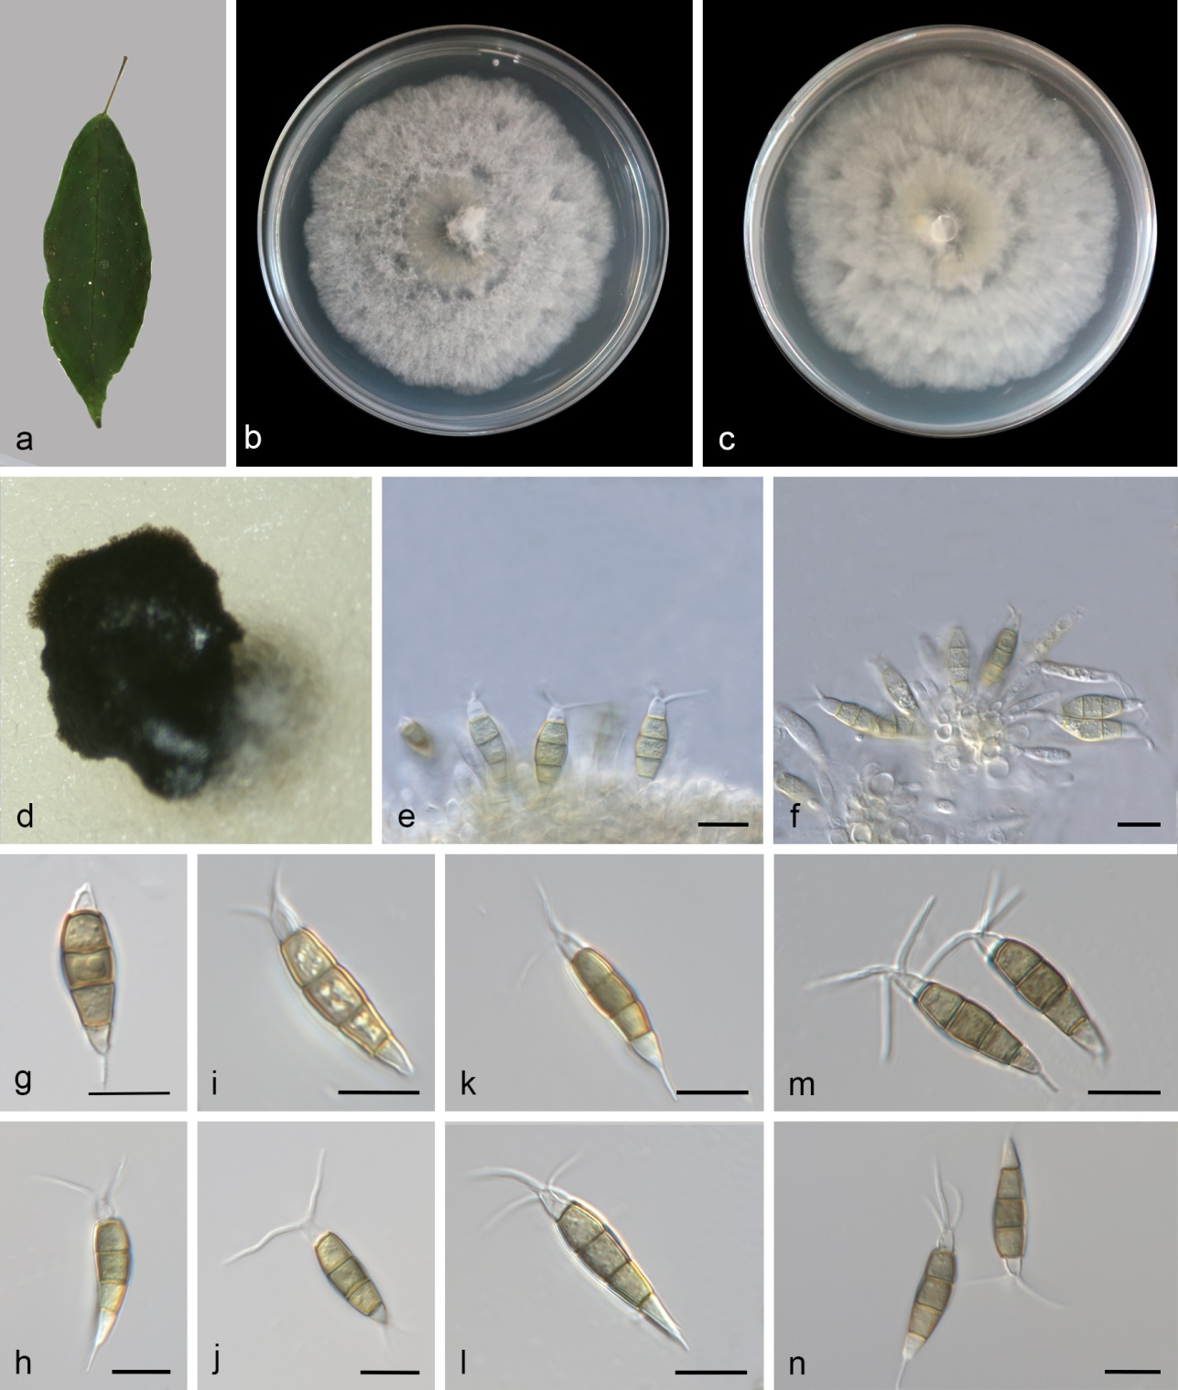
Figure S32. Pestalotiopsis hydei (CGMCC 3.29372, new host and geographical records). a Leaf of host plant. b–c Colonies on PDA after incubation for 7 days from above (b) and below (c). d Conidiomata formed in culture. e–f Conidiogenous cells giving rise to conidia. g–n Conidia. Scale bars: 10 μm (e–n).

Pestalotiopsis hydei Huanraluek & Jayaward, Phytotaxa 479 (1): 023–043 (2021) Figs. 37, S32
Asexual morph on PDA: conidiomata acervular, globose, black, solitary, releasing conidia in a black, slimy, globose mass. Conidiophores indistinct and reduced to conidiogenous cells. Conidiogenous cells discrete, smooth-walled, hyaline, cylindrical, 4.24–10.00 × 1.52–3.75 μm (av. = 6.43 ± 2.00 × 2.51 ± 0.85 μm). Conidia fusiform, straight or slightly curved, 21.89–25.98 × 5.03–7.34 μm (av. = 23.68 ± 1.07 × 5.88 ± 0.54 μm, n = 27); 4-septate, slightly constricted at the septa; basal cells obconic with a truncate base, 3.14–5.59 μm (av. = 4.43 μm) long, hyaline, smooth, thin-walled; the three intermediate cells columnar or cylindrical, concolourous, pale brown, 13.88–16.48 μm (av. = 15.09 ± 0.80 μm) long, septa and periclinal walls darker than rest of the cell; second cell from the base pale brown, 4.05–6.97 μm (av. = 5.44 ± 0.86 μm) long; third cell pale brown, 4.50–6.78 μm (av. = 5.50 ± 0.57 μm) long; fourth cell pale brown, 3.96–6.60 μm (av. = 5.43 ± 0.68 μm) long; apical cell hyaline, subcylindrical, 2.70–4.39 μm (av. = 3.68 ± 0.49 μm) long; with 0–3 tubular apical appendages (mostly 2), unbranched, 3.04–9.10 μm (av. = 4.74 ± 1.31 μm) long; basal appendages 0–2, tubular, unbranched, 3.00–4.93 μm (av. = 4.23 ± 0.54 μm) long.
Culture characteristics – Colonies on PDA were nearly circular, flat, white, floccose, pale yellow at the center and white at the margin, reverse spreading, white. PDA attaining 72 mm in diameter after 7 days at 25 °C, growth rate 10.3 mm/day.
Material examined – CHINA, Guangxi Zhuang Autonomous Region, Shangsi County (21.905823 N, 107.903671 E, 277 m), on diseased leaves of Ficus cyrtophylla, 02 December 2024, Y.L. Wang (HSAUP 13381-1A), living culture CGMCC 3.29372 = SAUCC 13381-1A; ibid., HSAUP 13381-1B, living culture SAUCC 13381-1B.
Distribution – Brazil, CHINA, and Thailand.
Ecology – Associated with Eucalyptus grandis, Ficus cyrtophylla, and Litsea Petiolata.
Notes – SAUCC 13381-1A and SAUCC 13381-1B are clustered with P. hydei (MFLUCC 20–0135, ex-type) (Fig. 37). The comparison of ITS, tef1-α, and tub2 genes showed only a few base pair differences. Furthermore, SAUCC 13381-1A and SAUCC 13381-1B showed similar characteristics of asexual morph with P. hydei (MFLUCC 20–0135, ex-type) in conidial size and basal appendages length ^{[112]}. MFLUCC 20–0135 was isolated from Litsea Petiolata in Thailand. Strains of E-72-2, E-72-3, E-72-4, and E-72-6 were isolated from Eucalyptus grandis in Brazil ^{[113]}. Thus, we identified these newly obtained isolates as P. hydei. SAUCC 13381-1A and SAUCC 13381-1B were first isolated from diseased leaves of Ficus cyrtophylla in China. Therefore, our isolates represent new host and geographical records.
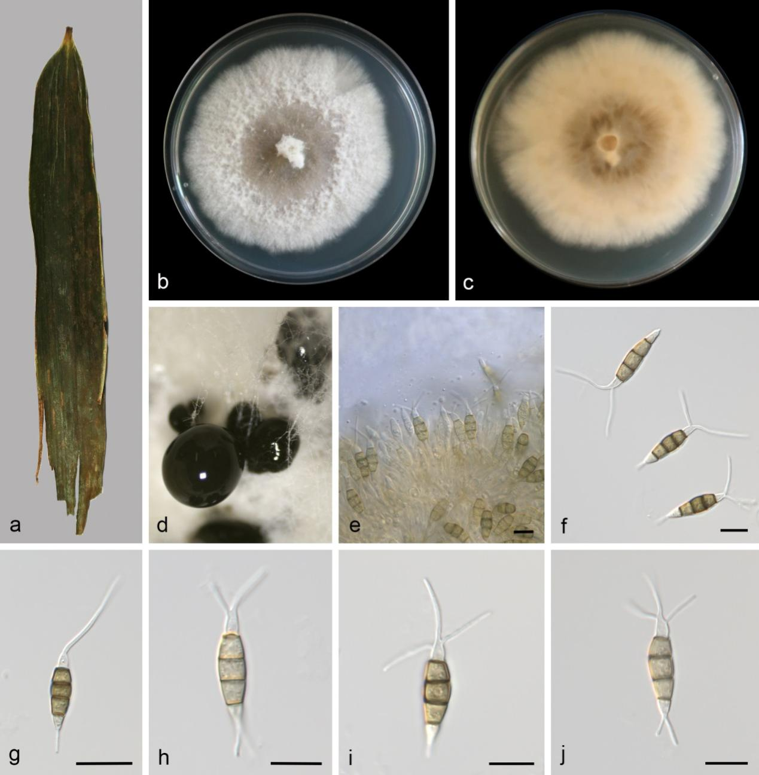
Figure S33. Pestalotiopsis smilacicola (CGMCC 3.29366, new host and geographical records). a Leaf of host plant. b–c Colonies on PDA after incubation for 7 days from above (b) and below (c). d Conidiomata formed in culture. e Conidiogenous cells giving rise to conidia. f–j Conidia. Scale bars: 10 μm (e–j).

Pestalotiopsis smilacicola Y.R. Sun & Yong Wang bis, Microbiology Spectrum 11(1): e03987-22, 15 (2023) Figs. 37, S33
Asexual morph on PDA: conidiomata acervular, globose, black, solitary, releasing conidia in a black, slimy, globose mass. Conidiophores indistinct and reduced to conidiogenous cells. Conidiogenous cells discrete, smooth-walled, hyaline to pale brown, cylindrical, 3.98–12.10 × 2.07–3.08 μm (av. = 8.15 ± 2.69 × 2.62 ± 0.34 μm). Conidia fusiform, straight or slightly curved, 18.98–23.66 × 4.66–6.69 μm (av. = 20.85 ± 1.42 × 5.75 ± 0.59 μm, n = 20); 4-septate, slightly constricted at the septa; basal cells obconic with a truncate base, 2.77–6.06 μm (av. = 4.25 μm) long, hyaline, smooth, thin-walled; the three intermediate cells columnar or cylindrical, concolourous, pale brown, 10.95–15.02 μm (av. = 13.20 ± 0.96 μm) long, septa and periclinal walls darker than rest of the cell; second cell from the base pale brown, 3.73–5.77 μm (av. = 4.62 ± 0.55 μm) long; third cell pale brown, 3.73–5.27 μm (av. = 4.31 ± 0.52 μm) long; fourth cell pale brown, 3.95–5.30 μm (av. = 4.63 ± 0.44 μm) long; apical cell hyaline, subcylindrical, 2.90–4.82 μm (av. = 3.67 ± 0.56 μm) long; with 1–3 tubular apical appendages (mostly 2), unbranched, 9.19–20.18 μm (av. = 15.27 ± 3.20 μm) long; basal appendages 1–2 (mostly 1), tubular, unbranched, 10.50–19.03 μm (av. = 14.68 ± 3.06 μm) long.
Culture characteristics – Colonies on PDA forming concentric brown rings, and entire edge, white, flat, white, floccose, reverse pale orange. PDA attaining 73 mm in diameter after 7 days at 25 °C, growth rate 10.43 mm/day.
Material examined – CHINA, Hainan Province, Ledong Li Autonomous County (18.725335 N, 108.835003 E, 742 m), on diseased leaves of Indocalamus tessellatus, 04 December 2024, Y.L. Wang (HSAUP 14533-2), living culture CGMCC 3.29366 = SAUCC 14533-2; ibid., on diseased leaves of bamboo (Poaceae sp.), 14 October 2023, Q.Y. Liu, HSAUP 6444-4, living culture SAUCC 6444-4.
Distribution – CHINA, Thailand.
Ecology – Associated with Indocalamus tessellatus and Smilax sp..
Notes – SAUCC 14533-2 and SAUCC 6444-4 are clustered with P. smilacicola (Fig. 37). The comparison of ITS, tef1-α, and tub2 genes showed only a few base pair differences. Furthermore, their conidia are similar (18.98–23.66 × 4.66–6.69 μm vs. 18–22 × 4–7 μm). Pestalotiopsis smilacicola was isolated from Smilax sp. in Thailand ^{[114]}. Our isolates were isolated from Indocalamus tessellatus in Hainan Province, China. Therefore, our isolates represent new host and geographical records.

