Supplementary File 1: Supplementary materials to this study.

Anthophilous cryptic yeasts: An integrative polyphasic approach reveals novel taxa in northern Thailand

Pratthana Kodchasee¹, Pannida Khunnamwong^{2,3}, Chanokned Senwanna^{1,4,5}, Nutchanan Duangkon¹, Karnthida Wongsa¹, Supawich Tiemsan¹, Atsadawut Kaewnunta^{1,4}, Jaturong Kumla^{1,4,5} and Nakarin Suwannarach^{1,4,5}*

¹ Center of Excellence in Microbial Diversity and Sustainable Utilization, Chiang Mai University, Chiang Mai 50200, Thailand
² Department of Microbiology, Faculty of Science, Kasetsart University, Bangkok 10900, Thailand
³ Biodiversity Center Kasetsart University (BDCKU), Bangkok 10900, Thailand
⁴ Department of Biology, Faculty of Science, Chiang Mai University, Chiang Mai 50200, Thailand
⁵ Office of Research Administration, Chiang Mai University, Chiang Mai 50200, Thailand
* Corresponding authors, E-mail: nakarin.su@cmu.ac.th

Note on ecology and distribution of known yeast species

Starmerella etchellsii Figs. S1b and S5
Ecology and distribution – Stingless bees in Brazil^{[1]}, honeybees in USA^{[2]}. Chinese horse bean-chili-paste in China^{[3]}, beverage in South Africa^{[4]}, fermented food in Thailand and China^{[5,6]}. Ipomoea crinicalyx and Opuntia dillenii flowers in Mexico^{[7]}, and flower of Passiflora caerulea in Thailand (this study).

Candida tropicalis Figs. S1d and S2
Ecology and distribution – Wastewater samples in Pakistan^{[8]}, soil and water of fruit shop dumps in Pakistan^{[9]}, sand in Brazil^{[10]}, soil in Thailand^{[11,12]}, mangrove forest in Thailand^{[13]}, peat swamp forest in Thailand^{[14]} and seawater and slurry sediments in Egypt^{[15]}. Fermented tea^{[16]} and fermented food in Thailand^{[5]}. Opportunistic human pathogen^{[17]}, gastrointestinal tract of fish in Thailand^{[18]}. Nectar of Hibiscus rosa sinensis in India^{[19]} and Melampodium divaricatum flower in Thailand (this study).

Kodamaea ohmeri Figs. S1e and S3
Ecology and distribution – Vetiver leaves and vetiver rhizosphere in Thailand^{[20]}, sand and seawater in Brazil ^{[21]}. Fermented food in USA^{[22]}. Opportunistic human pathogen and emerging pathogen in India and Vietnam^{[23–25]}. Aethina tumida in Australia^{[26]}, bee digestive tract and honey in Thailand^{[27]}. Lagenaria siceraria flower in India^{[28]}, Passiflora edulis and Conotelus sp. flowers in Brazil^{[29]}, fruits including papaya, rambutan, berry, banana, mango in French Guiana^{[30]}, Metrosideros polymorpha flower in Hawaii^{[31]} phylloplane of Zea mays in Thailand^{[32]}, Zoanthid (coral) in Thailand^{[33]}, duckweed in Thailand^{[34]}, flowers of Boesenbergia rotunda, Catharanthus roseus, Jasminum sambac, and Pentas lanceolata in Thailand (this study).

Kodamaea restingae Figs. S1f and S3
Ecology and distribution – Cereus pernambucensis and Pilosocereus arrabidae flowers in Brazil^{[35]}, Camellia sinensis var. assamica flower in Thailand^{[36]}, flowers of Bougainvillea hybrid and Crinum asiaticum in Thailand (this study).
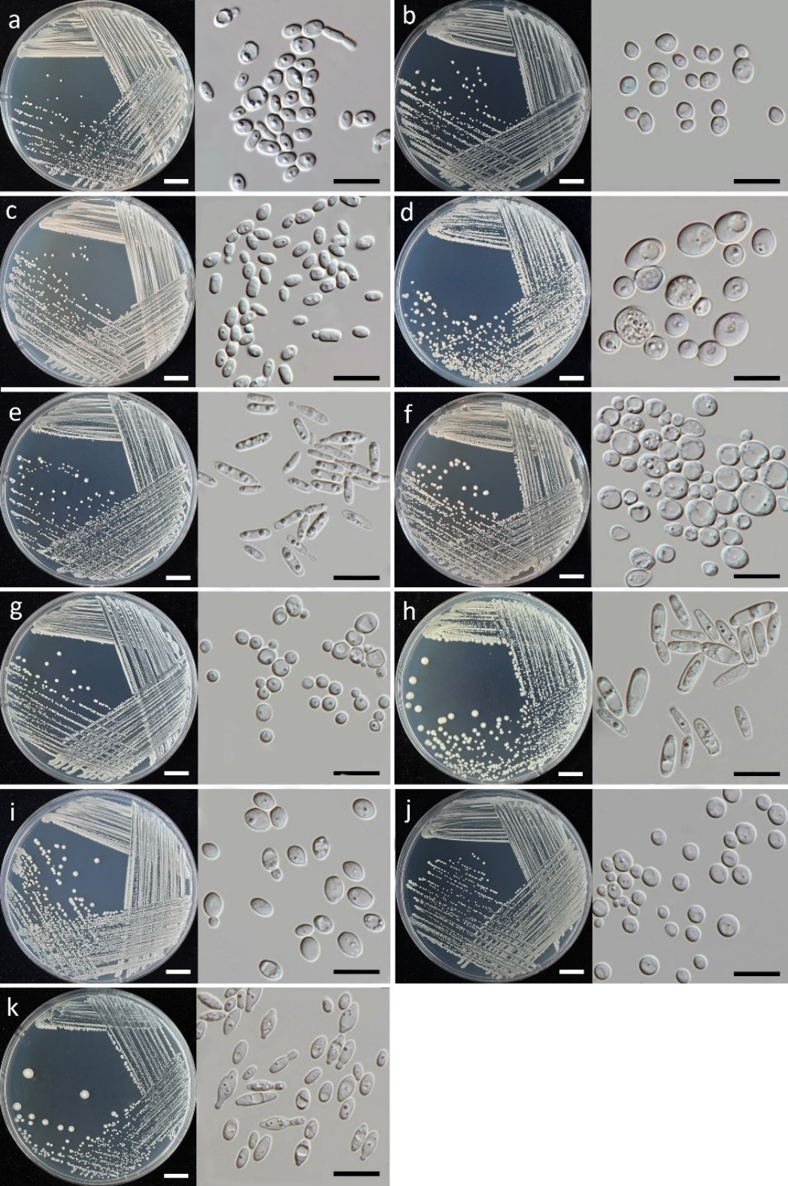

Fig. S1 Culture (left) and cells (right) of Entelesis stigmatis (a), Starmerella etchellsii (b), Starmerella orientalis (c), Candida tropicalis (d), Kodamaea ohmeri (e), Kodamaea restingae (f), Meyerozyma caribbica (g), Metschnikowia cibodasensis (h), Metschnikowia koreensis (i), Cyberlindnera fabianii (j), and Hanseniaspora lachancei (k) on YMA at 25°C for 5 days. Scale bars cultures a–k = 1 cm and cells a–k = 10 μm.
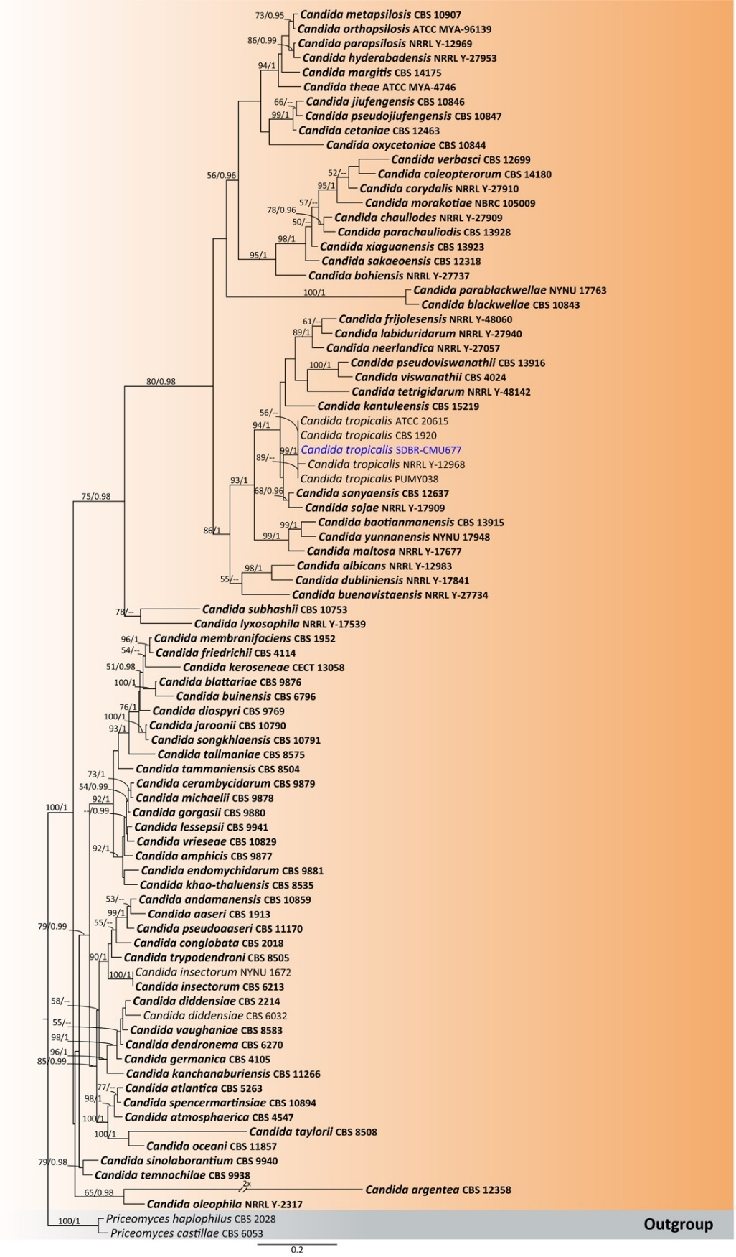

Fig. S2 Phylogenetic tree generated by maximum likelihood analysis of the combined D1/D2 domain of LSU and ITS sequence data representing genus Candida in Debaryomycetaceae. The tree is rooted to Priceomyces castillae (CBS 6053) and P. haplophilus (CBS 2028). Single-locus analyses were also performed, and topology and clade stability were compared from combined gene analyses. Eighty-five strains are included in the combined sequence analysis, which comprise 1,287 characters with gaps. Bootstrap support values for maximum likelihood (≥ 50%, ML, left) and Bayesian posterior probabilities (≥ 0.95, PP, right) are indicated above the nodes. Double dashes (--) denote support values below 50% ML and 0.95 PP. The scale bar represents 0.2 nucleotide substitutions per site. Ex-type strains are shown in bold, and sequences generated in this study are highlighted in blue.

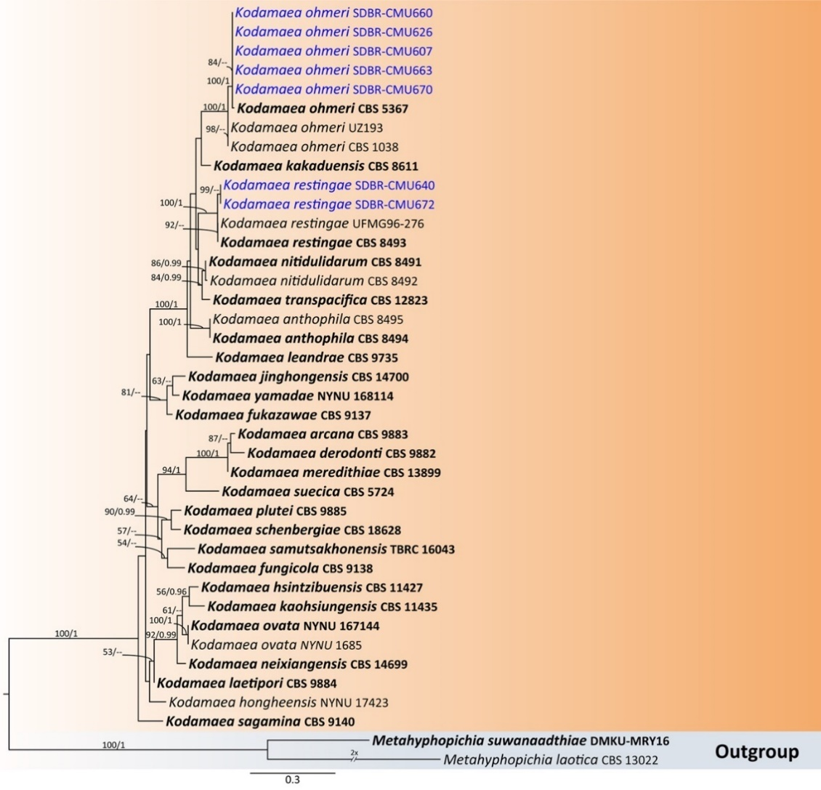

Fig. S3 Phylogenetic tree generated by maximum likelihood analysis of the combined D1/D2 domain of LSU and ITS sequence data representing genus Kodamaea in Debaryomycetaceae. The tree is rooted to Metahyphopichia suwanaadthiae (DMKU-MRY16) and Metahyphopichia laotica (CBS 13022). Single-locus analyses were also performed, and topology and clade stability were compared from combined gene analyses. Forty strains are included in the combined sequence analysis, which comprise 949 characters with gaps. Bootstrap support values for maximum likelihood (≥ 50%, ML, left) and Bayesian posterior probabilities (≥ 0.95, PP, right) are indicated above the nodes. Double dashes (--) denote support values below 50% ML and 0.95 PP. The scale bar represents 0.3 nucleotide substitutions per site. Ex-type strains are shown in bold, and sequences generated in this study are highlighted in blue.

Meyerozyma caribbica Figs. S1g and S4
Ecology and distribution – Soil in China^{[37,38]}, mine water in Brazil^{[39]}. Sarcophyton sp. and zoanthid in Thailand^{[33]}. Food: fermented tea leaf in Thailand^{[16]}, fermented fruit and Oryza sativa in Thailand^{[40]}, cashew-fermented juice in India^{[41]}, Ripe banana in India^{[42]}, Mangifera indica fruit in Mexico^{[43]}, wild flowers in Korea^{[44,45]}, phylloplane of Saccharum officinarum in Thailand^{[46,47]}, endophytic yeasts of pineapple in Bangladesh^{[48]}, duckweed in Thailand^{[34]}, flower of Camellia sinensis var. assamica^{[36]}, Melampodium divaricatum and Pentas lanceolata in Thailand (this study).

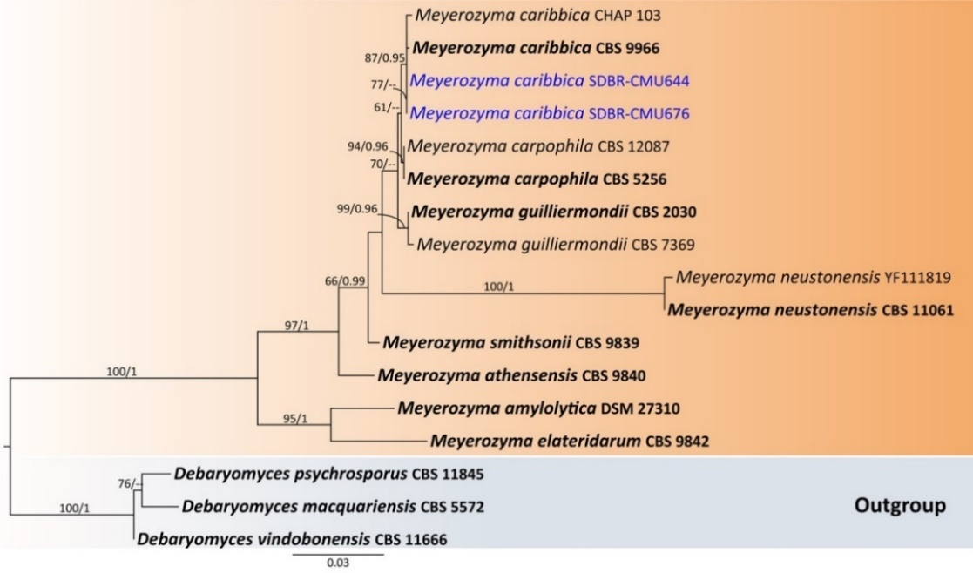

Fig. S4 Phylogenetic tree generated by maximum likelihood analysis of the combined D1/D2 domain of LSU and ITS sequence data representing genus Meyerozyma in Debaryomycetaceae. The tree is rooted to Debaryomycespsychrosporus (CBS 11845), D. macquariensis (CBS 5572) and D. vindobonensis (CBS 11666). Single-locus analyses were also performed, and topology and clade stability were compared from combined gene analyses. Seventeen strains are included in the combined sequence analysis, which comprise 1,210 characters with gaps. Bootstrap support values for maximum likelihood (≥ 50%, ML, left) and Bayesian posterior probabilities (≥ 0.95, PP, right) are indicated above the nodes. Double dashes (--) denote support values below 50% ML and 0.95 PP. The scale bar represents 0.03 nucleotide substitutions per site. Ex-type strains are shown in bold, and sequences generated in this study are highlighted in blue.

Metschnikowia cibodasensis Figs. S1h and S5
Ecology and distribution – Saurauia pendula, Berberis nepalensis, and Brunsfelsia americana flowers in Indonesia^{[49]}, Abelia sp. in Japan^{[50]} and flower of Tecoma stans in Thailand (this study).

Metschnikowia koreensis Figs. S1i and S5
Ecology and distribution – Peat swamp forest in Thailand^{[14]}, soil in Thailand^{[51]}. Soy sauce mash in Japan^{[52]}, fermented cider in China^{[53]}. Lilium sp. and Ipomoea sp. flowers in Korea^{[54]}, phylloplane of Saccharum officinarum in Thailand^{[46,47]}, entomophilic flowers in Moscow^{[55]}, wildflowers in Korea^{[44]}, phylloplane of Oryza sativa in Thailand^{[56,57]}, wild flowers in Korea^{[58]}, nectar of Echium leucophaeum and Echium strictum in Spain^{[59]}, Tecoma stans in Mexico^{[7]}, unknown flower in French Guiana^{[30]}, duckweed in Thailand^{[34]}, flower of Camellia sinensis var. assamica^{[36]}, Allamanda cathartica, Bougainvillea hybrid, Cnidoscolus aconitifolius, Dichorisandra thyrsiflora, Ixora chinensis,Jasminum sambac, Jatropha integerrima, Nerium oleander, Pentas lanceolata, Plumeria obtuse, and Syzygium jambos in Thailand (this study).

Cyberlindnera fabianii Figs. S1j and S6
Ecology and distribution – Feather and leather wastes in Egypt^{[60]}, chromium contaminated site in Morocco^{[61]}, environment in French Guiana^{[30]}, arabica coffee plantations in Indonesia^{[62]}, tannery wastewater in Morocco^{[63]}. Fermented masau fruits in Africa^{[64]}, fermented cocoa bean in French Guiana^{[30]}, baijiu in China^{[65]}, cigar tobacco leaves in China^{[66]}. Human pathogen in China, India Japan, Korea and Turkey^{[67–71]}. Phylloplane of Saccharum officinarum in Thailand^{[46]}, phylloplane of Oryza sativa in Thailand^{[56]}, Durio Kutejensis in Indonesia^{[72]}, flowers of Camellia sinensis var. assamica^{[36]} and Rosa sp. in Thailand (this study).

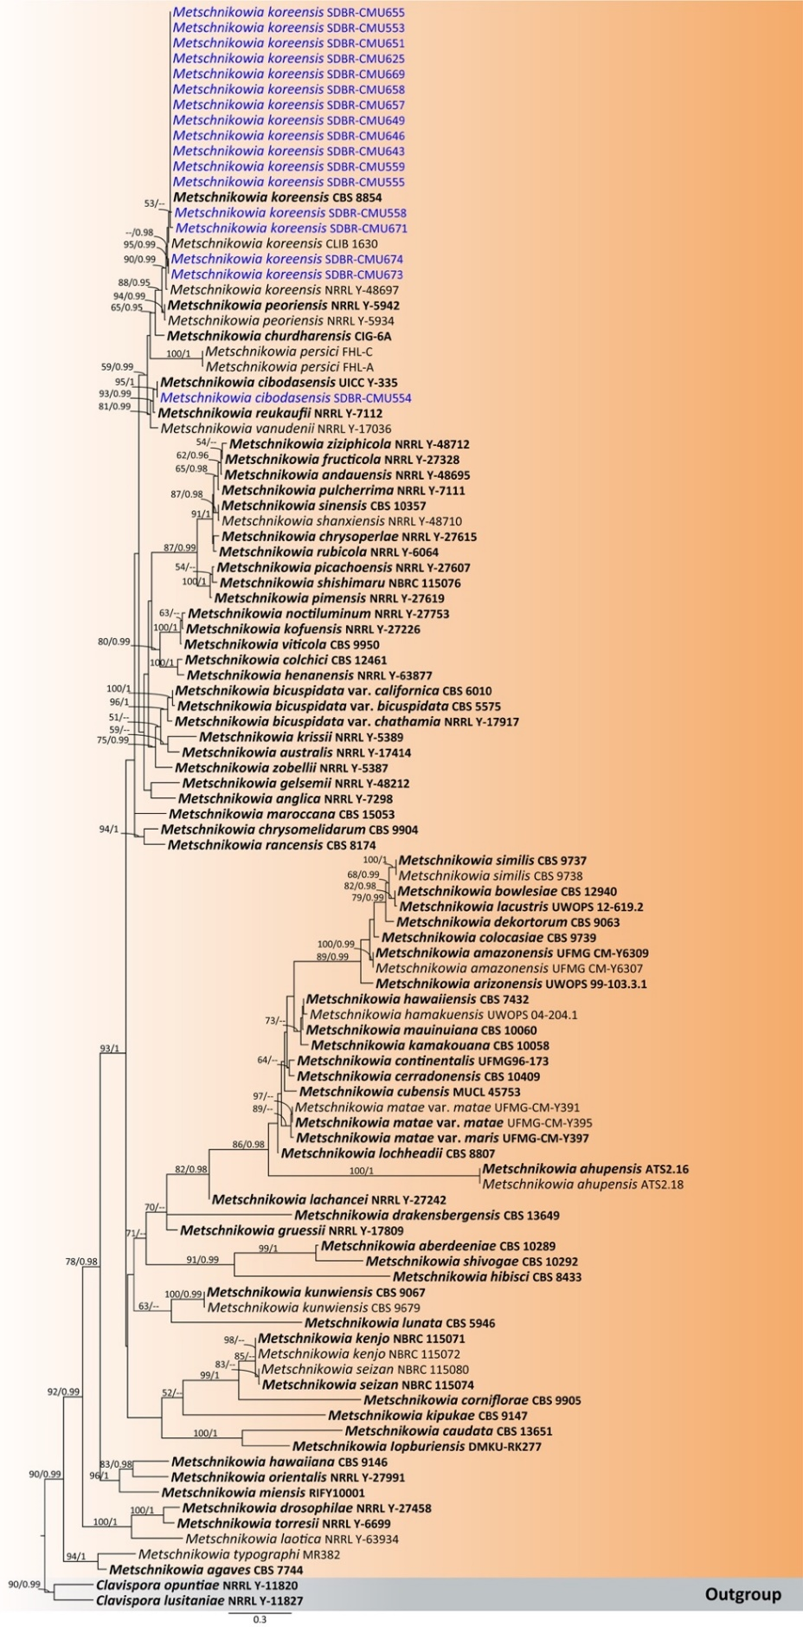
Fig. S5 Phylogenetic tree generated by maximum likelihood analysis of the combined D1/D2 domain of LSU and ITS sequence data representing Metschnikowia in Metschnikowiaceae. The tree is rooted to Clavispora lusitaniae (NRRL Y-11827) and C. opuntiae (NRRL Y-11820). Single-locus analyses were also performed, and topology and clade stability were compared from combined gene analyses. One hundred and four strains are included in the combined sequence analysis, which comprise 1,199 characters with gaps. Bootstrap support values for maximum likelihood (≥ 50%, ML, left) and Bayesian posterior probabilities (≥ 0.95, PP, right) are indicated above the nodes. Double dashes (--) denote support values below 50% ML and 0.95 PP. The scale bar represents 0.3 nucleotide substitutions per site. Ex-type strains are shown in bold, and sequences generated in this study are highlighted in blue.
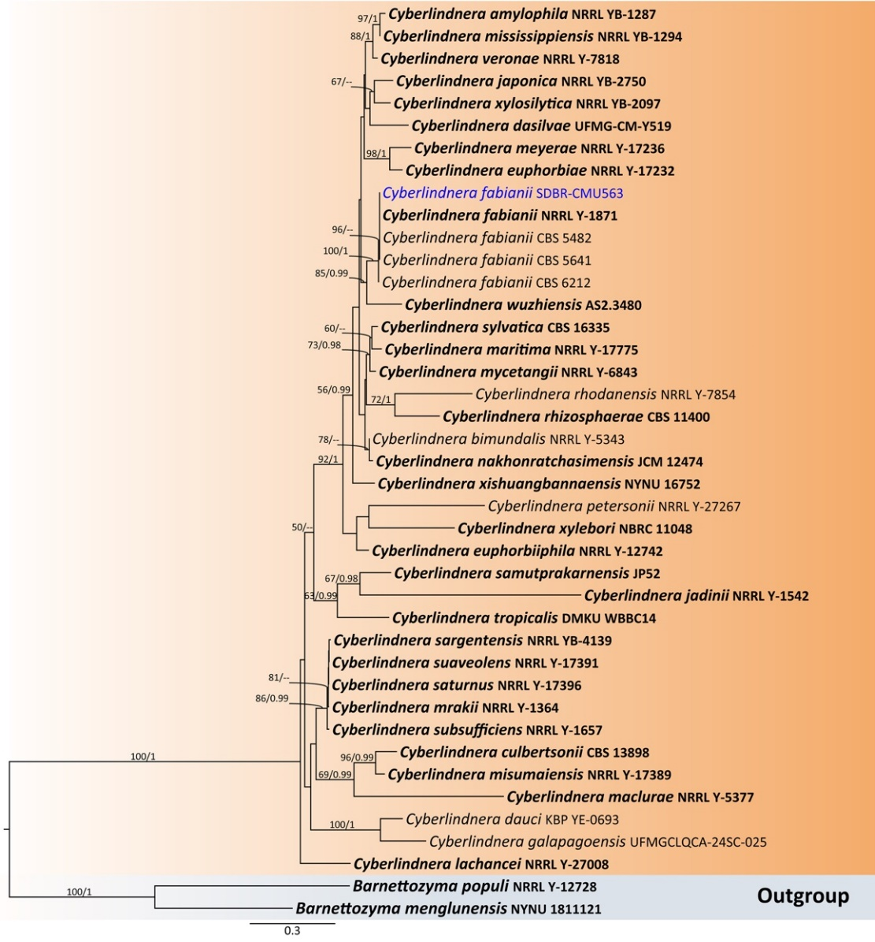

Fig. S6 Phylogenetic tree generated by maximum likelihood analysis of the combined D1/D2 domain of LSU and ITS sequence data representing genus Cyberlindnera in Phaffomycetaceae. The tree is rooted to Barnettozyma menglunensis (NYNU 1811121) and B. populi (NRRL Y-12728). Single-locus analyses were also performed, and topology and clade stability were compared from combined gene analyses. Forty-one strains are included in the combined sequence analysis, which comprise 1,337 characters with gaps. Bootstrap support values for maximum likelihood (≥ 50%, ML, left) and Bayesian posterior probabilities (≥ 0.95, PP, right) are indicated above the nodes. Double dashes (--) denote support values below 50% ML and 0.95 PP. The scale bar represents 0.3 nucleotide substitutions per site. Ex-type strains are shown in bold, and sequences generated in this study are highlighted in blue.

Hanseniaspora lachancei Figs. S1k and S7
Ecology and distribution – Fermented agave juice of Drosophila sp. in Mexico^{[73]}, fermented cacao in Mexico^{[74]}, ripe bananas and plantain fruits in Nigeria^{[75]} and Antigonon leptopus in Thailand (this study).
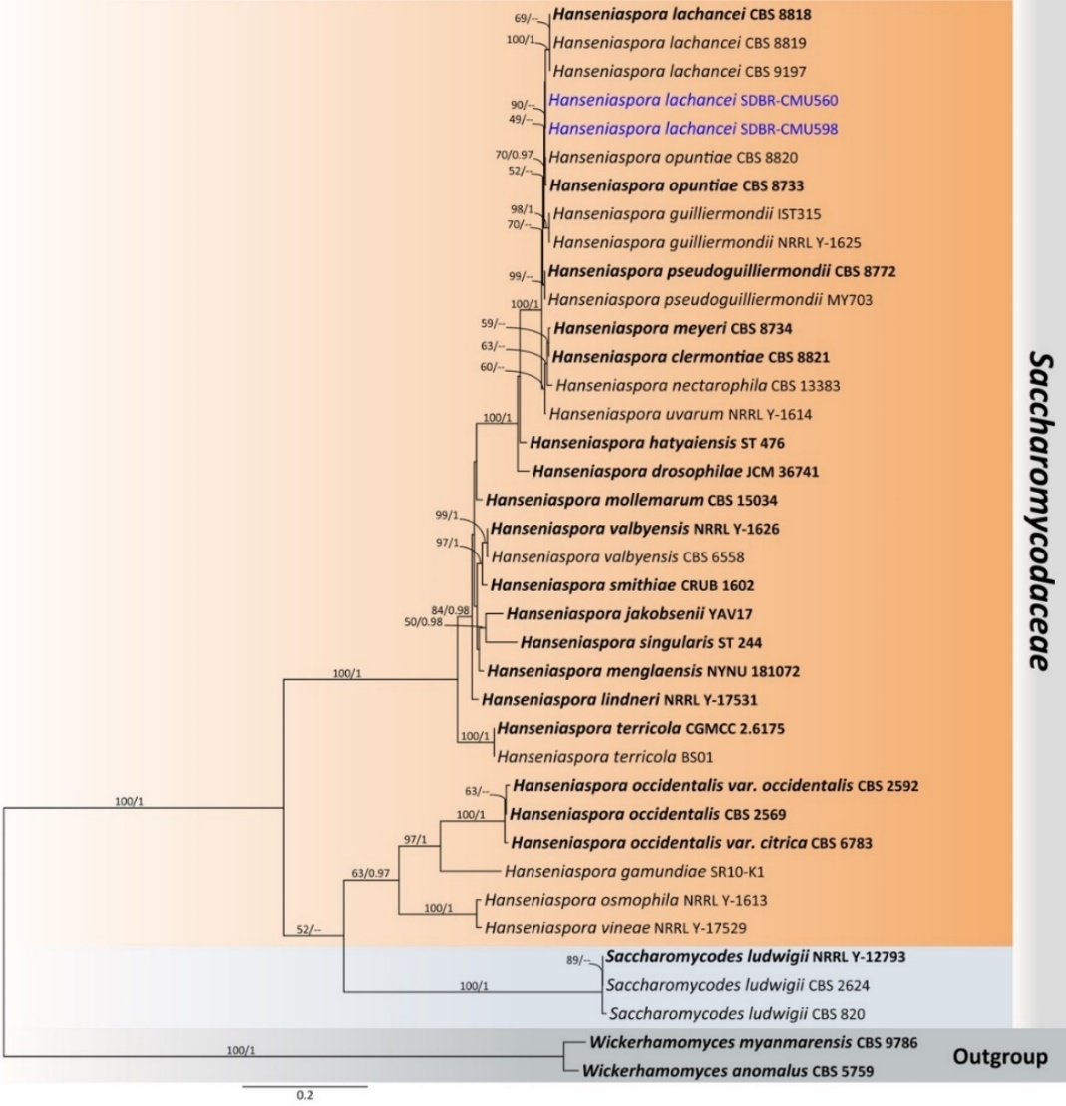

Fig. S7 Phylogenetic tree generated by maximum likelihood analysis of the combined D1/D2 domain of LSU and ITS sequence data representing Saccharomycodaceae. The tree is rooted to Wickerhamomyces anomalus (CBS 5759) and W. myanmarensis (CBS 9786). Single-locus analyses were also performed, and topology and clade stability were compared from combined gene analyses. Thirty-eight strains are included in the combined sequence analysis, which comprise 1,378 characters with gaps. Bootstrap support values for maximum likelihood ≥ 50% (ML, left) and Bayesian posterior probabilities ≥ 0.95 (PP, right) are indicated above the node. Double dashes (--) represent support values less than 50% ML/0.95 PP. The scale bar represents the expected number of nucleotide substitutions per site. The ex-type strains are in bold and the newly generated sequences in this study are in blue.

Naganishia albida Figs. S8a and 12
Ecology and distribution – Wide host range and widely distributed in temperate, tropical and subtropical regions, such as soil in USA and Iran ^{[76,77]}, cold soils of the Pamir Mountains in Russia^{[78]}, cold habitats of the Tibetan Plateau in Tibet^{[79]}, hypersaline soils in Iran^{[77]}, mangrove forest in Thailand^{[13]}, airborne in China^{[80]}, soil and soil crust samples and eight whole plant tissue and lichen samples in China^{[81]}, aircraft polymer-coated surface in USA^{[82]}. Opportunistic human pathogen in Brazil and Hungary^{[83,84]}, Turquoise-fronted parrots ^{[85]}, Honey in China^{[86]}, moss and lichen in Antarctica^{[87]}. Leaves and fruit of Prunus persica in China^{[88]}, flowers of Epilobium angustifolium in Germany^{[89]}, and flower of Nerium oleander in Thailand (this study).

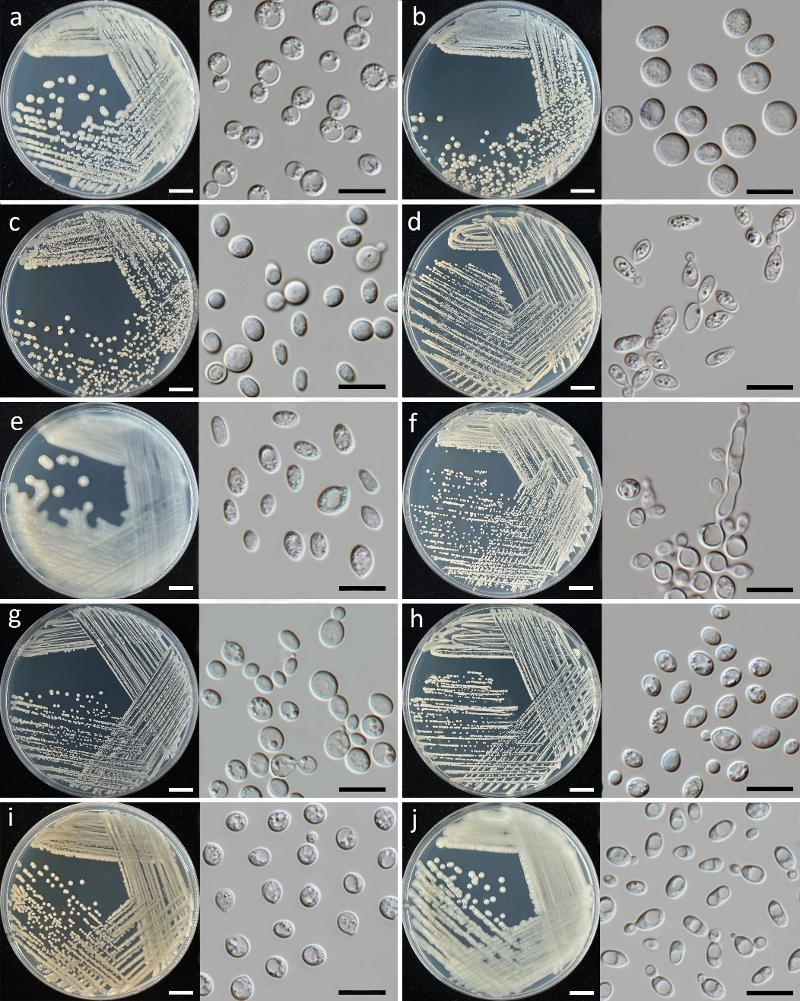

Fig. S8 Culture (left) and cells (right) of Naganishia albida (a), Naganishia diffluens (b), Naganishia liquefaciens (c), Hannaella pagnoccae (d), Hannaella phyllophila (e), Vishniacozyma marinae (f), Kwoniella bestiolae (g), Kwoniella heveanensis (h), Papiliotrema aspenensis (i), and Papiliotrema flavescens (j) on YMA at 25°C for 5 days. Scale bars culture a–j = 1 cm and cells a–j = 10 μm.

Naganishia diffluens Figs. S8b and 12
Ecology and distribution – Wide host range and widely distributed in temperate, tropical and subtropical regions, instance, petroleum sludge in Turkey^{[90,91]}, mangrove forrest in Thailand^{[92]}, dust in Japan^{[93]}, water in Brazil^{[94]}, soil in Thailand^{[95]}, North Atlantic Ocean^{[96]}, sides of volcanoes, near the active zones and in river and creek valleys in Russia^{[97]}, opportunistic human pathogen in Pakistan^{[98]}, Epilobium angustifolium flower in Germany^{[89]}, nectar of Atropa baetica, Erinacea anthyllis and Iris xyphium in Spain^{[99]}, organs of Columba livia in Brazil^{[100]}, and Argyranthemum frutescens flower in Thailand (this study).

Naganishia liquefaciens Figs. S8c and 12
Ecology and distribution – Wide host range and widely distributed in temperate, tropical and subtropical regions, instance, subglacial ice in Norway^{[101]}, wastewater treatment plant in India^{[102]}, cold-based mountain glacier systems in China^{[103]}, mangrove forest in Thailand^{[13]}, deep-sea Trench in Japan^{[104]}. Opportunistic human pathogen in Turkey, Iran and Japan^{[105–107]}. Cacospongia sp. in Thailand^{[33]}, Ipomoea sp. flower in Brazil^{[108]}, Piscidia piscipula flower in Mexico^{[7]}, leaf tissues of Zea mays in Thailand^{[109]}, duckweed in Thailand^{[34]}, wildflower in South Korea^{[110]}, Rosa sp. (this study).

Hannaella pagnoccae Figs. S8d and S9
Ecology and distribution – Soil in Taiwan, Prairie soil in USA, water in rock holes. Leaf of Tillandsia geminiflora, Saccharum spp., Vriesea friburgensis, and Vriesea gigantea, Phytotelmata of Bromelia karatas, Encholirium sp. and Vriesea minarum, flower bracts of Heliconia psittacorum and Pimenta dioica, Rhizoplane of Saccharum spp. in Brazil, leaf of Arundinaria pusilla, Cratoxylum maingayi, and Vitis vinifera in Thailand^{[111]}, Camellia sinensis var. assamica in Thailand^{[36]}, flowers of Curcuma sessilis, Dichorisandra thyrsiflora, and Plumeria pudica in Thailand (this study).

Hannaella phyllophila Figs. S8e and S9
Ecology and distribution – Phylloplane of Saccharum officinarum, Merremia sp., Manihot esculenta, Cunninghamia lanceolata, Villerbrunea pedunculata in Thailand and Taiwan^{[112]}, Phylloplane of Zea mays in Thailand^{[57]}, Phylloplane of Saccharum officinarum in Thailand^{[47]}, and flower of Oncidium sp. in Thailand (This study).

Vishniacozyma marinae Figs. S8f and 13
Ecology and distribution – Marine in Korea^{[113]}. Seawater in China, corn leaf, Saccharum officinarum sea sponge in Thailand^{[114]}, and flower of Plumeria pudica in Thailand (this study).

Kwoniella bestiolae Figs. S8g and 15
Ecology and distribution – Freshwaters and soils in South Korea^{[115]}, Conopomorpha sinensis Bradley in Vietnam^{[116]}, leaves of Berberis koreana, Betula schmidtii, Camellia japonica, Castanea crenata, Chamaecyparis obtuse, Corylus heterophylla, Pinus densiflora, and Rhododendron schlippenbachii in South Korea^{[117]}, and flower of Passiflora caerulea in Thailand (this study).

Kwoniella heveanensis Figs. S8h and 15
Ecology and distribution – Nectar of Isoplexis canariensis in Spain^{[59]}, leaves tissue of Saccharum officinarum in Thailand^{[46,47,109]}, leaves tissue of Zea mays in Thailand^{[109]}, rotting tissue of Cereus pernambucensis, Micranthocereus dolichospermaticus, flower of Cereus pernambucensis and fruits of Opuntia sp. in Brazil^{[118]}, duckweed in Thailand^{[34]}, flowers of Tectona grandis and Alstonia scholaris in Thailand (this study).

Papiliotrema aspenensis Figs. S8i and 19
Ecology and distribution – Grasshoppers in South Korea^{[119]}, Populus tremuloides tree in USA^{[120]}, leaves of Zea mays and Saccharum officinarum in Thailand^{[47,109]}, duckweed in Thailand^{[34]}, and flower of Plumeria pudica in Thailand (This study).

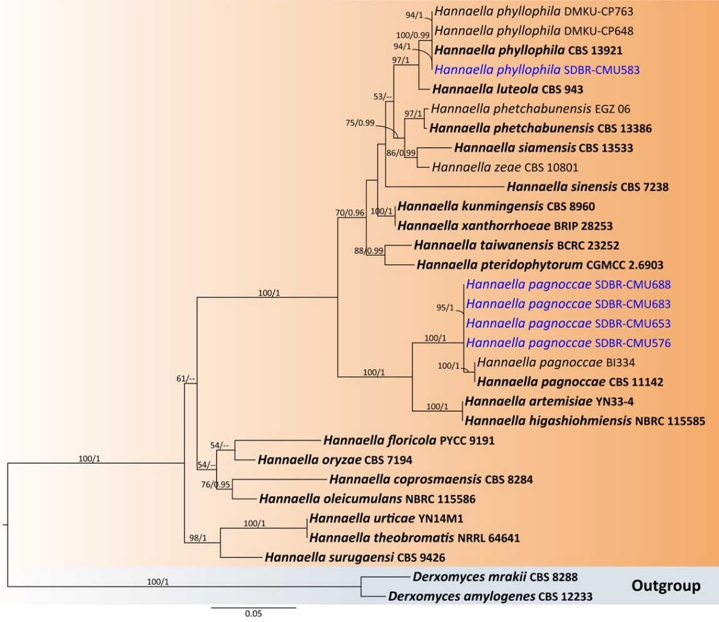

Fig. S9 Phylogenetic tree generated by maximum likelihood analysis of the combined D1/D2 domain of LSU and ITS sequence data representing Hannaella. The tree is rooted to Derxomyces amylogenes (CBS 12233) and D. mrakii (CBS 8288). Single-locus analyses were also performed, and topology and clade stability were compared from combined gene analyses. Thirty-one strains are included in the combined sequence analysis, which comprise 1,193 characters with gaps. Bootstrap support values for maximum likelihood ≥ 50% (ML, left) and Bayesian posterior probabilities ≥ 0.95 (PP, right) are indicated above the node. Double dashes (--) represent support values less than 50% ML/0.95 PP. The scale bar represents the expected number of nucleotide substitutions per site. The ex-type strains are in bold and the newly generated sequences in this study are in blue.

Papiliotrema flavescens Figs. S8j and 19
Ecology and distribution – Soil in India^{[121]}, mangrove forest in Thailand^{[13]}. Wildflower in South Korea^{[58]}, nectar of Echium leucophaeum and Echium strictum in Spain^{[59]}, flowers of Bravaisia berlandieriana and Gymnopodium floribundum in Mexico^{[7]}, ornamental plants in Egypt^{[122]}, leaves of Zea mays in Thailand^{[109]}, leaves of Saccharum officinarum in Thailand^{[47]}, grape berries and freshly crushed musts in France^{[123]}, flowers of Camellia sinensis var. assamica^{[36]}, and Pachystachys lutea in Thailand (this study).

Trichosporon asahii Figs. S11a and S10
Ecology and distribution – Oil, leaf, and decayed wood in Japan^{[124]}, industrial effluents in Pakistan^{[125]}, soil of assam tea plantation in Thailand^{[126]}, Opportunistic human pathogen in China, Colombia, Saudi Arabia, and Thailand^{[127–129]}, and flower of Bidens pilosa in Thailand (this study).

Cystobasidium benthicum Figs. S11b and 26
Ecology and distribution – Lamellibrachia sp. and Calyptogena sp. collected from the deep-sea floor of the Pacific Ocean^{[130]}, deep-sea sediment in the Indian ocean^{[131]}, paper and paperboard^{[132]}, sediments soil samples in Iraq^{[133]}, and flower of Lagerstroemia speciosa in Thailand (this study).

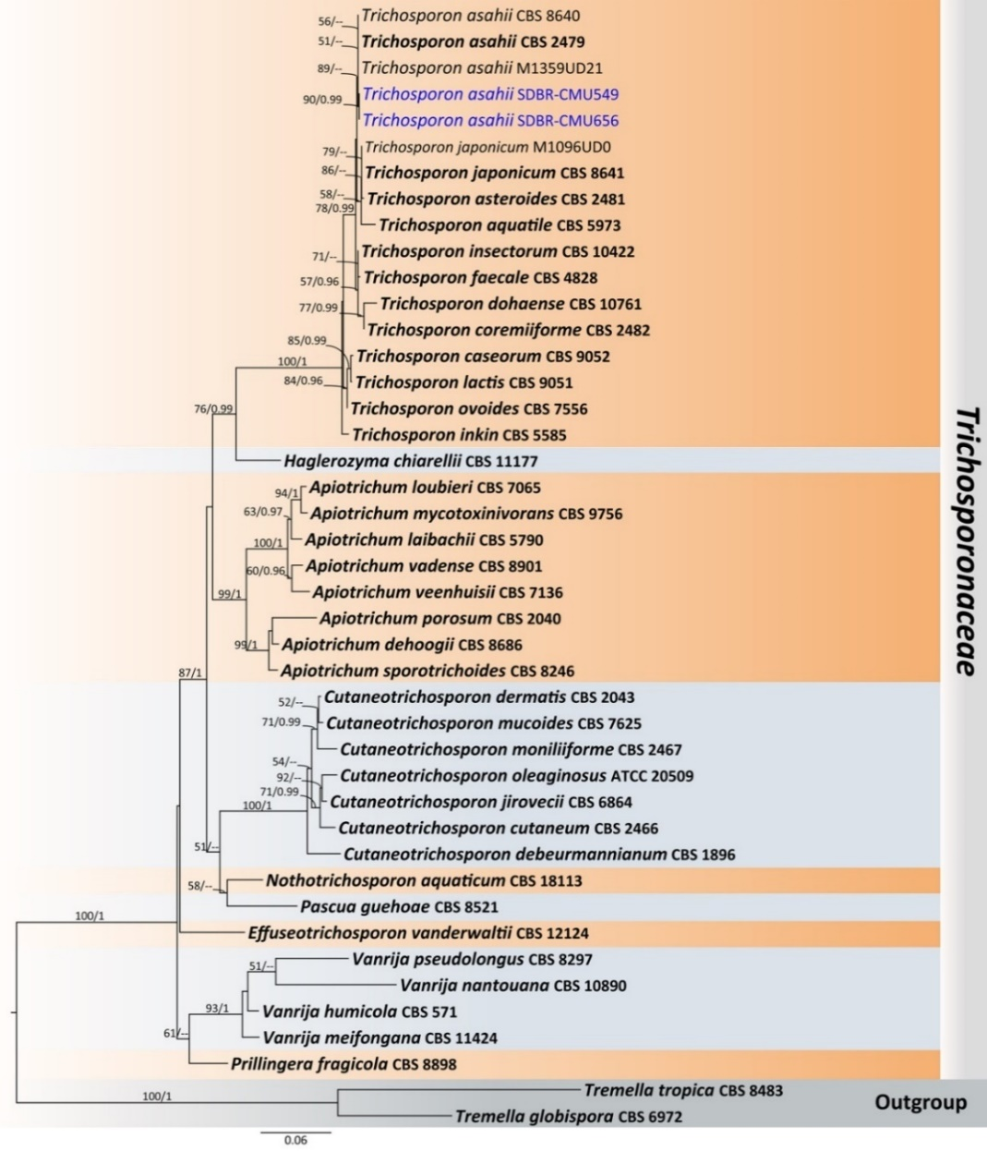
Fig. S10 Phylogenetic tree generated by maximum likelihood analysis of the combined D1/D2 domain of LSU and ITS sequence data representing Trichosporonaceae. The tree is rooted to Tremella globispora (CBS 6972) and T. tropica (CBS 8483). Single-locus analyses were also performed, and topology and clade stability were compared from combined gene analyses. Fourty-three strains are included in the combined sequence analysis, which comprise 1,174 characters with gaps. Bootstrap support values for maximum likelihood ≥ 50% (ML, left) and Bayesian posterior probabilities ≥ 0.95 (PP, right) are indicated above the node. Double dashes (--) represent support values less than 50% ML/0.95 PP. The scale bar represents the expected number of nucleotide substitutions per site. The ex-type strains are in bold and the newly generated sequences in this study are in blue.

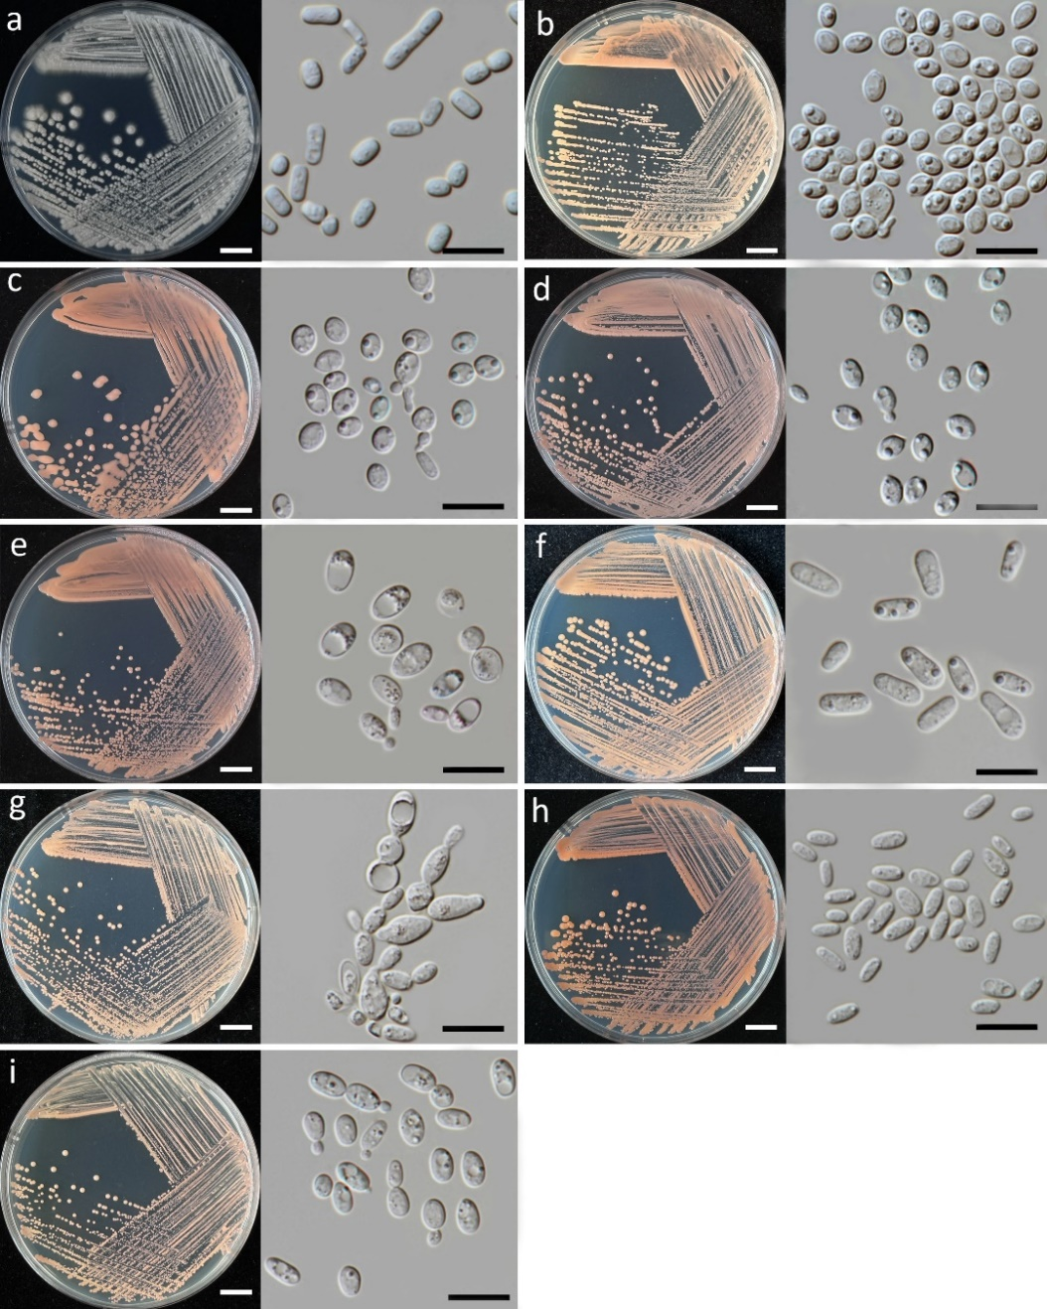

Fig. S11 Culture (left) and cells (right) of Trichosporon asahii (a), Cystobasidium benthicum (b), Cystobasidium keelungenes (c), Cystobasidium minutum (d), Erythrobasidium primogenitum (e), Rhodosporidiobolus fluvialis (f), Rhodosporidiobolus ruineniae (g), Rhodotorula paludigena (h), and Rhodotorula toruloides (i) on YMA at 25°C for 5 days. Scale bars culture a–i = 1 cm and cells a–i = 10 μm.

Cystobasidium keelungense Figs. S11c and 26
Ecology and distribution – Sea surface microlayer and underlying water in Taiwan^{[134]}, Bromelia laciniosa in Brazil^{[135]}, flowers of Mecardonia procumbens and Argyranthemum frutescens in Thailand (this study).

Cystobasidium minutum Figs. S11d and 26
Ecology and distribution – Mineral oil-contaminated local soil in India^{[136]}, sediments of Yap trench in Pacific Ocean^{[137]}, Antarctic penguins and pinnipeds^{[13]}, sediments soil samples in Iraq^{[133]}, the ruins of the Roman city of Conímbriga in Portugal^{[139]}, opportunistic human pathogen in Brazil, China and USA^{[140–142]} faucal samples from seabirds in Antarctic^{[143]}. Kaloula pulchra in Thailand^{[144]}, Melipona seminigra in Portuguese^{[145]}, Stereocaulon halei (lichen) in Indonesia^{[146]}, healthy and ripe fruit, such as apples, apricots, peaches, tomatoes and citrus fruit in Tunisia^{[147]}, marine algae in India^{[148]}, leaves of Saccharum officinarum in China and Thailand^{[109,149]}, flowers of Rosa sp. and Lagerstroemia speciosa in Thailand (this study).

Erythrobasidium primogenitum Figs. S11e and S12
Description – Colonies on YMA after five days at 25°C are circular form (1.5–2.0 mm in diameter), reddish orange, smooth surface, glistening appearance, entire margin, and convex elevation. The cells are ellipsoidal and cylindrical (3.82– 4.78 × 5.07–7.98 μm, n = 50), occur singly and polar budding. In Dalmau plates after 2 weeks on cornmeal agar and PDA at 25°C, neither pseudohyphae nor true hyphae are formed. Basidiospores were not obtained for individual strains and strain pairs on YMA, CMA, 5% MEA, PDA, and V8 agar after incubation at 25°C for one month.
Ecology and distribution – Senna alata in Queensland^{[150]} and Plumeria pudica flower in Thailand (this study).
Notes – We provide the first morphological description of Er. primogenitum because no descriptive data has been provided; only the D1/D2 and ITS sequences available for this species in GenBank^{[150]}.

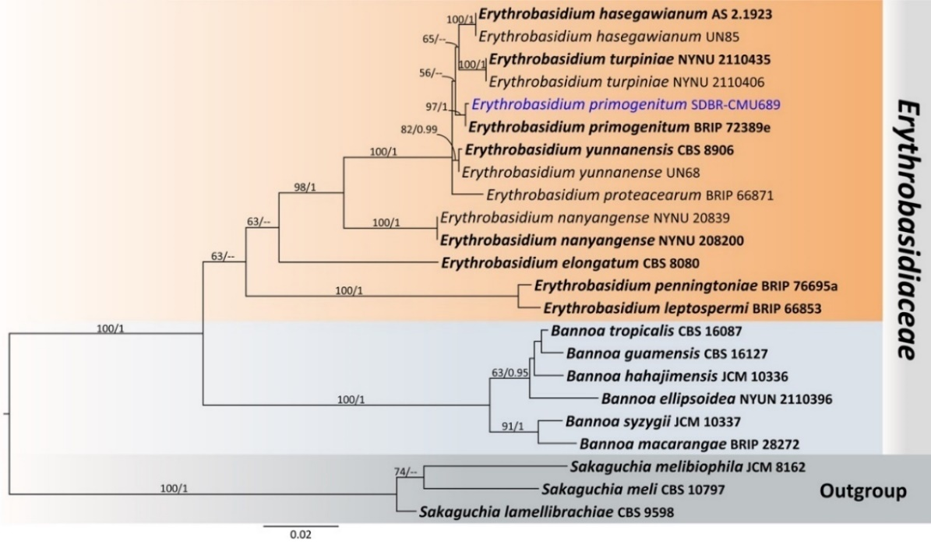

Fig. S12 Phylogenetic tree generated by maximum likelihood analysis of the combined D1/D2 domain of LSU and ITS sequence data representing Erythrobasidiaceae. The tree is rooted to Sakaguchia lamellibrachiae (CBS 9598), S. meli (CBS 10797), and S. melibiophila (JCM 8162). Single-locus analyses were also performed, and topology and clade stability were compared from combined gene analyses. Twenty-three strains are included in the combined sequence analysis, which comprise 1,202 characters with gaps. Bootstrap support values for maximum likelihood ≥ 50% (ML, left) and Bayesian posterior probabilities ≥ 0.95 (PP, right) are indicated above the node. Double dashes (--) represent support values less than 50% ML/0.95 PP. The scale bar represents the expected number of nucleotide substitutions per site. The ex-type strains are in bold and the newly generated sequences in this study are in blue.

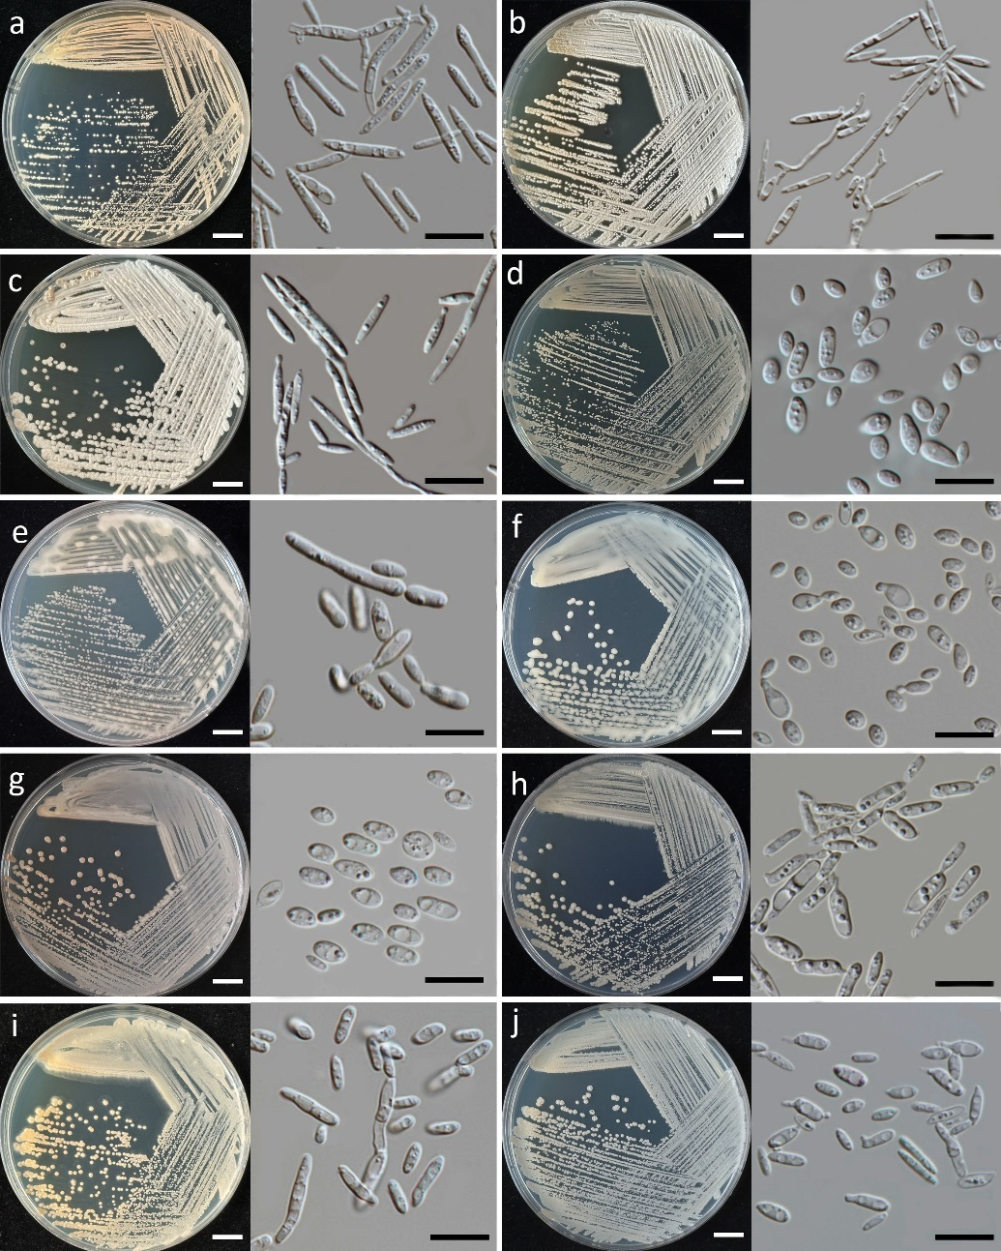

Figure S13 – Culture (left) and cells (right) of Meira argovae (a), Meira plantarum (b), Laurobasidium hachijoense (c), Jaminaea lantanae (d), Sympodiomycopsis europaea (e), Sympodiomycopsis paphiopedili (f), Anthracocystis heteropogonicola (g), Moesziomyces antarcticus (h), Moesziomyces bullatus (i), and Moesziomyces parantarcticus (j) on YMA at 25°C for 5 days. Scale bars culture a–j = 1 cm and cells a–j = 10 μm.

Rhodosporidiobolus fluvialis Figs. S11f and 35
Ecology and distribution – Seawater in Japan^{[151]}, Saccharum officinarum in Thailand^{[46,47]}, date fruits in Saudi Arabia^{[152]} and flowers of Citrus japonica, Nerium oleander, and Rosa sp. in Thailand (this study).

Rhodosporidiobolus ruineniae Figs. S11g and 35
Ecology and distribution – Dung of goat in Pakistan, woodland soil in Portugal and garden soil in Indonesia^{[153]}, soils of assam tea plantation in Thailand^{[126]}. Food and Beverage: fermented tea in South Korea^{[154]}, mountain honey in Chile^{[155]}, Ivorian robusta coffee in Ivory Coast^{[156]}. Leaves of Imperata cylindrica and Pennisetum sp. in Thailand^{[157]}, dry leaf, plant litter in Portugal and Malpighia coccigera in Indonesia^{[153]}, Saccharum officinarum in Thailand ^{[46,47]}, flowers of Ipomoea nil and Merremia aegyptia in Maxico^{[7]}, Leaves of Zea mays in Thailand^{[109]}, Syzygium malaccense fruit in Colombia^{[158]} rotting tissue of Pilosocereus arrabidae in Brazil^{[118]}, flower in northeast region of Brazil^{[118]}, Ixora coccinea and Acalypha in Thailand^{[159]}, duckweed in Thailand^{[34]}, and flowers of Combretum indicum, Ocimum tenuiflorum, and Zamioculcas zamiifolia in Thailand (this study).

Rhodotorula paludigena Figs. S11h and 35
Ecology and distribution – Coastal water in China^{[160]}, soil and water in Thailand^{[13]}, mangrove swamp (Rhizophora mangle) in southeast China Sea^{[161]}. Wild flower in South Korea^{[44]}, leaves of Oryza sativa and Zea mays in Thailand^{[46,109,162]}, Drosera spatulata leaves in Taiwan^{[163]}, rotting tissue of Pilosocereus arrabidae in Brazil^{[118]}, flowers of Ixora coccinea and Zinnia violacea in Thailand^{[159]}, duckweed in Thailand^{[34]}, and Exacum affine flower in Thailand (this study)

Rhodotorula toruloides Figs. S11i and 35
Ecology and distribution – Soil, water and decayed biological matter in Thailand^{[13]}, soils in South Korea and Thailand^{[51,164,165]}, unknown zoanthid and Sarcophyton sp.^{[33]}, sugary wastewater in Egypt^{[166]}, honeycomb of Apis mellifera and Apis cerana in China^{[167]}, sugarcane molasses^{[168]}. Flower in Brazil’s savanna^{[169]}, rotting tissue of Pilosocereus arrabidae in Brazil^{[118]}, and Melampodium divaricatum flower in Thailand (this study).

Meira argovae Figs. S13a and 38
Ecology and distribution – Ricinus communis and Tetranychus cinnabarinus in Israel^{[170]}, Apis mellifera in Mexico^{[7]}. Japanese bamboo in Japan^{[171]}, flowers of Alstonia scholaris and Morinda citrifolia in Thailand (this study).

Meira plantarum Figs. S13b and 38
Ecology and distribution – Leaf of an unidentified plant in China^{[172]} and Plumeria pudica flower in Thailand (this study).

Laurobasidium hachijoense Figs. S13c and 38
Ecology and distribution – Marine sediment in China^{[173]}, citrus rust mite in Israel^{[170]}. Japanese pear in Japan^{[174]}, Cinnamomum japonicum in Japan^{[175]}, the galls with aerial root-like outgrowths of Cinnamomum subavenium in Thailand^{[176]}, and Syzygium jambos flower in Thailand (this study).

Jaminaea lantanae Figs. S13d and 43
Ecology and distribution – Lantana camara in China^{[172]} and Hibiscus rosa-sinensis flower in Thailand (this study).

Sympodiomycopsis europaea Figs. S13e and 43
Ecology and distribution – Unidentified leaf in Germany^{[172]}, Plumeria obtusa and Bougainvillea hybrid flower in Thailand (this study).

Sympodiomycopsis paphiopedili Figs. S13f and 43
Ecology and distribution – Paphiopedilum primurinum in Japan^{[177]}, Gossypium hirsutum, Ipomoea hederifolia, Ipomoea nil, Merremia aegyptia and Piscidia piscipula in Mexico^{[7]}, and flower of Hamelia patens and Morinda citrifolia in Thailand (this study).

Anthracocystis heteropogonicola Figs. S13g and S14
Ecology and distribution – Heteropogon contortus in India and Australia^{[178]}, flowers of Antigonon leptopus and Bidens pilosa in Thailand (this study).

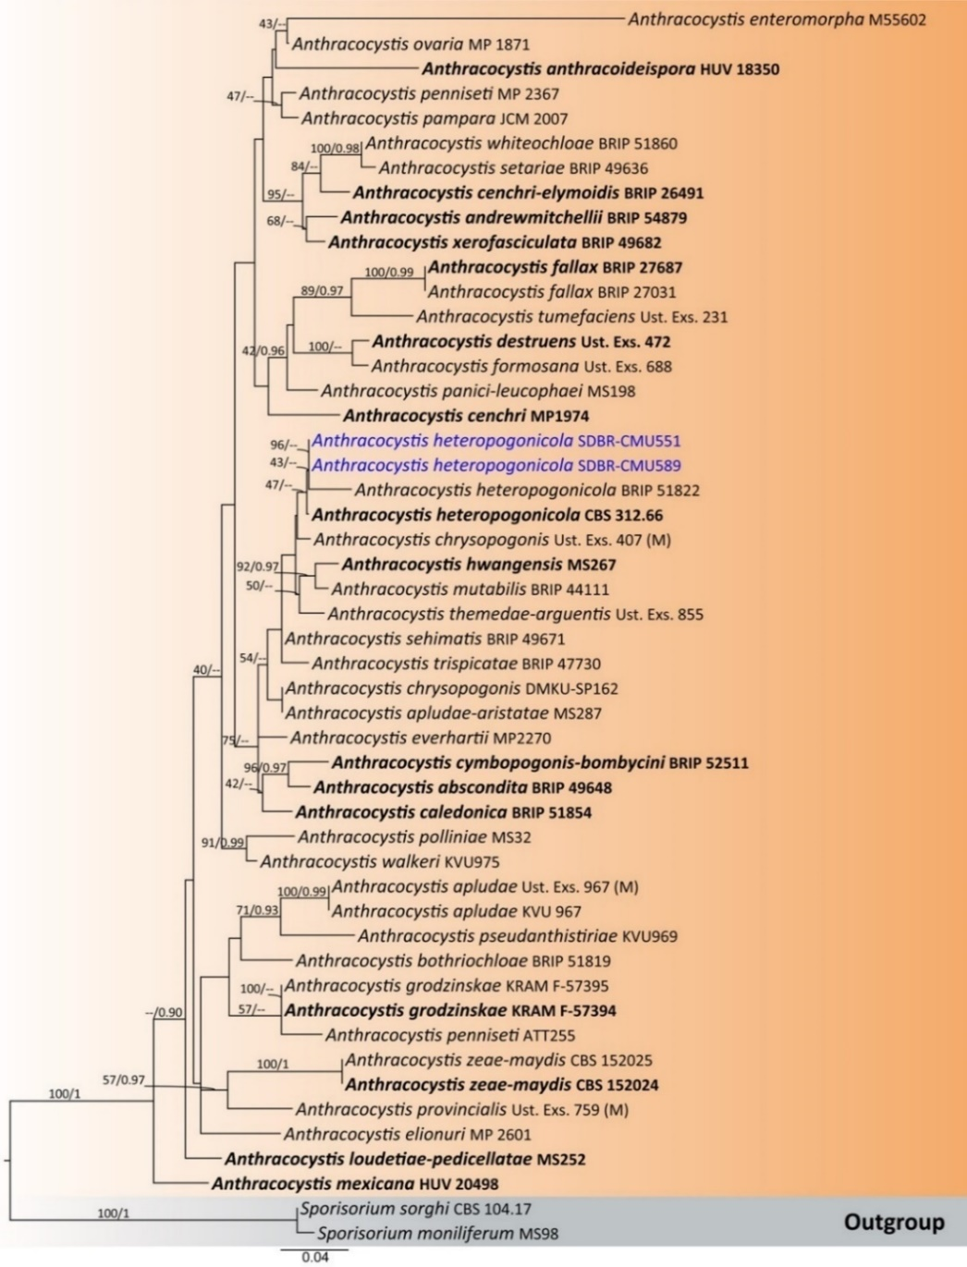

Fig. S14 Phylogenetic tree generated by maximum likelihood analysis of the combined ITS and D1/D2 domain of LSU sequence data representing Anthracocystis. The tree is rooted to Sporisorium moniliferum (MS98) and S. sorghi (CBS 104.17). Single-locus analyses were also performed, and topology and clade stability were compared from combined gene analyses. Fifty strains are included in the combined sequence analysis, which comprise 1,431 characters with gaps. Bootstrap support values for maximum likelihood ≥ 40% (ML, left) and Bayesian posterior probabilities ≥ 0.90 (PP, right) are indicated above the node. Double dashes (--) represent support values less than 40% ML/0.90 PP. The scale bar represents the expected number of nucleotide substitutions per site. The ex-type strains are in bold and the newly generated sequences in this study are in blue.

Moesziomyces antarcticus Figs. S13h and S15
Ecology and distribution – Opportunistic human pathogen in China and Japan^{[179,180]}, leaves of Oryza sativa in Thailand and South Korea^{[57,109,181]}, Saccharum officinarum in Thailand^{[47,109]}, Zea mays in Thailand^{[109]}, Echinochloa crus-galli in Japan^{[182]}, Camellia sinensis var. assamica flower in Thailand^{[36]}, duckweed in Thailand^{[34]}, Oryza sativa seed in South Korea^{[183]}, flowers of Zephyranthes minuta, Senna spectabilis, Momordica charantia, and Hibiscus rosa-sinensis in Thailand (this study).

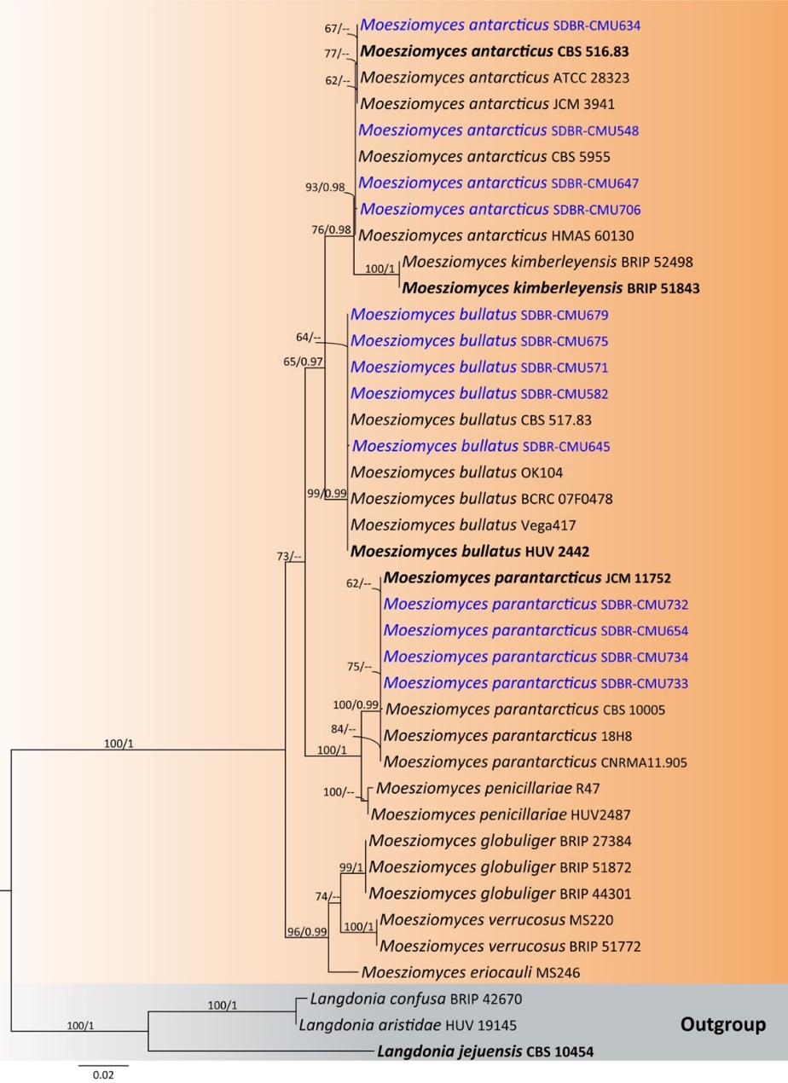
Fig. S15 Phylogenetic tree generated by maximum likelihood analysis of the combined ITS and D1/D2 domain of LSU sequence data representing Moesziomyces. The tree is rooted to Langdonia aristidae (HUV 19145), L. confusa (BRIP 42670) and L. jejuensis (CBS 10454). Single-locus analyses were also performed, and topology and clade stability were compared from combined gene analyses. Fourty strains are included in the combined sequence analysis, which comprise 1,391 characters with gaps. Bootstrap support values for maximum likelihood ≥ 50% (ML, left) and Bayesian posterior probabilities ≥ 0.95 (PP, right) are indicated above the node. Double dashes (--) represent support values less than 50% ML/0.95 PP. The scale bar represents the expected number of nucleotide substitutions per site. The ex-type strains are in bold and the newly generated sequences in this study are in blue.

Moesziomyces bullatus Figs. S13i and S15
Ecology and distribution – Opportunistic human pathogen in Nigeria, Thailand, USA and China^{[184–187]}, grasshoppers in South Korea^{[188]}. Beverage and raw material: variety Minttu, Hordeum vulgare, kernels in Finland^{[189]}. Leaves of Solanum pseudocapsicum^{[190]}, Ericaceae in Alaska^{[191]}, Saccharum officinarum in Japan^{[192]}, pearl millet in India^{[193]}, Oryza sativa in Thailand^{[57]}, Echinochloa crus-galli in Germany^{[194]}, Vitis vinifera in China^{[195]}, Saccharum officinarum in Thailand^{[47]}, mangrove in China^{[196]}, flowers of Citrus japonica, Cnidoscolus aconitifolius, and Melampodium divaricatum in Thailand (this study).

Moesziomyces parantarcticus Figs. S13j and S15
Ecology and distribution – Opportunistic human pathogen in Thailand^{[184]}, pomelo peel in Thailand^{[197]}, and flower of Pentas lanceolata and Ixora chinensis in Thailand (this study).

References

[1]. Santos ARO, Leon MP, Barros KO, Freitas LF, Hughes AF, et al. 2018. Starmerella camargoi f.a., sp. nov., Starmerella ilheusensis f.a., sp. nov., Starmerella litoralis f.a., sp. nov., Starmerella opuntiae f.a., sp. nov., Starmerella roubikii f.a., sp. nov. and Starmerella vitae f.a., sp. nov., isolated from flowers and bees, and transfer of related Candida species to the genus Starmerella as new combinations. International Journal of Systematic and Evolutionary Microbiology 68: 1333–1343
[2]. Barry JP, Metz MS, Hughey J, Quirk A, Bochman ML. 2018. Two novel strains of Torulaspora delbrueckii isolated from the honeybee microbiome and their use in honey fermentation. Fermentation 4: e22.
[3]. Lu Y, Yang L, An Y, Liu D, Yang G, et al. 2022. Salt tolerance and ester production mechanisms of Candida etchellsii in Chinese horse bean–chili–paste. LWT 167:e113806
[4]. van Breda V, Jolly N, van Wyk J. 2013. Characterization of commercial and natural Torulaspora delbrueckii wine yeast strains. International Journal of Food Microbiology 163:80–88
[5]. Punyauppa-Path S, Kiatprasert P, Sawaengkaew J, Mahakhan P, Phumkhachorn P, et al. 2022. Diversity of fermentative yeasts with probiotic potential isolated from Thai fermented food products. AIMS Microbiology 8:575–594
[6]. Wang J, Zhao M, Xie N, Huang M, Feng Y. 2022. Community structure of yeast in fermented soy sauce and screening of functional yeast with potential to enhance the soy sauce flavor. International Journal of Food Microbiology 370:e109652
[7]. Canto A, Herrera CM, Rodriguez R. 2017. Nectar-living yeasts of a tropical host plant community: diversity and effects on community-wide floral nectar traits. PeerJ 5:e3517
[8]. Rehman A, Sohail Anjum M. 2010. Cadmium uptake by yeast, Candida tropicalis, isolated from industrial effluents and its potential use in wastewater clean–up operations. Water, Air, & Soil Pollution 205:149–159
[9]. Sulman S, Rehman A. 2013. Isolation and characterization of cellulose degrading Candida tropicalis W2 from environmental samples. Pakistan Journal of Zoology 45:809–816
[10]. Zuza-Alves DL, de Medeiros SSTQ, de Souza LBFC, Silva-Rocha WP, Francisco EC, et al. 2016. Evaluation of virulence factors In vitro, resistance to osmotic stress and antifungal susceptibility of Candida tropicalis isolated from the Coastal Environment of Northeast Brazil. Frontiers in Microbiology 7: e01783
[11]. Pongsanat P, Miyuki KK. 2018. Identification and characterization of Candida tropicalis isolated from soil of sugarcane field in Thailand for ethanol production. The Asia-Pacific Journal of Science and Technology 23: APST-23
[12]. Wongchamreara S, Boontano P, Ungwiwatkul S, Emnin N, Chantarasiri A. 2023. The oleaginous Candida tropicalis isolated from mangrove soil in eastern Thailand and the fatty acid composition profile of its intracellular lipids. Biodiversitas 24:5088–5095
[13]. Hoondee P, Wattanagonniyom T, Weeraphan T, Tanasupawat S, Savarajara A. 2019. Occurrence of oleaginous yeast from mangrove forest in Thailand. World Journal of Microbiology and Biotechnology 35:e108
[14]. Boonmak C, Khunnamwong P, Limtong S. 2020. Yeast communities of primary and secondary peat swamp forests in southern Thailand. Antonie van Leeuwenhoek 113:55–69
[15]. Hegazy GE, Soliman NA, Farag S, El-Helow ER, Yusef HY, et al. 2024. Isolation and characterization of Candida tropicalis B: a promising yeast strain for biodegradation of petroleum oil in marine environments. Microbial Cell Factories 23:e20
[16]. Kanpiengjai A, Chui Chai N, Chaikaew S, Khanongnuch C. 2016. Distribution of tannin–'tolerant yeasts isolated from Miang, a traditional fermented tea leaf (Camellia sinensis var. assamica) in northern Thailand. International Journal of Food Microbiology 238:121–131
[17]. Ann Chai LY, Denning DW, Warn P. 2010. Candida tropicalis in human disease. Critical Reviews in Microbiology 36:282–298
[18]. Siangpro N, Chuakrut S, Sirimanapong W, Tanasupawat S, Phongsopitanun W, et al. 2023. Lactiplantibacillus argentoratensis and Candida tropicalis isolated from the gastrointestinal tract of fish exhibited inhibitory effects against pathogenic bacteria of Nile tilapia. Veterinary Sciences 10:e129
[19]. Misra S, Raghuwanshi S, Gupta P, Dutt K, Saxena RK. 2012. Fermentation behavior of osmophilic yeast Candida tropicalis isolated from the nectar of Hibiscus rosa sinensis flowers for xylitol production. Antonie van Leeuwenhoek 101:393–402
[20]. Chamnanpa T, Limtong P, Srisuk N, Limtong S. 2013. Seminar on natural resources adaptation to the global climate change: extended abstracts. Diversity of yeasts in vetiver phylloplane and soil in vetiver rhizosphere in Thailand and their ability to produce indole–3–acetic acid. Office of the Higher Education Commission, Bangkok (Thailand). Higher Education Research Promotion and National Research University (HERP-NRU), pp. 245–248.
[21]. Maciel NO, Johann S, Brandão RL, Kucharíková S, Morais CG, et al. 2019. Occurrence, antifungal susceptibility, and virulence factors of opportunistic yeasts isolated from Brazilian beaches. Memórias do Instituto Oswaldo Cruz 114:e180566
[22]. Groenewald M, Smith MT. 2010. Re-examination of strains formerly assigned to Hyphopichia burtonii, the phylogeny of the genus Hyphopichia, and the description of Hyphopichia pseudoburtonii sp. nov. International Journal of Systematic and Evolutionary Microbiology 60:2675–2680
[23]. Chakrabarti A, Rudramurthy SM, Kale P, Hariprasath P, Dhaliwal M, et al. 2014. Epidemiological study of a large cluster of fungaemia cases due to Kodamaea ohmeri in an Indian tertiary care centre. Clinical Microbiology and Infection 20:O83–O89
[24]. Biswal D, Sahu M, Mahajan A, Advani SH, Shah S. 2015. Kodameae ohmeri – an emerging yeast: two cases and literature review. Journal of Clinical and Diagnostic Research 9:DD01–DD3
[25]. Ngo TMC, Ton That DD, Ton Nu PA, Cao LC, Tra MN, et al. 2025. A case report of childhood onychomycosis caused by the rare yeast Kodamaea ohmeri. Medical Mycology Case Reports 47: e100695
[26]. Amos BA, Leemon DL, Hayes RA, Cribb BW, Furlong MJ. 2018. Associations between the small hive beetle and the yeast Kodamaea ohmeri throughout the host life cycle. Journal of Economic Entomology 111:1501–1508
[27]. Charoenphol N, Meelai S. 2023. Biodiversity of yeasts in native Thai bees and testing of potential antagonism for control of some bacteria. PhD., Thesis, Silpakorn University, Thailand.
[28]. Sharma S, Arora A, Sharma P, Singh S, Nain L, et al. 2018. Notable mixed substrate fermentation by native Kodamaea ohmeri strains isolated from Lagenaria siceraria flowers and ethanol production on paddy straw hydrolysates. Chemistry Central Journal 12:e8
[29]. Santos ARO, Lee DK, Ferreira AG, do Carmo MC, Rondelli VM, et al. 2020. The yeast community of Conotelus sp. (Coleoptera: Nitidulidae) in Brazilian passionfruit flowers (Passiflora edulis) and description of Metschnikowia amazonensis sp. nov., a large–spored clade yeast. Yeast 37:253–260
[30]. Jacques N, Casaregola S. 2019. Large biodiversity of yeasts in French Guiana and the description of Suhomyces coccinellae f.a. sp. nov. and Suhomyces faveliae f.a. sp. nov. International Journal of Systematic and Evolutionary Microbiology 69:1634–1649
[31]. Klaps J, de Vega C, Herrera CM, Junker RR, Lievens B, et al. 2020. Candida metrosideri pro tempore sp. nov. and Candida ohialehuae pro tempore sp. nov., two antifungal-resistant yeasts associated with Metrosideros polymorpha flowers in Hawaii. PLoS One 15:e0240093
[32]. Into P, Pontes A, Sampaio JP, Limtong S. 2020. Yeast diversity associated with the phylloplane of corn plants cultivated in Thailand. Microorganisms 8:e80
[33]. Kaewkrajay C, Chanmethakul T, Limtong S. 2020. Assessment of diversity of culturable marine yeasts associated with Corals and Zoanthids in the gulf of Thailand, South China sea. Microorganisms 8:e474
[34]. Kajadpai N, Angchuan J, Khunnamwong P, Srisuk N. 2023. Diversity of duckweed (Lemnaceae) associated yeasts and their plant growth promoting characteristics. AIMS Microbiology 9:e486
[35]. Rosa CA, Lachance MA, Starmer WT, Barker JSF, Bowles JM, et al. 1999. Kodamaea nitidulidarum, Candida restingae and Kodamaea anthophila, three new related yeast species from ephemeral flowers. International Journal of Systematic and Evolutionary Microbiology 49:309–318
[36]. Kanpiengjai A, Kodchasee P, Unban K, Kumla J, Lumyong S, et al. 2023. Three new yeast species from flowers of Camellia sinensis var. assamica collected in Northern Thailand and their tannin tolerance characterization. Frontiers in Microbiology 14:e1043430
[37]. Xu B, Zhang H, Chen K, Xu Q, Yao Y, et al. 2013. Biocontrol of postharvest rhizopus decay of peaches with Pichia caribbica. Current Microbiology 67:255–261
[38]. Wu Y, Ji C, Jiang Y, Hu H, Yu T, et al. 2024. Mechanisms of Meyerozyma caribbica isolated from Tibetan soil to inhibit Aspergillus ochraceus on grapes. Postharvest Biology and Technology 210:e112797
[39]. Amorim SS, Ruas FAD, Barboza NR, de Oliveira Neves VG, Leao VA, et al. 2018. Manganese (Mn2+) tolerance and biosorption by Meyerozyma guilliermondii and Meyerozyma caribbica strains. Journal of Environmental Chemical Engineering 6:4538–4545
[40]. Rattanapatpokin T, Tachaapikoon C, Waeonukul R, Wattanachaisaereekul S, Ratanakhanokchai K, et al. 2020. Newly isolated malic acid fermenting yeast Meyerozyma caribbica AY 33–1 for bioconversion of glucose and cassava pulp. The SEATUC Journal of Science and Engineering 1:62–70
[41]. Hebbale D, Mishra RS, Ramachandra TV. 2022. Prioritizing wild yeast strains for macroalgal bioethanol production. BioEnergy Research 15:202–217
[42]. Hande A, Mahajan S, Prabhune A. 2013. Evaluation of ethanol production by a new isolate of yeast during fermentation in synthetic medium and sugarcane bagasse hemicellulosic hydrolysate. Annals of Microbiology 63;63–70
[43]. Bautista-Rosales PU, Calderon Santoyo M, Servín Villegas R, Ochoa Álvarez NA, Ragazzo Sánchez JA. 2013. Action mechanisms of the yeast Meyerozyma caribbica for the control of the phytopathogen Colletotrichum gloeosporioides in mangoes. Biological Control 65;293–301
[44]. Hyun SH, Min JH, Lee HB, Kim HK, Lee JS. 2014. Isolation and diversity of yeasts from wild flowers in Ulleungdo and Yokjido, Korea. The Korean Journal of Mycology 42:28–33
[45]. Aguirre-Güitrón L, Calderón-Santoyo M, Lagarón JM, Prieto C, Ragazzo-Sánchez JA. 2022. Formulation of the biological control yeast Meyerozyma caribbica by electrospraying process: effect on postharvest control of anthracnose in mango (Mangifera indica L.) and papaya (Carica papaya L.). Journal of the Science of Food and Agriculture 102:696–706
[46]. Limtong S, Kaewwichian R, Yongmanitchai W, Kawasaki H. 2014. Diversity of culturable yeasts in phylloplane of sugarcane in Thailand and their capability to produce indole-3-acetic acid. World Journal of Microbiology and Biotechnology 30:1785–1796
[47]. Srisuk N, Nutaratat P, Surussawadee J, Limtong S. 2019. Yeast communities in sugarcane phylloplane. Microbiology 88:353–369
[48]. Islam F, Salam MA, Rahman MA, Paul SI, Das TR, et al. 2021. Plant endophytic yeasts Pichia fermentans and Meyerozyma caribbica improve growth, biochemical composition, haematological parameters and morphology of internal organs of premature Barbonymus gonionotus. Aquaculture Reports 19:e100575
[49]. Sjamsuridzal W, Oetari A, Nakashima C, Kanti A, Saraswati R, et al. 2013. New species of the genus Metschnikowia isolated from flowers in Indonesia, Metschnikowia cibodasensis sp nov. Journal of Microbiology and Biotechnology 23:905–912
[50]. Chaudhary A, Karita S. 2017. Screening of yeast isolates from flowers for effective ethanol production. Turkish Journal of Biology 41:890–900
[51]. Satianpakiranakorn P, Khunnamwong P, Limtong S. 2020. Yeast communities of secondary peat swamp forests in Thailand and their antagonistic activities against fungal pathogens cause of plant and postharvest fruit diseases. PLoS One 15:e0230269
[52]. Sasahara H, Izumori K. 2005. Production of L-talitol from L–psicose by Metschnikowia koreensis LA1 isolated from soy sauce mash. Journal of Bioscience and Bioengineering 100:335–338
[53]. Wu Y, Li Y, Liang H, Zhang S, Lin X, et al. 2025. Enhancing cider quality through co–fermentation with acid protease and esterase–producing Metschnikowia species and Saccharomyces cerevisiae. Journal of the Science of Food and Agriculture 105:1003–1011
[54]. Hong SG, Chun J, Oh H, Bae KS, 2001. Metschnikowia koreensis sp. nov., a novel yeast species isolated from flowers in Korea. International Journal of Systematic and Evolutionary Microbiology 51:1927–1931
[55]. Glushakova AM, Kachalkin AV, Chernov IY. 2014. Yeasts in the flowers of entomophilic plants of the Moscow region. Microbiology 83:125–134
[56]. Limtong S, Kaewwichian R. 2015. The diversity of culturable yeasts in the phylloplane of rice in Thailand. Annals of Microbiology 65:667–675
[57]. Nasanit R, Jaibangyang S, Tantirungkij M, Limtong S. 2016. Yeast diversity and novel yeast D1/D2 sequences from corn phylloplane obtained by a culture–independent approach. Antonie van Leeuwenhoek 109:1615–1634
[58]. Han SM, Hyun SH, Lee HB, Lee HW, Kim HK, et al. 2015. Isolation and identification of yeasts from wildflowers collected around Jangseong lake in Jeollanam-do, Republic of Korea, and characterization of the unrecorded yeast Bullera coprosmaensis. Mycobiology 43:266–271
[59]. Mittelbach M, Yurkov AM, Nocentini D, Nepi M, Weigend M, et al. 2015. Nectar sugars and bird visitation define a floral niche for basidiomycetous yeast on the Canary Islands. BMC Ecology 15:e2
[60]. Abdel-fattah AM, Nashy ESH, Sabiel ETA, Hussien MM, Attia AS. 2015. Novel keratinolytic activity of Cyberlindnera fabianii NRC3 Aza as a plant growth promoting agent (PGPA). International Journal of Applied Sciences and Biotechnology 3:609–618
[61]. Bahafid W, Joutey NT, Sayel H, Asri M, Laachari F, et al. 2017. Soil bioaugmentation with Cyberlindnera fabianii diminish phytotoxic effects of chromium (VI) on Phaseolus vulgaris L. Journal of materials and Environmental Sciences 8:438–443
[62]. Kusumawati DI, Iswanto T, Lisdiyanti P. 2021. Acid-producing bacteria and yeasts isolated from arabica coffee plantations in Central Java and East Java, Indonesia. Annales Bogorienses 25:28–40
[63]. Elabed A, Ezziat L, Ibnsouda S, Elabed S, Erable B. 2021. Bioelectrochemical characterization of heavy metals resistant yeast: Hansenula fabianii isolated from tannery wastewater. International Journal of Electrochemical Science 16:e140128
[64]. van Rijswijck IM, Derks MF, Abee T, de Ridder D, Smid EJ. 2017. Genome sequences of Cyberlindnera fabianii 65, Pichia kudriavzevii 129, and Saccharomyces cerevisiae 131 isolated from fermented masau fruits in Zimbabwe. Genome Announcements 5:10–1128
[65]. Liang J, Yuan H, Fei Y, Wang H, Qu C, et al. 2024. Effects of Saccharomyces cerevisiae and Cyberlindnera fabianii inoculation on rice-flavor Baijiu fermentation. Foods 13:e3175
[66]. Guo S, Li Y, Yang Z, Zhang Q, Li P, et al. 2024. Isolation and evaluation of Cyberlindnera fabianii strains to improve cigar tobacco leaves fermentation effect. Frontiers in Microbiology 15:e1492042
[67]. Wu Y, Wang J, Li W, Jia H, Che J, et al. 2013. Pichia fabianii blood infection in a premature infant in China: case report. BMC Research Notes 6:1–4
[68]. Jindal N, Arora S, Dhuria N, Arora D. 2015. Cyberlindnera (Pichia) fabianii infection in a neutropenic child: importance of molecular identification. JMM Case Reports 2:e000033
[69]. Katagiri S, Gotoh M, Tone K, Akahane D, Ito Y, et al. 2016. Fatal Cyberlindnera fabianii fungemia in a patient with mixed phenotype acute leukemia after umbilical cord blood transplantation. International Journal of Hematology 103:592–595
[70]. Park JH, Oh J, Sang H, Shrestha B, Lee H, et al. 2019. Identification and antifungal susceptibility profiles of Cyberlindnera fabianii in Korea. Mycobiology 47:449–456
[71]. Sariguzel FM, Unuvar GK, Kucukoglu O, Parkan OM, Koc AN. 2023. Identification, molecular characterization, and antifungal susceptibility of Cyberlindnera fabianii strains isolated from urinary tract. Journal of Medical Mycology 33:e101429
[72]. Sukmawati D, Nurkhasanah S, Afifah, ZN. 2021. Metagenomic–based approach for the analysis of yeast diversity associated with amylase production in Lai (Durio kutejensis). Journal of Pure and Applied Microbiology 15:75–90
[73]. Cadez N, Poot GA, Raspor P, Smith MT. 2003. Hanseniaspora meyeri sp. nov., Hanseniaspora clermontiae sp. nov., Hanseniaspora lachancei sp. nov. and Hanseniaspora opuntiae sp. nov., novel apiculate yeast species. International Journal of Systematic and Evolutionary Microbiology 53:1671–1680
[74]. Utrilla-Vázquez M, Kirchmayr M, Lugo E, Rodríguez-Campos J, Avendaño-Arrazate CH, et al. 2017. Identificación de microorganismos presentes en la fermentación de cacao criollo y trinitario de Chiapas, México. Poster session presented at: XI Simposio Internacional de Recursos Genéticos para las Américas y el Caribe. Guadalajara, Mexico.
[75]. Tope-Fatukasi BP, Afolabi OB, Ogunnusi TA, Akpor OB. 2024. Exploring the probiotic potential of yeast strains isolated from ripe banana and plantain peels: in vitro and in vivo assessment. International Microbiology 28:1305–1319
[76]. Vishniac HS. 1995. Simulated in situ competitive ability and survival of a representative soil yeast, Cryptococcus albidus. Microbial Ecology 30:309–320
[77]. Mokhtarnejad L, Arzanlou M, Babai-Ahari A, Di Mauro S, Onofri A, et al. 2016. Characterization of basidiomycetous yeasts in hypersaline soils of the Urmia Lake National Park, Iran. Extremophiles 20:915–928
[78]. Babjeva IP, Reshetova IS. 1971. Yeasts in Pamir soils (in Russian). Moscow University Soil Science Bulletin 2:80–86
[79]. Hu W, Zhang Q, Tian T, Cheng G, An L, et al. 2015. The microbial diversity, distribution, and ecology of permafrost in China: a review. Extremophiles 19:693–705
[80]. Nageen Y, Asemoloye MD, Põlme S, Wang X, Xu S, et al. 2021. Analysis of culturable airborne fungi in outdoor environments in Tianjin, China. BMC Microbiology 21:e134
[81]. Wei XY, Zhu HY, Song L, Zhang RP, Li AH, et al. 2022. Yeast diversity in the Qaidam basin desert in China with the description of five new yeast species. Journal of Fungi 8:e858
[82]. Wagner DN, Varaljay VA, Lyon WJ, Crouch AL, Drake CAet al. 2022. Draft Genome Sequence of the Nonmotile Tremellomycetes Yeast Naganishia albida, Isolated from Aircraft. Microbiology Resource Announcements 11:e0024222
[83]. Gyimesi A, Bátor A, Görög P, Telegdy E, Szepes É, et al. 2017. Cutaneous Cryptococcus albidus infection. International Journal of Dermatology 56:452–454
[84]. Oliveira VF, Funari AP, Taborda M, Magri ASGK, Levin AS, et al. 2023. Cutaneous Naganishia albida (Cryptococcus albidus) infection: a case report and literature review. Revista do Instituto de Medicina Tropical de São Paulo 65:e60
[85]. Nascimento DC, Paula CR, Ruiz LS, Domaneschi C, Navarro BS, et al. 2017. Cryptococcus albidus var. albidus isolated from turquoise–fronted parrots (Amazona aestiva: Psittacidae) kept in captivity: a probable reservoir ecological of fungal specimen. Journal of Veterinary Science and Technology 8:e489
[86]. Wei Y, Lei Y, Liu A, Zhu S, Li Y, et al. 2022. Analysis of the diversity of yeast communities in Xinjiang honey. Research Square. Research Square. https://doi.org/10.21203/rs.3.rs-1349085/v1
[87] Pavlova K, Angelova G, Savova I, Grigorova D, Kupenov L. 2002. Studies of Antarctic yeast for β-glucosidase production. World Journal of Microbiology and Biotechnology 18:569–573. Doi 10.1023/A:1016337529488
[88]. Janisiewicz WJ. 1988. Biocontrol of postharvest diseases of apples with antagonist mixtures. Phytopathology 78:194–198
[89]. Herzberg M, Fischer R, Titze A. 2002. Conflicting results obtained by RAPD–PCR and large–subunit rDNA sequences in determining and comparing yeast strains isolated from flowers: a comparison of two methods. International Journal of Systematic and Evolutionary Microbiology 52:1423–1433
[90]. Yalçın HT, Çorbacı C, Uçar FB. 2014. Molecular characterization and lipase profiling of the yeasts isolated from environments contaminated with petroleum. Journal of Basic Microbiology 54:S85–S92
[91]. Yılmaz DE, Sayar NA. 2015. Organic solvent stable lipase from Cryptococcus diffluens D44 isolated from petroleum sludge. Journal of Molecular Catalysis B: Enzymatic 122:72–79
[92]. Kunthiphun S, Chokreansukchai P, Hondee P, Tanasupawat S, Savarajara A. 2018. Diversity and characterization of cultivable oleaginous yeasts isolated from mangrove forests. World Journal of Microbiology and Biotechnology 34:e125
[93]. Hashimoto K, Yamazaki F, Kohyama N, Kawakami Y. 2020. Analysis of fungal flora in the Dust of bedding in Japanese houses and genetic identification of yeasts isolated from the Dust. Biocontrol Science 25:193–202
[94]. Carvalho JK, Panatta AAS, Silveira MAD, Tav C, et al. 2021. Yeasts isolated from a lotic continental environment in Brazil show potential to produce amylase, cellulase and protease. Biotechnology Reports 30:e00630
[95]. Sapsirisuk S, Polburee P, Lorliam W, Limtong S. 2022. Discovery of oleaginous yeast from mountain forest soil in Thailand. Journal of Fungi 8:e1100
[96]. Diver P, Ward BA, Cunliffe M. 2024. Physiological and morphological plasticity in response to nitrogen availability of a yeast widely distributed in the open ocean. FEMS Microbiology Ecology 100:fiae053
[97]. Shulenina OV, Sukhanova EA, Yarovoy BF, Tolstyko EA, Konevega AL, et al. 2024. The antibacterial activity of yeasts from unique biocenoses. Acta Naturae 16:95–104
[98]. Ashrafi Khozani M, Abastabar M, Moazeni M, Rezai MS, Farhadi R, et al. 2024. An unusual high prevalence of Cryptococcus (Naganishia) diffluens colonization in neonates hospitalized in a referral neonatal intensive care unit. The Pediatric Infectious Disease Journal 43:1194–1199
[99]. Pozo MI, Herrera CM, Bazaga P. 2011. Species richness of yeast communities in floral nectar of southern Spanish plants. Microbial Ecology 61:82– 91
[100]. Bermann CdS, Braga CQ, Silveira JdS, Milech A, Dos Santos CC, et al. 2022. Tremellomycetes isolated from organs of Columba livia. Medical Mycology 60:myac093
[101]. Turk M, Abramović Z, Plemenitaš A, Gunde-Cimerman N. 2007. Salt stress and plasma-membrane fluidity in selected extremophilic yeasts and yeast-like fungi. FEMS Yeast Research 7:550–557
[102]. Selvakumar P, Sivashanmugam P. 2018. Study on lipid accumulation in novel oleaginous yeast Naganishia liquefaciens NITTS2 utilizing pre-digested municipal waste activated sludge: a low-cost feedstock for biodiesel production. Applied Biochemistry and Biotechnology 186:731–749
[103]. Luo B, Sun H, Zhang Y, Gu Y, Yan w, et al. 2019. Habitat–specificity and diversity of culturable cold–adapted yeasts of a cold–based glacier in the Tianshan Mountains, northwestern China. Applied Microbiology and Biotechnology 103:2311–2327
[104]. Han YW, Kajitani R, Morimoto H, Palihati M, Kurokawa Y, et al. 2020. Draft genome sequence of Naganishia liquefaciens strain N6, isolated from the Japan Trench. Microbiology Resource Announcements 9:e00827–20
[105]. Serda Kantarcioğlu A, Boekhout T, Sybren De Hoog G, Theelen B, Yücel A, et al. 2007. Subcutaneous cryptococcosis due to Cryptococcus diffluens in a patient with sporotrichoid lesions case report, features of the case isolate and in vitro antifungal susceptibilities. Medical Mycology 45:173–181
[106]. Takemura H, Ohno H, Miura I, Takagi T, Ohyanagi T, et al. 2015. The first reported case of central venous catheter–related fungemia caused by Cryptococcus liquefaciens. Journal of Infection and Chemotherapy 21:392–394
[107]. Khozani MA, Abastabar M, Moazeni M, Rezai MS, Farhadi R, et al. 2024. An unusual high prevalence of Cryptococcus (Naganishia) diffluens colonization in neonates hospitalized in a referral neonatal intensive care unit. The Pediatric Infectious Disease Journal 43:1194–1199
[108]. Oliveira RQ, Rosa CA, Uetanabaro AP, Azeredo A, Neto AG, et al. 2009. Polygalacturonase secreted by yeasts from Brazilian semi-arid environments. International Journal of Food Sciences and Nutrition 60: 72–80
[109]. Khunnamwong P, Jindamorakot S, Limtong S. 2018. Endophytic yeast diversity in leaf tissue of rice, corn and sugarcane cultivated in Thailand assessed by a culture–dependent approach. Fungal Biology 122:785–799
[110]. Park S, Srinivasan S. 2024. Isolation and characterization of two unreported yeast species from wildflowers and mountain soil in Korea in the families Filobasidiaceae and Piskurozymaceae. Journal of Species Research 13:48–53
[111]. Landell MF, Brandão LR, Barbosa AC, Ramos JP, Safar SVB, et al. 2014. Hannaella pagnoccae sp. nov., a tremellaceous yeast species isolated from plants and soil. International Journal of Systematic and Evolutionary Microbiology 64:1970–1977
[112]. Surussawadee J, Jindamorakot S, Nakase T, Lee CF, Limtong S. 2015. Hannaella phyllophila sp. nov., a basidiomycetous yeast species associated with plants in Thailand and Taiwan. International Journal of Systematic and Evolutionary Microbiology 65:2135–2140
[113]. Yu WJ, Chung D, Bae SS, Kwon YM, Cho ES, et al. 2023. Characterization and Biological activities of yeasts isolated from Marine environments. Microbiology Research 14:1984–1999
[114]. Jiang YL, Bao WJ, Liu F, Wang GS, Yurkov AM, et al. 2024. Proposal of one new family, seven new genera and seventy new basidiomycetous yeast species mostly isolated from Tibet and Yunnan provinces, China. Studies in Mycology 109:57–153
[115]. Han SM, Kim HK, Lee HB, Lee JS. 2016. Isolation and identification of wild yeasts from freshwaters and soils of Nakdong and Yeongsan River, Korea, with characterization of two unrecorded yeasts. The Korean Journal of Mycology 44:350–354
[116]. Thanh VN, Hai DA, Lachance MA. 2006. Cryptococcus bestiolae and Cryptococcus dejecticola, two new yeast species isolated from frass of the litchi fruit borer Conopomorpha sinensis Bradley. FEMS Yeast Research 6:298–304
[117]. Han SM, Lee JS, 2017. Characterization of unrecorded yeasts isolated from leaves of trees of Oknyeobong Peak and Yeonjasan Mountain in Daejeon, Korea. The Korean Journal of Mycology 45:23–30
[118]. Freitas LFD, Batista TM, Santos ARO, Hilário HO, Moreira RG, et al. 2020. Yeast communities associated with cacti in Brazil and the description of Kluyveromyces starmeri sp. nov. based on phylogenomic analyses. Yeast 37:625–637
[119]. Kim JY, Jang JH, Park JH, Jung HY, Park JS, et al. 2018. Cellulose degrading basidiomycetes yeast isolated from the gut of grasshopper in Korea. The Korean Journal of Microbiology 54:362–368
[120]. Ferreira-Paim K, Ferreira TB, Andrade-Silva L, Mora DJ, Springer DJ, et al. 2014. Phylogenetic analysis of phenotypically characterized Cryptococcus laurentii isolates reveals high frequency of cryptic species. PLoS One 9:e108633
[121]. Prakash A, Randhawa HS, Khan ZU, Ahmad S, Hagen F, et al. 2018. Environmental distribution of Cryptococcus species and some other yeast‐like fungi in India. Mycoses 61:305–313
[122]. Moubasher AH, Abdel-Sater MA, Zeinab SM. 2018. Diversity of floricolous yeasts and filamentous fungi of some ornamental and edible fruit plants in Assiut area, Egypt. Current Research in Environmental & Applied Mycology 8:135–161
[123]. Oluwa SW. 2020. Structure and foaming properties of viscous exopolysaccharides from a wild grape-associated basidiomycetous yeast Papiliotrema flavescens formerly known as Cryptococcus flavescens. Journal of Microbiology and Biotechnology 30:1739–1749
[124]. Sugita T, Nishikawa A, Ichikawa T, Ikeda R, Shinoda T. 2000. Isolation of Trichosporon asahii from environmental materials. Medical Mycology 38:27–30
[125]. Ilyas S, Rehman A. 2018. Metal resistance and uptake by Trichosporon asahii and Pichia kudriavzevii isolated from industrial effluents. Archives of Environmental Protection 44:77–84
[126]. Kumla J, Nundaeng S, Suwannarach N, Lumyong S. 2020. Evaluation of multifarious plant growth promoting trials of yeast isolated from the soil of Assam tea (Camellia sinensis var. assamica) plantations in Northern Thailand. Microorganisms 8:e1168
[127]. Li H, Guo M, Wang C, Li Y, Fernandez AM, et al. 2020. Epidemiological study of Trichosporon asahii infections over the past 23 years. Epidemiology and Infection 148:e169
[128]. Assiry MM, Joseph MRP, Alqahtani AS, Assiri AM, Alshahrani AS, et al. 2023. Emerging nosocomial Trichosporon asahii in a tertiary hospital in Southern Saudi Arabia. King Khalid University Journal of Health Sciences 8:132–138
[129]. Pumeesat P, Wongsuk T. 2023. Genetic analysis of emerging fungal pathogen: Trichosporon asahii. Diagnostic Microbiology and Infections Disease 107:e116057
[130]. Nagahama T, Hamamoto M, Nakase T, Horikoshi K. 2003. Rhodotorula benthica sp. nov. and Rhodotorula calyptogenae sp. nov., novel yeast species from animals collected from the deep-sea floor, and Rhodotorula lysiniphila sp. nov., which is related phylogenetically. International Journal of Systematic and Evolutionary Microbiology 53:897–903
[131]. Lee HS, Lee HS, Lee JS, Lee YJ, Lee JH, et al. 2018. Bioactive compounds from a marine yeast Cystobasidium benthicum isolated from deep–sea sediment. 15th Deep–Sea Biology Symposium, 65 p.
[132]. Zaidi S, Vats M, Kumar N, Janbade A, Gupta MK. 2022. Evaluation of food packaging paper for microbial load and storage effect on the microbial activity of paper. Packaging Technology and Science 35:569–577
[133]. Mattoq ZQ, Jameel NM, Al Hilfi AAA. 2023. Production, purification and characterization of terpenes isolated from two new strains of yeasts in Iraq and study of their antiparasitic activity. Biomedicine and Chemical Sciences 2:63–67
[134]. Chang CF, Lee CF, Liu SM. 2019. Cystobasidium keelungensis sp. nov., a novel mycosporine producing carotenogenic yeast isolated from the sea surface microlayer in Taiwan. Archives of Microbiology 201:27–33
[135]. Félix CR, Nascimento BES, Tavares V, Landell MF. 2025. Effects of rainfall and drought on the functional and taxonomic diversity of cultivable yeasts associated with Bromelia laciniosa from a Brazilian tropical dryland. Yeast 42:70–84
[136]. Saxena V, Sharma CD, Bhagat SD, Saini VS, Adhikari DK. 1998. Lipid and fatty acid biosynthesis by Rhodotorula minuta. Journal of the American Oil Chemists' Society 75:501–505
[137]. Gao Y, Du X, Xu W, Fan R, Zhang X, et al. 2020. Fungal diversity in deep sea sediments from East Yap Trench and their denitrification potential. Geomicrobiology Journal 37:848–858
[138]. Brito Devoto T, Toscanini M, Hermida Alava K, Etchecopaz A, Pola SJ, et al. 2022. Exploring fungal diversity in Antarctic wildlife: isolation and molecular identification of culturable fungi from penguins and pinnipeds. New Zealand Veterinary Journal 70:263–272
[139]. Mateus DMR, Ferraz E, Perna V, Sales P, Hipólito Correia V. 2024. Essential oils and extracts of plants as biocides against microorganisms isolated from the ruins of the Roman city of Conímbriga (Portugal). Environmental Science and Pollution Research 31:40669–40677
[140]. Goldani LZ, Craven DE, Sugar AM. 1995. Central venous catheter infection with Rhodotorula minuta in a patient with AIDS taking suppressive doses of fluconazole. Journal of Medical and Veterinary Mycology 33:267–270
[141]. Zhou J, Chen M, Chen H, Pan W, Liao W. 2014. Rhodotorula minuta as onychomycosis agent in a Chinese patient: first report and literature review. Mycoses 57:191–195.
[142]. Inácio CP, Diniz MV, Araújo PSR, Barros MS, Andrade MC, et al. 2020. Bloodstream infection of a Cancer patient by Cystobasidium minutum: a case report and literature review. Mycopathologia 185:395–398
[143]. Chryssanthou E, Wennberg H, Bonnedahl J, Olsen B. 2011. Occurrence of yeasts in faecal samples from Antarctic and South American seabirds. Mycoses 54:811–815
[144]. Poonlaphdecha S, Ribas A. 2016. Yeasts in amphibians are common: isolation and the first molecular characterization from Thailand. Acta Herpetologica 11:81–84
[145]. Tiago MRM, Cortez ACA, Souza JVB, Brito DV, Carvalho-Zilse GA. 2022. Fungi associated with hives and castes of the Amazonian stingless bees Melipona interrupta and Melipona seminigra. Research Square, https://doi.org/10.21203/rs.3.rs-2355604/v1
[146]. Metri N. 2019. Isolasi dan uji aktivitas antibakteri metabolit sekunder ekstrak kultur jamur endofit Cystobasidium minutum Saito. dari lichen Stereocaulon halei Lamb. PhD., Thesis, Universitas Andalas, Indonesia.
[147]. Kheireddine A, Palmieri D, Vitullo D, Barberio A, Zouaoui M, et al. 2021. Characterization of new yeast isolates collected from different fruits in Tunisia and biocontrol activity against Penicillium expansum on apples. Journal of Plant Pathology 103:1169–1184
[148]. Harikrishnan M, Prakash P, Jayabaskaran, Bhat SG. 2021. Multi-functional bioactive secondary metabolites derived from endophytic fungi of marine algal origin. Current Research in Microbial Sciences 2:e100037
[149]. Xu YJ, Zhang HY, Xie XC, Deng DH, Wei JY, et al. 2023. Isolation, identification and fermentation performance of endophytic yeast in sugarcane. Food Research and Development 44:159–166
[150]. Tan YP, Shivas RG. 2022. Nomenclatural novelties. Index Australian Fungi 1:1–18
[151]. Nakata S, Hio M, Takase R, Kawai S, Watanabe D, Hashimoto W. 2020. Polyunsaturated fatty acids-enriched lipid from reduced sugar alcohol mannitol by marine yeast Rhodosporidiobolus fluvialis Y2. Biochemical and Biophysical Research Communications 526:1138–1142
[152]. Hamad SH. 2024. Microbial contamination and some chemical and physical properties of date fruits stored at room and refrigerator temperatures. Arab Gulf Journal of Scientific Research 42:1297–1306
[153]. Valério E, Gadanho M, Sampaio JP. 2002. Sporobolomyces odoratus sp. nov., a new species in the Sporidiobolus ruineniae clade. FEMS Yeast Research 2:9–16
[154]. Kim JY. 2009. Isolation of Sporidiobolus ruineniae CO–3 and characterization of its extracellular protease. Journal of the Korean Society for Applied Biological Chemistry 52:1–10
[155]. Rodríguez Machado A, Caro CM, Hurtado Murillo JJ, Gomes Lobo CJ, Zúñiga RN, et al. 2024. Unconventional yeasts isolated from chilean honey: a probiotic and phenotypic characterization. Foods 13:e1582
[156]. Lopez Rodríguez C, Strub C, Fontana A, Verheecke Vaessen C, Beugré C, et al. 2024. Biocontrol activities of yeasts or lactic acid bacteria isolated from Robusta coffee against Aspergillus carbonarius growth and ochratoxin a production in vitro. International Journal of Food Microbiology 16:e110638
[157]. Takashima M, Nakase T. 2000. Four new species of the genus Sporobolomyces isolated from leaves in Thailand. Mycoscience 41:357–369
[158]. Ramirez Castrillon M, Usman LM, Silva Bedoya LM, Osorio Cadavid E. 2019. Dominant yeasts associated to mango (Mangifera indica) and rose apple (Syzygium malaccense) fruit pulps investigated by culture–based methods. Anais da Academia Brasileira de Ciências 91:e20190052
[159]. Phuengjayaem S, Kingkaew E, Hoondee P, Rojsitthisak P, Sritularak B, et al. 2023. Diversity, astaxanthin production, and genomic analysis of Rhodotorula paludigena SP9-15. Heliyon 9:e18280
[160]. Yang SP, Wu ZH, Jian JC, Zhang XZ. 2010. Effect of marine red yeast Rhodosporidium paludigenum on growth and antioxidant competence of Litopenaeus vannamei. Aquaculture 309:62–65
[161]. Fell JW, Statzell Tallman A. 1980. Rhodosporidium paludigenum sp. nov., a basidiomycetous yeast from intertidal waters of South Florida. International Journal of Systematic Bacteriology 30:658–659
[162]. Nutaratat P, Srisuk N, Arunrattiyakorn P, Limtong S. 2014. Plant growth–promoting traits of epiphytic and endophytic yeasts isolated from rice and sugar cane leaves in Thailand. Fungal Biology 118:683–94
[163]. Fu SF, Sun PF, Lu HY, Wei JY, Xiao HS, et al. 2016. Plant growth-promoting traits of yeasts isolated from the phyllosphere and rhizosphere of Drosera spatulata Lab. Fungal Biology 120:433–448
[164]. Kraisintu P, Yongmanitchai W, Limtong S. 2010. Selection and optimization for lipid production of a newly isolated oleaginous yeast, Rhodosporidium toruloides DMKU3-TK16. Agriculture and Natural Resources 44:436–445
[165]. Wu CC, Tsai YY, Ohashi T, Misaki R, Limtong S, et al. 2018. Isolation of a thermotolerant Rhodosporidium toruloides DMKU3–TK16 mutant and its fatty acid profile at high temperature. FEMS Microbiology Letters 365:fny203
[166]. Almuhayawi MS, Hassan EA, Almasaudi S, Zabermawi N, Azhar EI, et al. 2023. Biodiesel production through Rhodotorula toruloides lipids and utilization of de–oiled biomass for Congo red removal. Sustainability 15:e13412
[167]. Xue SJ, Li XC, Huang X, Liu J, Li Y, et al. 2023. Diversity investigation of cultivable yeasts associated with honeycombs and identification of a novel Rhodotorula toruloides strain with the robust concomitant production of lipid and carotenoid. Bioresource Technology 370:e128573
[168]. Ochoa Viñals N, Alonso Estrada D, Faife Pérez E, Chen Z, Michelena-Alvarez G, et al. 2024. β–Carotene production from sugarcane molasses by a newly isolated Rhodotorula toruloides L/24–26–1. Archives of Microbiology 206:e245
[169]. Machado WRM, Silva LG, Vanzela ESL, Del Bianchi VL. 2019. Production of carotenoids by Rhodotorula toruloides isolated from Brazilian tropical savannah. International Food Research Journal 26:1259–1267
[170]. Boekhout T, Theelen B, Houbraken J, Robert V, Scorzetti G, et al. 2003. Novel anamorphic mite–associated fungi belonging to the Ustilaginomycetes: Meira geulakonigii gen. nov., sp. nov., Meira argovae sp. nov. and Acaromyces ingoldii gen. nov., sp. nov. International Journal of Systematic and Evolutionary Microbiology 53:1655–1664
[171]. Tanaka E, Shimizu K, Imanishi Y, Yasuda F, Tanaka C. 2008. Isolation of basidiomycetous anamorphic yeast-like fungus Meira argovae found on Japanese bamboo. Mycoscience 49:329–333
[172]. Li YY, Wang MM, Groenewald M, Li AH, Guo YT, et al. 2022. Proposal of two new combinations, twenty new species, four new genera, one new family, and one new order for the anamorphic basidiomycetous yeast species in Ustilaginomycotina. Frontiers in Microbiology 12:e777338
[173]. Gao XW, Liu HX, Sun ZH, Chen YC, Tan YZ, et al. 2016. Secondary metabolites from the deep–sea derived fungus Acaromyces ingoldii FS121. Molecules 21, e371.
[174]. Yasuda F, Yamagishi D, Akamatsu H, Izawa H, Kodama M, et al. 2005. Fruit stain of Japanese pear caused by basidiomycetous, yeast–like fungi, Acaromyces ingoldii and Meira sp. Japanese Journal of Phytopathology 71:156–165
[175]. Kakishima M, Nagao H, Denchev CM. 2017. Laurobasidium hachijoense, comb. nov. (Cryptobasidiaceae) causing aerialroot–like galls on Cinnamomum japonicum in Japan. Phytotaxa 303:97–100
[176]. Somrithipol S, Jones EG, Sommai S, Suetrong S, Mongkolsamrith S, et al. 2018. Laurobasidiaceae fam. nov. (Exobasidiales, Basidiomycota), a new family for fungi causing galls with aerial root–like outgrowths, with a new record from Thailand of Laurobasidium hachijoense on a new host, Cinnamomum subavenium. Phytotaxa 347:150–164
[177]. Sugiyama J, Tokuoka K, Suh SO, Hirata A, Komagata K. 1991. Sympodiomycopsis: a new yeast-like anamorph genus with basidiomycetous nature from orchid nectar. Antonie van Leeuwenhoek 59:95–108
[178]. Shivas RG, Vánky K. 1997. New smuts (Ustilaginales) on grasses from Western Australia. Mycological Research 101:835–840
[179]. Liu Y, Zou Z, Hu Z, Wang W, Xiong J. 2019. Morphology and molecular analysis of Moesziomyces antarcticus isolated from the blood samples of a Chinese patient. Frontiers in Microbiology 10:e254
[180]. Nishioka S, Yamanaka M, Kunisho Y, Aoki Y, Higasitani M, et al. 2022. A case of Moesziomyces antarcticus peritonitis in a patient undergoing peritoneal dialysis. Renal Replacement Therapy 8:e29
[181]. Jeong E, Lim JY, Seo JA. 2023. Complete genome sequence of Moesziomyces antarcticus KMA5 isolated from rice in Korea. The Microbiological Society of Korea 59:340–342
[182]. Tanaka E, Koitabashi M, Kitamoto H. 2019. A teleomorph of the ustilaginalean yeast Moesziomyces antarcticus on barnyardgrass in Japan provides bioresources that degrade biodegradable plastics. Antonie van Leeuwenhoek 112:599–614
[183]. Harris W, Choi G, Lee KK, Kim H, Lee YH. 2024. High-quality genome resource of a basidiomycetous yeast, Moesziomyces antarcticus isolate RS1, isolated from rice seed. Microbiology Resource Announcements 13:e00847-23
[184]. Sugita T, Takashima M, Poonwan N, Mekha N, Malaithao K, et al. 2003. The first isolation of ustilaginomycetous anamorphic yeasts, Pseudozyma species, from patients' blood and a description of two new species: P. parantarctica and P. thailandica. Microbiology and Immunology 47:183–190
[185]. Lin SS, Pranikoff T, Smith SF, Brandt ME, Gilbert K, et al. 2008. Central venous catheter infection associated with Pseudozyma aphidis in a child with short gut syndrome. Journal of Medical Microbiology 57:516–518
[186]. Okolo OM, van Diepeningen AD, Toma B, Nnadi NE, Ayanbimpe MG, et al. 2015. First report of neonatal sepsis due to Moesziomyces bullatus in a preterm low–birth–weight infant. JMM Case Reports 2:1–4.
[187]. Chen YY, Yeh TK, Wu CJ, Liu PY. 2025. Osteomyelitis caused by Moesziomyces aphidis in an immunocompetent adult: a case report and literature review. Tropical Medicine and Infectious Disease 10:e107
[188]. Kim JY, Jung HY, Park JS, Cho SJ, Lee HB, et al. 2019. Isolation and characterization of cellulolytic yeast belonging to Moesziomyces sp. from the gut of Grasshopper. Korean Journal of Microbiology 55: 234–241
[189]. Korhola M, Hakonen R, Juuti K, Edelmann M, Kariluoto S, et al. 2014. Production of folate in oat bran fermentation by yeasts isolated from barley and diverse foods. Journal of applied microbiology 117:679–689.
[190]. Henninger W, Windisch S. 1975. A new yeast of Sterigmatomyces, S. aphidis sp. n. Archives of Microbiology 105:49–50
[191]. Walker JF, Aldrich Wolfe L, Riffel A, Barbare H, Simpson NB, et al. 2011. Diverse Helotiales associated with the roots of three species of Arctic Ericaceae provide no evidence for host specificity. New Phytologist 191:515–527
[192]. Morita T, Fukuoka T, Imura T, Hirose N, Kitamoto D. 2012. Isolation and screening of glycolipid biosurfactant producers from sugarcane. Bioscience, Biotechnology, and Biochemistry 76:1788–1791
[193]. Khanna A, Raj K, Sangwan P. 2014. Smut of Pearl Millet: Current Status and Future Prospects. In Researh Trends in Agriculture Sciences, ed. Naresh RK. Vol. 10, AkiNik Publications, Delhi, India, pp. 123–129.
[194]. Kruse J, Doehlemann G, Kemen E, Thines M. 2017. Asexual and sexual morphs of Moesziomyces revisited. IMA Fungus 8:117–129
[195]. Ding S, Cao M, Chen G, Xie S, Huang Q, et al. 2019. First report of fruit stain caused by Moesziomyces aphidis on grape in China. Plant Disease 104:e586
[196]. Yu G, Wang X, Zhang C, Chi Z, Chi Z, et al. 2022. Efficient production of mannosylerythritol lipids by a marine yeast Moesziomyces aphidis XM01 and their application as self-assembly nanomicelles. Marine Life Science and Technology 4:373–383
[197]. Samranrit T, Ngernsombat K, Ritthisorn S, Teeka J, Chiu CH, et al. 2024. Sustainable production of yeast oil from rice straw hydrolysate by Pseudozyma parantarctica through fed–batch cultivation for bio–polyurethane foam formation. Bioresource Technology Reports 27:e101892

