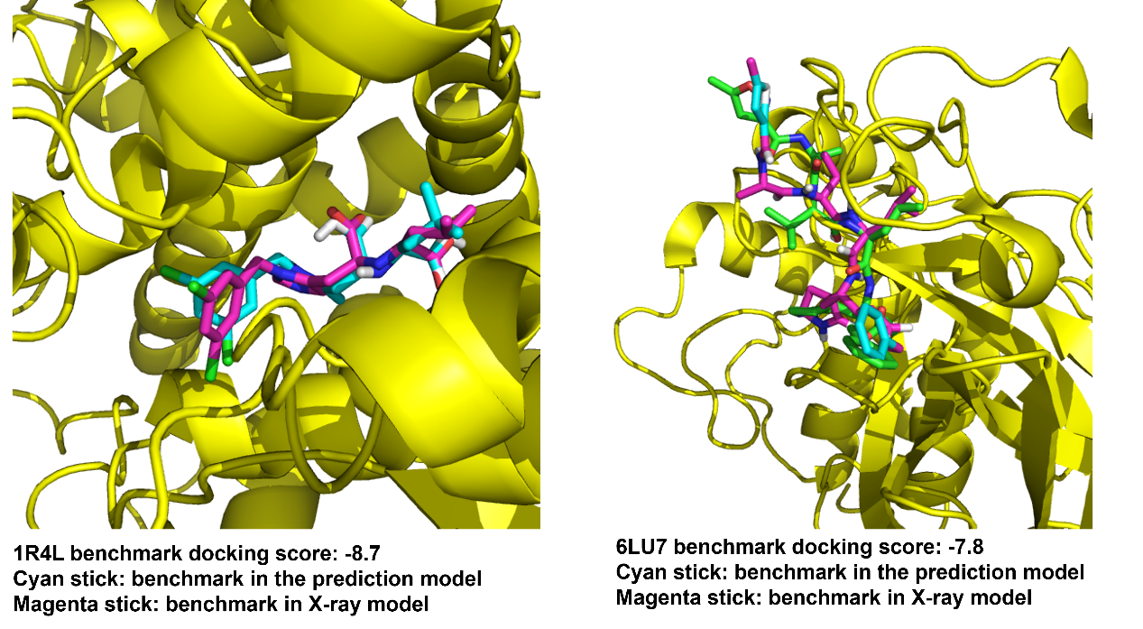
Figure S1. The docking validation by known inhibitors.

