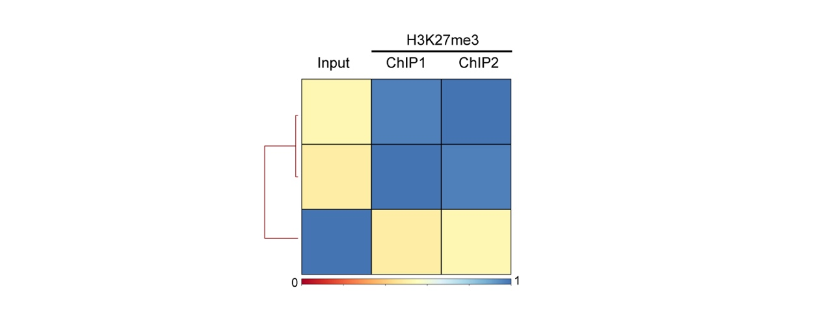
Figure S1. Heatmap showing the correlation between the H3K27me3 ChIP-seq experiments. ChIP1 and ChIP2 indicate the two biological replicates.

