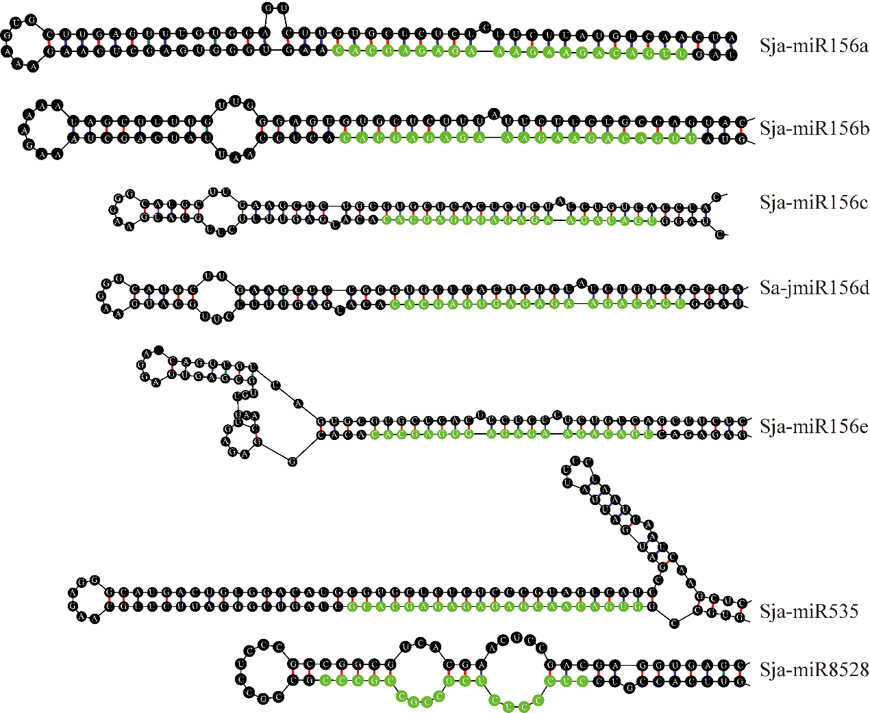
Figure S2. Secondary Structure of MicroRNA.

