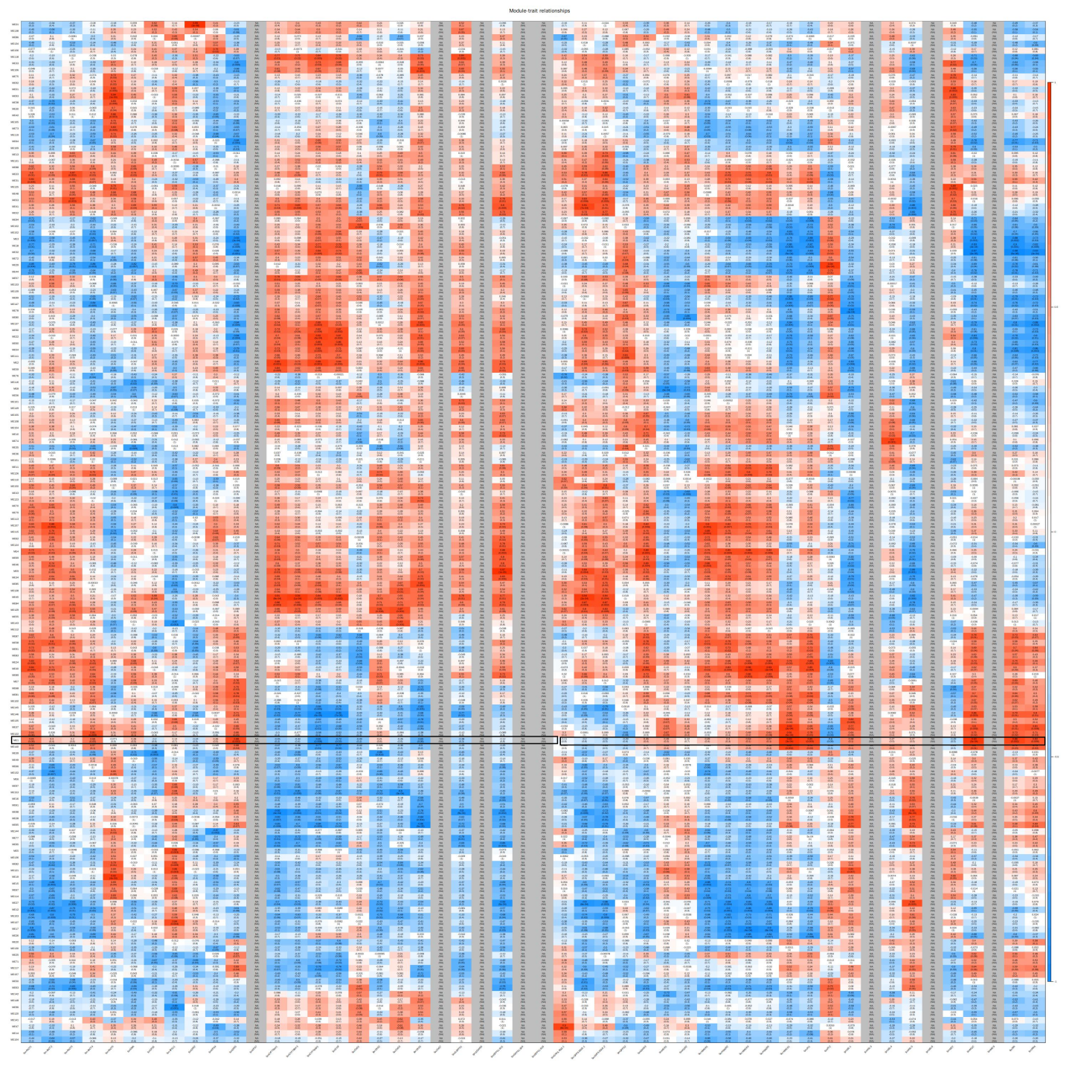
Supplemental Fig. S4 Co-expressed heatmap of gene modules and salvianolic acid B biosynthesis pathway genes.

