Electronic supplementary information
Supplementary Figures
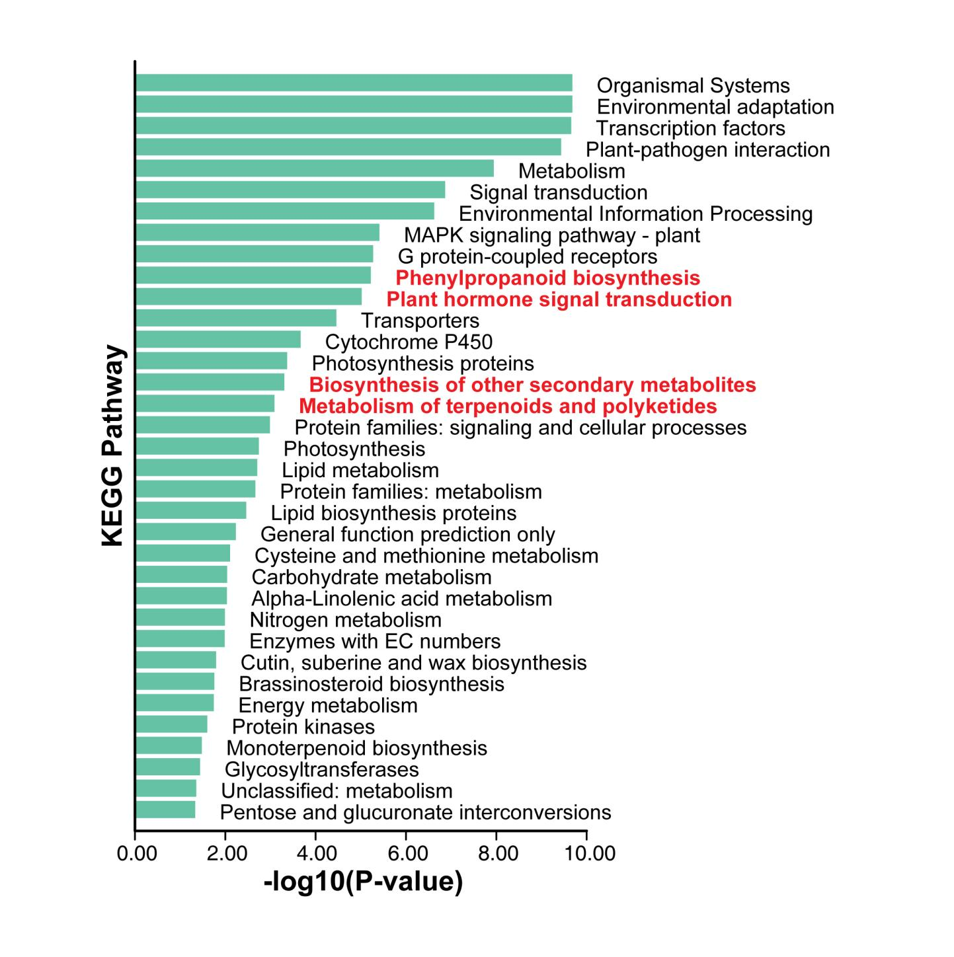
Supplemental Fig. S1 The KEGG enrichment results of genes differentially expressed under the treatment of Ag+.
Terms associated with secondary metabolites and terpenoid biosynthesis are labeled in red.

