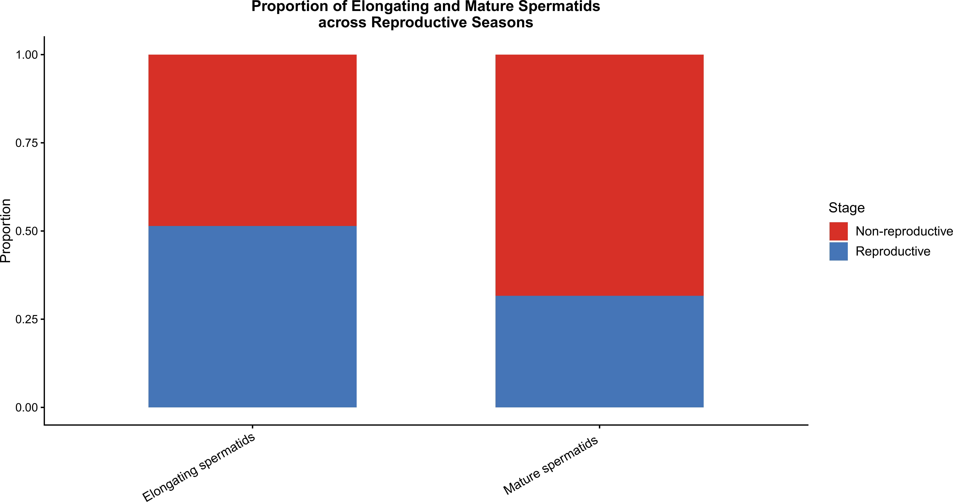
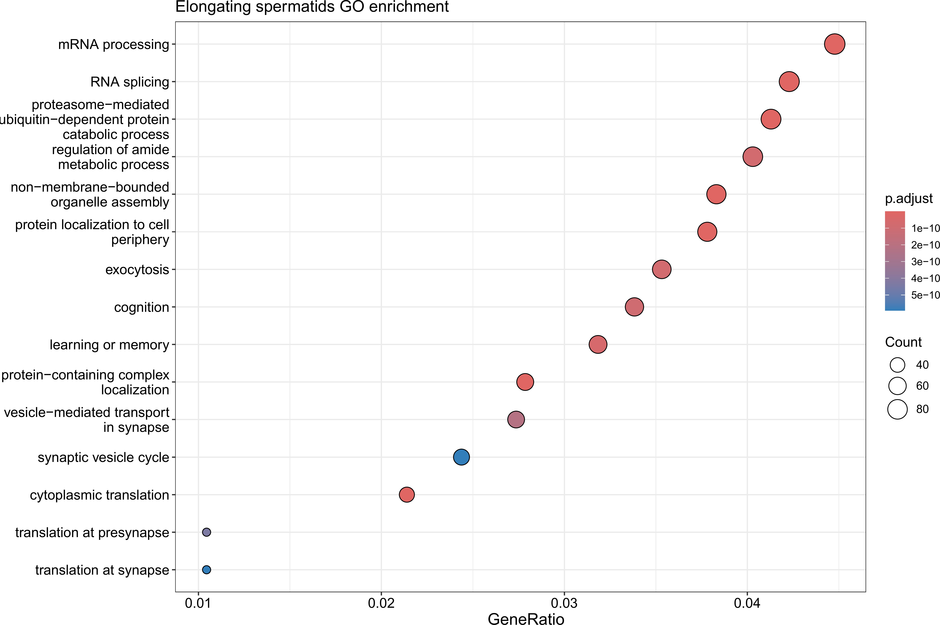
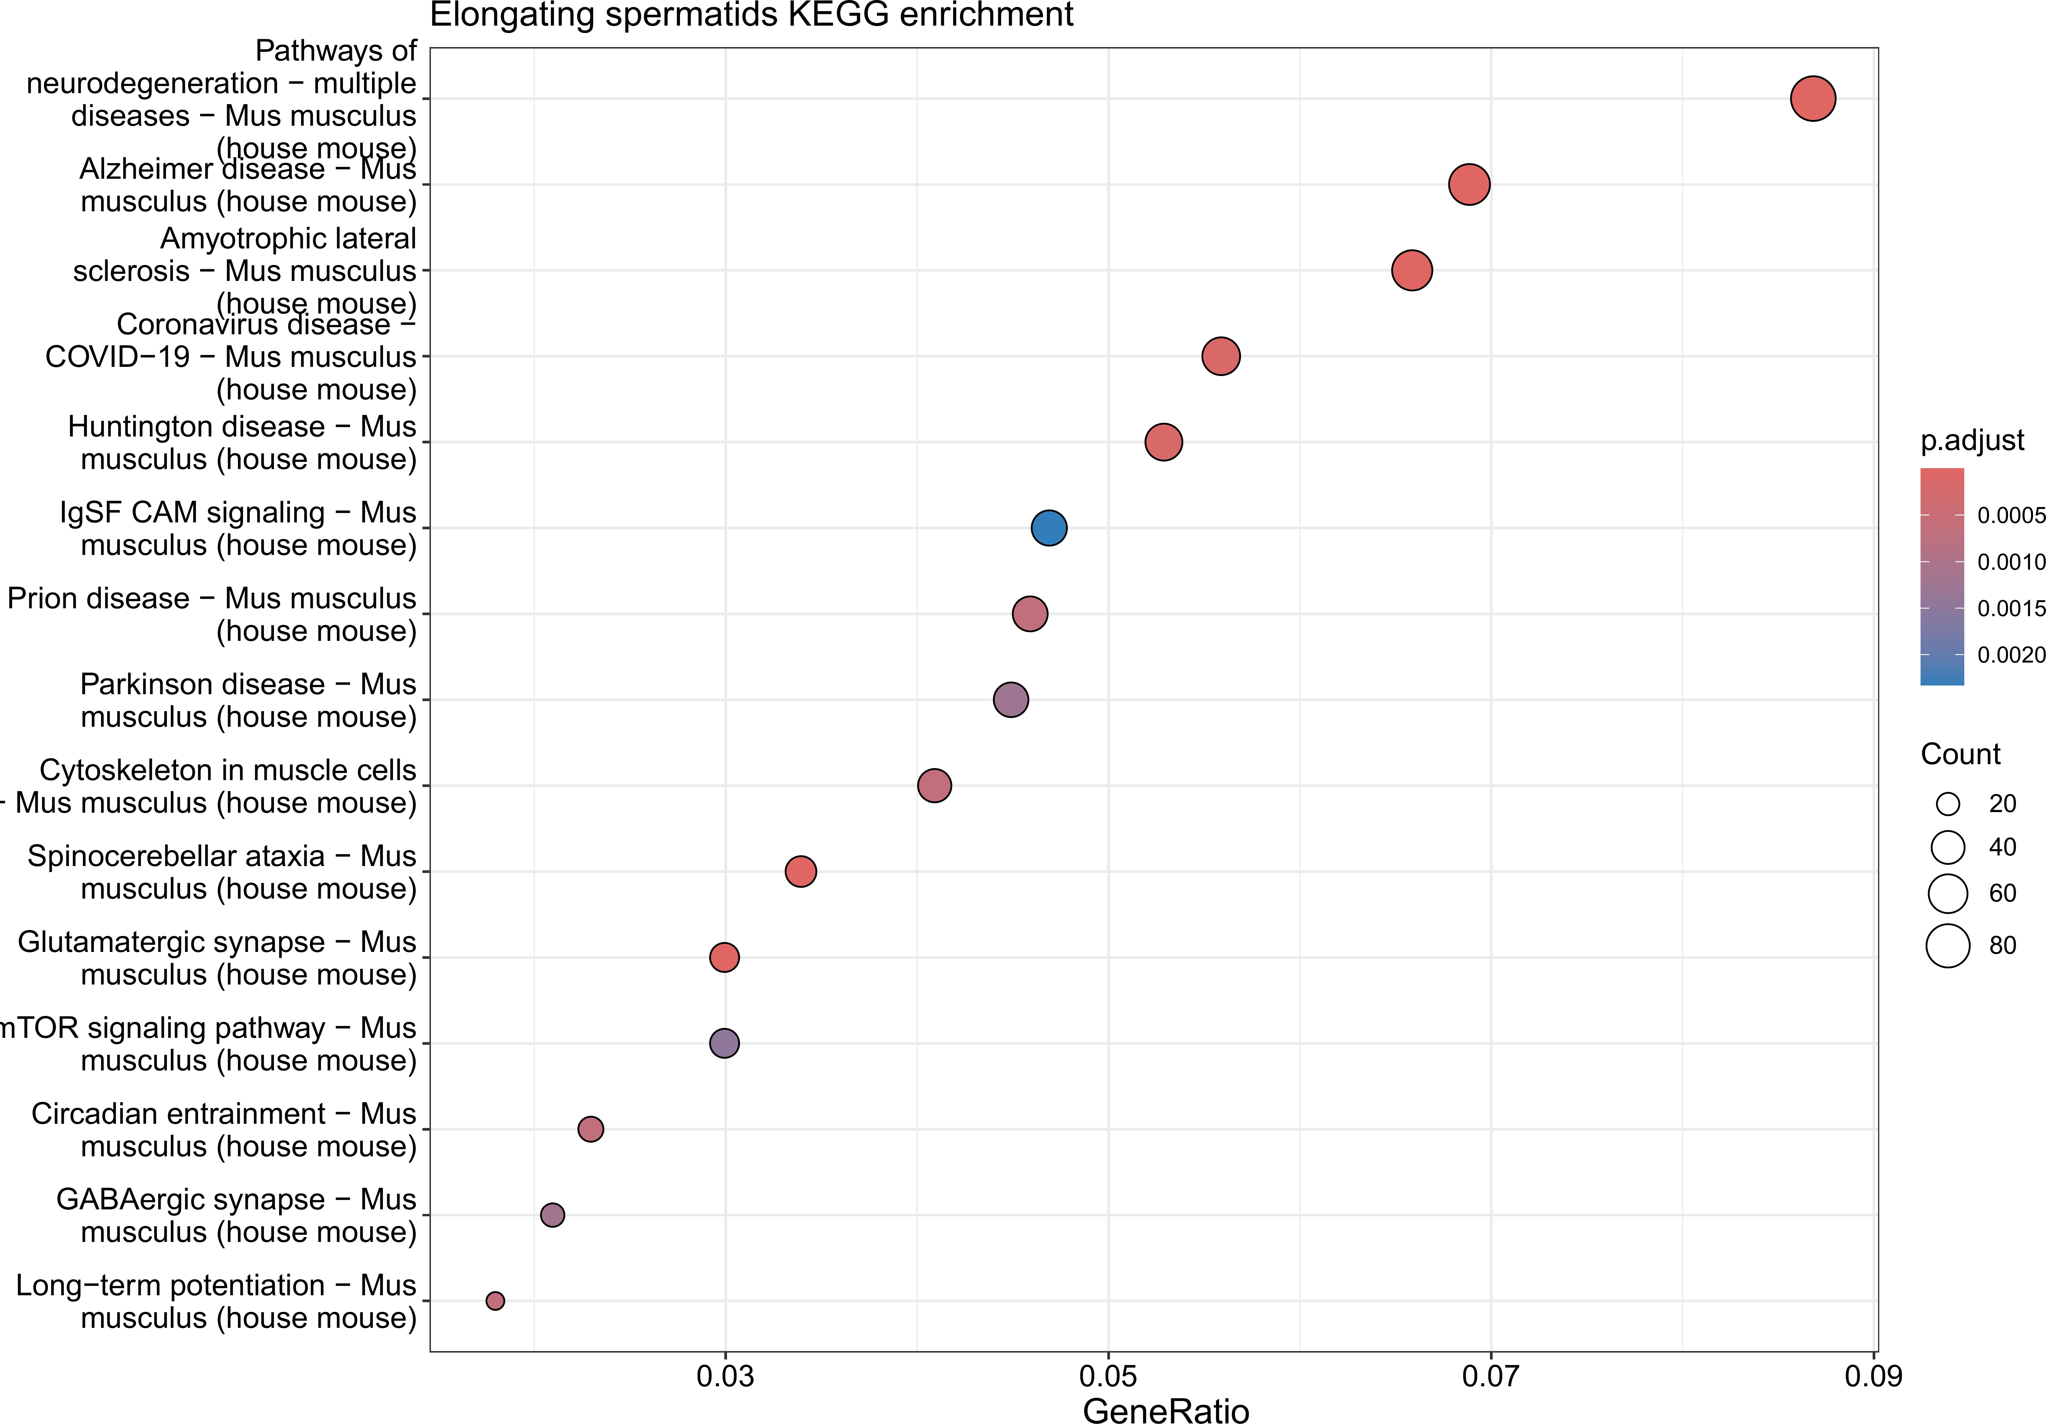
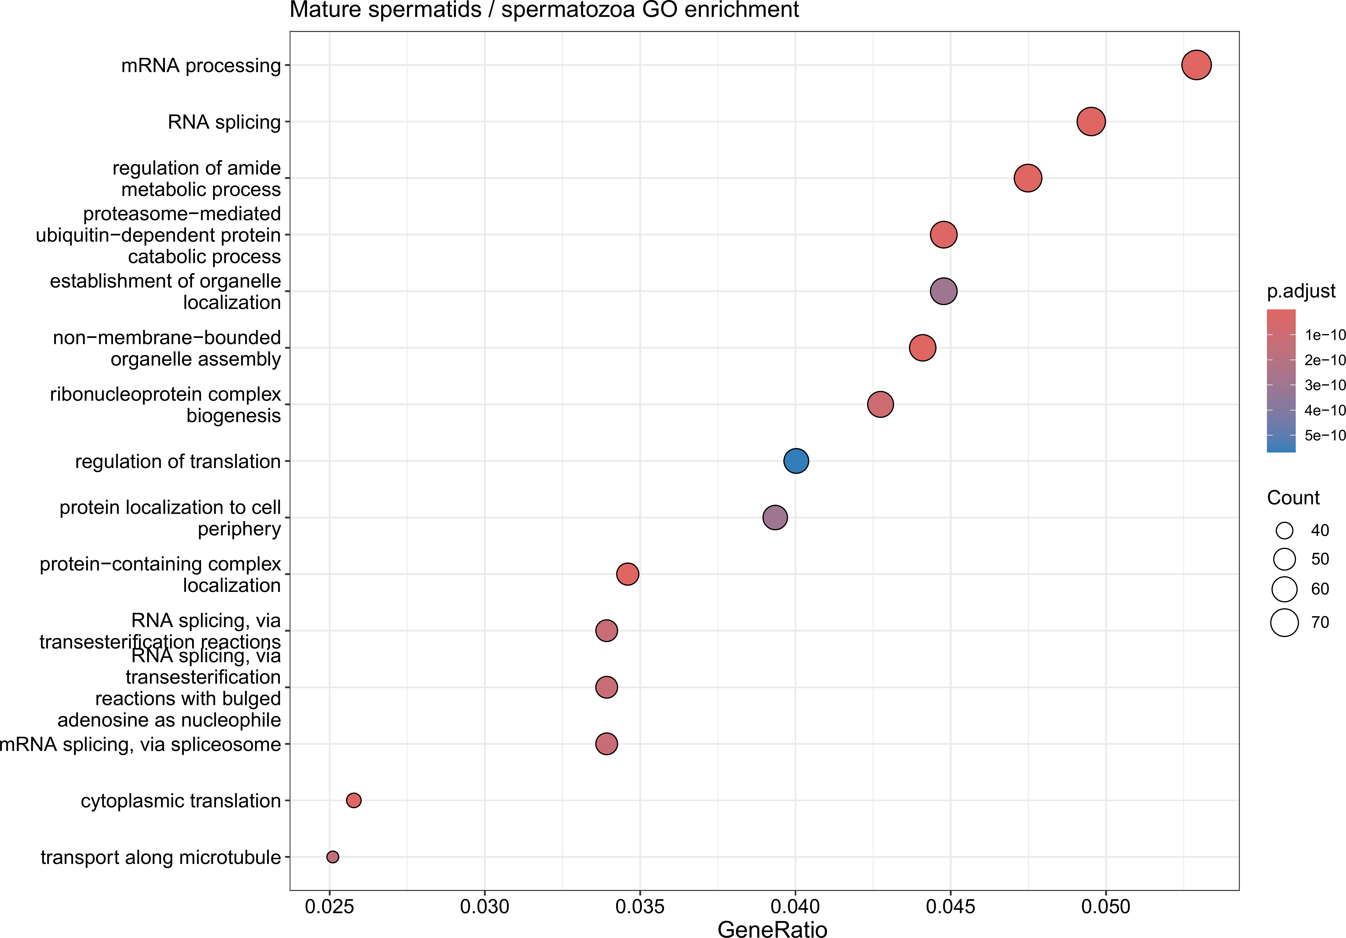
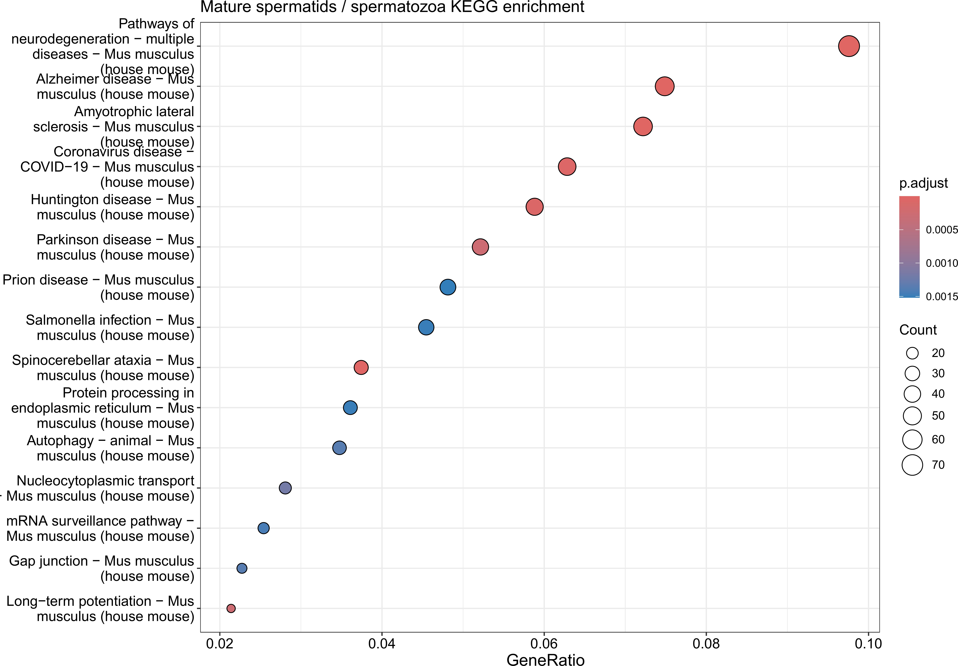
c
a
d
e
b

Figure S2. Gene Ontology (GO) and KEGG pathway enrichment analysis of differentially expressed genes in elongating spermatids and mature sper-matids/spermatozoa between reproductive and non-reproductive stages. (a) Stacked bar plot showing the proportion of elongating spermatids and mature spermatids/spermatozoa in re-productive versus non-reproductive stages. (b) GO Biological Process enrichment analysis of genes up-regulated in elongating spermatids during the reproductive stage, showing significant enrichment in mRNA processing, RNA splicing, proteasome-mediated ubiquitin-dependent protein catabolic process, and cytoplasmic translation. (c) KEGG pathway enrichment analysis of genes up-regulated in elongat-ing spermatids during the reproductive stage, highlighting enrichment in neurodegeneration-associated pathways, mTOR signaling pathway, glutamatergic synapse, and GABAergic synapse. (d) GO Biological Process enrichment analysis of genes up-regulated in mature spermatids/spermatozoa during the repro-ductive stage, revealing enrichment in mRNA processing, RNA splicing, regulation of amide metabolic process, and ribonucleoprotein complex biogenesis. (e) KEGG pathway enrichment analysis of genes up-regulated in mature spermatids/spermatozoa during the reproductive stage, showing enrichment in neurodegeneration-associated pathways, protein processing in endoplasmic reticulum, autophagy, and nucleocytoplasmic transport.

