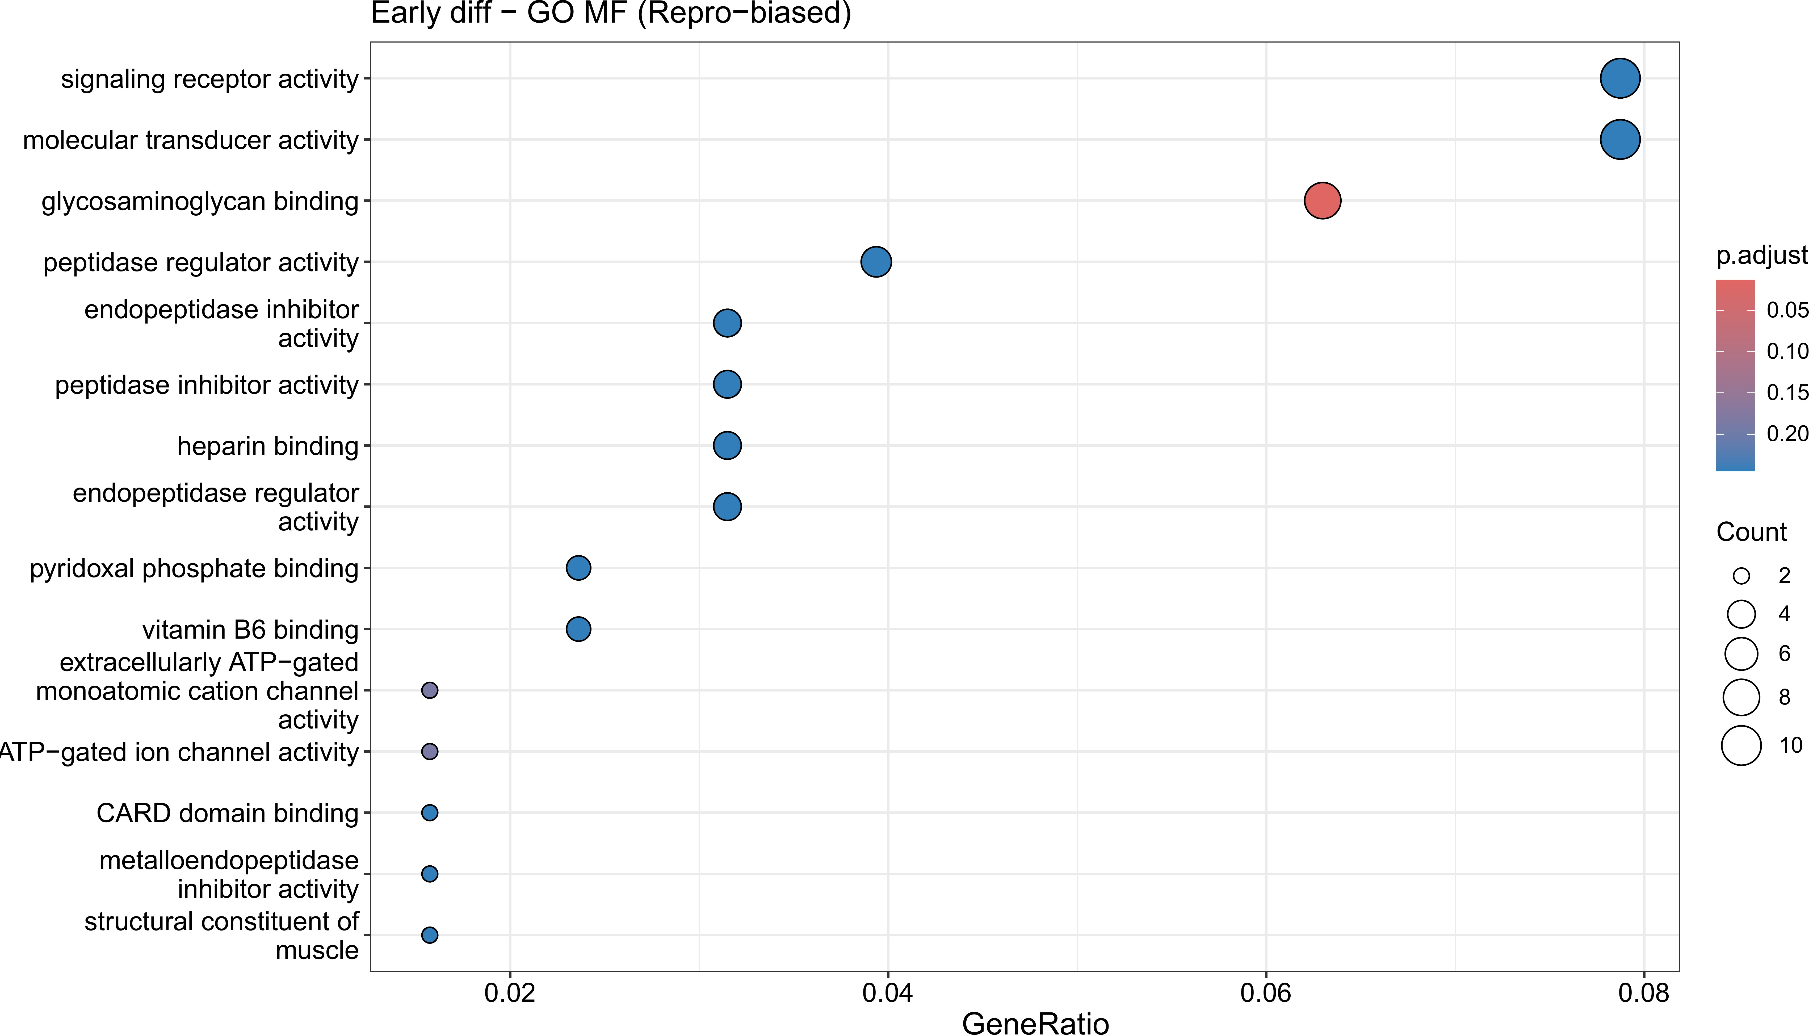
e
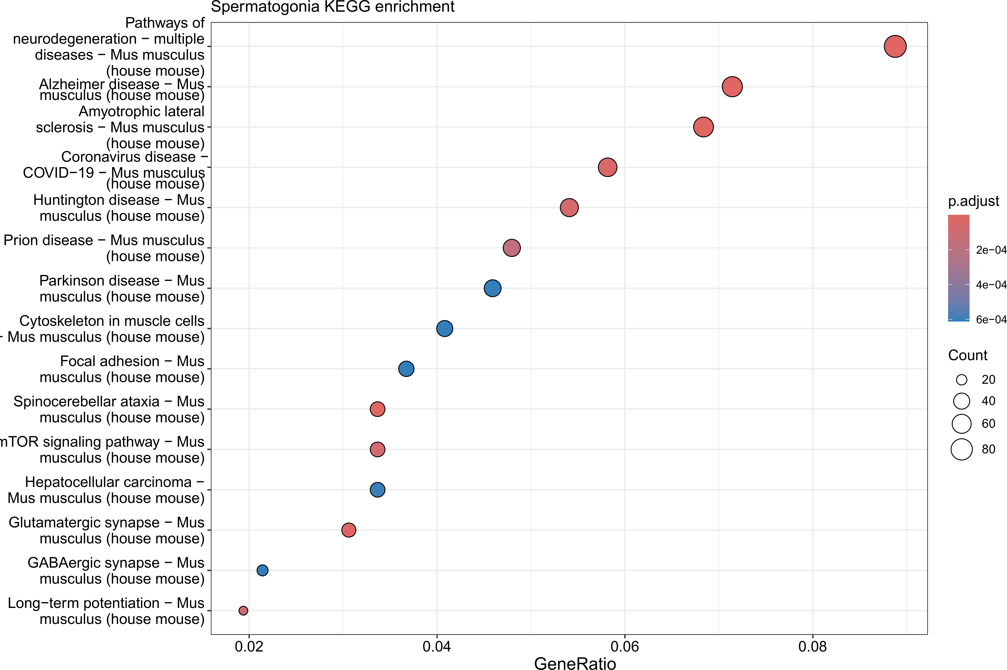
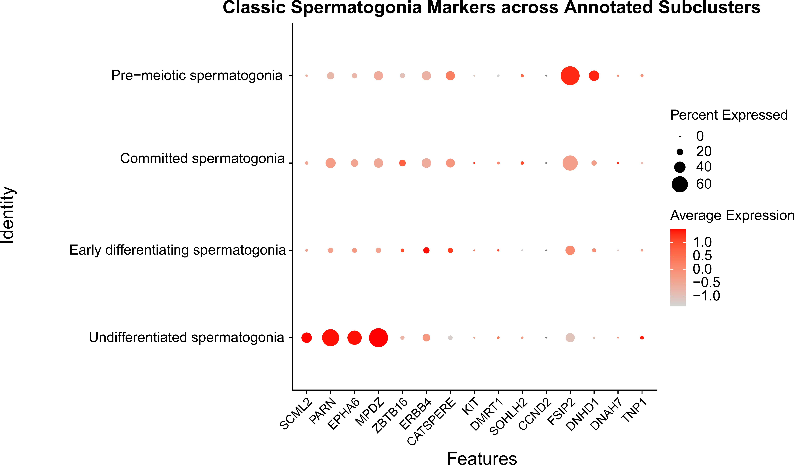
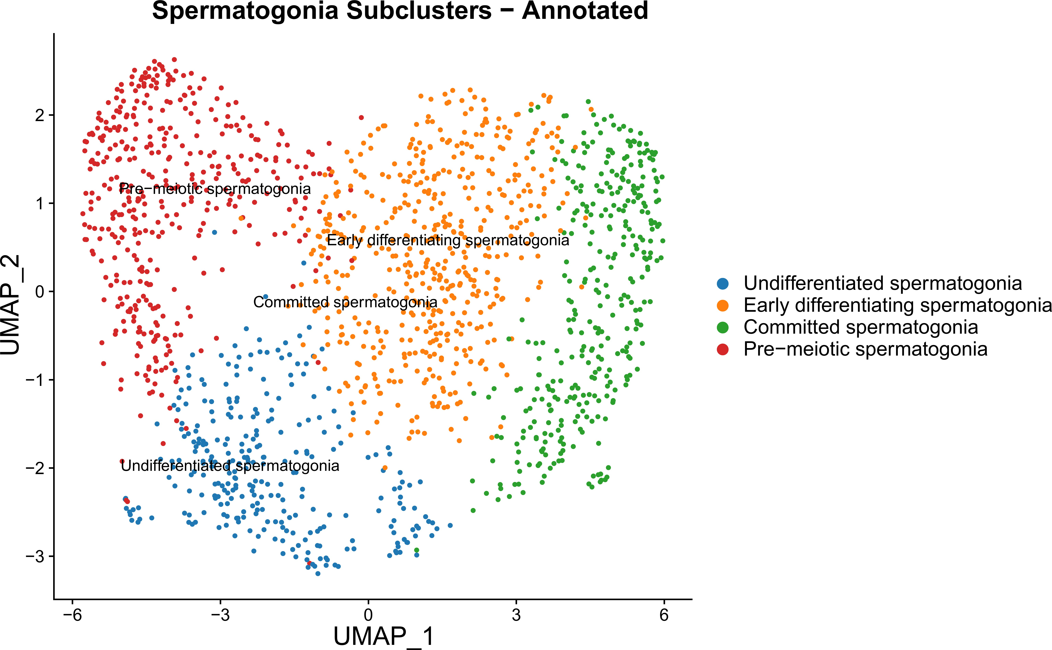
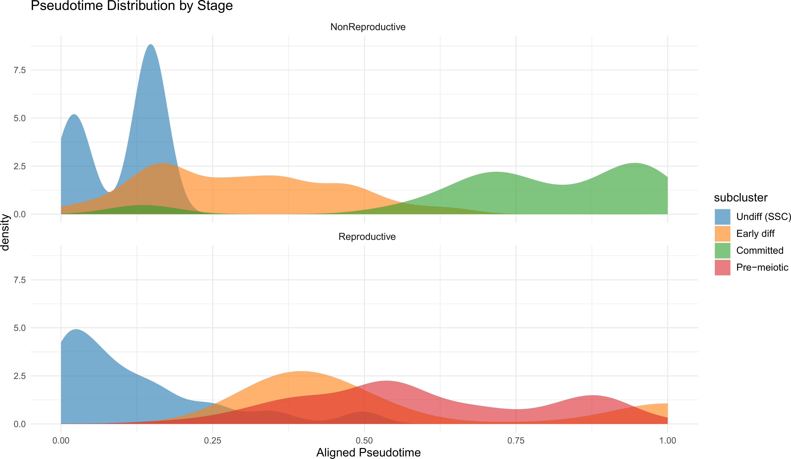
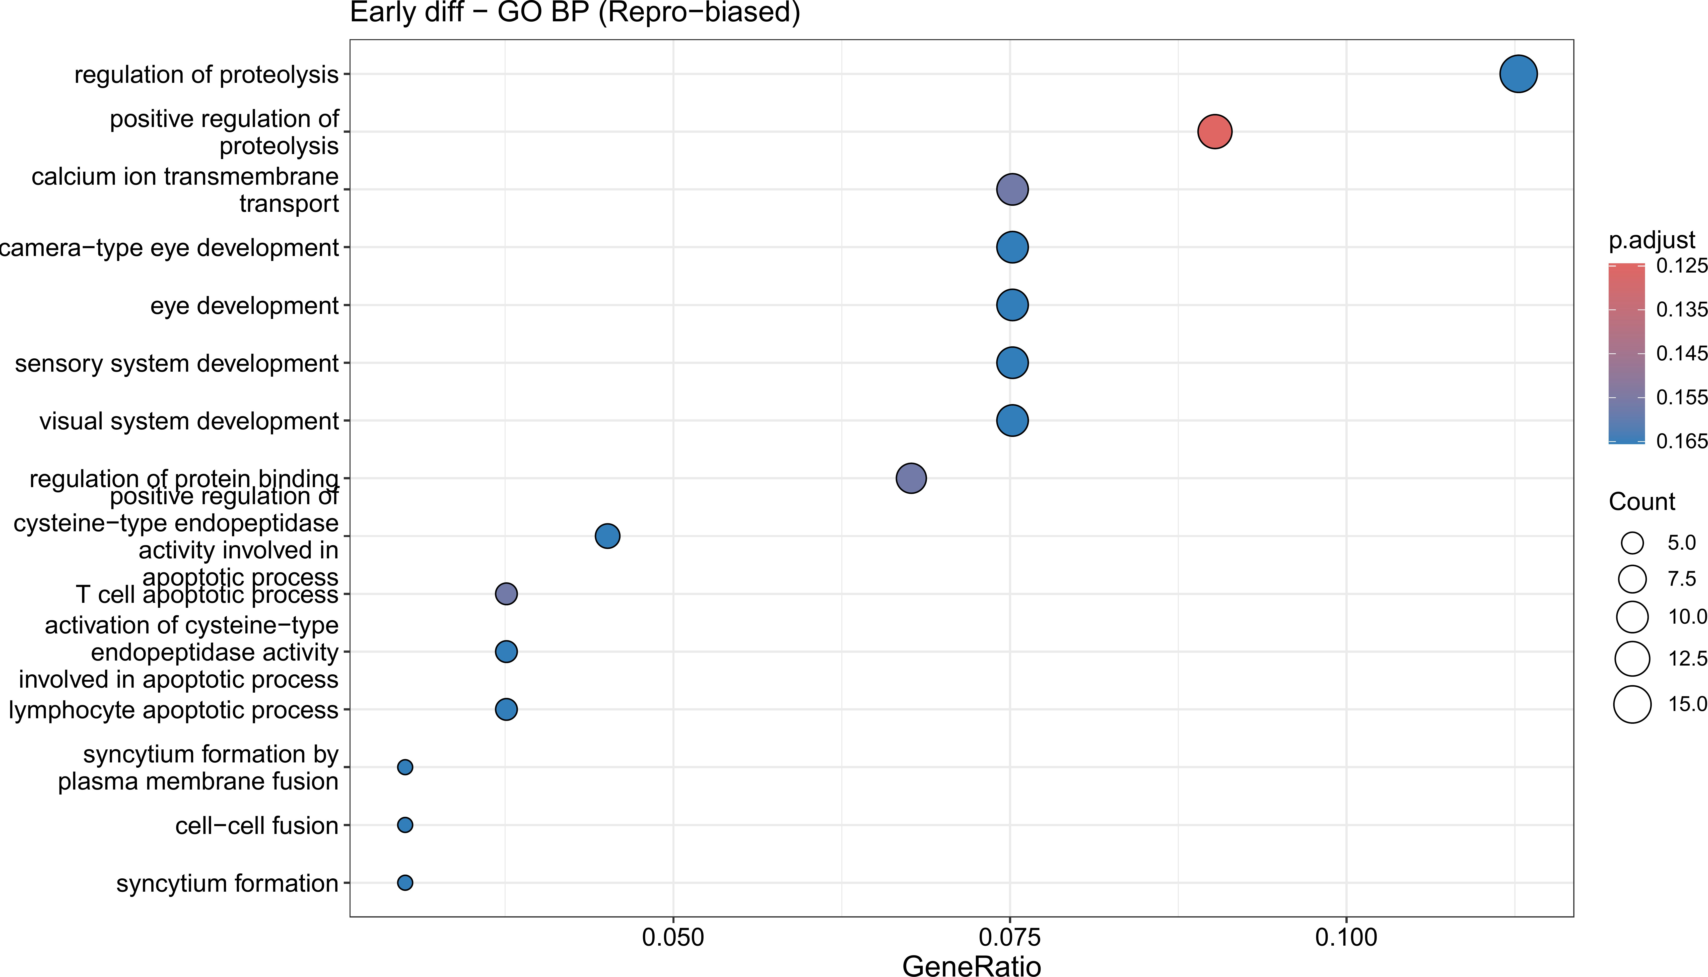
a b
c
d
f

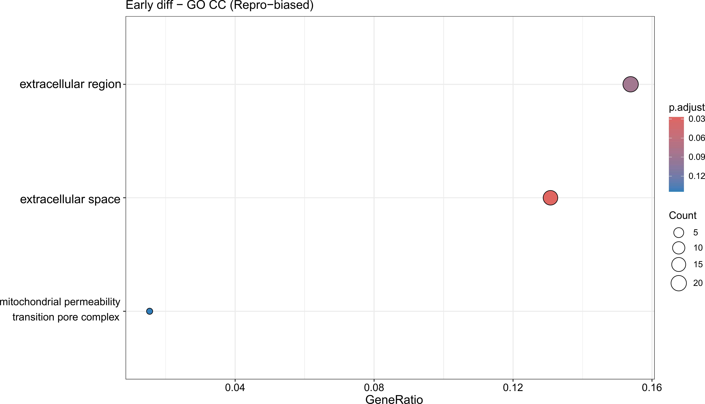
g

Figure S1. Spermatogonial subpopulation characterization and functional en-richment analysis. (a) KEGG pathway enrichment analysis of the top 100 reproductive-stage-specific genes in spermatogonia, showing significant enrichment in neurodegeneration-associated path-ways, mTOR signaling, glutamatergic synapse, and GABAergic synapse pathways. (b) Dot plot showing the expression of classic spermatogonial marker genes across the four annotated spermatogonial subclus-ters: undifferentiated/SSC-like, early differentiating, committed, and pre-meiotic spermatogonia. Dot size indicates the percentage of cells expressing each gene; color indicates average expression level. (c) UMAP visualization of annotated spermatogonial subclusters. (d) Pseudotime distribution density plots for reproductive and non-reproductive stages, illustrating the stage-specific distribution of spermato-gonial subpopulations along the differentiation continuum. The reproductive stage shows a prominent pre-meiotic population, whereas the non-reproductive stage shows accumulation at the committed state.
(e) GO Molecular Function (MF) enrichment analysis of the top 100 differentially expressed genes in early differentiating spermatogonia (reproductive-stage-biased), highlighting enrichment in signaling receptor activity, glycosaminoglycan binding, and peptidase regulator activity. (f ) GO Biological Process (BP) enrichment analysis of reproductive-stage-biased genes in early differentiating spermatogonia, showing significant enrichment in calcium ion transmembrane transport, regulation of proteolysis, and apoptosis-related processes. (g) GO Cellular Component (CC) enrichment analysis of reproductive-stage-biased genes in early differentiating spermatogonia, indicating enrichment in extracellular region, extracellular space, and mitochondrial permeability transition pore complex.

