Electronic supplementary information
- Isolation of bacterial endophytes and biochemical characterization
  - Isolation of endophytic bacteria
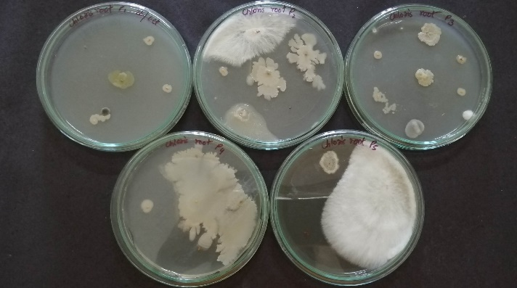

  - Purification and storage of isolates
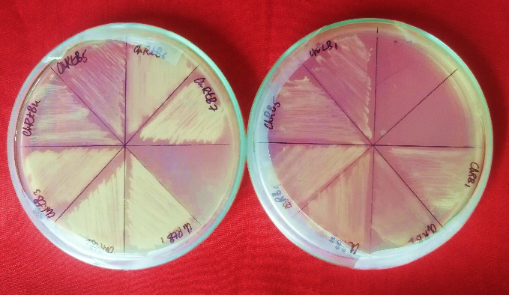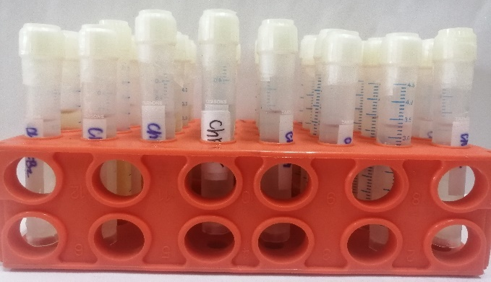
  - BIOCHEMICAL TESTS
    - 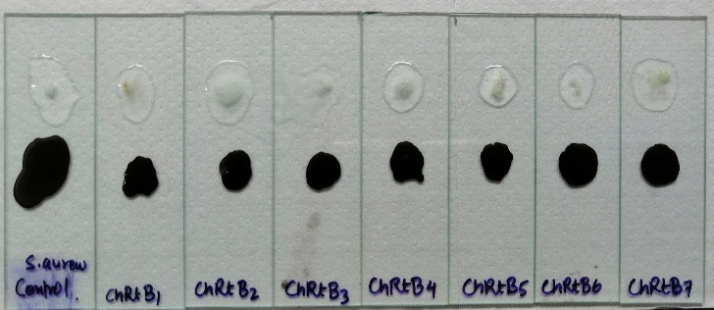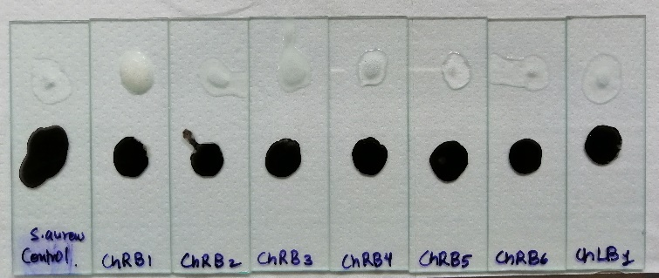Catalase and oxidase test

    - Indole production test
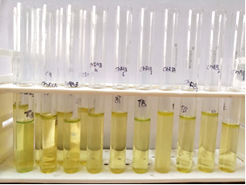
    - Methyl red test-Vogues-Proskauer test
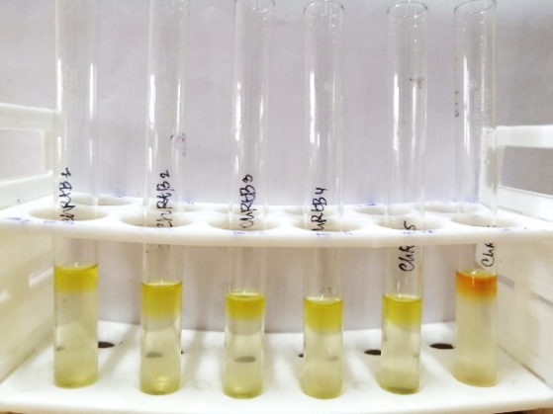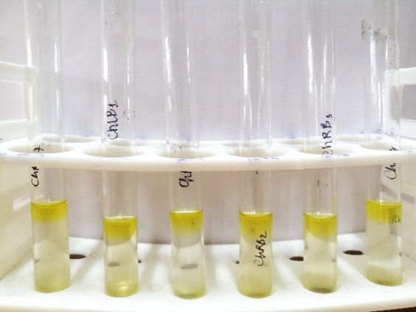
    - Citrate utillisation test
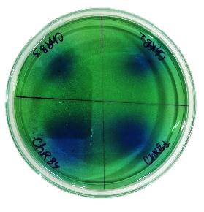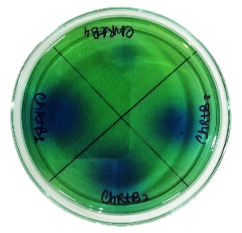

    - Oxidative-Fermentative test
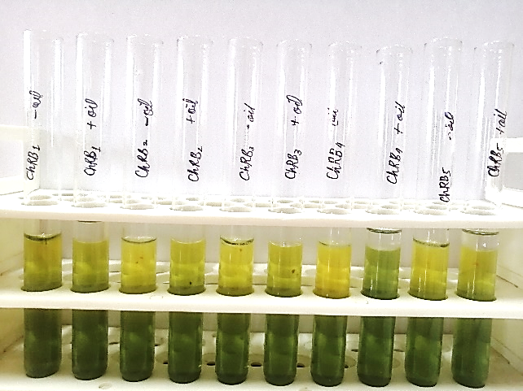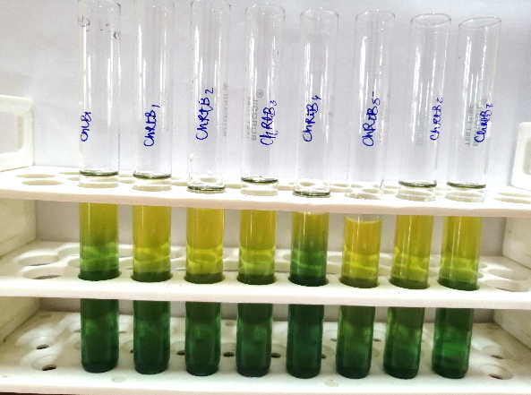
    - Nitrate reduction test
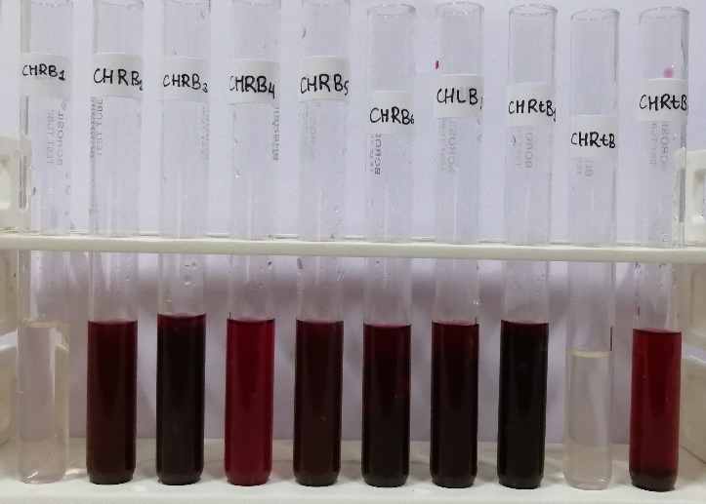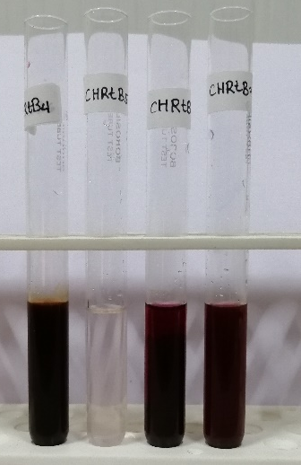

- PLANT GROWTH PROMOTING TRAITS
  - Enzyme activity assay
Amylase Cellulase Lipase
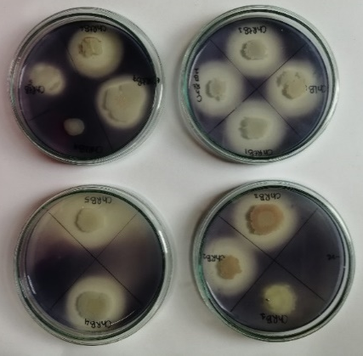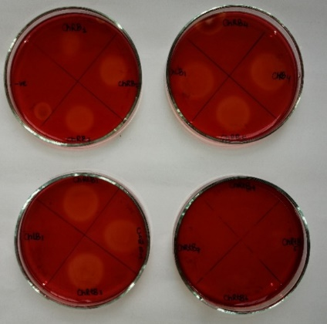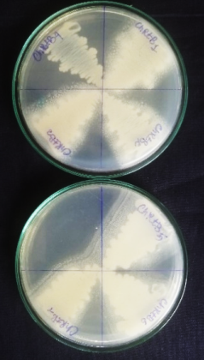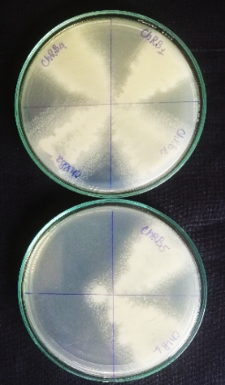
Protease
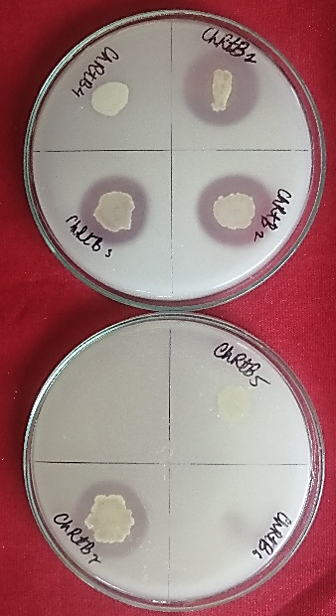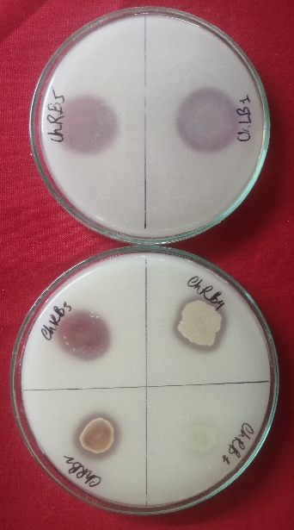
  - Inorganic Phosphate Solubilization
Tri-Calcium Phosphate Solubilization (TCP)
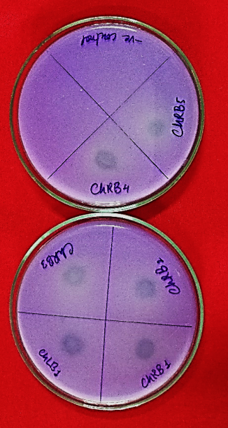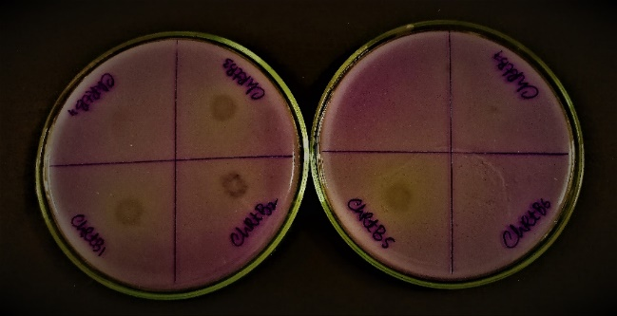
Di-Calcium Phosphate Solubilization (DCP)
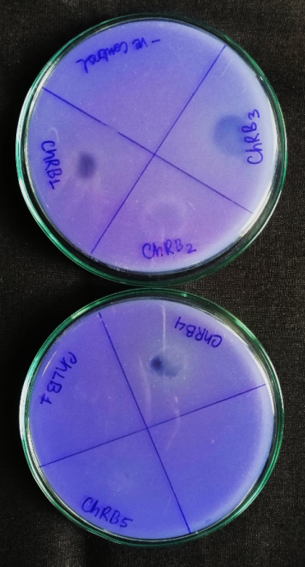
Zinc Solubilization
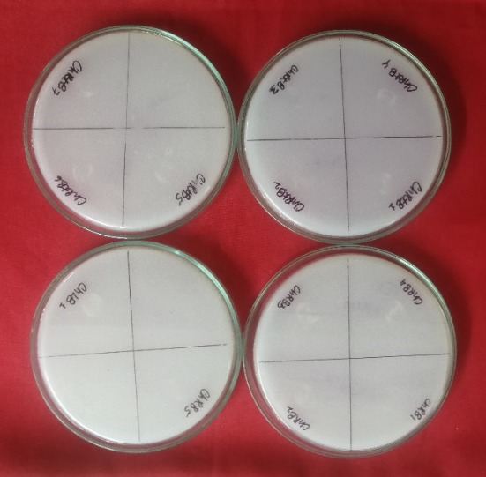
Siderophore Production
Ammonia Production
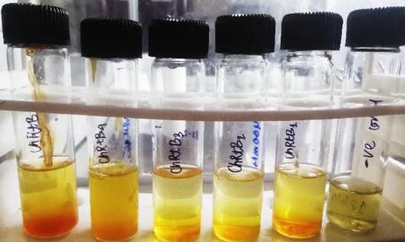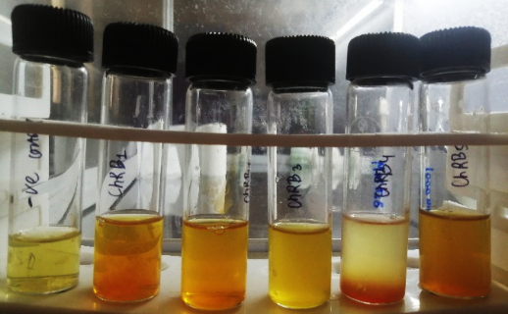
AMMONIA STANDARD CURVE | ABSORBANCE AT 425nm |  |  | Y=0.004792*X+0.09445
Concentration of (NH4)2SO4 (μgmL⁻¹) | R1 | R2 | R3 | MEAN ABSORBANCE | STD DEV | STD ER
0 | 0.103 | 0.107 | 0.095 | 0.102 | 0.006 | 0.004
10 | 0.139 | 0.147 | 0.135 | 0.140 | 0.006 | 0.004
20 | 0.156 | 0.155 | 0.16 | 0.157 | 0.003 | 0.002
30 | 0.215 | 0.222 | 0.213 | 0.217 | 0.005 | 0.003
40 | 0.319 | 0.315 | 0.312 | 0.315 | 0.004 | 0.002
50 | 0.36 | 0.374 | 0.356 | 0.363 | 0.009 | 0.005
60 | 0.411 | 0.404 | 0.406 | 0.407 | 0.004 | 0.002
80 | 0.464 | 0.445 | 0.437 | 0.449 | 0.014 | 0.008
100 | 0.58 | 0.56 | 0.567 | 0.569 | 0.010 | 0.006

HCN Production
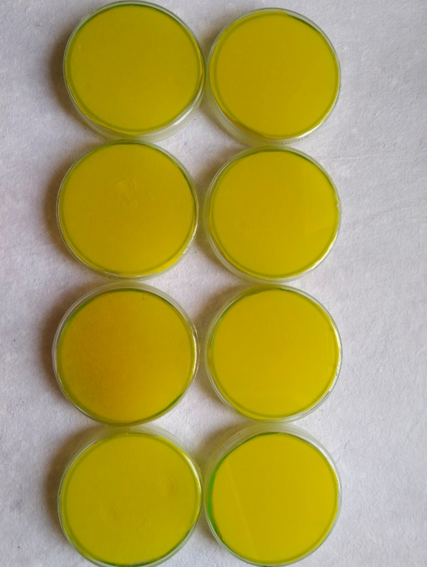

Indole Acetic Acid (IAA) Standard Curve
IAA STANDARD CURVE | ABSORBANCE AT 540nm |  |  | Y = 0.03073*X - 0.02317
Concentration of IAA (μgmL⁻¹) | R1 | R2 | R3 | MEAN ABSORBANCE | STD DEV |  | STD ER
0 | 0.083 | 0.079 | 0.067 | 0.076 | 0.01 |  | 0.005
10 | 0.238 | 0.186 | 0.290 | 0.238 | 0.05 |  | 0.030
20 | 0.505 | 0.825 | 0.614 | 0.648 | 0.16 |  | 0.094
30 | 0.824 | 0.961 | 1.696 | 1.160 | 0.47 |  | 0.271
40 | 1.196 | 1.665 | 2.018 | 1.626 | 0.41 |  | 0.238
50 | 1.900 | 1.712 | 2.194 | 1.935 | 0.24 |  | 0.140
60 | 2.024 | 1.726 | 2.200 | 1.983 | 0.24 |  | 0.138
70 | 2.571 | 2.271 | 2.610 | 2.484 | 0.19 |  | 0.107
80 | 2.870 | 2.637 | 2.617 | 2.708 | 0.14 |  | 0.081
90 | 3.100 | 3.079 | 2.948 | 3.042 | 0.08 |  | 0.048
100 | 3.119 | 3.228 | 3.537 | 3.295 | 0.22 |  | 0.125

GA3 standard curve
GA3 STANDARD CURVE | ABSORBANCE AT 540nm |  |  | Y=0.001012*X+0.04585
Concentration of GA3 (µgmL⁻¹) | R1 | R2 | R3 | MEAN ABSORBANCE | STD DEV | STD ER
0 | 0.018 | 0.013 | 0.015 | 0.015 | 0.003 | 0.001
5 | 0.057 | 0.063 | 0.058 | 0.059 | 0.003 | 0.002
10 | 0.07 | 0.065 | 0.062 | 0.066 | 0.004 | 0.002
20 | 0.071 | 0.069 | 0.069 | 0.070 | 0.001 | 0.001
30 | 0.082 | 0.081 | 0.078 | 0.080 | 0.002 | 0.001
40 | 0.088 | 0.089 | 0.082 | 0.086 | 0.004 | 0.002
50 | 0.102 | 0.114 | 0.106 | 0.107 | 0.006 | 0.004
60 | 0.117 | 0.118 | 0.11 | 0.115 | 0.004 | 0.003
70 | 0.119 | 0.119 | 0.114 | 0.117 | 0.003 | 0.002
80 | 0.128 | 0.128 | 0.116 | 0.124 | 0.007 | 0.004
90 | 0.134 | 0.13 | 0.136 | 0.133 | 0.003 | 0.002
100 | 0.14 | 0.137 | 0.138 | 0.138 | 0.002 | 0.001

Salinity and Drought stress tolerance
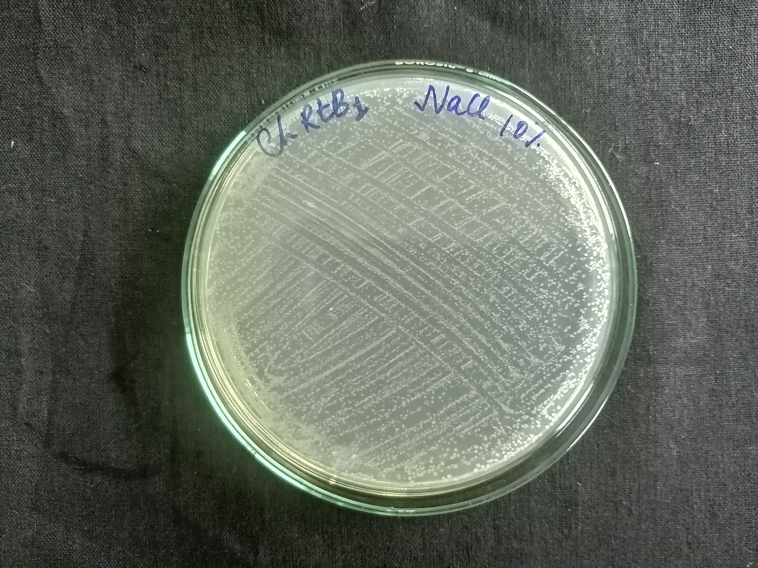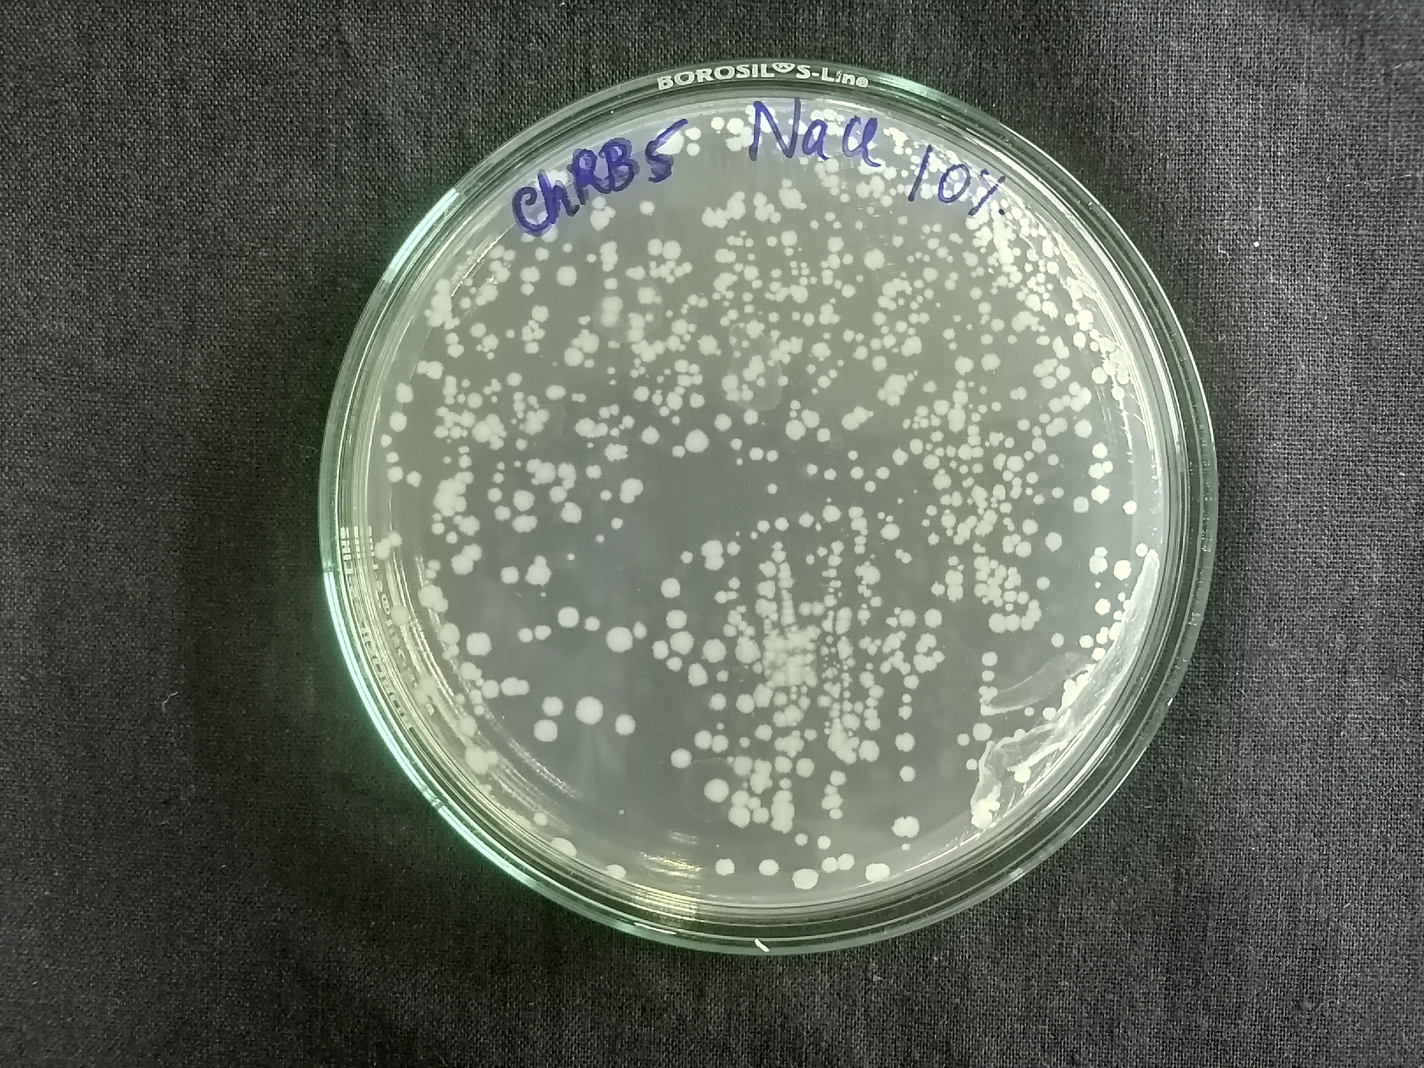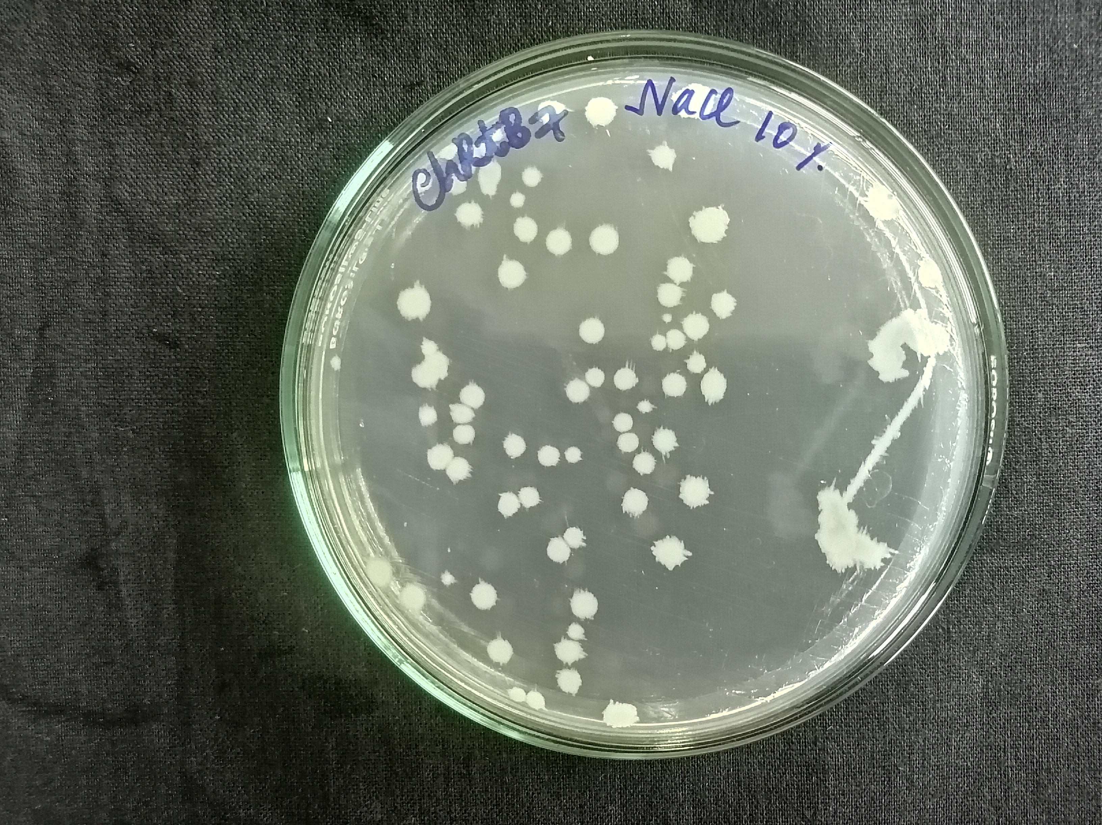
Isolates grown on 10% NaCl supplemented NA medium.

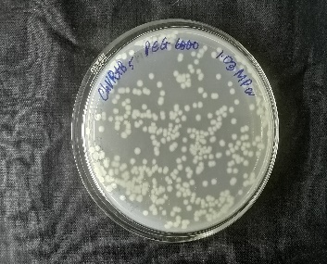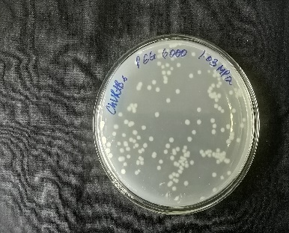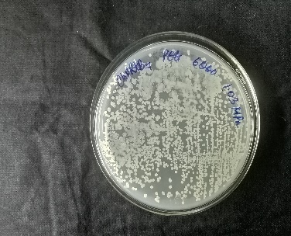

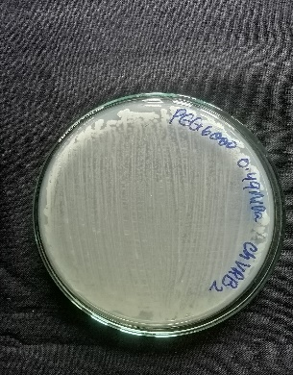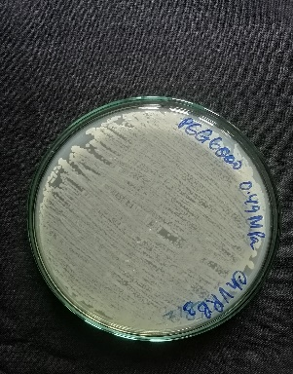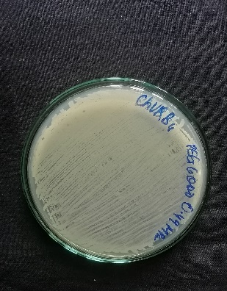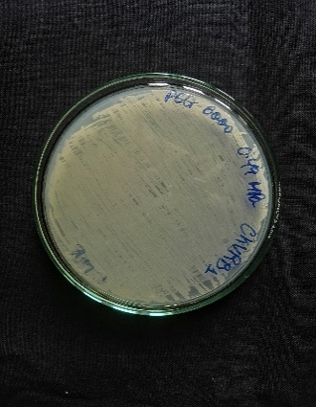
Isolates grown on PEG-6000 supplemented NA medium.

Phylogenetic analysis of Chloris virgata Sw. bacterial endophytes based on 16s rRNA sequencing
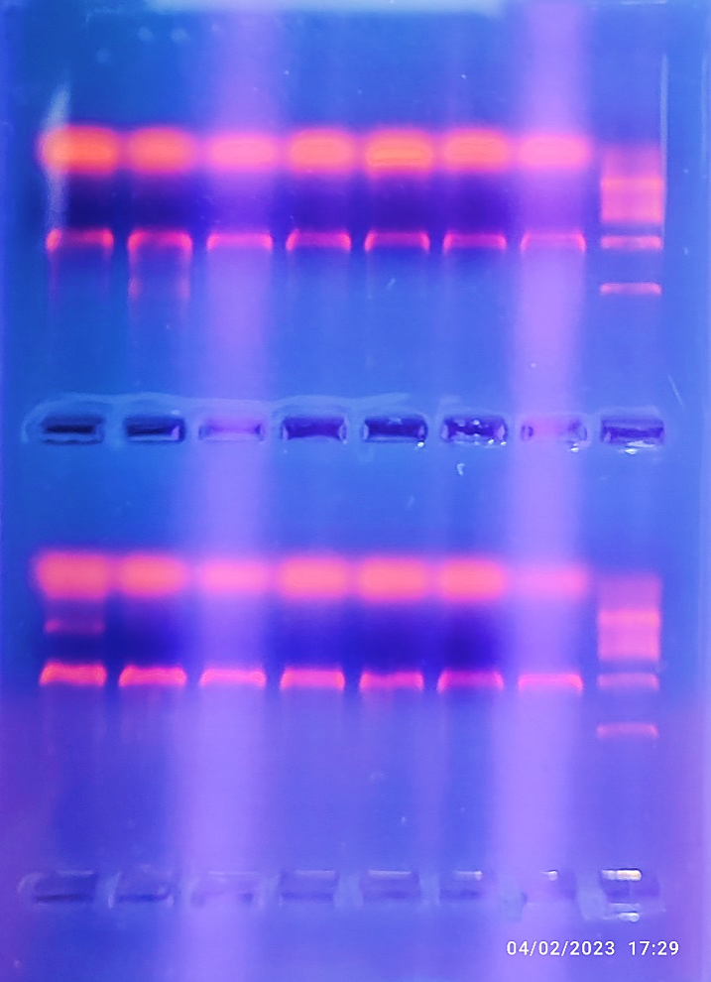
Genomic DNA
1500bp
L
100bp
Agarose gel picture of extracted genomic DNA of endophytic bacteria

