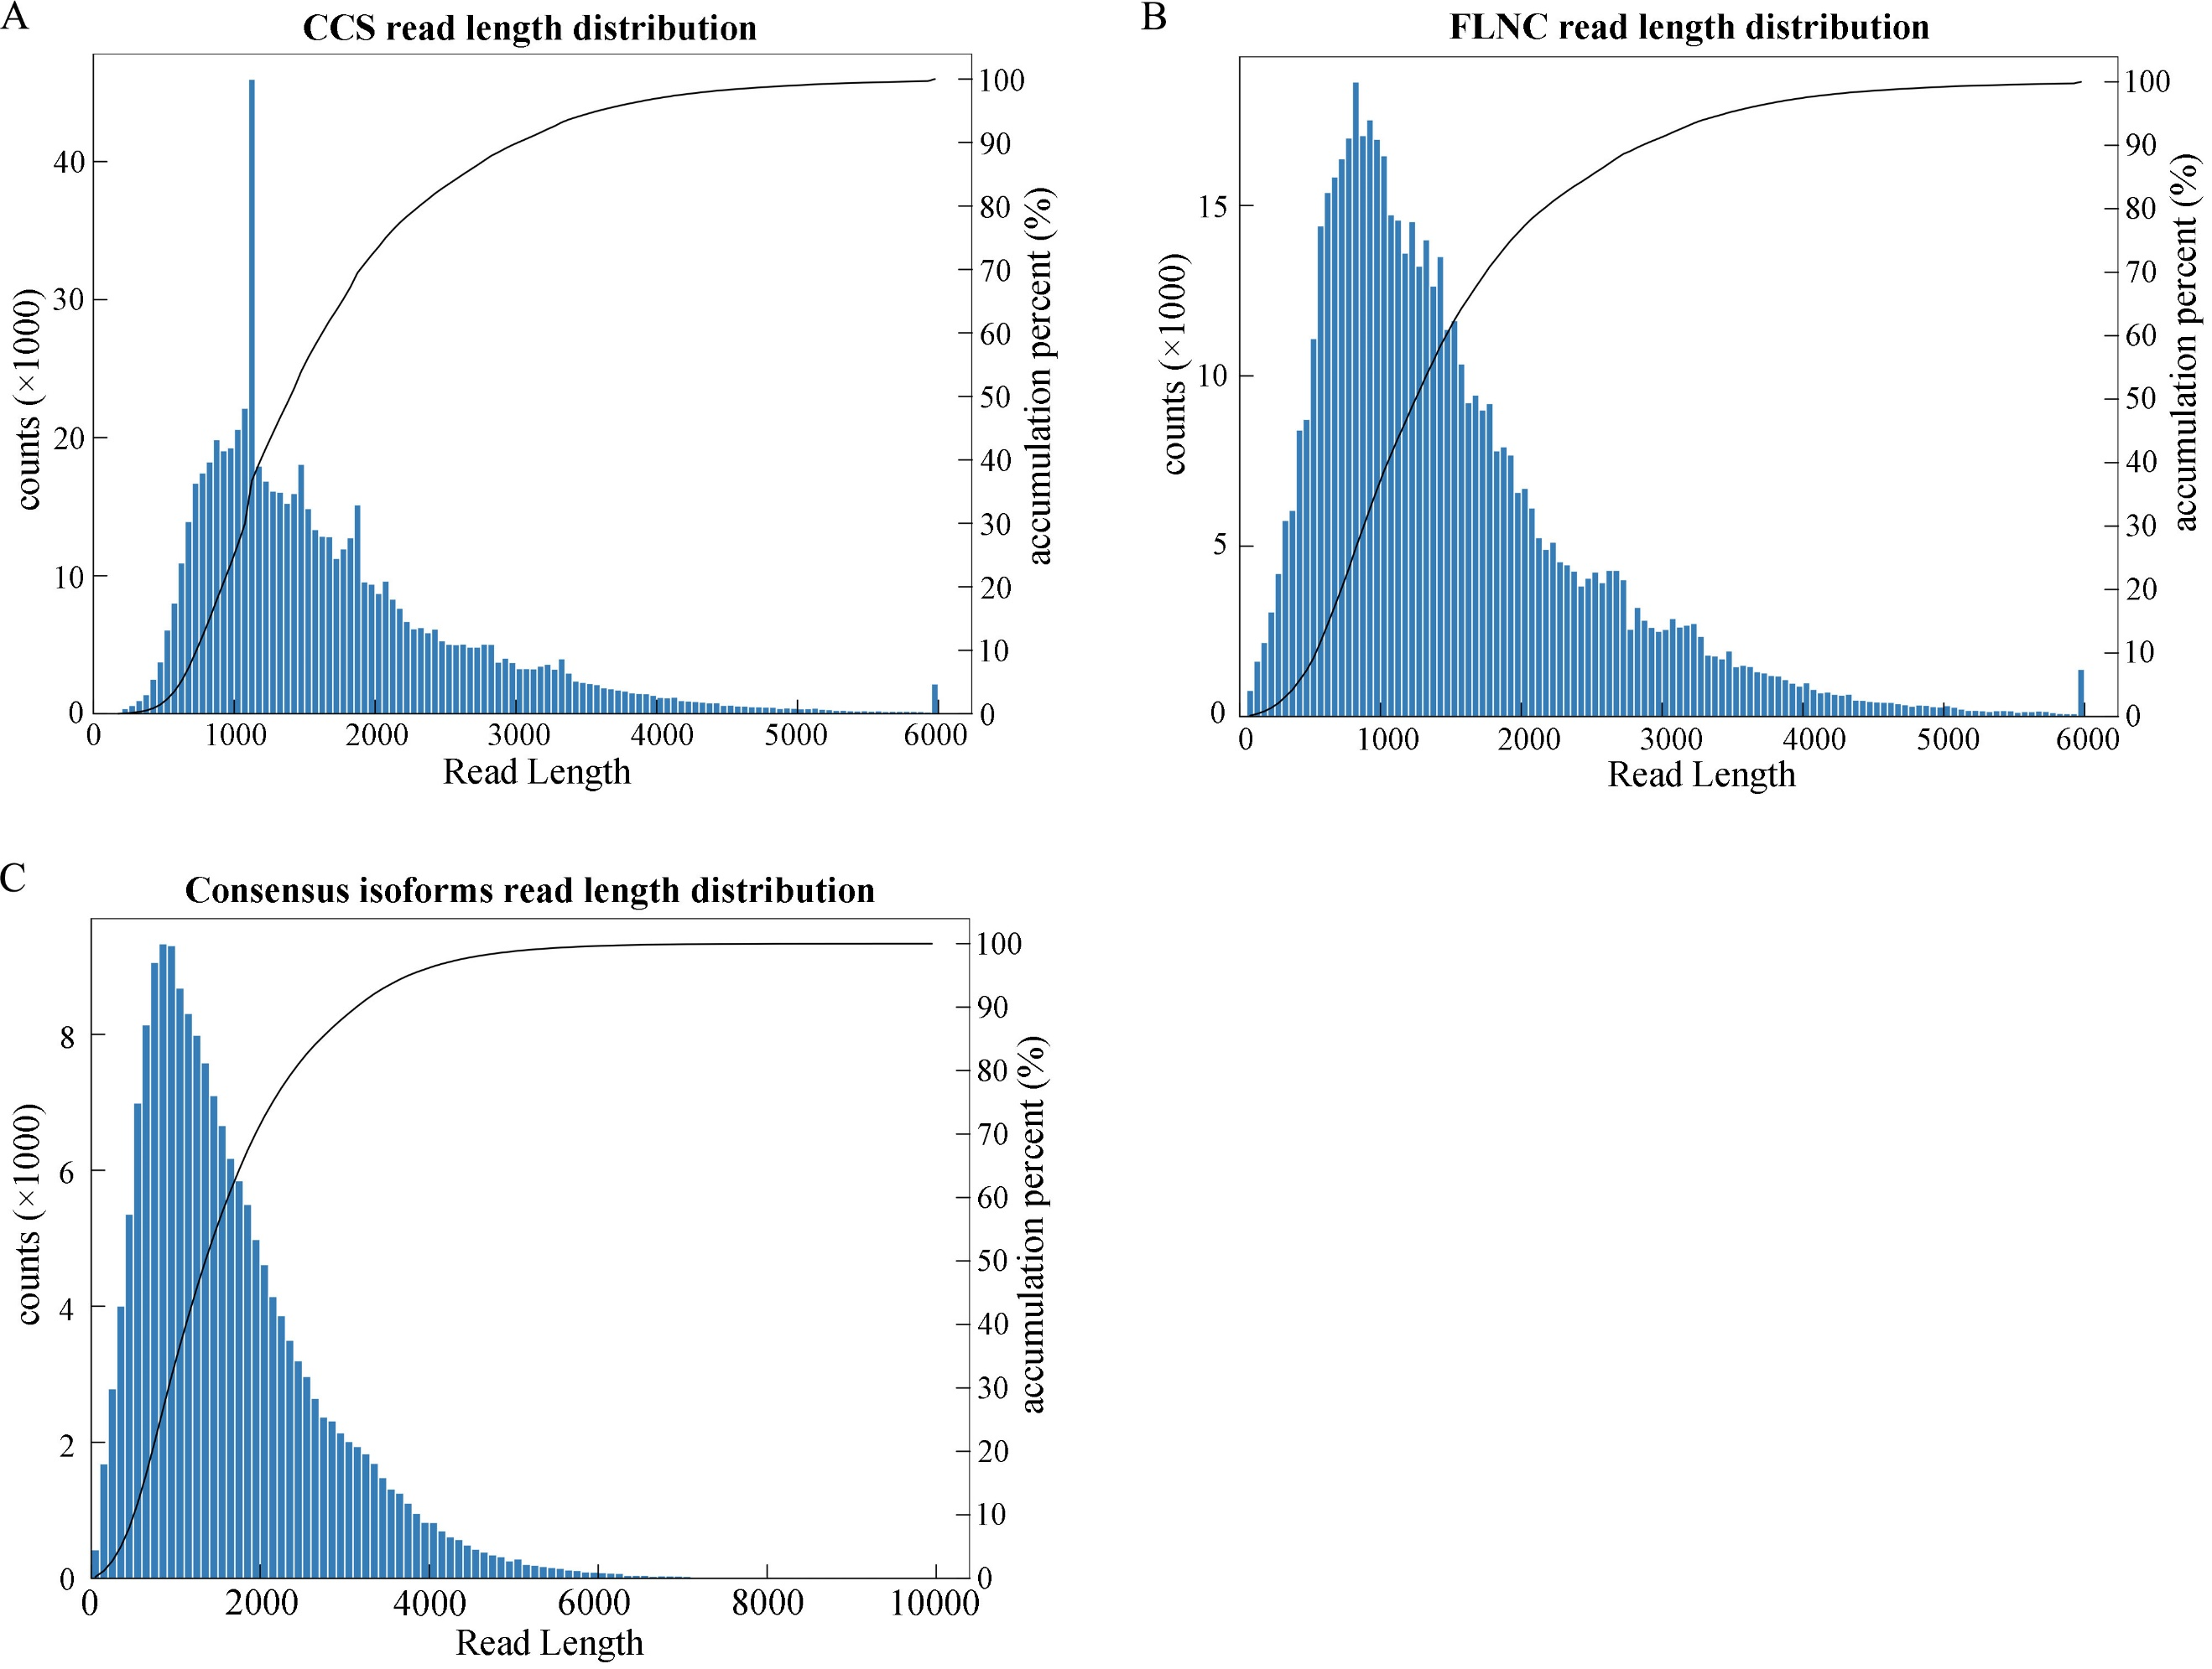
Fig. S1 Summary of SMRT sequencing. (A) CCS read length distribution. (B) FLNC sequences read length distribution. (C) Consensus isoforms read length distribution.
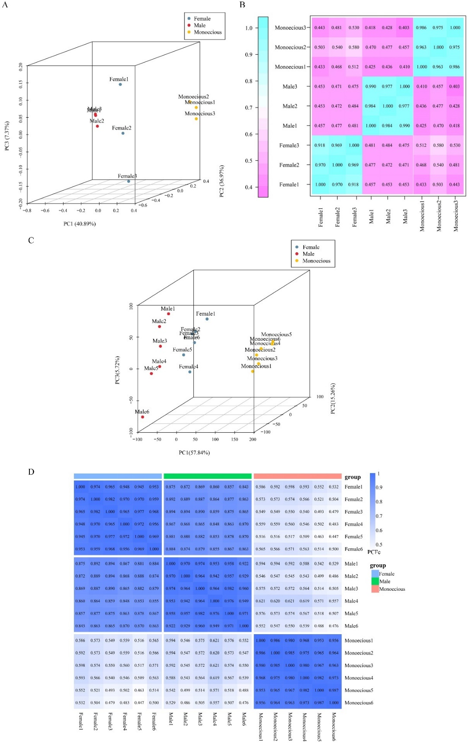
Fig. S2 The quality evaluation of transcriptomic and metabolomic data. PCA analysis of all transcripts (A) and metabolites (B), respectively. Heatmap analysis of correlation between samples in all transcripts (C) and metabolites (D), respectively.

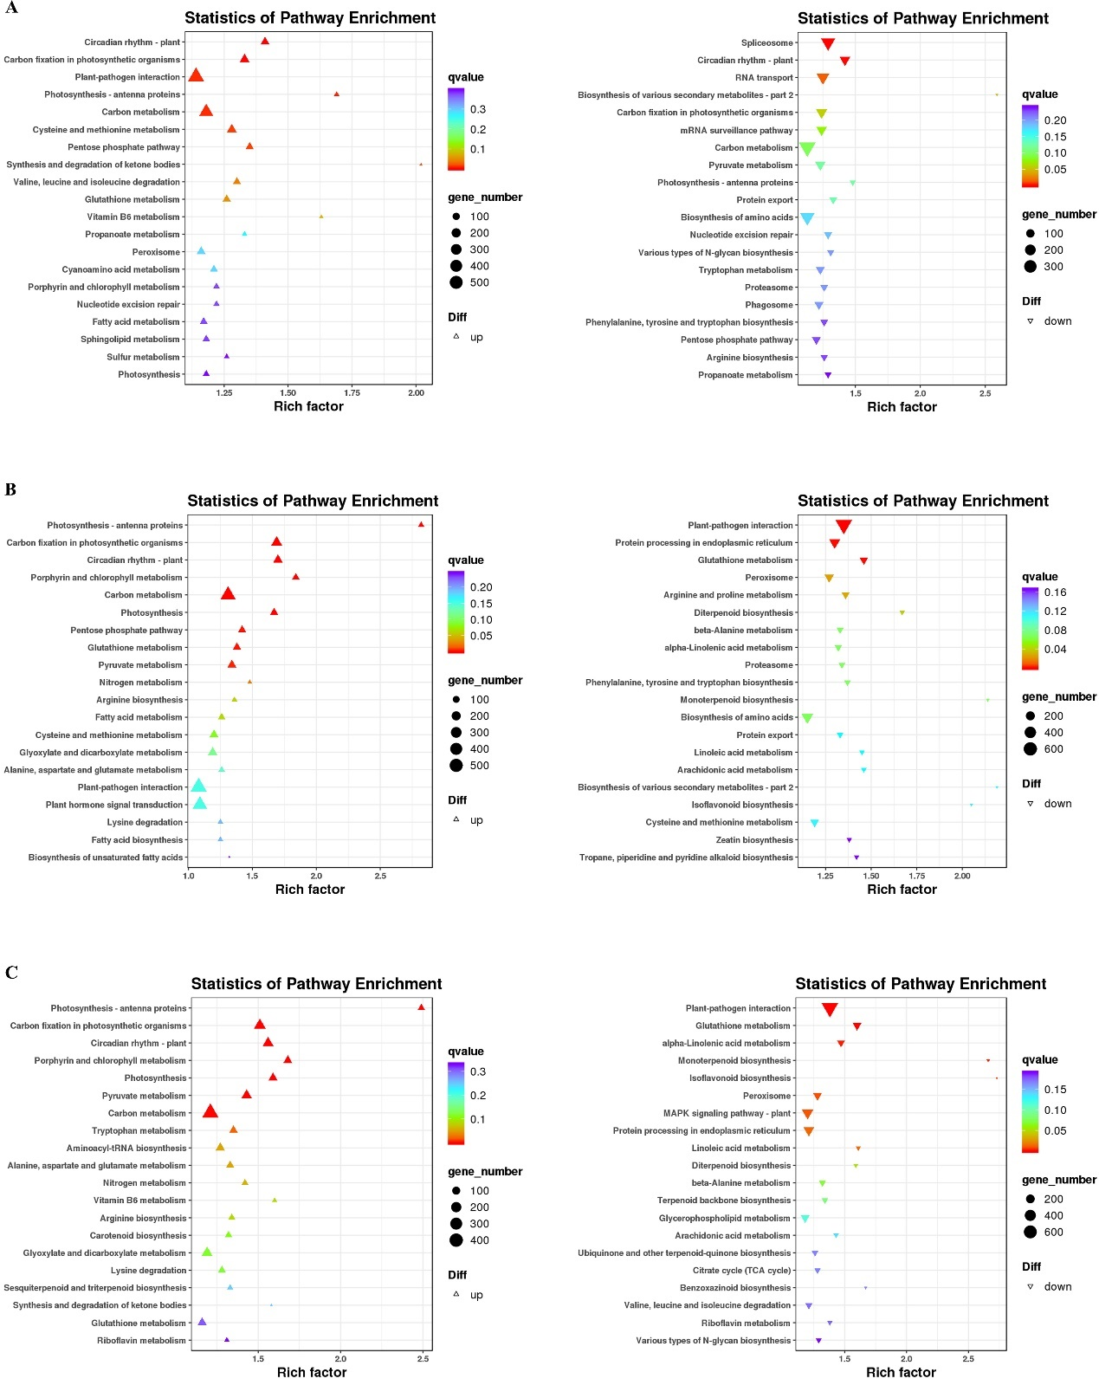
Fig. S3 KEGG enrichment of the up-regulated and down-regulated DEGs identified in Male vs Female (A), Monoecious vs Female (B), and Monoecious vs Male (C), respectively.
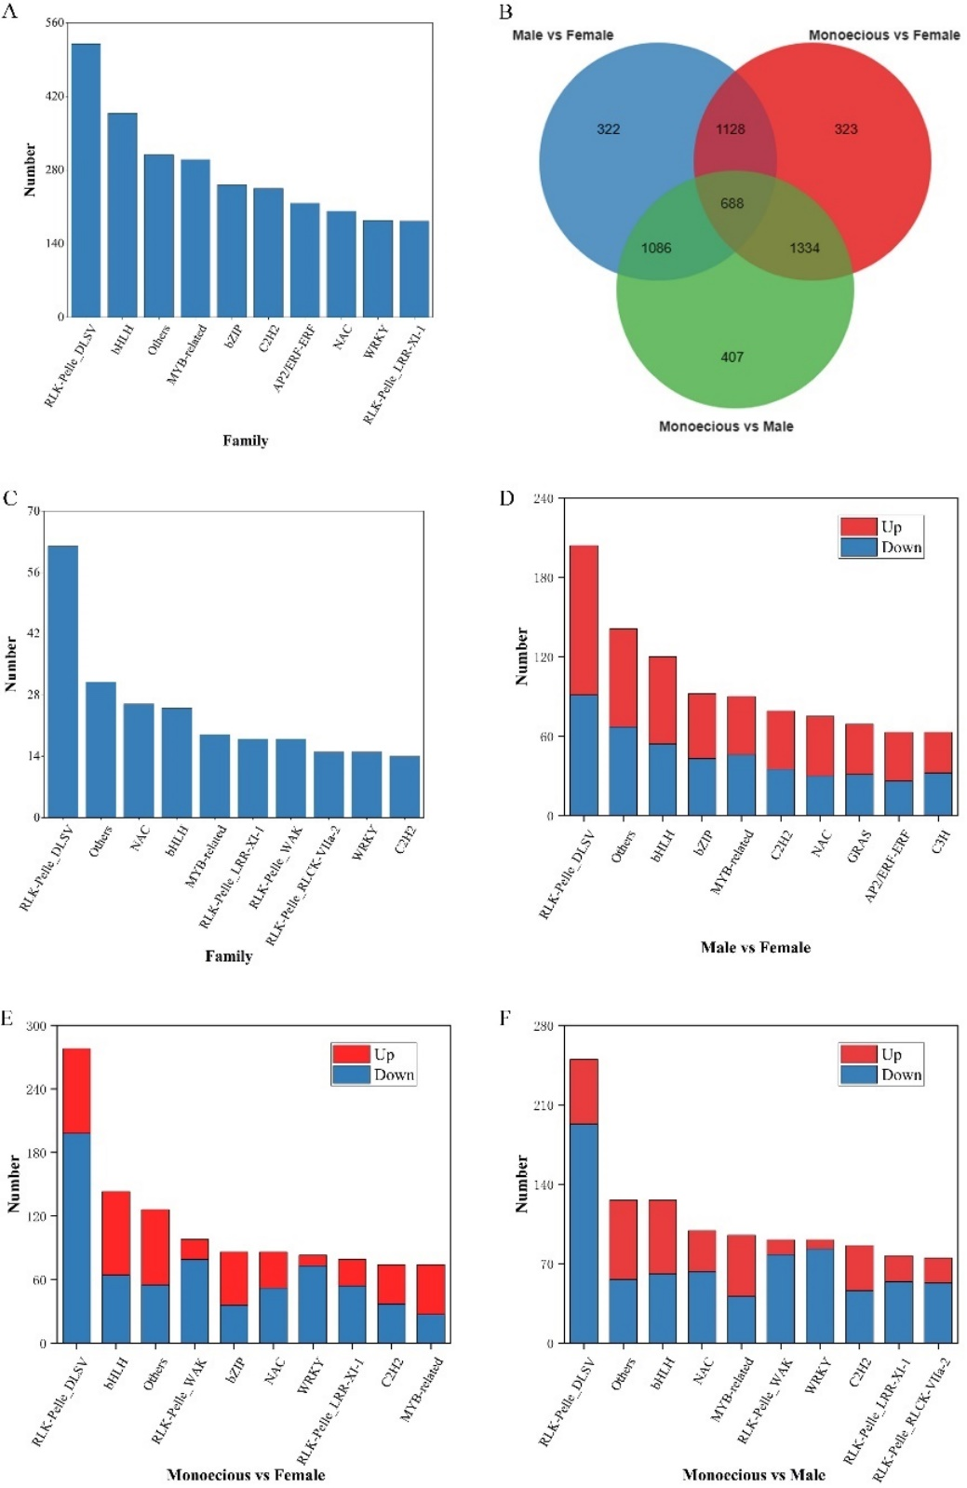
Fig. S4 Prediction of regulatory proteins. A Number and family of top ten regulatory proteins predicted by SMRT sequencing data. B Venn diagram of differentially expressed regulatory proteins. C Number and family of top ten differentially expressed regulatory proteins. D-F The differentially expressed regulatory proteins predicted in Male vs Female, Monoecious vs Female, and Monoecious vs Male, respectively.
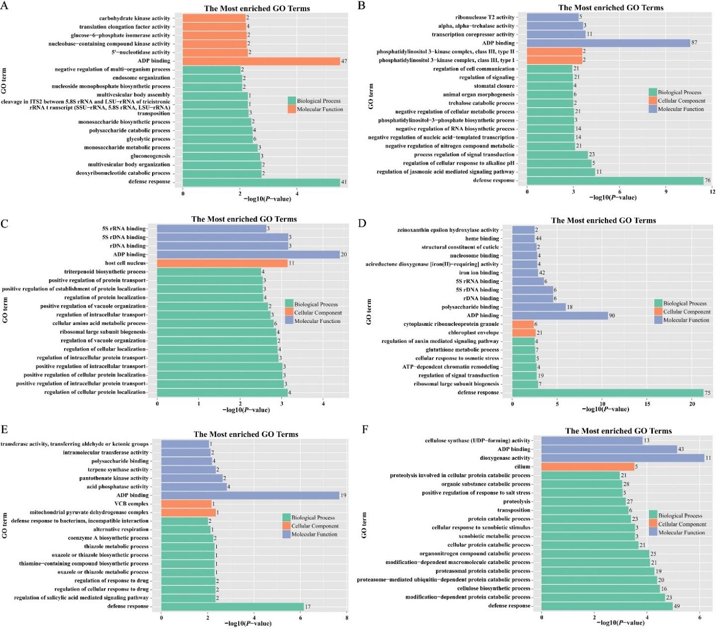
Fig. S5 GO enrichment of sex-specific genes. (A) Genes present only in female plants. (B) Genes absent in female plants. (C) Genes present only in male plants. (D) Genes absent in male plants. (E) Genes present only in monoecious plants. (F) Genes absent in monoecious plants.
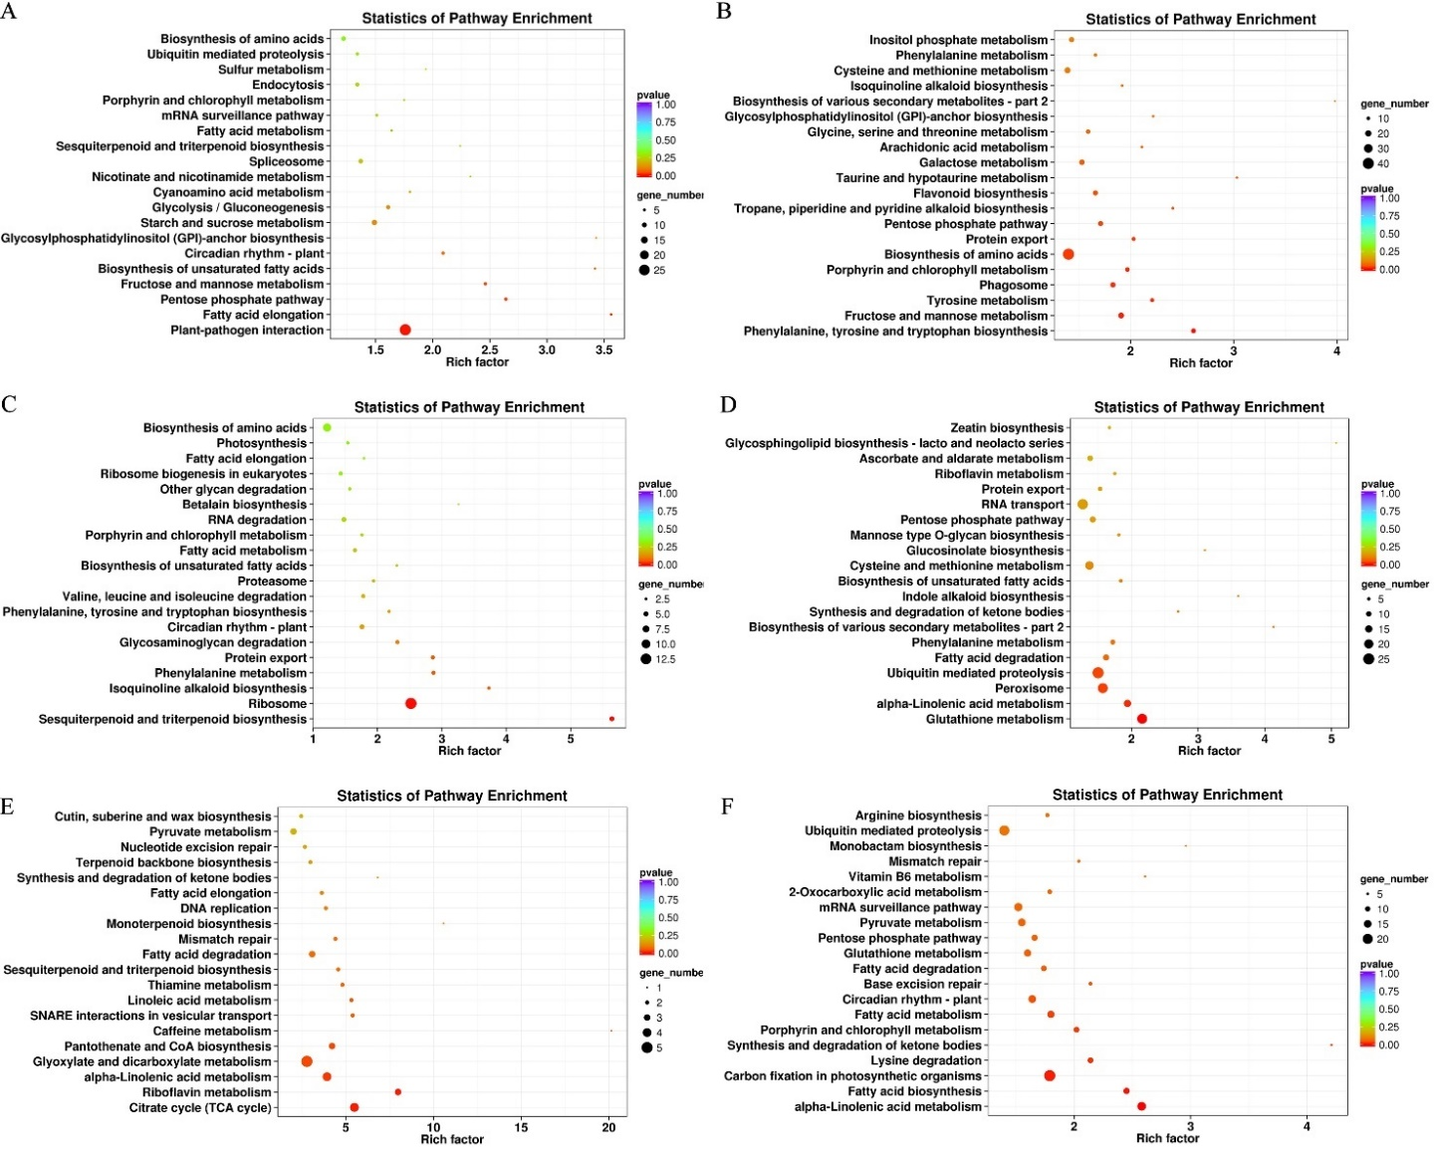
Fig. S6 KEGG enrichment of sex-specific genes. (A) Genes present only in female plants. (B) Genes absent in female plants. (C) Genes present only in male plants. (D) Genes absent in male plants. (E) Genes present only in monoecious plants. (F) Genes absent in monoecious plants.
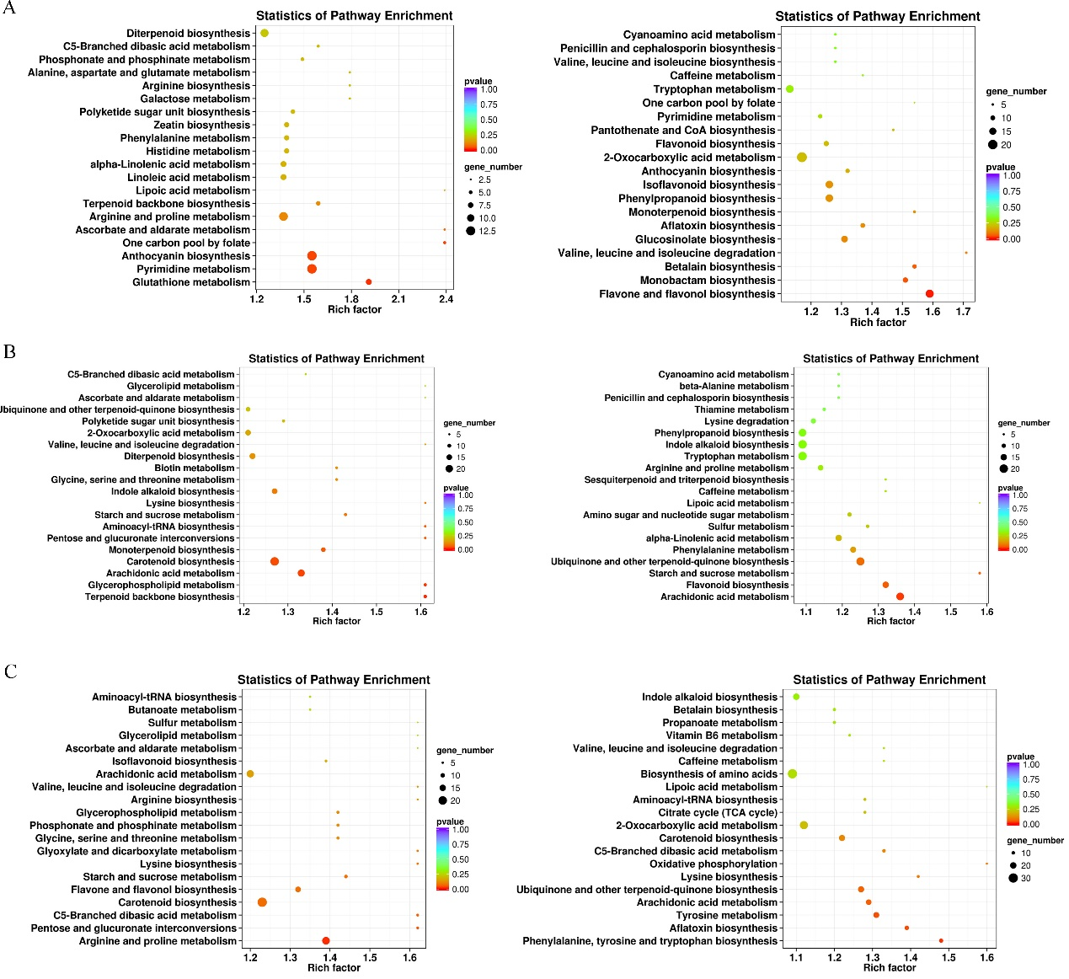
Fig. S7 KEGG enrichment analysis of DAMs in the positive (left) and negative (right) ion mode in the comparison of Male vs Female (A), Monoecious vs Female (B), and Monoecious vs Male (C) sample groups.

