Detailed demonstration and interpretation of the three discordant fallback benchmark samples and noisy or corrupted samples
The three discordant fallback benchmark samples

What a fallback result means
resolveS first evaluates individual rRNA targets under a progressive MAPQ strategy and asks whether the informative targets reach a stable consensus. A fallback result means that this progressive per-rRNA voting did not yield stable agreement. The final class is then assigned from the aggregate balance of forward- and reverse-dominant results among non-tied rRNA targets at the terminal MAPQ tier. A fallback call is therefore intrinsically lower confidence than a consensus-supported prediction and should not be interpreted as carrying equivalent evidential support.
Summary of the three discordant fallback benchmark samples.
Sample | Reported type | resolveS call | MAPQ | Fallback type | fwd/rev targets | Rel_  Diff | Principal failure pattern
SRR6357071 | fr-firststrand | fr-unstranded | 10 | multi-of8-fallback | 42/27 | 0.435 | N-only reads; dispersed and conflicting per-rRNA evidence
SRR6357072 | fr-firststrand | fr-unstranded | 20 | multi-of8-fallback | 29/16 | 0.578 | Similar read-quality anomaly reported; no stable per-rRNA consensus
SRR8368636 | fr-unstranded | fr-secondstrand | 20 | multi-of8-fallback | 55/29 | 0.619 | Exceptional organellar-like directional pile-up and heterogeneous rRNA profile
Note: fwd/rev values are counts of non-tied rRNA targets assigned to each orientation at the terminal MAPQ tier; they are not raw read counts.

SRR6357071
SRR6357071 was reported as fr-firststrand but was called fr-unstranded. At MAPQ 20, the run produced an incomplete-of8-fallback result, so the adaptive procedure relaxed to MAPQ 10. It then stopped at multi-of8-fallback because the per-rRNA evidence remained conflicted. At this terminal tier, 69 non-tied rRNA targets contributed 42 forward- and 27 reverse-dominant results, with a reported fallback Rel_Diff of 0.435.
Coverage was highly uneven. The most strongly covered rRNA target (SILVA_132_LSTRef;LBMA01000021.4930.8303) had 184 forward and 9,038 reverse alignments and individually supported fr-firststrand. Other informative targets, however, supported fr-secondstrand, fr-firststrand, or fr-unstranded patterns, while many low-coverage targets were classified as insufficient-data. Thus, the expected signal was present in the leading target but did not become a stable cross-target consensus.

SRR6357072
SRR6357072 was likewise reported as fr-firststrand but was called fr-unstranded. Its terminal result was multi-of8-fallback at MAPQ 20, based on 29 forward- and 16 reverse-dominant non-tied rRNA targets (Rel_Diff = 0.578). The most strongly covered target had 206 forward and 7,418 reverse alignments and supported fr-firststrand, whereas the remaining targets produced a mixture of first-strand, second-strand, unstranded, and insufficient-data patterns. The cross-target votes therefore did not form a stable progressive consensus. The source rebuttal also reports a similar read-quality problem in SRR6357072_2.fastq.gz; because no separate image or quantitative quality summary is available here, that statement should be treated as a reported observation rather than proof of a specific causal process.

SRR8368636
SRR8368636 was reported as fr-unstranded but was called fr-secondstrand. The terminal multi-of8-fallback result occurred at MAPQ 20, with 55 forward- and 29 reverse-dominant non-tied rRNA targets (Rel_Diff = 0.619). Its coverage profile contained an exceptional single-direction pile-up at SILVA_132_LSTRef;AGCB01005631.756.4253: 2,452 forward and 0 reverse alignments. The local debug annotation identifies this sequence as a likely chloroplast 23S rRNA target derived from Citrullus lanatus, whereas the next most covered target was nearly balanced (147 forward and 129 reverse alignments). This pattern is best described as anomalous organellar-like rRNA dominance within a heterogeneous target profile. The available records do not establish contamination, so contamination should not be stated as a confirmed cause.

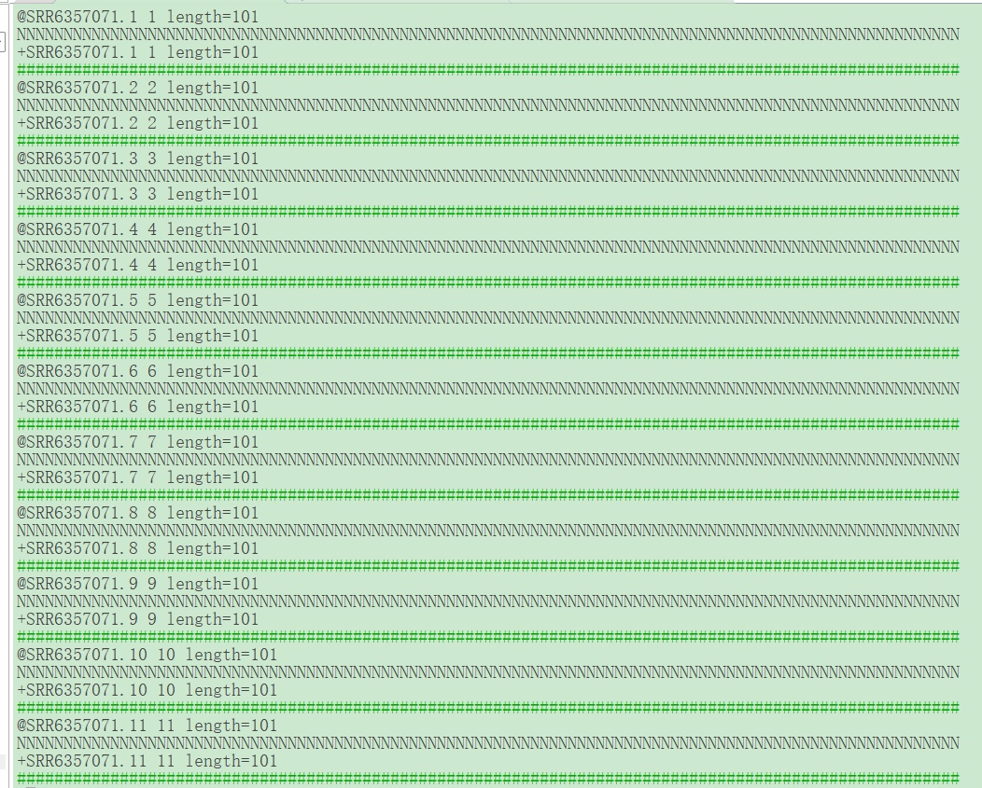
Figure. Representative read-quality anomaly in SRR6357071_1.fastq.gz, extracted from the source rebuttal. Multiple consecutive 101-nt records contain only N bases. The source rebuttal reports a similar problem for SRR6357072_2.fastq.gz. The image directly demonstrates undetermined-base reads but does not identify the process that produced them.

Practical interpretation
Fallback results should be treated as low-confidence calls. Users should inspect the -d per-rRNA output to distinguish sparse support, disagreement among targets, and atypical target dominance. When additional evidence is needed, the -u parameter can be used to increase the number of sampled reads, study- or batch-matched replicate results should be examined together, and strandedness should be verified independently when a reliable reference genome and annotation are available. For these three cases, the directly observed features are undetermined-base read records and irregular per-rRNA signal distributions. File corruption during upload, contamination, or a particular biological mechanism should remain hypotheses unless supported by additional evidence.

The noisy or corrupted samples
This is the data themselves may be corrupted, for example by sequence truncation, which is mainly caused by an incomplete or failed user uploading process.
Case by case:
SRR7759712/SRR7759714 has R1=75bp and R2=25bp; SRR7759713 has R1=75np and R2=27bp;
SRR7890157 has the following broken data:
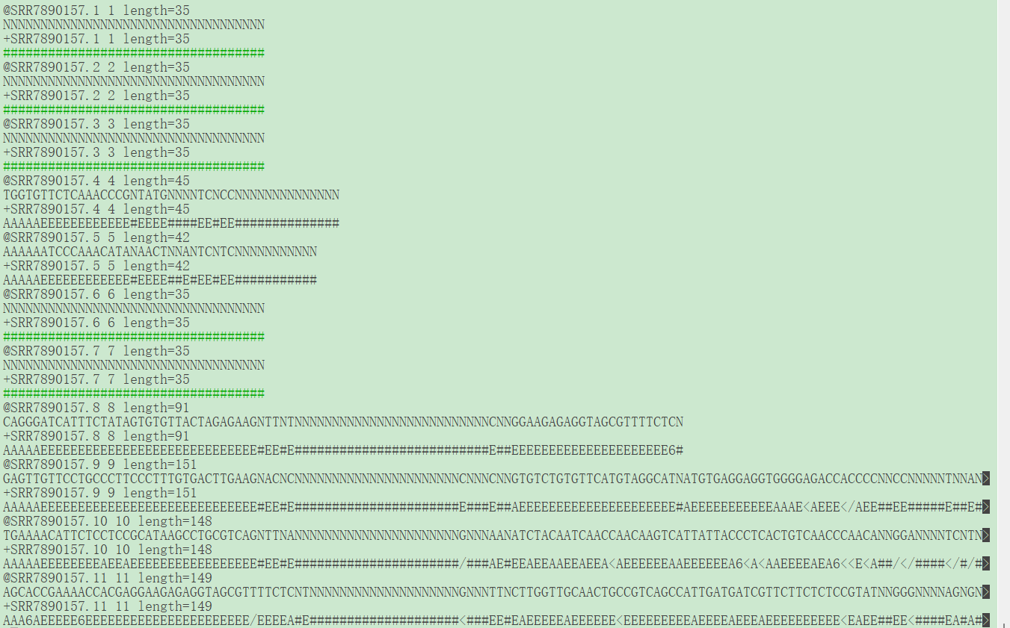

So such obviously broken raw data (SRR7759712/SRR7759714/ SRR7890157) is not used for down streaming identification.

