Condense the informal IGV screenshots to display the strand-specific and one unstranded mapping profile

To give the most original and accurate observational data. We present one clearly strand-specific and one unstranded rRNA mapping profile.
The IGV color scheme is `Color alignments by` -> `first-of-pair strand`
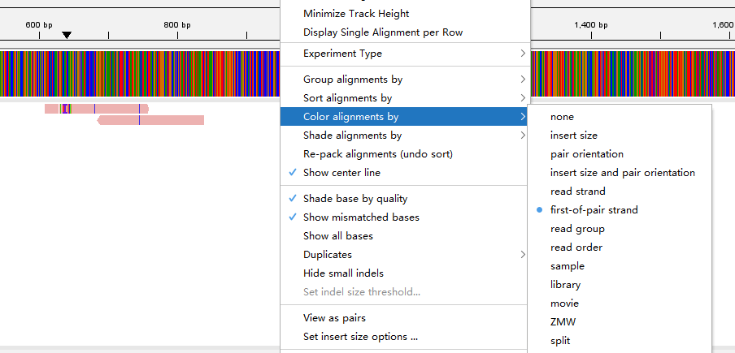
The pink color means the first-of-pair (R1 read) strand is same as the Forward strand of Reference genome, while the purple means the first-of-pair strand is same as the Reverse strand.

The strand-specific example
The overall mapping rate of the head 5M is:
5000000 reads; of these:
5000000 (100.00%) were paired; of these:
4965720 (99.31%) aligned concordantly 0 times
1632 (0.03%) aligned concordantly exactly 1 time
32648 (0.65%) aligned concordantly >1 times
0.69% overall alignment rate
The rRNA molecule with valid alignments:
[INSERT Table here:
chrom fwd rev total major strand_type
SILVA_132_LSTRef;JXWP01000089.154.3140 53 1170 1223 rev fr-firststrand
SILVA_132_LSTRef;LRIL01000285.22297.26045 9 333 342 rev fr-firststrand
SILVA_132_LSTRef;GEXQ01018700.525.4403 3 237 240 rev fr-firststrand
SILVA_132_LSTRef;GFKT010374289.516.3754 1 217 218 rev fr-firststrand
SILVA_132_LSTRef;GETT01004273.108.2101 2 121 123 rev fr-firststrand
SILVA_132_LSTRef;HC049454.5040.8406 39 0 39 fwd fr-secondstrand
SILVA_132_LSTRef;HACI01071117.32.3921 1 31 32 rev fr-firststrand
SILVA_138_SSTRef_NR99;FT295248.18.1357 32 0 32 fwd fr-secondstrand
SILVA_132_LSTRef;LDNV01005342.10.3308 0 11 11 rev insufficient-data
SILVA_132_LSTRef;GT372691.11134.15878 0 9 9 rev insufficient-data
SILVA_132_LSTRef;LCYE01003309.17311.20640 0 1 1 rev insufficient-data
SILVA_132_LSTRef;GETY01024557.1607.5101 0 1 1 rev insufficient-data
SILVA_132_LSTRef;GETY01004385.692.3952 0 1 1 rev insufficient-data
SILVA_138_SSTRef_NR99;ABGA01273066.557.2395 0 1 1 rev insufficient-data
SILVA_132_LSTRef;LGEJ01000021.17.2848 0 1 1 rev insufficient-data
SILVA_132_LSTRef;AX023546.6383.9335 1 0 1 fwd insufficient-data
SILVA_132_LSTRef;AEHK01169135.1.1950 0 1 1 rev insufficient-data
]

First IGV snapshot of SILVA_132_LSTRef;JXWP01000089.154.3140
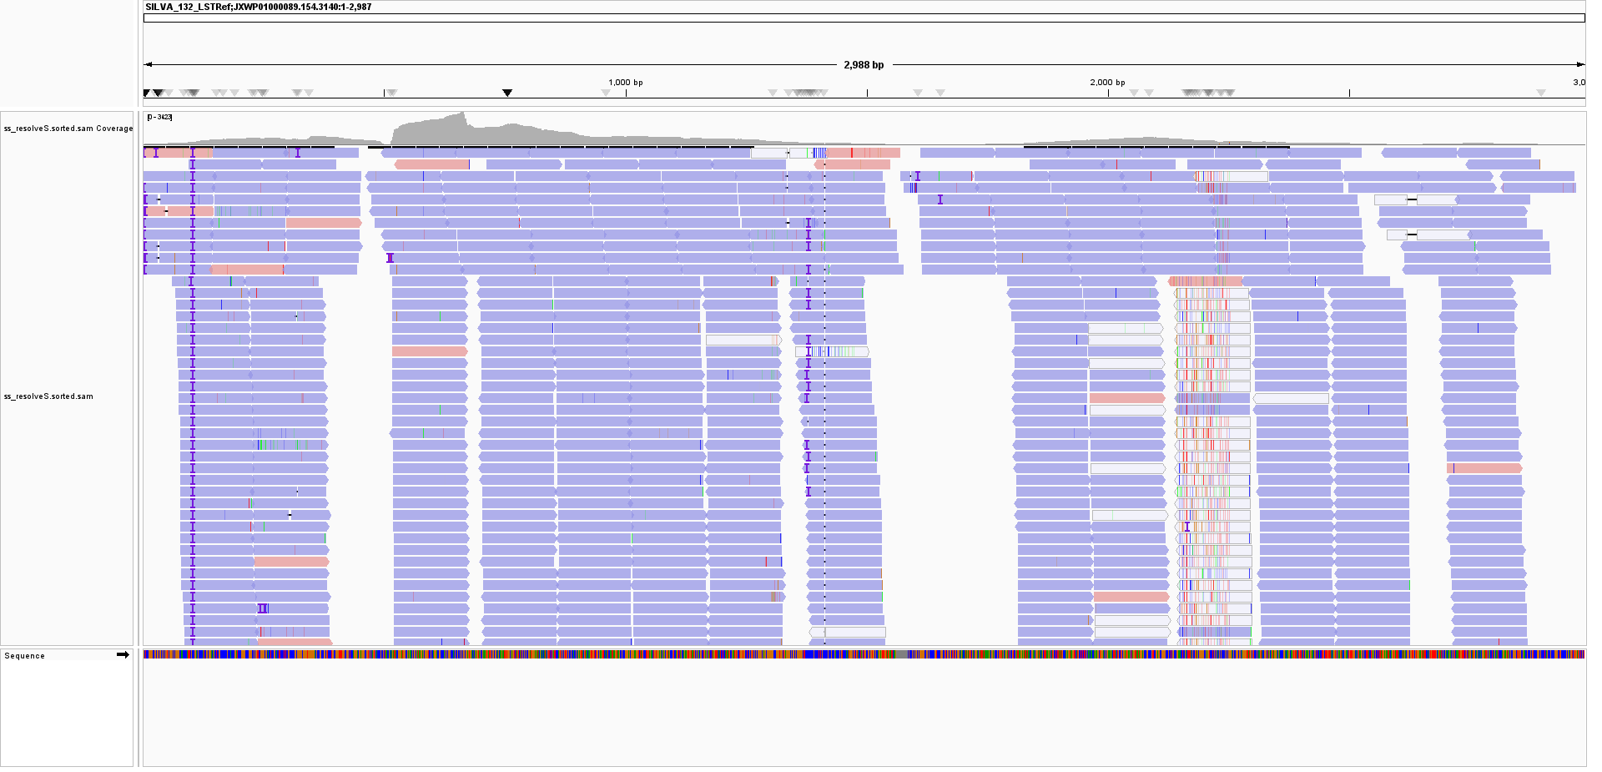
Second IGV snapshot of SILVA_132_LSTRef;LRIL01000285.22297.26045
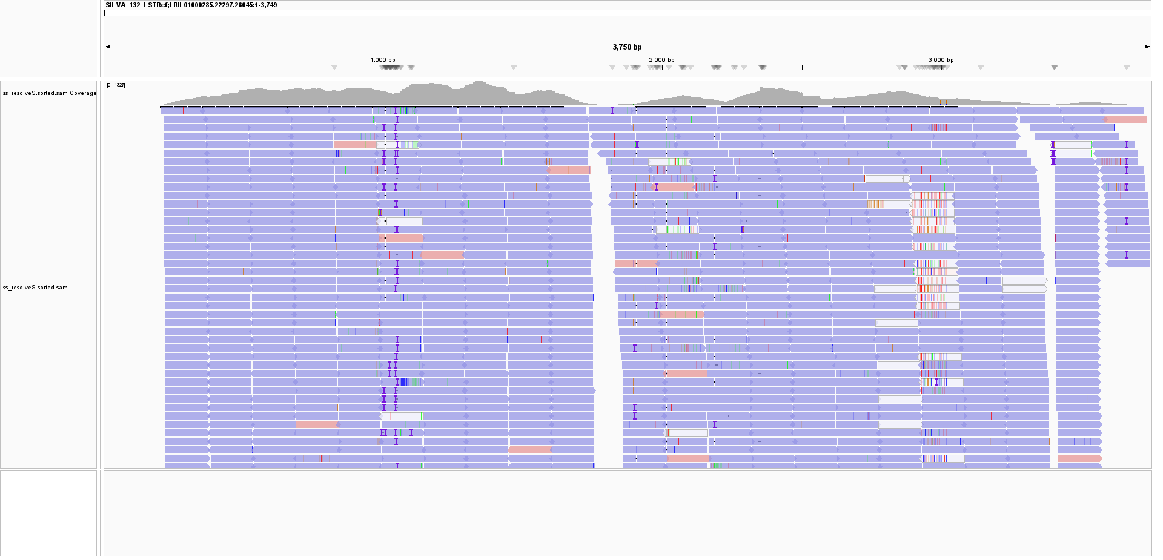
Third SILVA_132_LSTRef;GEXQ01018700.525.4403
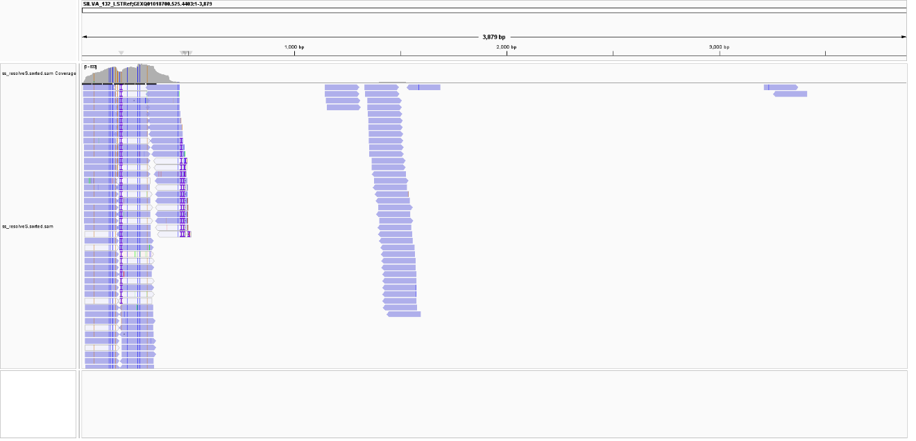

The unstranded example
The overall mapping rate of the head 5M is:
5000000 reads; of these:
5000000 (100.00%) were paired; of these:
4966153 (99.32%) aligned concordantly 0 times
1638 (0.03%) aligned concordantly exactly 1 time
32209 (0.64%) aligned concordantly >1 times
0.68% overall alignment rate
The rRNA molecule with valid alignments:
[INSERT Table here:
chrom fwd rev total major strand_type
SILVA_132_LSTRef;JXWP01000089.154.3140 303 350 653 rev fr-unstranded
SILVA_132_LSTRef;GEXQ01018700.525.4403 85 68 153 fwd fr-unstranded
SILVA_132_LSTRef;GETT01004273.108.2101 41 21 62 fwd fr-secondstrand
SILVA_132_LSTRef;HACI01071117.32.3921 31 16 47 fwd fr-secondstrand
SILVA_132_LSTRef;LRIL01000285.22297.26045 17 12 29 fwd fr-unstranded
SILVA_132_LSTRef;GT372691.11134.15878 12 17 29 rev fr-unstranded
SILVA_138_SSTRef_NR99;FT295248.18.1357 7 16 23 rev fr-firststrand
SILVA_132_LSTRef;GFKT010374289.516.3754 14 2 16 fwd insufficient-data
SILVA_132_LSTRef;LDNV01005342.10.3308 7 4 11 fwd insufficient-data
SILVA_132_LSTRef;HC049454.5040.8406 2 6 8 rev insufficient-data
SILVA_138_SSTRef_NR99;AB288313.1.1493 2 2 4 tie insufficient-data
SILVA_132_LSTRef;GETY01004385.692.3952 2 2 4 tie insufficient-data
SILVA_138_SSTRef_NR99;AAFC05032349.519.1904 1 2 3 rev insufficient-data
SILVA_132_LSTRef;LMNC01000003.432728.435535 2 0 2 fwd insufficient-data
SILVA_138_SSTRef_NR99;MBFK01000143.1.1414 1 1 2 tie insufficient-data
SILVA_132_LSTRef;LKAP01000055.660.3454 0 1 1 rev insufficient-data
SILVA_132_LSTRef;ABRQ02301566.10.2496 1 0 1 fwd insufficient-data
SILVA_132_LSTRef;ABRO02099778.1230.5051 1 0 1 fwd insufficient-data
SILVA_138_SSTRef_NR99;GETY01052887.521.2560 1 0 1 fwd insufficient-data
SILVA_132_LSTRef;LTOW01000055.3.2315 0 1 1 rev insufficient-data
SILVA_138_SSTRef_NR99;LMBD01002742.97.1557 0 1 1 rev insufficient-data
SILVA_132_LSTRef;GETY01024557.1607.5101 1 0 1 fwd insufficient-data
SILVA_138_SSTRef_NR99;JSAF02007699.3169.4976 0 1 1 rev insufficient-data
SILVA_138_SSTRef_NR99;JMZW01202421.3815.5663 0 1 1 rev insufficient-data
SILVA_138_SSTRef_NR99;LMBD01002992.1556.3410 0 1 1 rev insufficient-data
SILVA_138_SSTRef_NR99;GETG01013848.1639.3610 1 0 1 fwd insufficient-data
SILVA_132_LSTRef;LMPM01000001.173781.176591 0 1 1 rev insufficient-data]

First IGV snapshot of SILVA_132_LSTRef;JXWP01000089.154.3140
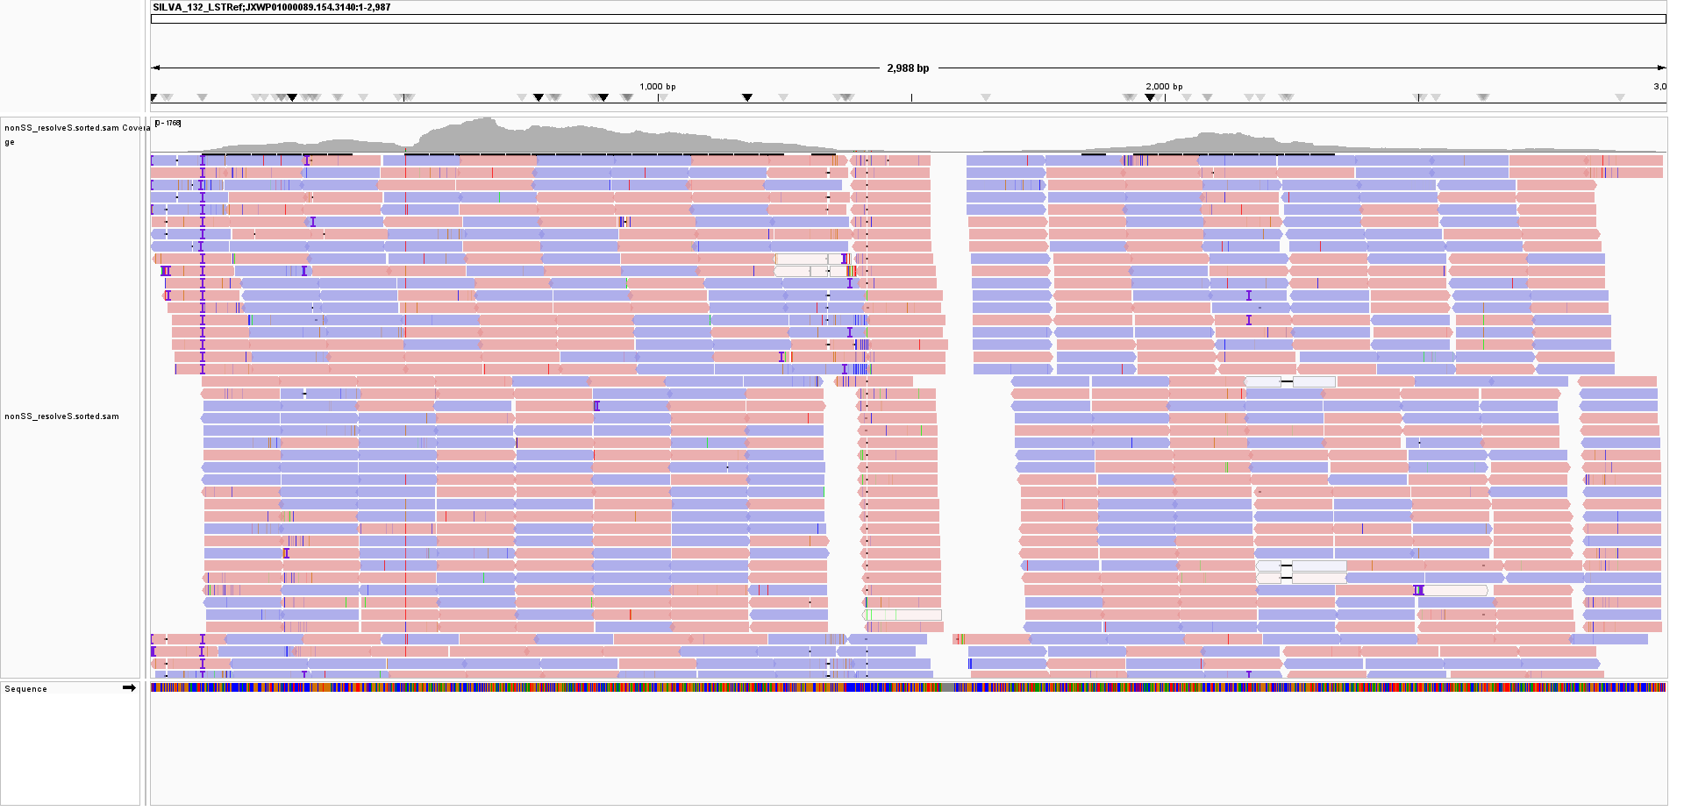
Second IGV snapshot of SILVA_132_LSTRef;GEXQ01018700.525.4403
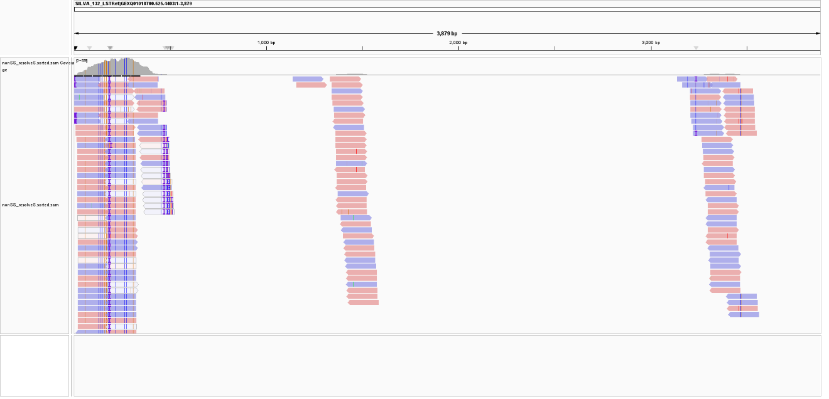
Third IGV snapshot of SILVA_132_LSTRef;GETT01004273.108.2101
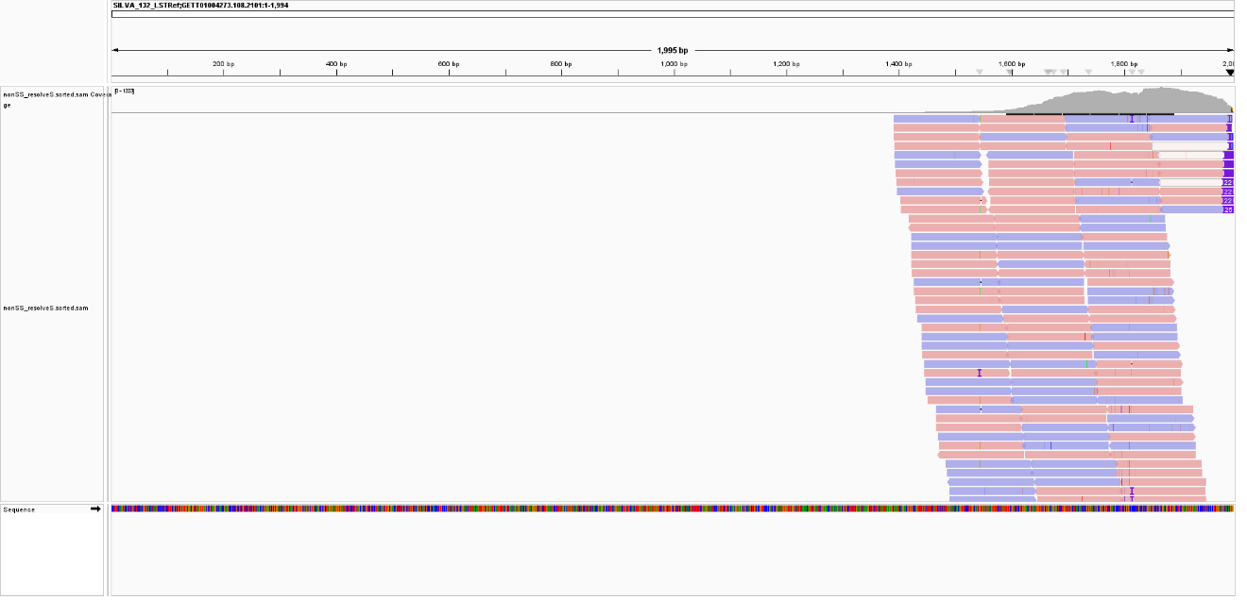
Fourth IGV snapshot of SILVA_132_LSTRef;HACI01071117.32.3921
