**Supplementary data**

b

a

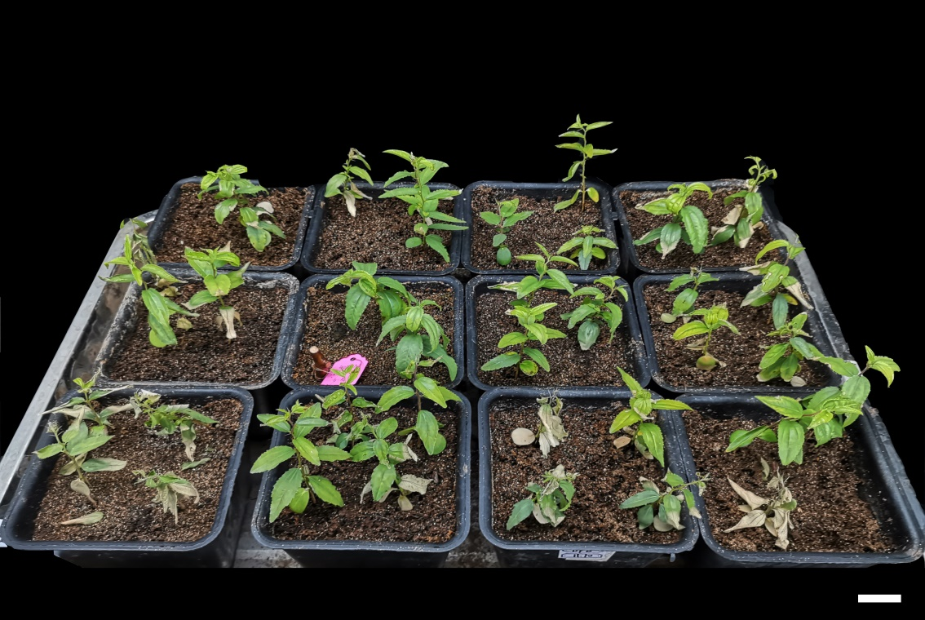

**1cm**

**Supplementary Fig.1** Overall observation of phonotypical changes of sour jujube seedlings after192 h NaCl (a) and MT plus NaCl (b) treatments, respectively.

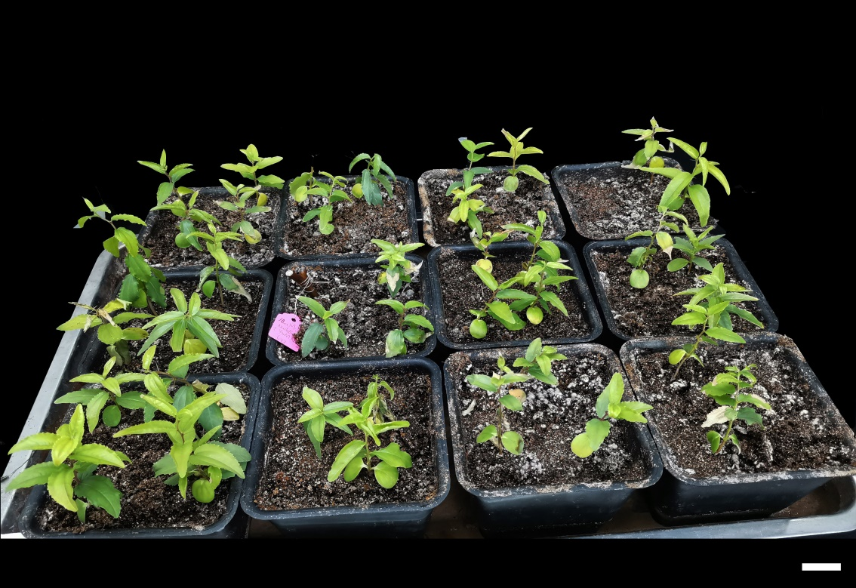

**1cm**