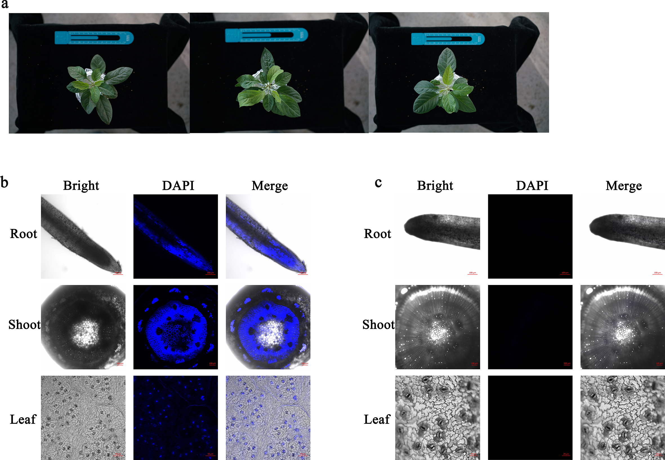
Fig. S2. (a) Seedlings treated by Ca-CDs for 20 days. Confocal microscopy images of seedlings treated by Ca-CDs for 20 days (b) and then followed by Ca-CD-free treatment for 30 days(c).

