Figure S1. Effects of different environmental factors on understory diversity in different forest ages
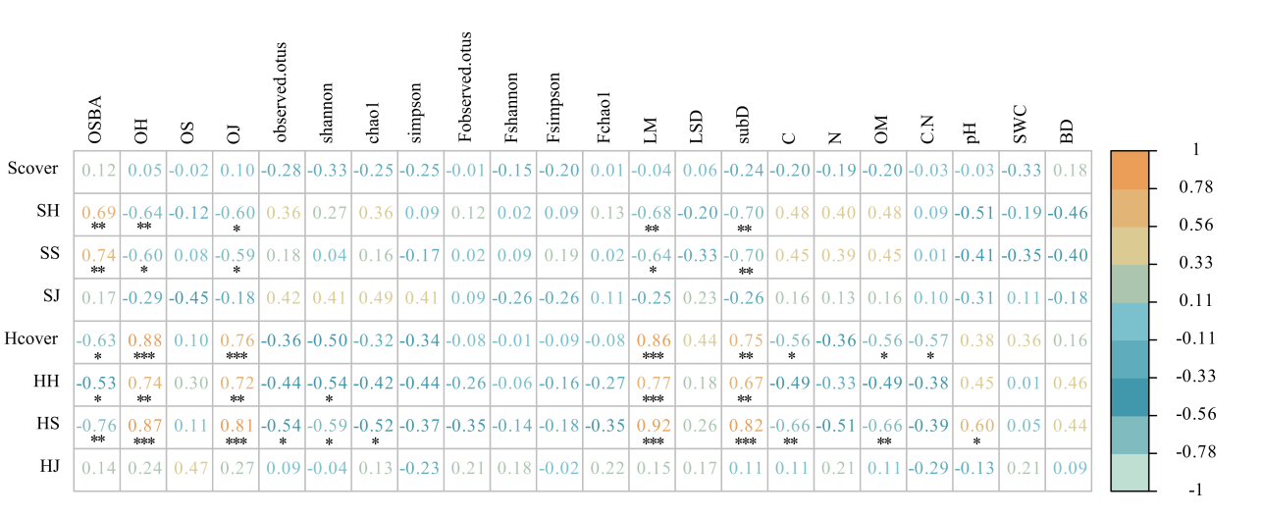
Note: Light availability (LM), light variability (LSD), substrate diversity (SubD), soil carbon (C), soil nitrogen (N), soil organic matter (OM), soil C/N ratio, soil pH, soil water content (SWC), and soil bulk density (BD).

