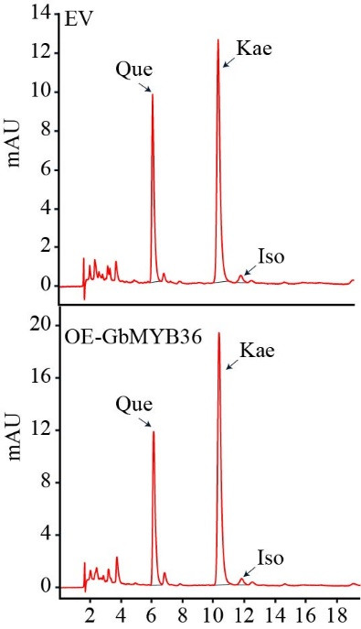
Fig. S6 Identification of flavonol in the EV and OE-GbMYB36 calli.

