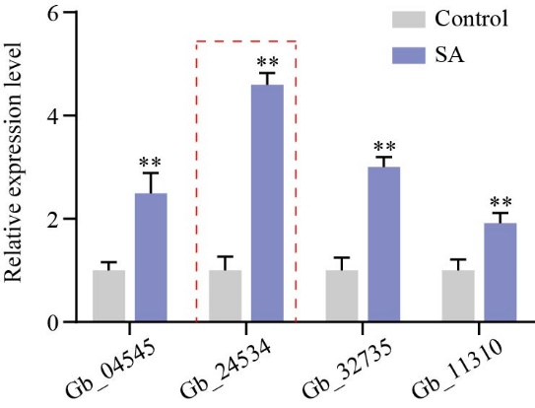
Fig. S3 The expression levels of four vital F3’H (Gb_04545, Gb_24534, Gb_32735 and Gb_11310) genes in SA treated calli and control.

