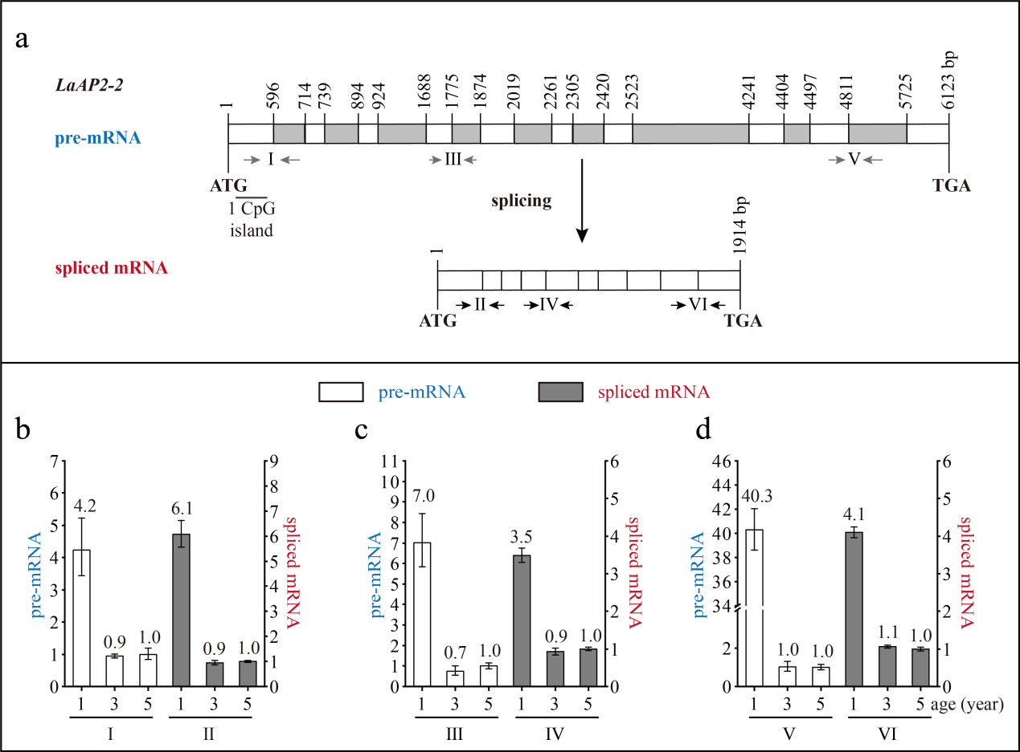
Fig. S3 The structure and expression pattern of LaAP2-2. (a) Schematic representation of the genomic structure of LaAP2-2. White indicates exon; grey indicates intron; grey arrows indicate the positions of the primers used to measure the pre-mRNA; black arrows indicate the positions of the primers used to measure the spliced mRNA. (b-d) Expression patterns of LaAP2-2 pre-mRNA and spliced mRNA during tree aging detected by three different primer pairs. The lateral branches of 1-, 3-, and 5-year-old active Larix kaempferi trees (n ≥6, sampled on 4 July 2019) were used to detect the expression patterns, which were assayed by qRT-PCR with LaEF1A1 as the internal control. The capitalized Roman numerals (I-VI) in Fig. a-d represent the different primers.

