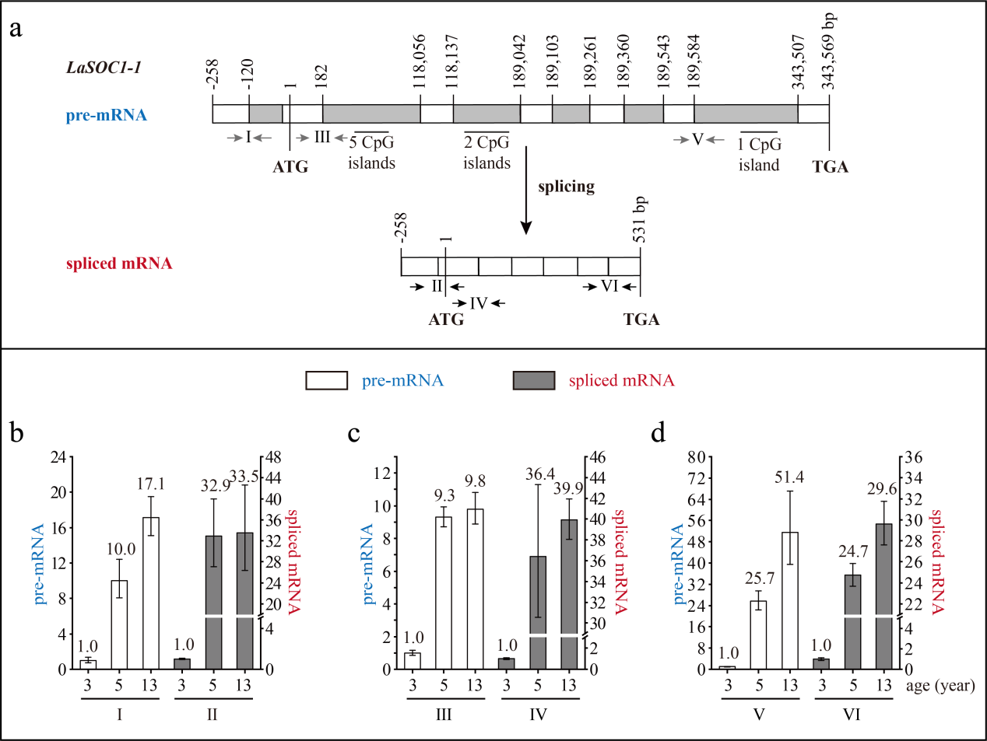
Fig. S2 The structure and expression pattern of LaSOC1-1. (a) Schematic representation of the genomic structure of LaSOC1-1. White indicates exon; grey indicates intron; grey arrows indicate the positions of the primers used to measure the pre-mRNA; black arrows indicate the positions of the primers used to measure the spliced mRNA. (b-d) Expression patterns of LaSOC1-1 pre-mRNA and spliced mRNA during tree aging detected by three different primer pairs. The lateral branches of 3-, 5-, and 13-year-old active Larix kaempferi trees (n ≥6, sampled on 4 July 2019) were used to detect the expression patterns, which were assayed by qRT-PCR with LaEF1A1 as the internal control. The capitalized Roman numerals (Ⅰ-Ⅵ) in Fig. a-d represent the different primers.

