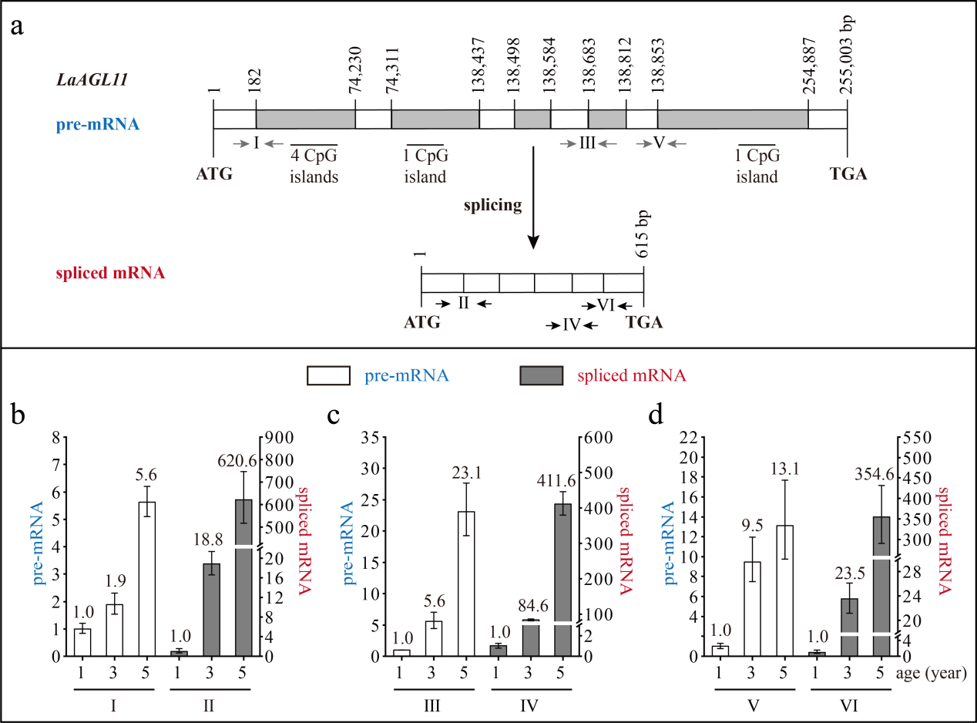
Fig. S1 The structure and expression pattern of LaAGL11. (a) Schematic representation of the genomic structure of LaAGL11. White indicates exon; grey indicates intron; grey arrows indicate the positions of the primers used to measure the pre-mRNA; black arrows indicate the positions of the primers used to measure the spliced mRNA. (b-d) Expression patterns of LaAGL11 pre-mRNA and spliced mRNA during tree aging detected by three different primer pairs. The lateral branches of 1-, 3-, and 5-year-old active Larix kaempferi trees (n ≥6, sampled on 4 July 2019) were used to detect the expression patterns, which were assayed by qRT-PCR with LaEF1A1 as the internal control. The capitalized Roman numerals (Ⅰ-Ⅵ) in Fig. a-d represent the different primers. The p-value was calculated between 3- and 1-year-old trees. One-way ANOVA Duncan’s test was used for statistical analysis.

