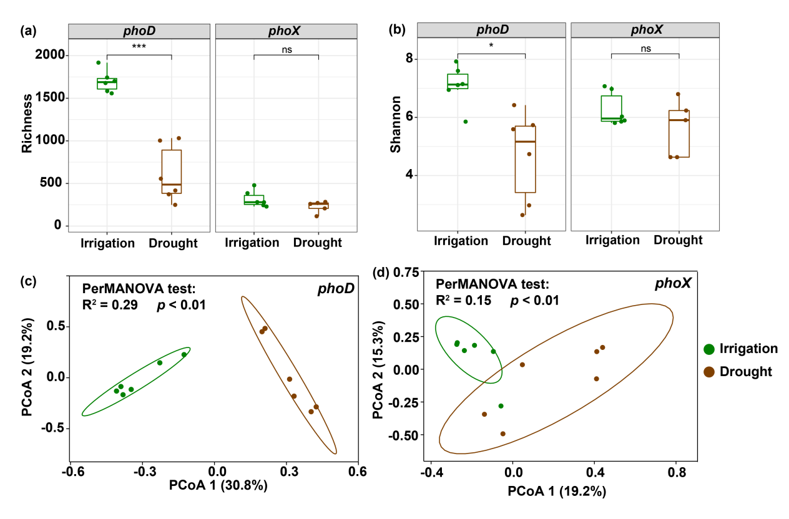

Figure S2 Comparisons of alpha and beta diversity of alkaline phosphatase gene communities under different water management treatments. (a) Richness of phoD and phoX. (b) Shannon-diversity of phoD and phoX. (c) Principal coordination analysis (PCoA) of phoD. (d) PCoA of phoX. Values on PCoA axes indicate the percentages of total variation explained by each axis.

