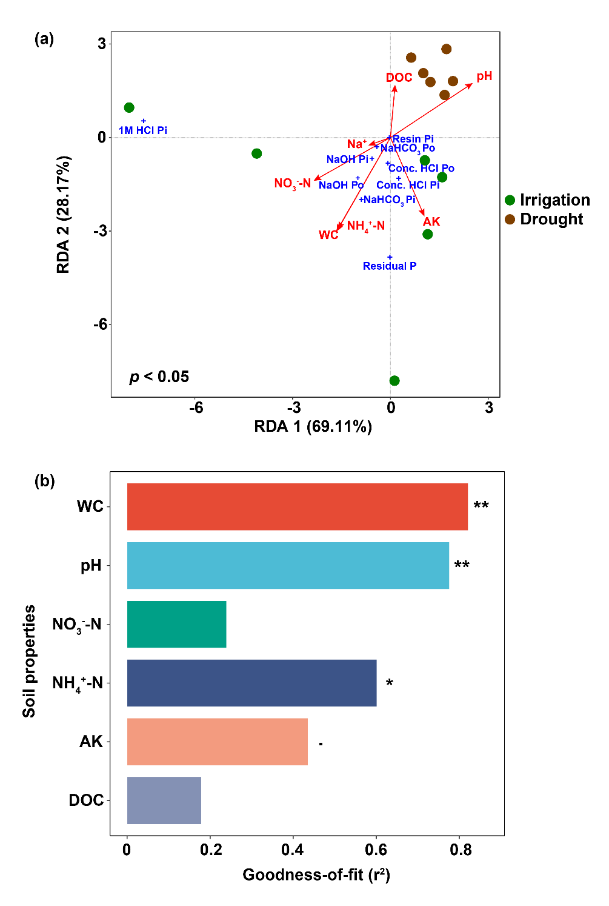
Figure S1 Redundancy analysis of soil P fractions impacted by soil properties. (a) RDA across all experimental units. (b) The variation in soil properties explaining soil P fractions. Red arrows represent soil properties. Blue crosses represent soil P fractions. Significance is indicated by **, p < 0.01; *, p < 0.05.

