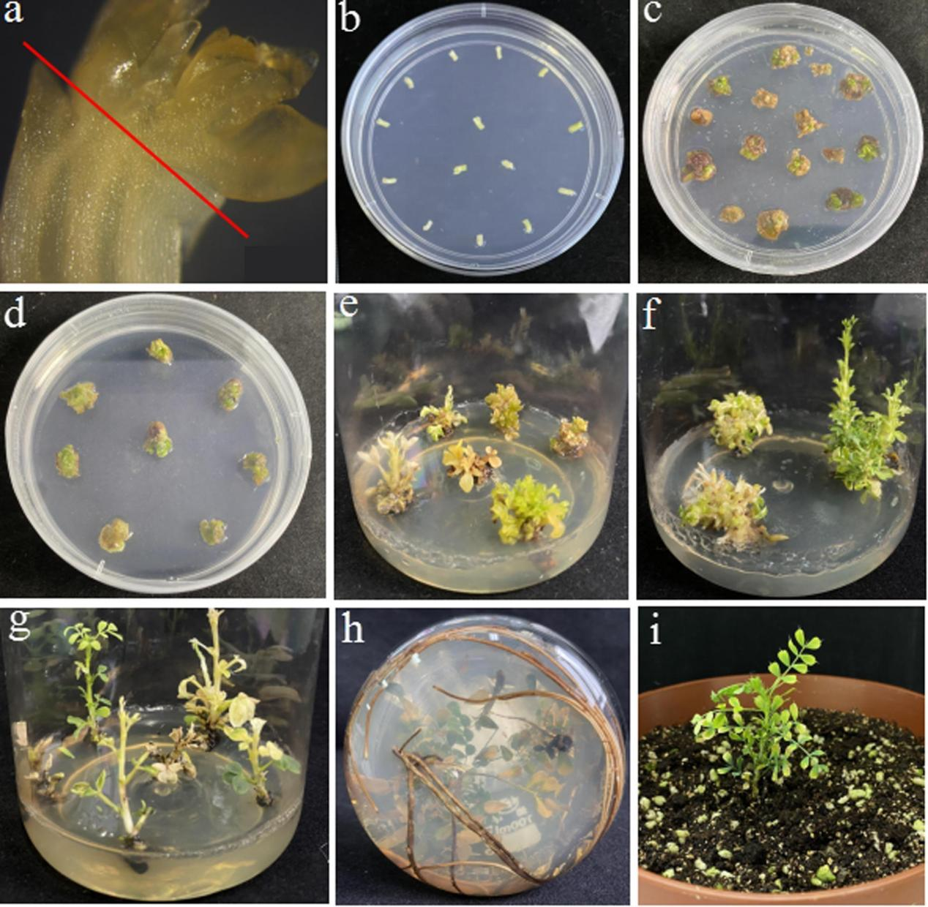
Fig.S4 The genetic transformation process of C. korshinskii with 35S::HA-CiDREB1C recombinant construct using embryonic tip as explants.
(a) Anatomical image of the embryonic tip starting explant. (b) Explants were co-cultured for 2 days. (c, d) The adventitious buds were transferred to the induction medium with kanamycin selection, and 4-8 weeks later, kanamycin-resistant granular protrusions were observed. (e) Resistant adventitious buds were effectively induced after 3 to 6 weeks. (f, g) The resistant adventitious buds were transferred to the elongation selection medium until shoots elongated. (h) Adventitious roots were successfully induced after roughly 5 weeks. (i) The transgenic plant was obtained.

