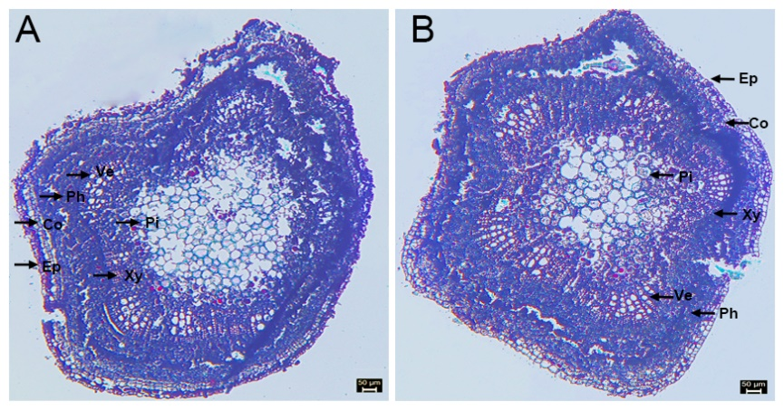
Fig. S3. Shoot cross-sectional anatomy of biennial plantlets. (A) root-sprout plantlets (RSs). (B) the RCs. Abbreviations: Ep, Epidermis; Co, Cortex; Ph, Phloem; Xy, Xylem; Ve, Vessel; Pi, Pith. Scale bars: 50µm.

