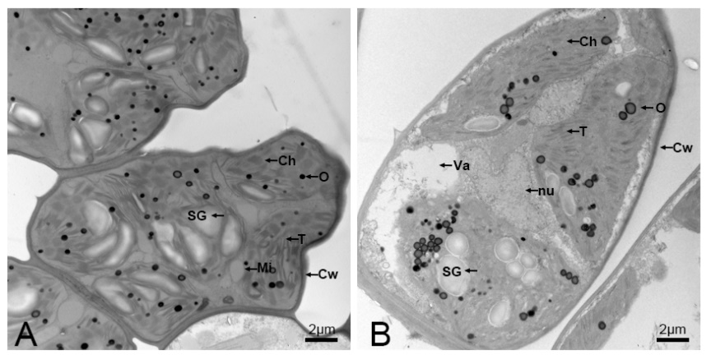
Fig. S4. Leaf-cell ultrastructure of biennial plantlets. (A) root-sprout plantlets (RSs). (B) root-cutting plantlets (RCs); Abbreviations: CW, cell wall; Ch, chloroplast; Mi, mitochondrion; nu, nucleus; SG, starch granule; Va, vacuole; T; thylakoid; O, osmiophilic droplet. Scale bars: 2µm.

