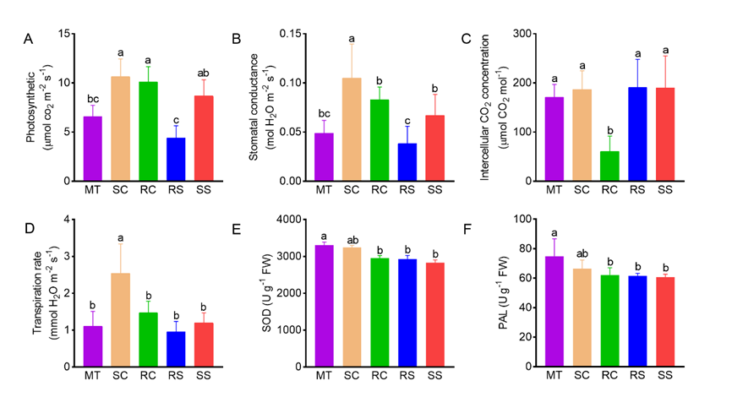
Fig. S1. Physiological and photosynthetic traits of juvenile plantlets/seedlings and mother trees. (A) Photosynthetic. (B) stomatal conductance. (C) intercellular CO₂ concentration. (D) transpiration rate. (E) SOD. (F) PAL. Different lowercase letters above the bars indicate significant differences among the plant materials. Abbreviations: SS, seed-derived seedlings; RS, root-sprout plantlets; RC, root-cutting plantlets; SC, shoot-cutting plantlets; MT, mother trees; SOD, superoxide dismutase; PAL, L-phenylalanine ammonia-lyase.

