Development of Anthocyanin-Enriched Oleogel from Hibiscus Rosa sinensis Petals and Syzygium cumini Seeds Waste for Sustainable Fat Replacement and Bio Functional Enhancement
Devilakshmi Manikandan¹, Tanmoy Das², Dr. Tanima Bhattacharya³

¹Saveetha Medical College & Hospital, Chennai, 602105, India
² Nano Bio Electronics & Smart Materials Lab, Department of Orthopaedics, Center For Global Health Research, Saveetha Medical College, Saveetha Institute of Medical and Technical Sciences, Chennai, 602105, India

³Sustainable Nanomaterials & Biopolymer Laboratory, Department of Paediatrics, Center For Global Health Research, Saveetha Medical College, Saveetha Institute of Medical and Technical Sciences, Chennai, 602105, India

*Corresponding Author: btanima1987@gmail.com

Supplementary File

1. Oil binding capacity calculation verification by Response Surface Methodolgy:
Response Surface Methodology (RSM) is a powerful statistical technique used to analyze the relationships between several independent variables and a desired response in order to model and optimize complicated processes. RSM makes it easier to determine the ideal formulation parameters for oil binding capacity (OBC) that either optimize or limit oil retention in a matrix. Additionally, it sheds light on how the material's oil binding effectiveness is influenced by both independent and combined effects of variables including temperature, gelling agent concentration, and oil type. This method is very useful for pharmaceutical and food compositions that want to decrease free oil release and improve structural stability.With substantial linear and quadratic terms showing a considerable influence of gelling agent concentration and temperature on OBC, as well as interaction effects that made a major contribution (p < 0.05), the model for OBC was statistically significant (p < 0.0001). The three-dimensional response surface plot (Fig. 3) illustrates the interactive influence of Rice Bran Oil (RBO) and Aloe vera concentrations on the oil binding capacity (OBC) of hibiscus flower petal-based oleogels. A clear curvature is observed on the response surface, signifying a significant interaction between the two independent variables.An increase in RBO content from 1.8 to 3.0 (coded levels) resulted in a marked enhancement in OBC, particularly when Aloe vera content was maintained at lower levels. The maximum OBC values (above 105%) were achieved in the region characterized by high RBO and low Aloe vera concentrations, indicating that the lipid content played a crucial role in forming a stable oleogel network with high oil entrapment efficiency. Conversely, increasing Aloe vera concentration from 1.0 to 1.5, especially at lower RBO levels, led to a significant decline in OBC, with minimum values dropping below 70%. This suggests that an excess of Aloe vera possibly disrupted the internal gel structure, weakening the gel matrix and reducing its oil retention capacity.The downward-sloping surface from high RBO low Aloe vera to low RBO high Aloe vera reflects the inverse relationship and interactive effect of these two factors. These findings support the microscopic observations, where optimized hibiscus oleogels displayed compact, globule-like microstructures that are favorable for efficient oil encapsulation. Similar study report is observed in Sinha etal(Sinha et al., 2024), where the researchers showed the OBC interference with polysaccharide ratio of the biphasic gels.
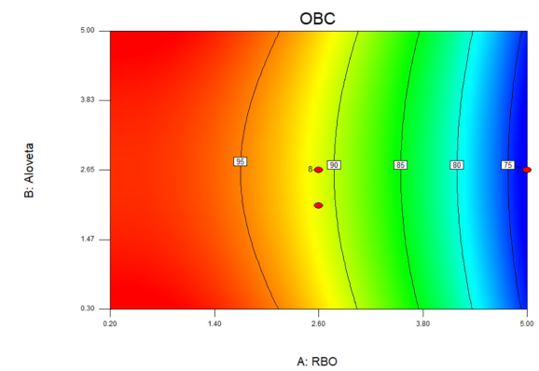
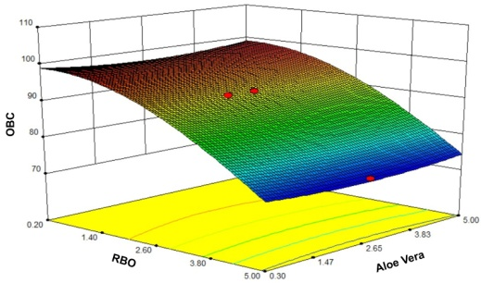

- (b)
Fig.S1. RSM surface plot of the Oil Binding capacity experiment

