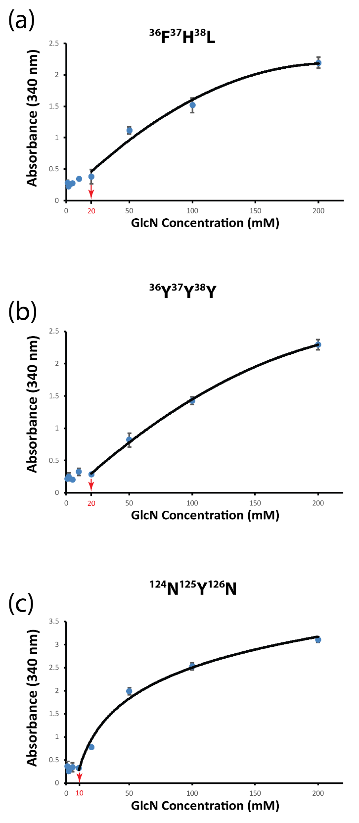

Figure S13. Concentration-depending absorbance values using purified GPDA enzyme variants (a) ³⁶F³⁷H³⁸L, (b) ³⁶Y³⁷Y³⁸Y, and (c) ¹²⁴N¹²³Y¹²⁶N. The red arrow indicates the minimum detectable concentration. Error bars show the standard deviation from 3 independent experiments.

