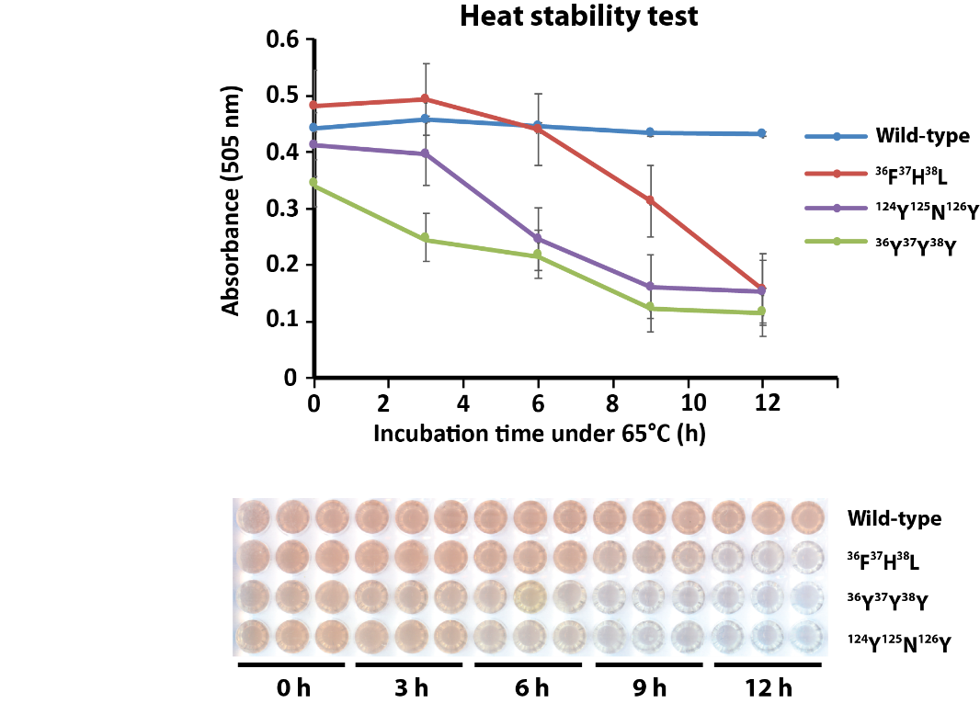

Figure S12. Heat stability test of GPDA wild-type and mutant variants. The activity test was conducted as follows: A reaction mixture (50 μL) containing 50 mM MES buffer (pH 6.5), 1.2 mM MgCl₂, 4 mM GlcN-6-P, 4 μL of purified GPDA enzyme variant (pre-incubated for either 0, 3, 6, 9 or 12 h at 65 °C) was incubated for 80 minutes at 37 °C. 23 μL of this mixture were mixed with 57 μL of resorcinol reagent (0.18 g resorcinol dissolved in 100 mL of 4M HCl solution). After heating at 95 °C for 10 minutes, 65 μL of the mixture was transferred into a 384-well plate and the absorbance was measured at λ=505 nm.

