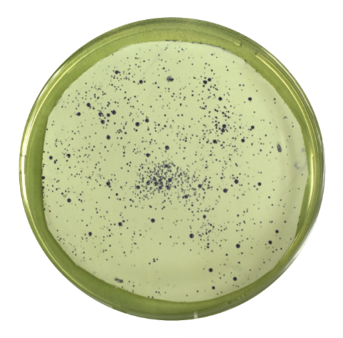

Figure S11. Mutant variant library (mutations at amino acids 36-38) visualized on a solidified MTT reaction mixture. Large colonies were selected for sequencing.

